# CIA2503: Web Applications Development

# Lab/Activity 7 - SOLUTION

Course Learning Outcome: CLO3-CLO3- Create interactive web pages using current standards-compliant client-side web technologies

Chapters: Chapter 7

Cognitive Levels:APPLY

Aim: The student should be able to:

* Create External JavaScript files
* Perform Form Data Validation
* Perform validation using pattern matching

Tools: Text Editor, Brackets, Notepad++, Web Browser

Document Revision Control:

# [MCQ- UNDERSTAND]

1. Where does the form validation occur?  
   **a) Client**  
   b) Server  
   c) Both Client and Server  
   d) User side
2. What is the purpose of data format validation?  
   **a) Data correctness**b) Mere data existence  
   c) Both Data correctness and Mere data existence  
   d) Data modification
3. Which is the function that is called to validate data?  
   a) validate()  
   b) valid()  
   c) validation()  
   **d) no predefined function name. Name is decided by the developer**

# Example- APPLY – JavaScript Form Validation Example

In this example, we are going to validate the name and password. The name can’t be empty and the password can’t be less than 6 characters long. The data in the form will be validated on form submit. The user will not be forwarded to the next stage until the given values are correct.

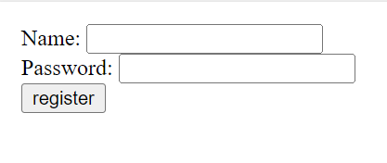

<html>

<body>

<script>

function validateform(){

var name=document.myform.name.value;

var password=document.myform.password.value;

if (name==null || name==""){

alert("Name can't be blank");

return false;

}

else if(password.length<6){

alert("Password must be at least 6 characters long.");

return false;

}

}

</script>

<body>

<form name="myform" method="post" action="/action_page.php" onsubmit="return validateform()" >

Name: <input type="text" name="name"><br/>

Password: <input type="password" name="password"><br/>

<input type="submit" value="register">

</form>

</body>

</html>

# Exercise 1- APPLY – JavaScript Number Validation

Build a simple form as below with a text box and a button. We are going to check using validation that any value added into the box is a number. Use a function called validate to perform the checking. *Hint: use isNAN*

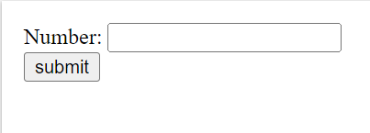

<!DOCTYPE html>

<html>

<head>

<script>

function validate(){

*Complete the code to perform the validation…..*

}

</script>

</head>

<body>

<form name="myform" action="/action_page.php" onsubmit="return validate()" >

Number: <input type="text" name="num"><span id="numloc"></span><br/>

<input type="submit" value="submit">

</form>

</body>

</html>

**SOLUTION**

<!DOCTYPE html>

<html>

<head>

<script>

function validate(){

var num=document.myform.num.value;

if (isNaN(num)){

document.getElementById("numloc").innerHTML="Enter Numeric value only";

return false;

}else{

return true;

}

}

</script>

</head>

<body>

<form name="myform" action="/action_page.php" onsubmit="return validate()" >

Number: <input type="text" name="num"><span id="numloc"></span><br/>

<input type="submit" value="submit">

</form>

</body>

</html>

# Exercise 2- APPLY – JavaScript Email Validation

We can validate the email by the help of JavaScript.

There are many criteria that need to be follow to validate the email id such as:

* email id must contain the @ and . character
* There must be at least one character before and after the @.
* There must be at least two characters after . (dot).
* Let's see the simple example to validate the email field.

Type the following code and test in the

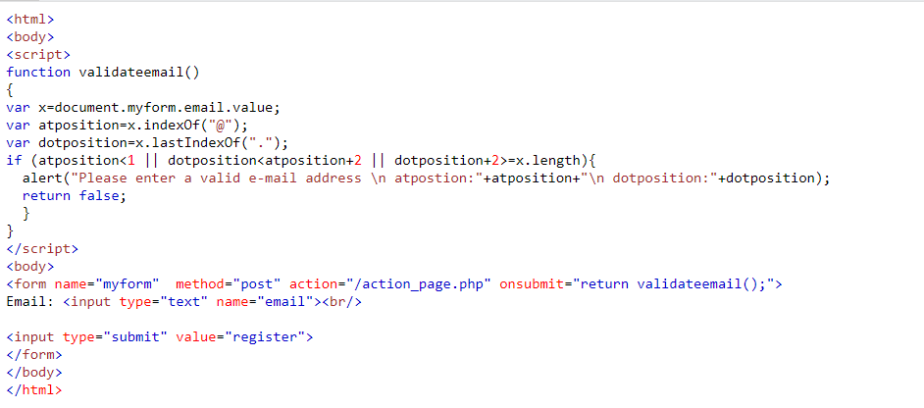

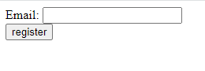

Update the code further so that the email must have:

* at least 3 characters in front of the “@” symbol,
* dot position should never be less than the “@” position plus 3 and
* dot position plus 2 spaces should never be greater than the length of the email.

**SOLUTION**

**<**html>

<body>

<script>

function validateemail()

{

var x=document.myform.email.value;

var atposition=x.indexOf("@");

var dotposition=x.lastIndexOf(".");

if (atposition<3 || dotposition<atposition+3 || dotposition+2>=x.length){

alert("Please enter a valid e-mail address \n atpostion:"+atposition+"\n dotposition:"+dotposition);

return false;

}

}

</script>

<body>

<form name="myform" method="post" action="/action_page.php" onsubmit="return validateemail();">

Email: <input type="text" name="email"><br/>

<input type="submit" value="register">

</form>

</body>

</html>

# Exercise 3 - APPLY – JavaScript Pattern Matching

With reference to the HTML page given below (*The HTML file for the given page is available with name EX3.html and can be found in Lab 7*), create an external JS script called Ex3.js implementing the following tasks.

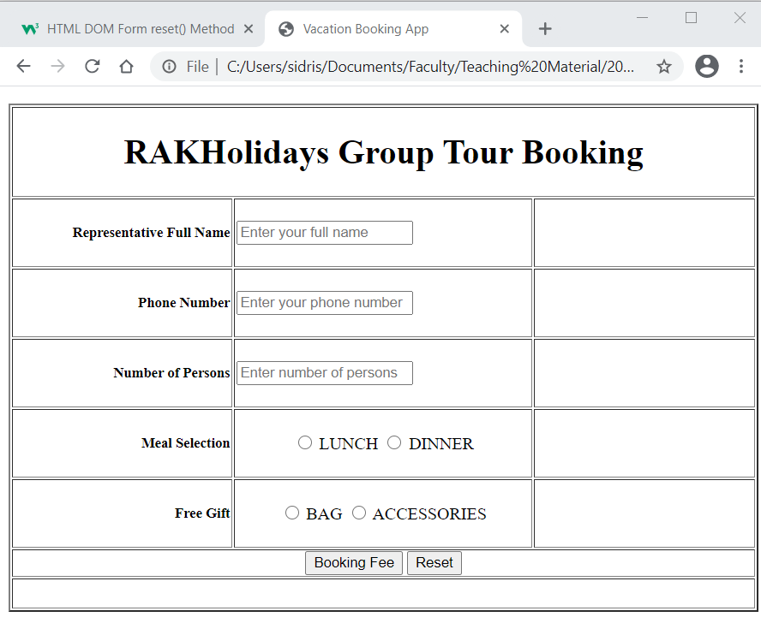

1. Create a JavaScript file called StudentID_Ex3.js and link it with the HTML page provided.
2. In the JavaScript file, create a function **Validate()** that checks the following:

* The name entered should be at least 10 letters, spaces are allowed.
* Number of persons should be more than 10.
* Phone number should start with 05 or 06 or 07 followed by 6 more digits.
* User must select one of the two meal choices.

Validation error messages should be displayed as shown in the snapshot below.

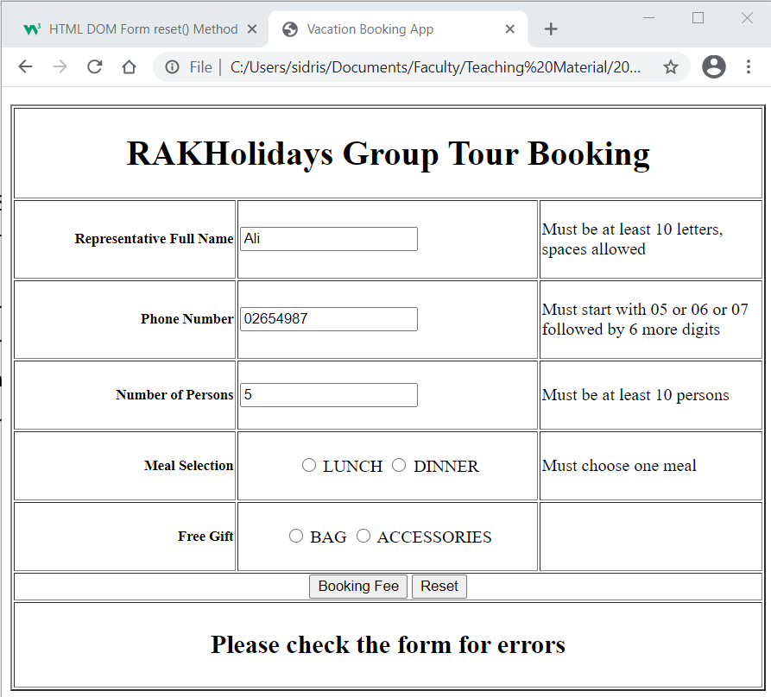

In the JavaScript file, create a function ***makeBooking()*** that:

Calls the function called ***Validate ()*** to check if all user inputs are valid.

If all the user inputs are valid, the method will:

Calculate the booking fee as follows:

**The booking fee is AED 4500 if the number of persons is more than 20,**

**otherwise it is AED 6000.**

Display the booking fee as shown in the snapshot below.

Otherwise, the method should display the error message “Please check the form for errors”

1. Call the function ***makeBooking()*** when the user clicks on the button “**Booking Fee**”.

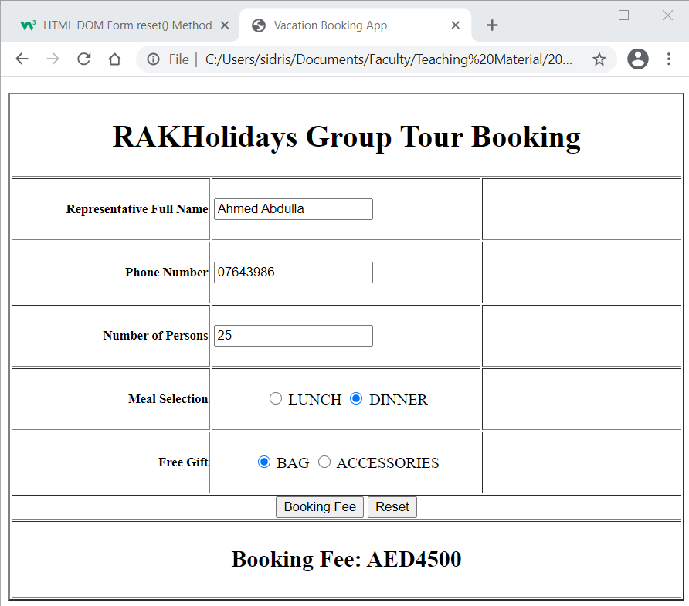

**SOLUTION – See solution files in Lab 7_SOLUTION.zip files**

**Ex3.html**

<!doctype html>

<html>

<head>

<meta charset="UTF-8">

<title>Vacation Booking App</title>

</head>

<body>

<form id="bookform">

<table width="700" height="103" border="2">

<tr align="center">

<td colspan="3"><h1>RAKHolidays Group Tour Booking</h1></td>

</tr>

<tr height="20" >

<td width="153" align="right"><h5>Representative Full Name</h5></td>

<p id="p1"><td width="208"><input type="text" id="fullname" name="fullname" required placeholder="Enter your full name"> </td></p>

<td width="153"><p id="fnameError"></p></td>

</tr>

<tr height="20" >

<td width="153" align="right"><h5>Phone Number</h5></td>

<p id="p1"><td width="208"><input type="text" id="phone" name="phone" required placeholder="Enter your phone number"> </td></p>

<td width="153"><p id="phoneError"></p></td>

</tr>

<tr height="20" >

<td width="153" align="right"><h5>Number of Persons</h5></td>

<p id="p1"><td width="208"><input type="text" id="numPersons" name="numPersons" required placeholder="Enter number of persons"> </td></p>

<td width="153"><p id="numPersonsError"></p></td>

</tr>

<tr>

<td width="153" align="right"><h5>Meal Selection</h5></td>

<td align="center">

<p>

<label>

<input type="radio" name="Meal" value="Lunch" id="lunch">

LUNCH</label>

<label>

<input type="radio" name="Meal" value="Dinner" id="dinner">

DINNER</label>

</p></td>

<td width="153"><p id="mealError"></p></td>

</tr>

<tr>

<td width="153" align="right"><h5>Free Gift</h5></td>

<td align="center">

<p>

<label>

<input type="radio" name="Gift" value="Bag" id="bag">

BAG</label>

<label>

<input type="radio" name="Gift" value="Access" id="access">

ACCESSORIES</label>

</p></td>

<td width="153"><p id="giftError"></p></td>

</tr>

<tr height="20" align="center">

<td colspan="3"><input type="button" onclick="makeBooking();" value="Booking Fee" > <input type="reset"></td>

</tr>

<tr height="20" align="center">

<td colspan="3"><h2> <p id="result"></p></h2></td>

</tr>

</table>

</form>

<script src="EX3.js"></script>

</body>

</html>

**EX3.js**

function makeBooking() {

var result;

var valid = Validate();

if (valid) {

var numPersons = document.getElementById("numPersons").value;

var fee = 0;

if (numPersons <= 20) {

fee = 6000;

}

else {

fee = 4500;

}

result = "Booking Fee: AED"+fee;

}

else {

result = "Please check the form for errors";

}

document.getElementById("result").innerHTML = result;

}

function Validate() {

var fullname = document.getElementById("fullname").value;

var phone = document.getElementById("phone").value;

var numPersons = document.getElementById("numPersons").value;

var lunch = document.getElementById("lunch");

var dinner = document.getElementById("dinner");

var result = true;

if (/^[a-zA-Z ]{10,}$/.test(fullname) == false) {

document.getElementById("fnameError").innerHTML = "Must be at least 10 letters, spaces allowed";

result = false;

}

if (/^(05|06|07)[0-9]{6}$/.test(phone) == false) {

document.getElementById("phoneError").innerHTML = "Must start with 05 or 06 or 07 followed by 6 more digits";

result = false;

}

numPersons = parseInt(numPersons);

if (numPersons <= 10) {

document.getElementById("numPersonsError").innerHTML = "Must be at least 10 persons";

result = false;

}

if (lunch.checked==false && dinner.checked==false) {

document.getElementById("mealError").innerHTML = "Must choose one meal";

result = false;

}

return result;

}

# Exercise 4 - APPLY – JavaScript Form Validation – Home work

Complete the JS-RoyalGym Activity which can be found in Lab7.zip folder. The activity can be found inside ans should be completed as your homework for this week.