# CIA2503: Web Applications Development

# Lab/Activity 8.1

Course Learning Outcome: CLO3

Chapters: Chapter 8

Cognitive Levels: APPLY

Aim: The student should be able to:

* Understand jQuery library fundamentals
* Use the jQuery Event model
* Construct jQuery Selectors

Tools: Text Editor, Brackets, Notepad++, Browser

Document Revision Control: 1.0

# [Example- APPLY]

Create your first Web Page using jQuery with the CDN See below. This will form the basis of your exercises in this lab.

*<!DOCTYPE html>*

*<html>*

*<head>*

*<script src="https://ajax.googleapis.com/ajax/libs/jquery/3.6.0/jquery.min.js"></script>*

*<script>*

*Your jQuery codes………..*

*</script>*

*</head>*

*<body>*

*<h2>Use jQuery</h2>*

*<p>This is a paragraph</p>*

*<p>This is another paragraph</p>*

*<p>I hope you enjoy programming with jQuery</p>*

*<button>Click</button>*

*</body>*

*</html>*

# Exercise 1- APPLY

Use the previous example template code with CDN to do the following by including jQuery?

* 1. Hide all paragraph elements when the button is clicked

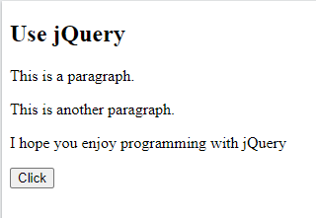 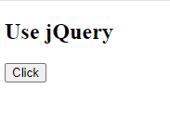

* 1. Update your program to use 2 buttons as shown below. One to hide the paragraphs and another to hide the heading. Hint: you may need to create separate classes for each button to differentiate between them.

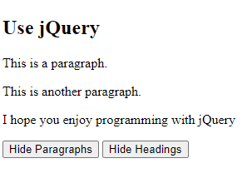

* 1. Update the code so that by clicking the buttons it will toggle between hide and show of the paragraphs and the headings. *Hint: you will need to use toggle method.*

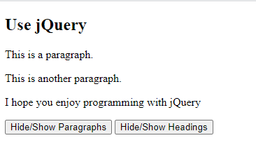

# Exercise 2- APPLY – Finding Specific id Elements

Using the same example, add another paragraph onto your page and give it the id **test**. Use the following text:

“***jQuery is a powerful addition to JavaScript making our web pages more extensible***”

Then add another button that will hide and show **only this new paragraph** when the button is clicked.

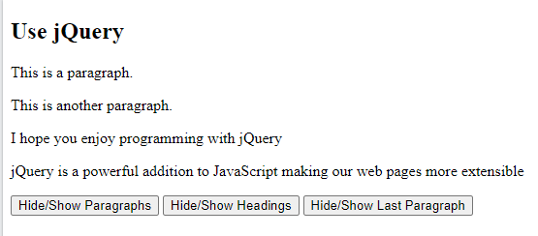 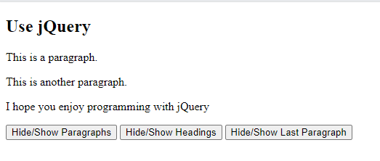

# Exercise 3 - APPLY – Events – focus () and blur()

Reuse the same html document from the previous exercise. We will use the focus() and blur() methods. The **focus()** and **blur()** methods attach an event handler function to an HTML form field.

The function is executed when the form field/text box gets focus from the user (user starts to type)

Add the 2 text inputs to the page with labels as shown below:

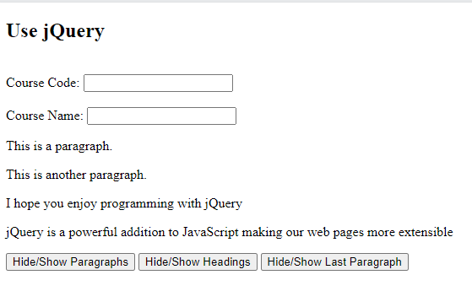

When the user starts to type in the input text field it will gain focus and turn “lightblue”. When focus is taken away it turns “lightgreen”

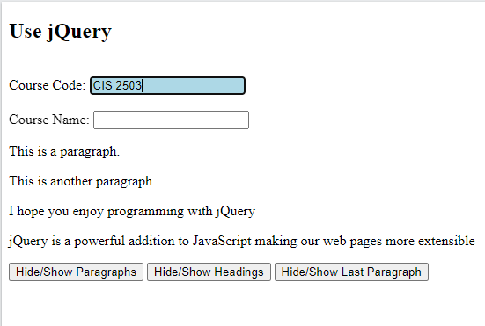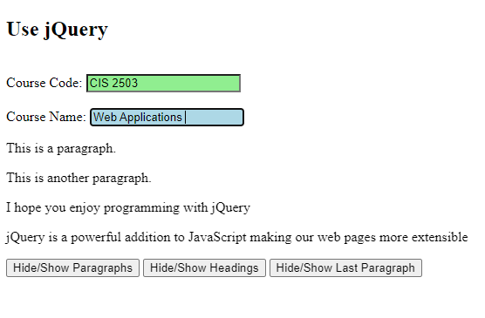

When the user takes focus away from both text input fields, these will turn green. Hint: You will need to use both the focus and the blur methods. See Lecture Chapter 8

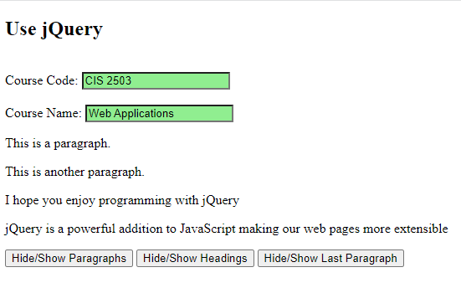

# Exercise 4 - APPLY – External .js file

Using the previous exercises, place the jQuery code (code which you wrote) inside of an external JavaScript file and refer to it from your <head> tags in the html code. See Chapter 8 Lecture. Place the **js** file in the same folder as your html file. Use the following code for guidance.

-Please note that an additional function has been added which when called will present an alert message.

***Lab8_1.html***

<!DOCTYPE html>

<html>

<head>

<script src="https://ajax.googleapis.com/ajax/libs/jquery/3.6.0/jquery.min.js"></script>

**<script src="Lab8_1.js"></script>**

</head>

<body>

<h2>Use jQuery</h2>

<br>Course Code: <input type="text" name="coursecode"><br><br>

Course Name: <input type="text" name="coursename"><br>

<p>This is a paragraph</p>

<p>This is another paragraph</p>

<p>I hope you enjoy programming with jQuery</p>

<p id="test">jQuery is a powerful addition to JavaScript making our web pages more extensible</p>

<button class="btn1">Hide/Show Paragraphs</button>

<button class="btn2">Hide/Show Headings</button>

<button class="btn3">Hide/Show Last Paragraph</button>

</body>

</html>

***Lab8_1.js***

window.onload = function() {

$(function(){ alert("jQuery + DOM loaded."); });

}

$(document).ready(function(){

$(".btn1").click(function(){

$("p").toggle();

});

$(".btn2").click(function(){

$("h2").toggle();

});

$(".btn3").click(function(){

$("#test").toggle();

});

$("input").focus(function(){

$(this).css("background-color", "lightblue");

});

$("input").blur(function(){

$(this).css("background-color", "lightgreen");

});

});

# Exercise 5 - APPLY – HOMEWORK - Advanced

Use the **on()** method to attach to one or more event handlers(*mouseenter, mouseleave, click*) for the selected elements.

Attach multiple event handlers to the <p> element. E.g. when the mouse pointer moves over paragraph highlight it with a background color. See Chapter 8 Lecture. Add codes to the **js** file.