**Wallet Service API Development and Data Modeling**

**Problem Context:**

Develop Rest based solution to deliver below wallet service

1. Every account can have a balance.

2. Every account can have a promotional Balance which should expire after 30 days.

3. REST API to add/use/check balance & passbook.

4. There are two following two promo-codes that can be applied.

● "WELCOME" : Instant 20$ added to account. Only 1st recharge and that too if it is greater then 50$.

● "SALTSIDE" : 10% of the recharge amount to max of 50$.

5. Admin API to list out all the Accounts with History.

**Solution Design**

Create 3 DB tables to hold below service attributes

* Customer Data
* Promotion Data
* Wallet Transactions

Develop REST API call to display below Data from DB

* Promotion Data
* Customer Data
* Wallet Transaction Data
* Wallet Transaction for Individual

**Solution Approach**

MYSQL DB is used to create the below table these are auto created during application initialization as per below script

|  |
| --- |
| CUSTOMERTable ="CREATE TABLE IF NOT EXISTS "+configdata['DATABASE']['MYSQL']['NAME']+".CUSTOMER"\  "(\  CustomerID INT NOT NULL AUTO_INCREMENT PRIMARY KEY,\  FirstName VARCHAR(50) NOT NULL ,\  LastName VARCHAR(50) NOT NULL ,\  MobileNumber VARCHAR(13) NOT NULL ,\  EnrollDate DATETIME DEFAULT CURRENT_TIMESTAMP(),\  ExpiryDate DATETIME,\  DeletionStatus char(1) DEFAULT 'N'\  );"  PromotionTable="CREATE TABLE IF NOT EXISTS "+configdata['DATABASE']['MYSQL']['NAME']+".PROMOTIONS"\  "(\  PromotionID INT NOT NULL AUTO_INCREMENT PRIMARY KEY,\  PromotionCode VARCHAR(20),\  PromotionAction VARCHAR(20),\  PromotionDescription VARCHAR(50),\  PromotionStartDate DATETIME DEFAULT CURRENT_TIMESTAMP(),\  PromotionExpiryDate DATETIME,\  PromotionMinAmount DECIMAL(10,2),\  PromotionMaxAmount DECIMAL(10,2),\  PromotionAmount DECIMAL(10,2),\  PromotionDuration INT,\  AllowedRechargEvent INT,\  PromotionPriority INT NOT NULL\  );"  WalletTransctionTable="CREATE TABLE IF NOT EXISTS "+configdata['DATABASE']['MYSQL']['NAME']+".WALLTETRANSACTION"\  "(\  WalletTranID INT NOT NULL AUTO_INCREMENT PRIMARY KEY,\  CustomerID INT REFERENCES WALLETSERVICE.CUSTOMER(CustomerID),\  RechargeDate DATETIME DEFAULT CURRENT_TIMESTAMP(),\  RechargeExpiryDate DATETIME,\  RechargeAmount DECIMAL(10,2),\  PromotionAmount DECIMAL(10,2),\  PromotionID INT REFERENCES WALLETSERVICE.PROMOTIONS(PromotionID),\  PromotionExpiryDate DATETIME\  );" |

**API Development**

Python Flask library used for WEB API development

Promotion Details

http://<HOSTNAME>:800/GetWalletPromotions

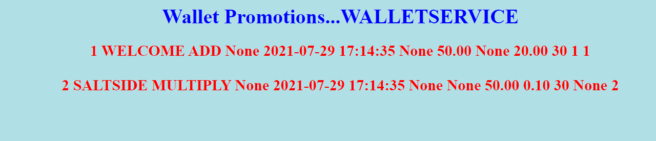

Customer Details

http://<HOSTNAME>:800/GetCustomerDetails

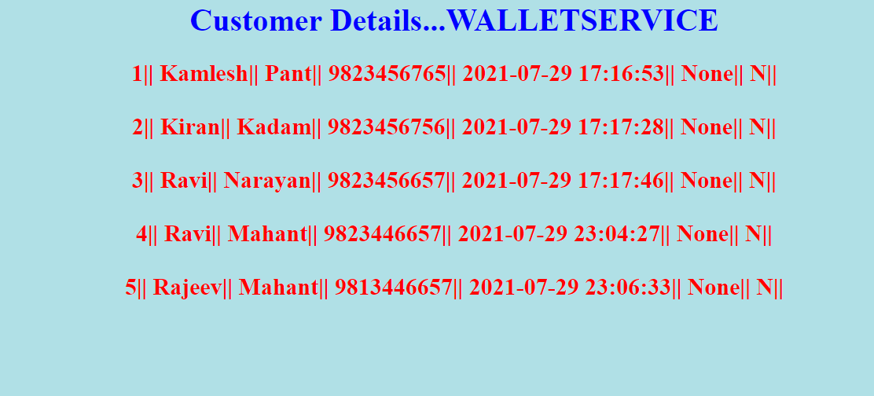

Wallet Transaction For All

http://<HOSTNAME>:800/GetWalletTransactions

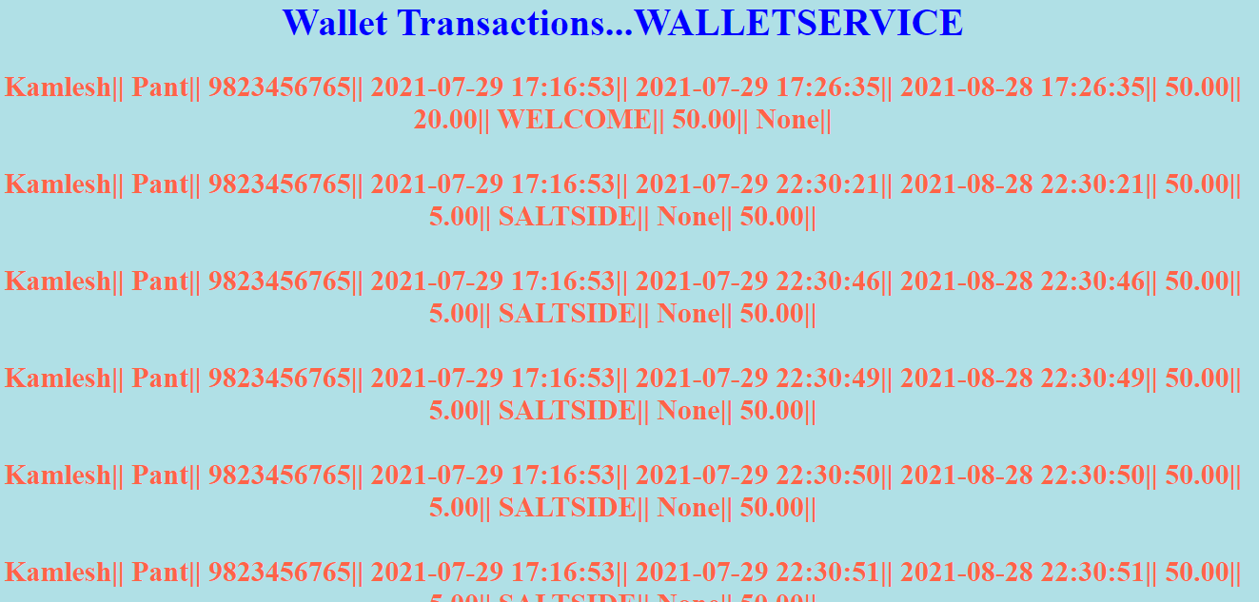

Wallet Transaction For Individual

http://<HOSTNAME>:800/ GetWalletTransactionsForIndividual/<Mobilenumber>

