RESUME

RESUME

NAME : R.KARTHIKEYAN 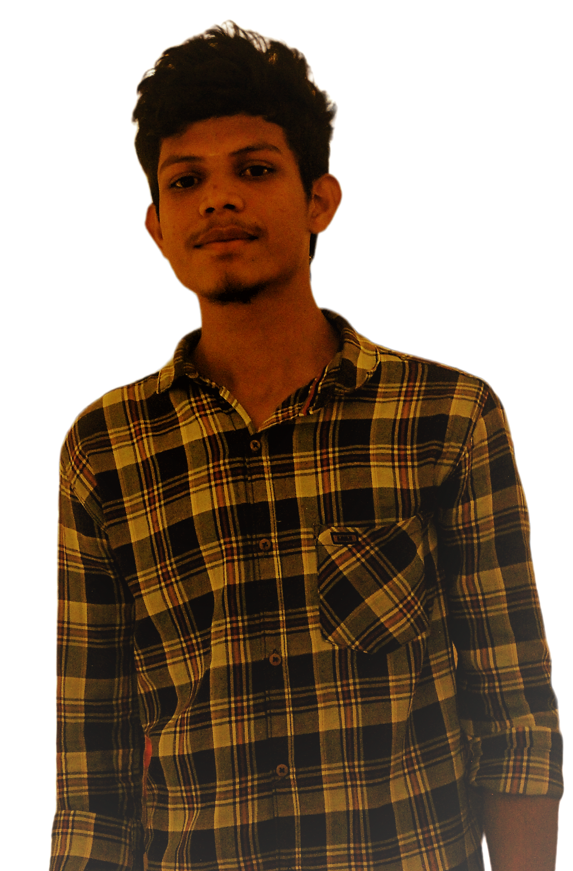

FATHER’S NAME : M.RAJA

GENDER : MALE

DATE OF BIRTH : 08/07/2002

NATION : INDIAN

RELIGION : HINDU

Hr.SEC MARK / Group : 485.13 / COMPUTER MATHS

YEAR OF PASSING : 2021

EDUCATIONAL MEDIUM : ENGLISH

SCHOOL NAME / LOCATION : S.B.M HR SEC SCHOOL / MELUR

LANGUAGE KNOWN : TAMIL & ENGLISH

|  |  |
| --- | --- |
| **AADHAR NO :** | 7605 3795 2606 |
| **EMAIL –ID :** | karthikeyan08720@gmail.com |
| **MOBILE NO/**  **PHONE NO :** | 7806921382 /  9944276834 |
| **ADDRESS** | 33/A1, OKKUPATTI,  SIVAGANGAI , Malampatti ,  Tamil Nadu -630562 |

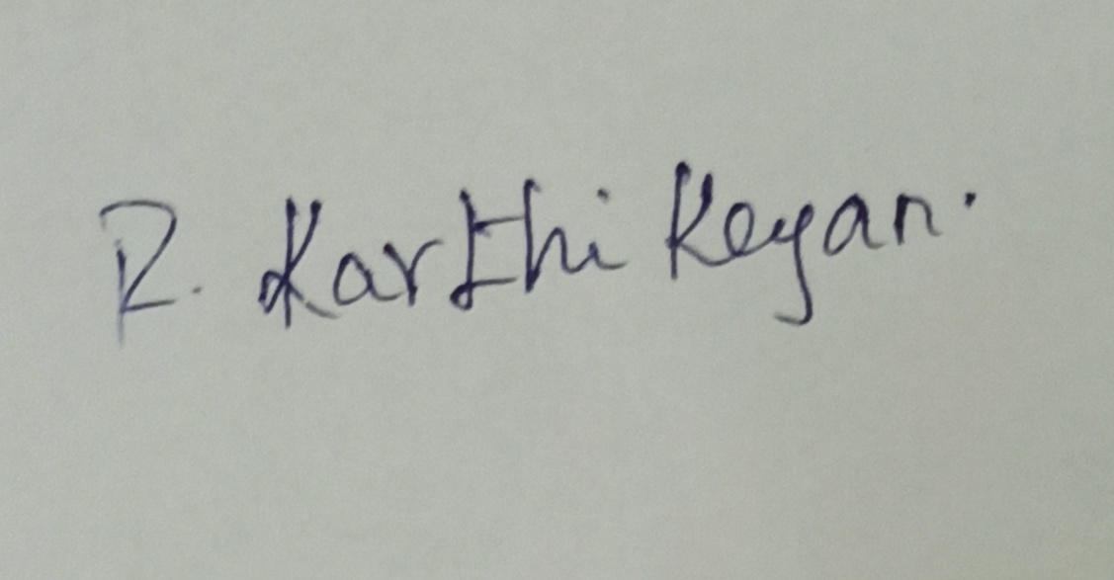 signature

s

STUDENT’S SINGNATURE