

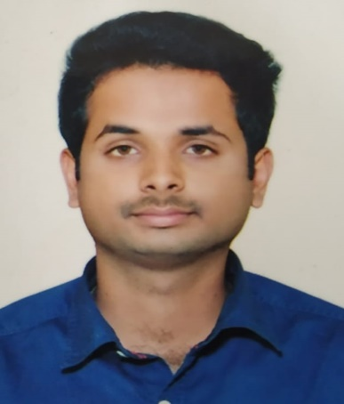**NAME** : KIRANKUMAR P PATIL

**EMP ID** : 186724

**PHONE** : +91-87792219594

**MAIL** : KIRAN97PATIL@GMAIL.COM

|  |  |
| --- | --- |
| **Title:** | Analyst / Software Engineer. |
| **Location:** | Bangalore, India. |
| **Languages:** | Kannada (Native), English (Fluent), Hindi (Fluent). |

# Experience Summary

To enhance my working capabilities, business efficiencies and professional skills in order to serve my organization with sheer commitment and determination. I also intend to work in a learning and challenging environment, utilizing my skills and knowledge to be the best of my abilities and contribute positively to my personal growth as well as growth of the organization. Fresher trained in java stream.

**KEY SKILLS:**

* **Functional:** Excellent Communication and Interpersonal Skills.
* **Technical:** Java Full Stack Development (Core Java, Angular6, Spring Boot, BDD).

# Higher Education

**BTECH**

**STREAM**- ELECTRONICS AND COMMUNICATION ENGINEERING.

**COLLEGE**- BMS INSTITUTE OF TECHNOLOGY, BANGLORE.

**YEAR**- 2019.