Design Document
For
Messaging Application

Submitted By
PRASAD K K
Mob: +91 9916255544
Email: kk.prasad@yahoo.com

Contents
Scope of Work 3
Messaging Server - Features 3
Messaging Client - Features 4
Design Patterns Used 4
Over All Architecture Diagram 5
Class Diagram 6
Sequence Diagram 7
Source File Directory Details 8
Messaging Server Application 8
Scripts used to make Messaging Server as a service 8
Installation scripts 8
Messaging Client Application 8
Directory Structure 8

Scope of Work
Messaging application implements client-server model architecture by using TCP protocol. The Messagin Server is running as a service in the Linux Server. It can also run on console by specifying “-t” option as command line argument

Messaging Server - Features
The features of the Messaging Server module are as follows:
- The Messaging Server listening to particular port and waiting for the client to connect
- By default the socket is listening to 8787
- The listening port can be changed through configuration file as well as command line argument
- The parameter values provided as the command line arguments are having more priority than that of in the configuration file
- It uses multi-threaded architecture to server concurrent connections from the clients. There are individual receive threads for receiving the messages from the client
- It accepts the GETMESSAGE message from the client and responds to the client with a random string of length 50
- The Messaging Server terminates the connection with the client whenever the client sends a BYE message
- Messaging Server can be run on console also by using the “-t” option
- The Messaging Server logs all the transactions to a specific directory which can be specified over command line argument as well as configuration file
- If the required configuration parameters are not supplied either through the command line argument or through configuration file, Messaging server will assign the default values by itself

The default values that are used for the Messaging Server is given below

Parameter Name | Default Value
SocketType | SynchronousSocket
Protocol | TCPSocket
PortNumber | 8787
SourceServerIP | localhost
MaxMessageHandlerThreads | 5
MaxMessageSendThreads | 5
LogDirectory | If the environment variable $MSGSERVER_HOME is set, the logs will be stored in the directory $MSGSERVER_HOME/var/log.  If the environment variable is not set, the default log file directory will be “/tmp/”

Messaging Client - Features
Messaging Client is an application developed by using perl. The features are as follows:
- It connects to the Messaging server by using TCP protocol
- It accepts port number, Server IP of the Messaging Server and the number of requests to be send to the server as command line arguments
- The above command line arguments are mandatory to run the Messaging Client. Otherwise the application will get exited
- It sends the GETMESSAGE packet to the server and receive the response
- It logs all the requests and response to a log file. The PID of the perl program is used for the naming of the log file
- The perl file can be executed multiple times in parallel

Design Patterns Used
Factory Method
Used to create the socket object. When ever we have to change the protocol to any other protocol like SCTP of UDP, we have to write the class for that and make necessary changes in this Factory method. No other classes has to be modified

Singleton
Used for writing data to file. Only single instance is required.

Over All Architecture Diagram
The overall architecture diagram is as shown below

Messaging Server Listen Thread
Receive Thread 1
Receive Thread 2
Receive Thread N
Messaging Client 1
Messaging Client 2
Messaging Client N
Message Handling Thread
Message Sending Thread
Obselete Client Removing Thread
Data Queue

Class Diagram
The class diagram of Messaging Server application is below:
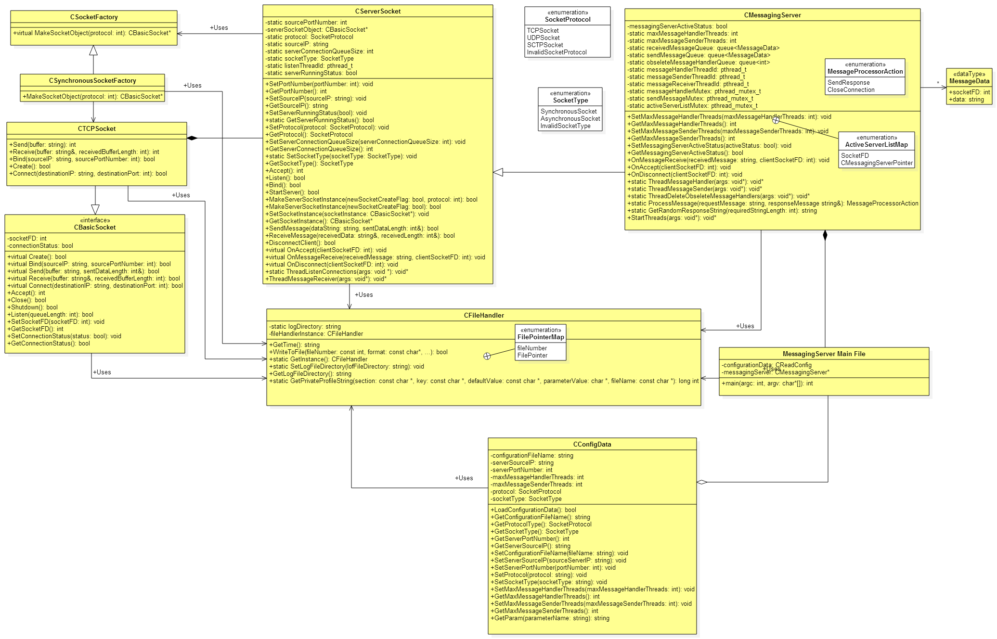

Sequence Diagram

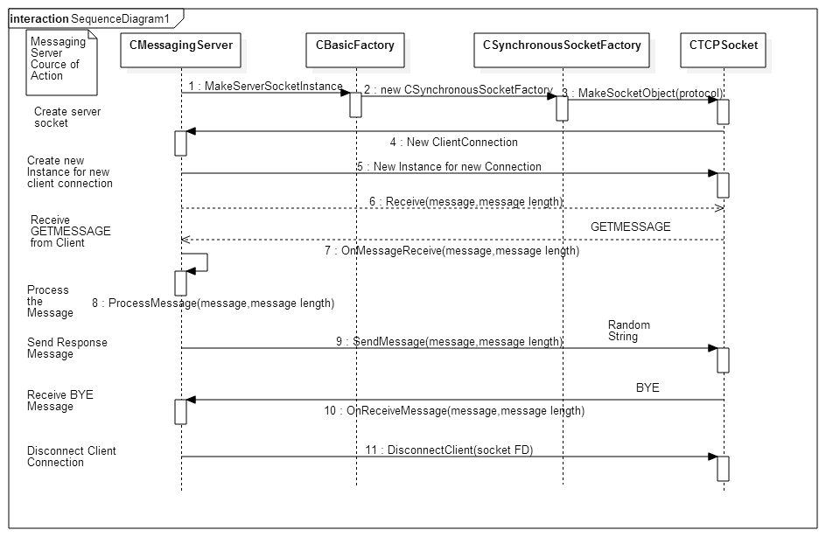

Source File Directory Details

Messaging Server Application
All the source files are present in the MessagingServer/source directory

Scripts used to make Messaging Server as a service
The scripts used to make the Messaging Server as a service is present in MessagingServer/scripts directory. The files are “initmsgserverd” and “servicemsgserverd”. The install.sh will copy the initmsgserverd file to /etc/init.d/ folder. This file will internally call the script servicemsgserverd which is actually starting and stopping the service. This method is used to ensure that the application is invoked as the specified user and to keep all the associated files in the same folder where we stores the MessagingServer related files.

Installation scripts
Install.sh is the installation script and it is present in MessagingServer directory. This script is used to install the msgserverd as a service

Messaging Client Application
The perl program is present in the MessagingClient directory

Directory Structure
Messaging Server related files are stored in MessagingServer Directory
MessagingServer
src - Source Files
sbin - Executable Files
etc - Configuration files
scripts - Scripts for making Messaging Server as service
var - Stores the lock file, PID file and log files
lock - Stores the lock file
run - Stores the PID file
log - Stores the log files

