Integration And Scaling Test Report
For
Messaging Application

Submitted By
PRASAD K K
Mob: +91 9916255544
Email: kk.prasad@yahoo.com

Contents
Hardware & Software Specification of Testing Server 3
Hardware Details 3
Software Details 3
Functionality 4
Messaging Server 4
Messaging Client 5
Valgrind Leak Check Output 6
Scaling Test Report 7
Statistics 7
NMON Statistics 8
CPU Utilization 8
Memory Usage 9
Ethernet Usage 10
Disk Read And Write 11

Hardware & Software Specification of Testing Server
The below is the specifications of the hardware and software which is used for performing the integration and load test.

Hardware Details

Parameter | Value
System Manufacturer | Dell Inc.
System Product Name | dell precision690
Processor Manufacturer | Intel
Processor Version | Intel(R) Xeon(R) CPU 5130 @ 2.00GHz
Number of Processors | 2 quad core processors
RAM | 4 GB

Software Details
Parameter | Value
Operating System | CentOS 6.4
GCC Version | 4.4.7 20120313

Functionality

Messaging Server
Test Case Number | Test Case | Test Method | Observation | Result
1 | Starting Message Server with command line arguments | Run the application ./msgserver –t –p 8786  Check netstat output | tcp 0 0 0.0.0.0:8786 0.0.0.0:* LISTEN 12746/msgserverd | OK
2 | Starting Message Server with configuration file | Give port number as 8785 in etc/msgserverd.conf and run application as ./msgserver -t  Check netstat output | tcp 0 0 0.0.0.0:8785 0.0.0.0:* LISTEN 29032/msgserverd | OK
3 | Starting message server with default values | Clear port number entry in etc/msgserverd.conf and run application as ./msgserver –t  Check netstat output with executable name | tcp 0 0 0.0.0.0:8787 0.0.0.0:* LISTEN 28714/msgserverd | OK
4 | Accepting New Connections | Start the application as ./msgserverd –p 8787  Run the perl application as “perl MessagingClient.pl -s localhost -p 8787 -n10” | Message “Received New Connection Request on Socket FD:<socket FD>” is displayed | OK
5 | Processing Received Messages | Start the application as ./msgserverd –p 8787  Run the perl application as “perl MessagingClient.pl -s localhost -p 8787 -n1” | Message “REQUEST:SockeFD:5:GETMESSAGE  RESPONSE:SocketFD=5:The message is jeDHTrgMRv8Nwf9e88Eg1430629658LaN72CCTn9lWem1v5EBq” is displayed in Message Server | OK
6 | Clearing connections which are disconnected | Start the application as ./msgserverd –p 8787  Run the perl application as “perl MessagingClient.pl -s localhost -p 8787 -n1” | Message “REQUEST:SockeFD:5:BYE  Removed object from ActiveMessagingServerList:SocketFD=5  Exiting from ThreadMessageReceiver for SocketFD:5”  Received thread is exited and Connection is closed | OK
7 | Running as daemon | Install the messaging server as service by executing ./install.sh  Start the service as “service msgserverd start”  Start the service as “service msgserverd stop”  Start service as “service msgserverd status” | Starting msgserverd: [ OK ]  Stopping msgserverd: [ OK ]  msgserverd is stopped | OK

Messaging Client
Test Case Number | Test Case | Test Method | Observation | Result
1 | Connect to messaging server | Run the perl application as “perl MessagingClient.pl -s localhost -p 8787 -n1” | PID=16063|03-May-2015 10:37:38|Connecting to Server IP = localhost Port Number = 8787 Number of Requests = 1  PID=16063|03-May-2015 10:37:38|TCP Connection Success. | OK
2 | Send request and receive response | Run the perl application as “perl MessagingClient.pl -s localhost -p 8787 -n1” | PID=16063|03-May-2015 10:37:38|Request Packet Number: 1 to Server. Data: GETMESSAGE  PID=16063|03-May-2015 10:37:38|Response Packet Number:1 from Server. Data : The message is jeDHTrgMRv8Nwf9e88Eg1430629658LaN72CCTn9lWem1v5EBq | OK
3 | Disconnecting connection | Run the perl application as “perl MessagingClient.pl -s localhost -p 8787 -n1” | PID=16063|03-May-2015 10:37:38|Request Packet to Server. Data:BYE  PID=16063|03-May-2015 10:37:38|Exiting From Client Application | OK

Valgrind Leak Check Output

==29213== HEAP SUMMARY:
==29213== in use at exit: 289 bytes in 5 blocks
==29213== total heap usage: 32,072,986 allocs, 32,072,981 frees, 1,114,527,710 bytes allocated

==29213== LEAK SUMMARY:
==29213== definitely lost: 0 bytes in 0 blocks
==29213== indirectly lost: 0 bytes in 0 blocks
==29213== possibly lost: 289 bytes in 5 blocks
==29213== still reachable: 0 bytes in 0 blocks
==29213== suppressed: 0 bytes in 0 blocks
==29213==
==29213== For counts of detected and suppressed errors, rerun with: -v
==29213== ERROR SUMMARY: 5 errors from 5 contexts (suppressed: 16 from 8)

Scaling Test Report

Statistics

Sl No | Start Time | End Time | Mode | Message Handler Threads | Send Threads | Clients | Requests/Client | Total Requests | Total Time Taken( Seconds) | Messaging Server TPS
1 | 02/05/2015 21:57:30 | 02/05/2015 22:15:53 | Console | 10 | 10 | 10 | 100000 | 1000000 | 1103 | 907
2 | 02/05/2015 22:51:50 | 02/05/2015 23:10:43 | Daemon | 10 | 10 | 20 | 100000 | 2000000 | 1133 | 1765
3 | 02/05/2015 23:28:29 | 02/05/2015 23:47:39 | Daemon | 1 | 1 | 5 | 100000 | 500000 | 1150 | 435

Conclusion:
The Messaging Server gives best result when the ratio between the number of message handling threads and number of clients is 1:2. Ie, one message handling thread can handle 2 clients with the optimum output

NMON Statistics

CPU Utilization
User Average utilization was 1.207 percentage . The diagram with the CPU usage is as given below.
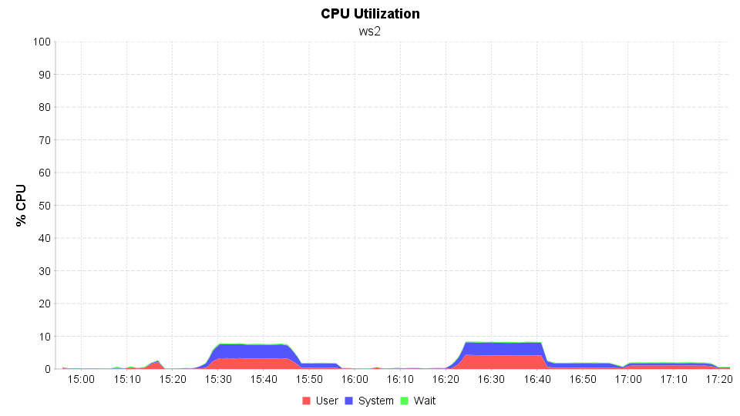

The CPU usage is seems to be steady.

Memory Usage

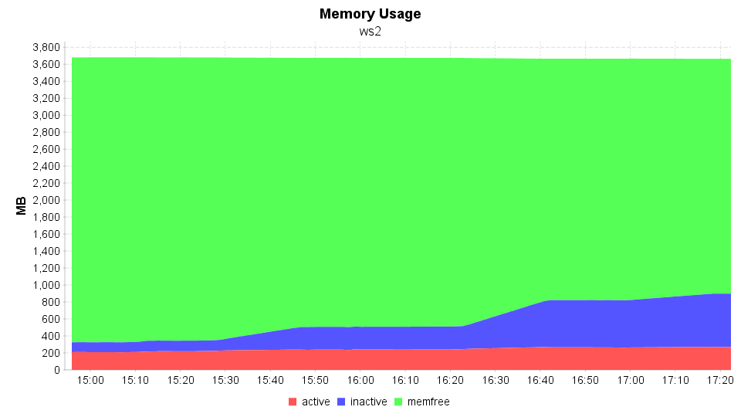

Average Memory Usage is 243.294 and the memory utilization is not growing drastically.

Ethernet Usage

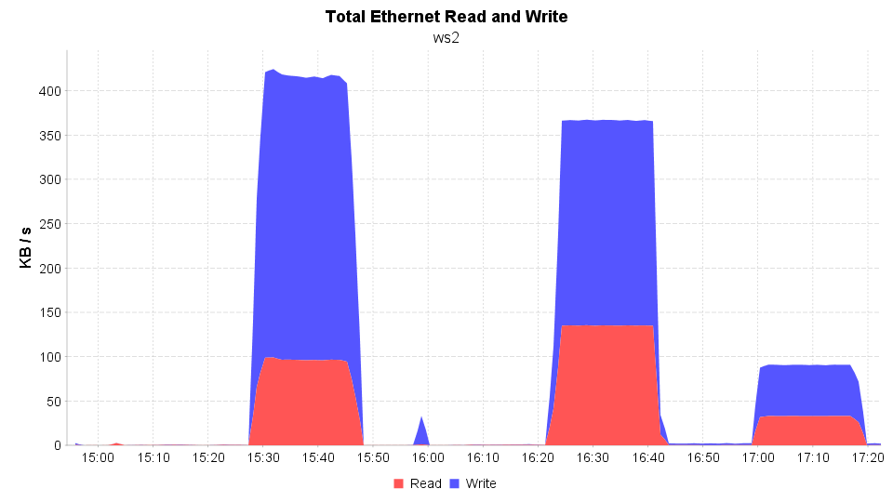

The Ethernet read and write during this scaling test is stable.

Disk Read And Write

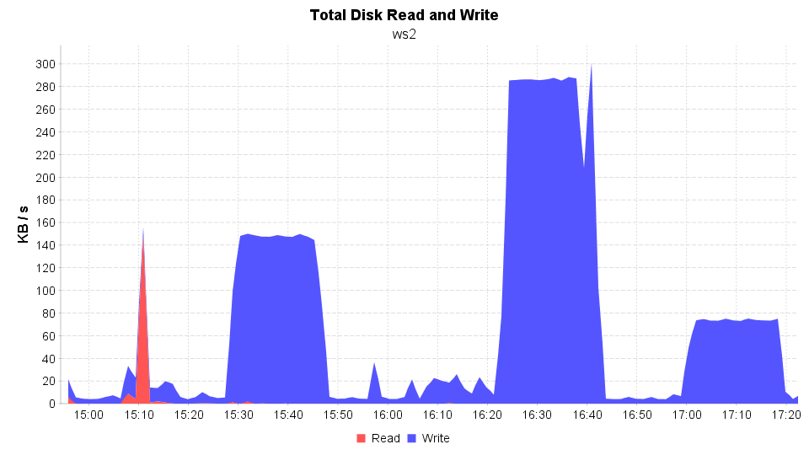

The disk ready and write operations seems to be steady. The graph shows that the disk access are regularized.

