BOSCH PRODUCTION LINE
PERFORMANCE PROJECT HANDBOOK
PART II - UNDERSTANDING THE BOSCH DATASET
A guided tour of the competition, files, features, timestamps, anonymization, limitations, and manufacturing interpretation
Author
Krishnakanth Reddy Karingula
Project repository: github.com/kkr199/Bosch-Production-line-performance
Dashboard: bosch-peformance-line.streamlit.app

How to Use Part II
Part II explains the Bosch Production Line Performance dataset before the handbook moves into data science and modeling. The goal is not merely to list columns. A beginner should finish this part understanding what one row represents, how the files relate to one another, why the data is extremely sparse, what the feature names reveal, what they deliberately hide, and how to communicate findings without claiming more than the data supports.
The most important rule in this part
The dataset preserves manufacturing structure but removes physical meaning. You can identify a line, station, feature number, value type, relative measurement time, and labelled outcome. You cannot identify the real sensor, unit, operation, machine setting, product type, defect mechanism, or physical root cause without additional Bosch factory documentation.

Part II learning roadmap
Chapter | Purpose
Chapter 7 | Understand the Kaggle task, target, train/test design, class imbalance, and MCC metric.
Chapter 8 | Learn how the six large CSV files and sample submission fit together.
Chapter 9 | Understand numerical measurements, sparsity, preprocessing, and safe interpretation.
Chapter 10 | Understand categorical values, encoding choices, high cardinality, and unseen levels.
Chapter 11 | Understand relative date features, feature pairing, station presence, and timestamp-derived engineering.
Chapter 12 | Learn why data is anonymized and how that changes interpretation.
Chapter 13 | Master the Lx_Sy_Fz and Lx_Sy_Dz naming convention and metadata parsing.
Chapter 14 | Recognize the dataset limitations and separate benchmark readiness from factory readiness.
Chapter 15 | Apply a disciplined manufacturing interpretation framework to project findings.

Dataset snapshot from this project
Item | Value
Training parts | 1,183,747
Unlabelled test parts | 1,183,748
Failure rate in training | 0.5811% (6,879 failures)
Raw model feature columns | 4,264
Numerical features | 968
Categorical features | 2,140
Date features | 1,156
Encoded production lines | 4
Encoded stations | 52
Approximate raw CSV size | 14.3 GB across train and test files

Source policy
The core description is based on the official Kaggle competition materials and the data-quality, metadata, exploratory-analysis, feature-engineering, and research artifacts produced in this project. The Kaggle discussion forum is used as supplementary evidence for competition techniques and community observations. Such observations are not treated as official descriptions of Bosch operations. Where a community technique exploits ordering or information that would not exist in a future factory deployment, the handbook labels it as competition-style rather than production-safe.

Contents
- Chapter 7: Bosch Kaggle Competition
- Chapter 8: Dataset Structure
- Chapter 9: Numerical Features
- Chapter 10: Categorical Features
- Chapter 11: Date Features
- Chapter 12: Why Features are Anonymous
- Chapter 13: Understanding Line-Station-Feature Naming
- Chapter 14: Dataset Limitations
- Chapter 15: Manufacturing Interpretation
- Part II Glossary
- References

Chapter 7: Bosch Kaggle Competition
Learning objectives
By the end of this chapter, the reader should be able to:
• describe the goal and unit of analysis of the Bosch competition
• explain the Response target and the train/test arrangement
• calculate and interpret the severe class imbalance
• explain why accuracy is unsuitable and why MCC was used
• separate competition performance from production-readiness claims

7.1 The business problem behind the competition
Bosch records many measurements and tests while parts move through production. The competition asked participants to use those records to predict internal failures. The general manufacturing motivation is straightforward: if high-risk parts can be recognized earlier or prioritized for additional review, a manufacturer may reduce waste, rework, missed defects, and unnecessary inspection. The competition converted this broad industrial objective into a supervised binary classification problem [1][10].
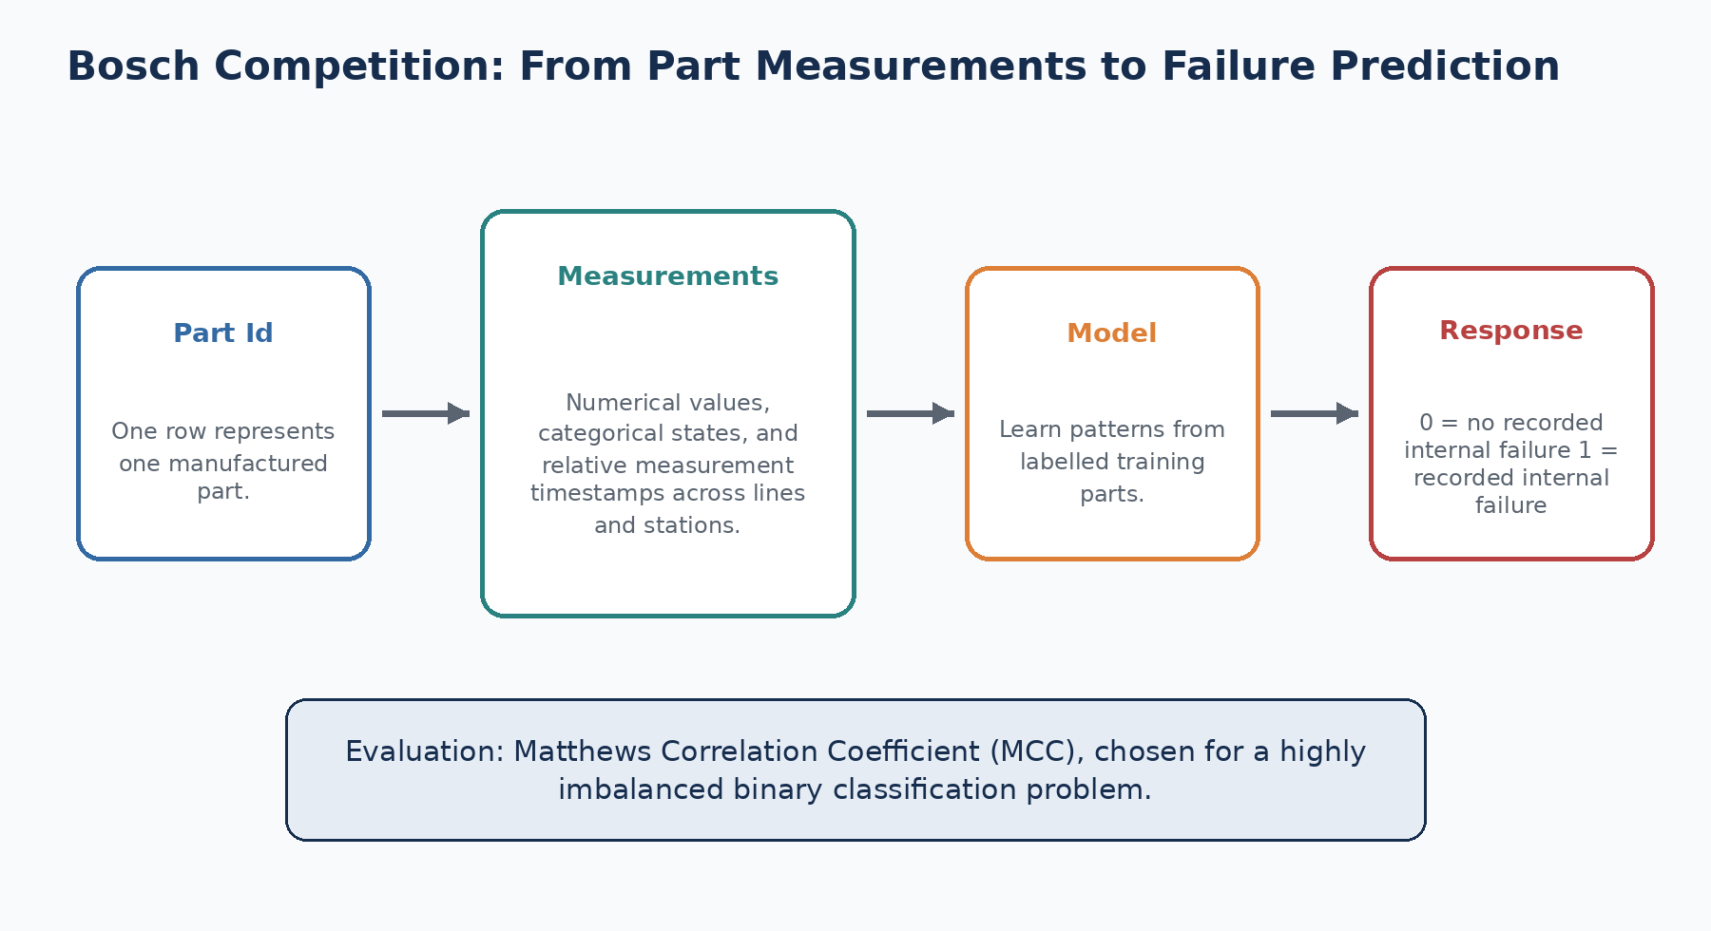
Figure 7.1 - The competition converts production records for each part into a binary failure prediction task.
Unit of analysis
One row represents one manufactured part or component, identified by Id. Measurements from the numerical, categorical, and date files must be associated with that same Id before they can be analyzed together.

7.2 What does Response mean?
The target column is named Response and appears only in train_numeric.csv. A value of 1 indicates a recorded internal failure for that training part, while 0 indicates that the part was not labelled as a failure in the competition data. The test files do not contain Response because Kaggle held the test outcomes and used them to score submissions.
Response | Competition meaning | Modeling class
0 | No recorded internal failure in the provided label | Negative class
1 | Recorded internal failure | Positive class

Careful wording
Response = 0 should not be described as proof that the part was perfect in every possible way. It means the competition label did not mark the part as an internal failure. The exact inspection rule, failure mode, and downstream disposition are not provided.

7.3 Train and test splits
The labelled training split contains 1,183,747 parts. The unlabelled test split contains 1,183,748 parts. Each split is divided into numerical, categorical, and date files. A sample_submission.csv file provides the required submission format, typically Id and Response. It is not a source of training features and should not be included in data profiling as though it were another model table.
Split | Rows | Label available? | Purpose
Train | 1,183,747 | Yes | Fit models, create validation splits, and evaluate locally
Test | 1,183,748 | No | Generate final competition predictions

7.4 The rare-event challenge
Only 6,879 of the 1,183,747 training parts are labelled as failures. This is a failure rate of approximately 0.5811%. There are about 171 non-failures for every failure. Such a distribution is called severe class imbalance.
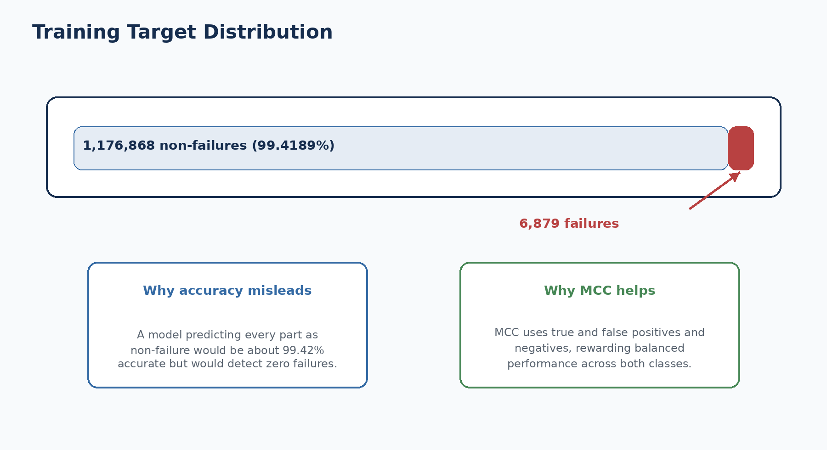
Figure 7.2 - The failure class is visually tiny compared with the non-failure class.
A beginner may believe that 99% accuracy is excellent. In this dataset, a model that predicts every part as non-failure would achieve approximately 99.42% accuracy while identifying none of the 6,879 failures. This is why the evaluation metric must look at both classes and all parts of the confusion matrix.

7.5 Confusion matrix foundations
Term | Meaning in this project
True Positive (TP) | A failed part is predicted as failure.
False Positive (FP) | A non-failed part is predicted as failure.
True Negative (TN) | A non-failed part is predicted as non-failure.
False Negative (FN) | A failed part is predicted as non-failure.

False positives can create additional inspection work, while false negatives can allow risky parts to pass without the intended intervention. The relative business impact of these errors is not provided in the competition. A real factory POC would require cost, safety, capacity, and process-owner input before selecting an operating threshold.

7.6 Matthews Correlation Coefficient
Kaggle evaluated submissions using the Matthews Correlation Coefficient (MCC). MCC combines TP, TN, FP, and FN into a single score. It is particularly useful for imbalanced binary classification because it rewards predictions that perform well across both classes rather than being dominated by the majority class [1][2].
MCC formula
MCC = (TP*TN - FP*FN) /
sqrt((TP+FP)*(TP+FN)*(TN+FP)*(TN+FN))

MCC value | Interpretation
+1 | Perfect agreement between predictions and labels
0 | No better than an uncorrelated prediction pattern
-1 | Perfect disagreement

Threshold matters
Most classifiers output probabilities. The competition submission requires a binary Response prediction. The probability threshold that maximizes MCC is often not 0.5, especially when failures are rare. Threshold tuning must be performed only on validation data, not on the final test labels.

7.7 Competition learning versus factory learning
Kaggle competitions encourage experimentation and leaderboard optimization. Public discussions and solution write-ups showed that time ordering, neighboring products, path patterns, missingness, threshold tuning, and ensembles could improve MCC [3][9]. These lessons are valuable, but a high leaderboard score does not automatically represent future-factory performance.
Competition question | Factory question
Can the hidden Kaggle labels be predicted? | Can future parts be scored before the quality decision must be made?
What feature gives the best leaderboard gain? | Is the feature available, stable, governed, and causally safe enough for the intended action?
What threshold maximizes MCC? | What threshold balances missed failures, inspection capacity, cost, and safety?
Can train/test ordering be exploited? | Will the same relationship exist for future production periods and new products?

7.8 How this project uses the competition
This project treats the Bosch data as a benchmark for an end-to-end manufacturing analytics POC. It includes a production-safe Phase 6 LightGBM model, while keeping a separate leaderboard-style research extension that uses order and neighbor features. The separation is important: the leaderboard extension is informative for competition research, but its optimistic validation score is not used as the official production-readiness claim [4][9].
Common beginner mistakes
• Using accuracy as the main metric for a 0.58% failure rate.
• Assuming Response = 0 proves the part has no possible quality issue.
• Tuning the threshold on the Kaggle test result or repeatedly using a holdout until it becomes training data.
• Describing a leaderboard feature as production-safe without checking whether it exists at prediction time.
• Comparing MCC values obtained from different splits as though they were directly equivalent.

Review questions
1. What does one row represent?
2. Where is Response stored, and why is it absent from test files?
3. Why would an always-zero model appear accurate?
4. What four confusion-matrix quantities are used by MCC?
5. Why can a Kaggle leaderboard strategy fail in a real future-production setting?

Practice exercise
Assume a validation set contains 100,000 parts with 580 failures. Create a hypothetical confusion matrix for a model that finds 200 failures but raises 500 false alarms. Calculate precision and recall, then explain why a factory manager would need more information before approving the threshold.
Chapter summary
• The competition is a rare-event binary classification problem at part level.
• Response = 1 identifies a recorded internal failure in the training labels.
• Only about 0.58% of training parts are failures, making accuracy misleading.
• MCC evaluates all four confusion-matrix outcomes.
• Leaderboard performance is not the same as factory performance.

Chapter 8: Dataset Structure
Learning objectives
By the end of this chapter, the reader should be able to:
• identify every supplied file and its purpose
• explain why the dataset is separated by feature type
• join numerical, categorical, and date records safely by Id
• describe the scale, dimensionality, sparsity, lines, and stations
• design a memory-aware data-loading workflow

8.1 Why the files are separated
The dataset is extremely large, so Kaggle separated it into files by feature type: numerical, categorical, and date. This separation allows a participant to start with one feature family, read the data in chunks, or build separate preprocessing pipelines. The project Phase 1 inventory shows that the six train/test CSV files together occupy roughly 14.3 GB before derived outputs are created [5].
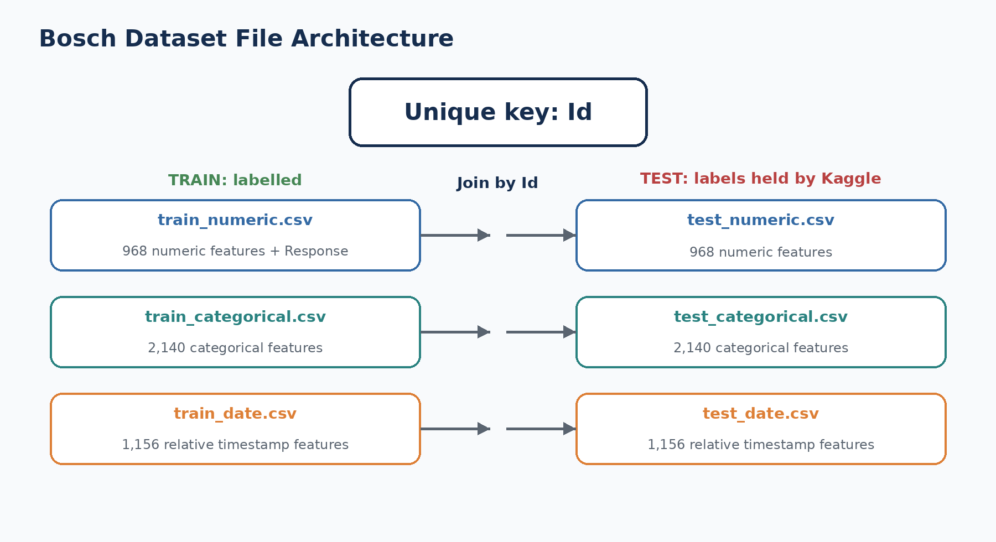
Figure 8.1 - The numerical, categorical, and date tables are linked by the unique Id column.

8.2 Complete file inventory
File | Rows | Columns | Contents | Approx. size
train_numeric.csv | 1,183,747 | 970 | Id, 968 numeric features, Response | 2,040.77 MB
train_categorical.csv | 1,183,747 | 2,141 | Id, 2,140 categorical features | 2,554.27 MB
train_date.csv | 1,183,747 | 1,157 | Id, 1,156 date features | 2,759.33 MB
test_numeric.csv | 1,183,748 | 969 | Id, 968 numeric features | 2,038.27 MB
test_categorical.csv | 1,183,748 | 2,141 | Id, 2,140 categorical features | 2,554.20 MB
test_date.csv | 1,183,748 | 1,157 | Id, 1,156 date features | 2,759.20 MB
sample_submission.csv | 1,183,748 | 2 | Id and placeholder Response | Format reference

Why train_numeric has two more columns than numeric features
The 970 columns are: Id + 968 numerical feature columns + Response. In test_numeric.csv, Response is absent, so there are 969 columns.

8.3 Raw feature count
Across the three feature types, the project parsed 4,264 raw feature columns: 968 numerical, 2,140 categorical, and 1,156 date features. The naming convention reveals four encoded production lines and 52 encoded stations [6].
Line | Stations | Numerical | Categorical | Date | Total features
L0 | 24 | 168 | 323 | 184 | 675
L1 | 2 | 513 | 1,227 | 621 | 2,361
L2 | 3 | 42 | 159 | 78 | 279
L3 | 23 | 245 | 431 | 273 | 949

Feature count should not be confused with physical importance. Line 1 has only two encoded stations but a very large number of feature columns. This may reflect many tests or measurement channels at those stations, but the anonymized data does not tell us the real operations.

8.4 Sparsity is a defining characteristic
Most cells are missing. In the training files, approximately 80.92% of numerical cells, 97.28% of categorical cells, and 82.17% of date cells are missing. This is not a conventional tidy table where every product has every measurement. Different rows appear to contain different subsets of stations and features.
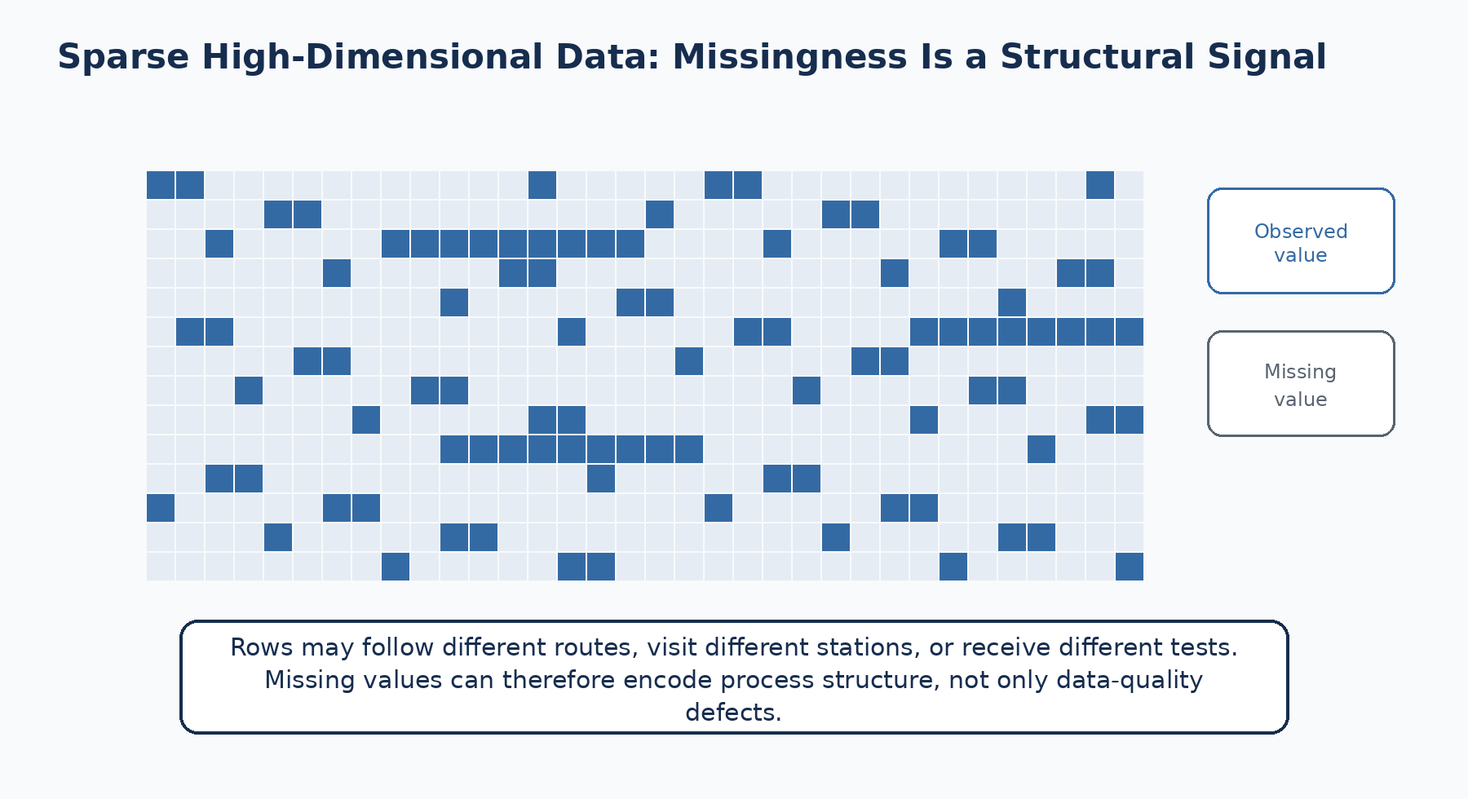
Figure 8.2 - A conceptual sparse matrix. Blue cells are observed; light cells are missing.
Training file | Missing-value percentage
Numerical | 80.9177%
Categorical | 97.2840%
Date | 82.1725%

Missingness can be information
A missing value may mean a measurement was not taken, a product did not visit the station, a test was not applicable, a value was not recorded, or the feature is absent for that product family. The true mechanism is not documented, so missingness indicators are useful predictive and routing signals, but their physical meaning remains a hypothesis.

8.5 Joining files safely
The Id column is the key that connects feature families. Even when files appear to have aligned row order, robust code should validate uniqueness and join by Id rather than relying silently on position. The same principle applies when reading chunks: preserve Id, confirm row counts, and check that no duplicate or missing keys are introduced.
Safe one-to-one join example
import pandas as pd
numeric = pd.read_csv("train_numeric.csv", usecols=["Id", "Response", "L3_S36_F3939"])
dates = pd.read_csv("train_date.csv", usecols=["Id", "L3_S36_D3940"])
assert numeric["Id"].is_unique
assert dates["Id"].is_unique
joined = numeric.merge(dates, on="Id", how="left", validate="one_to_one")
assert len(joined) == len(numeric)

8.6 Memory-aware processing
Loading every CSV and every column into memory can exceed the capacity of an ordinary laptop. The correct strategy depends on the task. Metadata extraction may require only column headers. Target analysis may need only Id and Response. Station analysis may load a selected group of columns. Model training may use sampled rows, selected features, efficient formats, or chunked aggregation.
1. Read headers first and parse line/station/feature metadata without loading all rows.
2. Use usecols to load only the columns needed for a specific analysis.
3. Specify data types where practical to reduce memory use.
4. Read CSVs in chunks when computing counts, missingness, or simple aggregates.
5. Convert reusable processed tables to Parquet for faster, typed, columnar access.
6. Separate raw, processed, feature, report, and model artifacts so the data lineage remains understandable.
Chunked reading pattern
for chunk in pd.read_csv(
"train_numeric.csv",
usecols=["Id", "Response", "L3_S36_F3939"],
chunksize=100_000,
):
# perform chunk-level checks or aggregation
print(len(chunk), chunk["Response"].sum())

8.7 Repository and data-license boundary
The raw competition data is not committed to the GitHub repository. Large raw assets are ignored, while the repository stores code, reports, metadata, selected processed artifacts, models, and documentation. Anyone reproducing the project should obtain the data directly through Kaggle after accepting the competition terms. A public repository should not redistribute the Bosch CSV files without permission.
Common beginner mistakes
• Treating sample_submission.csv as another training dataset.
• Concatenating files horizontally without verifying Id alignment.
• Loading all 4,264 features when only headers or selected columns are needed.
• Dropping all columns with high missingness before testing whether missingness encodes routing.
• Uploading Kaggle raw data to GitHub and violating competition data terms.

Review questions
1. Why are the feature families stored in separate files?
2. How many raw model feature columns are present in total?
3. Why must Id be preserved during every transformation?
4. What are three possible meanings of a missing value?
5. Why is Parquet useful after initial CSV processing?

Practice exercise
Design a loading plan for a laptop with 16 GB RAM. Your task is to calculate the failure rate for products with any observed value at station L3_S32. List the minimum files and columns you would load, the checks you would perform, and whether you would use chunks.
Chapter summary
• The dataset consists of six large train/test feature files plus a sample submission.
• All feature families are connected by Id.
• There are 4,264 raw feature columns across four encoded lines and 52 stations.
• The dataset is extremely sparse, and missingness may carry routing information.
• Memory-aware, key-safe, and reproducible processing is essential.

Chapter 9: Numerical Features
Learning objectives
By the end of this chapter, the reader should be able to:
• read and parse a numerical feature name
• describe the scale and sparsity of the numerical table
• distinguish numerical value meaning from anonymous feature identity
• choose preprocessing strategies that preserve missingness information
• identify common leakage, scaling, and interpretation risks

9.1 What is a numerical feature?
A numerical feature contains a numeric measurement or test result associated with a part at an encoded line and station. Examples may include decimals, positive values, negative values, or repeated values. The dataset does not reveal the physical quantity or unit. Therefore, a numerical column could represent many possible engineering concepts, but none should be named without evidence.
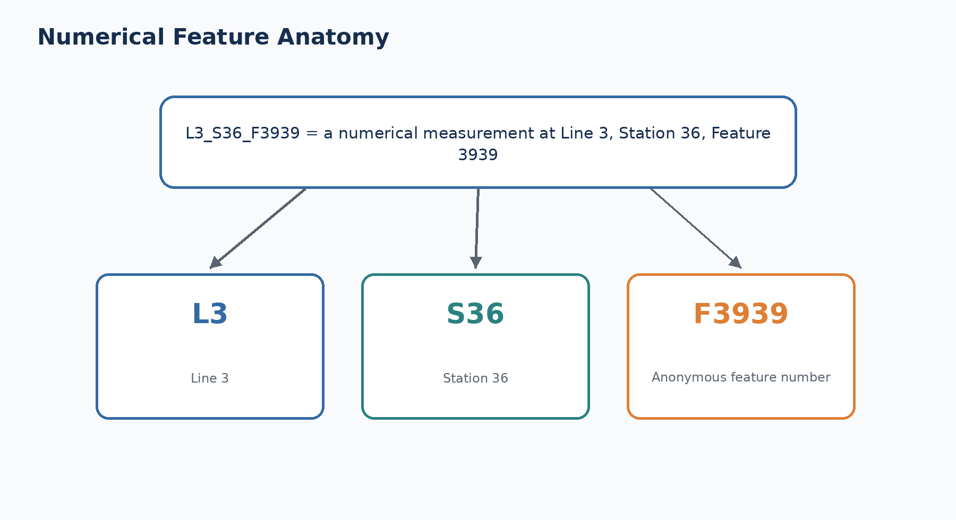
Figure 9.1 - The name reveals structure but not the physical sensor or unit.
Correct interpretation
L3_S36_F3939 is an anonymous numerical feature measured or recorded at Line 3, Station 36. It is not automatically temperature, pressure, torque, vibration, or dimensional error.

9.2 Numerical file scale
train_numeric.csv contains Id, 968 numerical feature columns, and Response. The test numerical file contains the same 968 features and Id but no target. The training numerical table has about 80.92% missing cells, so only a minority of possible part-feature combinations are observed [5].
Item | Training numerical table
Rows | 1,183,747
Feature columns | 968
Additional columns | Id and Response
Total columns | 970
Approximate file size | 2,040.77 MB
Missing cells | 80.9177%

9.3 Why numerical values can be negative or normalized
The values in an anonymized competition dataset may already have been transformed, standardized, centered, scaled, or encoded relative to an undisclosed reference. A negative value does not prove that the underlying physical quantity is negative. For example, it might represent a centered deviation from a nominal setting. Because the preprocessing history is not fully described, the safe approach is to analyze distributions rather than reverse-engineer units.

9.4 Numerical missingness
Missing numerical measurements are not automatically errors. If a product does not visit a station, a corresponding feature may be absent. If a test is applied only to a product family, many rows may be blank. Some columns are nearly entirely missing, while certain stations such as L3_S37 and L3_S29 have much higher completeness in the project metadata [6].
Possible reason for NaN | What the analyst can say
Station not visited | Missingness may act as a route indicator.
Test not applicable | Feature availability may depend on product family.
Sensor or logging gap | Data-quality issue is possible but not proven.
Feature absent in split | Schema or split-specific availability must be checked.
Value intentionally withheld/anonymized | Physical meaning cannot be recovered from NaN alone.

9.5 Imputation choices
Imputation replaces missing values with a defined value so that a model can process the table. The method must match the algorithm and the meaning of missingness. Tree-based models often handle NaN directly or can learn missing-value directions. Linear models generally require explicit imputation.
Method | Benefit | Risk
Median imputation | Robust and simple | Can hide route information if used without a missing indicator
Constant sentinel | Makes missingness explicit | Sentinel may be confused with a legitimate value if poorly chosen
Native NaN handling | Lets a tree model learn missing branches | Behavior depends on implementation and validation
Station-level aggregation | Reduces dimensionality | May discard useful feature-level variation
Missing indicator + imputation | Separates value and presence effects | Adds many columns and can increase memory use

Why filling with zero can be dangerous
Zero may be a valid numerical result. Replacing every NaN with zero can make “not measured” indistinguishable from “measured as zero.” Use a missing indicator or a model that handles NaN, and validate the choice.

9.6 Scaling and transformation
Gradient-boosted trees generally do not require standardization, while logistic regression, distance-based methods, and neural networks may benefit from scaling. Scaling parameters must be fitted on training data only. If imputation is used, the imputer must also be fitted only on the training portion of each validation fold.
Model family | Typical numerical preprocessing
Logistic regression | Impute, add indicators, scale, regularize
Random forest | Impute or use compatible missing handling; scaling usually unnecessary
LightGBM/XGBoost | Native or explicit missing handling; scaling usually unnecessary
k-nearest neighbours | Impute and scale; usually difficult at this dataset scale
Neural network | Impute, add masks/indicators, normalize, monitor sparse input design

9.7 Feature selection and dimensionality
With 968 numerical features and more than one million rows, feature selection can reduce memory, speed training, and simplify interpretation. However, selecting features using the full dataset before validation can leak information. Selection should be performed within the training process or on a training-only development split.
1. Remove columns that are completely missing in the relevant training and serving schema.
2. Check train/test availability and distribution differences.
3. Use univariate statistics, missingness, variance, or model importance as candidate filters.
4. Preserve station and line metadata so selected features remain traceable.
5. Evaluate whether a smaller feature set maintains MCC, precision, recall, and PR-AUC.

9.8 Correlation is not physical meaning
A numerical feature may correlate with Response or receive high SHAP importance. This means the model uses its values or missingness to distinguish risk. It does not identify the measurement as a physical cause. The feature may proxy for product family, route, production period, station condition, or another hidden variable.
Reader-facing wording example
Safe: “L1_S24_F1846 is a strong predictive numerical signal in the validation data.”
Unsafe: “L1_S24_F1846 proves that excess pressure at Station 24 causes the defect.”

9.9 Parsing numerical metadata
Feature-name parser
import re
pattern = re.compile(r"^L(?P<line>\d+)_S(?P<station>\d+)_F(?P<feature>\d+)$")
name = "L3_S36_F3939"
match = pattern.match(name)
metadata = {key: int(value) for key, value in match.groupdict().items()}
# {'line': 3, 'station': 36, 'feature': 3939}

Common beginner mistakes
• Assigning a real sensor name or unit to an anonymized feature.
• Replacing every NaN with zero without preserving missingness.
• Scaling or imputing before the train/validation split.
• Removing nearly all sparse features without testing route information.
• Using feature importance as proof of causation.

Review questions
1. What information is encoded in L3_S36_F3939?
2. Why might a numerical value be negative?
3. Why is zero imputation risky?
4. Which model families usually require feature scaling?
5. What is the difference between a predictive numerical signal and a physical root cause?

Practice exercise
Select one numerical feature from the project reports. Write a five-step analysis plan covering missingness, distribution, train/test consistency, association with Response, and safe interpretation. Do not assign a physical sensor name.
Chapter summary
• Numerical feature names encode line, station, and anonymous feature number.
• The numerical table contains 968 features and is about 81% missing.
• Missingness may be predictive and should not be erased blindly.
• Preprocessing depends on the model and must be fitted within training folds.
• Statistical importance does not reveal the undisclosed engineering meaning.

Chapter 10: Categorical Features
Learning objectives
By the end of this chapter, the reader should be able to:
• explain how categorical features differ from numerical features
• describe the extreme sparsity and high dimensionality of the categorical table
• compare one-hot, frequency, target, hashing, and native categorical methods
• handle missing and unseen categories safely
• interpret categorical levels without inventing engineering semantics

10.1 What is a categorical feature?
A categorical feature records a state, code, class, test result, configuration, or other discrete value rather than a continuous measurement. In the Bosch data, categorical columns use the same Lx_Sy_Fz structural naming pattern as numerical columns, while observed values commonly appear as anonymous tokens such as T1, T2, or T3. Neither the column meaning nor the token meaning is disclosed.
Example
L1_S24_F1525 = T3 means that anonymous categorical feature 1525 at Line 1, Station 24 has category token T3 for that part. It does not tell us whether T3 is a machine mode, test code, product type, material class, or operator choice.

10.2 Scale and sparsity
train_categorical.csv contains Id and 2,140 categorical feature columns. Approximately 97.284% of its possible cells are missing, making it the sparsest of the three feature families [5]. Some feature groups are completely missing in one split or nearly empty. This requires schema checks before training and careful treatment of rare categories.
Item | Training categorical table
Rows | 1,183,747
Feature columns | 2,140
Total columns | 2,141 including Id
Approximate file size | 2,554.27 MB
Missing cells | 97.2840%

10.3 Why categorical encoding is required
Most machine-learning algorithms require numeric input. Categorical tokens therefore need to be represented in a form the model can use. The choice affects memory use, leakage risk, treatment of rare categories, and the model ability to learn interactions.
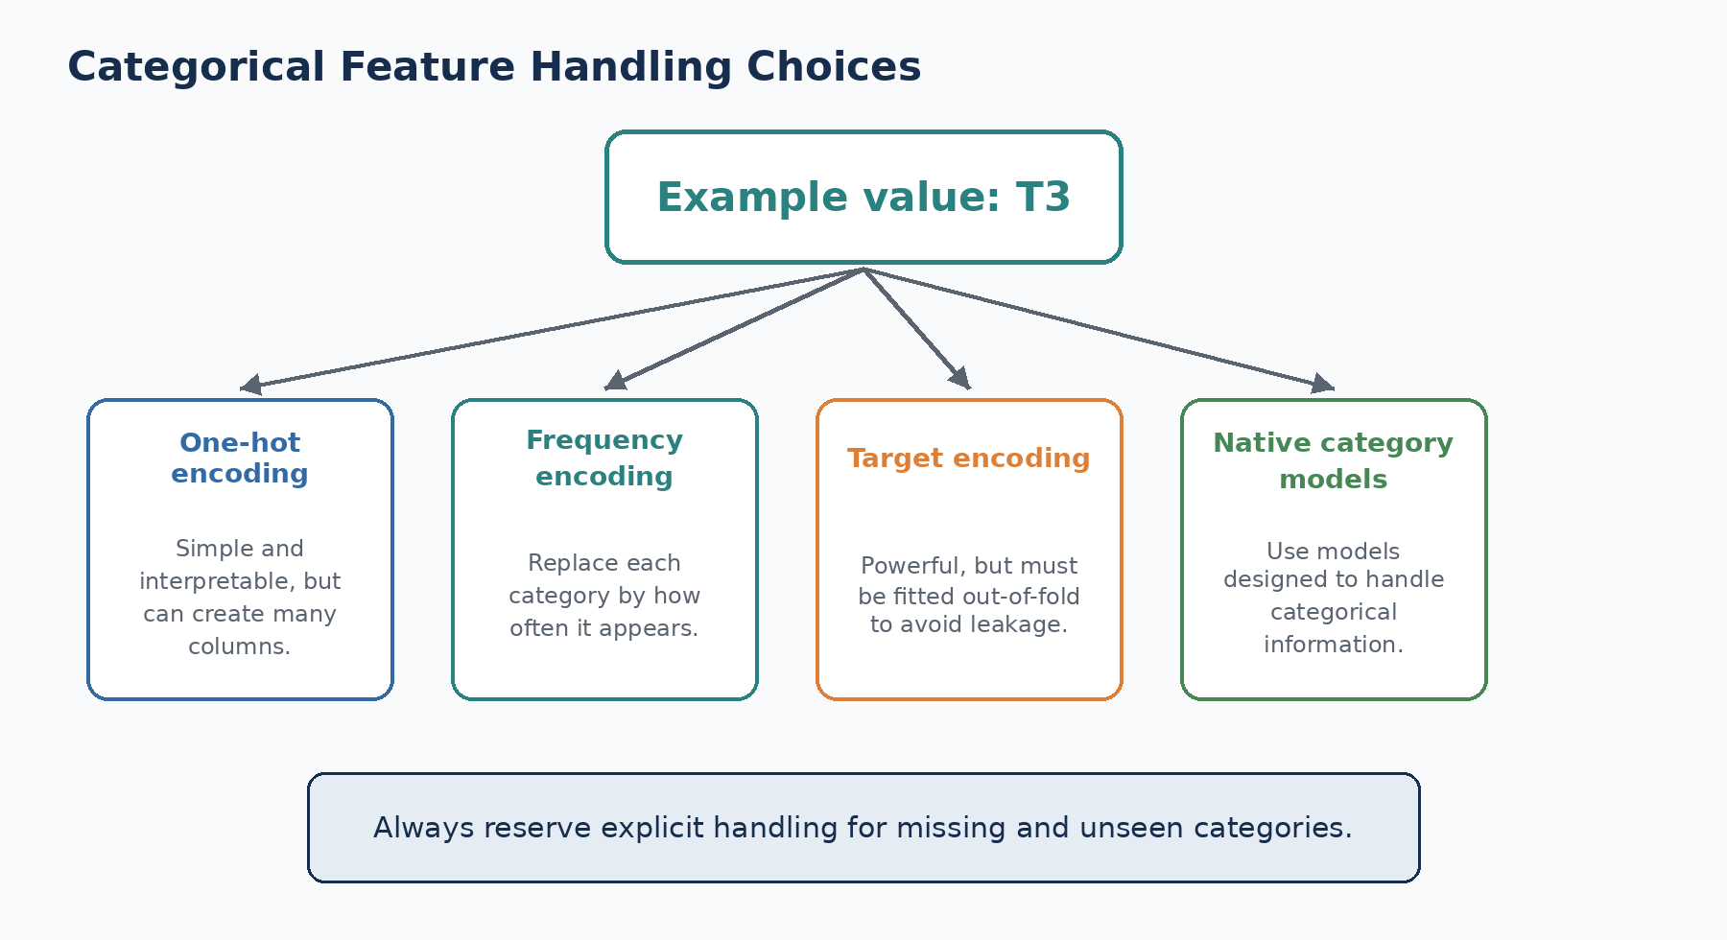
Figure 10.1 - Common encoding choices for anonymous categorical values.
Method | How it works | When useful | Main caution
One-hot | Creates one binary column per category | Low/medium cardinality and linear models | Column explosion and rare levels
Ordinal/label codes | Maps tokens to integers | Tree models when codes are treated categorically | Integers must not imply false order
Frequency | Uses category count or frequency | Large sparse tables and stable frequencies | Loses category identity and may drift
Target encoding | Uses target rate for a category | High-cardinality predictive categories | Severe leakage unless fitted out-of-fold
Hashing | Maps categories into fixed buckets | Very high cardinality and streaming | Collisions reduce interpretability
Native categorical model | Model handles category structure internally | CatBoost or compatible boosting workflows | Correct dtype and unseen-level policy still needed

10.4 Missing is often a category of its own
For categorical features, NaN may be more informative than any observed token because it can indicate that the part did not receive that test or did not follow that route. A practical pipeline often maps missing to a dedicated token such as __MISSING__ before encoding, while keeping the interpretation cautious.
Explicit missing and unseen handling
train[col] = train[col].astype("string").fillna("__MISSING__")
valid[col] = valid[col].astype("string").fillna("__MISSING__")
known = set(train[col].unique())
valid[col] = valid[col].where(valid[col].isin(known), "__UNSEEN__")

10.5 Unseen categories
A validation, test, or future production record may contain a token that was absent from the training data. A robust encoder needs a defined policy. OneHotEncoder can ignore unknown levels, ordinal encoders can reserve a code, and native categorical models have their own behavior. The important requirement is that unseen values do not crash the scoring pipeline or silently change the feature layout.

10.6 Rare categories and statistical instability
A category observed in only a few parts can show an extreme failure rate by chance. This is especially dangerous when the overall failure class is rare. A category with two parts and one failure has a 50% observed failure rate, but that does not make it a reliable engineering signal. Minimum support, smoothing, cross-validation, and confidence intervals help prevent overreaction.
Category | Parts | Failures | Observed failure rate | Interpretation
T2 | 4,136 | 667 | 16.13% | Strong association worth validation
T99 | 2 | 1 | 50.00% | Too little support for a stable conclusion
T3 | 124,053 | 1,109 | 0.89% | Moderate lift with substantial support

Project example
Phase 3 generated selected one-hot categorical levels and failure-rate reports. These reports are useful for discovering high-lift tokens, but support counts and out-of-sample validation must accompany every rate.

10.7 Target encoding leakage example
Suppose the target mean for T2 is calculated using every row, including the validation rows. The encoded feature now contains information from the validation labels. The model may appear unusually accurate because the validation target has leaked into the input. Correct target encoding calculates category statistics only from the training folds and applies them to held-out rows.
1. Split training data into folds.
2. For each fold, compute category statistics using the other folds only.
3. Encode the held-out fold with those statistics.
4. Use smoothing and a global prior for rare or unseen categories.
5. Fit final mappings on the approved training data after model selection.

10.8 Interpretation language
Avoid | Prefer
T2 is the defective machine mode. | T2 is an anonymous category associated with higher observed failure risk.
Missing means the station broke. | Missingness may reflect route, applicability, or recording differences.
This category causes failures. | This category is a predictive signal requiring engineering confirmation.
The code has an order because T16 > T2. | Token numbers are identifiers unless an order is documented.

Common beginner mistakes
• Treating category token numbers as ordered quantities.
• One-hot encoding every level without considering memory.
• Calculating target encoding on the full dataset.
• Dropping missing categories even though they may encode route information.
• Ignoring categories that appear only in validation, test, or production.

Review questions
1. How does a categorical token differ from a numerical value?
2. Why is one-hot encoding difficult with thousands of sparse features?
3. What is target leakage in target encoding?
4. How should unseen categories be handled?
5. Why should a high failure rate for a very rare category be treated cautiously?

Practice exercise
Create a comparison table for one-hot, frequency, and target encoding for a hypothetical categorical column with 500 levels, 90% missing values, and a 0.58% target rate. Recommend one approach for logistic regression and another for CatBoost, explaining the leakage controls.
Chapter summary
• Categorical values are anonymous tokens attached to line/station feature columns.
• The categorical table contains 2,140 features and is more than 97% missing.
• Encoding choice affects memory, leakage, rare levels, and interpretability.
• Missing and unseen categories require explicit policies.
• Category associations are predictive evidence, not decoded engineering meanings.

Chapter 11: Date Features
Learning objectives
By the end of this chapter, the reader should be able to:
• explain what the date columns record
• relate date names to measurement feature numbers
• derive safe temporal and station-presence features
• distinguish observed measurement spans from verified cycle time or delay
• recognize competition ordering effects and production leakage risks

11.1 What a date feature represents
The date files contain relative timestamps indicating when measurements were taken. The competition documentation gives a pairing convention: a date column number corresponds to the preceding measurement feature number. For example, L0_S0_D1 is the time at which L0_S0_F0 was taken [2].
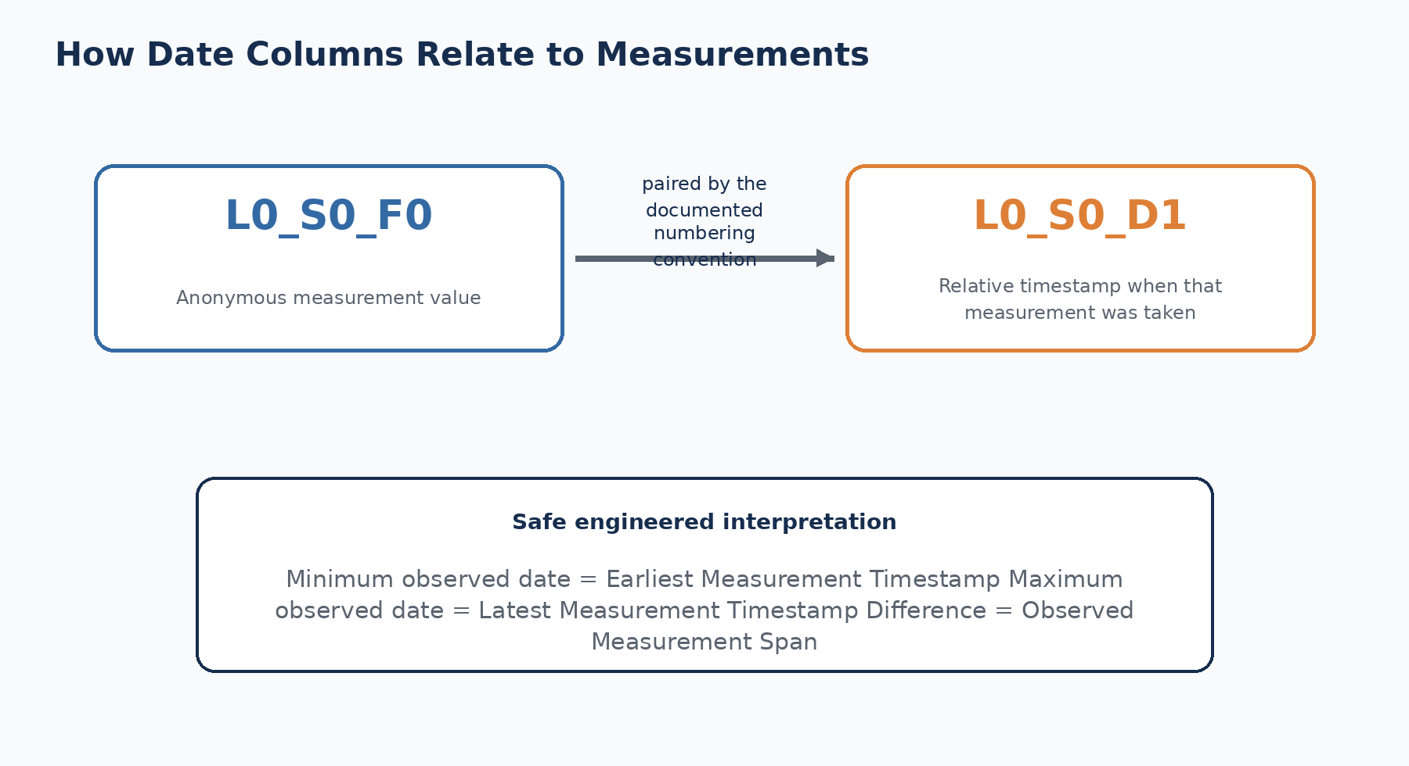
Figure 11.1 - The date feature provides the relative time associated with a measurement feature.
Not a calendar date
The values are anonymized relative production times. They do not reveal the actual date, clock time, day of week, shift, month, or year. They should be analyzed as relative temporal coordinates, not as ordinary calendar timestamps.

11.2 Date file scale
Item | Training date table
Rows | 1,183,747
Feature columns | 1,156
Total columns | 1,157 including Id
Approximate file size | 2,759.33 MB
Missing cells | 82.1725%

The date table is the largest single CSV by disk size in the project inventory. Many date columns at the same station can contain repeated or nearly repeated timestamps, because multiple measurements may be recorded at the same production step. Community solutions often compressed these columns into station-level temporal summaries [3][9].

11.3 Safe temporal features
The project creates interpretable engineered fields from the raw date values. The names shown below were revised to prevent readers from treating relative timestamps as verified factory events.
Stored feature key | Reader-facing name | Definition | Important limitation
start_time | Earliest Measurement Timestamp | Minimum observed date value for the part | Not the official production start
end_time | Latest Measurement Timestamp | Maximum observed date value for the part | Not the official completion time
cycle_time | Observed Measurement Span | Latest minus earliest observed timestamp | Not confirmed cycle time
processing_duration | Observed Active Measurement Span | Within-station observed temporal span aggregation | Not confirmed processing time
waiting_time | Observed Measurement Gap | Positive gaps between station observations | Not confirmed physical waiting or delay
station_count | Stations with Recorded Measurements | Number of stations with at least one date value | Presence is inferred from recorded timestamps

11.4 Station presence from date values
If a part has at least one observed date value at a station, the project marks that station as present for the part. This creates a station-presence matrix and a manufacturing-flow dataset. The method is reasonable because a recorded timestamp is evidence that some measurement at that station occurred. However, it remains an inferred route, not an official MES event log.
Station-presence feature
station_columns = [c for c in date_columns if c.startswith("L3_S36_")]
flow["present_L3_S36"] = dates[station_columns].notna().any(axis=1).astype("int8")

11.5 Observed gaps versus physical waiting
A positive difference between the last timestamp at one observed station and the first timestamp at the next observed station can be calculated. The project originally used names such as waiting_time and delay_ratio. The dashboard now displays them as measurement gaps and relative measurement-gap ratios. This is more defensible because the data does not state whether the gap represents queueing, transport, batching, parallel work, timestamp resolution, an unrecorded station, or ordinary processing.
Correct explanation for a dashboard reader
“Products with larger observed gaps between recorded station measurements show a different failure-risk pattern.”
Do not say: “The product was delayed for this exact amount of time.”

11.6 Pairing date and measurement columns
The documented example D1 -> F0 illustrates the numbering relationship. A robust parser should identify line, station, type, and numeric suffix, then validate which measurement columns actually exist. Because feature numbers are not a simple consecutive sequence in every station, code should not assume that all possible pairs are present.
Documented date-to-feature convention
import re
feature_re = re.compile(r"^L(\d+)_S(\d+)_F(\d+)$")
date_re = re.compile(r"^L(\d+)_S(\d+)_D(\d+)$")
# Documented example: D1 corresponds to F0.
# Pairing logic should still verify that the expected F column exists.
def expected_measurement(date_suffix: int) -> int:
return date_suffix - 1

11.7 Temporal order and the Kaggle benchmark
Public competition research found that production ordering and neighboring parts were highly predictive. Train and test records were sampled from a shared historical period, so the failure of nearby known training products could provide information about test products. This was a major competition insight, but it creates a production-readiness concern [3][9].
Feature idea | Competition value | Production concern
Id or time neighbours | Can capture local clusters of failures | Future neighbours and their labels may not be available at decision time
Distance to known failure | Strong MCC improvement in historical mixed-period data | Uses label information that would not exist for future unlabelled parts
Global ordering | May reveal batches or process periods | Ordering definition can change across systems and time
Start/end summaries | Compact temporal indicators | Need point-in-time availability and drift validation

Project governance choice
The project keeps the order/leak-style leaderboard model separate from the official production-safe LightGBM. This allows the reader to learn competition techniques without overstating future-factory performance.

11.8 Temporal validation
A random validation split can mix earlier and later parts. This may be acceptable for reproducing a competition setup, but a future manufacturing system should also use time-aware holdouts. For example, train on earlier production periods and validate on a later period. This tests whether learned temporal relationships survive beyond the period used for training.
Common beginner mistakes
• Treating anonymized date values as real calendar dates or shifts.
• Calling minimum and maximum timestamps official production start and end.
• Calling every positive temporal gap a confirmed delay.
• Using future neighbouring labels in a production-safe model.
• Creating temporal features with information that is unavailable when the prediction must be issued.

Review questions
1. What does L0_S0_D1 represent according to the documentation?
2. Why is Earliest Measurement Timestamp safer than Start Time?
3. How is station presence inferred from date features?
4. Why are observed gaps not necessarily waiting time?
5. Why can a strong Kaggle order feature be unsafe for future production?

Practice exercise
For one hypothetical part, the earliest recorded measurement is 100.2 and the latest is 112.7. There are station observations at L0_S0, L0_S2, and L3_S36. Write the safe engineered features and their values, then list three claims that cannot be made from these values alone.
Chapter summary
• Date features are anonymized relative timestamps associated with measurements.
• They support station-presence, ordering, and temporal-summary features.
• Earliest/latest timestamps and their difference are observed indicators, not verified factory start, end, cycle time, or delay.
• Ordering effects were powerful in the competition but can create leakage for future deployment.
• Temporal features require point-in-time and time-split validation.

Chapter 12: Why Features are Anonymous
Learning objectives
By the end of this chapter, the reader should be able to:
• explain why an industrial company may anonymize production data
• identify what structural information remains available
• identify what physical and business information is hidden
• write technically correct interpretations of anonymous features
• describe what a live factory data dictionary would need to add

12.1 Why release real data without full meanings?
Industrial production data can reveal product designs, process settings, machine capabilities, quality specifications, supplier relationships, production volumes, and failure mechanisms. Releasing raw engineering names and units could expose intellectual property or operationally sensitive information. Anonymization allows a realistic machine-learning challenge while reducing the risk of reverse engineering.
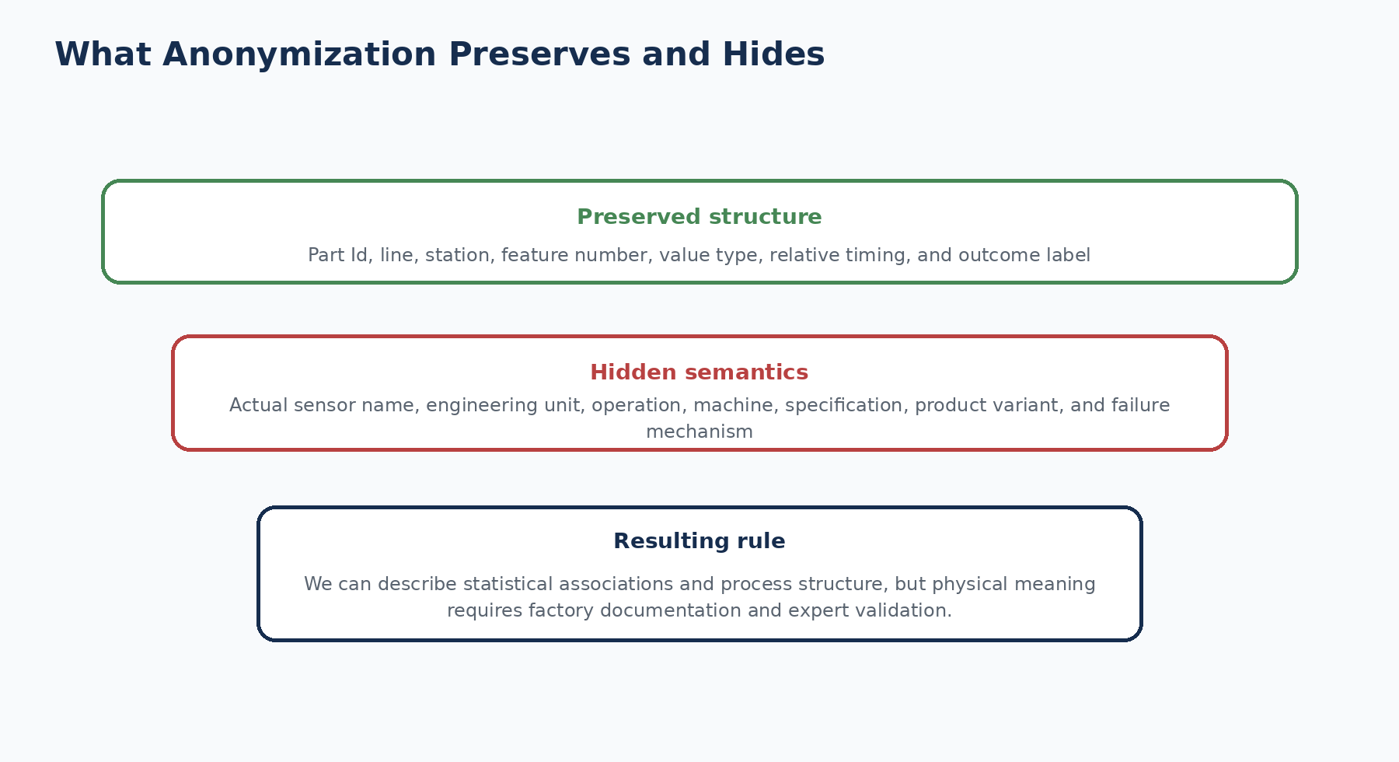
Figure 12.1 - Anonymization preserves analytical structure while hiding engineering semantics.

12.2 What remains visible
- A unique part identifier (Id).
- A binary training outcome (Response).
- Encoded production-line and station identifiers.
- An anonymous feature number.
- Whether the value is numerical, categorical, or date-like.
- The observed value or missingness pattern.
- Relative temporal relationships among recorded measurements.

12.3 What is hidden
- The physical sensor or test name.
- Engineering unit and valid operating range.
- Exact operation performed at a station.
- Machine, tool, fixture, program, or recipe identifier.
- Product type, variant, supplier, or material definition.
- The failure code, severity, repair, scrap, or disposition.
- Maintenance, calibration, operator, environmental, and shift context.
- Actual calendar date and production schedule.

12.4 Advantages of anonymization for a benchmark
Advantage | Explanation
Protects sensitive operations | Competitors cannot directly reconstruct proprietary processes.
Focuses on modeling skill | Participants must extract patterns from structure and data rather than domain labels.
Supports broad participation | The same dataset can be used by people without Bosch factory access.
Reduces bias from names | A modeler cannot select a feature merely because its label sounds important.

12.5 Costs of anonymization
Cost | Project consequence
No units or specifications | Cannot assess engineering plausibility or safe ranges.
No operation names | Cannot connect signals to standard work or control plans.
No failure-mode labels | Cannot build cause-specific models or prioritize severity.
No process ownership | Cannot assign investigation actions to real teams.
No calendar context | Cannot verify shift, maintenance, supplier lot, or seasonality effects.
No intervention outcome | Cannot prove business savings or causal improvement.

12.6 Three levels of interpretation
1. Structural interpretation: “The feature belongs to Line 3, Station 36.” This is supported by the name.
2. Statistical interpretation: “The feature value or missingness is associated with model risk.” This is supported by analysis and validation.
3. Physical interpretation: “The feature is torque and its high value causes failure.” This requires a factory dictionary and engineering evidence.
Safe wording pattern
Feature identifier + observed pattern + predictive relationship + limitation.
Example: “The missing-measurement indicator for L3_S32_F3854 is a strong predictive signal in the validation sample. Because the feature is anonymized, the associated operation and physical mechanism require engineering confirmation.”

12.7 What a factory feature registry would contain
In a real implementation, every model input should be connected to a governed feature registry or data dictionary. The registry would transform an anonymous benchmark into an operational data product.
Registry field | Why it matters
Business/engineering name | Explains the real measurement or event.
Source system and tag | Allows traceability to MES, PLC, historian, or quality system.
Unit and valid range | Supports validation and safe interpretation.
Station, equipment, and operation | Connects the feature to process ownership.
Collection method and frequency | Clarifies sampling, timing, and duplicates.
Point-in-time availability | Prevents data leakage at prediction time.
Missingness meaning | Distinguishes route, not applicable, sensor failure, and data loss.
Owner and change history | Supports governance and drift investigation.

12.8 Anonymization and explainable AI
SHAP can explain how anonymous features influence a model prediction, but it cannot reveal the hidden sensor meaning. An explanation such as “L3_S36_F3939 increased the predicted probability” is valid at model level. The next step is not to invent a cause; it is to ask a process engineer what the signal represents and whether the association is plausible.

12.9 Ethical and legal use
Anonymized data is not automatically unrestricted data. The competition files remain subject to Kaggle competition terms. The project therefore references the source and stores code and derived documentation in GitHub while requiring users to download the raw data through Kaggle. Responsible use also means not presenting inferred operations as confidential Bosch facts.
Common beginner mistakes
• Guessing that a feature is a specific sensor because its distribution looks familiar.
• Treating a SHAP explanation as a decoded physical explanation.
• Publishing the raw competition files in a public repository.
• Assuming anonymization removes the need for data governance.
• Writing recommendations for a real station without knowing the operation or owner.

Review questions
1. Why would Bosch hide feature meanings?
2. What structural information is still available?
3. What additional information is needed to claim a physical root cause?
4. How does anonymization limit SHAP interpretation?
5. Name five fields required in a factory feature registry.

Practice exercise
Rewrite the following claim into safe language: “High temperature at Station 36 causes failure.” Assume the only evidence is that L3_S36_F3939 has high SHAP importance and the feature is anonymous.
Chapter summary
• Anonymization preserves a realistic analytical challenge while protecting sensitive operations.
• Structural identifiers, values, missingness, relative timing, and Response remain available, while physical meanings are hidden.
• Model explanations describe prediction behavior; factory use needs a governed feature dictionary and engineering ownership.

Chapter 13: Understanding Line-Station-Feature Naming
Learning objectives
By the end of this chapter, the reader should be able to:
• parse Lx_Sy_Fz and Lx_Sy_Dz column names
• construct line, station, and feature metadata tables
• group features by station and data type
• use the naming convention for route and feature engineering
• validate names and handle exceptions safely

13.1 The naming grammar
Feature names follow a compact grammar. L identifies the encoded production line, S identifies the encoded station, and F identifies an anonymous numerical or categorical feature number. Date columns use D followed by a date-feature number. Underscores separate the components.
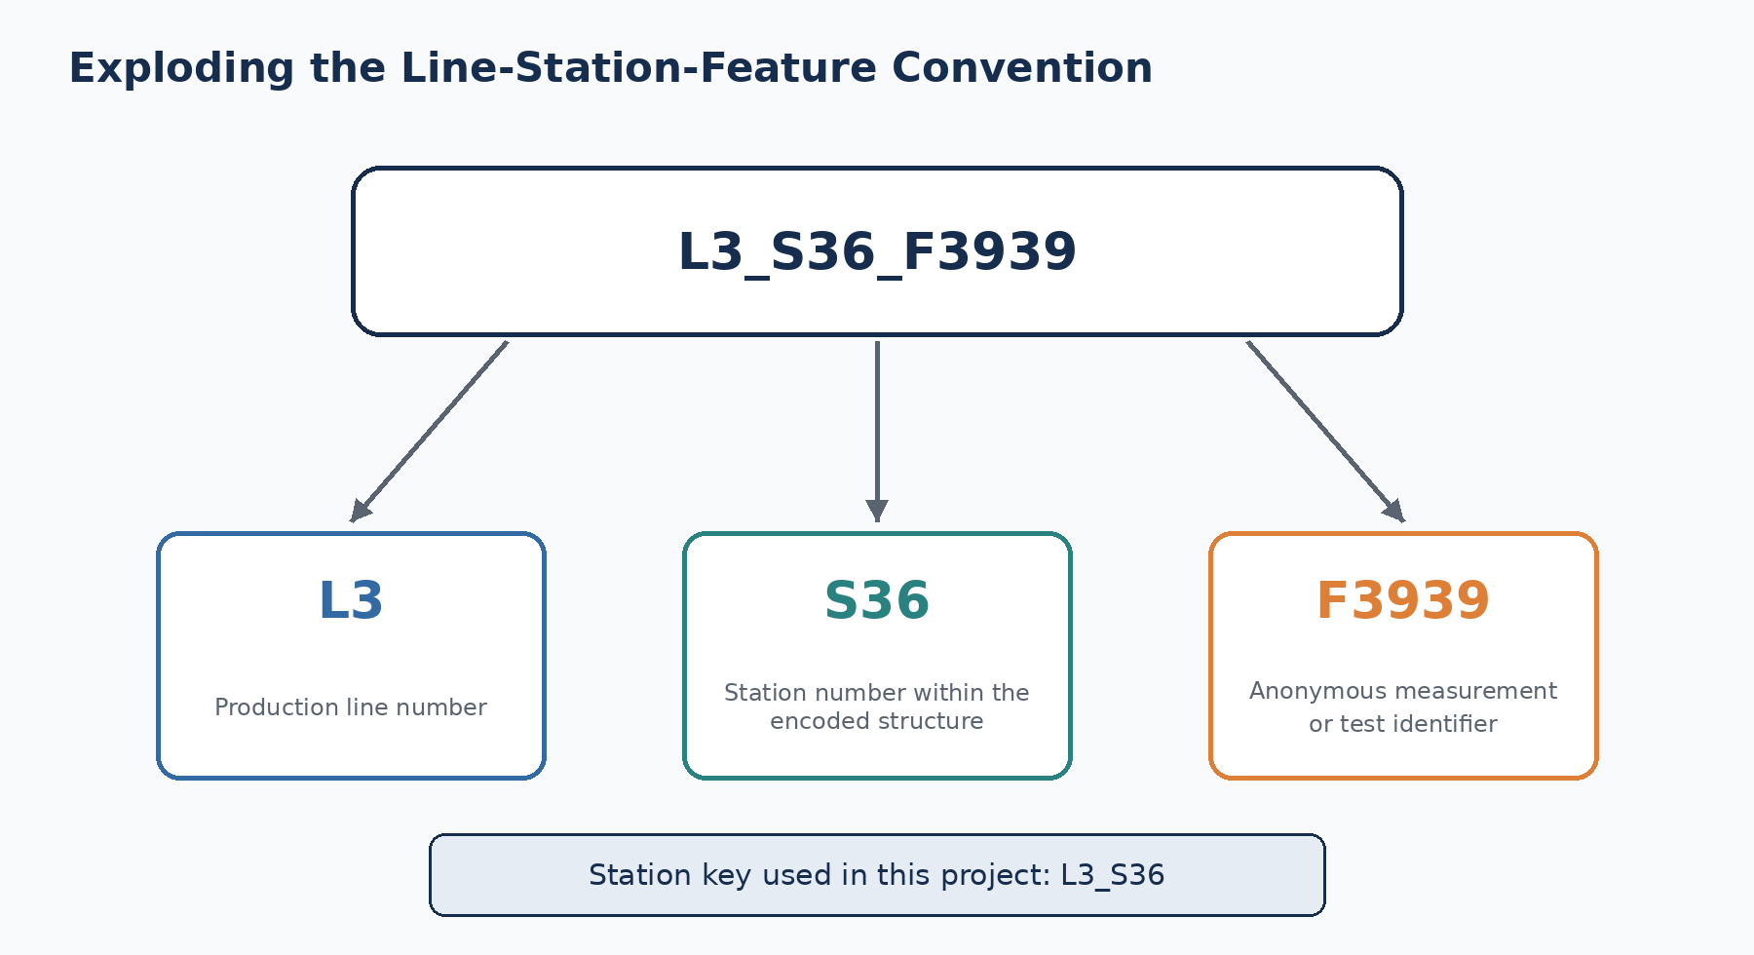
Figure 13.1 - Decomposition of L3_S36_F3939 into line, station, and anonymous feature number.
Pattern | Example | Meaning
Lx_Sy_Fz | L3_S36_F3939 | Feature z at station y on line x
Lx_Sy_Dz | L0_S0_D1 | Date/timestamp feature z at station y on line x
Lx_Sy | L3_S36 | Station key used for grouping

13.2 Parsing with a regular expression
Reusable metadata parser
import re
import pandas as pd
pattern = re.compile(r"^L(?P<line>\d+)_S(?P<station>\d+)_(?P<kind>[FD])(?P<number>\d+)$")
def parse_feature(name: str, data_type: str) -> dict:
match = pattern.match(name)
if not match:
raise ValueError(f"Unexpected feature name: {name}")
row = match.groupdict()
return {
"feature": name,
"line": int(row["line"]),
"station": int(row["station"]),
"station_key": f"L{row['line']}_S{row['station']}",
"kind": row["kind"],
"feature_number": int(row["number"]),
"data_type": data_type,
}

13.3 Why metadata tables are valuable
A raw header contains thousands of strings. A metadata table converts those strings into searchable fields. This makes it possible to count features by line, find all columns for a station, compare data types, select a line for analysis, and document model inputs.
Metadata column | Example | Use
feature | L3_S36_F3939 | Original model column
line | 3 | Group or filter by production line
station | 36 | Group by station number
station_key | L3_S36 | Stable display and join key
data_type | numeric | Choose preprocessing pipeline
feature_number | 3939 | Trace anonymous feature identifier
missing_pct | 99.2% | Assess availability and sparsity

13.4 Structural findings from parsing
The project parsed 4,264 feature columns across four lines and 52 stations. Parsing reveals a highly uneven distribution: Line 1 contains 2,361 features but only two encoded stations, while Line 0 contains 675 features across 24 stations. These are dataset structures, not direct measures of line size, workload, or importance [6].
Line | Station count | Total features | Share of 4,264 features
L0 | 24 | 675 | 15.83%
L1 | 2 | 2,361 | 55.37%
L2 | 3 | 279 | 6.54%
L3 | 23 | 949 | 22.26%

13.5 Using names to create station presence
Once columns are grouped by station, a station-presence indicator can be created. The project uses date columns because an observed date is direct evidence of a recorded measurement at that station. The same grouping supports station completeness, feature counts, line summaries, flow signatures, product-family clustering, and station-level reports.
Grouping columns by station
from collections import defaultdict
station_to_date_columns = defaultdict(list)
for column in date_columns:
meta = parse_feature(column, "date")
station_to_date_columns[meta["station_key"]].append(column)
for station_key, columns in station_to_date_columns.items():
flow[f"present_{station_key}"] = dates[columns].notna().any(axis=1)

13.6 Naming collisions and data types
Numerical and categorical files can contain feature columns with the same structural pattern. The data type must therefore be stored separately in metadata. A complete unique key for the feature registry may combine data_type and feature name. Date features use D rather than F, but the station key remains the same.

13.7 Validation rules
1. Exclude non-feature columns such as Id and Response before applying the regex.
2. Reject unexpected names instead of silently assigning incorrect metadata.
3. Verify that line and station values match the known dataset inventory.
4. Record data type from the source file rather than inferring it only from F.
5. Compare train and test feature sets and flag missing or extra columns.
6. Store the parser version so future schema changes are traceable.

13.8 Reader practice
Feature name | Line | Station | Kind | Number | Station key
L0_S0_F0 | 0 | 0 | Feature | 0 | L0_S0
L0_S0_D1 | 0 | 0 | Date | 1 | L0_S0
L1_S24_F1525 | 1 | 24 | Feature | 1525 | L1_S24
L2_S26_D3098 | 2 | 26 | Date | 3098 | L2_S26
L3_S36_F3939 | 3 | 36 | Feature | 3939 | L3_S36

Do not infer production sequence from station number alone
S36 has a higher number than S29, but the station number is an encoded identifier. Route order should be derived from observed relative timestamps or documented process information, not from numeric sorting alone.

Common beginner mistakes
• Including Id and Response in feature-name parsing.
• Assuming F means numerical; categorical columns also use F names.
• Sorting stations by station number and calling it the true route.
• Using feature count as a measure of physical station importance.
• Failing to compare train and test schemas.

Review questions
1. What do L, S, F, and D represent?
2. Why must data_type be stored separately for F columns?
3. What is a station key?
4. How does parsing support station-presence engineering?
5. Why should unexpected feature names raise an error?

Practice exercise
Write pseudocode that reads only CSV headers, builds a metadata table for all feature families, and outputs feature counts by line, station, and data type. Include validation for Id, Response, and malformed names.
Chapter summary
• The naming convention provides a machine-readable map of lines, stations, feature types, and identifiers.
• A regex parser converts thousands of column names into structured metadata.
• Metadata enables grouping, completeness analysis, route inference, and feature registries.
• Station numbers are identifiers, not guaranteed process order.
• Schema validation is essential before modeling or serving.

Chapter 14: Dataset Limitations
Learning objectives
By the end of this chapter, the reader should be able to:
• identify the major technical, statistical, engineering, and operational limitations
• explain why benchmark validation is not live-factory validation
• recognize missing context, leakage, drift, and external-validity risks
• match each limitation to a practical mitigation
• state defensible project claims

14.1 Every dataset defines a boundary
A strong project does not hide limitations. It explains what the data allows, what remains uncertain, and what evidence would be required next. The Bosch dataset is unusually valuable because it is large, industrial, high-dimensional, sparse, and difficult. The same properties also create important boundaries.
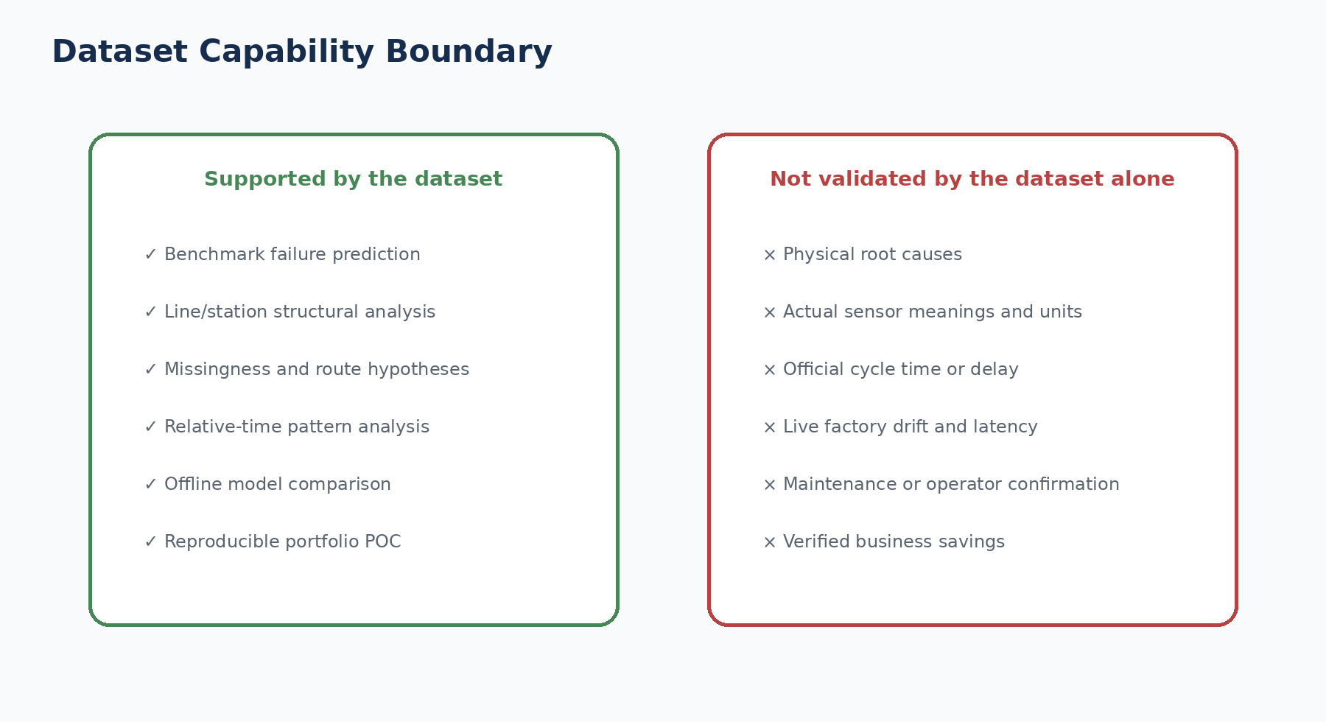
Figure 14.1 - The public dataset supports a rich benchmark but not full live-factory validation.

14.2 Anonymized physical meaning
The largest limitation is the absence of engineering definitions. A model can rank features and stations, but the analyst cannot determine the real sensor, test, specification, or failure mechanism. This limits causal analysis, action design, safety review, and communication with real process owners.

14.3 Historical and static data
The competition data is a fixed historical snapshot released in 2016. It cannot show whether current machines, products, suppliers, software, maintenance practices, or inspection rules have changed. A model that performs on this snapshot may degrade under future production conditions, a problem known as concept drift or data drift.

14.4 Hidden test labels
Kaggle test labels are not available to the project. A leaderboard score can be obtained only by submission, and the private test set cannot be used for detailed error analysis. Local validation must therefore be carefully designed, preserved, and documented. Repeatedly adjusting the model to the same validation set can overfit it even when the test labels remain hidden.

14.5 Severe class imbalance
With only 0.5811% failures, model evaluation is statistically and operationally difficult. Small changes in false positives and false negatives can strongly affect MCC. Rare product families or categories may contain very few failures, making their observed rates unstable. Random sampling can accidentally create validation folds with different risk compositions.

14.6 Ambiguous missingness
Missing values may represent routes, non-applicable tests, sensor gaps, logging gaps, or hidden product structure. The dataset does not provide a missing-reason code. Models can use missingness predictively, but engineering actions based on missingness require confirmation.

14.7 Relative timestamps are not a full event log
Date values record relative times for measurements, but the dataset is not a complete MES event log. It does not explicitly provide operation start, operation end, queue entry, queue exit, planned duration, downtime code, or transport event. Consequently, process-mining outputs are observational reconstructions and monitoring hypotheses.

14.8 Competition-specific ordering effects
Public solutions exploited the fact that train and test products were interleaved within a common historical production sequence. Neighboring known failures could help predict nearby test products. This can greatly improve benchmark scores but may use information that is unavailable for a future part. The project correctly separates these research features from production-safe claims [9].

14.9 No business decision or cost matrix
The dataset does not define the action taken after a high-risk prediction, the cost of additional inspection, the cost of a missed failure, inspection capacity, safety severity, or customer impact. Therefore, an optimal business threshold cannot be derived from MCC alone. The dashboard business-impact page is a scenario tool, not verified savings.

14.10 No live systems or operational feedback
The public project is not connected to MES, SCADA, PLC, historian, quality, maintenance, or identity systems. It cannot measure real scoring latency, system availability, operator acceptance, alert fatigue, intervention outcomes, or live drift. The implemented Docker, API, registry, audit log, tests, and rollback demonstrate local production engineering, but factory readiness remains partial.

14.11 Limitation and mitigation matrix
Limitation | Current project mitigation | What still requires factory access
Anonymous features | Structural metadata and careful predictive wording | Feature dictionary, units, operations, owners
Historical snapshot | Validation splits and documented limitations | Current data and time-based shadow evaluation
Hidden test labels | Internal labelled holdout and model card | Independent current-factory labels
Class imbalance | MCC, precision, recall, PR-AUC, threshold tuning | Cost and capacity-based operating threshold
Ambiguous missingness | Presence features and missingness-aware models | Missing-reason codes and route confirmation
Relative dates | Reader-friendly temporal names | MES event definitions and verified durations
Order leakage | Separate research-only leaderboard model | Point-in-time serving design
No live feedback | Local API, logging, registry, golden tests | Monitoring platform, owners, alerts, retraining

14.12 Defensible maturity statement
Recommended project claim
“This is an advanced portfolio-grade manufacturing analytics and machine-learning POC built on the historical anonymized Bosch Kaggle dataset. It demonstrates an end-to-end analytics workflow and local production-serving controls, but it is not validated as a live Bosch factory deployment.”

Common beginner mistakes
• Calling the project a real-time Bosch production system.
• Reporting scenario savings as achieved business savings.
• Describing inferred measurement gaps as verified downtime.
• Using a competition leak feature as the official future-factory model.
• Ignoring product, process, and calendar changes since the historical data was collected.

Review questions
1. Why does anonymization limit root-cause analysis?
2. What is concept drift?
3. Why can repeated validation-set use create overfitting?
4. What information is missing for a business threshold?
5. Which production controls can be demonstrated locally, and which require a factory?

Practice exercise
Create a two-column risk register for this dataset. Include at least ten risks and one mitigation for each. Classify each mitigation as implementable with the public dataset or requiring factory access.
Chapter summary
• The dataset is a strong benchmark with clear limits on physical and operational interpretation.
• Historical performance does not establish current or future factory performance.
• Class imbalance, missingness, hidden labels, and ordering effects require disciplined validation.
• Business decisions need cost, capacity, safety, and stakeholder context.
• The correct claim is an advanced POC reference, not a live Bosch deployment.

Chapter 15: Manufacturing Interpretation
Learning objectives
By the end of this chapter, the reader should be able to:
• apply an interpretation ladder from observed facts to confirmed causes
• translate model features into reader-friendly manufacturing language
• separate association, prediction, hypothesis, and causation
• communicate findings to students, data scientists, engineers, and managers
• design a validation process for future factory use

15.1 Why interpretation is the central skill
The Bosch dataset makes it easy to produce impressive charts and difficult to explain them correctly. The best interpretation is neither too weak nor too confident. It should state the observed evidence, the analytical result, the plausible manufacturing hypothesis, and the missing confirmation.
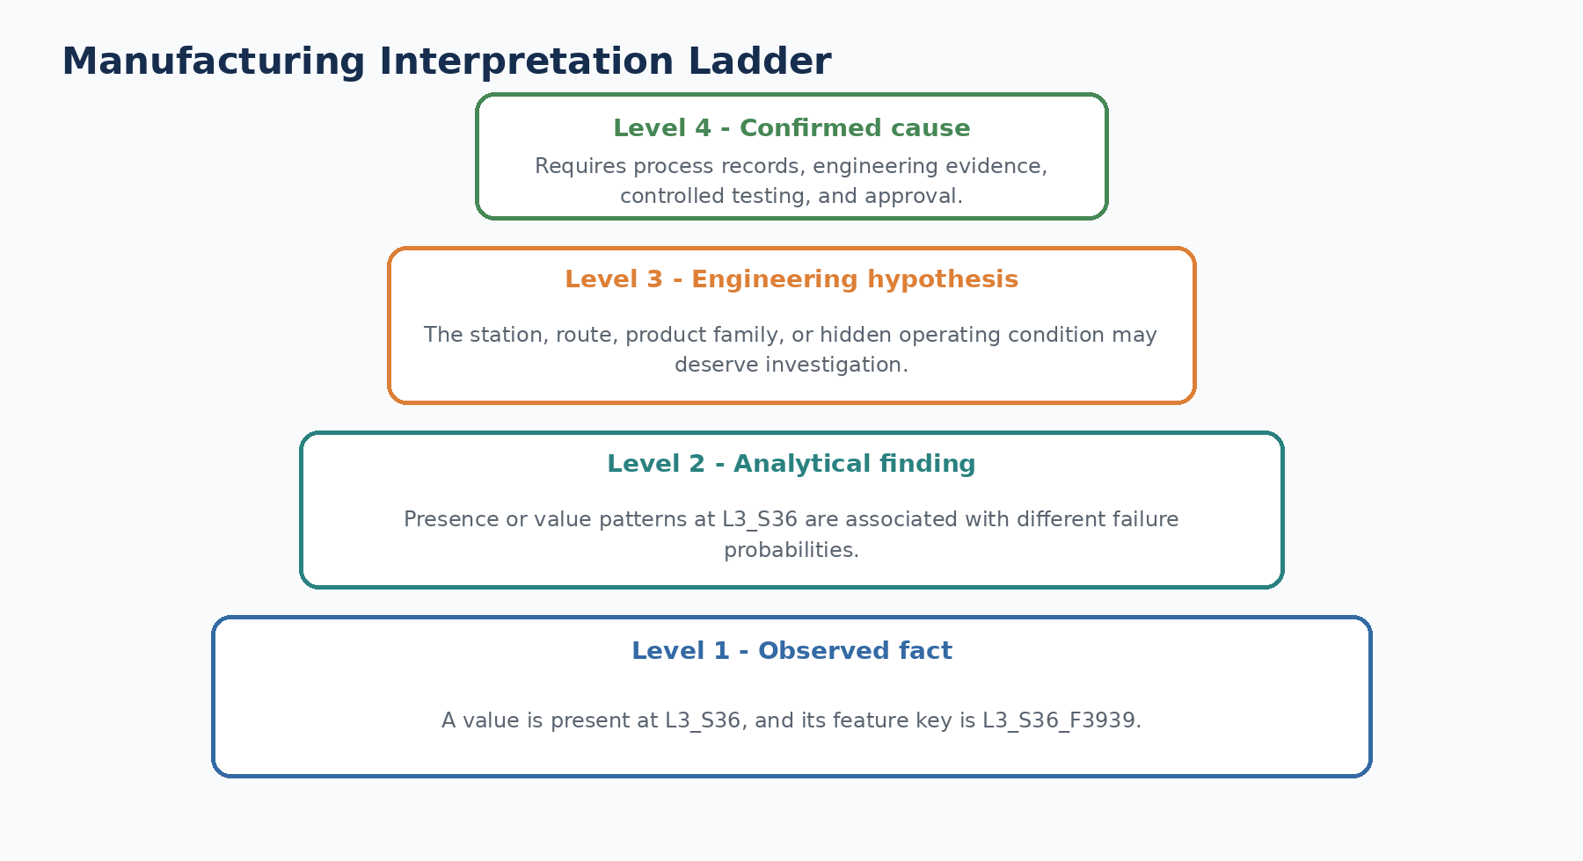
Figure 15.1 - Move upward from observed facts to confirmed causes only when additional evidence supports the step.

15.2 Four interpretation levels
Level | Question | Evidence available from public data? | Example
Observed fact | What is recorded? | Yes | A date value is present at L3_S36.
Analytical finding | What pattern is measured? | Yes, with validation | L3_S36 presence has a higher observed failure rate.
Engineering hypothesis | What hidden condition might explain it? | Partly | Route or product-family differences may be involved.
Confirmed cause | What physically caused the failure? | No | Requires engineering records and controlled evidence.

15.3 Interpreting raw feature values
Raw evidence | Safe statement | Unsafe statement
L3_S36_F3939 is high | The anonymous numerical value is high relative to its observed distribution. | Station 36 temperature is too high.
L1_S24_F1525 = T3 | The part has anonymous category T3 for this feature. | The machine used operating mode 3.
L2_S26 date values are present | Recorded measurements indicate observed presence at L2_S26. | The part definitely completed the official Station 26 operation.
A feature is missing | The measurement is unavailable for this row. | The sensor failed.

15.4 Interpreting engineered temporal features
The project changed dashboard labels to reduce ambiguity. This is an important example of responsible communication: internal model keys can remain stable while reader-facing labels become more accurate.
Internal key | Dashboard label | Recommended interpretation
start_time | Earliest Measurement Timestamp | The earliest relative timestamp recorded for the part
end_time | Latest Measurement Timestamp | The latest relative timestamp recorded for the part
cycle_time | Observed Measurement Span | The interval covered by observed measurements
waiting_time | Observed Measurement Gap | Positive gaps in the reconstructed observation sequence
delay_ratio | Relative Measurement-Gap Ratio | Gap total relative to observed measurement span

Start-time example
High SHAP importance for Earliest Measurement Timestamp does not mean “starting late caused the failure.” It means the model found different failure probabilities across relative production windows. The signal may proxy for batch, machine state, route, product family, tool condition, or another hidden factor.

15.5 Interpreting station presence and risk
Phase 3 found that products with observed presence at L3_S32 had a much higher failure rate than the overall training population. This is a strong descriptive finding. However, the station may process a special product family or route that is inherently higher risk. The station presence may therefore be a marker rather than the cause.
1. Observed fact: 24,543 training parts have recorded presence at L3_S32.
2. Descriptive finding: 1,106 of those parts are failures, an observed rate of about 4.51%.
3. Comparison: the overall training failure rate is about 0.58%, so the station-presence group has high lift.
4. Hypotheses: product family, routing, test type, upstream condition, or the station itself may be involved.
5. Required confirmation: actual operation, product mix, quality codes, maintenance records, and controlled engineering investigation.

15.6 SHAP interpretation
SHAP answers a model question: how much did each input push a prediction higher or lower relative to a baseline? It does not answer a physical-causation question. A global SHAP chart ranks signals used across many predictions, while a local explanation describes one part. Both depend on the model, feature engineering, data sample, and correlation structure.
SHAP statement | Status
“This feature had a large mean absolute SHAP value.” | Valid model-behavior statement
“This feature often pushed predicted risk upward.” | Valid if direction is supported by the analysis
“This station causes failures.” | Not established by SHAP
“Changing this feature will reduce failures.” | Intervention claim requiring causal evidence

15.7 Audience-specific communication
Audience | What to emphasize | What to avoid
Student/fresher | Feature structure, sparsity, imbalance, and prediction-versus-causation | Overloading with factory acronyms without explanation
Data scientist | Validation design, leakage, feature availability, calibration, and uncertainty | Only reporting leaderboard score
Process engineer | Station, route, measurement pattern, support count, and evidence needed | Inventing units or operations
Plant manager | Decision supported, alert volume, risk trade-off, limitations, and next pilot step | Technical model detail without operational consequence
Governance reviewer | Data lineage, model card, controls, ownership, monitoring, and rollback | Claiming production approval from a public benchmark

15.8 A future factory validation workflow
1. Map each anonymous benchmark concept to real factory signals and approved definitions.
2. Define the prediction moment, user, action, false-positive cost, and false-negative cost.
3. Collect historical current-factory data with feature and label lineage.
4. Use time-aware validation and a final untouched test period.
5. Review important signals with process, quality, maintenance, and safety experts.
6. Run shadow scoring without changing production decisions.
7. Measure latency, drift, alert volume, operator feedback, and label delay.
8. Conduct a controlled pilot with approved success and stop criteria.
9. Promote gradually with monitoring, rollback, and documented ownership.

15.9 The Part II interpretation checklist
- What exactly is observed in the raw data?
- Is the statement descriptive, predictive, causal, or prescriptive?
- Is the feature raw, engineered, or derived from labels/order?
- Was the finding validated out of sample?
- Is the feature available at prediction time?
- Could product family, route, time, or missingness confound the result?
- Does the wording imply an unknown sensor, unit, delay, or operation?
- What engineering evidence is required before recommending action?
Final Part II principle
The public Bosch dataset is rich enough to teach sophisticated manufacturing analytics. A trustworthy analyst finds patterns and clearly explains their boundaries.

Common beginner mistakes
• Using “root cause” when the evidence is SHAP importance or association.
• Calling relative timestamps real production delays.
• Ignoring product mix or route confounding in station-level failure rates.
• Presenting an engineered feature name as though Bosch supplied it directly.
• Giving the same explanation to an engineer and a business manager without adapting the message.

Review questions
1. What are the four levels of the interpretation ladder?
2. How should start_time be explained to a dashboard reader?
3. Why can a high-risk station be a marker rather than a cause?
4. What does SHAP explain?
5. What steps are required to convert this benchmark into a factory pilot?

Practice exercise
Choose three findings from the project dashboard: one temporal, one station-level, and one numerical/categorical SHAP signal. For each, write an observed fact, an analytical finding, a manufacturing hypothesis, and the evidence needed for causal confirmation.
Chapter summary
• Good interpretation moves from observed facts to analytical findings, hypotheses, and confirmed causes.
• Anonymous values and engineered timestamps require careful reader-facing language.
• Station and feature associations can be strong without being causal.
• SHAP explains model behavior, not physical failure mechanisms.
• Future factory use requires mapped features, time-aware validation, engineering review, shadow scoring, and controlled rollout.

Part II Glossary
Term | Meaning
Anonymous feature | A column whose structural identifier is available but whose physical engineering meaning is hidden.
Binary classification | A prediction problem with two classes, here Response 0 or 1.
Categorical feature | A feature containing discrete tokens or states rather than continuous numeric values.
Class imbalance | A target distribution in which one class is far less common than the other.
Competition-style feature | A feature useful for Kaggle scoring but not necessarily safe or available in future production.
Confusion matrix | Counts of true positives, false positives, true negatives, and false negatives.
Date feature | An anonymized relative timestamp associated with a measurement.
Data leakage | Use of information during training that would not legitimately be available when making a prediction.
Feature engineering | Creation of new model inputs from raw columns, such as station count or observed measurement span.
Feature registry | A governed record of feature definitions, sources, units, owners, ranges, and availability.
Id | The unique key for a manufactured part in the competition files.
MCC | Matthews Correlation Coefficient, the competition evaluation metric.
Missing indicator | A binary feature recording whether another value is absent.
Numerical feature | An anonymous numeric measurement or test result.
Observed Measurement Gap | A project label for a positive gap between reconstructed measurement observations; not a verified physical delay.
Observed Measurement Span | Latest minus earliest observed relative timestamp; not a verified official cycle time.
Out-of-fold encoding | A leakage-safe method in which encodings for each held-out fold are built from other folds.
Positive class | The rare failure class, Response = 1.
Response | The binary target stored in train_numeric.csv.
Schema | The expected columns, data types, names, and constraints of a dataset or model request.
Station key | A line-and-station identifier such as L3_S36.
Station presence | An inferred indicator that at least one measurement timestamp is observed for a station.
Target encoding | Replacement of a category by a target statistic calculated with leakage controls.
Temporal validation | Validation that trains on earlier data and evaluates on later data.
Unseen category | A category present during validation or scoring but absent from model training.

References
[1] Kaggle. Bosch Production Line Performance - competition overview and evaluation. Source
[2] Kaggle. Bosch Production Line Performance - data description. Source
[3] Kaggle. Bosch Production Line Performance discussion forum, sorted by most comments. Used as supplementary community evidence. Source
[4] Project repository. Bosch Production Line Performance by Krishnakanth Reddy Karingula. Source
[5] Project report. Phase 1 Data Quality Report and file inventory. Source
[6] Project report. Phase 2 Data Understanding and Engineering Report. Source
[7] Project report. Phase 3 Exploratory Data Analysis Report. Source
[8] Project report. Phase 4 Feature Dictionary and Feature Engineering Report. Source
[9] Project research note. Phase 6 Leaderboard Research Notes: public solution lessons and production caveats. Source
[10] A. Mangal and N. Kumar. Using Big Data to Enhance the Bosch Production Line Performance: A Kaggle Challenge. IEEE Big Data 2016 / arXiv:1701.00705. Source
[11] J. K. Park and Y. B. Kim. Evaluating the Role of Data Enrichment Approaches towards Rare Event Analysis in Manufacturing. Sensors, 2024. Source
Reference note
Kaggle discussion posts are community contributions. They are useful for learning competition strategies, but they do not reveal official Bosch feature meanings or prove that a technique is production-safe.

