BOSCH PRODUCTION LINE
PERFORMANCE PROJECT HANDBOOK
PART I — MANUFACTURING FUNDAMENTALS
A beginner-friendly foundation for students and freshers
Author
Krishnakanth Reddy Karingula
Project repository: github.com/kkr199/Bosch-Production-line-performance
Dashboard: bosch-peformance-line.streamlit.app

How to Use Part I
Part I builds the manufacturing knowledge required to understand the later data-science and machine-learning chapters. It assumes no previous factory experience. The reader will learn what production lines and stations are, how quality is checked, where manufacturing data comes from, and how prediction can support engineering decisions. The Bosch project is used as a running case study, but the principles apply to automotive, electronics, pharmaceuticals, food processing, construction materials, and many other industries.
Important interpretation rule
The Bosch competition data is anonymized. A feature name tells us the production line, station, and feature identifier, but not the physical meaning of the measurement. Therefore, this handbook separates three ideas: what the data predicts, what the data may represent, and what would require confirmation from factory engineers.

Part I learning roadmap
Chapter | Purpose
Chapter 1 | Learn how raw manufacturing data becomes information and action.
Chapter 2 | Understand Industry 4.0 and the connected factory.
Chapter 3 | Learn how products move through production lines and why bottlenecks occur.
Chapter 4 | Understand stations, sensors, measurements, timestamps, and routing evidence.
Chapter 5 | Learn quality assurance, quality control, inspection, defects, and rare failures.
Chapter 6 | Understand predictive manufacturing and the difference between a POC and a live factory system.

Source policy
This handbook prioritizes official and primary sources such as NIST, Bosch, ASQ, the Kaggle competition materials, and the project repository. Kaggle discussion posts are useful supplementary evidence because they reveal practical ideas explored by competition participants. However, forum observations are treated as community findings rather than official descriptions of Bosch manufacturing processes.

Contents
- Chapter 1: Introduction to Manufacturing Analytics
- Chapter 2: Industry 4.0
- Chapter 3: Production Lines
- Chapter 4: Manufacturing Stations
- Chapter 5: Quality Control & Inspection
- Chapter 6: Predictive Manufacturing
- Part I Glossary
- References

Chapter 1: Introduction to Manufacturing Analytics
Learning objectives
By the end of this chapter, the reader should be able to:
• define manufacturing analytics in simple and technical terms
• identify common sources of factory data
• distinguish descriptive, diagnostic, predictive, and prescriptive analytics
• explain why business and engineering context must guide data analysis
• connect manufacturing analytics to the Bosch project

1.1 What is manufacturing?
Manufacturing is the organized conversion of materials, components, energy, information, and human effort into a product. The product may be a vehicle component, electronic circuit, medicine, steel beam, packaged food item, or any other physical good. A manufacturing system is more than a machine. It includes people, equipment, tools, instructions, materials, software, quality rules, maintenance, logistics, and decisions.
A factory is therefore a system of connected activities. Material enters, operations are performed, measurements are taken, decisions are made, and products are released, reworked, or rejected. Every activity creates information. Manufacturing analytics is the discipline of using that information to understand and improve the system.
Beginner definition
Manufacturing analytics means using production data to answer practical questions such as: What happened? Why did it happen? What is likely to happen next? What action should we take?

1.2 From data to a manufacturing decision
A sensor value is not automatically useful. It becomes useful when it is connected to a product, station, time, specification, outcome, and possible action. For example, a torque measurement of 8.2 is meaningless without knowing the unit, acceptable range, tool, product variant, and whether the product later passed inspection. Analytics creates this context and converts observations into evidence for decisions.
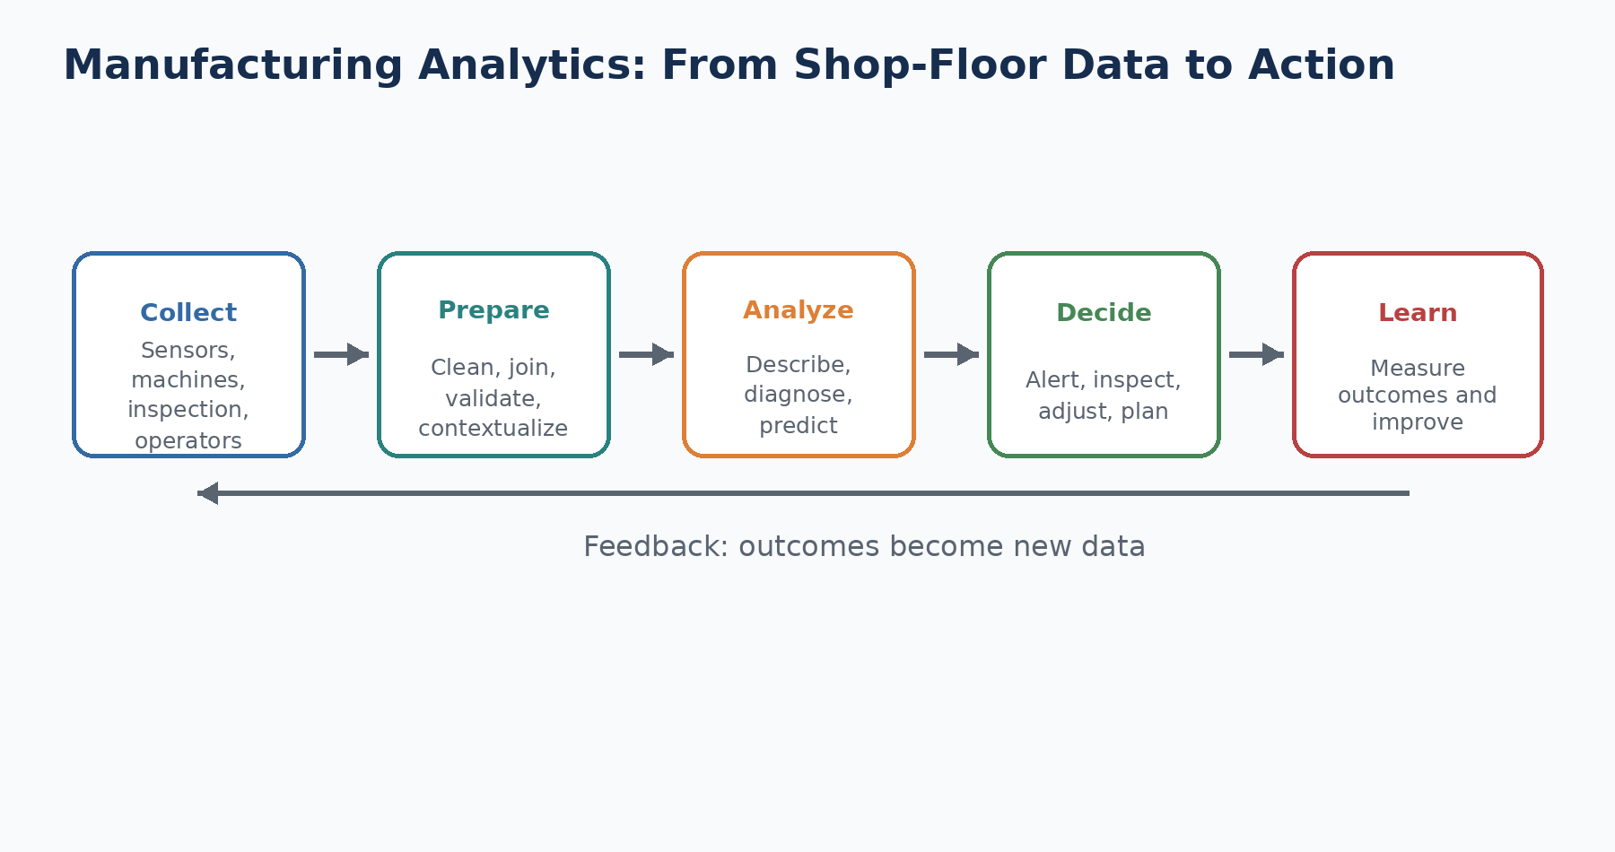
Figure 1.1 — A simplified manufacturing analytics feedback loop.
The loop is continuous. A model may identify a high-risk product, an engineer may inspect it, and the inspection result becomes new data. If the engineer discovers that the warning was useful, the process is reinforced. If the warning was wrong, the model, threshold, feature logic, or data quality may need improvement.

1.3 Common sources of manufacturing data
Data source | Examples
Machine and sensor data | Temperature, pressure, torque, current, force, speed, vibration, images, alarms
Product and process data | Product ID, route, recipe, material batch, station sequence, operation status
Quality data | Inspection result, measurement, defect code, rework, scrap, final disposition
Maintenance data | Failure event, work order, replaced part, technician note, downtime
Planning data | Production order, schedule, target quantity, takt time, shift
Human-entered data | Operator checks, comments, deviations, approvals
Enterprise data | ERP, MES, warehouse, supplier, warranty, customer-return information

In the Bosch competition dataset, participants receive anonymized numerical, categorical, and date features for individual parts. The target indicates whether a part failed internal quality control. The raw data therefore resembles a large table of product-level manufacturing evidence rather than a fully documented factory database [8, 9].

1.4 Four levels of analytics
Level | Question | Manufacturing example
Descriptive | What happened? | Failure rate by line, station coverage, daily output
Diagnostic | Why might it have happened? | Compare failure patterns, routes, missingness, and measurement groups
Predictive | What is likely to happen? | Estimate failure probability for a product
Prescriptive | What should be done? | Prioritize inspection, maintenance, or process adjustment under defined rules

These levels are related but not interchangeable. A predictive model can be accurate without proving the physical cause of failure. A diagnostic pattern can suggest an investigation without justifying an automatic machine adjustment. Prescriptive actions need stronger evidence, safety review, ownership, and operational approval.

1.5 Important manufacturing KPIs
KPI | Meaning
Throughput | Number of acceptable units produced per unit of time
Yield | Share of produced units that meet requirements
First-pass yield | Share that pass without rework
Defect rate | Share or count of units with nonconformities
Scrap rate | Share of output that cannot be economically recovered
Cycle time | Time required for a unit or operation, based on a clearly defined start and end
Takt time | Required production pace derived from customer demand and available production time
Work in process (WIP) | Units that have entered production but are not yet complete
Downtime | Time when equipment or a line cannot perform the intended operation
OEE | Combined view of availability, performance, and quality

Terminology caution
In anonymized datasets, a time difference calculated from the earliest and latest recorded measurement is not automatically the true factory cycle time. In this project, the safer term is “Observed Measurement Span” unless engineering documentation confirms the physical interpretation.

1.6 A small worked example
Imagine a plant producing 10,000 components in one week. Sixty components fail final inspection. A data analyst discovers that most failures are associated with products that visited a particular route and had unusual measurements at one station. A model ranks products by estimated risk. Engineers decide to inspect the top 150 alerts more closely.
1. Descriptive result: 60 of 10,000 products failed.
2. Diagnostic hypothesis: the route and station measurements are associated with higher failure risk.
3. Predictive output: each new product receives a failure probability.
4. Operational decision: only products above an approved threshold receive additional inspection.
5. Learning step: actual inspection outcomes are compared with predictions.
This example demonstrates why model quality is not the only issue. The plant must also consider inspection capacity, the cost of missing a failure, the cost of false alarms, product safety, and how quickly the result is available.

1.7 Connection to the Bosch project
Project connection
The repository implements a complete analytics pathway: data-quality checks, feature metadata, manufacturing-flow datasets, exploratory analysis, feature engineering, product-family discovery, predictive modeling, SHAP explainability, process mining, knowledge graphs, a SQLite-backed copilot, and a Streamlit dashboard [10].

The project is strongest when described as an advanced benchmark and automotive manufacturing POC reference. It uses historical anonymized data and demonstrates how an analytics solution can be engineered. It does not have access to current factory systems, true feature definitions, live operators, maintenance records, or new verified labels. That boundary will appear throughout the handbook.
Common beginner mistakes
• Starting with an algorithm before defining the decision and user.
• Treating every correlation as a physical root cause.
• Reporting accuracy without considering rare failures.
• Using unclear time words such as delay or cycle time for anonymized timestamps.
• Ignoring whether a feature is available at the moment a prediction must be made.

Review questions
1. What is manufacturing analytics?
2. How do descriptive and predictive analytics differ?
3. Why does a sensor value need context?
4. Name five manufacturing data sources.
5. Why can a predictive signal be useful even when it is not a confirmed cause?

Practice exercise
Choose a familiar manufactured product, such as a water bottle, phone charger, cement block, or automobile component. Draw a simple data-to-decision loop showing what could be measured, what problem could be predicted, who would receive the result, and what action might follow.
Chapter summary
• Manufacturing analytics converts production data into evidence for decisions.
• Analytics may be descriptive, diagnostic, predictive, or prescriptive.
• The value of analysis depends on context, timing, ownership, and actionability.
• The Bosch project demonstrates a broad analytics workflow but must preserve the boundary between predictive evidence and factory-confirmed causation.

Chapter 2: Industry 4.0
Learning objectives
By the end of this chapter, the reader should be able to:
• describe the four industrial revolutions
• define Industry 4.0 and smart manufacturing
• identify the main technologies in a connected factory
• explain the relationship among OT, IT, edge, cloud, MES, and ERP
• recognize the human, data, security, and governance challenges of digital manufacturing

2.1 Why the term Industry 4.0 exists
Industry 4.0 is a name for the ongoing transformation of production through connected machines, digital information, automation, analytics, and intelligent decision support. NIST describes smart manufacturing as a setting in which production data can be transformed into actionable knowledge for decision-making [1]. Bosch describes the factory of the future as connected, transparent, efficient, flexible, and centered on cooperation between people and machines [4].
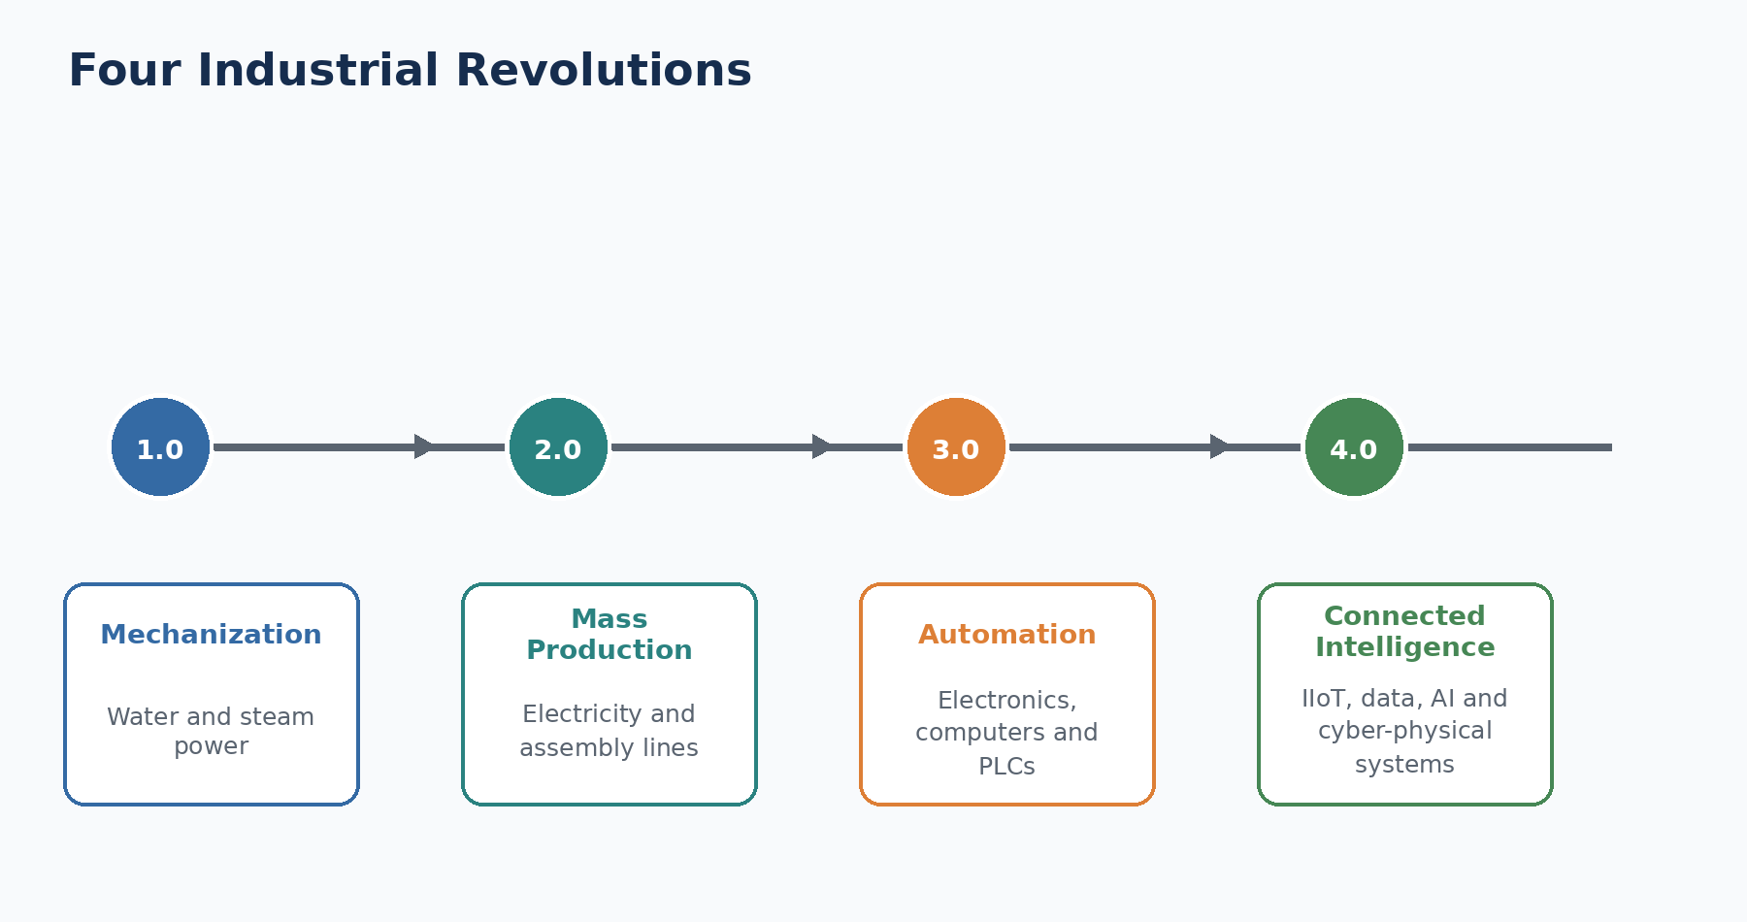
Figure 2.1 — A simplified view of the four industrial revolutions.
Stage | Main idea | Manufacturing effect
Industry 1.0 | Mechanization using water and steam power | Mechanized equipment
Industry 2.0 | Electric power and organized mass production | Assembly lines and scale
Industry 3.0 | Electronics, computers, PLCs, and automation | Programmable machines
Industry 4.0 | Connected physical and digital systems using data and intelligence | Smart, adaptive production

2.2 The core idea: connected physical and digital systems
Traditional automation can operate a machine according to programmed logic. Industry 4.0 adds connectivity and system-wide visibility. A station can send measurements to a local controller, a manufacturing execution system can associate the measurements with a product and operation, and an analytics service can detect a pattern across thousands of products. The result can be displayed to engineers or used within an approved control workflow.
Simple analogy
A conventional machine is like a person performing a task from instructions. An Industry 4.0 system is like a team in which workers, machines, planners, quality engineers, and software share timely information and coordinate decisions.

2.3 Major Industry 4.0 technologies
Technology | Role
Industrial Internet of Things (IIoT) | Connected sensors, machines, tools, and devices that exchange operational data
Cyber-physical systems | Tight connection between physical equipment and digital monitoring or control
Edge computing | Data processing near the machine or production line for low latency and resilience
Cloud computing | Scalable storage, computing, collaboration, and enterprise analytics
MES | Manufacturing execution functions such as orders, traceability, dispatching, and production status
ERP | Enterprise planning for materials, finance, purchasing, and business processes
AI and machine learning | Pattern detection, prediction, visual inspection, optimization, and decision support
Digital twins | Digital representations used to monitor, simulate, or reason about physical assets and processes
Robotics and automation | Programmable or adaptive execution of physical tasks
Data standards and APIs | Common structures and interfaces that allow different systems to communicate
Cybersecurity | Protection of safety, availability, integrity, confidentiality, and controlled access

2.4 OT and IT must work together
Operational technology (OT) includes systems that sense, control, and operate physical processes: PLCs, robots, sensors, drives, safety systems, and supervisory controls. Information technology (IT) includes servers, databases, networks, identity systems, analytics platforms, and business applications. Smart manufacturing depends on the controlled integration of OT and IT.
This integration is powerful but difficult. OT prioritizes safety, deterministic operation, availability, and long equipment lifetimes. IT often changes faster and prioritizes scalability, data services, and software lifecycle practices. A production AI project must respect both worlds. A model cannot be deployed simply because it performs well in a notebook.

2.5 A simplified manufacturing information stack
Layer | Typical systems or elements
Enterprise level | ERP, supply chain, finance, customer and supplier systems
Operations level | MES, quality management, scheduling, maintenance management
Supervisory level | SCADA, line monitoring, historian, alarms
Control level | PLC, robot controller, motion control, machine logic
Physical level | Sensors, actuators, machines, tools, products, people

A model may be trained in an analytics environment but consume data from several layers. For example, a quality prediction may use sensor measurements from the physical level, product route information from MES, and supplier batch information from ERP. Its alert may return to a dashboard or inspection workflow. Data lineage is therefore essential.

2.6 Benefits and limits
Potential benefit | Example
Higher transparency | Engineers can see process and quality patterns across stations and shifts.
Earlier intervention | Risk can be identified before final release.
Reduced downtime | Condition signals can support maintenance planning.
Higher flexibility | Digital instructions and connected systems can support product variants.
Reduced waste | Better detection and process control can reduce scrap and rework.
Knowledge sharing | Data and digital models can preserve and distribute engineering knowledge.

2.7 Challenges that beginners often underestimate
- Data from different machines may use different formats, units, clocks, IDs, or naming conventions.
- A sensor may be calibrated, replaced, moved, or reconfigured without the model knowing.
- The same feature may have different acceptable ranges for different product variants.
- Rare failures create severe class imbalance and limited examples for learning.
- Cybersecurity and safety requirements can restrict connectivity and deployment options.
- A useful model needs an owner, response procedure, monitoring plan, and retraining evidence.
- Operators and engineers must trust and understand the system enough to use it appropriately.

2.8 Human-centered smart manufacturing
Industry 4.0 does not mean removing people from every decision. Experienced operators and engineers often understand process conditions that are absent from the dataset. A strong system combines data-driven evidence with domain knowledge. Bosch describes industrial AI applications such as anomaly detection, root-cause analysis, automated optical inspection, and production scheduling, while emphasizing robust and explainable solutions [5].
Human-in-the-loop principle
The model should support the person responsible for the manufacturing decision. The interface must communicate risk, evidence, limitations, and the recommended next step without pretending that the model knows more than the data allows.

2.9 Connection to the Bosch project
The project reflects Industry 4.0 thinking because it connects multiple analytical layers: structured manufacturing-flow features, product families, failure prediction, explainability, process mining, knowledge graphs, local APIs, audit logs, and an offline copilot. The repository also adds Docker, dependency locking, CI, tests, an input contract, model registry, rollback, and an authenticated endpoint [10]. These software controls move the work beyond a notebook, although real factory integration remains outside the available data.
Common beginner mistakes
• Equating Industry 4.0 with buying new machines.
• Sending all factory data to the cloud without considering latency, security, cost, or resilience.
• Treating OT like ordinary office IT.
• Ignoring interoperability and data standards.
• Assuming automation eliminates the need for engineering judgment and ownership.

Review questions
1. What is Industry 4.0?
2. How does Industry 4.0 differ from Industry 3.0?
3. What is the difference between OT and IT?
4. Why might edge computing be necessary in a factory?
5. Name four challenges of smart manufacturing adoption.

Practice exercise
Draw a five-layer architecture for a smart quality system. Include a sensor, PLC, line-level data system, analytics model, dashboard, and human decision. Mark which elements belong mainly to OT and which belong mainly to IT.
Chapter summary
• Industry 4.0 connects physical production with digital data, communication, and intelligence.
• Smart manufacturing requires OT and IT to cooperate safely and reliably.
• AI is only one part of a larger system that includes sensors, control, MES, ERP, cybersecurity, and people.
• The Bosch project demonstrates an Industry 4.0 analytical architecture but not a live factory deployment.

Chapter 3: Production Lines
Learning objectives
By the end of this chapter, the reader should be able to:
• define a production line and distinguish it from a station
• explain product routing, buffers, work in process, and bottlenecks
• distinguish takt time, cycle time, throughput, and lead time
• understand why products may follow different paths
• connect line and route concepts to the Bosch dataset and project features

3.1 What is a production line?
A production line is an organized sequence or network of manufacturing activities through which products or components move. Each activity performs part of the transformation, assembly, measurement, test, handling, or release process. Some lines are highly automated; others combine machines and manual work. Some produce one standard product, while mixed-model lines produce multiple variants.
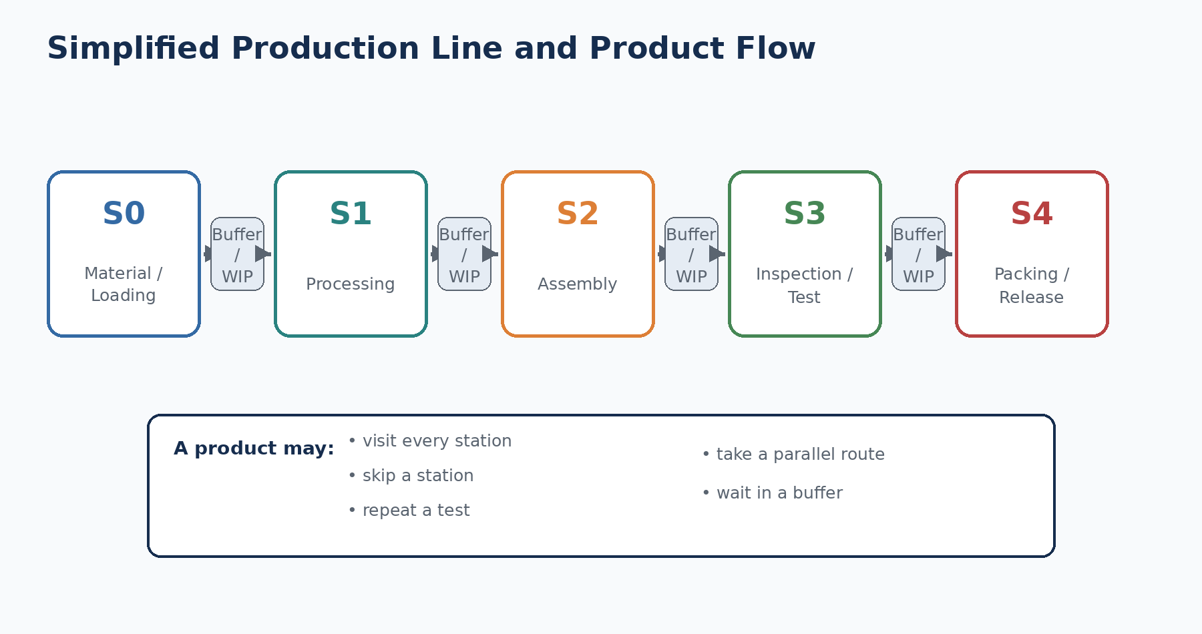
Figure 3.1 — A simplified production line with stations, buffers, and product flow.

3.2 Line, station, cell, and operation
Term | Meaning
Line | A coordinated flow of production activities that creates or processes a product.
Station | A specific point where one or more operations, measurements, tests, or handling activities occur.
Cell | A grouped set of equipment and people organized to complete related operations, sometimes with flexible routing.
Operation | A defined task such as drilling, fastening, welding, testing, or inspection.
Route | The ordered set of stations or operations followed by a product.
Buffer | A controlled waiting area between operations.
WIP | Products that have started but are not yet completed.

3.3 Different production-system structures
Structure | Description
Straight serial line | Products pass through a largely fixed sequence of stations.
Parallel line | Similar operations are performed on multiple parallel machines or branches.
Mixed-model line | Different product variants share the same line with different parameters or steps.
Rework loop | A product repeats an operation or follows a corrective route.
Job shop | Products follow diverse routes through functional work areas.
Cellular manufacturing | Grouped resources process a product family with reduced movement and waiting.

A dataset that records station measurements can reveal route diversity through patterns of observed and missing values. However, missingness must be interpreted carefully. A missing measurement may mean the product skipped a station, the measurement was not applicable, the sensor did not record, the value was filtered, or the data was not joined correctly.

3.4 The language of flow
Term | Practical meaning
Takt time | The pace required to satisfy demand: available production time divided by required units.
Cycle time | The measured time for a defined operation or unit, using an agreed start and end.
Lead time | Total elapsed time from a defined request or entry point to completion or delivery.
Throughput | Completed acceptable units per unit of time.
Capacity | Maximum sustainable output under defined conditions.
Utilization | Share of available capacity being used.
Bottleneck | The constraint that most strongly limits system flow or output.
Queue / waiting time | Time spent waiting for the next resource or operation.
Changeover | Time and work required to switch equipment or a line between products or conditions.

Why definitions matter
Two analysts can calculate different “cycle times” from the same data if they choose different start and end events. Every time-based KPI should state the event definitions, units, exclusions, and whether the value is observed, estimated, or engineered.

3.5 Bottlenecks and line balancing
A bottleneck is not simply the station with the highest average time. The true system constraint depends on demand, variability, downtime, product mix, buffers, parallel capacity, quality losses, and interactions with upstream and downstream resources. A station can have a long processing time but sufficient parallel machines, while a faster station may become the bottleneck because of frequent failures or changeovers.
Line balancing assigns work across stations so that the line can meet the required pace with reasonable workload and minimal waiting. Analytics can support balancing by measuring actual operation times, variation, queues, stoppages, rework, and route frequencies.

3.6 A numerical example
Suppose a line has 420 available minutes per shift and must produce 210 acceptable units. The required takt time is 2 minutes per unit. If the main stations have average cycle times of 1.4, 1.8, 2.3, and 1.6 minutes, the third station cannot keep pace unless capacity is increased or work is redistributed.
1. Available time = 420 minutes.
2. Required quantity = 210 units.
3. Takt time = 420 / 210 = 2 minutes per unit.
4. Station 3 average cycle time = 2.3 minutes, which exceeds takt.
5. Potential responses include process improvement, parallel capacity, workload redistribution, reduced downtime, or schedule changes.
This simple calculation is only a starting point. Real systems contain variability. A station averaging 1.9 minutes may still create queues if the variation is large or if failures and changeovers occur in bursts.

3.7 Product paths as analytical features
In anonymized manufacturing data, the set of stations with recorded values can be converted into a station-presence vector. Products with similar station-presence patterns may represent related routes, variants, or process families. Clustering these vectors can create product-family groups that are easier to analyze than thousands of raw columns.
Project connection
The Bosch project creates manufacturing-flow datasets, station-presence matrices, unique path mappings, product-family clusters, station counts, line counts, and path-complexity features. These engineered features help translate sparse anonymized tables into route-level manufacturing representations [10].

3.8 Why route differences matter for prediction
- Different product variants may require different operations.
- A product may be sent to extra inspection because of an earlier result.
- Rework can create repeated or extended paths.
- A machine outage may redirect products to another branch.
- Some measurements may only exist for a specific process option.
- Route complexity can influence exposure to equipment, waiting, and process variation.
A predictive model may learn that a route pattern is associated with failure. This association can be operationally useful, but it does not prove that the route caused the failure. The route may be a proxy for product type, material, process difficulty, or an earlier quality decision.
Common beginner mistakes
• Calling every long-duration station a bottleneck without checking system constraints.
• Assuming missing station data always means the product skipped the station.
• Confusing takt time with observed cycle time.
• Ignoring product variants and rework routes.
• Using future route information to make an early prediction, creating leakage.

Review questions
1. What is the difference between a line and a station?
2. Define takt time and cycle time.
3. Why might products follow different routes?
4. What is a bottleneck?
5. How can station-presence patterns be used in machine learning?

Practice exercise
Design a fictional five-station production line. Give each station an operation and an average cycle time. Calculate takt time for a chosen demand. Identify the likely constraint, then list three reasons why the true bottleneck might be different from the slowest average station.
Chapter summary
• A production line is a flow of connected stations and operations.
• Products may follow fixed, parallel, variant-specific, or rework routes.
• Takt time, cycle time, throughput, lead time, buffers, and WIP describe different aspects of flow.
• Station-presence and route features can make anonymized manufacturing data more interpretable.
• Route associations are predictive evidence, not automatic proof of causation.

Chapter 4: Manufacturing Stations
Learning objectives
By the end of this chapter, the reader should be able to:
• explain what a manufacturing station is and what it can do
• identify common station data types
• interpret the Bosch line–station–feature naming convention
• explain the meaning and limitation of date features
• understand station presence, missingness, and data lineage

4.1 What happens at a station?
A manufacturing station is a defined point in the process where work, measurement, testing, movement, or a decision occurs. A station can be a single machine, a manual workstation, a robot cell, an inspection bench, a test rig, or a logical step represented in the production system.
Station type | Typical purpose
Processing station | Changes material or geometry: machining, forming, heating, coating.
Assembly station | Joins components: fastening, pressing, welding, adhesive, fitting.
Inspection station | Measures characteristics and compares them with requirements.
Test station | Applies functional, electrical, pressure, leak, performance, or endurance tests.
Handling station | Loads, unloads, transports, positions, or identifies products.
Decision station | Routes a product based on recipe, result, variant, or quality status.
Rework station | Corrects a nonconformity or repeats an operation.

4.2 Stations generate multiple kinds of evidence
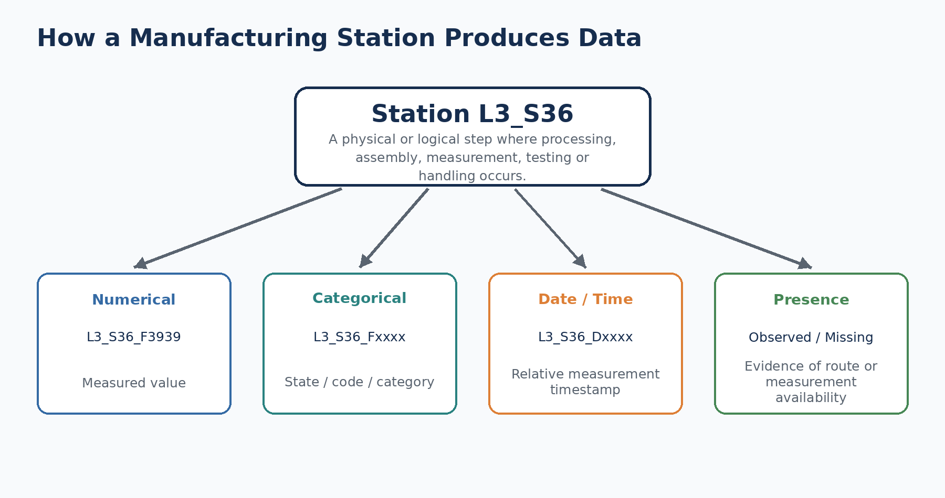
Figure 4.1 — A station may generate measurements, categories, timestamps, and presence patterns.
A single physical operation can generate many columns. A fastening station, for example, might record target torque, measured torque, angle, tool ID, program code, pass/fail result, retry count, and timestamp. In the Bosch dataset, these physical meanings are hidden. The naming convention provides structural context but not engineering semantics.

4.3 Understanding the feature name
Example: L3_S36_F3939
L3 means production line 3. S36 means station 36. F3939 is an anonymized feature identifier. The name does not reveal whether the value is temperature, force, torque, pressure, dimension, current, or another measurement.

This structure is valuable because it allows the analyst to group features by line and station. Thousands of individual columns can be summarized into station-level coverage, missingness, counts, aggregates, and importance reports. However, the physical interpretation still requires a feature dictionary or factory subject-matter expert.

4.4 Numerical, categorical, and date features
Feature type | What it stores | Possible meaning
Numerical | Continuous or discrete numeric measurement | Magnitude, reading, count, parameter
Categorical | Code, state, program, product option, or discrete outcome | A, B, C; program_7; status code
Date / timestamp | Relative time at which a related measurement was recorded | L0_S0_D1 associated with an earlier-numbered measurement
Missingness / presence | Whether a value exists for the product | Route, applicability, data availability, or recording behavior

The competition data was split by feature type because of its scale. Public descriptions report thousands of features across numerical, categorical, and date files. Competition work frequently relied on careful feature selection, station aggregation, time-derived features, and memory-efficient processing [8, 9].

4.5 Correct interpretation of date features
The date columns provide relative timestamps for when measurements were taken. A date feature such as L0_S0_D1 corresponds to the timing of a related measurement such as L0_S0_F0. These values are not ordinary calendar dates visible to the analyst. They are anonymized production-time indicators.
Safe naming used in this project
start_time → Earliest Measurement Timestamp
end_time → Latest Measurement Timestamp
cycle_time → Observed Measurement Span
waiting_time → Observed Measurement Gap
These names describe what was actually calculated without claiming official production start, end, processing time, or verified delay.

If the earliest observed timestamp is 82.24 and the latest is 83.10, the difference is 0.86 in the dataset’s relative time scale. It can be a useful feature, but it should be interpreted as the span between recorded measurements. The product may have entered the factory earlier, completed later, skipped measurements, or been processed in parallel.

4.6 Why missing values are information
Manufacturing datasets are often sparse because not every product receives every measurement. Missingness can encode process structure. A product variant may use only certain stations, a test may be conditional, or a sensor may report only when an event occurs. For this reason, deleting every column or row with many missing values can destroy route information.
Possible reason | Interpretation
Not applicable | The operation or measurement is not required for this product.
Station not visited | The product followed another route.
Conditional test | The measurement exists only after a previous result or trigger.
Data collection issue | Sensor, network, system, or join failure.
Filtered or censored value | The value was suppressed or not retained.
True unknown | The reason cannot be established from the available data.

4.7 Station-presence engineering
A station-presence feature answers a simple question: does this product have at least one recorded value at the station? For each product, the analyst can create a vector such as [1, 1, 0, 1, 0], where 1 means present and 0 means absent. This vector can support path discovery, product-family clustering, route comparisons, and model features.
1. Parse each feature name to obtain its line and station.
2. Group columns belonging to the same station.
3. Check whether any grouped value is present for each product.
4. Create station-presence indicators.
5. Summarize station count, line count, route signature, and completeness.
6. Validate the interpretation before using presence as a business explanation.

4.8 Data lineage and point-in-time availability
Data lineage records where a feature came from, how it was calculated, when it becomes available, and which version of the logic produced it. This is essential for preventing leakage. For example, a final-station timestamp may strongly predict failure, but it cannot be used for an early-station intervention if the value does not exist yet.
Leakage test
Ask: At the exact moment the model must make a decision, would this feature already exist in the real process? If the answer is no, the feature cannot be used for that operational prediction, even if it improves offline validation.

4.9 Connection to the Bosch project
Phase 2 parses feature names into line, station, and feature metadata; calculates completeness metrics; and creates manufacturing-flow datasets. Phase 4 creates date-derived temporal indicators, station counts, path complexity, and line-level aggregates. The README explicitly states that timestamps are anonymized relative measurement times rather than verified physical delays or official start/end times [10].
Common beginner mistakes
• Inventing physical meanings for anonymized features.
• Calling earliest and latest recorded values official production start and end.
• Dropping sparse features without checking whether missingness represents routing.
• Combining timestamps from different contexts without validating units and event meaning.
• Using measurements that occur after the intended prediction point.

Review questions
1. What can be learned from L3_S36_F3939?
2. What cannot be learned from that name alone?
3. Why are date features useful?
4. Why is “Observed Measurement Span” safer than “Production Delay”?
5. List four possible reasons for a missing station measurement.

Practice exercise
Create a mock table containing two production lines, four stations, numerical features, categorical features, and timestamps. Then design station-presence indicators and explain two different reasons why the same pattern of missingness could occur.
Chapter summary
• Stations are the operational points where products are processed, assembled, tested, inspected, handled, or routed.
• The Bosch naming convention provides line, station, and feature structure but hides physical semantics.
• Date columns are anonymized relative measurement timestamps.
• Missingness can be valuable route information but can also result from data-quality problems.
• Feature lineage and point-in-time availability are essential for trustworthy prediction.

Chapter 5: Quality Control & Inspection
Learning objectives
By the end of this chapter, the reader should be able to:
• distinguish quality assurance, quality control, and inspection
• explain incoming, in-process, and final inspection
• define defect, nonconformity, failure, rework, and scrap
• understand false positives and false negatives in quality prediction
• explain why rare failures require appropriate evaluation metrics

5.1 What does quality mean?
Quality means consistently meeting defined requirements and satisfying the intended use. In manufacturing, requirements may include dimensions, strength, appearance, function, reliability, safety, traceability, packaging, and regulatory conditions. Quality is not created only by final inspection. It is designed into the product and process, controlled during production, verified by measurement, and improved through feedback.
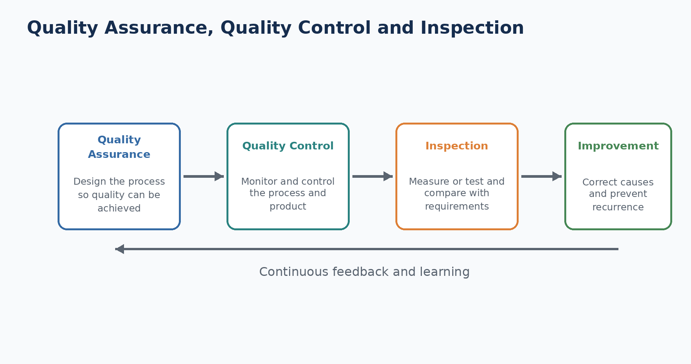
Figure 5.1 — Quality assurance, control, inspection, and improvement are connected but distinct.

5.2 Quality assurance, quality control, and inspection
Concept | Primary focus | Examples
Quality assurance (QA) | Preventive system-level activities | Process design, procedures, training, audits, calibration systems
Quality control (QC) | Operational techniques to maintain conformity | Monitoring measurements, reaction plans, process adjustments
Inspection | Verification of characteristics against requirements | Measure, examine, test, gauge, and compare with specification
Quality improvement | Structured reduction of causes of poor performance | Root-cause investigation, corrective and preventive actions

ASQ defines inspection as measuring, examining, testing, or gauging one or more characteristics and comparing the results with requirements to determine conformity [3]. This makes inspection an evidence-producing activity within the broader quality system.

5.3 Where inspection occurs
Inspection stage | Purpose
Incoming inspection | Checks supplied material or components before use.
First-piece inspection | Verifies the first unit after setup, changeover, or adjustment.
In-process inspection | Checks characteristics while production is still in progress.
Automated inspection | Uses sensors, vision, gauges, or test equipment integrated with production.
Final inspection | Verifies finished-product requirements before release.
Audit inspection | Samples products or processes to verify ongoing control.
Field / return analysis | Uses customer, warranty, or service evidence to improve future production.

5.4 Important quality terms
Term | Meaning
Specification | Documented requirement or acceptable range.
Conformity | Meeting a requirement.
Nonconformity | Failure to meet a specified requirement.
Defect | A nonconformity related to intended or specified use; usage can depend on the quality system.
Failure | Inability to perform a required function or a failed quality outcome.
Rework | Action that brings a nonconforming product into conformity.
Repair | Action that makes a product acceptable for use, which may not fully restore original conformity.
Scrap | Product that is rejected and not economically recovered for its intended purpose.
False reject | A good product is classified as bad.
False accept | A bad product is classified as good.

5.5 100% inspection versus sampling
Inspection of every unit may be necessary for critical characteristics, automated checks, or regulatory requirements. Sampling inspects only selected units and uses the result to make a decision about the process or lot. Neither approach is automatically superior. Inspection may be destructive, expensive, slow, imperfect, or unable to detect every failure mode. The best quality system combines process control, prevention, suitable inspection, and learning.

5.6 Statistical process control: a beginner view
A process naturally varies. Statistical process control (SPC) distinguishes ordinary common-cause variation from unusual signals that may indicate a process change. A control chart displays a statistic over time with a center line and statistically derived control limits. Control limits describe process behavior; specification limits describe customer or engineering requirements. They are not the same.
Control limit versus specification limit
A process can be statistically stable but still produce outside specification if it is centered incorrectly or varies too much. It can also temporarily meet specification while showing an unstable pattern that requires investigation.

5.7 The cost of quality
Cost category | Examples
Prevention costs | Training, process design, mistake proofing, maintenance, supplier development
Appraisal costs | Inspection, testing, audits, calibration
Internal failure costs | Scrap, rework, downtime, sorting before shipment
External failure costs | Warranty, returns, recalls, penalties, lost trust

Predictive quality aims to reduce total cost by detecting risk early enough for an economical action. A model that creates too many false alarms may increase appraisal and disruption costs. A model that misses critical failures may create much larger internal or external failure costs.

5.8 Confusion matrix for quality prediction
Outcome | Meaning | Operational effect
True positive | Model predicts failure and the product fails | Useful alert
False positive | Model predicts failure but the product passes | Extra inspection or disruption
True negative | Model predicts pass and the product passes | Correct non-alert
False negative | Model predicts pass but the product fails | Missed risk

The correct balance depends on the use case. For a safety-critical defect, missing a failure may be unacceptable. For a costly destructive test, false alarms may also be expensive. The threshold should therefore be selected with engineers and business owners, not only by maximizing a generic score.

5.9 Rare failures and misleading accuracy
The Bosch training data has a very low positive failure rate. In a dataset where roughly 0.58% of parts fail, a model that predicts “pass” for every product would appear more than 99% accurate but would detect no failures [8]. This is why the competition used Matthews correlation coefficient (MCC), which reflects all four confusion-matrix outcomes and is useful for highly imbalanced binary classification.
Accuracy trap
High accuracy does not mean a model is useful when one class is extremely rare. Always inspect precision, recall, confusion-matrix counts, PR-AUC, MCC, threshold behavior, and the operational cost of errors.

5.10 Quality prediction is not the same as inspection
A prediction estimates risk from available evidence. Inspection measures or tests actual product characteristics. A predictive model can prioritize inspection, increase monitoring, or support investigation, but it does not automatically replace an approved measurement or test. The replacement decision requires validation against requirements, measurement-system analysis, safety review, regulatory acceptance, and controlled change management.

5.11 Connection to the Bosch project
Project connection
The target Response indicates whether a product failed internal quality control. The official Phase 6 model predicts failure probability, while Phase 7 uses SHAP to explain model behavior. The dashboard warns that SHAP signals are not confirmed physical root causes and that timestamp-derived features are not verified delays [10].

This distinction is important for a student. The project demonstrates predictive quality analytics. It does not define the exact Bosch inspection process, defect types, safety consequences, or engineering reaction plan because those details are not included in the public anonymized dataset.
Common beginner mistakes
• Treating quality as the responsibility of the final inspector only.
• Confusing a model prediction with a measured inspection result.
• Reporting accuracy for a rare-event problem without confusion-matrix metrics.
• Ignoring the cost difference between false positives and false negatives.
• Calling SHAP importance a confirmed defect cause.

Review questions
1. How do QA, QC, and inspection differ?
2. What is the difference between a false reject and a false accept?
3. Why can 99% accuracy be useless in a rare-failure dataset?
4. What is the difference between control limits and specification limits?
5. Why might a prediction support inspection rather than replace it?

Practice exercise
Create a confusion matrix for 10,000 products with 60 actual failures. Choose values for true positives, false positives, true negatives, and false negatives. Calculate precision and recall, then explain the likely operational consequences of your chosen errors.
Chapter summary
• Quality is created through design, prevention, control, inspection, and improvement.
• Inspection verifies characteristics against requirements but does not create quality by itself.
• False accepts and false rejects have different operational costs.
• Rare failures make accuracy misleading, so balanced metrics and threshold analysis are required.
• Predictive quality supports decisions but does not automatically replace approved inspection.

Chapter 6: Predictive Manufacturing
Learning objectives
By the end of this chapter, the reader should be able to:
• define predictive manufacturing and its main use cases
• distinguish predictive quality, maintenance, anomaly detection, and optimization
• describe the end-to-end predictive lifecycle
• explain the difference between prediction and causation
• distinguish a portfolio POC from a validated live production system

6.1 What is predictive manufacturing?
Predictive manufacturing uses historical and current production data to estimate future or unknown outcomes that matter to operations. The prediction may concern product quality, equipment condition, process deviation, completion time, energy use, output, or material demand. The goal is not prediction for its own sake. The goal is to improve a defined decision while respecting safety, cost, timing, and human responsibility.
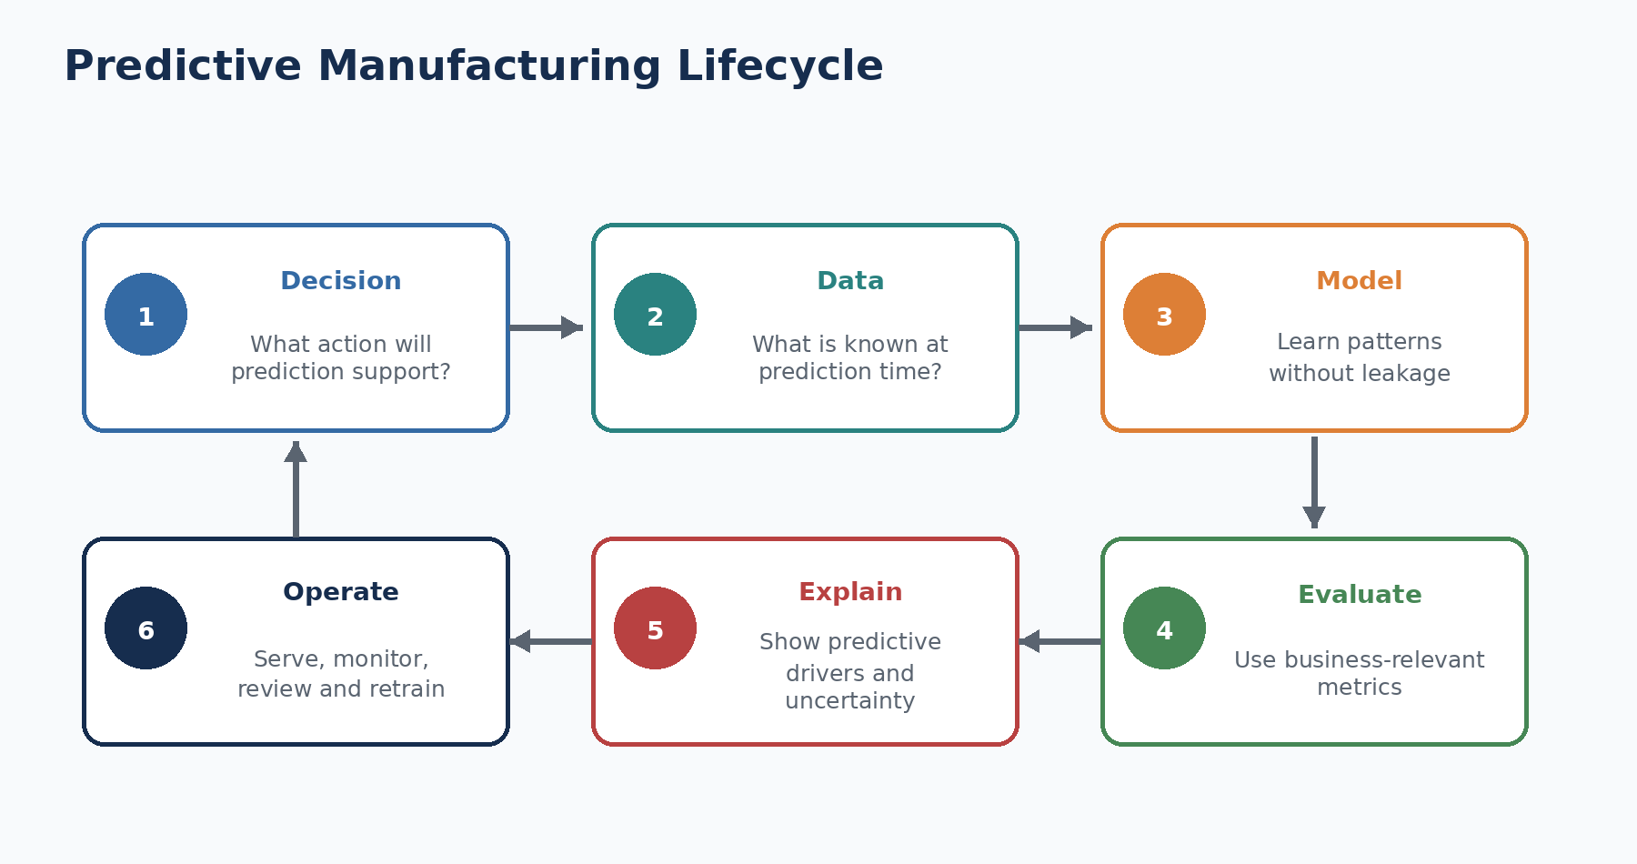
Figure 6.1 — The predictive manufacturing lifecycle from decision definition to operation.

6.2 Main predictive use cases
Use case | Typical question
Predictive quality | Estimate whether a product will fail or which characteristic is at risk.
Predictive maintenance | Estimate equipment failure risk, degradation, or maintenance need.
Anomaly detection | Identify unusual patterns when failure labels are limited or unavailable.
Remaining useful life | Estimate time or usage before an asset reaches a defined failure state.
Throughput / lead-time prediction | Estimate completion time, delay risk, or output under current conditions.
Energy prediction | Estimate energy demand or detect inefficient operation.
Demand and inventory prediction | Support materials, staffing, and scheduling decisions.
Process optimization | Recommend settings or plans under objectives and constraints.

6.3 Supervised, unsupervised, and hybrid approaches
Approach | Idea | Manufacturing example
Supervised learning | Learns from examples with known outcomes | Failure prediction using Response labels
Unsupervised learning | Finds structure without labelled outcomes | Clustering product routes; anomaly detection
Semi-supervised learning | Uses a small labelled set and a larger unlabelled set | Quality analysis with limited verified defects
Hybrid / knowledge-guided | Combines data-driven learning with rules or engineering models | Model plus process limits or domain constraints

6.4 Begin with the decision, not the model
A useful predictive project begins by defining who will act, what decision will change, when the decision occurs, what evidence is available, and how success will be measured. Without this definition, the team may optimize a model that cannot be used.
1. Decision: Should this product receive extra inspection?
2. Prediction point: After station S24 but before final test.
3. Available data: Measurements and route evidence recorded up to S24.
4. Output: Failure probability and approved alert category.
5. Action: Route high-risk products to an additional inspection procedure.
6. Success: Detect more true failures without exceeding inspection capacity or unacceptable false alarms.

6.5 The end-to-end lifecycle
Stage | Key work
Problem definition | Define decision, user, prediction point, target, cost, and release gates.
Data strategy | Inventory sources, labels, IDs, timestamps, lineage, privacy, and access.
Exploration | Check quality, imbalance, missingness, routes, distributions, and time structure.
Feature engineering | Create point-in-time-safe variables that represent product, station, route, and process evidence.
Modeling | Train baselines and candidate models with controlled splits and reproducibility.
Evaluation | Measure discrimination, calibration, threshold behavior, stability, and business effects.
Explainability | Communicate predictive drivers, local evidence, limitations, and uncertainty.
Serving | Package model, contract, authentication, logging, and versioning.
Monitoring | Track inputs, outputs, performance, latency, failures, and operational response.
Retraining and governance | Use fresh labels, review evidence, approve promotion, and support rollback.

6.6 Prediction is not causation
A model learns statistical relationships that help separate higher-risk and lower-risk examples. A feature can be important because it is directly related to a physical mechanism, because it is correlated with another hidden factor, because it identifies a product family, or because it reflects a data-collection pattern. SHAP explains how the model used the feature; it does not prove that changing the feature will change the outcome.
Example from this project
Earliest Measurement Timestamp can be an important predictive signal because certain relative production periods have different failure patterns. It may act as a proxy for batch, route, machine condition, or another hidden state. It must not be presented as a confirmed delay or physical root cause.

6.7 Offline validation versus live validation
Validation stage | Purpose
Offline historical validation | Tests performance on held-out historical records.
Temporal validation | Tests whether a model trained on earlier data generalizes to later data.
Shadow deployment | Scores live data without changing operational decisions.
Controlled pilot | Uses the model in a limited line, shift, product, or workflow with monitoring.
Production rollout | Expands use after approved technical, operational, safety, and business gates.
Post-deployment monitoring | Checks drift, performance, latency, user response, and unintended effects.

The public Bosch dataset supports offline modeling and simulation. It cannot by itself validate live latency, current factory drift, operator acceptance, business savings, maintenance effects, or retraining on new labels. Those require access to real production systems and stakeholders.

6.8 POC versus production system
Dimension | POC / benchmark | Live production
Data | Historical anonymized competition data | Current governed factory data with documented semantics
Prediction point | Inferred or simulated | Defined in the actual process
Integration | Files, SQLite, local API, dashboard | MES/SCADA/quality workflow integration
Validation | Holdout and regression tests | Temporal, shadow, pilot, safety, and business validation
Monitoring | Local or simulated logs | Live observability, alerts, ownership, service levels
Governance | Project documentation and model card | Formal approvals, change control, audit, accountability
Outcome claim | Demonstrates technical capability | Demonstrates sustained operational benefit

6.9 Connection to the Bosch project
The project implements a production-like local framework: exact dependency locking, Docker, CI, automated tests, an input contract, file-backed model registry, artifact hashing, prediction audit logging, a golden regression set, rollback, and an API-key-protected FastAPI endpoint. These controls demonstrate good engineering and make the project reproducible [10].
The official production-safe LightGBM model is intentionally separated from research-only leaderboard experiments. This is an important learning outcome: a score is not enough. The feature set, data policy, validation design, and intended use determine whether a result is trustworthy for a real decision.

6.10 A practical checklist for students
- Can I state the decision in one sentence?
- Do I know when the prediction must be available?
- Are all model features available at that time?
- Is the target clearly defined and reliably labelled?
- Does the split reflect the intended future use?
- Am I using metrics suitable for class imbalance?
- Can I explain the difference between association and causation?
- Have I documented limitations and forbidden uses?
- Can I reproduce the environment and model artifact?
- What evidence would be needed before a live pilot?
Common beginner mistakes
• Calling a high-scoring notebook a production system.
• Using future information in training features.
• Choosing a threshold without operational cost or capacity analysis.
• Assuming feature importance proves root cause.
• Claiming live business impact from historical competition data.

Review questions
1. What is predictive manufacturing?
2. How does predictive quality differ from predictive maintenance?
3. Why should the prediction point be defined before feature engineering?
4. What is shadow deployment?
5. Why is the Bosch project best described as an advanced benchmark and POC reference rather than a live production deployment?

Practice exercise
Write a one-page predictive-manufacturing charter for a fictional factory. Define the user, decision, prediction point, target, data available at prediction time, model output, action, error costs, success metrics, and evidence required before a pilot.
Chapter summary
• Predictive manufacturing uses data to support future-oriented operational decisions.
• The use case, prediction point, available evidence, action, and error costs must be defined before modeling.
• Prediction explains risk, not automatically causation.
• Offline validation, shadow deployment, controlled pilots, and production rollout are different maturity stages.
• The Bosch project demonstrates strong local POC engineering while clearly retaining the boundary around live factory validation.

Part I Glossary
Term | Beginner-friendly meaning
Analytics | Methods used to transform data into understanding, prediction, or decision support.
Anomaly | An observation or pattern that differs from expected behavior.
Bottleneck | The constraint that most strongly limits the output or flow of a system.
Buffer | A controlled area where work waits between operations.
Categorical feature | A variable representing a state, code, class, or discrete option.
Common-cause variation | Natural variation produced by the stable structure of a process.
Control limit | Statistically derived boundary used to evaluate process behavior.
Cycle time | Elapsed time for a precisely defined unit or operation.
Data lineage | Record of where data came from and how it was transformed.
Defect / nonconformity | A condition that does not meet a defined requirement; exact terminology depends on the quality system.
Digital twin | A digital representation used to monitor, simulate, or reason about a physical asset or process.
Edge computing | Processing located near the physical equipment or data source.
ERP | Enterprise Resource Planning system.
False negative | A failed product predicted as pass.
False positive | A passing product predicted as failure.
First-pass yield | Share of units that pass without rework.
Industry 4.0 | Connected, data-enabled, intelligent manufacturing and its supporting technologies.
Inspection | Measurement, examination, testing, or gauging against requirements.
IIoT | Industrial Internet of Things.
Lead time | Total elapsed time from a defined request or entry point to completion.
Manufacturing analytics | Use of manufacturing data to understand, predict, and improve production decisions.
MCC | Matthews correlation coefficient, a balanced binary-classification metric.
MES | Manufacturing Execution System.
Model drift | Change in data or relationships that can reduce model suitability over time.
OEE | Overall Equipment Effectiveness: availability × performance × quality.
OT | Operational technology used to monitor and control physical processes.
POC | Proof of Concept.
Prediction point | The exact process moment when a prediction must be made.
Predictive quality | Prediction of product or process quality risk.
Quality assurance | Systematic activities intended to provide confidence that quality requirements will be fulfilled.
Quality control | Operational techniques used to maintain and verify quality.
Route | Ordered set of operations or stations followed by a product.
SCADA | Supervisory Control and Data Acquisition.
SHAP | A method for attributing a model prediction to its input features.
Special-cause variation | Unusual variation that may indicate a specific change or disturbance.
Station | A defined point where processing, assembly, measurement, testing, handling, or routing occurs.
Takt time | Required production pace based on demand and available time.
Throughput | Acceptable completed units per unit of time.
WIP | Work in process: units that have started but are not complete.
Yield | Share of output that meets defined acceptance conditions.

References and Further Reading
[1] NIST — Data Analytics for Smart Manufacturing Systems — https://www.nist.gov/programs-projects/data-analytics-smart-manufacturing-systems
[2] NIST — An Analytical Framework for Smart Manufacturing — https://www.nist.gov/publications/analytical-framework-smart-manufacturing
[3] ASQ — Quality Glossary: Inspection and related quality terms — https://asq.org/quality-resources/quality-glossary
[4] Bosch — Ten Years of Industry 4.0 — https://www.bosch.com/stories/10-years-industry-4-0-at-bosch/
[5] Bosch — Industrial AI and manufacturing applications — https://www.bosch.com/research/bcai/industrial-ai/
[6] Bosch — Artificial Intelligence in Manufacturing — https://www.bosch.com/stories/ai-in-manufacturing/
[7] NIST — Cybersecurity and Industry 4.0 — https://www.nist.gov/blogs/manufacturing-innovation-blog/cybersecurity-and-industry-40-what-you-need-know
[8] Kaggle — Bosch Production Line Performance competition — https://www.kaggle.com/competitions/bosch-production-line-performance
[9] Mangal and Kumar — Using Big Data to Enhance the Bosch Production Line Performance: A Kaggle Challenge — https://arxiv.org/abs/1701.00705
[10] Krishnakanth Reddy Karingula — Bosch Production Line Performance project repository — https://github.com/kkr199/Bosch-Production-line-performance
[11] Bosch project dashboard — https://bosch-peformance-line.streamlit.app/
[12] Kaggle — Bosch Production Line Performance community discussions (supplementary source) — https://www.kaggle.com/competitions/bosch-production-line-performance/discussion?sort=most-comments
[13] NIST — 2026 Roadmap on AI and Machine Learning for Smart Manufacturing — https://www.nist.gov/publications/2026-roadmap-artificial-intelligence-and-machine-learning-smart-manufacturing
Reference note
Kaggle discussion posts are community contributions. They are valuable for discovering modeling ideas, data behaviors, and practical implementation challenges, but they should not be treated as official descriptions of Bosch factory operations unless independently confirmed.

End of Part I — Manufacturing Fundamentals
Next planned part: Understanding the Bosch Dataset

