PART V

Feature Engineering
Chapters 39–46
Temporal Signals • Manufacturing Flow • Product Segmentation • Path Structure

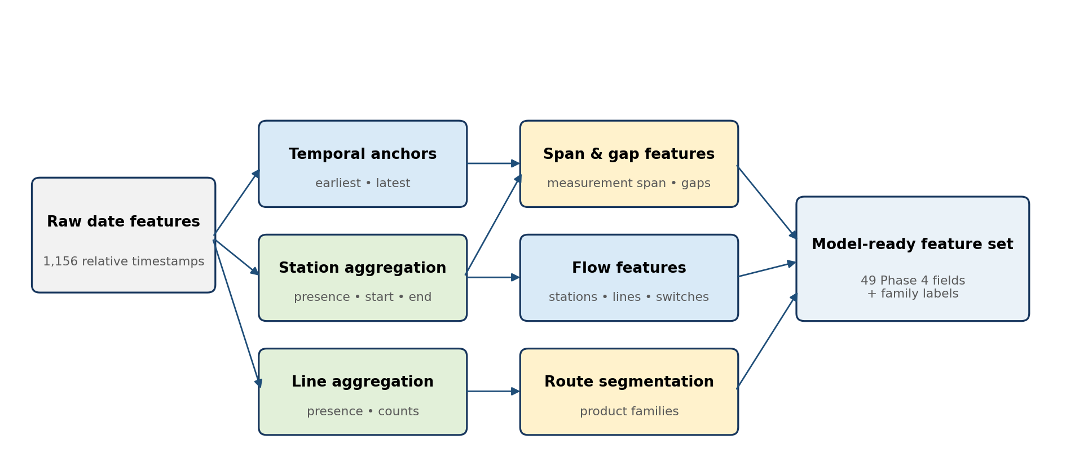
Figure V.1 — Repository feature-engineering pipeline from anonymized raw timestamps to model-ready variables.
Interpretation boundary: Bosch timestamps are relative and anonymized. Every duration or gap in this part is an analytical measurement-time proxy, not a verified physical cycle time, queue time, delay, or root cause.

Author: Krishnakanth Reddy Karingula
Repository-driven technical handbook edition

Contents and Scope
Part V isolates the most important engineered variables used by the Bosch project and explains how they are calculated, validated, interpreted, and passed into later modeling phases. The focus is implementation rather than generic feature-engineering theory.
Chapter | Topic | Core question
39 | Earliest Measurement Timestamp | Relative temporal anchor and production-window signal
40 | Observed Measurement Span | Difference between the latest and earliest observed timestamps
41 | Observed Measurement Gaps | Positive inter-station timestamp gaps and their summaries
42 | Station Count | Number of stations with at least one observed date value
43 | Line Count | Number of production lines represented in the observed route
44 | Manufacturing Flow | Line–station hierarchy, route signatures, and flow datasets
45 | Product Families | Clustering station-presence patterns into eight route-based groups
46 | Path Complexity | Composite route structure from station count, line count, switches, and density

Part-level output summary
Artifact | Train | Test
Phase 4 engineered features | 1,183,747 rows × 49 columns | 1,183,748 rows × 48 columns
Manufacturing-flow dataset | 1,183,747 products | 1,183,748 products
Product-family labels | 8 final families | 8 family labels transferred
Parsed manufacturing structure | 4 lines • 52 stations • 4,264 features | Same schema

Reading convention
- “Observed” means present in the public Bosch data, not independently verified against plant event logs.
- Failure-rate differences are descriptive associations. Sparse groups can have unstable percentages and must be interpreted with their product counts.
- Features are keyed by Id and engineered identically for train and test; Response is attached only to the labeled train output.
- The pipeline streams raw CSV files in 20,000-row chunks to keep memory bounded.

CHAPTER 39

Earliest Measurement Timestamp
Using the first available relative timestamp as a temporal anchor without treating it as an official production start time

Definition and purpose
For each product, the pipeline scans every raw date feature and retains the minimum observed value. In the repository this variable is stored as start_time and presented to readers as Earliest Measurement Timestamp. It anchors a product within the anonymized production-time ordering and can capture batch windows, route regimes, maintenance periods, or other latent operating conditions.
Do not over-interpret: The value is not a calendar date and is not guaranteed to be the moment physical production started. It is the earliest timestamp visible in the supplied feature matrix.

Repository implementation
date_values = date_chunk.drop(columns=['Id'])
earliest = date_values.min(axis=1, skipna=True).astype('float32')
features['start_time'] = earliest

The operation is row-wise, ignores missing values, preserves the float32 representation used throughout Phase 4, and is repeated with the same logic for every 20,000-row chunk. Per-line variants are also created so the model can distinguish the earliest observed timestamp on L0, L1, L2, and L3.

Observed dataset profile
Statistic | Value
Train products with value | 1,183,165
Mean | 848.41
Median | 877.71
10th–90th percentile | 198.86 – 1,476.23
99th percentile | 1,666.98
Correlation with Response | -0.0144
Mean for non-failures | 848.93
Mean for failures | 760.34

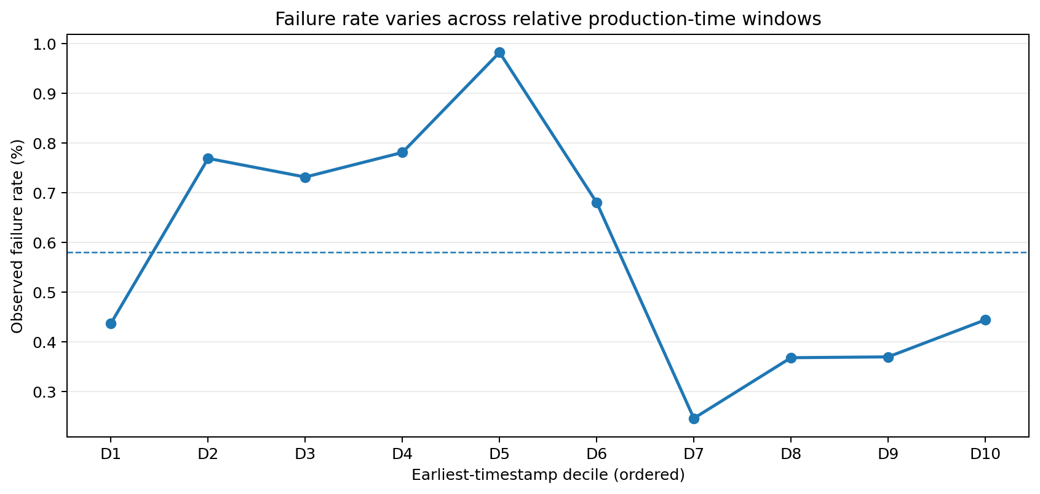
Figure 39.1 — Failure rate by ordered earliest-timestamp decile. The non-monotonic pattern suggests production-window context rather than a simple linear effect.

Engineering interpretation
- Useful as an ordering feature: products produced in similar relative windows may share unobserved conditions.
- Useful in interaction with product family and line-level timestamp features, because the same time window can contain different routes.
- Potentially leakage-prone when future data collection rules differ; a deployment must confirm the value exists at the intended scoring time.
- Non-monotonic failure rates make tree models more appropriate than assuming a single linear relationship.

Validation checks
- Verify that a product with all date values missing receives a missing earliest timestamp rather than an invented zero.
- Confirm train and test use the same feature headers and the same row-wise minimum rule.
- Track the distribution by data window; a large timestamp-range shift can indicate a different production period or extraction convention.
- Use SHAP or partial-dependence analysis only as predictive evidence, not proof that time itself caused failure.

CHAPTER 40

Observed Measurement Span
Representing the distance between the earliest and latest recorded timestamps

Definition
Observed Measurement Span is stored as cycle_time for backward compatibility with the original pipeline, but the reader-facing name is deliberately more conservative. It is calculated as the latest observed timestamp minus the earliest observed timestamp for the same product.
latest = date_values.max(axis=1, skipna=True)
earliest = date_values.min(axis=1, skipna=True)
observed_span = (latest - earliest).astype('float32')

Interpretation boundary: Observed Measurement Span is not verified end-to-end manufacturing cycle time. Parallel operations, sparse timestamps, skipped features, and anonymization can change its physical meaning.

Profile and comparison
Metric | Observed value
Mean span | 10.718
Median span | 3.700
90th percentile | 35.200
99th percentile | 62.950
Maximum | 699.200
Mean, non-failures | 10.700
Mean, failures | 13.914
Correlation with Response | 0.0144

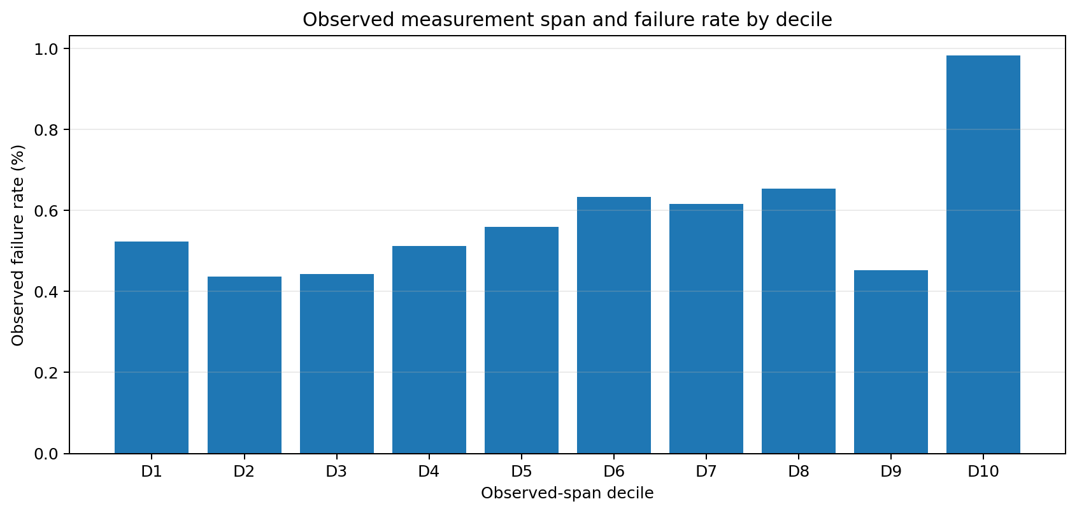
Figure 40.1 — Descriptive failure rates across observed-span deciles. The highest decile contains a materially higher rate but still requires route and product-mix validation.

Why the feature is useful
A longer observed span may reflect a more complex route, a large inter-station gap, a different product family, or a production window with a different timestamp pattern. The feature therefore compresses many raw date columns into one interpretable scalar. It also supports engineered ratios and line-level comparisons.

Related span features
Feature | Meaning in this project
processing_duration | Sum of within-station observed timestamp spans; not verified active processing time.
line_n_processing_duration | Latest minus earliest observed timestamp inside line n.
date_completeness_pct | Share of raw date fields observed; helps distinguish a short span from sparse recording.
delay_ratio | Observed gaps divided by the overall observed span when the span is positive.

Recommended modeling treatment
- Keep the continuous value and allow tree-based models to learn nonlinear cut points.
- Retain missingness explicitly if scoring can occur before any timestamp is recorded.
- Compare distribution stability by product family and route; global drift can hide stable within-family behavior.
- Avoid winsorizing extreme values until the corresponding route and timestamp completeness have been inspected.

CHAPTER 41

Observed Measurement Gaps
Summarizing positive differences between one station’s last timestamp and the next station’s first timestamp

Calculation logic
The pipeline first derives a start and end timestamp for every station. For each product, stations are held in manufacturing order. Positive differences between the next station start and the previous station end are retained; zero or negative differences are ignored. Four summaries are produced: total gap, mean gap, maximum gap, and number of positive gap events.
gaps = station_starts[1:] - station_ends[:-1]
positive = gaps[gaps > 0]
waiting_time = positive.sum()
mean_waiting_time = positive.mean()
max_waiting_time = positive.max()
wait_event_count = len(positive)

Terminology safeguard: The stored names contain “waiting,” but the evidence is only a gap between anonymized timestamps. It may represent queueing, transport, unrecorded operations, sparse measurement, or overlapping process logic.

Observed profile
Feature | Mean | Median | P90 | Failure mean | Corr. with Response
Total observed gap | 10.540 | 3.690 | 33.910 | 13.729 | 0.0146
Mean observed gap | 2.378 | 0.652 | 7.987 | 3.087 | 0.0130
Maximum observed gap | 8.887 | 3.320 | 26.820 | 11.639 | 0.0145
Gap event count | 5.409 | 5.000 | 7.000 | 5.397 | -0.0007
Relative gap ratio | 0.995 | 1.000 | 1.000 | 0.996 | 0.0015

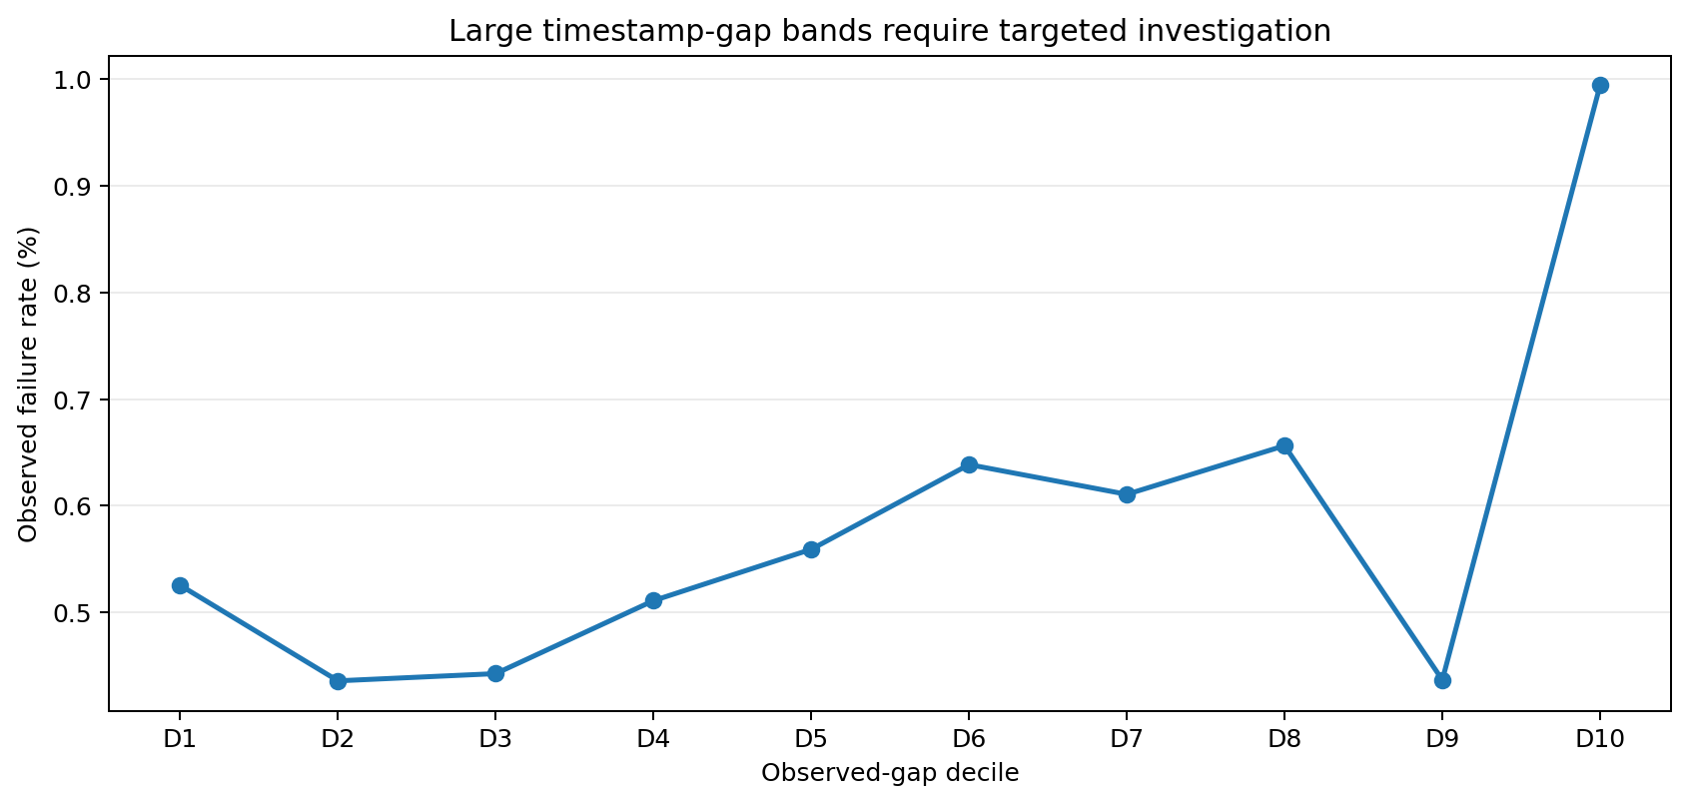
Figure 41.1 — Failure rate across ordered observed-gap bands. The last band deserves investigation but is not by itself causal evidence.

How the four summaries complement one another
Question | Best feature
How much positive gap was recorded overall? | Total observed gap
Were gaps generally large or concentrated in one event? | Mean and maximum observed gap
Did the route contain many separated timestamp intervals? | Gap event count
How dominant were gaps relative to the complete observed span? | Relative gap ratio

Operational use
- Rank products or routes for review when unusually large gaps co-occur with elevated failure probability.
- Compare the same station transition inside different product families before proposing capacity or scheduling changes.
- Validate candidate delays against real event logs, transport records, staffing, maintenance, and process-control history.
- Monitor the gap distribution separately from model performance; an upstream timestamp change can alter the feature without changing the physical process.

CHAPTER 42

Station Count
Compressing sparse station-level observations into a route-length feature

Definition
Station Count is the number of station groups for which at least one date value is present for a product. The raw date schema is first grouped by station key such as L1_S24. A station receives a presence value of one when any of its date columns is non-null; Station Count is the row-wise sum of these binary indicators.
present_station = station_values.notna().any(axis=1).astype('uint8')
station_count = station_presence_matrix.sum(axis=1).astype('int16')

Dataset behavior
Statistic | Value
Mean | 12.15
Median | 13
90th percentile | 14
99th percentile | 16
Mean, failures | 11.73
Mean, non-failures | 12.15
Correlation with Response | -0.0133

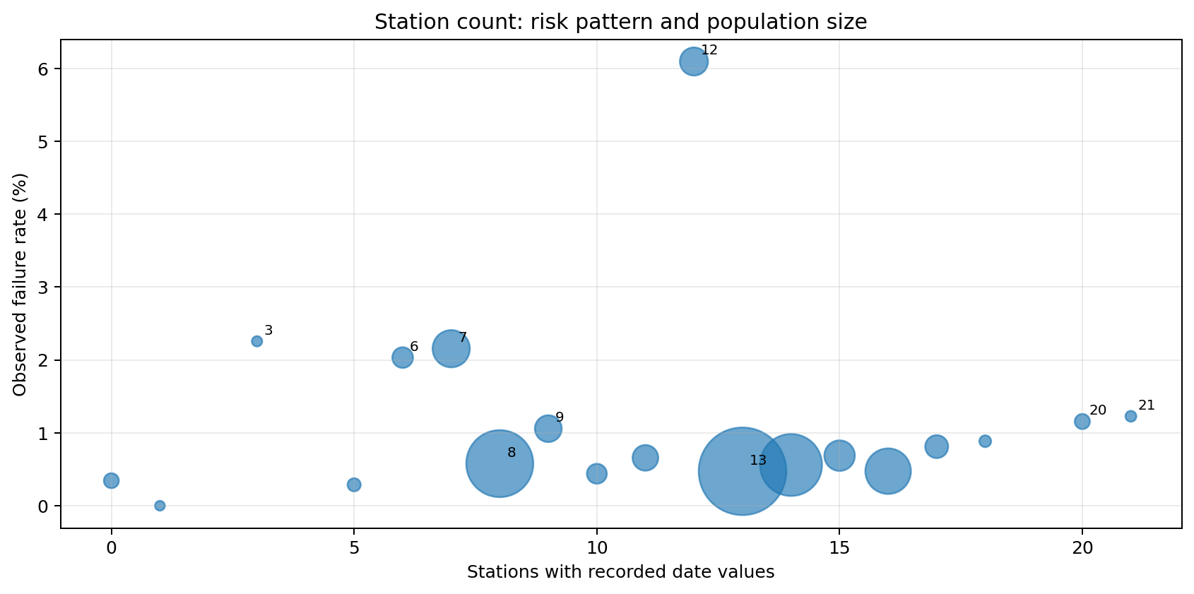
Figure 42.1 — Bubble area represents product count. Small station-count groups can show high rates but require sample-size caution.

Why count is not the same as complexity
Two products can visit the same number of stations but follow completely different lines or branches. Station Count measures route breadth, not route identity. It therefore works best together with line count, first and last station, station span, line switches, path density, and product family.

Quality checks
- A zero count is allowed only when no date feature is observed; the dataset contains a small such group.
- Presence must be derived from date observations consistently in train and test, rather than from the target-bearing numeric file.
- Counts should use integer dtypes to reduce memory and make invalid fractional values impossible.
- Rare count values should not be interpreted through raw failure percentages without confidence intervals or minimum-volume thresholds.

Model role
The feature is directly included in Phase 4 and is also repeated in Phase 5 product-family outputs. In Phase 6, the merged dataset can therefore contain both the original date-derived count and a suffixed family-phase count. The pipeline preserves both only when names are unique and removes accidental duplicate columns before training.

CHAPTER 43

Line Count
Representing how many of the four production lines appear in a product’s observed path

Definition and implementation
For each of the four line groups, the pipeline checks whether any date feature is observed. The binary line-presence flags are summed to create Line Count. The feature ranges from zero to four, although the overwhelming majority of products contain two or three observed lines.
line_present = date_chunk[line_columns].notna().any(axis=1)
line_count += line_present.astype('int8')

Line count | Products | Failures | Failure rate
0 | 582 | 2 | 0.344%
1 | 2,531 | 30 | 1.185%
2 | 823,147 | 4,267 | 0.518%
3 | 355,294 | 2,570 | 0.723%
4 | 2,193 | 10 | 0.456%

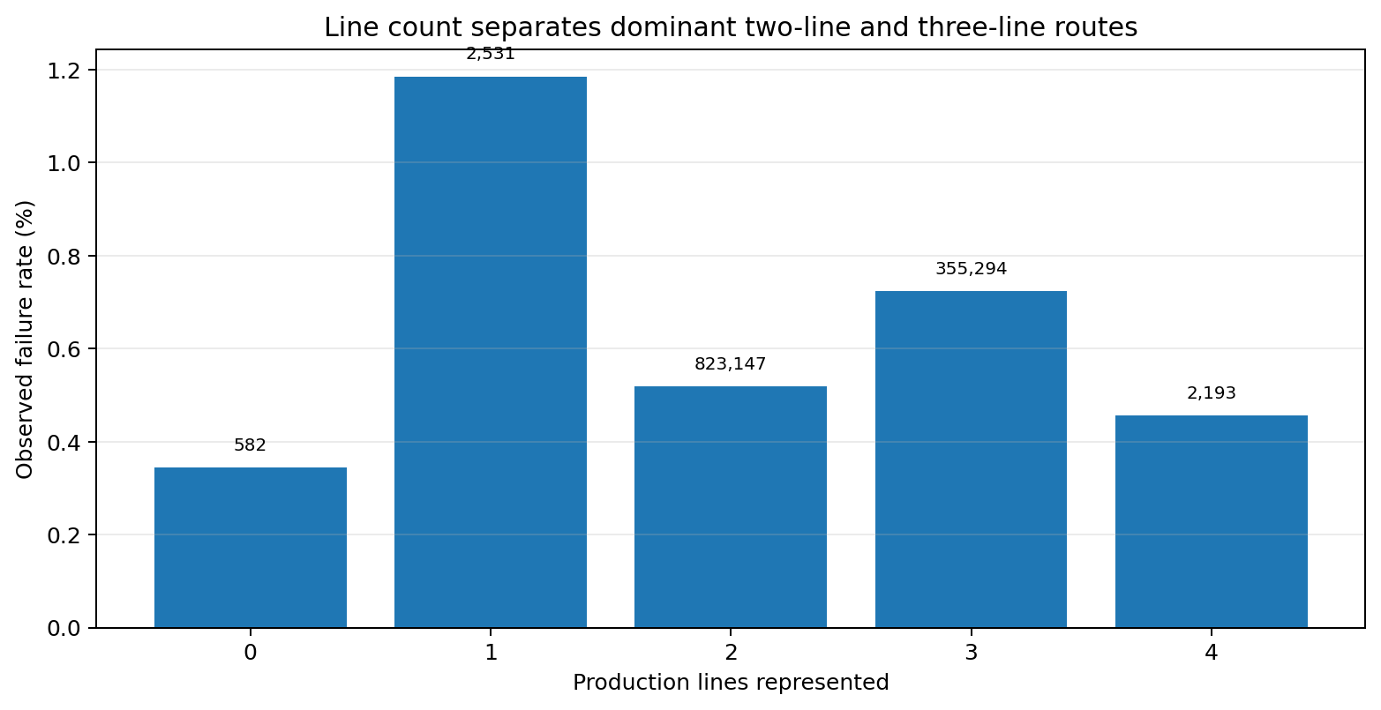
Figure 43.1 — Product count is printed above each bar; percentages are descriptive and not adjusted for product family or route.

Interpretation
- Two-line routes dominate the dataset and have a lower observed failure rate than the large three-line group.
- A higher line count can represent extra routing breadth, but it does not prove rework or inefficiency.
- Line Count is tightly related to line-switch count because products are ordered through line-numbered station groups; both should be checked for redundancy.
- Per-line presence and per-line timestamp features provide the route identity that the count alone cannot provide.

Per-line companion features
Pattern | Created fields
Presence | line_0_present … line_3_present
Temporal anchor | line_n_start_time and line_n_end_time
Observed span | line_n_processing_duration
Measurement density | line_n_observed_date_values and line_n_date_completeness_pct
Route breadth | line_n_station_count

Deployment check
A live scoring system must define when line count is considered complete. Scoring too early can systematically undercount downstream lines and change the meaning of every route-based feature. The production contract should therefore specify the scoring point and reject or label incomplete records when necessary.

CHAPTER 44

Manufacturing Flow
Turning 4,264 anonymized features into a line–station hierarchy and reusable route representation

Structural parsing
Bosch feature names encode manufacturing structure. The pattern L{line}_S{station}_{type}{feature} is parsed into line, station key, data type, and feature identifier. Across the repository this yields 4 production lines, 52 stations, and 4,264 parsed feature columns.
Line | Stations | Numeric | Categorical | Date | Total features
L0 | 24 | 168 | 323 | 184 | 675
L1 | 2 | 513 | 1,227 | 621 | 2,361
L2 | 3 | 42 | 159 | 78 | 279
L3 | 23 | 245 | 431 | 273 | 949

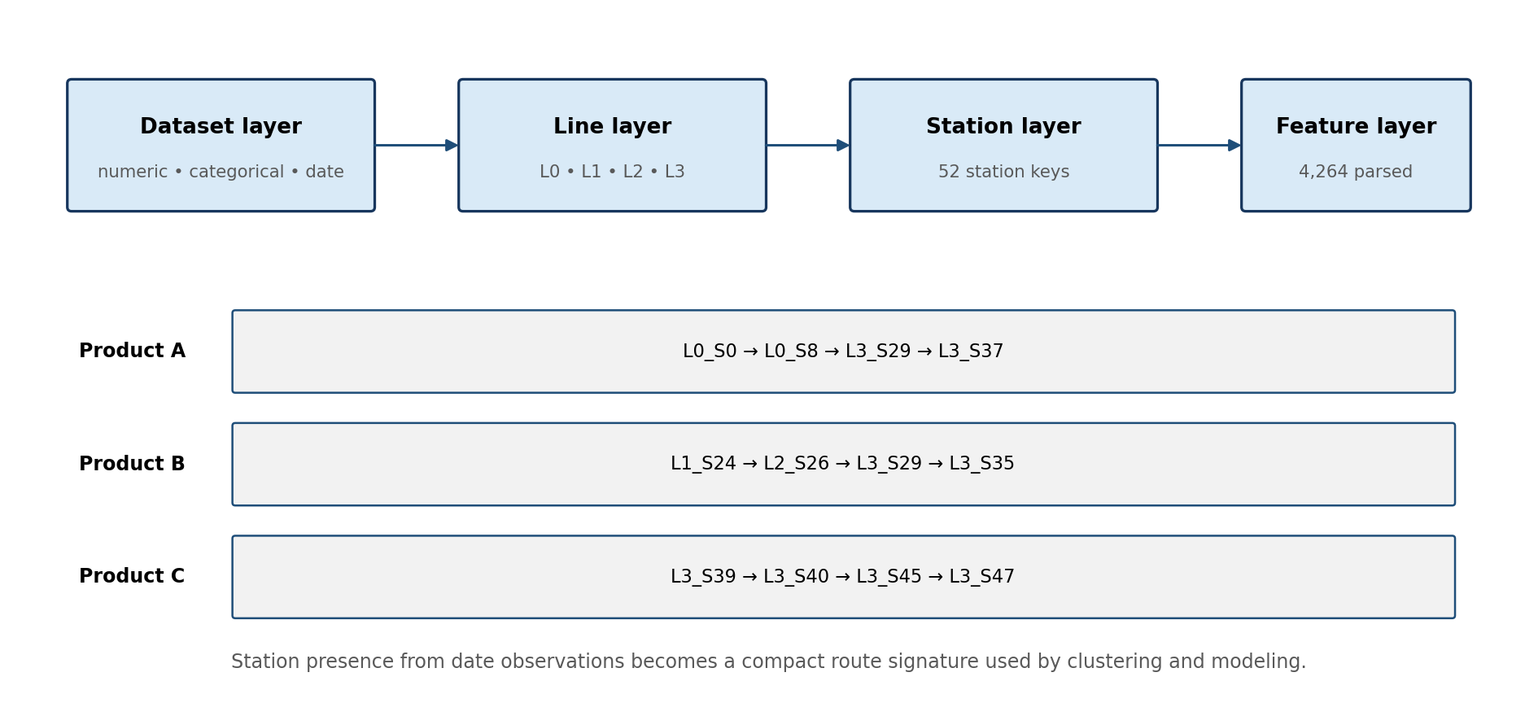
Figure 44.1 — Manufacturing hierarchy and example route signatures constructed from date-derived station presence.

Manufacturing-flow dataset
Phase 2 creates train and test manufacturing-flow Parquet datasets. Station presence is derived from date features because a non-null date indicates that the product appears to have passed through the station. The resulting flow representation is compact, model-independent, and reusable by exploratory analysis, product-family discovery, process mining, and knowledge-graph construction.

Flow representation components
Component | Purpose
Station presence matrix | Binary product × station view used for route comparison and clustering.
Ordered station list | Sequence used to calculate first/last station, switches, and inter-station gaps.
Path signature | Packed binary station-presence pattern used to identify unique routes efficiently.
Line–station metadata | Connects anonymous features to manufacturing structure without requiring real sensor names.
Train/test parity | Ensures the same structural map is applied to both labeled and unlabeled products.

Engineering advantages
- Reduces thousands of sparse columns to a small set of route features while preserving the original hierarchy.
- Supports station-level diagnostics even though the sensor semantics are anonymized.
- Creates a common backbone for clustering, prediction, explainability, process mining, and graph analytics.
- Allows future factory mappings to replace anonymous station labels without rewriting every downstream analytical step.

Limits
Presence indicates that at least one date value is available, not that the station definitely performed a complete physical operation. Missing dates can represent routing, sensor availability, extraction rules, or true absence. Any live implementation should reconcile the inferred route with the manufacturing execution system or event log.

CHAPTER 45

Product Families
Grouping products by station-presence patterns before building family-aware models

Why product families are engineered features
A single global model must learn many distinct manufacturing routes. Phase 5 uses the station-presence matrix to discover route-based product families and adds the final family label to the model dataset. The family becomes a categorical path feature and also supports specialized family-level baseline models.

Clustering workflow
- Convert each product to a binary vector over the 52 stations.
- Pack the vector into a compact hexadecimal path signature so repeated routes can be aggregated.
- Fit MiniBatch KMeans with eight clusters on all train station-presence vectors and predict the same labels for test products.
- Run DBSCAN and hierarchical clustering as diagnostics on unique path patterns.
- Use KMeans as final_product_family because it provides complete, stable train/test assignment without noise labels.
Method | Clusters | Noise rows | Unique paths | Sample silhouette
KMeans | 8 | 0 | 7,927 | 0.191
DBSCAN | 7 | 855 | 7,927 | 0.231
Hierarchical | 8 | 0 | 7,927 | 0.258

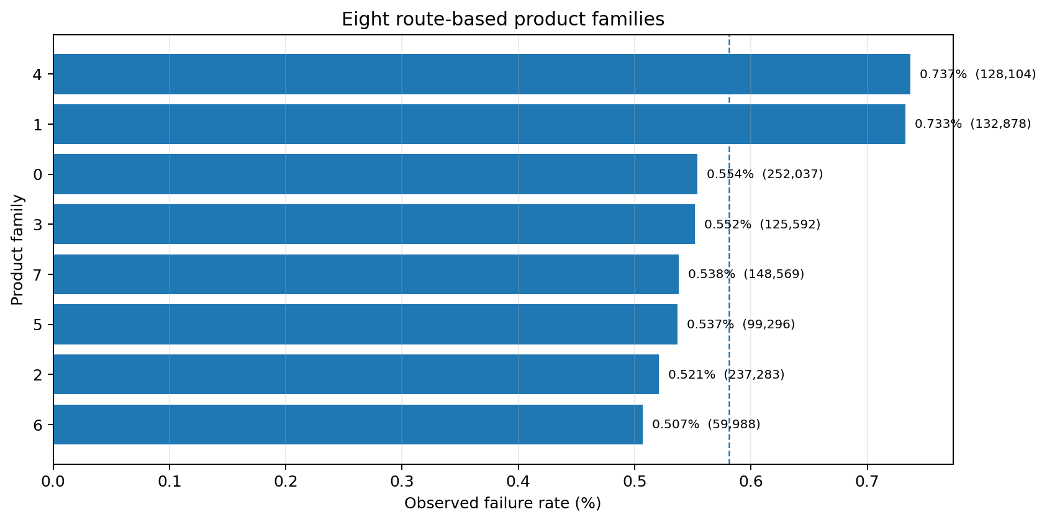
Figure 45.1 — Failure rate and product volume for the eight final route-based product families. Dashed line: overall train failure rate.

Family findings
- Family 4 has the highest observed failure rate at 0.737% across 128,104 products.
- Family 1 is similar at 0.733% and is dominated by a different L3 branch.
- Family 6 has the greatest average station count (15.45) but the lowest observed family failure rate (0.507%).
- The result demonstrates that route identity is more informative than assuming that more stations always mean higher failure risk.

Family-specific models
Family | Rows used | ROC AUC | Average precision
0 | 150,000 | 0.663 | 0.028
1 | 132,878 | 0.725 | 0.133
2 | 150,000 | 0.676 | 0.024
3 | 125,592 | 0.702 | 0.039
4 | 128,104 | 0.758 | 0.115
5 | 99,296 | 0.705 | 0.042
6 | 59,988 | 0.657 | 0.028
7 | 148,569 | 0.695 | 0.037

Leakage control: The family label is learned from route structure, not from Response. Failure rates are used only after clustering to profile risk and train labeled family models.

CHAPTER 46

Path Complexity
Combining route breadth, line transitions, and station density into a compact structural score

Formula
The repository defines Path Complexity Score as a deterministic composite of Station Count, Line Count, Line Switch Count, and Path Density:
Implemented formula: Path Complexity = Station Count + 2 × Line Count + Line Switch Count + (1 − Path Density)

Path Density is Station Count divided by Station Span, where Station Span is the inclusive distance between the first and last observed station numbers. Dense routes receive a smaller sparsity penalty; broad multi-line routes receive higher complexity through station and line terms.

Component definitions
Component | Calculation | Interpretation
Station Count | Number of stations present | Route breadth
Line Count | Number of lines present | Cross-line breadth
Line Switch Count | Adjacent active-line changes | Observed line transitions
Path Density | Station Count ÷ Station Span | How densely the station range is occupied
1 − Path Density | Sparse-span penalty | Branches or skipped station numbers

Observed profile
Statistic | Value
Mean | 18.624
Median | 18.658
90th percentile | 21.692
99th percentile | 23.423
Mean, failures | 18.412
Mean, non-failures | 18.625
Correlation with Response | -0.0078

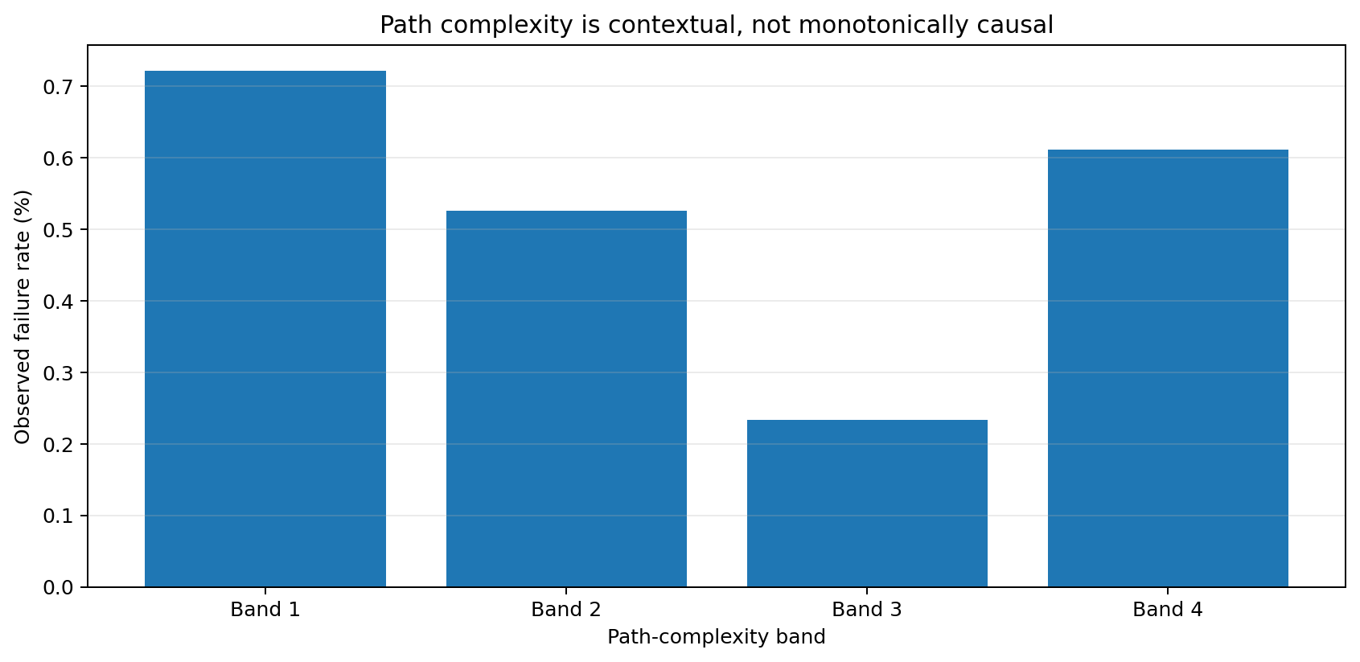
Figure 46.1 — Descriptive failure rates across path-complexity bands. Complexity is not monotonic and should be interpreted jointly with route identity.

Why the score is useful
- Provides a single model feature that summarizes several related route attributes.
- Supports quick segmentation and visual diagnostics without expanding every station presence flag.
- Creates an interpretable cross-feature interaction for tree models.
- Can be recalculated deterministically for test or future data without target information.

Why the score is not sufficient alone
The lower-complexity band contains a higher observed failure rate than some middle bands because it includes specific high-risk route families. A single composite score cannot identify which stations or branches were traversed. The project therefore retains the original components, per-line features, and product-family labels alongside the score.

Integrated feature-engineering checklist
Gate | Required evidence
Schema | Date features parse to the expected line and station hierarchy.
Parity | Train and test receive the same formulas, dtypes, and feature ordering.
Timing | All features are available at the chosen scoring point.
Missingness | Missing timestamps remain distinguishable from valid zeros.
Stability | Distributions are monitored by route and product family.
Interpretation | Timestamp spans/gaps are described as proxies, not verified physical times.
Governance | Feature changes are versioned and revalidated before model promotion.

Part V Summary
The feature-engineering layer converts an extremely sparse, anonymized manufacturing dataset into a compact representation of temporal position, observed timestamp span, inter-station gaps, route breadth, production-line coverage, flow structure, route families, and path complexity. These features form the bridge between raw data understanding and predictive failure modeling.
Feature group | Primary value | Main safeguard
Temporal anchor | Captures relative production windows | Not an official start time
Observed span | Compresses first-to-last timestamp distance | Not verified cycle time
Observed gaps | Summarizes positive inter-station timestamp gaps | Not confirmed waiting or delay
Station and line counts | Represent route breadth | Do not encode route identity alone
Manufacturing flow | Creates reusable line–station structure | Presence is inferred from date availability
Product families | Encodes recurring route patterns | Cluster without target leakage
Path complexity | Summarizes breadth, switching, and density | Retain original components and family labels

Repository traceability
Topic | Primary repository artifact
Feature calculations | src/data/phase4_feature_engineering.py
Feature dictionary and summary | reports/phase4_feature_dictionary.csv; reports/phase4_engineered_feature_summary.csv
Manufacturing metadata and flow | src/data/phase2_data_understanding_engineering.py; data/processed/manufacturing_flow_*.parquet
Product-family discovery | src/data/phase5_product_family_discovery.py
Family profiles and diagnostics | reports/phase5_product_family_*.csv; reports/phase5_cluster_diagnostics.csv
Model integration | src/data/phase6_predictive_failure_modeling.py

Terminology note
The source code retains historical variable names such as start_time, cycle_time, waiting_time, and processing_duration. This handbook uses reader-facing labels that better match the evidence available from the public data. Renaming the stored model inputs would break existing artifacts, so the safer practice is to preserve technical keys while improving documentation and dashboard labels.

