Manufacturing Failure Prediction, Root-Cause Analytics, and Decision Intelligence for Bosch Production-Line Data
IEEE-style full technical research paper
Generated: 2026-07-08 11:31

Abstract
This paper presents an end-to-end manufacturing analytics system developed from the Bosch Production Line Performance dataset. The production-safe LightGBM classifier achieved MCC=0.339, precision=0.574, recall=0.213, F1=0.311, and PR-AUC=0.253. The project identifies station L3_S32 as the highest observed risk station, station L1_S25 as the top bottleneck, and station L1_S24 as the highest-ranked knowledge-graph critical node. The system is packaged as scripts, notebooks, models, SQLite tables, Streamlit applications, documentation, and presentation artifacts.

1. Introduction
Manufacturing quality analytics requires more than a classifier. It requires station context, route context, model interpretation, process constraints, and decision interfaces that can be used by engineers and executives. This project builds a reusable architecture from the Bosch production-line data while preserving a distinction between competition-style modeling and production-safe deployment logic.

2. Research Objectives
The research objective is to determine whether raw numeric, categorical, and date-derived manufacturing data can be converted into a complete quality-intelligence system. The implemented system covers setup, metadata parsing, EDA, feature engineering, segmentation, predictive modeling, SHAP analysis, process mining, knowledge graph construction, advanced AI diagnostics, copilot querying, executive monitoring, and final documentation.

3. Dataset and Scope
The labeled train population contains 1,183,747 products and 6,879 failures, for a historical failure rate of 0.581%. The validation set contains 56,720 products and 1,720 failures. The test population contains 1,183,748 products, and the selected threshold generated 6,998 predicted alerts. Test labels are unavailable, so test predictions are operational scores rather than measured outcomes.

4. Data Quality and Metadata Engineering
Feature names were parsed into line, station, and feature identifiers. Missingness was treated as manufacturing information rather than purely as data error because missing values can represent skipped operations, routing alternatives, or sensor availability. The metadata layer supports station-level aggregation, line-level reporting, station presence matrices, and downstream graph construction.

5. Exploratory Data Analysis
EDA showed that failure risk is sparse but concentrated. Station L3_S32 had 4.506% failure rate and 7.75x lift over the overall rate. Relative production-time trend analysis was used instead of calendar-seasonality analysis because Bosch timestamps are relative process times.

6. Feature Engineering
The project engineered start time, end time, cycle time, processing duration, waiting time, mean waiting time, maximum waiting time, delay ratio, station count, line count, station span, path density, line-switch count, and product path complexity. These features preserve operational meaning and support both predictive modeling and process-mining interpretation.

7. Product Family Discovery
Station-presence matrices were clustered with KMeans, DBSCAN, and hierarchical clustering. The final segmentation produced eight product families. Family 4 had the highest observed failure rate at 0.737% and 1.27x lift. This supports route-aware monitoring and product-mix analysis.

Product family failure rates
final_product_family | part_count | failure_count | failure_rate_pct | failure_lift_vs_overall | avg_station_count | avg_line_count | top_stations
4 | 128104 | 944 | 0.7369 | 1.2681 | 7.9195 | 2.9045 | L3_S35:100.0%, L3_S37:99.9%, L3_S30:99.8%, L3_S33:99.5%, L3_S34:99.5%, L3_S29:99.4%, L1_S24:68.3%, L2_S26:64.4%
1 | 132878 | 974 | 0.7330 | 1.2614 | 7.8690 | 2.8900 | L3_S36:99.3%, L3_S37:99.3%, L3_S30:99.2%, L3_S33:98.8%, L3_S34:98.8%, L3_S29:98.8%, L1_S24:67.9%, L2_S26:64.0%
0 | 252037 | 1396 | 0.5539 | 0.9531 | 13.2136 | 2.1469 | L0_S8:99.9%, L0_S1:99.9%, L0_S0:99.9%, L3_S29:99.8%, L3_S37:99.7%, L3_S30:99.7%, L3_S34:99.2%, L3_S33:99.2%
3 | 125592 | 693 | 0.5518 | 0.9495 | 13.1853 | 2.0933 | L0_S20:100.0%, L0_S13:100.0%, L0_S12:100.0%, L3_S29:99.8%, L3_S37:99.7%, L3_S30:99.7%, L3_S34:99.3%, L3_S33:99.2%
7 | 148569 | 799 | 0.5378 | 0.9254 | 13.2117 | 2.1441 | L0_S0:99.9%, L0_S1:99.9%, L0_S8:99.9%, L3_S29:99.7%, L3_S37:99.7%, L3_S30:99.6%, L3_S34:99.2%, L3_S33:99.1%
5 | 99296 | 533 | 0.5368 | 0.9237 | 13.1855 | 2.0942 | L0_S20:100.0%, L0_S13:100.0%, L0_S12:100.0%, L3_S29:99.7%, L3_S37:99.7%, L3_S30:99.6%, L3_S34:99.2%, L3_S33:99.1%
2 | 237283 | 1236 | 0.5209 | 0.8964 | 13.2187 | 2.1454 | L0_S1:99.9%, L0_S8:99.9%, L3_S29:99.9%, L0_S0:99.9%, L3_S37:99.8%, L3_S30:99.8%, L3_S34:99.4%, L3_S33:99.3%
6 | 59988 | 304 | 0.5068 | 0.8721 | 15.4540 | 2.1309 | L3_S47:99.9%, L3_S45:99.9%, L3_S48:99.9%, L3_S40:99.9%, L3_S41:99.9%, L3_S39:99.9%, L3_S51:99.8%, L0_S1:60.8%
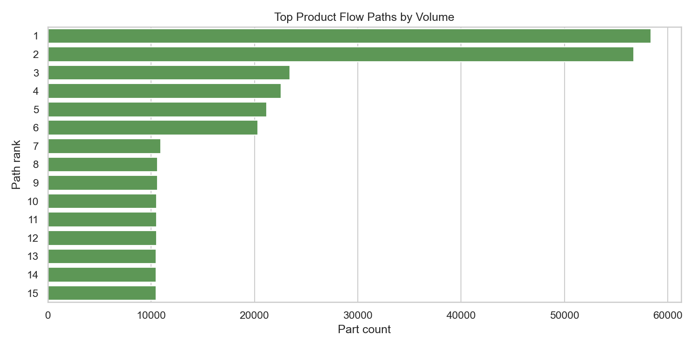
Figure. Product-flow path concentration.

8. Predictive Failure Modeling
Logistic Regression, Random Forest, XGBoost, LightGBM, and CatBoost were compared. LightGBM was selected as the production-safe model with MCC=0.339, precision=0.574, recall=0.213, F1=0.311, and PR-AUC=0.253. The selected threshold is 0.785083.

Model comparison metrics
model | threshold | mcc | precision | recall | f1 | pr_auc | rank
LightGBM | 0.7851 | 0.3386 | 0.5743 | 0.2134 | 0.3111 | 0.2529 | 1
XGBoost | 0.7479 | 0.3359 | 0.5674 | 0.2128 | 0.3095 | 0.2469 | 2
CatBoost | 0.7970 | 0.3279 | 0.5571 | 0.2070 | 0.3018 | 0.2261 | 3
Random Forest | 0.6743 | 0.3250 | 0.5524 | 0.2052 | 0.2993 | 0.2390 | 4
Logistic Regression | 0.8973 | 0.3045 | 0.5196 | 0.1930 | 0.2815 | 0.1650 | 5
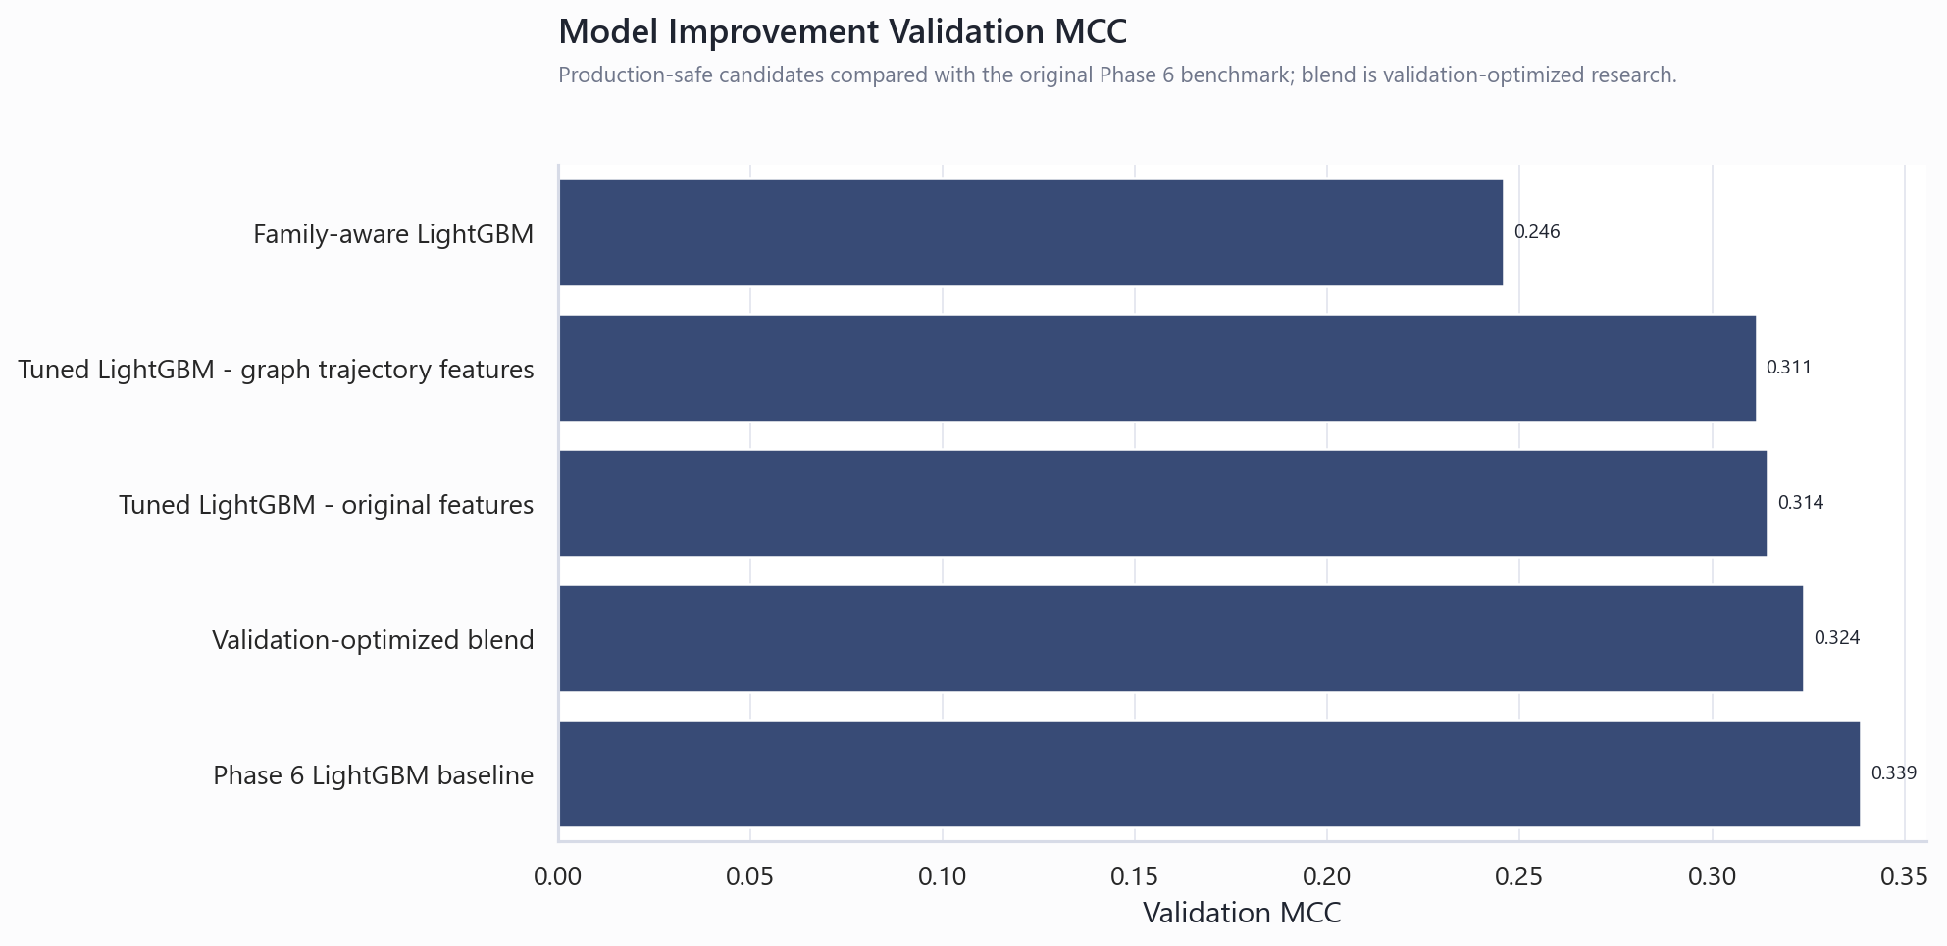
Figure. Production-safe model and improvement comparison.

9. Improvement Experiments and Negative Results
Additional experiments included tuned LightGBM, graph and trajectory features, family-aware models, and a validation-optimized blend. None outperformed the original Phase 6 LightGBM baseline under production-safe evaluation. This negative result is important because it prevents unnecessary complexity from being promoted into the official system.

10. Root-Cause Analysis
SHAP and feature importance identified timing features, line timing signals, station measurements, and missingness indicators as key model drivers. SHAP explains model behavior, not physical causality. The station-level root-cause report converts model signals into engineering review actions such as inspecting queue behavior, skipped measurements, sensor availability, tooling condition, and calibration records.

Top SHAP drivers
feature | mean_abs_shap | mean_signed_shap | line | station | feature_family | model_importance | driver_rank | driver_type
start_time | 0.1970 | -0.0039 | timing | timing_level | timing | 512.0000 | 1 | Timing or delay signal
line_0_start_time | 0.1145 | 0.0110 | L0 | line_level | line_timing | 385.0000 | 2 | Line-level timing signal
line_3_end_time | 0.0947 | -0.0040 | L3 | line_level | line_timing | 88.0000 | 3 | Line-level timing signal
line_3_start_time | 0.0829 | -0.0271 | L3 | line_level | line_timing | 264.0000 | 4 | Line-level timing signal
end_time | 0.0763 | 0.0129 | timing | timing_level | timing | 474.0000 | 5 | Timing or delay signal
L3_S32_F3850__is_missing | 0.0656 | -0.0155 | L3 | L3_S32 | raw_measurement_missingness | 111.0000 | 6 | Missingness / skipped measurement signal
mean_waiting_time | 0.0478 | -0.0208 | timing | timing_level | timing | 875.0000 | 7 | Timing or delay signal
line_0_end_time | 0.0461 | -0.0131 | L0 | line_level | line_timing | 184.0000 | 8 | Line-level timing signal
max_waiting_time | 0.0438 | 0.0178 | timing | timing_level | timing | 772.0000 | 9 | Timing or delay signal
cycle_time | 0.0432 | -0.0021 | timing | timing_level | timing | 732.0000 | 10 | Timing or delay signal
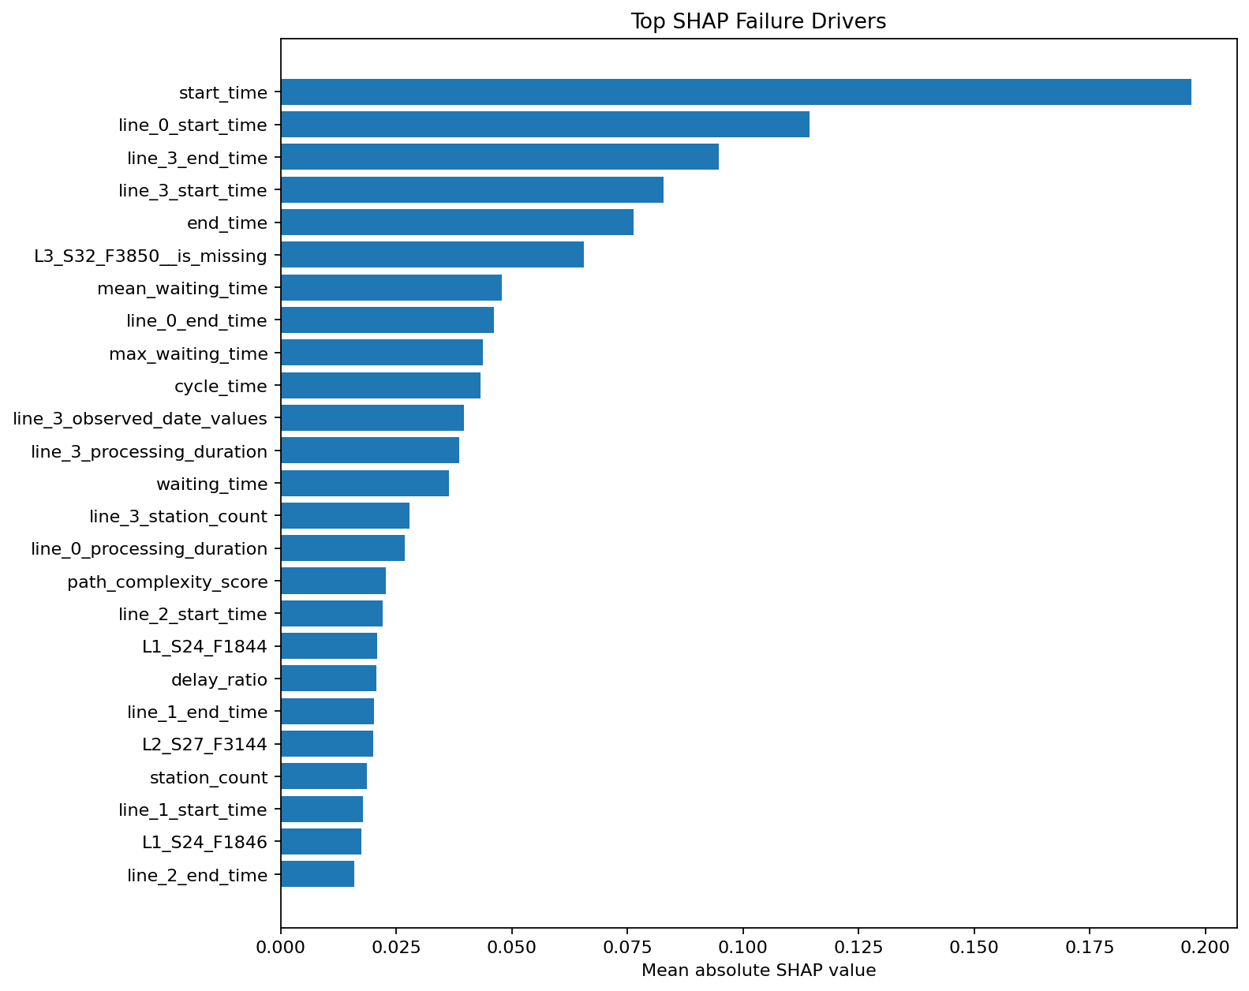
Figure. Top global SHAP drivers.

11. Process Mining and Bottleneck Analysis
Process mining reconstructed station transitions from raw date features. Station L1_S25 ranked as the top bottleneck with score 88.34, average waiting time 30.31, and p90 waiting time 36.50. Throughput efficiency is treated as a relative timestamp-derived proxy, not OEE.

Top bottlenecks
station | product_count | avg_dwell | p90_dwell | avg_waiting_time | p90_waiting_time | positive_wait_rate | failure_count | labeled_count | failure_rate_pct | failure_lift | bottleneck_score | bottleneck_rank
L1_S25 | 167220 | 2.2360 | 8.6487 | 30.3054 | 36.4951 | 0.9993 | 424.0000 | 83658.0000 | 0.5068 | 0.9033 | 88.3371 | 1
L1_S24 | 366583 | 0.0970 | 0.0630 | 23.2534 | 41.0135 | 0.9942 | 1521.0000 | 183727.0000 | 0.8279 | 1.4754 | 74.3720 | 2
L3_S38 | 54175 | 0.0000 | 0.0000 | 22.4587 | 32.7650 | 1.0000 | 212.0000 | 27142.0000 | 0.7811 | 1.3920 | 70.6311 | 3
L0_S13 | 484481 | 0.0000 | 0.0000 | 18.2520 | 31.5788 | 0.2472 | 1323.0000 | 242065.0000 | 0.5465 | 0.9741 | 58.9562 | 4
L2_S28 | 19153 | 0.0000 | 0.0000 | 7.8845 | 13.4357 | 0.9979 | 67.0000 | 9583.0000 | 0.6992 | 1.2460 | 57.2127 | 5
L2_S27 | 240285 | 0.0000 | 0.0000 | 6.2710 | 12.2277 | 0.9985 | 822.0000 | 120729.0000 | 0.6809 | 1.2134 | 57.1323 | 6
L2_S26 | 454344 | 0.0000 | 0.0000 | 5.4932 | 9.8604 | 0.9991 | 1695.0000 | 227011.0000 | 0.7467 | 1.3307 | 55.5054 | 7
L0_S12 | 484476 | 0.0000 | 0.0000 | 21.7767 | 28.6266 | 0.0020 | 1323.0000 | 242061.0000 | 0.5466 | 0.9741 | 55.4933 | 8
L3_S29 | 2239066 | 0.0000 | 0.0000 | 5.7875 | 9.2511 | 0.8785 | 6546.0000 | 1119629.0000 | 0.5847 | 1.0420 | 54.2751 | 9
L3_S39 | 120019 | 0.0000 | 0.0000 | 6.1715 | 8.5118 | 0.8872 | 303.0000 | 59908.0000 | 0.5058 | 0.9014 | 51.8482 | 10
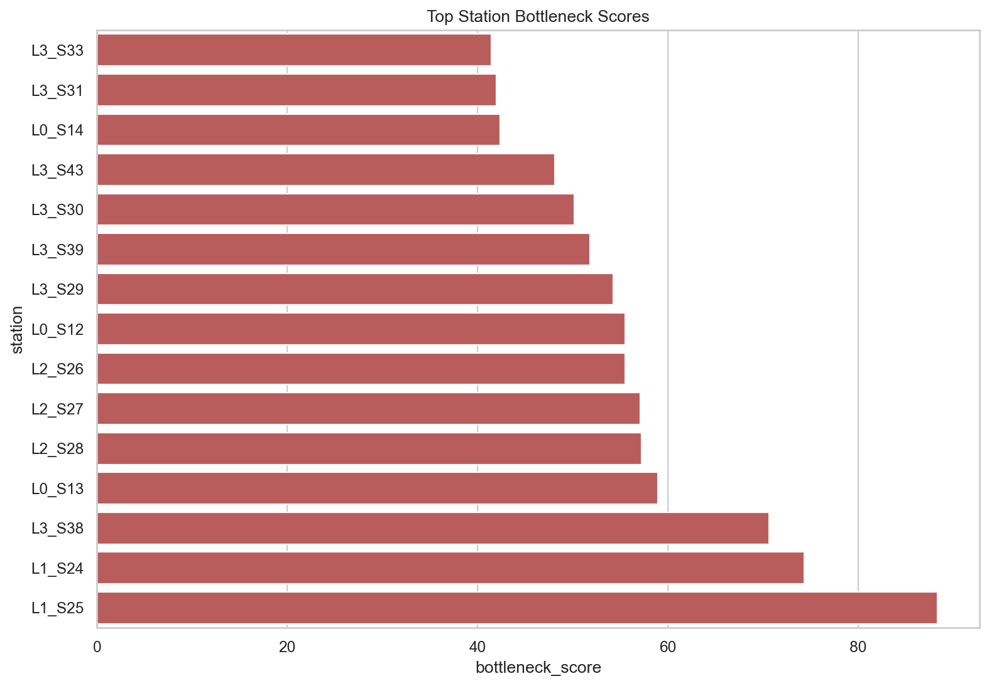
Figure. Bottleneck score ranking.

12. Knowledge Graph
The manufacturing knowledge graph contains 4,321 nodes and 4,923 edges. It links lines, stations, features, process relationships, and failure evidence. Station L1_S24 ranked as the top critical node with score 60.08. Candidate propagation routes are monitoring hypotheses, not proof of causal propagation.

Critical knowledge-graph nodes
station | in_degree_centrality | out_degree_centrality | weighted_inflow | weighted_outflow | pagerank | betweenness_centrality | closeness_centrality | product_count | avg_dwell | p90_dwell | avg_waiting_time | p90_waiting_time | positive_wait_rate | failure_count | labeled_count | failure_rate_pct | failure_lift | bottleneck_score | bottleneck_rank | station_shap_importance | centrality_score | critical_node_score | critical_rank | line
L1_S24 | 0.1961 | 0.3333 | 5833.0000 | 366579.0000 | 0.0031 | 0.0008 | 1.4784 | 366583 | 0.0970 | 0.0630 | 23.2534 | 41.0135 | 0.9942 | 1521.0000 | 183727.0000 | 0.8279 | 1.4754 | 74.3720 | 2 | 0.2618 | 0.0914 | 60.0837 | 1 | L1
L3_S29 | 0.4902 | 0.1765 | 2237105.0000 | 2239065.0000 | 0.0529 | 0.0561 | 3.4607 | 2239066 | 0.0000 | 0.0000 | 5.7875 | 9.2511 | 0.8785 | 6546.0000 | 1119629.0000 | 0.5847 | 1.0420 | 54.2751 | 9 | 0.0000 | 0.6401 | 52.9543 | 2 | L3
L3_S32 | 0.1961 | 0.1176 | 48678.0000 | 47205.0000 | 0.0041 | 0.0000 | 2.7596 | 48678 | 0.0000 | 0.0000 | 1.2056 | 1.2208 | 0.7954 | 1106.0000 | 24543.0000 | 4.5064 | 8.0313 | 40.1792 | 16 | 0.0680 | 0.1267 | 50.8970 | 3 | L3
L3_S30 | 0.4118 | 0.1569 | 2237113.0000 | 2239366.0000 | 0.0475 | 0.0259 | 2.7629 | 2239366 | 0.0000 | 0.0000 | 6.8875 | 8.8900 | 0.5652 | 6551.0000 | 1119811.0000 | 0.5850 | 1.0426 | 50.1608 | 11 | 0.0000 | 0.5021 | 47.3429 | 4 | L3
L3_S34 | 0.2353 | 0.1176 | 2230053.0000 | 2207703.0000 | 0.0940 | 0.0016 | 3.2147 | 2230053 | 0.0000 | 0.0000 | 2.4692 | 2.4803 | 0.3855 | 5718.0000 | 1115118.0000 | 0.5128 | 0.9139 | 34.1502 | 21 | 0.0000 | 0.6117 | 46.0180 | 5 | L3
L3_S33 | 0.2353 | 0.1176 | 2229189.0000 | 2093661.0000 | 0.0680 | 0.0004 | 3.1510 | 2229189 | 0.0000 | 0.0000 | 4.5434 | 4.5440 | 0.4437 | 5546.0000 | 1114695.0000 | 0.4975 | 0.8867 | 41.4470 | 15 | 0.0000 | 0.5066 | 44.6273 | 6 | L3
L3_S39 | 0.4314 | 0.1569 | 119768.0000 | 120019.0000 | 0.0068 | 0.1192 | 2.9603 | 120019 | 0.0000 | 0.0000 | 6.1715 | 8.5118 | 0.8872 | 303.0000 | 59908.0000 | 0.5058 | 0.9014 | 51.8482 | 10 | 0.0000 | 0.4996 | 44.2361 | 7 | L3
L1_S25 | 0.2157 | 0.2549 | 1333.0000 | 167220.0000 | 0.0030 | 0.0000 | 1.3183 | 167220 | 2.2360 | 8.6487 | 30.3054 | 36.4951 | 0.9993 | 424.0000 | 83658.0000 | 0.5068 | 0.9033 | 88.3371 | 1 | 0.0227 | 0.0684 | 42.7627 | 8 | L1
L3_S37 | 0.1961 | 0.1176 | 2240647.0000 | 1022189.0000 | 0.1026 | 0.0024 | 3.0802 | 2240660 | 0.0000 | 0.0000 | 0.7739 | 0.7769 | 0.5079 | 6556.0000 | 1120394.0000 | 0.5852 | 1.0429 | 26.8599 | 25 | 0.0000 | 0.5589 | 42.5794 | 9 | L3
L0_S13 | 0.1176 | 0.1765 | 484476.0000 | 484481.0000 | 0.0086 | 0.0494 | 1.0088 | 484481 | 0.0000 | 0.0000 | 18.2520 | 31.5788 | 0.2472 | 1323.0000 | 242065.0000 | 0.5465 | 0.9741 | 58.9562 | 4 | 0.0000 | 0.2411 | 39.5984 | 10 | L0
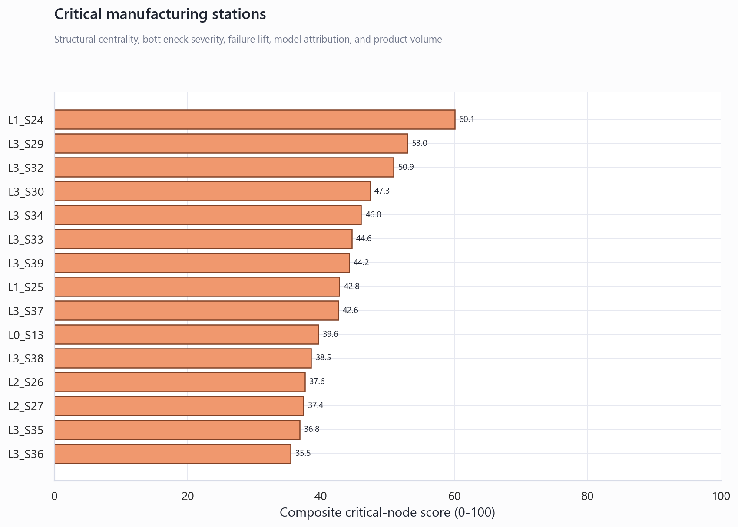
Figure. Critical graph nodes.

13. Advanced AI Experiments
Isolation Forest, MLP reconstruction anomaly detection, graph message-passing risk, and failure trajectory prediction were tested. Failure trajectory prediction was the best advanced diagnostic model but remained below the Phase 6 LightGBM reference. The advanced models are retained as supplementary diagnostic signals.

Advanced AI comparison
model | threshold | mcc | precision | recall | f1 | pr_auc | notes
Phase 6 LightGBM reference | 0.7851 | 0.3386 | 0.5743 | 0.2134 | 0.3111 | 0.2529 | Production-safe supervised benchmark from Phase 6.
Failure trajectory prediction | 0.9897 | 0.2419 | 0.4615 | 0.1395 | 0.2143 | 0.1648 | LightGBM model using timing, path, family, and ordered station-risk exposure.
MLP reconstruction anomaly detection | 4.3655 | 0.0923 | 0.2535 | 0.0419 | 0.0719 | 0.0643 | Scikit-learn reconstruction model using 120 selected features.
Graph message-passing risk model | 0.5287 | 0.0611 | 0.0534 | 0.3017 | 0.0907 | 0.0411 | Logistic model using graph-propagated station risk exposure.
Isolation Forest anomaly detection | -0.1217 | 0.0537 | 0.0445 | 0.4349 | 0.0808 | 0.0395 | Unsupervised model trained on normal products only.
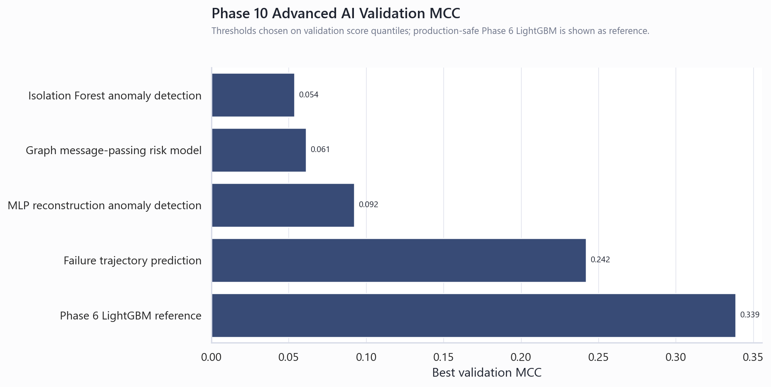
Figure. Advanced AI MCC comparison.

14. Leaderboard Research Excluded from Production
Competition-style nearby-label and row-order features were tested separately. These features can create high validation scores but rely on information that would not be available for live future products. Therefore leaderboard leakage work is documented as research-only and excluded from the production-safe model, root-cause analysis, dashboards, and copilot.

15. Manufacturing Copilot
The Phase 11 SQLite database stores 1,240,468 product prediction rows and reviewed tables for model metrics, root causes, failure rates, bottlenecks, critical nodes, propagation routes, and advanced diagnostics. The copilot uses deterministic intent mapping and parameterized SQL for auditable natural-language answers.

16. Executive and Unified Dashboards
The executive dashboard provides KPI scorecards, failure trends, station heatmaps, bottleneck analytics, SHAP explanations, and scenario-based business impact. The unified project dashboard consolidates KPIs, models, segmentation, process mining, root cause, knowledge graph, copilot, business impact, and final deliverables in one Streamlit application.

17. Business Impact Scenario
Business impact is calculated from production volume, historical failure rate, alert rate, validation precision, cost per failure, review cost, and intervention effectiveness. The result is an illustrative planning scenario, not observed savings. This avoids presenting financial value that the dataset cannot support.

18. Validation and Robustness
Validation included model metric checks, script compilation, notebook JSON checks, SQLite integrity checks, Streamlit page tests, HTTP server checks, Word and PowerPoint open checks, and artifact manifest checks. The production-safe boundary excludes future-label leakage and validation-selected blends.

19. Limitations
Limitations include missing test labels, relative timestamps, absent plant financial records, absent maintenance and operator logs, no causal confirmation from SHAP, and no live deployment feedback. A real client deployment requires forward-time validation, data contracts, monitoring, access control, and workflow integration.

20. Recommendations
Future client work should replace Kaggle files with governed plant sources, define stable event schemas, validate with forward-time splits, calibrate thresholds against inspection capacity, connect alerts to engineering workflows, and monitor drift, alert precision, recall, and intervention effectiveness.

21. Conclusion
The project demonstrates a complete manufacturing analytics architecture. The value is not only the LightGBM classifier, but also the surrounding segmentation, process mining, root-cause, knowledge-graph, copilot, dashboard, and documentation layers that make the system usable for future manufacturing engagements.

Appendix A. Phase-by-Phase Artifact Summary
The project produced phase reports, notebooks, processed datasets, models, SHAP outputs, process maps, graph files, SQLite tables, Streamlit applications, final documentation, a presentation deck, and a unified dashboard. These artifacts provide reproducibility and auditability across the full roadmap.

Appendix B. Supplemental Work Not Used as Production Inputs
Completed but non-production inputs include leaderboard leakage modeling, validation-optimized blending, family-aware model variants, advanced AI anomaly models, graph message-passing risk, trajectory-risk scoring, and business-impact scenario estimates. These are documented for learning and future research but excluded from official deployment logic.

Appendix C. References
References include the Bosch Kaggle dataset, LightGBM, XGBoost, CatBoost, SHAP, Random Forests, process mining, network analysis, scikit-learn, Streamlit, Plotly, and internal project artifacts covering leaderboard research, model improvement, advanced AI, root-cause analysis, process mining, knowledge graph, copilot, executive dashboard, and final deliverable manifests.

