Manufacturing Failure Prediction and Process Intelligence for Bosch Production-Line Data
IEEE-style technical research report

Abstract
This report documents an end-to-end manufacturing analytics system for the Bosch Production Line Performance dataset. The system includes failure prediction, product-family segmentation, process mining, root-cause analysis, knowledge-graph analytics, advanced AI diagnostics, a manufacturing copilot, and an executive dashboard.
The selected production-safe model is LightGBM, with validation MCC=0.339, precision=0.574, recall=0.213, F1=0.311, and PR-AUC=0.253.
Keywords: manufacturing analytics, failure prediction, process mining, root-cause analysis, knowledge graph, SHAP, LightGBM.

I. Introduction
The objective is to move beyond a competition classifier and create a reusable manufacturing intelligence system that predicts failures, explains likely drivers, maps product flow, and supports executive decision-making.

II. Dataset and Scope
- Labeled train products: 1,183,747
- Train failures: 6,879
- Historical failure rate: 0.581%
- Test products scored: 1,183,748
- Validation rows: 56,720

III. Methodology
- Feature names were parsed into production line, station, and feature identifiers.
- Timing, waiting, cycle-time, station-count, path-complexity, and line-level aggregate features were engineered.
- Product families were discovered from station-presence patterns using clustering methods.
- Failure models were benchmarked across logistic regression, random forest, XGBoost, LightGBM, and CatBoost.
- Root-cause diagnostics were produced from feature importance and SHAP explanations.
- Process mining reconstructed station transitions, bottlenecks, critical paths, and throughput proxies.
- A knowledge graph linked lines, stations, features, and failure evidence.
- A SQLite-backed copilot and Streamlit dashboards operationalized the outputs.

IV. Results
The official production-safe model remains LightGBM. It achieved MCC=0.339, precision=0.574, recall=0.213, F1=0.311, and PR-AUC=0.253.
The highest-risk station is L3_S32 with 4.506% failure rate. The highest-risk product family is family 4 with 0.737% failure rate.
L1_S25 is the top bottleneck, while L1_S24 is the highest-ranked critical knowledge-graph node.
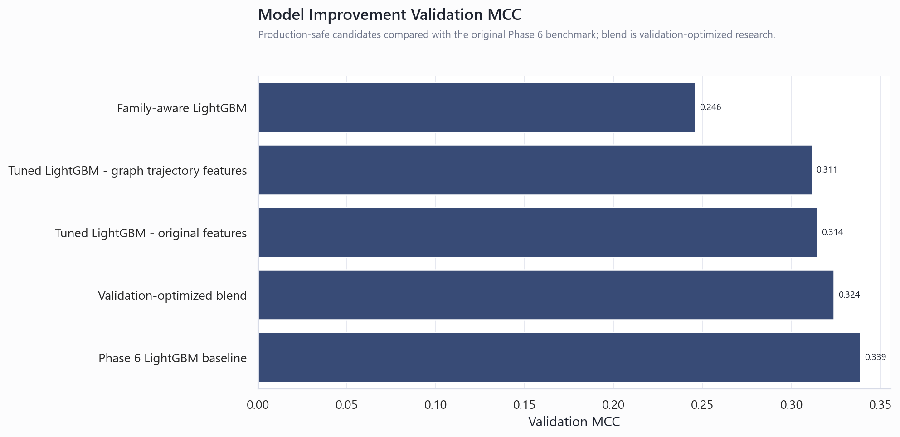
Fig. 1. Production-safe model comparison and improvement experiments.
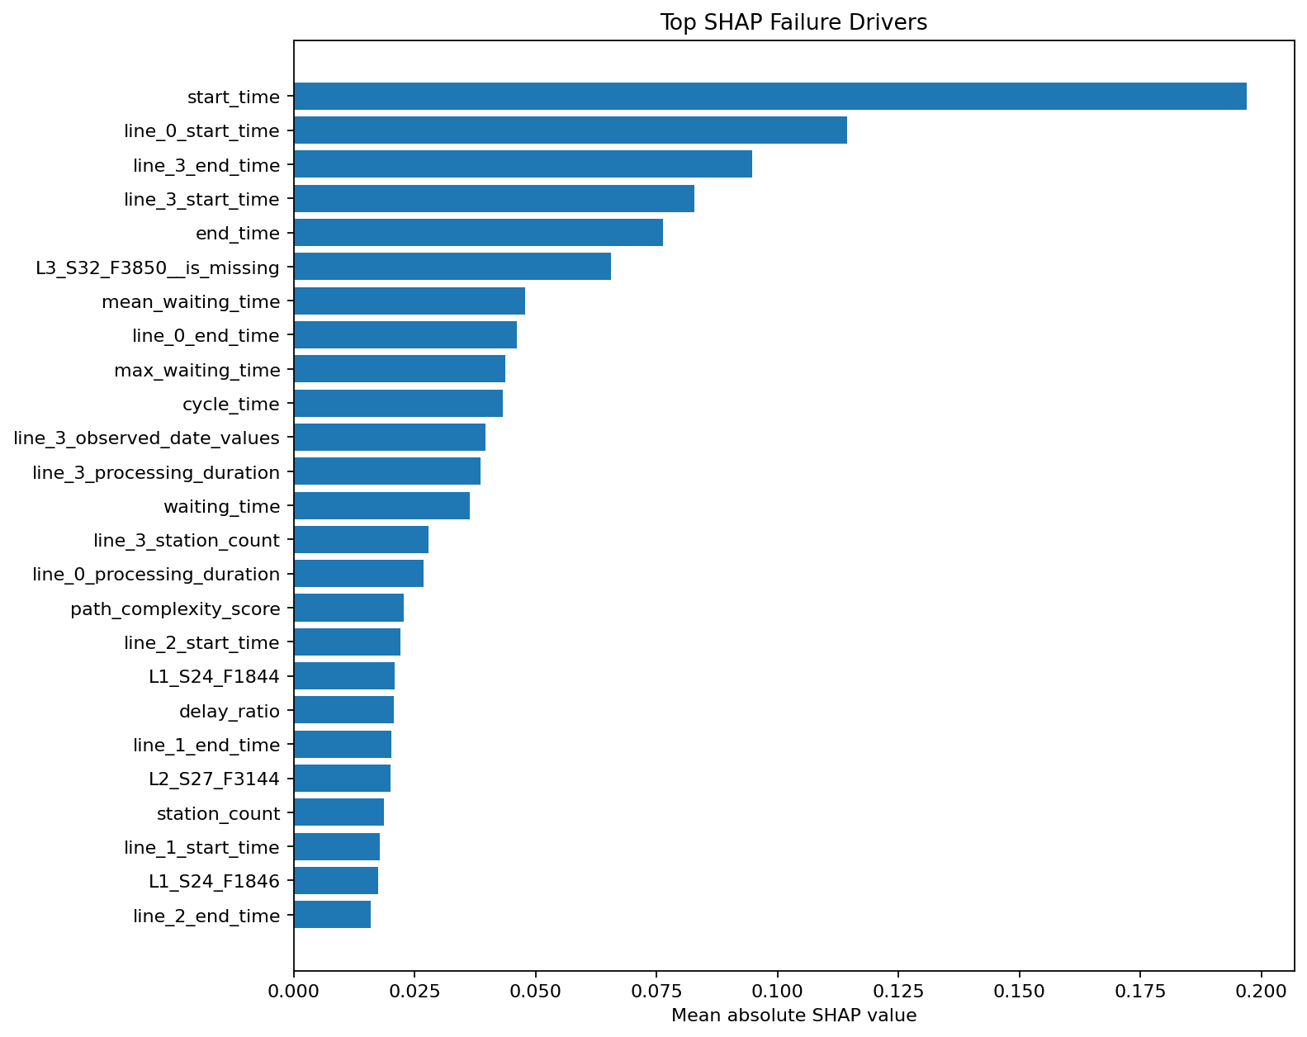
Fig. 2. Global SHAP failure drivers.
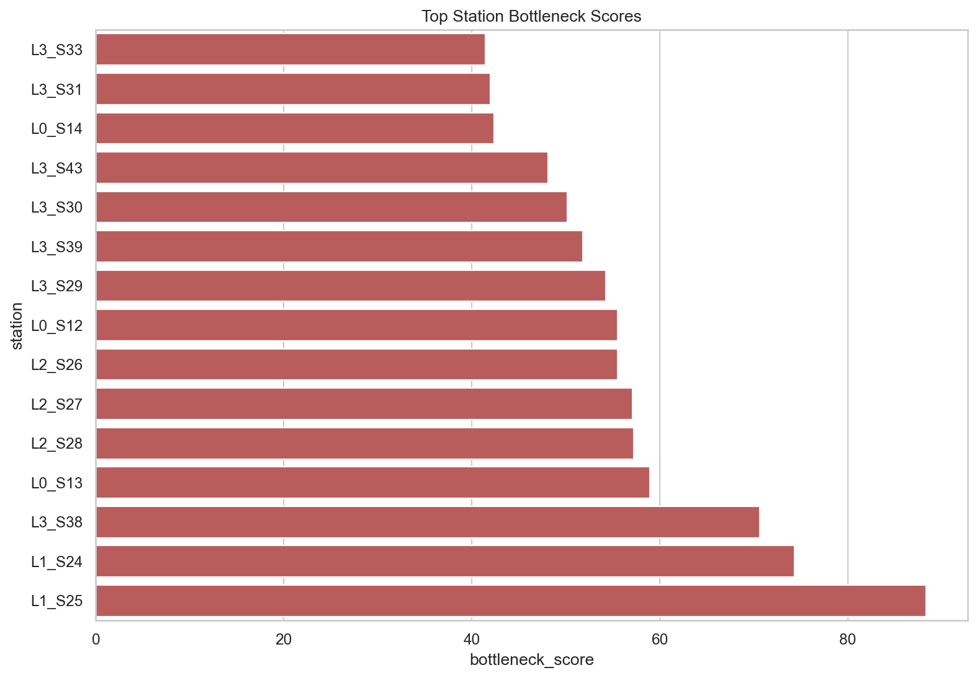
Fig. 3. Top process bottlenecks.
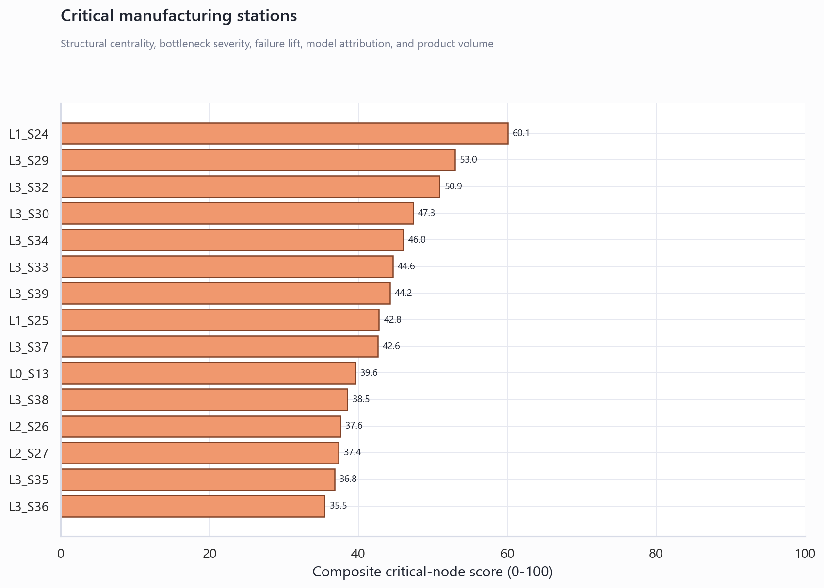
Fig. 4. Critical manufacturing knowledge-graph nodes.

V. Deliverables
ID | Deliverable | Status | Primary Artifact
68 | Production Failure Prediction Model | Complete | models/phase6_best_model.joblib
69 | Product Family Segmentation Module | Complete | src/data/phase5_product_family_discovery.py
70 | Process Mining Engine | Complete | src/data/phase8_process_mining_bottleneck_analysis.py
71 | Root Cause Analysis Engine | Complete | src/data/phase7_root_cause_analysis.py
72 | Knowledge Graph | Complete | src/data/phase9_knowledge_graph.py
73 | Manufacturing Copilot | Complete | app/phase11_manufacturing_copilot.py
74 | Executive Dashboard | Complete | app/phase12_executive_dashboard.py
75 | Project Documentation and Presentation | Complete | docs/final_deliverables/Bosch_Production_Line_Performance_Research_Report.docx

VI. Limitations
- Test labels are unavailable, so test predictions cannot be measured as observed failures.
- Leaderboard leakage strategies are excluded from production deliverables.
- SHAP and graph routes are diagnostic associations, not causal proof.
- Financial impact is scenario-based and requires client-specific validation.
- Relative Bosch timestamps do not directly map to calendar dates.

VII. Conclusion
The project delivers a complete manufacturing analytics reference architecture for future production-line quality use cases. It combines model accuracy, interpretability, process intelligence, graph analytics, and decision interfaces while preserving clear production-safety boundaries.

References
[1] Bosch Production Line Performance, Kaggle competition dataset.
[2] LightGBM: A Highly Efficient Gradient Boosting Decision Tree.
[3] SHAP: A Unified Approach to Interpreting Model Predictions.
[4] Process mining and event-log analysis methods for production systems.
[5] Network centrality and graph analytics methods for manufacturing process graphs.

