PART X

Dashboard Guide
━━━━━━━━━━━━━━━━━━━━━━━━━━━━━━━━━━━━━━━━━━━━━━━━━━━━━━━━━━━━
Chapters 68–75
Overview • Prediction Model • Product Families • Process Mining • Explainability • Knowledge Graph • Business Impact • Manufacturing Copilot
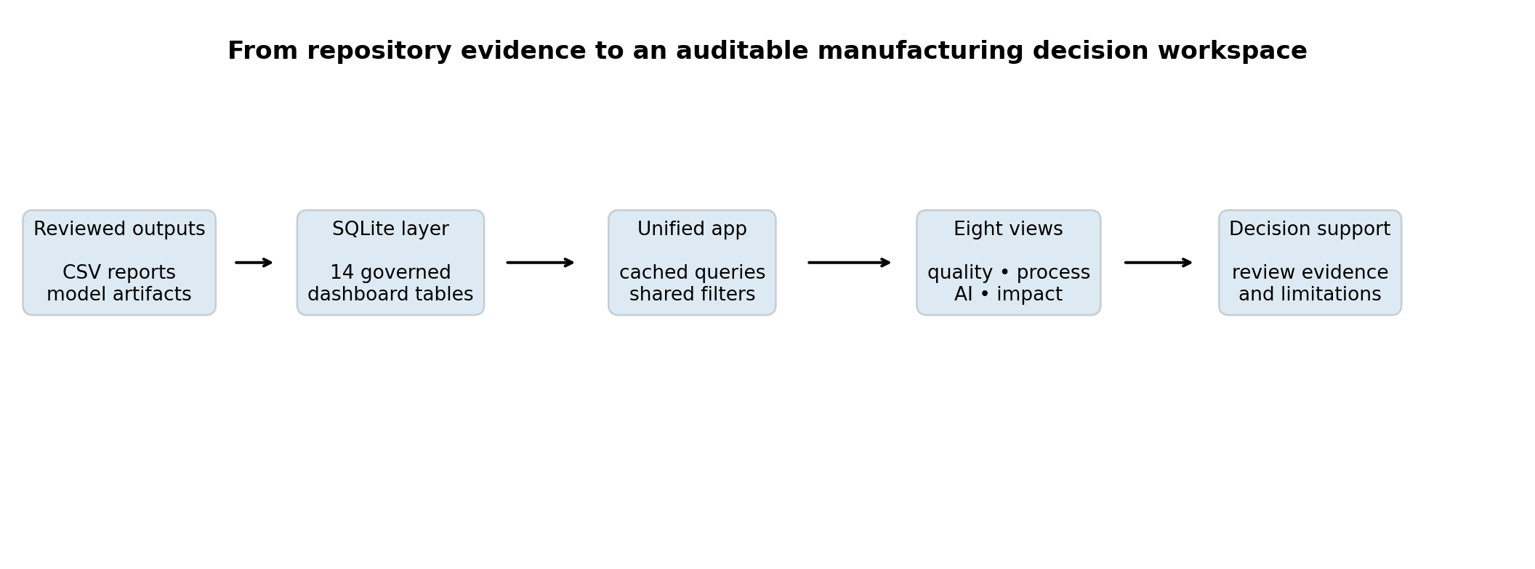
Unified dashboard architecture used in the Bosch manufacturing analytics project.
Bosch Production Line Performance — Technical Handbook
A page-by-page operating guide, updated for the full-data advanced-ML benchmark and complete test scoring

Contents and Quick Start
Chapter | Dashboard view | Primary question
68 | Overview | What is the current project-level quality and scoring position?
69 | Prediction Model | Which production-safe model was selected and how does it perform?
70 | Product Families | Which route-based product groups have different risk patterns?
71 | Process Mining | Where are the strongest waiting-gap and bottleneck signals?
72 | Explainability | Which predictive signals drive the model and what should engineers verify?
73 | Knowledge Graph | Which stations are structurally and operationally critical?
74 | Business Impact | Under explicit assumptions, what value could an intervention create?
75 | Manufacturing Copilot | How can a reviewer ask project questions in plain English?

Start the unified dashboard
# Build or refresh the local SQLite evidence layer
.\.venv\Scripts\python.exe src\data\phase11_manufacturing_copilot.py
# Install/pull the two local Ollama models once
ollama pull nomic-embed-text
ollama pull llama3.2:1b
# Launch the unified Streamlit application
.\.venv\Scripts\streamlit.exe run app\project_streamlit_dashboard.py

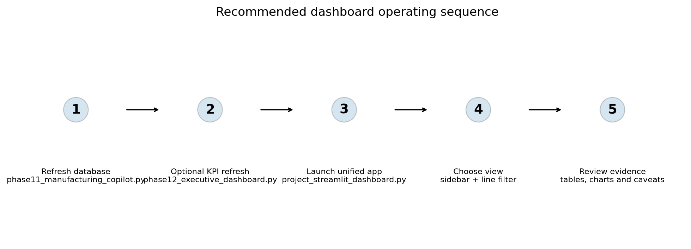
Figure X.1 — Recommended sequence for refreshing evidence and launching the dashboard.
Prerequisites: `data/database/manufacturing_copilot.db` must exist for deterministic SQL answers. For the Local Handbook Copilot, Ollama must be installed and running with `nomic-embed-text` and `llama3.2:1b` available. The RAG feature is designed primarily for local execution.

Navigation and Evidence Boundaries
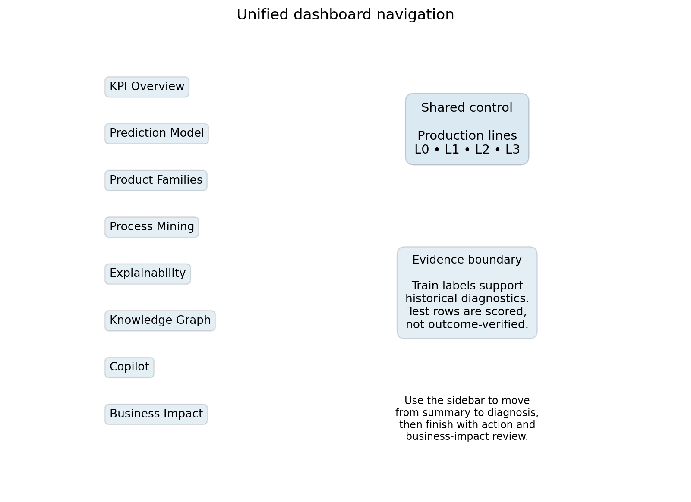
Figure X.2 — Sidebar navigation, shared line filter and the main evidence boundary.
Control or element | What it changes | What it does not change
Production-line multiselect | Filters line-aware bottleneck, root-cause and graph tables. | It does not retrain the model or change historical outcomes.
Sidebar page selector | Moves among analytical views. | It does not create a different data snapshot.
Cached SQLite queries | Improve interactive performance. | They do not replace the need to refresh the database when reports change.
CSV/JSON loaders | Bring model-improvement, family and manifest outputs into the app. | They do not validate source freshness automatically.
Warnings and captions | State interpretation boundaries. | They are not optional footnotes; they are part of the decision context.

Reading order: Begin with Overview, open the relevant diagnostic page, inspect the supporting table, and then use Business Impact or Copilot only after the technical evidence and caveats are understood.

CHAPTER 68

Overview
A summary-first page for quality, model, scoring volume and historical movement

Purpose of the overview page
The Overview page gives executives, mentors and plant stakeholders a stable first view of project performance. It combines the historical train failure rate, validation performance of the selected production-safe model, unlabelled test scoring volume, predicted alert volume, relative-time failure movement and line-level historical failure rates. The embedded KPI-card figure is a legacy snapshot; the current table and the full-data panel on Prediction Model are authoritative for the new model.
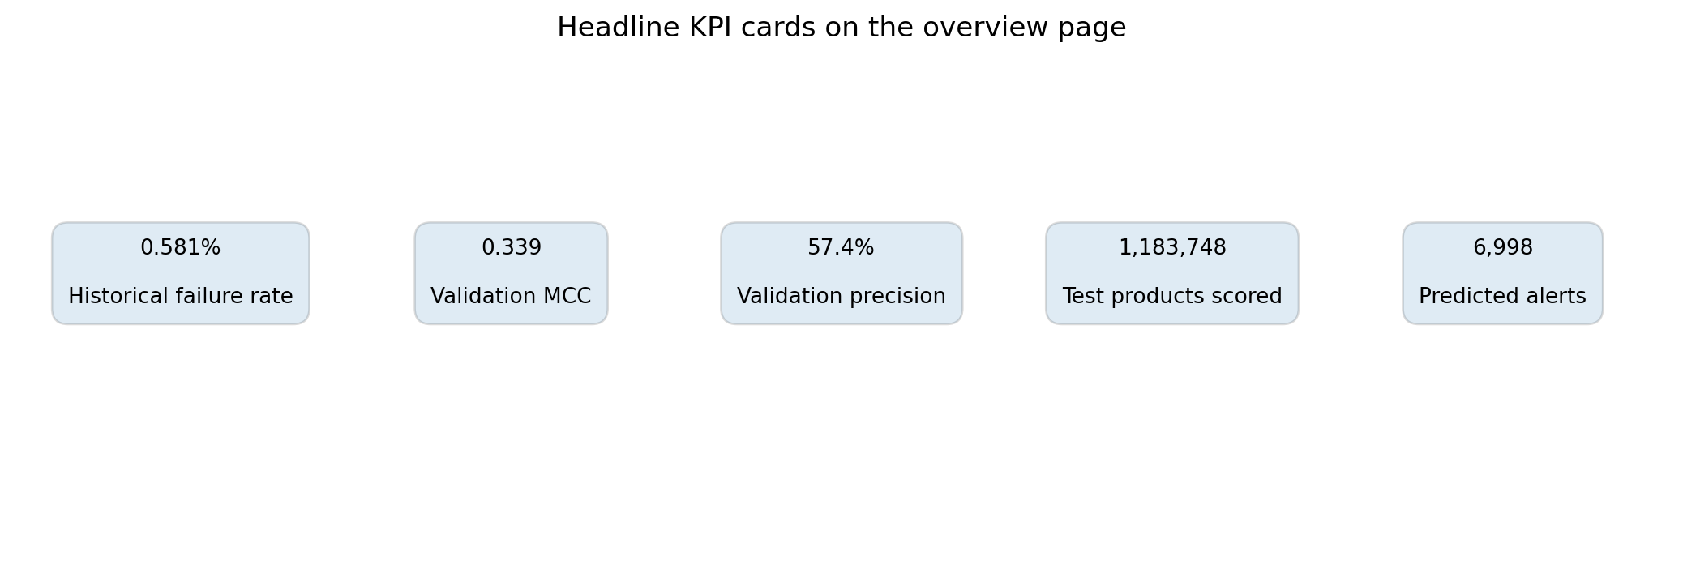
Figure 68.1 — The five headline KPI cards displayed at the top of the overview page.
KPI | Current repository value | How to interpret it
Historical failure rate | About 0.581% | Observed train-label baseline; not a live factory rate.
Selected full-data validation MCC | 0.2102 | Primary clean-benchmark selection metric.
Selected validation precision | 21.52% | Share of validation alerts that were true failures at the selected operating point.
Test products scored | 1,183,748 | Complete unlabelled Kaggle test population.
Predicted alerts | 7,003 | Rows above threshold 0.754167; actual outcomes are unknown.
Test alert rate | 0.5916% | Predicted inspection workload, not test accuracy or confirmed failure rate.

Failure movement and line comparison
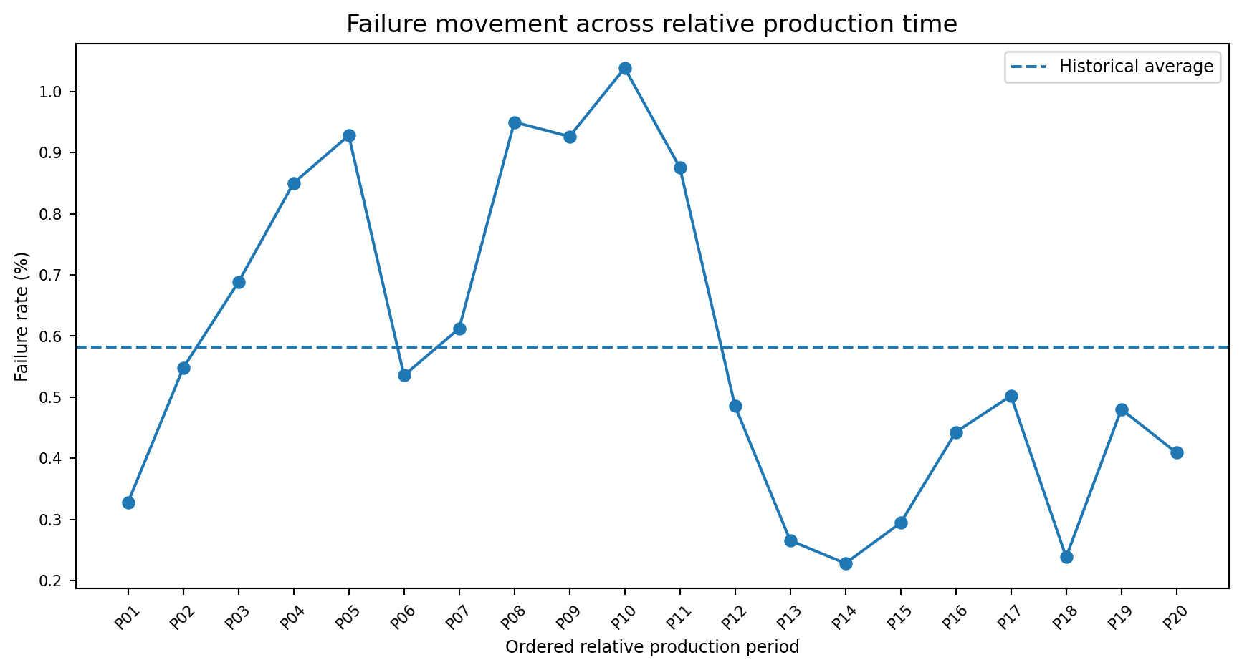
Figure 68.2 — Historical failure rate across 20 ordered relative production-time periods.
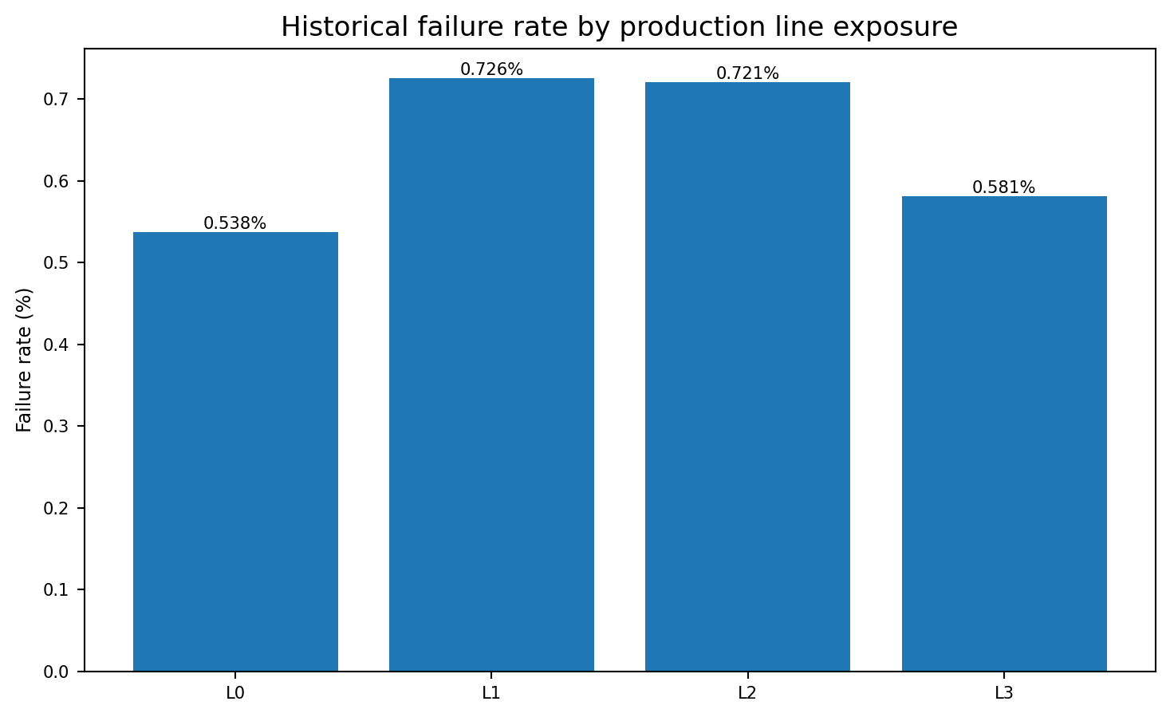
Figure 68.3 — Failure rate among products with recorded measurements on each production line.
Time-axis warning: The period labels P01–P20 are ordered relative Bosch production-time segments, not calendar months, weeks or shifts. The chart is suitable for movement detection, not date-specific reporting.

Recommended review sequence
1. Check whether historical failure movement is stable or concentrated in specific relative periods.
2. Compare line rates, but remember that products can appear on more than one line.
3. Confirm that the official model card still lists LightGBM as the production-safe model.
4. Treat the alert card as workload estimation, not as confirmed defects.
5. Use the source summary table to identify the repository artifact behind each KPI.
Repository evidence: `app/project_streamlit_dashboard.py`, `reports/phase12_executive_dashboard_report.md`, and `reports/phase12_executive_dashboard_manifest.json`.

CHAPTER 69

Prediction Model
Comparing the historical sampled benchmark, clean full-data benchmark, advanced diagnostics, and final test inference

What the page displays
- Selected model name and validation MCC, precision, recall and PR-AUC.
- MCC comparison across Logistic Regression, Random Forest, XGBoost, CatBoost and LightGBM.
- Precision-recall trade-off with threshold information.
- Production-safe improvement experiments.
- Advanced-AI diagnostics that remain supporting signals rather than the official model.
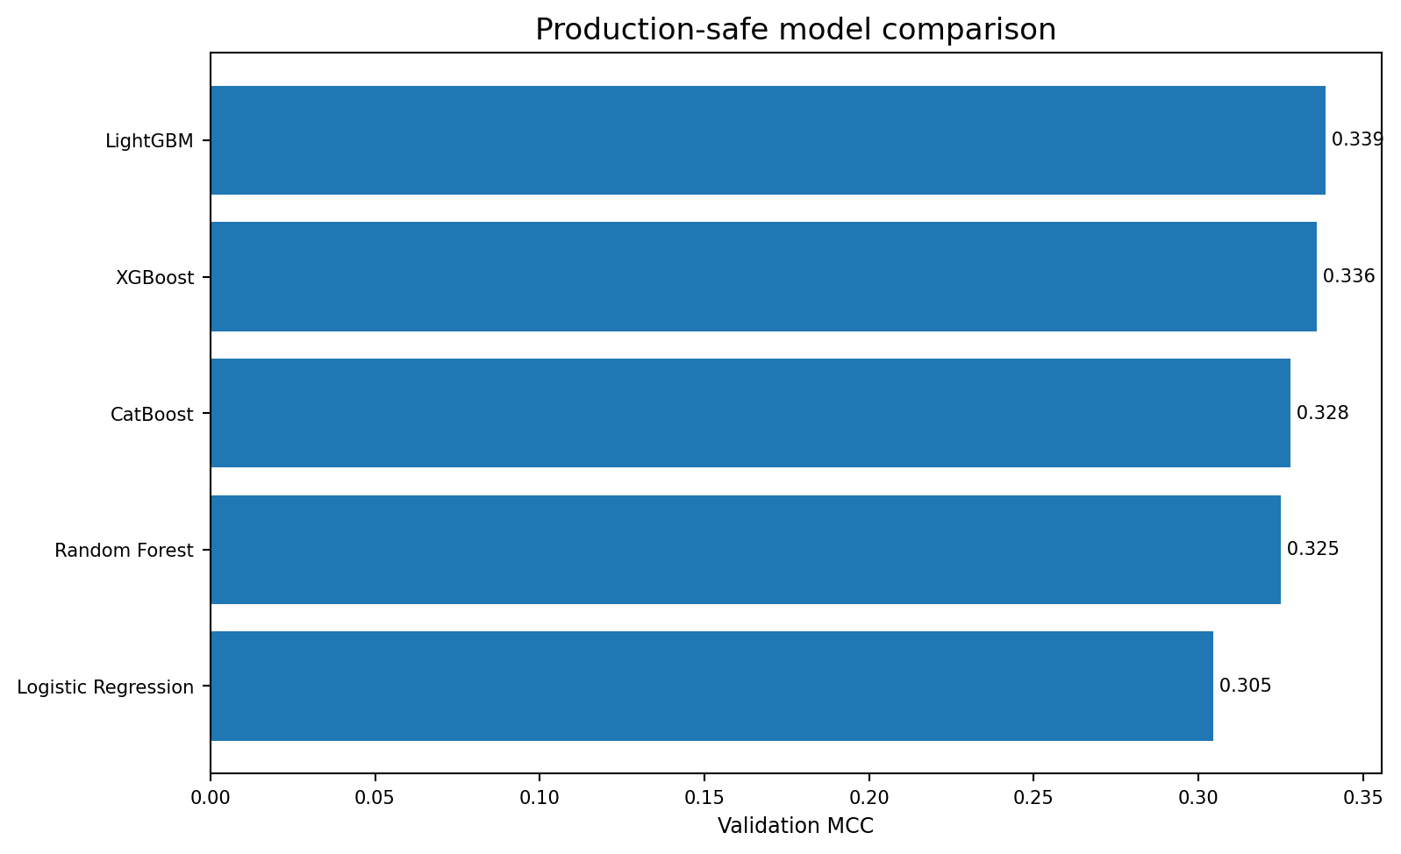
Figure 69.1 — Legacy sampled Phase 6 model comparison. Use the current full-data table below for final model selection.
Model | Split | Present rate | MCC | PR-AUC | Precision | Recall
LightGBM | 80/20 | 0.0025 | 0.2102 | 0.1271 | 21.52% | 21.44%
Random Forest | 90/10 | 0.0200 | 0.2089 | 0.1009 | 21.75% | 20.93%
XGBoost | 90/10 | 0.0200 | 0.2023 | 0.1161 | 20.61% | 20.78%
Logistic Regression | 80/20 | 0.0100 | 0.1923 | 0.0815 | 19.78% | 19.62%
CatBoost | 80/20 | 0.0100 | 0.1860 | 0.0726 | 19.04% | 19.11%

Operating trade-off
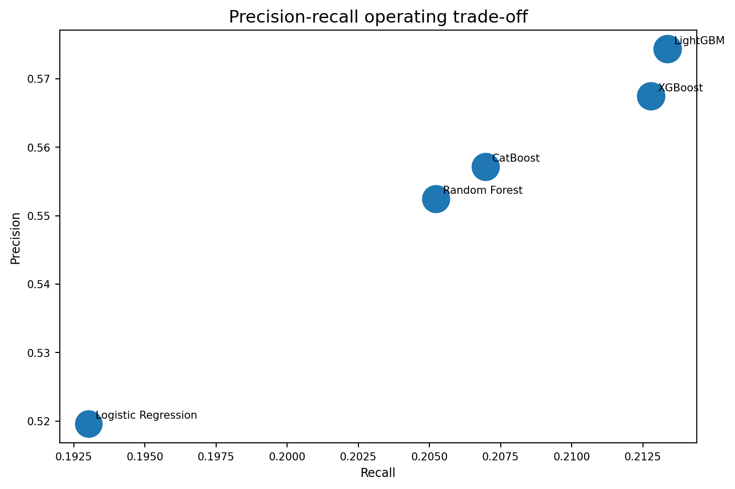
Figure 69.2 — Legacy sampled Phase 6 precision–recall snapshot; it is not directly comparable with the current clean full-data benchmark.
Current selection rule
Use the full-data LightGBM selected under the clean 80/20 benchmark with present rate 0.0025 and 283 final features. Keep the earlier sampled MCC 0.3386 and Phase 10 diagnostics visibly labelled as historical or research-only.

Questions to ask before changing the threshold
Question | Why it matters
How many products can quality teams review? | The threshold determines alert workload.
What is the false-negative tolerance? | Higher recall can require more inspections and lower precision.
Are probabilities calibrated? | A ranking model may not provide literal probability estimates.
Was the threshold chosen on validation only? | Holdout outcomes must remain isolated from selection decisions.
Will the feature set exist at scoring time? | Unavailable future or neighbour outcomes create leakage.

Repository evidence: `reports/phase6_model_comparison_metrics.csv`, `reports/phase6_model_improvement_summary.csv`, and `reports/phase10_advanced_ai_model_comparison.csv`.

CHAPTER 70

Product Families
Comparing route-based clusters by size, complexity and historical failure rate

What a family represents
A product family is a cluster of products that share similar station-presence patterns. The dashboard uses eight reviewed families to summarize route diversity without implying that family membership is a physical defect cause.
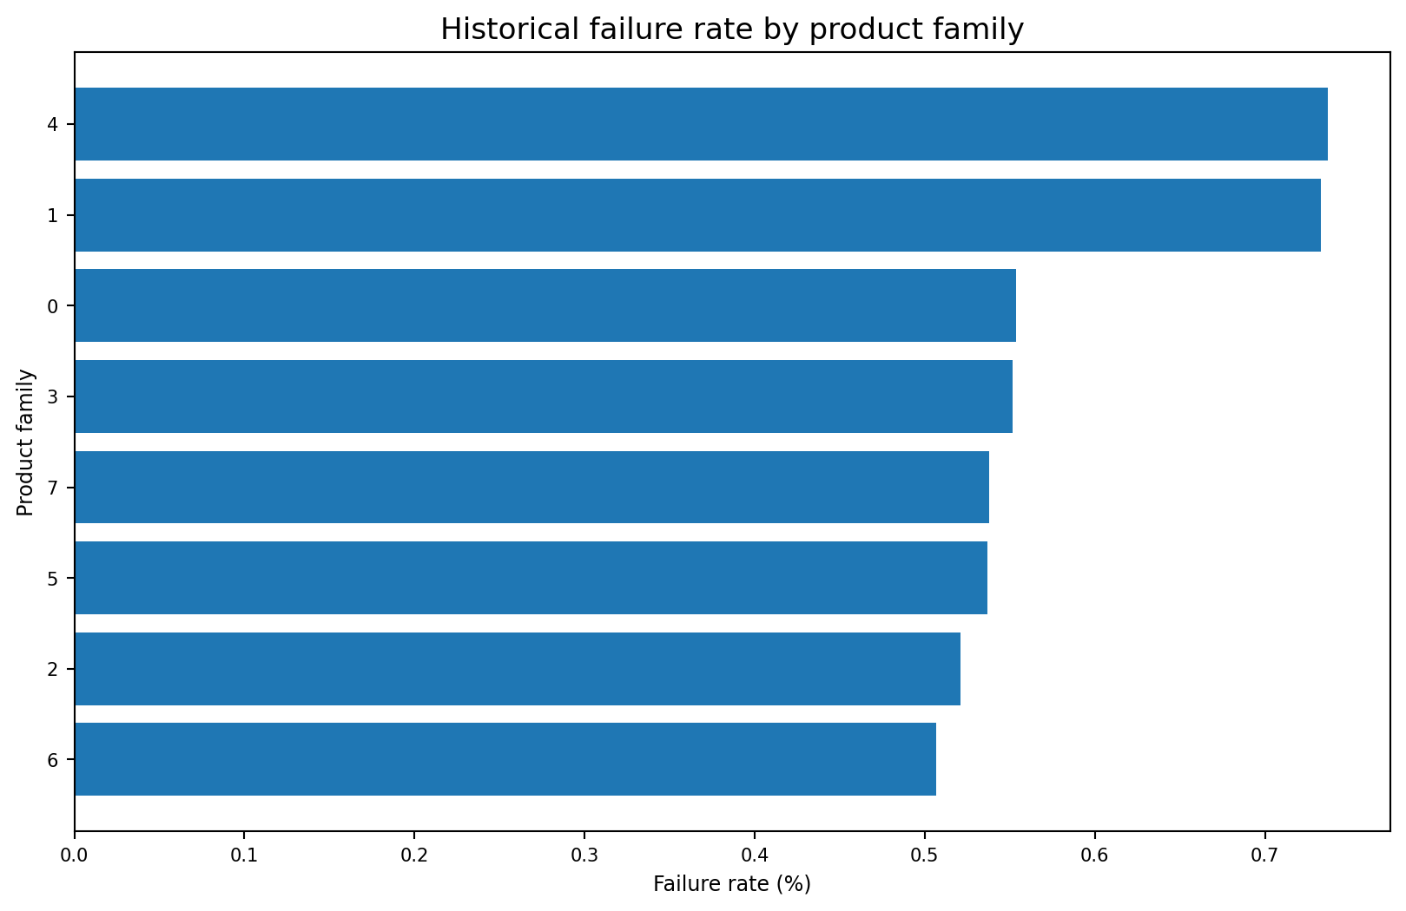
Figure 70.1 — Family 4 has the highest observed failure rate, closely followed by Family 1.
Family | Products | Failure rate | Lift | Avg stations | Avg lines
0 | 252,037 | 0.554% | 0.95× | 13.21 | 2.15
1 | 132,878 | 0.733% | 1.26× | 7.87 | 2.89
2 | 237,283 | 0.521% | 0.90× | 13.22 | 2.15
3 | 125,592 | 0.552% | 0.95× | 13.19 | 2.09
4 | 128,104 | 0.737% | 1.27× | 7.92 | 2.90
5 | 99,296 | 0.537% | 0.92× | 13.19 | 2.09
6 | 59,988 | 0.507% | 0.87× | 15.45 | 2.13
7 | 148,569 | 0.538% | 0.93× | 13.21 | 2.14

Path complexity and family risk
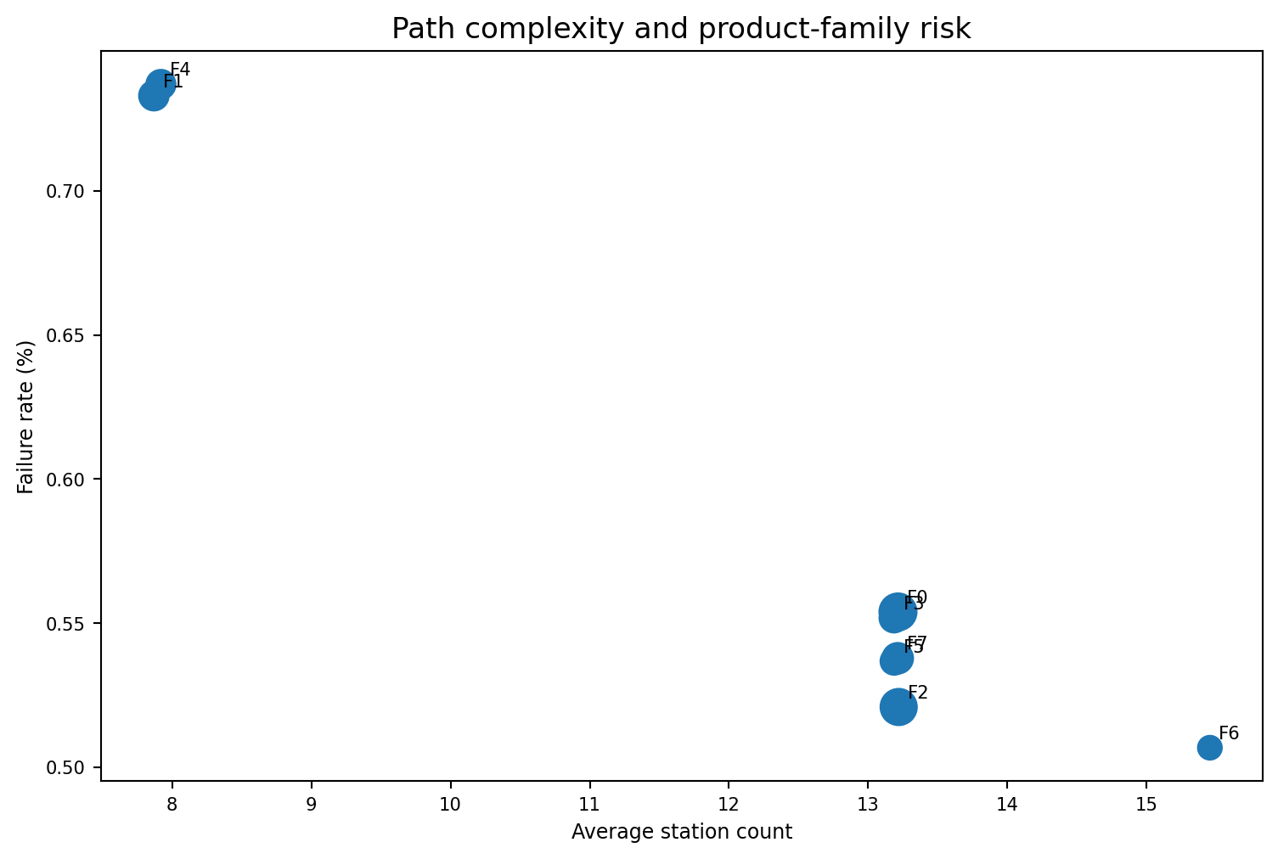
Figure 70.2 — Bubble size represents family population; labels identify family number.
Common mistake: Do not conclude that a larger station count causes lower or higher risk. Family risk can reflect product mix, routing, measurement availability and unobserved process conditions.

How to use the page
1. Use the KPI cards to identify the highest-risk family and its population.
2. Compare failure rate with family size before prioritizing an investigation.
3. Use average station and line counts to understand route complexity.
4. Open the family-profile expander to review station-presence patterns.
5. Move to Process Mining or Knowledge Graph to examine the stations shared by high-risk families.
Repository evidence: `reports/phase5_product_family_failure_rates.csv` and `reports/phase5_product_family_profiles.csv`.

CHAPTER 71

Process Mining
Reviewing timestamp-gap proxies, bottleneck priorities and candidate propagation routes

Page structure
- Top bottleneck KPI cards for station, score, average gap, P90 gap and failure rate.
- Bubble chart connecting observed gap, bottleneck score, volume and failure rate.
- Top-15 bottleneck table.
- Train/test throughput-efficiency table.
- Candidate failure-propagation route table.
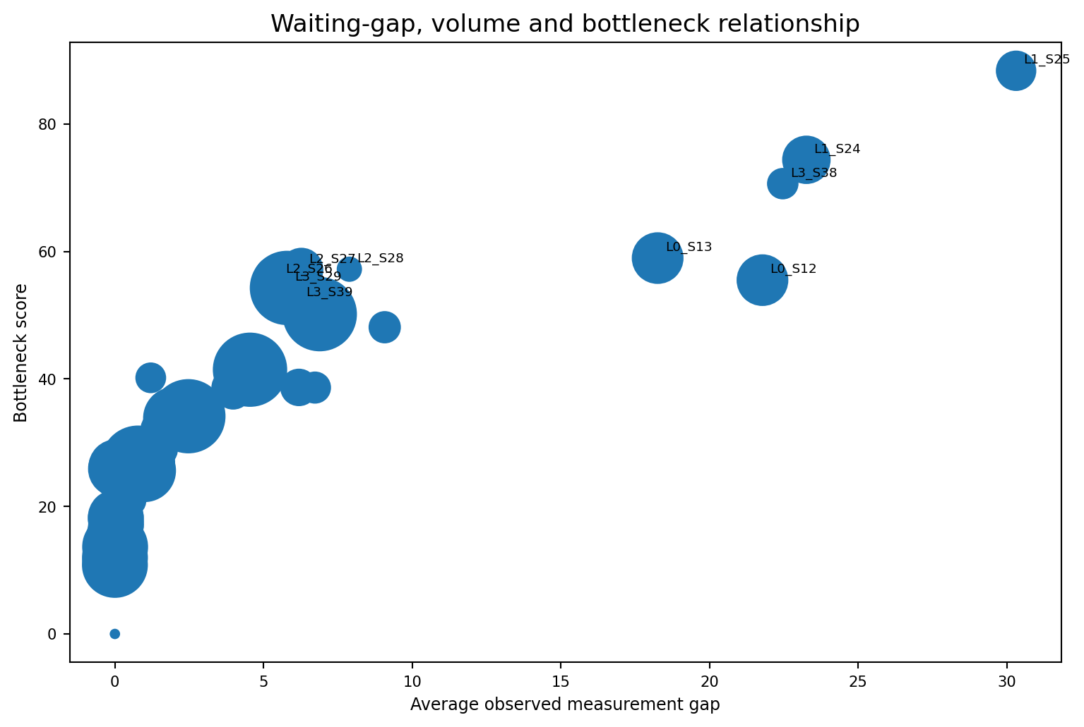
Figure 71.1 — The dashboard emphasizes both operational gap severity and product exposure.
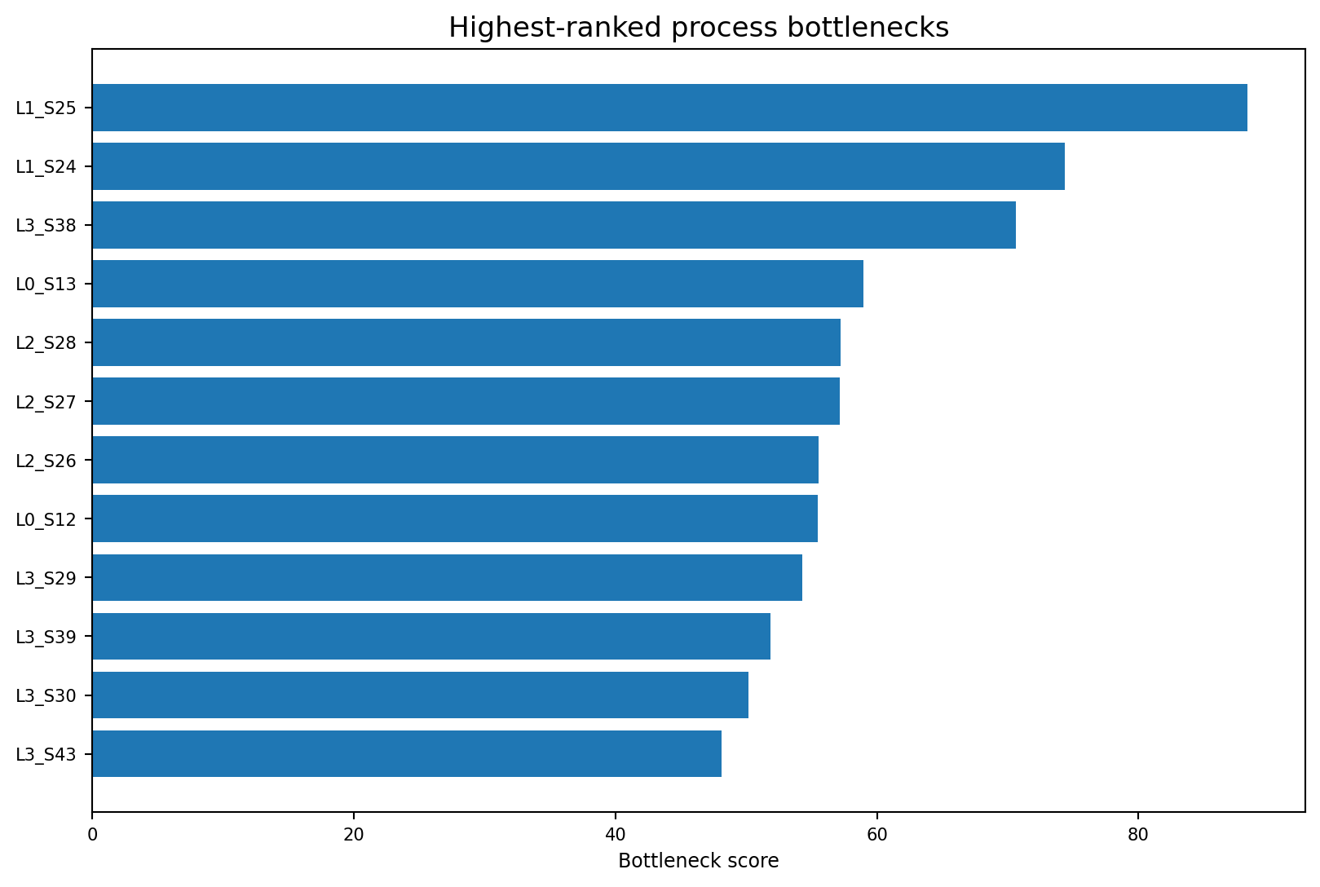
Figure 71.2 — L1_S25 is the highest-ranked bottleneck, while L1_S24 combines high bottleneck and elevated failure evidence.

Read bottleneck and quality evidence separately
Station | Bottleneck score | Avg gap | P90 gap | Failure rate | Failure lift
L1_S25 | 88.3 | 30.31 | 36.50 | 0.507% | 0.90×
L1_S24 | 74.4 | 23.25 | 41.01 | 0.828% | 1.48×
L3_S38 | 70.6 | 22.46 | 32.77 | 0.781% | 1.39×
L0_S13 | 59.0 | 18.25 | 31.58 | 0.547% | 0.97×
L2_S28 | 57.2 | 7.88 | 13.44 | 0.699% | 1.25×
L2_S27 | 57.1 | 6.27 | 12.23 | 0.681% | 1.21×
L2_S26 | 55.5 | 5.49 | 9.86 | 0.747% | 1.33×
L0_S12 | 55.5 | 21.78 | 28.63 | 0.547% | 0.97×
L3_S29 | 54.3 | 5.79 | 9.25 | 0.585% | 1.04×
L3_S39 | 51.8 | 6.17 | 8.51 | 0.506% | 0.90×

Proxy boundary: Average and P90 waiting values are positive inter-station timestamp-gap proxies. They are not confirmed queue times. Throughput efficiency is not OEE.

Candidate routes
Rank | Route | Score | Minimum transition volume | Mean transition failure
1 | L3_S29 → L3_S30 → L3_S33 → L3_S34 | 51.72 | 965,844 | 0.507%
2 | L3_S29 → L3_S30 → L3_S33 → L3_S37 | 50.81 | 654,274 | 0.520%
3 | L1_S24 → L3_S29 → L3_S30 → L3_S33 | 50.28 | 25,747 | 0.744%
4 | L1_S24 → L2_S26 → L3_S29 → L3_S30 → L3_S33 → L3_S34 | 50.09 | 243,524 | 0.630%
5 | L1_S24 → L2_S26 → L3_S29 → L3_S30 | 50.07 | 243,524 | 0.734%

Repository evidence: `reports/phase8_bottleneck_scores.csv`, `reports/phase8_throughput_efficiency.csv`, and `reports/phase9_failure_propagation_routes.csv`.

CHAPTER 72

Explainability
Translating model behavior into a prioritized engineering evidence review

What the page explains
The Explainability page displays global SHAP predictive signals, station-level root-cause evidence and a reviewed engineer action plan. It explains what influenced the model, not what physically caused a product failure.
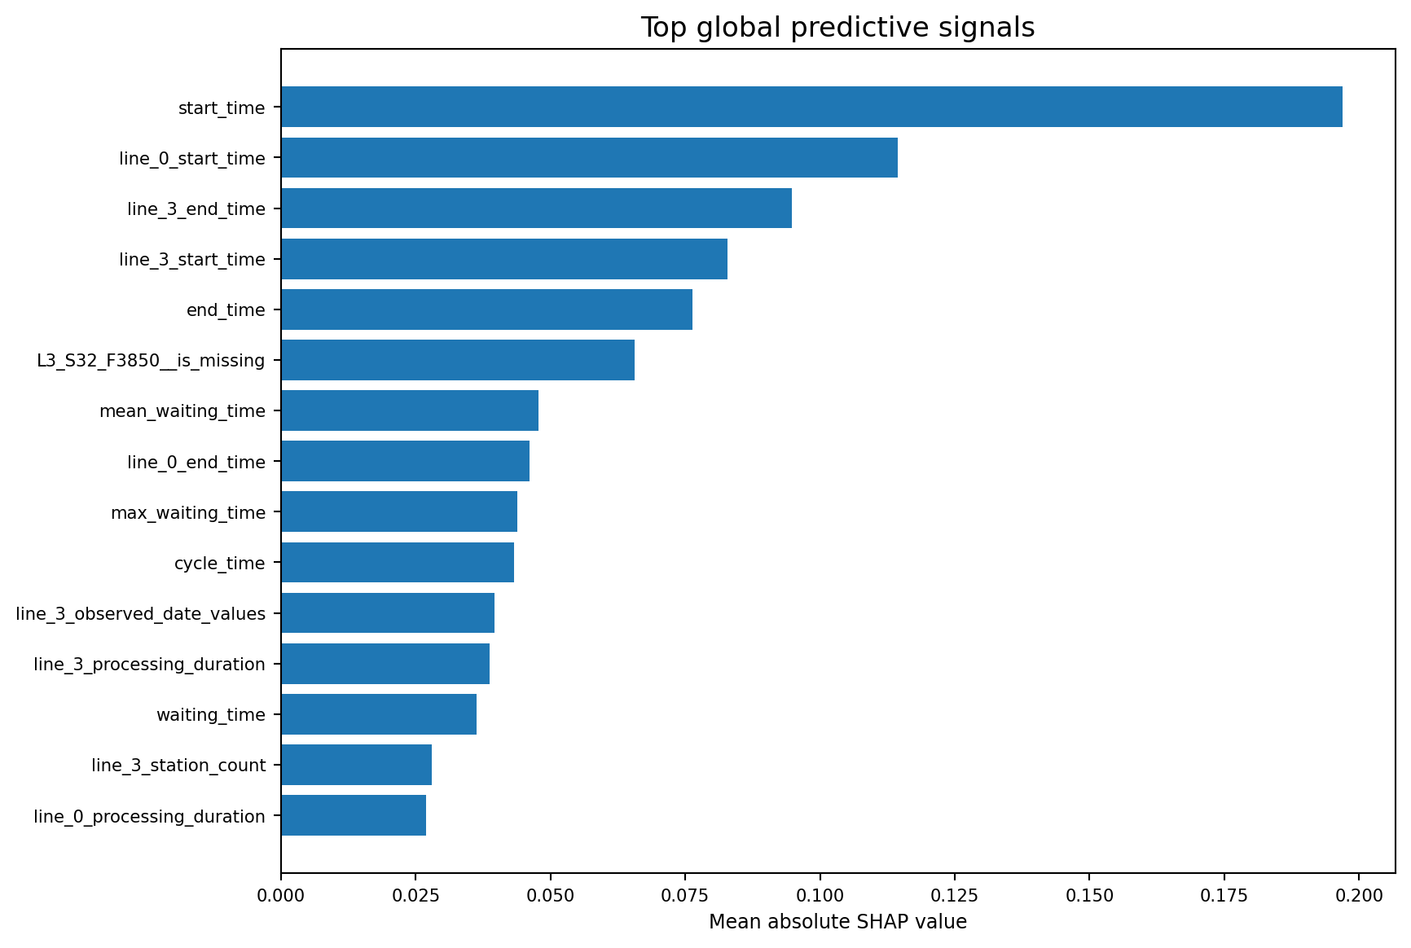
Figure 72.1 — Timing and line-level temporal indicators dominate the global SHAP ranking.
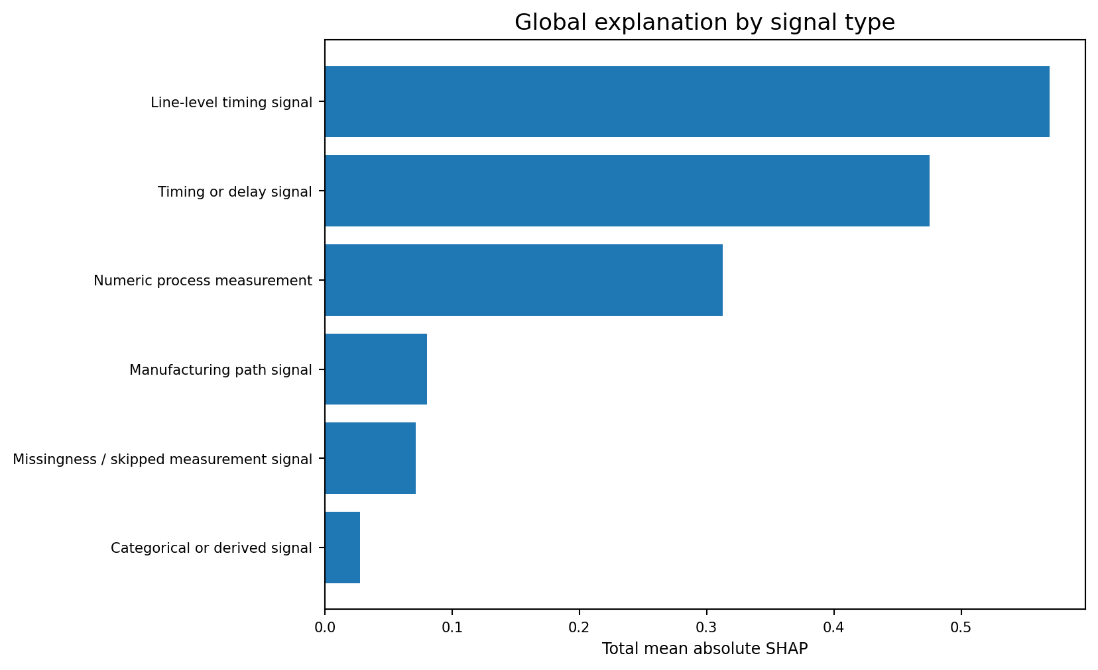
Figure 72.2 — Global SHAP evidence aggregated by reviewed signal type.

Top signals and safe language
Rank | Predictive signal | Signal type | Mean |SHAP| | Area
1 | Earliest Measurement Timestamp | Timing or delay signal | 0.1970 | timing_level
2 | Line 0 Earliest Measurement Timestamp | Line-level timing signal | 0.1145 | line_level
3 | Line 3 Latest Measurement Timestamp | Line-level timing signal | 0.0947 | line_level
4 | Line 3 Earliest Measurement Timestamp | Line-level timing signal | 0.0829 | line_level
5 | Latest Measurement Timestamp | Timing or delay signal | 0.0763 | timing_level
6 | L3_S32_F3850__is_missing | Missingness / skipped measurement signal | 0.0656 | L3_S32
7 | mean_waiting_time | Timing or delay signal | 0.0478 | timing_level
8 | line_0_end_time | Line-level timing signal | 0.0461 | line_level
9 | max_waiting_time | Timing or delay signal | 0.0438 | timing_level
10 | cycle_time | Timing or delay signal | 0.0432 | timing_level

Required wording: Use `predictive signal`, `association` and `recommended check`. Avoid saying that SHAP proved a root cause, that a timestamp feature is a verified delay, or that missingness is automatically a sensor failure.

Engineer review pattern
1. Read the top global signal and its feature type.
2. Check the station-level root-cause table for concentrated SHAP evidence.
3. Review the recommended action next to the operational bottleneck evidence.
4. Validate the signal against tooling, calibration, maintenance, routing and sensor records.
5. Document whether the evidence supports correlation, mechanism or controlled causal proof.
Repository evidence: `reports/phase7_top_failure_drivers.csv`, `reports/phase7_station_root_cause_report.csv`, and `reports/phase7_engineer_action_plan.csv`.

CHAPTER 73

Knowledge Graph
Combining structural centrality, bottleneck severity and failure evidence

Page purpose
The Knowledge Graph page identifies stations that are important for more than one reason. The critical-node score combines graph position, bottleneck severity, historical failure lift, station-level SHAP evidence and product volume.
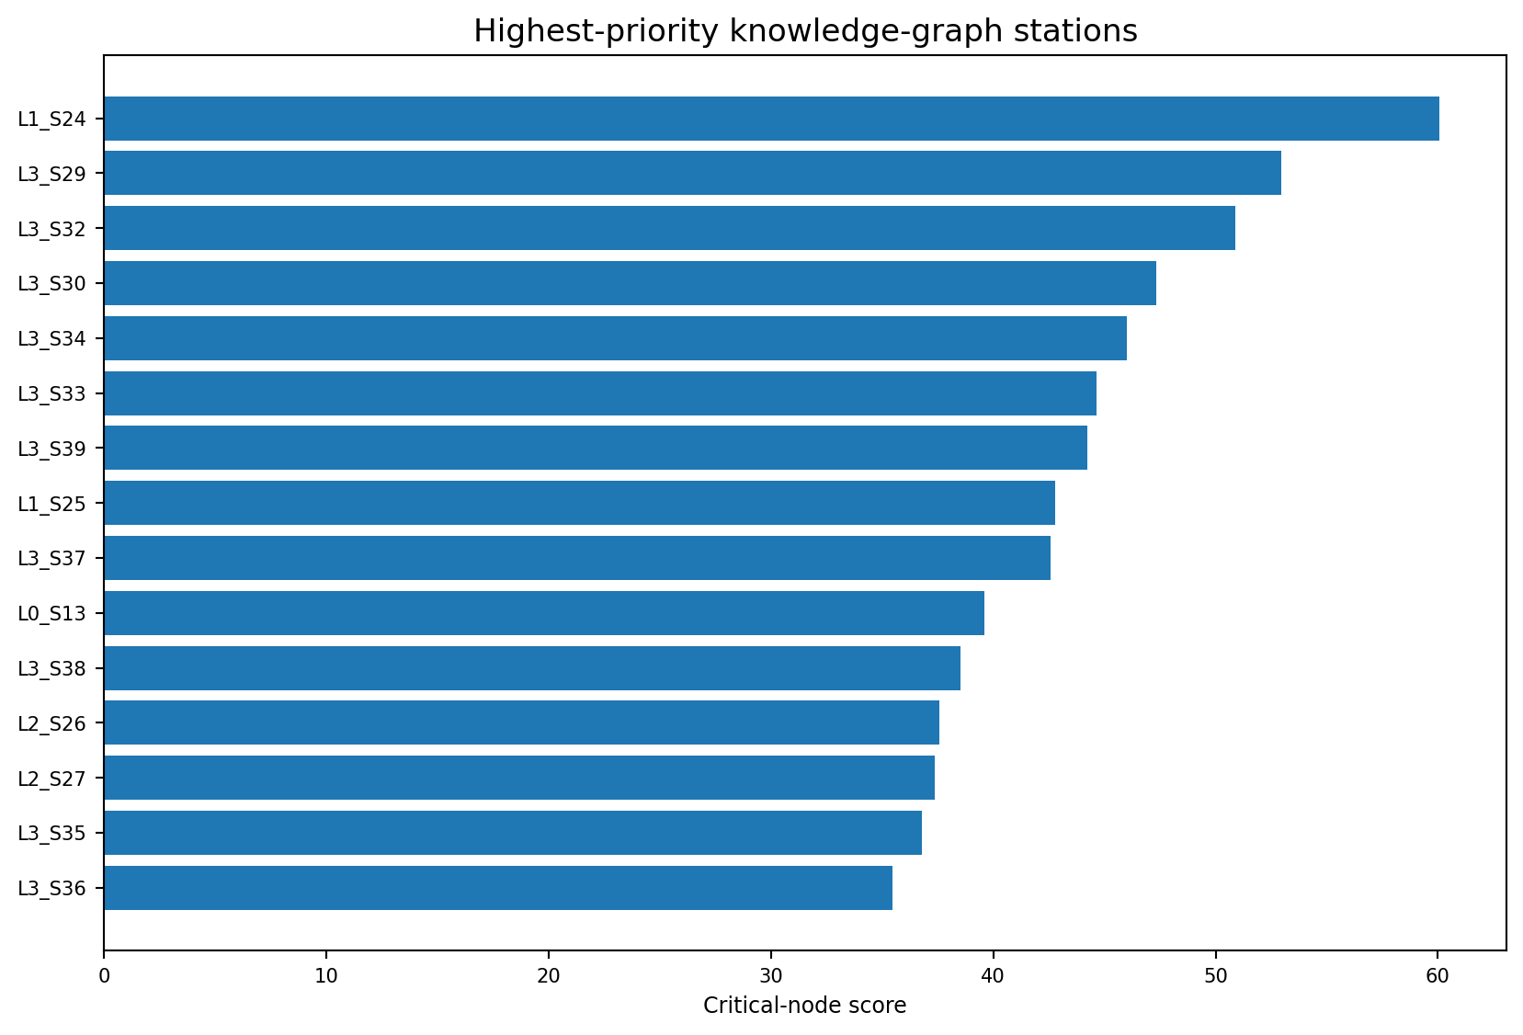
Figure 73.1 — L1_S24 is the highest-ranked critical graph node.
Rank | Station | Line | Critical score | Centrality | Bottleneck | Failure rate
1 | L1_S24 | L1 | 60.1 | 0.091 | 74.4 | 0.828%
2 | L3_S29 | L3 | 53.0 | 0.640 | 54.3 | 0.585%
3 | L3_S32 | L3 | 50.9 | 0.127 | 40.2 | 4.506%
4 | L3_S30 | L3 | 47.3 | 0.502 | 50.2 | 0.585%
5 | L3_S34 | L3 | 46.0 | 0.612 | 34.2 | 0.513%
6 | L3_S33 | L3 | 44.6 | 0.507 | 41.4 | 0.498%
7 | L3_S39 | L3 | 44.2 | 0.500 | 51.8 | 0.506%
8 | L1_S25 | L1 | 42.8 | 0.068 | 88.3 | 0.507%
9 | L3_S37 | L3 | 42.6 | 0.559 | 26.9 | 0.585%
10 | L0_S13 | L0 | 39.6 | 0.241 | 59.0 | 0.547%

Structural influence versus operational constraint
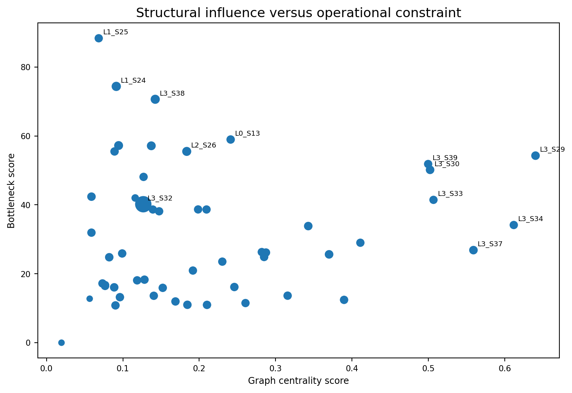
Figure 73.2 — Bubble size represents historical station failure rate.
Interpretation: A structurally central station can be important because many high-volume routes pass through it. A high bottleneck score indicates operational gap severity. A high critical-node score combines these with failure evidence; none of the scores alone proves causation.

Best uses of the page
- Prioritize cross-functional investigations that involve routing, capacity and quality.
- Identify bridge stations whose disruption could affect several route communities.
- Compare high-risk stations with high-volume central stations.
- Select candidate routes for deeper Process Mining review.
- Use graph findings to organize evidence collection, not assign automatic blame.
Repository evidence: `reports/phase9_critical_nodes.csv`, `reports/phase9_station_centrality_metrics.csv`, and `reports/phase9_failure_propagation_routes.csv`.

CHAPTER 74

Business Impact
Converting model and workflow assumptions into a transparent scenario

Inputs controlled by the reviewer
Input | Current dashboard evidence | Meaning
Production volume | 1,183,748 | Complete test population scored.
Cost per failure | User assumption | Must be supplied by the target factory.
Cost per alert review | User assumption | Manual or automated review cost.
Intervention effectiveness | User assumption | Share of true alerts converted into avoided failures.
Failure rate | Historical train baseline | Not a known test failure rate.
Alert rate | 0.5916% | 7,003 predicted alerts / 1,183,748 test products.
Precision | 21.52% clean validation | Scenario assumption; transfer to unlabelled test products is unverified.

expected_failures = volume × failure_rate
expected_alerts = volume × alert_rate
true_positive_alerts = min(expected_failures, expected_alerts × precision)
potentially_prevented = true_positive_alerts × intervention_effectiveness
net_impact = potentially_prevented × failure_cost − expected_alerts × review_cost

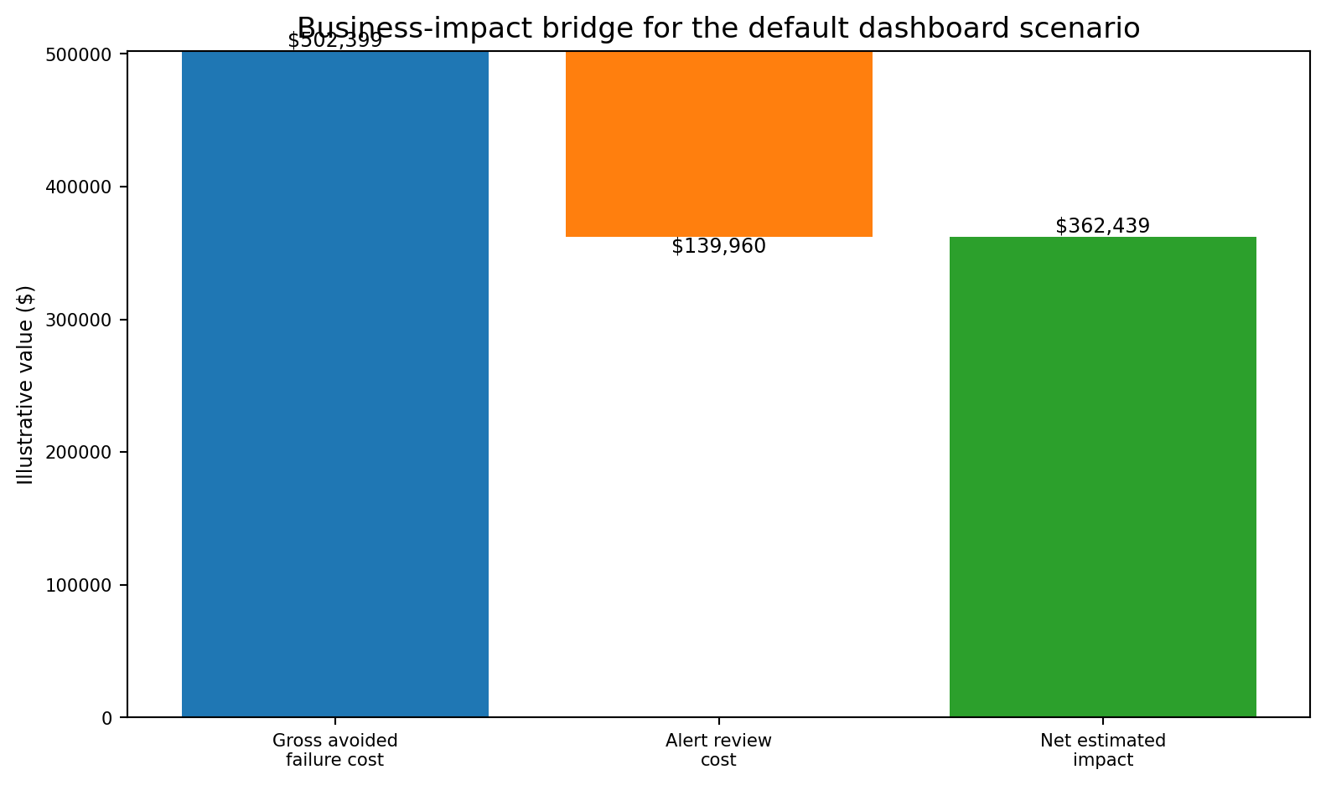
Figure 74.1 — Worked scenario using the dashboard defaults.

Worked scenario output
Output | Illustrative value
Expected failures | 6,879
Expected alerts | 7,003
Expected true-positive alerts | 1,507
Potentially prevented failures | 377
Gross avoided failure cost | $188,500
Alert review cost | $140,060
Net estimated impact | $48,440
Estimated ROI on review cost | 0.35?

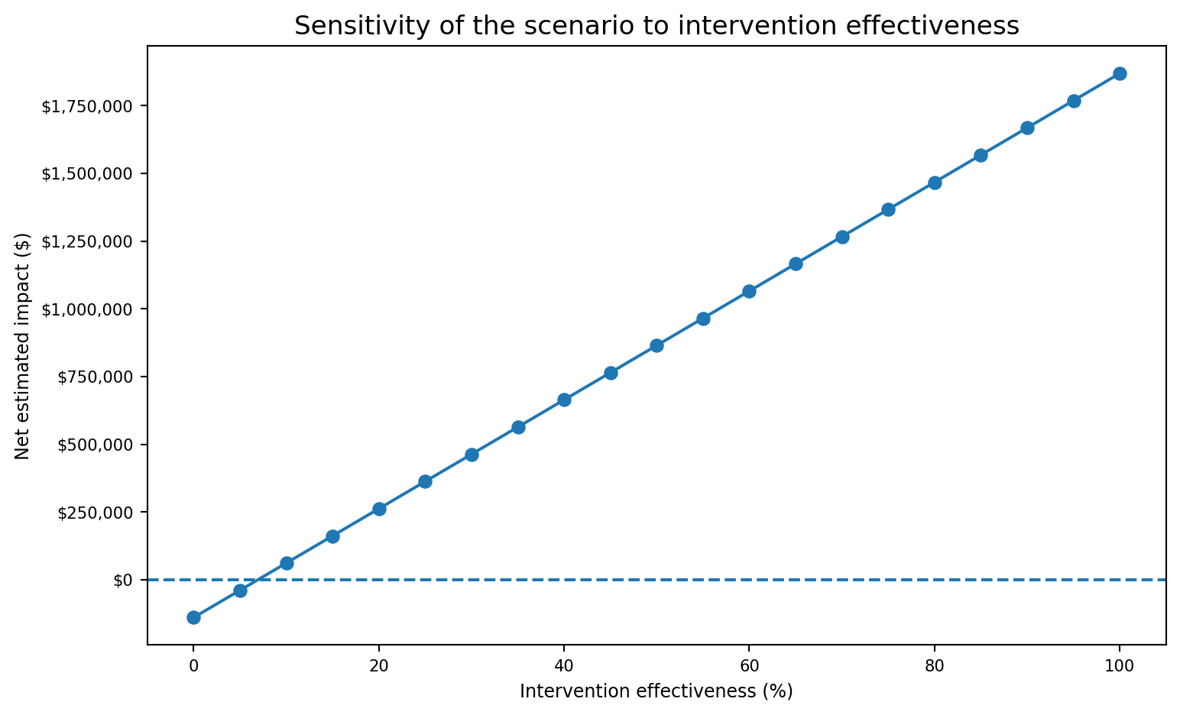
Figure 74.2 — Net impact changes materially with the assumed intervention effectiveness.
Scenario, not savings: The dashboard does not claim realized savings. Costs, effectiveness, precision transfer, operational capacity and model stability must be validated in the target factory.

Repository evidence: `src/dashboard/business_impact.py` and `app/project_streamlit_dashboard.py`.

CHAPTER 75

Manufacturing Copilot
Using local LangChain retrieval, Ollama generation, handbook evidence and deterministic SQL templates

How the Copilot works
The current unified dashboard includes a local retrieval-augmented generation (RAG) Copilot. LangChain retrieves relevant excerpts from the Bosch Markdown handbook, Ollama generates the answer on the local computer, and the page shows the excerpts used as evidence. No cloud AI API key is required. A separate deterministic SQL-template mode remains available for exact, reviewed database questions.

Current local RAG architecture
- Handbook source loading. The Copilot reads every Bosch_Handbook_*.md file from Bosch_Handbook_md or Bosch_Handbook_MD. Embedded images and link markup are removed before retrieval so the index contains readable handbook text.
- Chunking. RecursiveCharacterTextSplitter divides the handbook into chunks of 1,600 characters with 220 characters of overlap. The overlap helps preserve meaning when an explanation crosses a chunk boundary.
- Fast candidate screening. A local lexical pass counts meaningful terms from the question and keeps up to 12 promising chunks. This limits the amount of text sent to the embedding stage.
- Local embeddings. OllamaEmbeddings uses nomic-embed-text to convert the candidate chunks and the question into numeric vectors on the local machine.
- LangChain retrieval. The vectors are stored in an InMemoryVectorStore created for the current question. The retriever returns the three most similar handbook chunks (k = 3). The index is temporary and is not a cloud vector database.
- Local answer generation. ChatOllama uses llama3.2:1b with temperature 0.2, a 4,096-token context window and a maximum response budget of 500 tokens. The low temperature is intended to reduce unnecessary variation.
- Evidence display. The system prompt instructs the model to answer only from supplied excerpts, avoid invented deployment claims and cite statements as [1], [2] and [3]. Streamlit then displays the answer, local model name and the source excerpts used.

Why both LangChain and Ollama are used
LangChain provides the application workflow: document objects, text splitting, vector storage, retrieval and message construction. Ollama provides the local AI runtime: nomic-embed-text creates embeddings and llama3.2:1b writes the final natural-language response. LangChain orchestrates the steps; Ollama runs the models.

Two Copilot modes in the dashboard
- Local Handbook Copilot: flexible natural-language explanation using handbook retrieval plus the local Ollama chat model. It is best for project walkthroughs, model interpretation, limitations and non-technical explanations.
- Legacy reviewed template questions: deterministic parameterized SQL answers from manufacturing_copilot.db. This mode is preferable when the user needs an exact ranked table, such as highest-risk stations, model metrics or bottlenecks.
- The two modes are complementary. The RAG Copilot improves language flexibility; deterministic SQL preserves exactness for known structured questions.

Local operation and prerequisites
Install Ollama and make sure its local service is running. Pull the two required models with `ollama pull nomic-embed-text` and `ollama pull llama3.2:1b`. The Python environment also requires langchain, langchain-ollama and langchain-text-splitters. The Streamlit Community Cloud deployment cannot use a user's local Ollama service unless a compatible hosted Ollama endpoint is separately configured; the documented implementation is primarily a local-computer feature.
If Ollama or either model is unavailable, the dashboard returns a safe setup message rather than fabricating an answer. The deterministic SQL-template expander can still be used when its SQLite database is available.

Security and interpretation boundary
Local execution reduces the need to send handbook content to a third-party AI API, but it does not automatically make every answer correct. The Copilot is grounded in project documents, not live factory systems. Retrieved passages can be incomplete, the small local model can summarize them incorrectly, and citations must still be checked. It must not approve products, change thresholds, modify machines, claim confirmed physical root causes or replace engineering review.
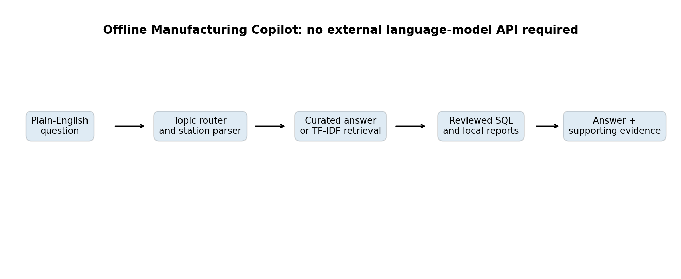
Figure 75.1 — Legacy deterministic/retrieval architecture snapshot. The current Copilot additionally uses LangChain retrieval and local Ollama models as described above.
Mode | Strength | Typical use
Local Handbook RAG | LangChain retrieves handbook evidence and local Ollama generates a cited explanation. | Project walkthroughs, model interpretation, limitations and non-technical summaries.
LangChain retrieval | Lexical shortlist, Ollama embeddings, temporary in-memory vector index and top-3 evidence retrieval. | Finding relevant sections across the complete Markdown handbook.
Legacy SQL template | Deterministic parameterized queries over the SQLite database. | Exact station risk, bottleneck, route and model-metric tables.

Example interaction and evidence review
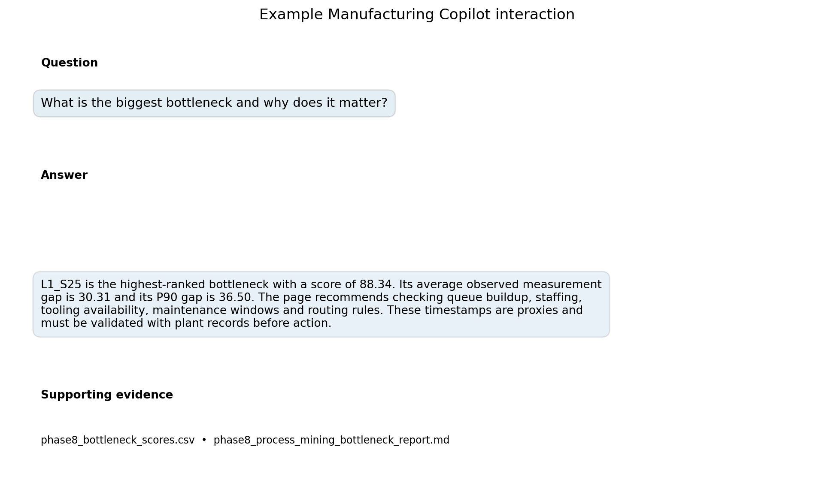
Figure 75.2 — Example evidence-backed interaction. Current answers also show the Ollama model name and the handbook excerpts retrieved by LangChain.

Recommended questions
- Explain the eight product families in non-technical language.
- Why was LightGBM selected as the production-safe model?
- What are the main predictive signals linked to failure risk?
- What is the biggest bottleneck and why does it matter?
- Why is L3_S32 risky?
- What are the most critical process nodes?
- What are the leading candidate failure-propagation routes?
- Explain the whole project to a plant manager.
Copilot limitation: The Copilot summarizes reviewed evidence. It does not observe live production, create new causal proof, approve corrective action or replace engineering judgement.

Evidence quality checklist
1. Confirm the answer identifies the local model and review the LangChain handbook references displayed beneath it.
2. Open every retrieved excerpt and verify that it directly supports the claim beside its [1], [2] or [3] citation.
3. Prefer deterministic SQL-template answers for exact ranked tables and use RAG for explanation and navigation.
4. Refine broad questions with a model name, metric, station, family or phase when the retrieved excerpts are not specific enough.
5. Verify important decisions against the relevant dashboard table, source report and responsible engineer; never act only on generated text.
Repository evidence: `src/copilot/langchain_handbook.py`, `app/project_streamlit_dashboard.py`, `src/copilot/query_engine.py`, `app/requirements.txt`, `Bosch_Handbook_md/`, and `data/database/manufacturing_copilot.db`.

Dashboard Operations, Troubleshooting and Final Checklist

Common issues
Symptom | Likely cause | Action
App stops with missing database | `manufacturing_copilot.db` has not been built. | Run the Phase 11 database builder, then relaunch Streamlit.
A page shows stale values | SQLite or CSV/JSON artifacts were not refreshed. | Regenerate the upstream phase and rebuild the database.
Line filter returns no rows | The chosen page/table has no matching line evidence. | Restore all lines and check the source table.
Charts look correct but conclusions conflict | Different views answer different questions. | Separate prediction, bottleneck, graph and historical-rate evidence.
Copilot answer is too general | The retrieved handbook chunks are too broad or do not closely match the question. | Add a model, metric, station, product family or phase name, then verify the displayed excerpts.
Business impact looks unexpectedly high | Cost or effectiveness assumptions dominate. | Review inputs and run sensitivity scenarios.
Ollama is not ready | The local service is stopped or `nomic-embed-text` is missing. | Start Ollama and run `ollama pull nomic-embed-text`.
Ollama cannot answer | The local chat model is unavailable or returned an empty/error response. | Run `ollama pull llama3.2:1b`, retry, and check the local Ollama service.

Final review checklist
1. Confirm the dashboard database and report manifests were refreshed from the same repository state.
2. Verify the Overview cards before presenting diagnostic pages.
3. Keep the production-safe LightGBM separate from research-only models.
4. Use family, bottleneck, SHAP and graph pages as complementary evidence.
5. Label test alerts as predictions with unknown outcomes.
6. Label timestamp measures as relative proxies and throughput efficiency as non-OEE.
7. Present Business Impact as an assumption-driven scenario.
8. Use the Copilot to navigate evidence, not to authorize actions.

Primary dashboard files
File | Role
app/project_streamlit_dashboard.py | Unified Streamlit interface and page navigation.
src/data/phase11_manufacturing_copilot.py | Builds the SQLite evidence database.
src/copilot/query_engine.py | Reviewed parameterized SQL answers.
src/copilot/langchain_handbook.py | Loads and chunks handbook Markdown, builds the local retriever, invokes Ollama and returns cited sources.
src/dashboard/business_impact.py | Transparent business-impact scenario calculations.
reports/phase11_database_manifest.json | Table and row-count audit.
reports/phase12_executive_dashboard_manifest.json | Executive KPI audit.
Bosch_Handbook_md/ | Primary Markdown evidence corpus used by the LangChain retriever.
app/requirements.txt | Pins LangChain, langchain-ollama and text-splitter runtime dependencies.

Final principle: The dashboard is a governed communication layer over reviewed project artifacts. Its value comes from making evidence understandable while preserving the limits of a public benchmark dataset.

DASHBOARD UPDATE

Full-Data Advanced ML and Test Prediction Features
This update documents the new panels implemented in the Prediction Model page and the evidence now available to dashboard users. It should be read together with Chapters 68-75.

New full-data benchmark panel
- Best validated model card for the controlled full-data benchmark.
- Completed split-rate benchmark table with split ratio, present rate, MCC, PR-AUC, precision, recall and runtime.
- Current final model metadata: LightGBM, 80/20 split, present rate 0.0025 and 283 features.
- Explicit warning that test labels are unavailable and test outcomes cannot be evaluated locally.
Current selected-model field | Value
Model | LightGBM
Validation split | 80/20 stratified
Training rows | 946,997
Validation rows | 236,750
Numeric present rate | 0.0025
Numeric candidates | 908
Final features | 283
Validation MCC | 0.2102
Validation PR-AUC | 0.1271
Validation precision | 21.52%
Validation recall | 21.44%
Final inference threshold | 0.754167

New test-outcome prediction panel
The dashboard reads advanced_ml_test_prediction_summary.csv and advanced_ml_top_test_risk_preview.csv. It presents scoring volume, alert volume, alert rate and the highest-risk product IDs. These are prediction outputs, not labelled performance results.
Displayed value | Current result | Correct interpretation
Test products scored | 1,183,748 | All unlabelled test products
Test alerts | 7,003 | Products above the frozen threshold
Alert rate | 0.5916% | Estimated review workload
Highest-risk products | Top 25 preview | Priority ranking for inspection simulation
Test accuracy / MCC | Not available | Response labels are hidden

Required language Say predicted alert, risk score, or inspection priority. Do not say confirmed failure, test accuracy, or test defect rate.

Legacy versus current model views
The dashboard still contains the historical Phase 6 comparison and Phase 10 diagnostic table because they explain project evolution. The new full-data benchmark is the preferred final prediction evidence. The interface and handbook must keep the sources visibly separated.
View | Status | Use
Original Phase 6 MCC 0.3386 | Historical sampled benchmark | Explain initial model development; do not use as the current clean estimate
Full-data LightGBM MCC 0.2102 | Selected final benchmark | Report validation performance and justify final test scoring
Phase 10 advanced diagnostics | Research/supporting | Anomaly, graph and trajectory investigation only

Updated page-by-page review flow
- Open Overview and confirm the historical failure baseline and current scoring population.
- Open Prediction Model and read the full-data benchmark before the legacy comparison.
- Review the top-risk test products as a ranking; do not infer true outcomes.
- Use Product Families and Process Mining to add route and flow context.
- Use Explainability for predictive drivers and verify timestamp/proxy warnings.
- Use Knowledge Graph for structural prioritization, not causal blame.
- Run Business Impact with current alert-rate evidence and explicit cost assumptions.
- Use the Copilot to locate evidence, then verify the source table before acting.

Updated dashboard evidence files
File | Dashboard purpose
reports/advanced_ml_test_prediction_summary.csv | Selected configuration, scoring volume, alerts, alert rate and threshold
reports/advanced_ml_top_test_risk_preview.csv | Highest-risk test products
adv ML Models/phase6_full_clean_split_rate_metrics_completed.csv | Controlled benchmark results
reports/advanced_ml_model_card.json | Governed final model metadata
data/processed/advanced_ml_test_predictions.parquet | Complete probability and binary-alert output
models/advanced_ml_lightgbm_80_20_0_0025.joblib | Final serialized prediction bundle

Final dashboard principle The dashboard is an evidence and decision-support layer. It does not reveal hidden test labels, prove physical causes, provide official OEE, or authorize factory actions.

