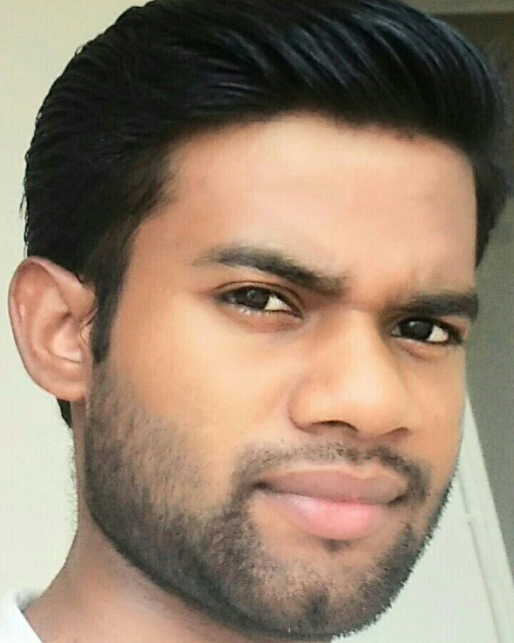
Present Address:
Kurji Kothiyan Vikash Nagar Road No.:-9
Patna - 800010

Karan Kumar
B.E , Computer Science Engineering
Contact No. : - +919677418570
E-mail:- kkr31398@gmail.com

CAREER OBJECTIVE
To work in a firm with a professional work driven environment where I can utilize and apply my knowledge, skills which would enable me as a fresh graduate to grow while fulfilling organizational goals.

BASIC ACADEMIC CREDENTIALS

Qualification | Board/University | Year | Percentage
B.E (Computer Science Engineering) | KSR College Of engineering(Chennai) | 2015-2019 | 8.1 cgpa upto 4th sem
Intermediate | Amnour Inter High School (B.S.E.B)  Bihar | 2015 | 75%
High School | Amnour High School (B.S.E.B)  Bihar | 2013 | 83%

EXPERIENTIAL LEARNING (SUMMER INTERNSHIP PROGRAM)

    - Company Name :- Pingal Tech Pvt. Ltd.
    - Project Title :- c, java
    - Duration :- one Months (24th May’10 to 24th june’10)

PROJECTS REPORT

- E- Commerce using C

IT PROFICIENCY

- Microsoft Office Word, Microsoft Office Excel, Microsoft Office Power Point
- Internet Browsing
- Language: C++ , C,Oracle,Java ,Python
- General and graphic application: HTML, JAVA Script,Css

CO-/EXTRA –CURRICULAR ACTIVITIE

- Executive Member of sport Committee in school days.
- Executive Member of Event Organizing Committee in College.

ACHIEVEMENTS

- Won a bronze medal in relay in zonal in year 2011.
- Actively participated in various sports activities for inter school.

INTERPERSONAL SKILL

  - Ability to rapidly build relationship and set up trust.
  - Confident and Determined
  - Ability to cope up with different situations.

REFERENCES

Samta Singh, Head of Department, School of Computer Science Engineering, KSRCE.
Thamarai Selvan, Assistant Professor, School of Computer Science Engineering, KSRCE
Rashmi Misra Assistant Professor, School of Computer Science Engineering, KSRCE

PERSONAL DETAILS

- Father’s Name :- Krishna Shah
Permanent Address :- Kurji Kothiyan Vikash Nagar Road No.:-9
- Date of Birth :- 31st march,1998
- Language Known :- English, Hindi, Punjabi, Bengali &Tamil
- Marital Status :- Single
- Nationality/Religion :- Indian / Hindu
- Interest & Hobbies :- Internet browsing ,dance, badminton and reading novel

DECLARATION

I do hereby declare that the above information is true to the best of my knowledge.

Place: Patna V. Karan Kumar
Date: 24.12.2017 (Signature)

