Defining the Total Magnitude of Upsets in a Given NCAA Basketball Tournament
Defining the

INTRODUCTION

The goal of this project is to define a metric for quantifying the total magnitude of upsets in a given year of the NCAA tournament. The basic idea is that the upset (or non-upset) level of a given game will be a function of the tournament seedings (1-16) of the wining and losing teams. Applying this function to every game in the tournament results in a single number representing the “Upset Magnitude” for that year.

For any given upset metric there exists a maximum possible upset level – where the underdog wins every game – and a minimum possible upset level – where the favorite wins every game. The upset rating for a given year can be calculated as a percentage within that benchmark range.

I explored a number of different ideas for defining this upset metric. My first attempt (see Metric 01, below) was to determine the average winning seed for each round and then take the average over all rounds. My second attempt (see Metric 02) was similar to the first except that I took the average winning seed over all games, instead of all rounds. For my third attempt (Metric 03) I shifted to looking at the difference between the winning and losing seed, taking the average over all games. With Metric 04, I looked at the losing seed divided by the sum of the winning and losing seeds, averaged over all games. Finally, for Metric 5 I…

Conclusions and further research.

- Have to assume seedings are accurate to within some manageable margin of error
- Have to try to determine upset probabilities from historical data
- The Upset Magnitude may be the inverse of the Probability (which I discovered empirically)
- Originally had Min and Max wrong for Metric 5

Odds and ends

- Trying to define exactly “half” upsets (sMID)
- The mystery of Metric 5: why do seed differentials averaged each round, and then summed over all rounds, always converge to an integer by the 4th or 5th round?!

CANDIDATE METRICS

- Winning Seeds Averaged Per Round

The first metric I defined took the average winning seed as an indicator of the upset magnitude for a given year. The higher the average winning seed, the greater the upset level. Initially I looked at the average winning seed for each round, and then later I combined them by averaging together the per-round results. The formula for this metric looks like this:

01a) Winning Seeds Averaged Over All Rounds

I define “N” as the number of rounds being averaged, and “num_teams_{R}” as the number of teams in round R. Since I start with the seed matchups for round 2 (which also indicate who won in round 1), and since there are 7 rounds for a 64-team NCAA tournament, N, in this case, equals 6.

In order to get a sense of scale for the number generated by my upset metric, I first decided to compare it to the minimum possible upset level for a tournament. This is derived quite simply by feeding in a set of data where there are no upsets (which I call “sMIN”). I then subtracted my upset number from…

- Minimum Average Winning Seed

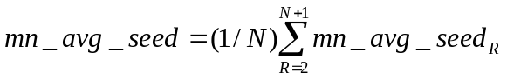

mn_avg_seed_{R} = (mn_avg_seed_{R-1} + 0.5)/2 (1 < R < 6)
mn_avg_seed₁ = 8.5 (R = 1)
mn_avg_seed_{6,7} = 1 (R = 6, R = 7)
N = R_{mx} – 1 (for a full 63-game tournament N = 6 and R_{mx} = 7)

- Number of Teams Per Round

num_teams_{R} = 2^{7-R}

- Sum of All Winning Seeds Per Round

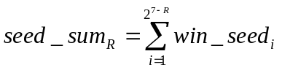

- Winning Seeds Averaged Over All Rounds

My first impulse was to just subtract the average remaining seed from the minimum average seed and use that for the metric.

- Difference Between Average and Minimum Average Winning Seed

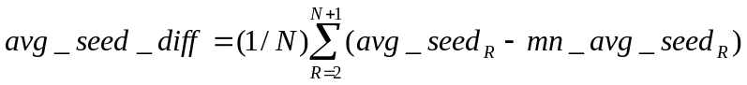

- Maximum Average Winning Seed Per Round

mx_avg_seed_{R} = 17 – mn_avg_seed_{R}

- Difference Per Round Normalized as a Percentage

avg_seed_pct_{R} = 100*(avg_seed_{R} – mn_avg_seed_{R})/(17 – 2*mn_avg_seed_{R})

- Difference Over All Rounds Normalized as a Percentage

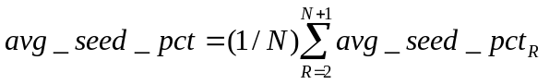

- Winning Seeds Averaged Over All Games

- Total Number of Games Played

For a normal 64-team NCAA tournament this will be 63, but I use a more general expression that allows for partial results after earlier rounds, before the tournament is finished.

games_played = 64 – 2^{7-Rmx} (where R_{mx} is the last round played)

I don’t use the above expression in the program, however, because the number of seeds I read into the program from the data file will be equivalent to the number of games played (since there will be one winning seed per game played.)

- Winning Seeds Averaged Over All Games

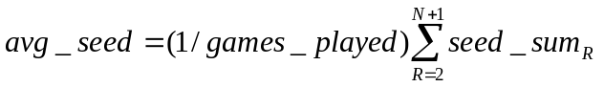

- Minimum Winning Seed Summed Over All Games

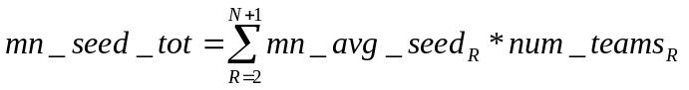

- Maximum Winning Seed Summed Over All Games

mx_seed_tot = 17*games_played – mn_seed_tot

- Difference Over All Games Normalized as a Percentage

avg_seed_pct = 100*(seed_sum – mn_seed_tot)/(17*games_played – 2*mn_seed_tot)

- Seed Differentials Averaged Over All Games

- Seed Differential

seed_diff_{i} = win_seed_{i} – lose_seed_{i}

- Probability As A Function Of Seed Differential

prob_{i} = 0.5 – C* seed_diff_{i} (C = 1/30.5)

- Seed Differential Summed Over All Games

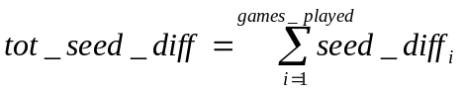

- Average Probability Over All Games

- Minimum Seed Differential Summed Over All Games

min_seed_diff = games_played – 2*mn_seed_tot + f(N)

f(N) = 0 (N < 5)
f(N) = N – 3 (N = 5, 6)

- Maximum Seed Differential Summed Over All Games

max_seed_diff = –min_seed_diff

- Difference Over All Games Normalized as a Percentage

avg_seed_diff = 100*(tot_seed_diff – mn_seed_diff)/(–2*mn_seed_diff)

- Normalized Seed Factor Averaged Over All Games

- Probability As A Function Of Normalized Seed Factor

norm_prob_{i} = losing_seed_{i}/(win_seed_{i} + lose_seed_{i})

- Normalized Seed Factor Summed Over All Games

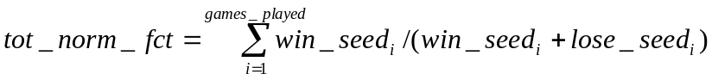

- Minimum Normalized Seed Factor Summed Over All Games

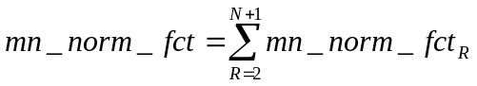
mn_norm_fct_{R} = num_teams_{R}*mn_avg_seed_{R}/(4*mn_avg_seed_{R} – 1) (1 < R < 6)
mn_norm_fct_{6,7} = num_teams_{R}/2 (R = 6, R = 7)

- Maximum Normalized Seed Factor Summed Over All Games

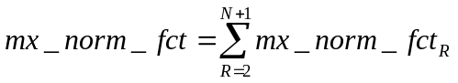
mx_norm_fct_{R} = num_teams_{R}*(17 – mn_avg_seed_{R})/(35 – 4*mn_avg_seed_{R}) (1 < R < 6)
mx_norm_fct_{6,7} = num_teams_{R}/2 (R = 6, R = 7)

- Normalized Seed Factor Over All Games Normalized as a Percentage

avg_norm_fct = 100*(tot_norm_fct – mn_norm_fct)/(mx_norm_fct – mn_norm_fct)

RESULTS AND CONCLUSIONS

APPENDIX

- Mathematical Derivations

  - Minimum Average Remaining Seed

This is the average remaining seed for each round if there are no upsets in any of the previous rounds. Therefore it is the minimum possible value. We can see that seeds 1-8 will be left if there are no upsets in the first round, 1-4 will be left if that trend continues in the second round, and so on. For round one we can see that 1 + 8 = 9, 2 + 7 = 9, 3 + 6 = 9, and 4 + 5 = 9, giving an average in each case – and an overall minimum possibly average – of 4.5. Similar reasoning applies to the remaining rounds.

Round Number | 1 | 2 | 3 | 4 | 5 | 6 | 7
Minimum Average Seed | 8.5 | 4.5 | 2.5 | 1.5 | 1 | 1 | 1
Difference Between Rounds | N/A | -4 | -2 | -1 | -0.5 | 0 | 0

N
min_avg_seed = ∑
_{R = 1}

- Perl and Script Notes

Used a heap data structure to store the seed data.

