Box Diagram (nitrogen in dashed green, carbon in blue solid):

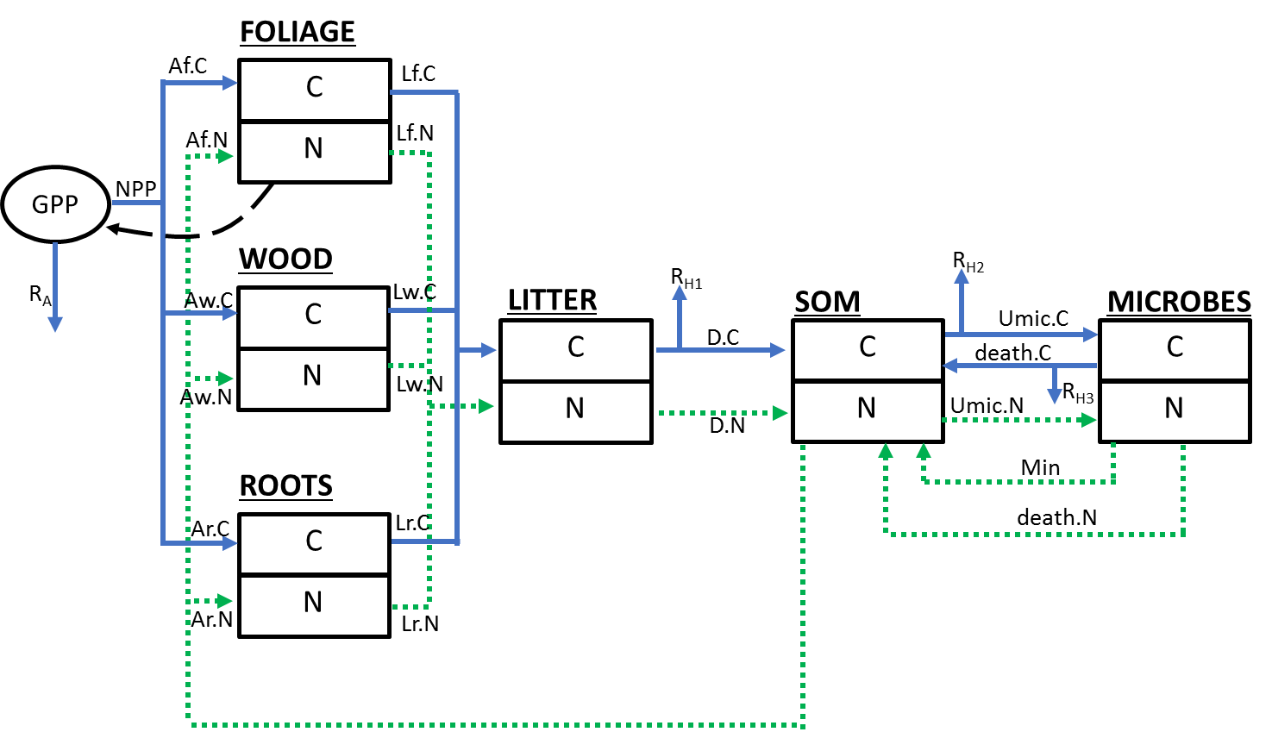

* Assuming closed N cycle because of the extreme N limitation in the Arctic
* Assuming steady state for each pool

Forcing Variables:

1. PAR (mol) – used to calculate GPP using PLIRTLE model
2. Temperature (°C) – used to calculate GPP using PLIRTLE model

Pools:

1. C.f and N.f– plant foliage C and N (g C m-2 and g N m-2)
2. C.r and N.r– plant root C and N (g C m-2 and g N m-2)
3. C.lit and N.lit – litter C and N (g C m-2 and g N m-2)
4. C.som and N.som – SOM C and N (g C m-2 and g N m-2)
5. C.mic and N.mic – Microbe C and N (g C m-2 and g N m-2)

Process equations:

1. units: g C m-2 day-1 (Shaver et al. 2013)
2. units: g C m-2 day-1
3. units: g C m-2 day-1
4. units: g C m-2 day-1

Fluxes:

1. Af.C = Assimilation of carbon to foliage

$θ_{1}NPP$ units: g C m-2 day-1

1. Aw.C = Assimilation of carbon to wood

units: g C m-2 day-1

1. Ar.C = Assimilation of carbon to roots

units: g C m-2 day-1

1. Af.N= Assimilation of carbon to foliage

$θ_{1}×θ_{14}(C.f+C.r+C.w)×\frac{N.som}{θ_{15}+N.som}×{{q10}_{p}}^{T/10}$ units: g N m-2 day-1

1. Aw.N= Assimilation of carbon to wood

units: g N m-2 day-1

1. Ar.N= Assimilation of carbon to roots

units: g N m-2 day-1

1. Lf.C – Litterfall of foliage carbon

$θ_{16}×C.f$ units: g C m-2 day-1

1. Lf.C – Litterfall of foliage nitrogen

$θ_{16}×N.f$ units: g N m-2 day-1

1. Lw.C – Litterfall of wood carbon

$θ_{17}×C.r$ units: g C m-2 day-1

1. Lw.N – Litterfall of wood nitrogen

$θ_{17}×N.r$ units: g N m-2 day-1

1. Lr.C – Litterfall of root carbon

$θ_{18}×C.r$ units: g C m-2 day-1

1. Lr.N – Litterfall of root nitrogen

$θ_{18}×N.r$ units: g N m-2 day-1

1. D.N – Decomposition of nitrogen from litter

$θ_{3}×N.lit×{q10}^{T/10}$ units: g N m-2 day-1

1. D.C – Decomposition of carbon from litter

$θ_{4}×C.lit×{q10}^{T/10}$ units: g C m-2 day-1

1. Umic.C – Microbial uptake of carbon

$θ_{8}×C.mic×\frac{C.som}{θ_{9}+C.som}×{q10}^{T/10}$ units: g C m-2 day-1

1. Umic.N – Microbial uptake of nitrogen

$θ_{10}×C.mic×\frac{N.som}{θ_{9}+N.som}×{q10}^{T/10}$ units: g N m-2 day-1

1. death.C – Carbon from death of microbes

$θ_{11}×C.mic$ units: g C m-2 day-1

1. death.N – Nitrogen from death of microbes

$θ_{11}×N.mic$ units: g N m-2 day-1

1. Min – Mineralization

units: g N m-2 day-1

1. Rh1 – Heterotrophic respiration flux 1 (from decomposition of litter)

$θ_{5}×C.lit×{q10}^{T/10}$ units: g C m-2 day-1

1. Rh2 – Heterotrophic respiration flux 2 (from microbial uptake of C)

$θ_{6}×C.som×{q10}^{T/10}$ units: g C m-2 day-1

1. Rh3 – Heterotrophic respiration flux 3 (from microbial death)

$θ_{7}×C.mic×{q10}^{T/10}$ units: g C m-2 day-1

Differential Equations:

$\frac{dC.f}{dt}=Af.C-Lf.C$

$\frac{dN.f}{dt}=Af.N-Lf.N$

$\frac{dC.w}{dt}=Aw.C-Lw.C$

$\frac{dN.w}{dt}=Aw.N-Lw.N$

$\frac{dC.r}{dt}=Ar.C-Lr.C$

$\frac{dN.r}{dt}=Ar.N-Lr.N$

$\frac{dC.lit}{dt}=Lf.C+Lr.C-D.C- R_{h1}$

$\frac{dN.lit}{dt}=Lf.N+Lr.N-D.N$

$\frac{dC.som}{dt}=D.C+death.C-Umic.C- R_{h2}$

$\frac{dN.som}{dt}=D.N+death.N-Umic.N- Af.N-Ar.N$

$\frac{dC.mic}{dt}=Umic.C- R_{h3}-death.C$

$\frac{dN.mic}{dt}=Umic.N-Min- death.N$