Box Diagram (nitrogen in dashed green, carbon in blue solid):

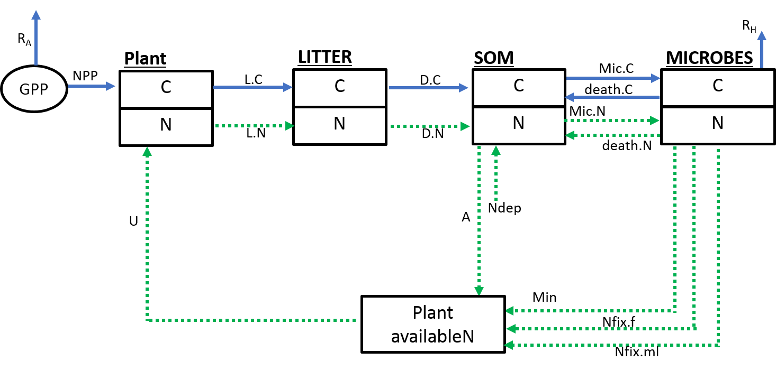

Forcing Variables:

1. PAR (mol) – used to calculate GPP using PLIRTLE model
2. Temperature (°C) – used to calculate GPP using PLIRTLE model
3. LAI – used to calculate GPP using PLIRTLE model

Differential equations:

$\frac{dPlantC}{dt}=NPP-L.C$

$\frac{dPlantN}{dt}=U-L.N$

$\frac{dLitterC}{dt}=L.C-D.C$

$\frac{dLitterN}{dt}=L.N-D.N$

$\frac{dSOMC}{dt}=D.C-Mic.C$

$\frac{dSOMN}{dt}=D.N+Ndep-A-Mic.N$

$\frac{dNFIXMICC}{dt}=Mic.C-Rh$

$\frac{dNFIXMICN}{dt}=Mic.N-Nfix.f-Nfix.ml-Min$

**Table 1:** Model flux and process equations and parameter values. All fluxes are in units of g C or N m-2 day-1. T is soil temperature in ºC, and Q10 = 2.

|  |  |  |  |
| --- | --- | --- | --- |
|  | **Description** | **Equations** | **Parameters** |
| **GPP** | Gross primary productivity | $\frac{Pmax}{k}×\frac{Pmax+E×PAR}{Pmax+E×PAR×e^{(-k×LAI)}}×\frac{{10}^{-6}mol}{μmol}×\frac{ 34 g {CO}_{2}}{mol}×\frac{86400 s}{day}$ | Pmax = 14.747 µmol CO2 m-2 s-1  E = 0.041 µmol CO2  µmol PAR-1  k = 0.5 m2 m-2 |
| **NPP** | Net primary productivity | $$GPP×CUE$$ | --- |
| **Ra** | Autotrophic respiration | $$GPP×(1-CUE)$$ | --- |
| **L.C and  L.N** | Litter fall |  | θ1 = 0.0065 day-1 |
| **D.C and  D.N** | Decomposition |  | θ2 = 0.07 day-1 |
| **Rh** | Heterotrophic respiration |  | θ3 = 0.05 day-1 |
| **Nfix.ml** | N fixation from mosses and lichens |  | θ4 = 0.004 g N m-2 day-1 |
| **Min** | Mineralization |  | θ5 = 0.0018 g N m-2 day-1 |
| **Ndep** | N deposition | 0.00015 g N m-2 day-1 | --- |
| **Mic.C** | Microbial C uptake |  | θ6 = 0.2 day-1 |
| **Mic.N** | Microbial N uptake |  | θ7 = 0.02 day-1 |
| **A** | N available to plants |  | θ8 = 0.05 day-1 |
| **Nfix.f** | N fixation from fungi |  | θ9 = 0.0025 g N m-2 day-1 |
| **U** | Plant N uptake |  | θ10 = 6 day-1 |
| **death.C and death.N** | Microbial death |  | θ11 = 0.004 day-1 |
| **CUE** | Carbon use efficiency |  | θ12 = |
| **S** | Temperature scalar | $$\frac{1}{1+e^{-T}}$$ | --- |

