**NEED A COOL NAME!!**

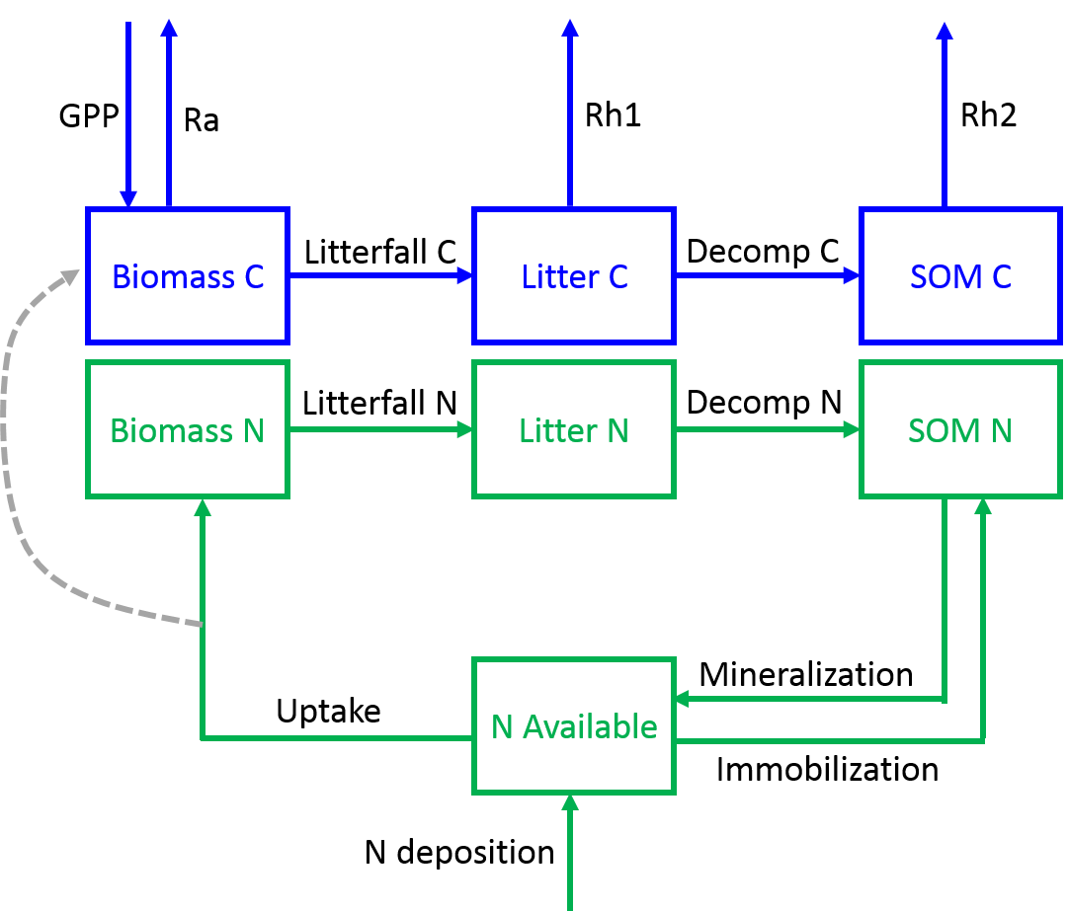

***Model Inputs:***

1. Air Temperature
2. PAR available to plants (albedo filtered PAR)
3. Normalized Difference Vegetation Index (NDVI)

***State Variables:***

**Table 1: Description of state variables (pools) in model**

|  |  |  |  |
| --- | --- | --- | --- |
| State Variable | Description | Starting Value | Units |
| *Biomass_C* | Carbon in biomass | 200 | g C m-2 |
| *Biomass_N* | Nitrogen in biomass | 3.5 | g N m-2 |
| *Litter_C* | Carbon in litter | 110 | g C m-2 |
| *Litter_N* | Nitrogen in litter | 3 | g N m-2 |
| *SOM_C* | Carbon in SOM | 2000 | g C m-2 |
| *SOM_N* | Nitrogen in SOM | 57 | g N m-2 |
| *Available_N* | Nitrogen available to plants | 0.1 | g N m-2 |

***Parameters:***

**Table 2: Model Parameters**

|  |  |  |  |
| --- | --- | --- | --- |
| Parameter | Description | Starting Value | Units |
| *Pmax* | Maximum photosynthetic rate | 1.5 | µmol CO2 g N-1 s-1 |
| *E0* | Light use efficiency | 0.03 | µmol CO2 µmol PAR-1 |
| *k* | Beer’s law extinction coefficient | 0.5 | m2 m-2 |
| *LitterRate* | Litterfall rate of foliage | 0.0014 | day-1 |
| *q10* | Microbial Q10 | 2 | unitless |
| *DecompRateC* | SOM C decomposition rate constant | 0.00008 | day-1 |
| *DecompRateN* | SOM N decomposition rate constant | 0.00017 | day-1 |
| *RespRateSOM* | Rate of heterotrophic respiration from SOM decomp | 1 E -6 | day-1 |
| *RespRateL* | Rate of heterotrophic respiration from Litter decomp | 0.0025 | day-1 |
| *kplant.n* | Half saturation constant of N uptake by plants | 0.11 | g N m-2 |
| *UptakeRate* | Plant N uptake rate constant | 0.01 | day-1 |
| *Uptake5* | Uptake rate constant that results in CUE = 0.5 | 0.003 | day-1 |
| *FCM* | Grams of foliar C per m2 leaf | 130 | g C m-2 leaf |
| *retrans* | Proportion of N retranslocated | 0.9 | unitless |

***Differential Equations:***

$\frac{dAvailable_N}{dt}=Mineralization+N_deposition-Immobilization -Uptake$

$\frac{dBiomass_C}{dt}=GPP -Ra -Litterfall_C$

$\frac{dBiomass_N}{dt}=Uptake-Litterfall_N$

$\frac{dLitter_C}{dt}=Litterfall_C-Rh1 -Decomp_C$

$\frac{dLitter_N}{dt}=Litterfall_N -Decomp_N$

$\frac{dSOM_C}{dt}=Decomp_C-Rh2$

$\frac{dSOM_N}{dt}=Decomp_N-Immobilization-Mineralizaiton$

***Process Equations and Fluxes:***

1. *NDVI scalar for seasonality (unitless, ranges from 0 to 1): $s.ndvi=\frac{NDVI(t)-NDVImin}{NDVImax-NDVImin}$*
2. *Leaf Area Index (LAI, m2 m-2)*

1. *Gross Primary Productivity calculated using the PLIRTLE model (g C m-2 day-1):*
2. *Uptake of nitrogen by plants (g N m-2 day-1)*

1. *Carbon use efficiency (CUE) as a function of N uptake (unitless)*

$CUE= \frac{Uptake}{Uptake5}×0.5$

1. *Autotrophic respiration (Ra, g C m-2 day-1):*
2. *Heterotrophic respiration from litter decomposition (g C m-2 day-1):*
3. *Heterotrophic respiration from SOM decomposition (g C m-2 day-1):*
4. *Litterfall of carbon (g C m-2 day-1):*
5. *Litterfall of nitrogen (g N m-2 day-1):*

1. *Decomposition of carbon in litter (g C m-2 day-1):*

1. *Decomposition of nitrogen in litter (g N m-2 day-1):*

1. *Immobilization of nitrogen (g N m-2 day-1)*

1. *Mineralization of nitrogen (g N m-2 day-1)*

1. *Nitrogen deposition = 0.0017 (g N m-2 day-1)*
2. *Ecosystem respiration (Re, g C m-2 day-1)*

1. *Net ecosystem exchange (NEE, g C m-2 day-1)*