**CCaN – Coupled Carbon and Nitrogen Model**

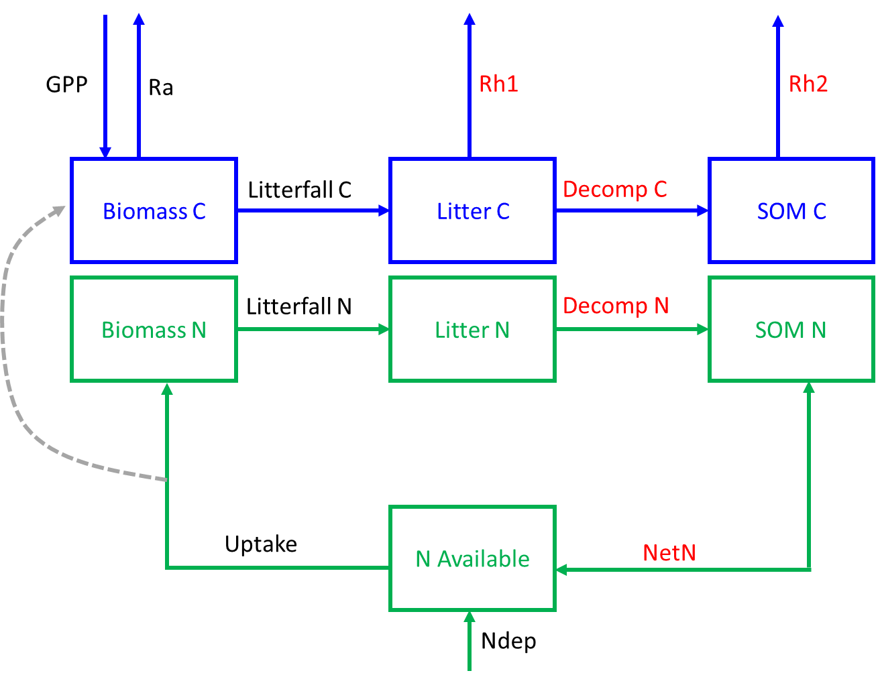

***Github link:*** *https://github.com/kkremers/C-N-model.git*

***Model Inputs:***

1. Air Temperature
2. PAR available to plants (albedo filtered PAR)

***State Variables:***

**Table 1: Description of state variables (pools) in model**

|  |  |  |  |
| --- | --- | --- | --- |
| State Variable | Description | Starting Value | Units |
| *Biomass_C* | Carbon in biomass | 200 | g C m-2 |
| *Biomass_N* | Nitrogen in biomass | 3.5 | g N m-2 |
| *Litter_C* | Carbon in litter | 90 | g C m-2 |
| *Litter_N* | Nitrogen in litter | 2 | g N m-2 |
| *SOM_C* | Carbon in SOM | 2000 | g C m-2 |
| *SOM_N* | Nitrogen in SOM | 57 | g N m-2 |
| *Available_N* | Nitrogen available to plants | 0.1 | g N m-2 |

***Parameters:***

**Table 2: Model Parameters**

|  |  |  |  |
| --- | --- | --- | --- |
| Parameter | Description | Current Value | Units |
| Pmax | Maximum photosynthetic rate | 1.18 | mol C m-2 day-1 |
| E0 | Light use efficiency | 0.03 | mol C mol PAR-1 |
| k | Beer’s light extinction coefficient | 0.63 | m2 m-2 |
| q10 | Microbial Q10 | 2 | unitless |
| LAC | Leaf area per gram foliar C | 0.012 | m2 leaf g-1 C leaf |
| LitterRate | Litterfall rate of foliage | 0.0012 | day-1 |
| DecompRateC | Litter C decomposition rate constant | 0.00004 | day-1 |
| DecompRateN | Litter N decomposition rate constant | 0.00017 | day-1 |
| retrans | Proportion of N retranslocated | 0.9 | unitless |
| RespRateSOM | Rate of heterotrophic respiration from SOM decomp | 0.000001 | day-1 |
| RespRateL | Rate of heterotrophic respiration from Litter decomp | 0.0025 | day-1 |
| kCUE | Half saturation constant of N uptake limited CUE | 0.001 | g N m-2 day-1 |
| CUEmax | Maximum carbon use efficiency | 0.6 | unitless |
| kplant | Half saturation constant of N uptake by plants | 0.11 | g N m-2 |
| UptakeMax | Maximum uptake rate | 0.01 | g N m-2 day-1 |

***Differential Equations:***

$\frac{dAvailable_N}{dt}=NetN+N_deposition -Uptake$

$\frac{dBiomass_C}{dt}=GPP -Ra -Litterfall_C$

$\frac{dBiomass_N}{dt}=Uptake-Litterfall_N$

$\frac{dLitter_C}{dt}=Litterfall_C-Rh1 -Decomp_C$

$\frac{dLitter_N}{dt}=Litterfall_N -Decomp_N$

$\frac{dSOM_C}{dt}=Decomp_C-Rh2$

$\frac{dSOM_N}{dt}=Decomp_N-NetN$

***Process Equations and Fluxes:***

1. *GDD scalar for seasonality (unitless, ranges from 0 to 1): $s.GDD=\frac{delGDD(t)-delGDDmin}{delGDDmax-delGDDmin}$* where delGDD is the daily change in GDD (or daily slope)
2. *Leaf Area Index (LAI, m2 m-2)*

1. *Gross Primary Productivity calculated using the PLIRTLE model (g C m-2 day-1):*
2. *Uptake of nitrogen by plants (g N m-2 day-1)*

1. *Carbon use efficiency (CUE) as a function of N uptake (unitless)*

$CUE= \frac{CUEmax×Uptake}{kCUE+Uptake}$

1. *Autotrophic respiration (Ra, g C m-2 day-1):*
2. *Heterotrophic respiration from litter decomposition (g C m-2 day-1):*
3. *Heterotrophic respiration from SOM decomposition (g C m-2 day-1):*
4. *Litterfall of carbon (g C m-2 day-1):*
5. *Litterfall of nitrogen (g N m-2 day-1):*

1. *Decomposition of carbon in litter (g C m-2 day-1):*

1. *Decomposition of nitrogen in litter (g N m-2 day-1):*

1. *Net transfer of N from SOM to available N pool (g N m-2 day-1)*

1. *Nitrogen deposition = 0.00008 (g N m-2 day-1)*
2. *Ecosystem respiration (Re, g C m-2 day-1)*

1. *Net ecosystem exchange (NEE, g C m-2 day-1)*