<https://support.rackspace.com/how-to/what-is-a-cdn/>

CDNs generally push the Edge Network closer to end users. The Edge Network grows outward from the origin server by the addition of co-location facilities, bandwidth, and servers. CDNs choose the best location for serving content while optimizing for performance. They may choose locations that are the fewest hops or fewest number of network seconds away from the requesting client. CDNs choose the least expensive locations while optimizing for cost. CDNs use various techniques such as web caching, server-load balancing, and request routing to achieve the optimization goals.

* Because closer is better, web caches store popular content closer to the user. These shared network appliances reduce bandwidth requirements, reduce server load, and improve the client response times for content stored in the cache.
* Server-load balancing uses a web switch, content switch, or multilayer switch to share traffic among a number of servers or web caches. In CDNs, the switch is assigned a single virtual IP address. Traffic arriving at the switch is then directed to one of the real web servers attached to the switch. This has the advantages of balancing load, increasing total capacity, improving scalability, and providing increased reliability by redistributing the load of a failed web server and providing server health checks.

**Global Server Load Balancing**

* Request routing directs client requests to the content source best able to serve the request. This may involve directing a client request to the service node that is closest to the client, or to the node with the most capacity. A variety of algorithms for Global Server Load Balancing (shown in preceding diagram) are used to route the request. Choosing the closest service node is done using a variety of techniques including proactive probing and connection monitoring.

<https://gtmetrix.com/why-use-a-cdn.html>

A Content Delivery Network (CDN) works by providing alternative server nodes for users to download resources (usually static content like images and JavaScript). These nodes spread throughout the world, therefore being geographically closer to your users, ensuring a faster response and download time of content due to reduced [latency](http://en.wikipedia.org/wiki/Latency_(engineering))

A CDN is essentially a network of geographically dispersed servers. Each CDN node (also called Edge Servers) caches the static content of a site like the images, CSS/JS files and other structural components. The majority of an end-user's page load time is spent on retrieving this content, and so it makes sense to provide these "building blocks" of a site in as many server nodes as possible, distributed throughout the world.

When a user requests your site, the node closest in proximity to user will deliver the static content, ensuring the shortest distance for the data to travel (reduced latency), therefore providing the fastest site experience.

## Why do I need a CDN?

The number one reason for using a CDN is **to improve your user's experience in terms of speed**, and as we know - [speed matters](https://gtmetrix.com/faq.html#faq-why)!

Ensuring a consistent experience for all your users is important.

A website may be hosted in a particular region, but have the majority of its users coming from an entirely different region - for example, if your site is hosted in North America, GTmetrix might report fast speeds based on our default test location, but if a good chunk of your users come from Europe, their speed will not be as fast as you experience it to be.

# **Why use a Content Delivery Network (CDN)?**

## Overview

A Content Delivery Network (CDN) works by providing alternative server nodes for users to download resources (usually static content like images and JavaScript). These nodes spread throughout the world, therefore being geographically closer to your users, ensuring a faster response and download time of content due to reduced [latency](http://en.wikipedia.org/wiki/Latency_(engineering)).

While CDNs are an appropriate solution for most websites looking for speed improvements, not every site necessarily needs one. It's important to understand how CDNs work and ultimately, if the benefits are worth the cost of adding one.

##### **How does your website score?**

Top of Form

Analyze

Bottom of Form

## What is a CDN?

A CDN is essentially a network of geographically dispersed servers. Each CDN node (also called Edge Servers) caches the static content of a site like the images, CSS/JS files and other structural components. The majority of an end-user's page load time is spent on retrieving this content, and so it makes sense to provide these "building blocks" of a site in as many server nodes as possible, distributed throughout the world.

When a user requests your site, the node closest in proximity to user will deliver the static content, ensuring the shortest distance for the data to travel (reduced latency), therefore providing the fastest site experience.

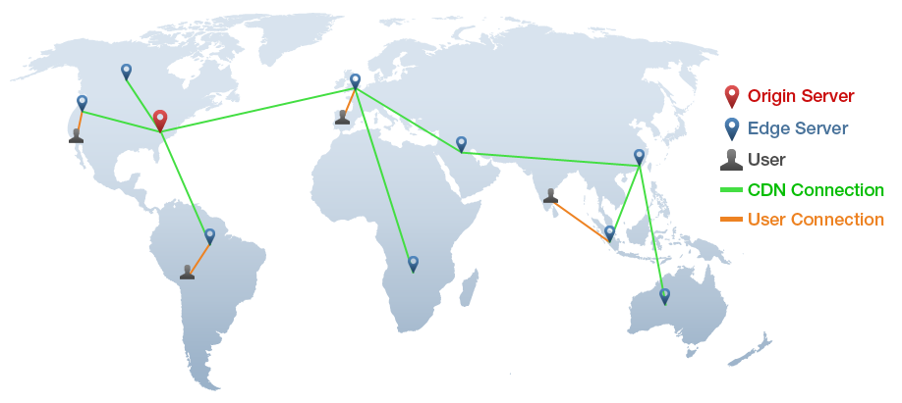

*CDNs ensure users download data from servers that are closest in geographical proximity.*

## Why do I need a CDN?

The number one reason for using a CDN is **to improve your user's experience in terms of speed**, and as we know - [speed matters](https://gtmetrix.com/faq.html#faq-why)!

Ensuring a consistent experience for all your users is important.

A website may be hosted in a particular region, but have the majority of its users coming from an entirely different region - for example, if your site is hosted in North America, GTmetrix might report fast speeds based on our default test location, but if a good chunk of your users come from Europe, their speed will not be as fast as you experience it to be.

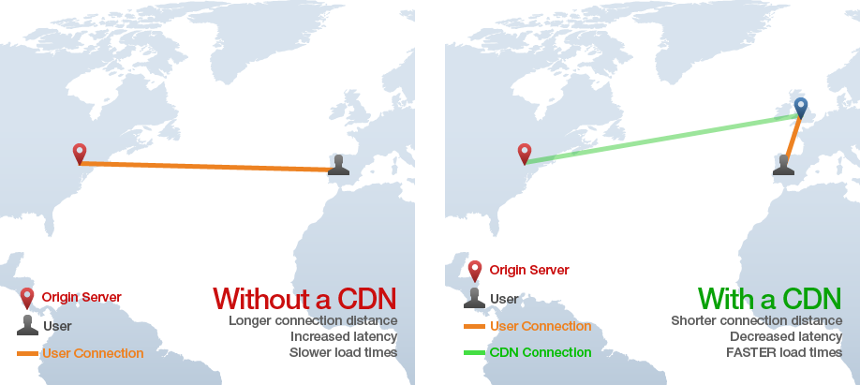

*With a CDN, users from a European point of origin will be able to download your site's static content faster from a closer server node.*

A global CDN would allow users from a European point of origin to download static content from a closer source. Instead of spanning the Atlantic ocean to retrieve data, they can connect to a server in say, London, UK, to get the same data. This reduces latency and provides a faster loading of your website.

CDNs not only ensure a faster experience to your users, but they also help to prevent site crashes in the event of traffic surges - CDNs help to distribute bandwidth across multiple servers, instead of allowing one server to handle all traffic.

### **...But CDNs Aren't Absolutely Necessary.**

Most users who analyze their site through GTmetrix will have YSlow's "[Use a Content Delivery Network (CDN)](https://gtmetrix.com/use-a-content-delivery-network-cdn.html)" recommendation triggered. This leads many to believe that it's a recommendation on the same level as "[Minify CSS/HTML](https://gtmetrix.com/minify-css.html)" or "[Specify image dimensions](https://gtmetrix.com/specify-image-dimensions.html)".

**A CDN is a "next-level" optimization.** It is not a self-contained fix like a server configuration change or a small code modification. CDNs are paid, third-party services, and so implementation of one depends on your goals, priorities and budget.

Will a CDN help improve the performance of your website? Yes. Is it absolutely required for all websites? No. You can still provide a decently fast website experience without a CDN - but it would probably be faster with one.

For those with heavy traffic, mission critical websites and that are serious about providing the best possible experience for all their users, a CDN should be a crucial part of their optimization strategy.

**CDNs are easy to implement**. Essentially, you need to tell the CDN which files (typically static resources) it needs to mirror. Then, you need to configure your site to send requests to those files to the CDN for handling.

For anybody using a popular CMS (WordPress, Drupal, Magento, etc), plugins exist to set your site up for to a CDN provider without much difficulty. Other implementations may involve modifying DNS records and changing the name servers of your domain.

[Reasons to Choose NodeJs for Your Business in 2016 | CDN Solutions Group Blog](https://www.cdnsol.com/blog/how-businesses-seeing-nodejs-development-in-2016/)www.cdnsol.com

2:33 PM

<https://www.google.co.uk/url?sa=t&rct=j&q=&esrc=s&source=web&cd=26&cad=rja&uact=8&ved=0ahUKEwjo6LOu2dPSAhVTGhQKHaKHB3s4FBAWCFgwBQ&url=https%3A%2F%2Fwww.cdnsol.com%2Fblog%2Fhow-businesses-seeing-nodejs-development-in-2016%2F&usg=AFQjCNFBwIZgZIyca6qklS9Z2MH1i06o3w>www.google.co.uk

2:33 PM

[What's the best static asset management library for Express.js or Node.js? - Quora](https://www.quora.com/Whats-the-best-static-asset-management-library-for-Express-js-or-Node-js)www.quora.com

2:33 PM

<https://www.google.co.uk/url?sa=t&rct=j&q=&esrc=s&source=web&cd=25&cad=rja&uact=8&ved=0ahUKEwjo6LOu2dPSAhVTGhQKHaKHB3s4FBAWCFIwBA&url=https%3A%2F%2Fwww.quora.com%2FWhats-the-best-static-asset-management-library-for-Express-js-or-Node-js&usg=AFQjCNFS_aobX6M1hy1enYVLgSCua8FdNg>www.google.co.uk

2:33 PM

[Lodash](https://lodash.com/)lodash.com

2:32 PM

<https://www.google.co.uk/url?sa=t&rct=j&q=&esrc=s&source=web&cd=22&cad=rja&uact=8&ved=0ahUKEwjo6LOu2dPSAhVTGhQKHaKHB3s4FBAWCEQwAQ&url=https%3A%2F%2Flodash.com%2F&usg=AFQjCNGsKnLCYwhsMie1b9WLg7sWHzm1jQ>www.google.co.uk

2:32 PM

[https://www.google.co.uk/webhp?sourceid=chrome-instant&ion=1&espv=2&ie=UTF-8#q=cdn+node.js&start=20&*](https://www.google.co.uk/webhp?sourceid=chrome-instant&ion=1&espv=2&ie=UTF-8#q=cdn+node.js&start=20&*)www.google.co.uk

2:32 PM

[Show HN: Express CDN, deliver optimized and CDN-hosted assets in Node.js | Hacker News](https://news.ycombinator.com/item?id=4198028)news.ycombinator.com

2:32 PM

[Node.js express-cdn support on Nodejitsu (Example)](https://coderwall.com/p/zyt6zg/node-js-express-cdn-support-on-nodejitsu)coderwall.com

2:32 PM

<https://www.google.co.uk/url?sa=t&rct=j&q=&esrc=s&source=web&cd=17&cad=rja&uact=8&ved=0ahUKEwj5jI-Y2dPSAhXFwBQKHaFdAsU4ChAWCGcwBg&url=https%3A%2F%2Fnews.ycombinator.com%2Fitem%3Fid%3D4198028&usg=AFQjCNFftdgTLiHvSIVPa4Tkql3vqFa0tg>www.google.co.uk

2:32 PM

<https://www.google.co.uk/url?sa=t&rct=j&q=&esrc=s&source=web&cd=16&cad=rja&uact=8&ved=0ahUKEwj5jI-Y2dPSAhXFwBQKHaFdAsU4ChAWCGEwBQ&url=https%3A%2F%2Fcoderwall.com%2Fp%2Fzyt6zg%2Fnode-js-express-cdn-support-on-nodejitsu&usg=AFQjCNELwbjjGWbWRhKuQ6VA4qd28djTdQ>www.google.co.uk

2:32 PM

[A collection of nodejs CDN for Celestial Imperial | Abitrarily Idiosyncratic Randomness](https://herringtondarkholme.github.io/2016/06/07/how-to-config-node-cdn/)herringtondarkholme.github.io

2:32 PM

<https://www.google.co.uk/url?sa=t&rct=j&q=&esrc=s&source=web&cd=15&cad=rja&uact=8&ved=0ahUKEwj5jI-Y2dPSAhXFwBQKHaFdAsU4ChAWCFwwBA&url=https%3A%2F%2Fherringtondarkholme.github.io%2F2016%2F06%2F07%2Fhow-to-config-node-cdn%2F&usg=AFQjCNEo9y5a2DtmQdIWlM7BbgU-CKONiw>www.google.co.uk

2:32 PM

[Cloudinary - Cloud image service, upload, storage & CDN](http://cloudinary.com/)cloudinary.com

2:32 PM

<https://www.google.co.uk/url?sa=t&rct=j&q=&esrc=s&source=web&cd=14&cad=rja&uact=8&ved=0ahUKEwj5jI-Y2dPSAhXFwBQKHaFdAsU4ChAWCFYwAw&url=http%3A%2F%2Fcloudinary.com%2F&usg=AFQjCNHdB1vHvyak24JJorhTDwa62ngJPg>www.google.co.uk

2:32 PM

[Google](https://www.google.co.uk/webhp?sourceid=chrome-instant&ion=1&espv=2&ie=UTF-8#q=cdn+node.js&start=10&*)www.google.co.uk

2:32 PM

[Serving Static Files  |  App Engine flexible environment for Node.js docs  |  Google Cloud Platform](https://cloud.google.com/appengine/docs/flexible/nodejs/serving-static-files)cloud.google.com

2:32 PM

<https://www.google.co.uk/url?sa=t&rct=j&q=&esrc=s&source=web&cd=12&cad=rja&uact=8&ved=0ahUKEwj5jI-Y2dPSAhXFwBQKHaFdAsU4ChAWCEswAQ&url=https%3A%2F%2Fcloud.google.com%2Fappengine%2Fdocs%2Fflexible%2Fnodejs%2Fserving-static-files&usg=AFQjCNEWfHyy0eH3NKq9b-Q_0mJYV_d_Jg&bvm=bv.149397726,d.d24>www.google.co.uk

2:31 PM

[Rackspace Developer Center](https://developer.rackspace.com/sdks/node-js/)developer.rackspace.com

2:31 PM

<https://www.google.co.uk/url?sa=t&rct=j&q=&esrc=s&source=web&cd=10&cad=rja&uact=8&ved=0ahUKEwiklcKC2dPSAhVFVRQKHUatDDQQFgh8MAk&url=https%3A%2F%2Fdeveloper.rackspace.com%2Fsdks%2Fnode-js%2F&usg=AFQjCNFxszXnid5QMXaeRilNdOMcBsqQXw&bvm=bv.149397726,d.d24>www.google.co.uk

2:31 PM

[Get started with the Azure CDN SDK for Node.js | Microsoft Docs](https://docs.microsoft.com/en-us/azure/cdn/cdn-app-dev-node)docs.microsoft.com

2:31 PM

<https://www.google.co.uk/url?sa=t&rct=j&q=&esrc=s&source=web&cd=7&cad=rja&uact=8&ved=0ahUKEwiklcKC2dPSAhVFVRQKHUatDDQQFghoMAY&url=https%3A%2F%2Fdocs.microsoft.com%2Fen-us%2Fazure%2Fcdn%2Fcdn-app-dev-node&usg=AFQjCNHpWVEhTtC6a9CZwwxbj3F-Dkf8JA&bvm=bv.149397726,d.d24>www.google.co.uk

2:31 PM

[Versions: The Node.js Content Delivery Network | Nodejitsu Inc.](https://blog.nodejitsu.com/content-delivery-network-in-node-js/)blog.nodejitsu.com

2:31 PM

<https://www.google.co.uk/url?sa=t&rct=j&q=&esrc=s&source=web&cd=5&cad=rja&uact=8&ved=0ahUKEwiklcKC2dPSAhVFVRQKHUatDDQQFghbMAQ&url=http%3A%2F%2Fblog.nodejitsu.com%2Fcontent-delivery-network-in-node-js%2F&usg=AFQjCNEu3ObUvNLN28pygun4n2C-uUH2Ow&bvm=bv.149397726,d.d24>www.google.co.uk

2:31 PM

[CDN server written in node.js - Stack Overflow](http://stackoverflow.com/questions/16425263/cdn-server-written-in-node-js)stackoverflow.com

2:31 PM

<https://www.google.co.uk/url?sa=t&rct=j&q=&esrc=s&source=web&cd=4&cad=rja&uact=8&ved=0ahUKEwiklcKC2dPSAhVFVRQKHUatDDQQFghUMAM&url=http%3A%2F%2Fstackoverflow.com%2Fquestions%2F16425263%2Fcdn-server-written-in-node-js&usg=AFQjCNFYjL_VIBJHhkQUjAoTf20_LPZ1Yg&bvm=bv.149397726,d.d24>www.google.co.uk

2:31 PM

[express-cdn](https://www.npmjs.com/package/express-cdn)www.npmjs.com

2:31 PM

<https://www.google.co.uk/url?sa=t&rct=j&q=&esrc=s&source=web&cd=2&cad=rja&uact=8&ved=0ahUKEwiklcKC2dPSAhVFVRQKHUatDDQQFghIMAE&url=https%3A%2F%2Fwww.npmjs.com%2Fpackage%2Fexpress-cdn&usg=AFQjCNEnkR3C49OmFSUM_A3isXp3Ucx3jg&bvm=bv.149397726,d.d24>www.google.co.uk

2:31 PM

[cdn node.js - Google Search](https://www.google.co.uk/webhp?sourceid=chrome-instant&ion=1&espv=2&ie=UTF-8#q=cdn+node.js&*)www.google.co.uk

2:31 PM

[node-waves - cdnjs.com - The best FOSS CDN for web related libraries to speed up your websites!](https://cdnjs.com/libraries/node-waves)cdnjs.com

2:31 PM

<https://www.google.co.uk/url?sa=t&rct=j&q=&esrc=s&source=web&cd=17&cad=rja&uact=8&ved=0ahUKEwjruNz12NPSAhXCyRQKHYwoAMg4ChAWCGQwBg&url=https%3A%2F%2Fcdnjs.com%2Flibraries%2Fnode-waves&usg=AFQjCNGzbLP93sqKP4UiKyB81ymphl0AXA&bvm=bv.149397726,d.d24>www.google.co.uk

2:31 PM

[node-uuid - cdnjs.com - The best FOSS CDN for web related libraries to speed up your websites!](https://cdnjs.com/libraries/node-uuid)cdnjs.com

2:31 PM

<https://www.google.co.uk/url?sa=t&rct=j&q=&esrc=s&source=web&cd=16&cad=rja&uact=8&ved=0ahUKEwjruNz12NPSAhXCyRQKHYwoAMg4ChAWCF8wBQ&url=https%3A%2F%2Fcdnjs.com%2Flibraries%2Fnode-uuid&usg=AFQjCNFolJP8c4OOkAiDE6ZF7wQo1oVV6w&bvm=bv.149397726,d.d24>www.google.co.uk

2:30 PM

[express-simple-cdn](https://www.npmjs.com/package/express-simple-cdn)www.npmjs.com

2:30 PM

<https://www.google.co.uk/url?sa=t&rct=j&q=&esrc=s&source=web&cd=11&cad=rja&uact=8&ved=0ahUKEwjruNz12NPSAhXCyRQKHYwoAMg4ChAWCEEwAA&url=https%3A%2F%2Fwww.npmjs.com%2Fpackage%2Fexpress-simple-cdn&usg=AFQjCNGcEX-_InF_n4736xQecHufGGwnvQ&bvm=bv.149397726,d.d24>www.google.co.uk

2:30 PM

[https://www.google.co.uk/webhp?sourceid=chrome-instant&ion=1&espv=2&ie=UTF-8#q=cdn+node&start=10&*](https://www.google.co.uk/webhp?sourceid=chrome-instant&ion=1&espv=2&ie=UTF-8#q=cdn+node&start=10&*)

Express-cdn module with Amazon cloudfare? (amazons cdn)

<https://github.com/niftylettuce/express-cdn>

* 1. best theory info on cdn:

<https://www.quora.com/Whats-the-best-static-asset-management-library-for-Express-js-or-Node-js>

* 1. nodejitsu/versions

<https://blog.nodejitsu.com/content-delivery-network-in-node-js/>

<https://github.com/3rd-Eden/versions>

* 1. express cdn and express simple

<https://www.npmjs.com/package/express-cdn> and https://github.com/niftylettuce/express-cdn

<https://www.npmjs.com/package/express-simple-cdn>

google

<https://cloud.google.com/appengine/docs/flexible/nodejs/serving-static-files>

from 1:

So, in our layout file, we have something like:  
  
<head>  
  <link href="{{cdn '/css/app.css'}}">  
</head>  
  
In dev mode, that just resolves to http://localhost:3000/css/app.css but in production is [https://cdn-something.com/2.10.2...](https://cdn-something.com/2.10.22/css/app.css)  
  
Your templates/helpers basically need to know the current version of your project and  the base URL of the cdn.

<https://www.quora.com/Is-Node-js-overrated>

Mustache cdn search:

<https://github.com/janl/mustache.js/>

<http://stackoverflow.com/questions/31798037/unable-to-download-mustache-js-file-from-cdn>

the above link did the trick for testing alredy hosted mustache file – I replaced localhost

also, got a rest effect by pssing just the data needed to the template