Question 1:  Find out the mail | servers | of | the | following | domain
1.lbm.com
nslookup

>www .ibm.com

>set type=mx

>www .ibm.com

[§J P"nT"<l.,r-Win-2016 - VM• "' Worht.ation - " x

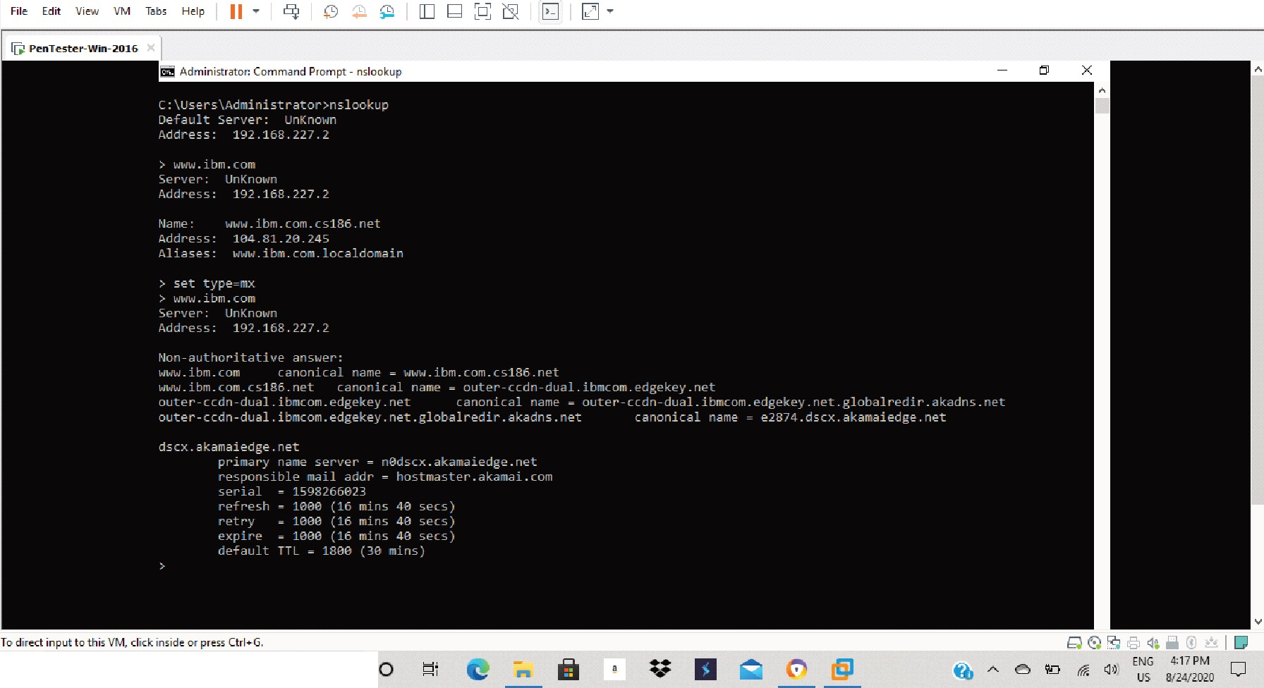
;; ,P Type here to search

nslookup

>www .wipro .com

>set type=mx

>www .wipro .com

[§J P"nT">t"r-Win-2016-VM, ar"Worlcrtation - Lii X

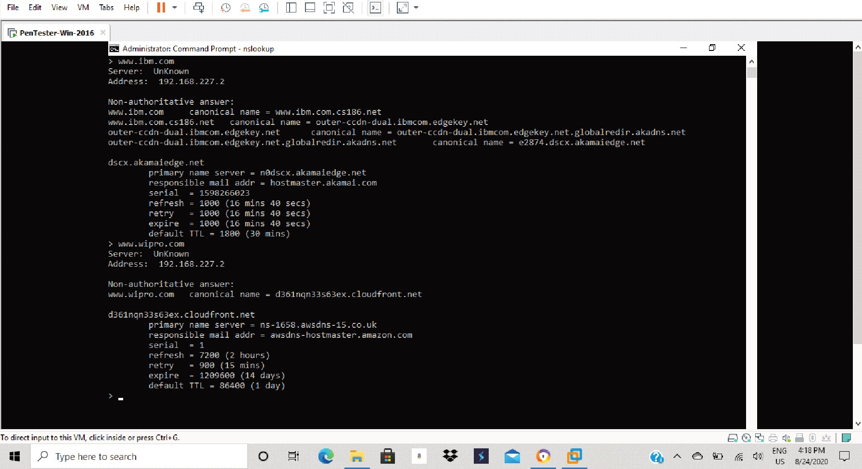

Find the locations, where these email servers are hosted.
those email's are not able to traced by email tracer insted of them i m trying other email
[§J P"nT"<l.,r-Win-2016 - VMw r" Worht...tion " x
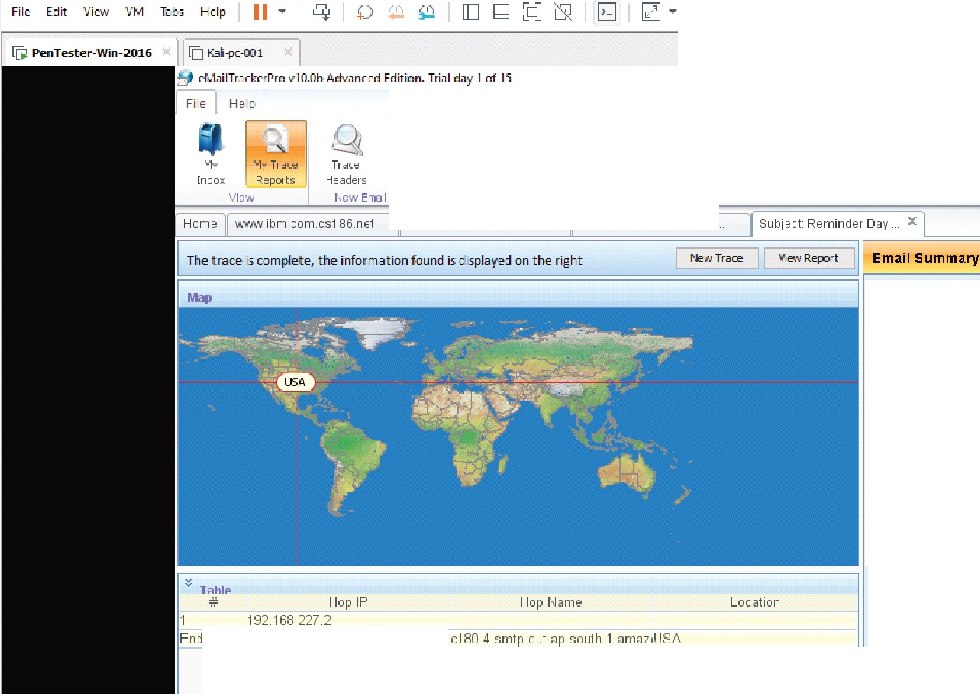
"x
E; ;ens
Tr aceEmailSettirq.; Address
Confisµ-e

hostmaste r_ aka maLcomSubject Te nable Nessu
From: lets11pgrade@ttm.ed11
To: Kkr.wa rior@email.com
Date: Sun,23Aug 2020 13 :07:09 t-0000
Subject:Reminder Day 4 I LetsUpgrade C)'ber Security E>.<
Location: LJ )A

Misdirected:No
Abuse Address: email-abuw@ a mazon.com
Abuse Reporting: To a utomatically generate an email abt
report
From IP: 75.223.1&0.4

System Information:
•There is no SMTP se rver running on t hi> sy>tem (t i
port is do5ed).
• There is no HTTP wrver running on this syst em (t t i5. clO'ied).
• There is no HTTPS s.erver running on this syst em ll
76 .223 . 1804
port is dosed).
• There is no FTP server running on t his syst em !t he v
fo direct input to thi VM, dick ins ide or p r e.is Ctr I + G.
;; ,P Type here to search

Question 3:

Scan and f ind out port numbers open 203 .163 .246. 23

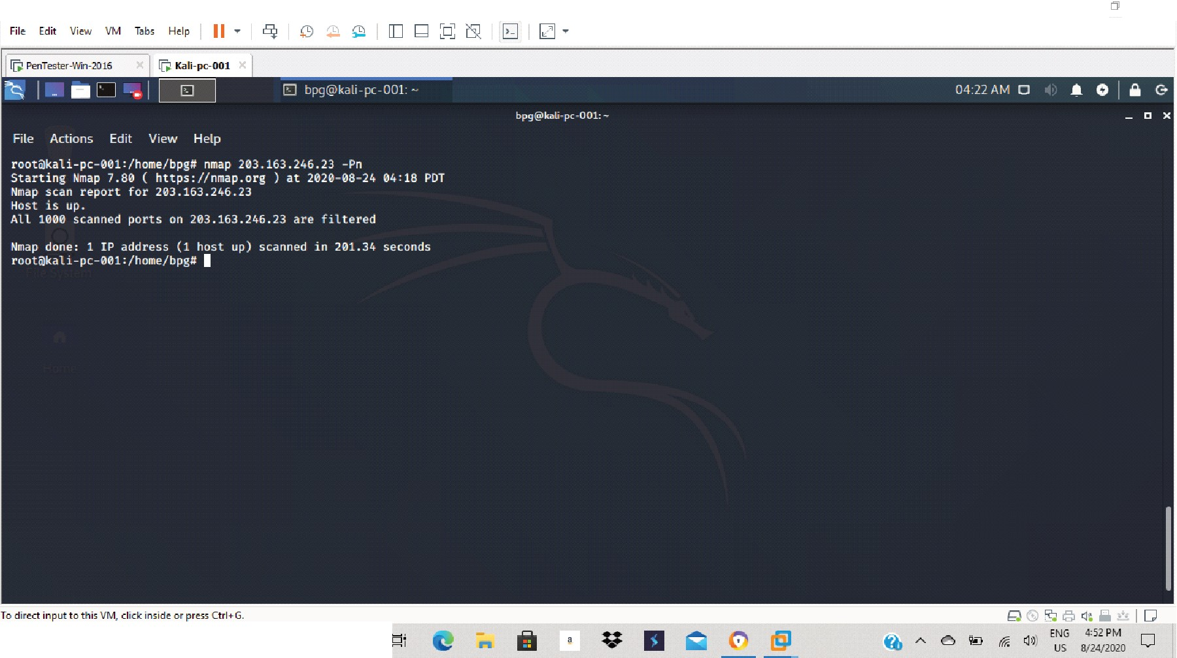
[§J k'.ali-pc-001 -VMwareWorlc>tation
x
II ,P Type here ta search
0

[§J k'.ali-pc-001 -VMwareWorkstation x
Fil e Edit V iew VM T bs Help II • i5!i [] (;] D ['9 IZJ •

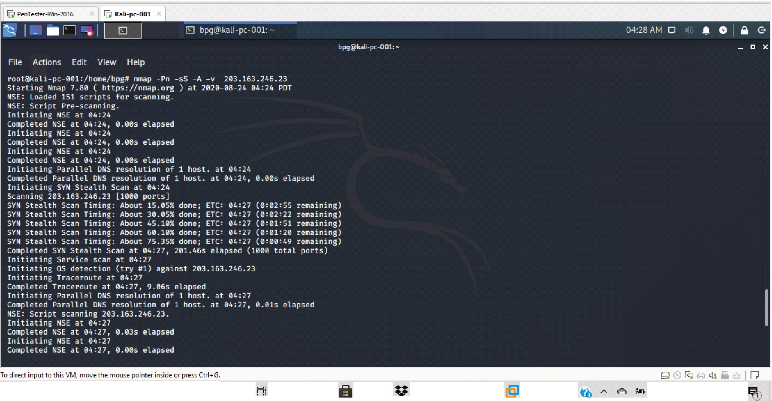
II ,P Type here ta search 0 a

ENG 4:SB P M
ra
I) US 8/24/2020

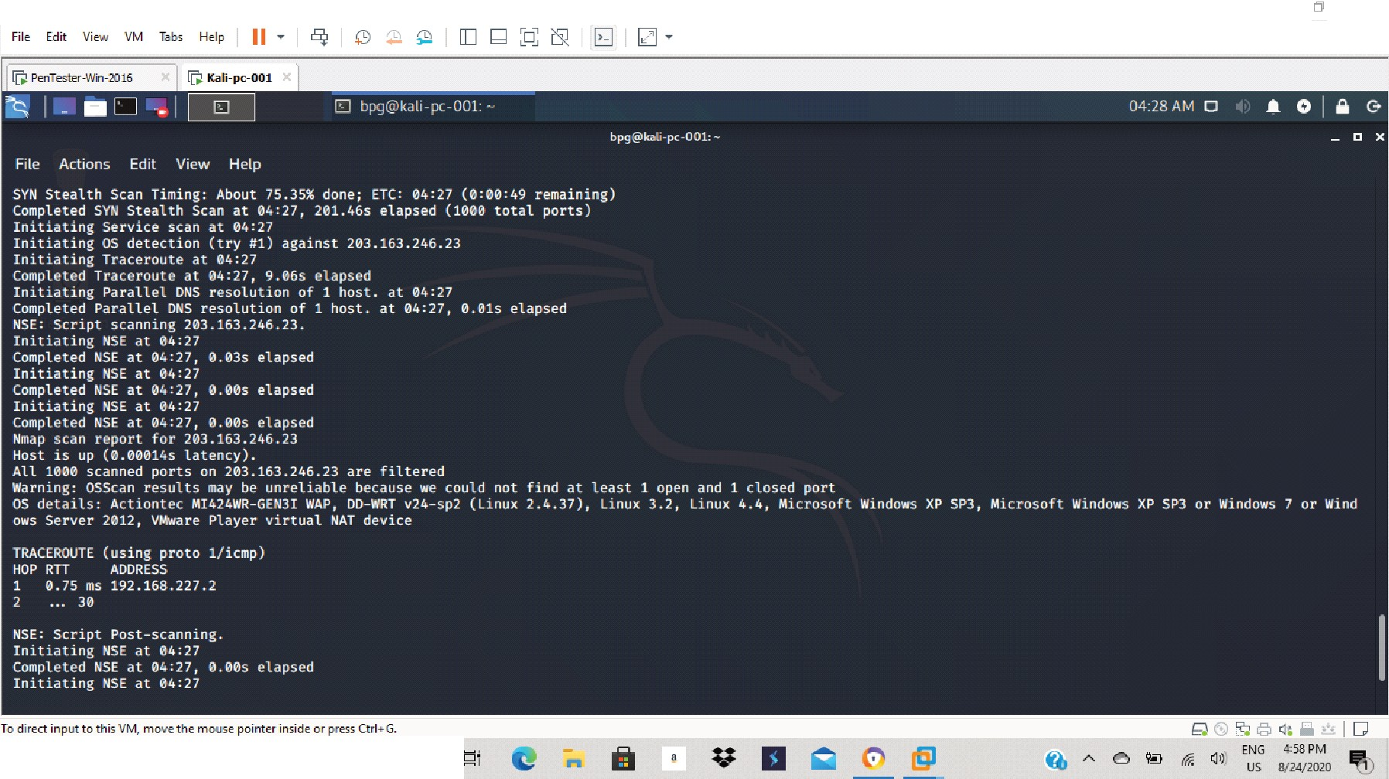
[§J k'.ali-pc-001 -VMwareWorlc>tation
x
II ,P Type here ta search
0

[§J k'.ali-pc-001 -VMwareWorkstation x
Fil e Edit V iew VM T bs Help II • i5!i [] (;] D ['9 IZJ •

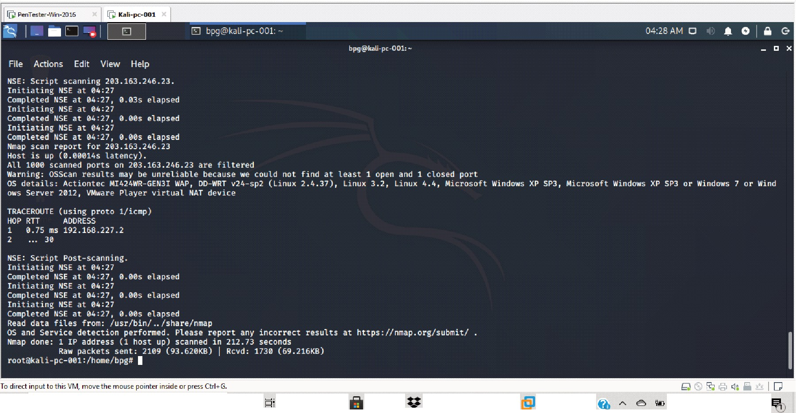
II ,P Type here ta search 0 a

ENG 4:SB P M
ra
I) US 8/24/2020

Question 4:

Install nessus in a VM and scan your laptop/desktop for CVE

nessus installation setup:

§PenTe•ter-Win-2016- VMw re Wortltion - " x

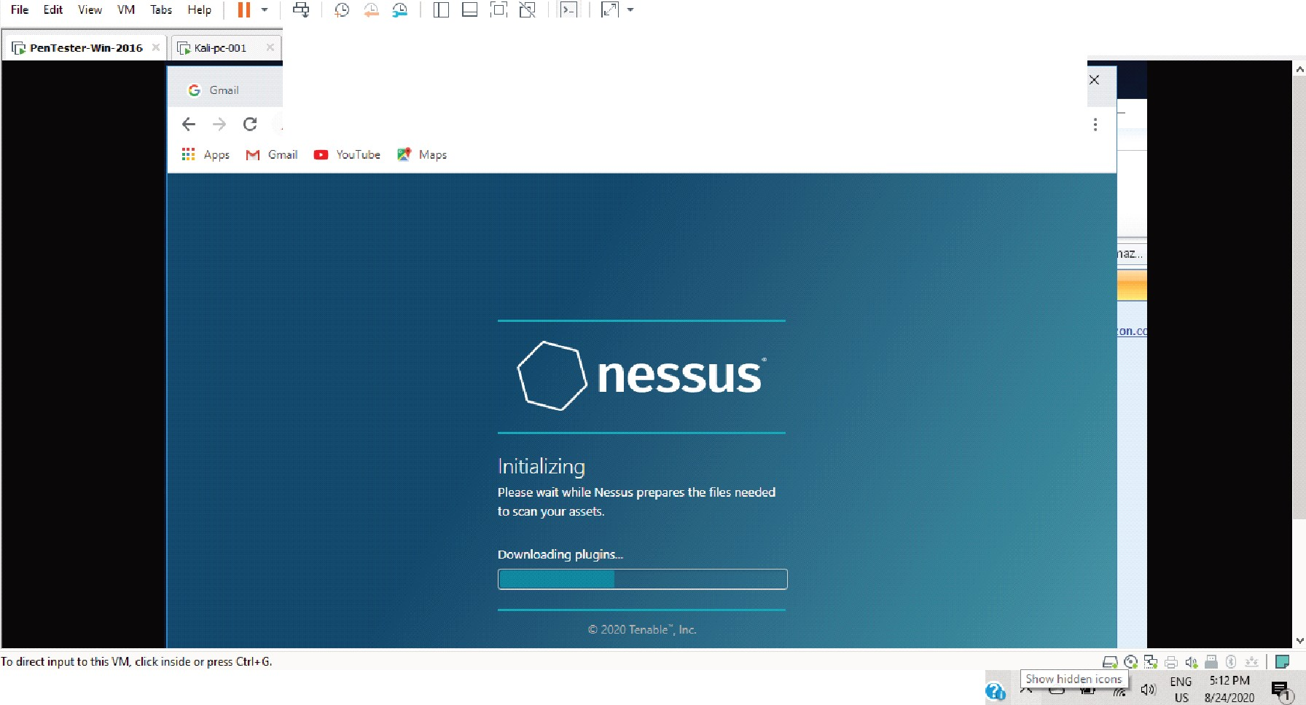
X I G A. ll domain•ow ned by hmtmi>•t X Q Ne ••u• / lnitilizing
<E- 7 c A Not sernre I localho.st:8834/#/
X +
fr e :
;; ,P Type here ta search
0
n
•
a
'@ .

Results of scan

my laptop:

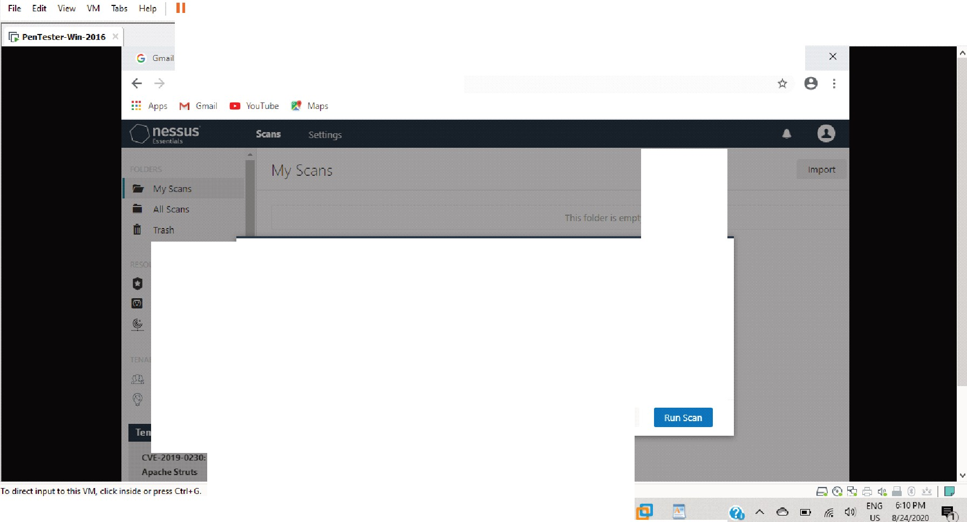
X I G) Dom<> inS.ecurity. DNS r<>1l<<>nC X Q Ne<rn<h<ential</ fold,.,... /My X + "

C A Not secure I localhost:8834/#/scans/folders/my -scans

Create a new scan

Policits PluginRules

My Host Discovery Scan Resu lts x
Nessus found the following hosts listed below from your list of targets (192.1158.227.129).

To launch your first basic network S<:an, select the tiosts you want to scan. Ttiese hosts count towards ttie 16

....
-
host limit onyour license.

DNS

Community
.....
""

., 192.163.227. 129 WIN-2POT021FDJH.localdomain

., DisuJ.,.ery Complete. Bad

II ,P Type here ta searcti

[§J PenTester-Win-2016- VMware Workstation

0 !:li

x

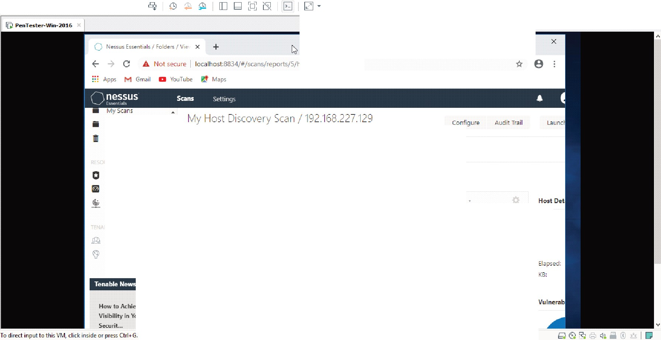
File E.dit View VM T bs Help11
D
C A Not secure I localtiost:8834/#/.scans/reports/5/hosts/2/vulnerabi lities
AH Scans
< Backto H osts
Trasti
Vu lne-rabi liti H 2
Policies
Filter ..
2 Vulnerabilrties
Plugin Rules
Family ·
scan ners
.
Nessus Scan Information Settings
Community
.
Ping ttie remote host
Researcti
IP:
DNS:
Start:
End:
How to Achieve 20/20
Viiibilityin VourOT Sec:urit ...

II ,P Type here ta search
v a
I
tit A
ra I) E. i :2;0

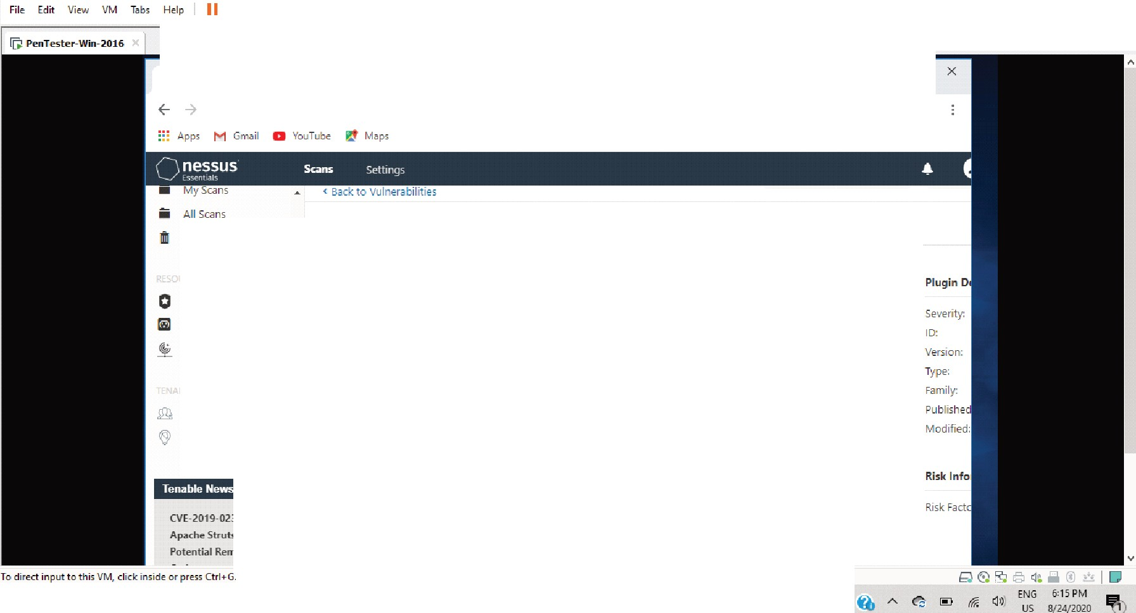
Q Nessus Es"Sent i al I Folders I V i e· X +
C A N ot seCLJre I localhost:8834/#/scans/reports/5/hosts/2/vulnerabi lities/19506
D
"' e

Vu lnera bi lities 2
Trash
-
N essus Scan I nformation
Polici es
Descr ipt ion
Plugin Ru l es
This plugin displays, for each tested host, i nforma tion a bout t he scan itsel f :
Scan ners
Co mm u n ity

Resea rch

CVE-2019-0230:
Af>"ch.,S Uuts
Potential Remote
The version of the p l ugin set
The type of scan ner (Ne:1.su or N es:1.u:1. Hom e-).
The version of the Nessus E ng ine.
The port scanner (s) used.
The pon ra ng e sca nned.
Whether credentia led or th i rd - party pa tch management checks are poss ible.
The date of t hesca n.
The du ration of t he sca n.
Ttie nu m ber of hosts scanned i n pa rallel.
The nu m be r of checks done i n parallel.
II ,P Type here ta search
0 !:li

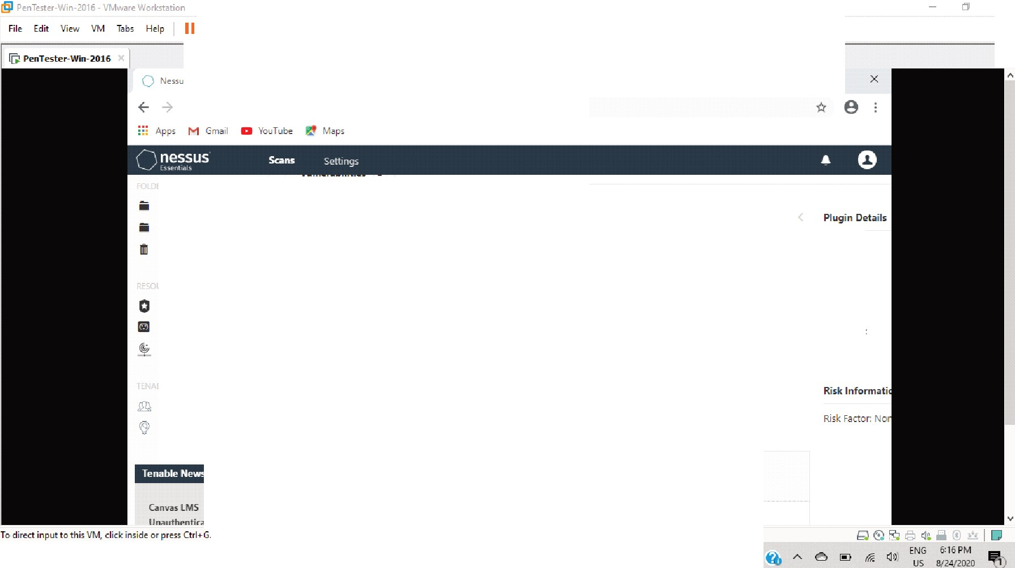
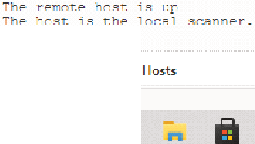
x

Q Ne sms hential• I Folder-. I V.e X + "

C A Not secure I localhost:8834/#/scans/reports/5/ ho:sts/2/vu lnerabilities/10180

My Scaris A ll Scans

-P i ng the remote host

Trash Oe5cription
Nessu s was able to determ i ne if the remote tiost is a li ve using one or more of !ti e following p i ng types :
Severity

Version:
'"'

Polic ies
- An ARP p i ng, provided U1e host is on the local subnet and N essus i s run ning over Ethern et Type:
Fam i ly :

Plu gin Ru l es - An ICMP p i ng

Scan ners - A TCP p ing, in wh ich the p lug i n send s lo the remote host a packet with the flag SYN, and t h.e host will reply with a RST or
a SYN/ACK.
Pu blished Mod if ied:

commu n i ty

- A UDP ping (e.g, DN S, RPC, and NTP}

Researc h

Output

Canvail M S
IJ ,..,11tt...nt ir.;itM Rlirnt

II ,P Type here ta search 0 t

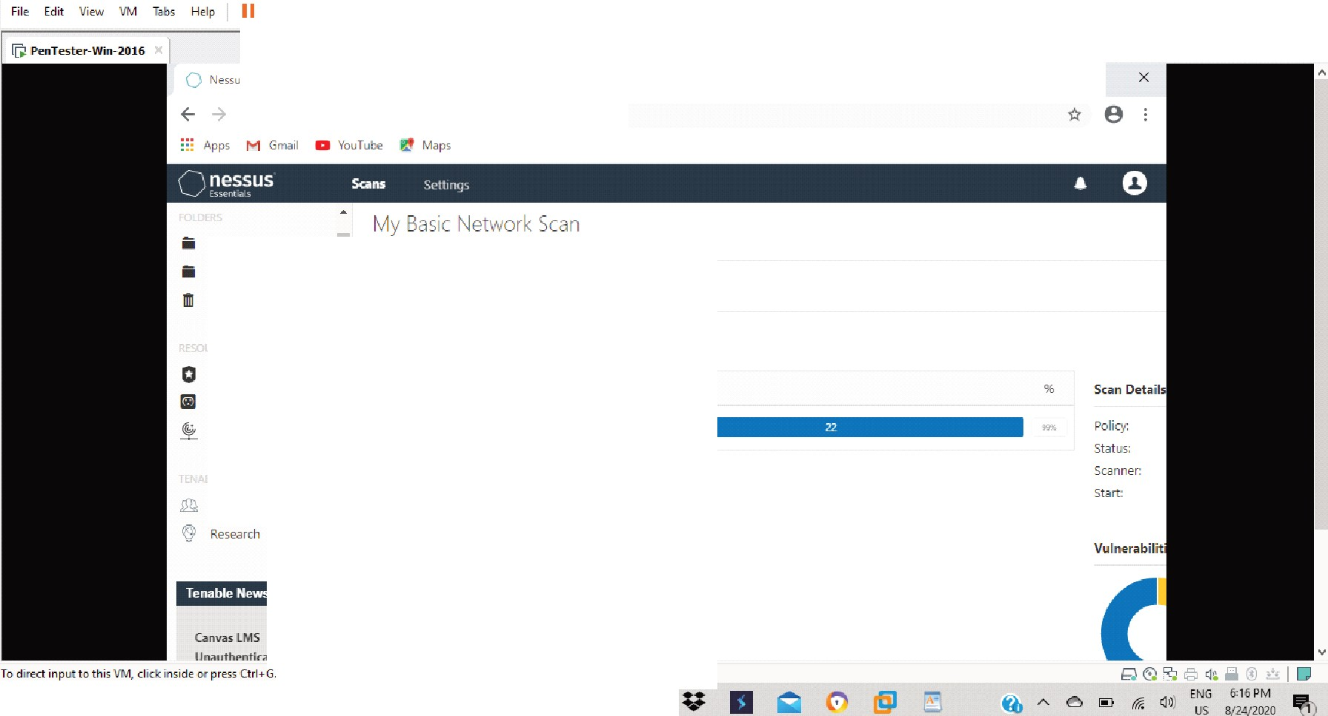
Q N «u< hntial< I Fold "' I Vie X +
"
C A Not secure I localhost:8834/#/scans/report.s/8/ host.s
My S.caris
A ll scans Trasti
( Back to My Scaris
H osts 1
VLilnerabi l it ies
10Histo ry 1
Filter '"'
1 Host
Polic ies

Plugin Ru les
VLil nerabilities •
commun i ty
C1111va ilM S
IJ n;mtt...nt i..-;il...t Rlirul

II ,P Type here ta searcti
0 !:li

[§J PenTester -Win-2016 - VMware Workstation x

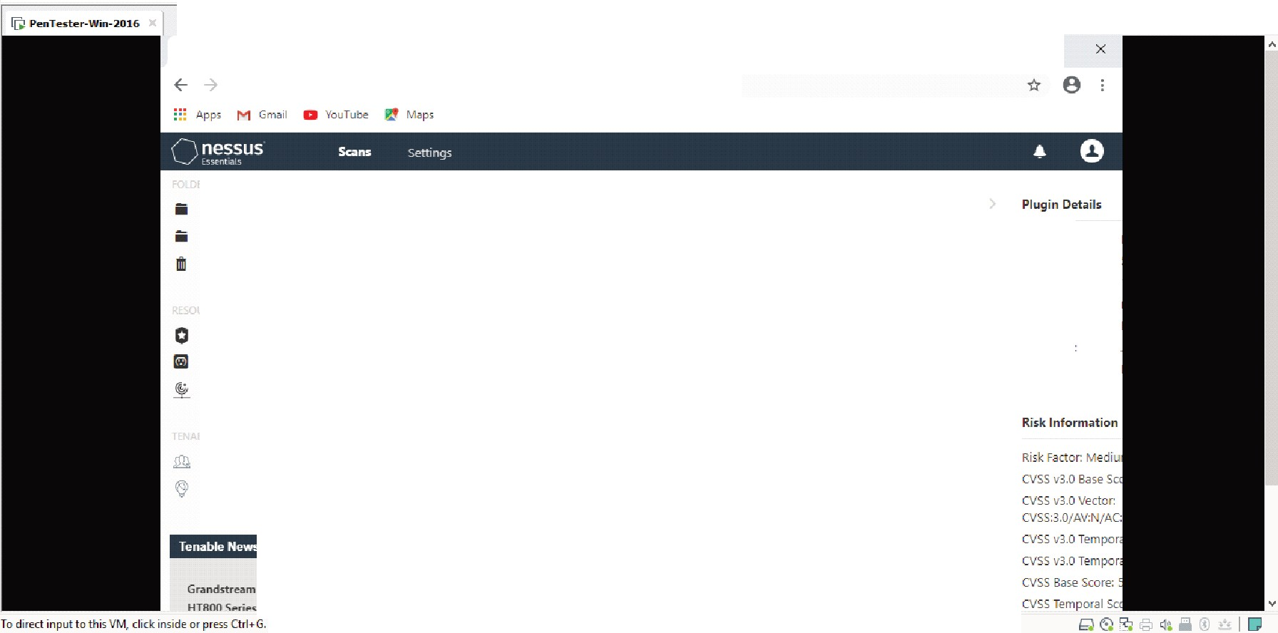
Fil e E.d it View VM Ta bs Help11

0 N essus Essentials J Folders I Vie X +
"
C
A Not secure I loca lhost:8834/l!l/scans/ reports/8/hosts/2/v nerabil it ies/57608
My Scans
SMB Signing not required
A ll Scans

Trasti
Oe5cription
.S igning i s not req uired on t he remote SMB server. An umtJttienticated, remote attacker ca n exploit t his to conduct m <J n- in -the -m iddle attacks ag<J i nst ttie SMB server.
Polic i es
Plugin Ru l es Scanners
Solution
Enforce messa ge signing in the host 's rnnfigu r<Jt ion. On Windows, tti i s is found i n!ti e policy setting 'Miuosoft network server: Digita l ly sign comm Lin ic.:itions (a lways) '. on samba, the sening is called 'server sign ing'. see t he 'see also' l inks fo r furtti erdetails.
Severlty:
ID:
Versi on: Type: Fam i ty :
Published
Modified:
Commun i ty

Rese<Jrch
SeeAl5o
hltps://support.microsoft .rnm/en- us/help/887429/overview-of -server-message - block-signing http://lechnet.m icrosuft.com/en- us/ I ib ra ry/cc73 1957.<Jsp
http:/twww.nessus.org/u ?74b80723
hltps://www.samba.org/samba/docs/currenljma n-htmljsmb.rnnf.5.titml http:/jwww.nessus.org/u ?a3cac4ea
Grandstream ATA
HTROO .__;., M 11l1inl..
Output
II ,P Type here ta search
v a
tit A
ra
I) E i :2;0
I


