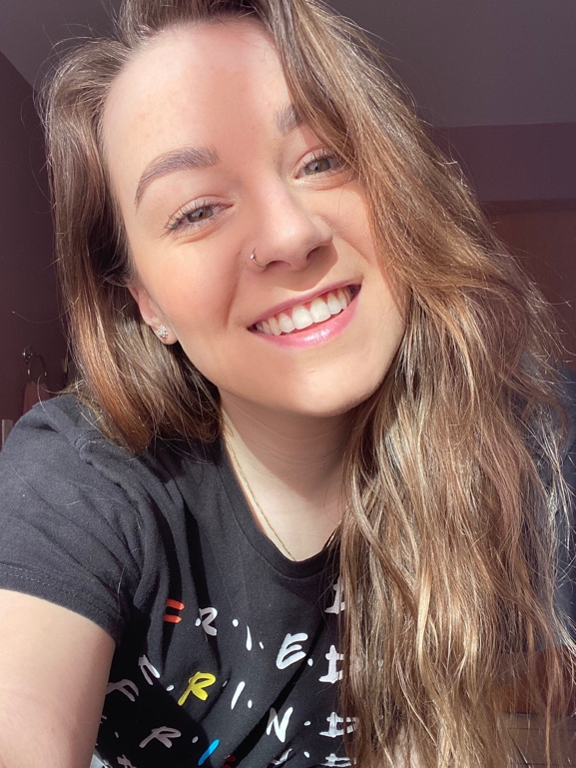Karolina Krzak

Values & Beliefs

Kindness

I believe if we take a moment to be nice to someone in any way of form or gesture. I believe that we can cause more happiness around us. As a person we don’t realize that everyone goes through struggles every day. Personally I feel that everyone is going through something, and I feel that just being kind to someone can go a long way.

Loyalty

Feeling safe and secure is what most people strive for in life. I feel comfortable when I know the family and friends around have my back. To have loyalty is hard for some, but once you commit to a friendship or to a bond. I personally feel like you can go forward with your life knowing you can have trust in the people around you, and with yourself.

Knowledge

I believe that we are constantly learning throughout our life. To have knowledge is what can help you strive as a person in this world. To learn basic necessities, complex equations, or how to know what right from wrong. There is so much to learn in this world and I do believe we can never stop learning.

Interests

Some things that I like include food, fitness, and family. During the weekends I love to try new places to go out to eat. I have recently got into cooking show so I have been experiencing new foods I haven’t tried before. I love to go out and get active as well. If it is mini golf, going to the gym , or going on a hike with my dog. I like to be out of the house and enjoy myself while staying active. I do love to spend time with my family. Making good food and conversation with them is what brings me joy.

Career

I haven’t made a my mind just yet what I would like to do for my career. I have goals that I do want to accomplish throughout these next few years. I would like to keep perusing school to get my masters or teaching degree. I would love to bring the language of coding and the art of engineering to the younger youth. Growing up I wasn’t expose to any type of those topics or careers. I would love to present this material to the youth in towns that I grew up and expose them to be able to get creative. I know it will take a while to get there, but one step at a time I will get the experience and knowledge to be able to achieve this goal.

Learning Goals

To become more familiar with coding in java. To learn news ways on how to be able to write code, fully understand it, and be able to understand and to be able to get creative with my work. Cannot wait to learn how to run multiple codes in one program. I would like to become more familiar with coding in general. I am also taking an algorithm and data class. I feel like I have a lot to learn, and I am excited.