LARGE DEFORMATION MODELLING IN GEOMECHANICS

Krishna Kumar

Research Associate, Department of Engineering, University of Cambridge, UK.

E-mail address: kks32@cam.ac.uk

Kenichi Soga

Chancellor’s Professor, Department of Civil and Environmental Engineering, University of California, Berkeley.

E-mail address: [soga@berkeley.edu](mailto:soga@berkeley.edu)

ABSTRACT: Geophysical hazards, such as avalanches, debris flows and submarine landslides, involve rapid and large mass movement of granular solids, water and air as a multi-phase system. The momentum transfer between the discrete and continuous phases significantly affect the dynamics of the movement. This study aims to understand the ability of continuum models in capturing the micro - mechanism of granular flow dynamics. Most macroscopic models are able to capture simple mechanical behaviours, however the complex physical mechanisms that occur at the grain scale, such as hydrodynamic instabilities, the formation of clusters, collapse, and transport, have largely been ignored. In this study, to understand the evolution of immersed granular flows, Material Point Method (MPM), a hybrid Lagrangian and Eulerian approach is used to describe the continuum behaviour of granular flow dynamics, while the micro - mechanics is captured using Discrete Element Method coupled with the Lattice Boltzmann Method (LBM) for fluid grain interactions. The effect of hydrodynamic forces and hydroplaning on the run-out evolution is analysed by comparing the mechanism of energy dissipation and flow evolution in dry and immersed granular flows.

Keywords: Granular Flows, MPM, DEM, LBM

Introduction

Geophysical hazards and industrial processes involves flow of dense granular material. Understanding the mechanics of granular flow is of particular importance in predicting the run-out distances of debris flows. The dynamics of a homogeneous granular flow involve at least three distinct scales: the microscopic scale, which is characterised by contact between grains, the meso-scale that represents micro-structural effects such as grain rearrangement, and the macroscopic scale, where geometric correlations can be observed (Cambou, Jean, & Radjaï, 2009). Different approaches have been adopted to model granular flows at different scales of description. Conventionally, granular materials such as soils are modelled as a continuum. On a macroscopic scale, granular materials exhibit many collective phenomena and the use of continuum mechanics to describe the macroscopic behaviour can be justified. However, on a grain scale, the granular materials exhibit complex solid-like and/or fluid-like behaviour depending on how the grains interact with each other. Recent works on granular materials suggest that a continuum law may be incapable of revealing in-homogeneities at the grain-scale level, such as orientation of force chains, which are purely due to micro-structural effects (Topin, Dubois, Monerie, Perales, & Wachs, 2011). Discrete Element approaches are capable of simulating the granular material as a discontinuous system allowing one to probe into local variables such as position, velocities, contact forces, etc. The fundamental question is how to model granular materials which exhibit complex phenomenon.

The collapse of a granular column on a horizontal surface is a simple case of granular flow, however a proper model that describes the flow dynamics is still lacking. Experimental investigations have shown that the flow duration, the spreading velocity, the final extent of the deposit, and the energy dissipation can be scaled in a quantitative way independent of substrate properties, grain size, density, and shape of the granular material and released mass (Lajeunesse, Monnier, & Homsy, 2005; Lube, Huppert, Sparks, & Freundt, 2005). Simple mathematical models based on conservation of horizontal momentum capture the scaling laws of the final deposit, but fail to describe the initial transition regime. Granular flow is modelled as a frictional dissipation process in continuum mechanics but the lack of influence of inter-particle friction on the energy dissipation and spreading dynamics (Lube et al., 2005) is surprising.

In order to describe the mechanism of saturated and/or immersed granular flows, it is necessary to consider both the dynamics of the solid phase and the role of the ambient fluid (Denlinger & Iverson, 2001). In two-phase models (Pitman & Le, 2005), the momentum transfer between the grains and the suspension fluid depends on the momentum equations of both phases. Using mixture theory-based models, the shear-induced migration and grains collisions can be considered in an average sense. However, the dynamics of the solid phase alone are insufficient to describe the mechanism of submerged granular flow in fluid. In particular, when the solid phase reaches a high volume fraction, the strong heterogeneity arising from the contact forces between the grains and the hydrodynamic forces, is difficult to integrate into the homogenization process involving global averages such as the mixture-theory.

In the present study, multi-scale numerical modelling, i.e. discrete-element and continuum analyses, of the quasi-two dimensional collapse of granular columns are performed using Discrete Element (DEM) approach and Material Point Method (MPM) to understand the ability and limitations of continuum approaches in modelling dense granular flows. The effect of fluid on the run-out behavior of a granular column collapse is studied using a 2D lattice Boltzmann – Discrete Element method. The flow kinematics are compared with the dry and buoyant granular collapse to understand the influence of hydrodynamic forces and lubrication on the run-out behaviour.

NUMERICAL SET-UP AND CONFIGURATION

The granular column collapse experiment involves filling a column of height H0 and length L0 with a granular material of mass ‘m’. The granular column is then released *en masse* by quickly removing the gate, thus allowing the granular material to collapse onto the horizontal surface, forming a deposit having a final height Hf and length Lf. A computational study on an equivalent two-dimensional configuration (circular disks) was carried out using Discrete Element and Continuum (MPM) approaches.

Discrete-Element Approach

Two-dimensional DEM analyses were carried out by varying the aspect ratio (‘a’) of the granular column from 0.2 to 10. The contact models are well established in a 2D discrete-element approach, which enables us to understand the mechanism of energy dissipation in dense granular flows. The normal contact force is modelled using linear-spring with dashpot. The tangential contact force is modelled using a sliding/striking tangential friction model (Luding, 2008). An inter-particle friction coefficient of 0.53 is adopted. Further details about the micro-mechanical parameters used in this study are presented in (Soundararajan, 2015).

Material Point Method

Material Point Method (MPM) (Bardenhagen, Brackbill, & Sulsky, 2000; Sulsky, Chen, & Schreyer, 1994) is a particle based method that represents a body as a collection of material points, and their deformations are determined by Newton’s laws of motion. MPM is a hybrid Eulerian–Lagrangian approach, which uses moving material points, and computational nodes on a background mesh. This approach is very effective particularly in the context of large deformations (Soga, Alonso, Yerro, Kumar, & Bandara, 2016). Although, not derived directly from what is classically considered as mesh-free or mesh-less methods, the background mesh is used only to perform discretization, integration, and to solve equations of motions.

The Material Point Method involves discretizing a domain with a set of material points and assigning an initial value of position, velocity, mass, volume, and stress. The material points are assumed to be within the computational grid, which is assumed to be a Cartesian lattice for convenience. At every time step tk, the MPM computation cycle involves projecting the data, such as position, mass, and velocity from the material points to the computational grid using standard nodal basis functions, called shape functions, derived based on the position of particle with respect to the grid. Gradient terms are calculated in the computational grid and the governing equation, i.e. the equation of motion, is solved and the updated position and velocity values are mapped back to the material points. The mesh is reinitialized to its original state and the computational cycle is repeated. The MPM solution scheme is shown in Figure 1.

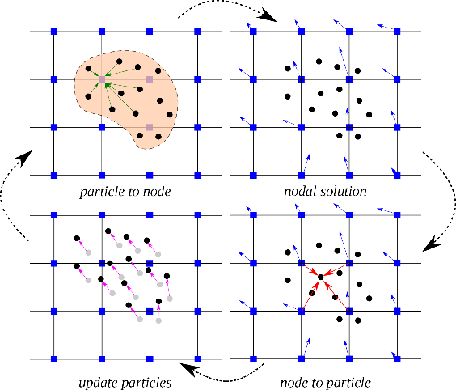

Figure 1. MPM solution scheme

In the MPM simulations, the granular flow was assumed to be in the critical state and the critical state friction angle was used as an input in the Mohr-Coulomb model. A bi-periodic shear test using DEM grains yielded a critical state friction angle of 23°.

FLOW KINEMATICS AND ENERGY

DISSIPATION

The final run-out distance normalised to the initial length is shown in Figure 2 as a function of the initial aspect ratio. Two distinct flow regimes can be observed: (a) for ‘a’ <1.7 a linear relation between the spread and aspect ratio can be observed, and (b) for ‘a’ > 1.7 a power-law relationship exists. MPM and DEM simulations are able to capture the linear relationship for ‘a’ < 1.7, and the simulation results agree with the experimental investigation (Lajeunesse et al., 2005). Significant difference between MPM, which is based on a simple frictional model for dissipation of potential energy, and DEM simulations for ‘a’ > 1.7 indicates a change in the mechanism of energy dissipation for columns with large aspect ratios (‘a’ > 1.7). A constant frictional dissipation model cannot describe a power-law relation (Staron & Hinch, 2007). A transition in the run-out behaviour at an aspect ratio of 1.7 indicates a change in flow dynamics.

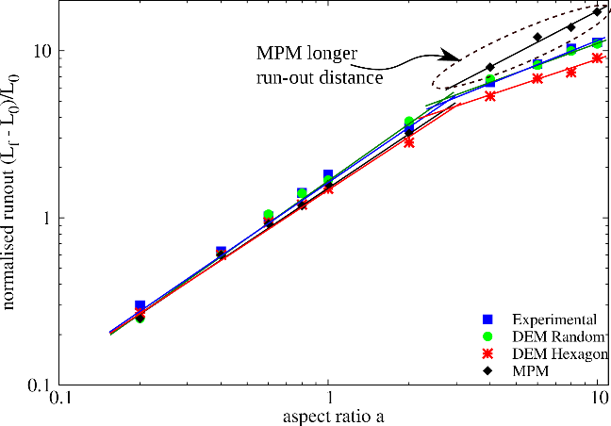

Figure 2: Evolution of run-out with initial aspect ratio

The flow dynamics of two granular columns (‘a’=0.4 and ‘a’=6) are compared to understand the difference in the energy dissipation mechanism, and in turn on the run-out behaviour for different aspect ratios. The granular column collapse is initiated by a failure at the edge of the pile along a well-defined failure surface. The grains located above the failure surface move “en masse” leaving a static region underneath the failure surface. After a transient time of order τc, defined as (Ho/g)^0.5, the flow is fully developed and the flow comes to a rest at time t = 3 τc (Staron & Hinch, 2007). Columns with small aspect ratio fail by avalanching of the flanks, forming a truncated cone-like deposit. Velocity profiles of a granular column with ‘a’=0.4 are presented in Figure 3. Both MPM and DEM simulations show a well-defined failure surface and predict similar run-out behaviour. Although, the MPM simulation predicts 25% longer for the flow to be fully mobilised (see Figure 3), the flow evolution happens quicker, which can be attributed to the marginally lower mobilised potential energy. The initial potential energy stored in the column is converted to kinetic energy that is then dissipated as the material flows down. MPM and DEM predict similar energy evolution behaviour which indicates that most of the stored initial potential energy is dissipated through friction. Hence, for columns with smaller aspect ratios, the run-out distance is proportional to the mass flowing above the failure.

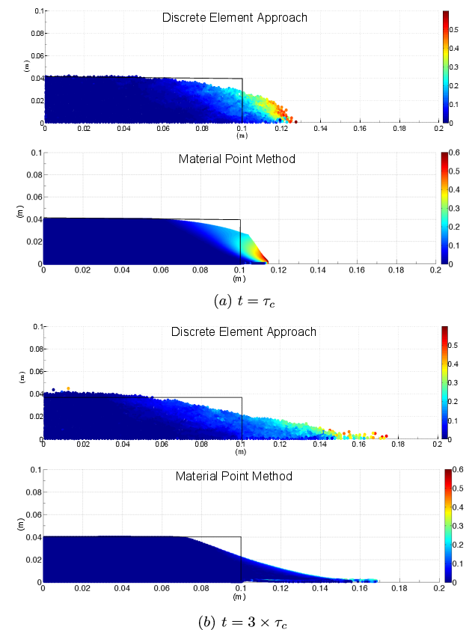

Figure 3: Comparison of flow profile between DEM and MPM of a column with `a` = 0.4.

A significant difference in the run-out behaviour between MPM and DEM (see Figure 2) indicates that a simple frictional model is insufficient to describe the flow kinematics for columns with large aspect ratios. Velocity profiles of a granular column with ‘a’ = 6 are presented in Figure 4. At critical time (t = τc), both MPM and DEM predict almost identical run-out behaviour on a distinct failure plane. The flow evolution is much faster in MPM and results in a larger run-out distance. For larger aspect ratios, the flow is still initiated by a well-defined failure surface. However, the centre of gravity of the granular column is much higher than the top of the failure surface, which results in free fall of grains under gravity consuming the column along their way. When they reach the vicinity of the failure surface, the grains undergo collisions with the bottom plane and the neighbouring grains, thus causing the flow to deviate along the horizontal direction releasing a large amount of kinetic energy gained during the free fall (see Figure 5). The grains then eventually leave the base area of the column and flow sideways undergoing frictional dissipation. The process involves collective dynamics of all the particles, and DEM simulations model both collisional and frictional dissipation process. However, MPM simulations assume that the total initial potential energy stored in the system is completely dissipated through friction over the entire run-out distance, resulting in larger run-out distance.

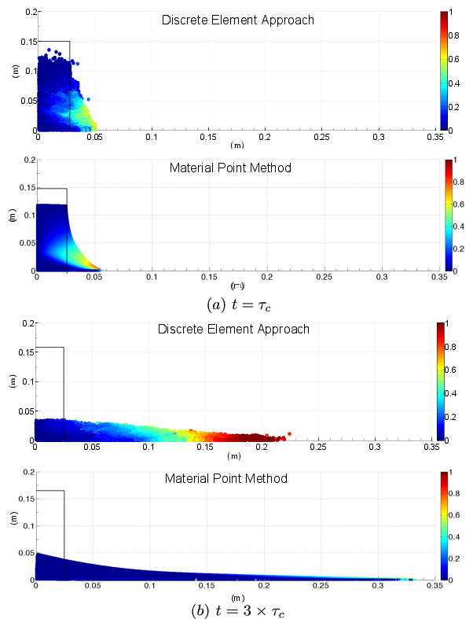

Figure 4: Comparison of flow profile between DEM and MPM of a column with `a` = 6.

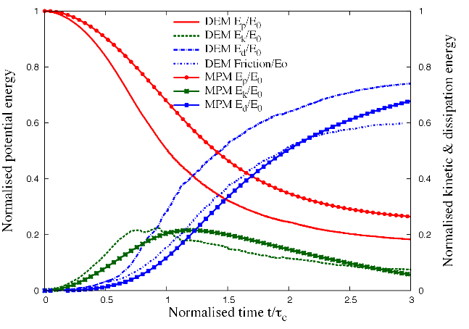

Figure 5: Energy evolution for a column with ‘a’ = 6

LBM-DEM Formulation

The Lattice Boltzmann equation Method (LBM) is an alternative approach to the classical Navier-Stokes solvers for fluid flow and works on an equidistant grid of cells, called lattice cells, which interact only with their direct neighbours (He & Luo, 1997). The fluid domain is divided into a rectangular grid or lattice, with the same spacing ‘h’ in both the x- and the y-directions, as shown in Figure 6. The present study focuses on 2-D problems; hence, the D2Q9 momentum discretization is adopted, where the fluid particles at each node are allowed to move to their eight intermediate neighbors with eight different velocities **e**i (i = 1, . . . ,8).

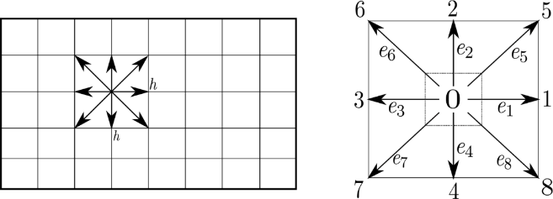

Figure 6 The Lattice Boltzmann discretization and D2Q9 scheme: (a) a standard LB lattice; (b) D2Q9 model

The nine discrete velocity vectors are defined as:



in which *C* is the lattice speed (=h/t). Where, t is the discrete time step. The primary variables in the Lattice Boltzmann formulation are called the fluid density distribution functions, fi, each relating the portable amount of fluid particles moving with the velocity ei along the ith direction at each node. The macroscopic variables such as density and velocity can be obtained from the particle distribution functions. There are nine fluid density distribution functions, fi (i = 0, . . . , 8), associated with each node in the D2Q9 model. This simple equation allows us to pass from the discrete microscopic velocities that comprise the LBM back to a continuum of macroscopic velocities representing the fluid’s motion. The BGK (Bhatnagar-Gross-Krook) approximation is used to describe the streaming and the collision of the particles. Streaming and collision (i.e., relaxation to local equilibrium) is defined as:



where, the left hand side describes the streaming part and the collision part, which brings the system to local equilibrium is described by the right hand side. τ is a non-dimensional relaxation time parameter, which is related to the fluid viscosity.

LBM-DEM Coupling

Lattice Boltzmann approach can accommodate large grain sizes and the interaction between the fluid and the moving grains can be modelled through relatively simple fluid – grain interface treatments. Further, employing the Discrete Element Method (DEM) to account for the grain – grain interaction naturally leads to a combined LB – DEM procedure (Kumar, Soga, & Delenne, 2012). The Eulerian nature of the LBM formulation, together with the common explicit time step scheme of both LBM and DEM makes this coupling strategy an efficient numerical procedure for the simulation of grain – fluid systems. Such a coupled methodology is used in simulating grain – fluid systems dominated by grain – fluid and grain – grain interactions. To capture the actual physical behavior of the fluid – grain system, it is essential to model the boundary condition between the fluid and the grain as a non-slip boundary condition, i.e. the fluid near the grain should have similar velocity as the grain boundary. The solid grains inside the fluid are represented by lattice nodes. The discrete nature of lattice, results in a stepwise representation of the surfaces, which are circular, hence sufficiently small lattice spacing is adopted.

In a 3D granular assembly, the pore spaces between the grains are interconnected, whereas in a 2-D assembly, a non-interconnected pore-fluid space is formed as the grains are in contact with each other. This means that the fluid enclosed between the grains cannot flow to the neighbouring pore-spaces; this results in an unnatural no flow condition in a 2-D case. In order to overcome this effect, a reduction in radius is assumed only during the LBM computation (fluid and fluid – solid interaction) steps. The hydrodynamic radius *r*, allows for interconnected pore space through which the pore-fluid can flow thus simulating a 3D-flow-like behaviour. The reduction in the radius is assumed only during LBM computations, hence this technique has no effect on the grain – grain interactions computed using DEM.

GRANULAR AVALANCHES IN FLUID

In this section, we study the behaviour of immersed granular avalanches for different permeability. We consider 2D poly-disperse system (dmax/dmin=1.8) of circular discs in fluid. The simulations were carried out with 1000 grains of density 2650 kg/m3 and a contact friction angle of 26°. The collapse of the column was simulated inside a fluid with a density of 1000 kg/m3 and a kinematic viscosity of 1x10-6 m2/s. The choice of a 2D geometry has the advantage of cheaper computational effort than a 3D case, making it feasible to simulate very large systems with an important number of nodes for a reasonable computing time. A granular column of aspect ratio ‘a’ of 0.8 was considered. Radius of the grains was varied from 0.7R to 0.95R during LBM computations. Dry and buoyant analyses were done to compare the effect of hydrodynamic forces on the run-out distance.

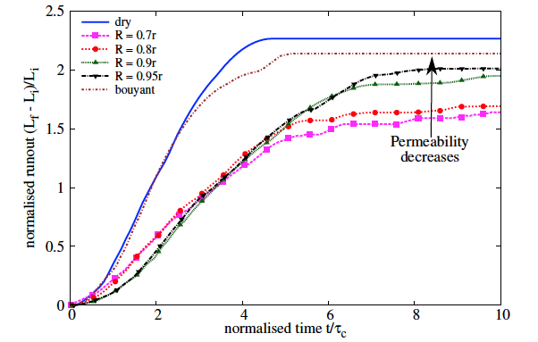

Figure 7: Evolution of normalised run-out distance with time for different initial permeability.

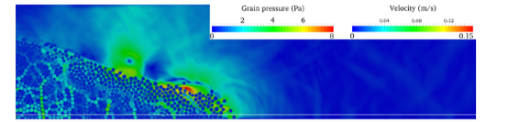

1. High permeability (r = 0.7 R)

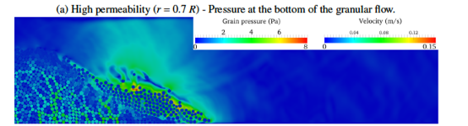

(b) Low permeability (r = 0.95R) – Pressure at the bottom of the granular flow.



(c) Porewater pressure at bottom plane for low and high permeability cases

Figure 8: Effect of permeability on the excess pore water pressure distribution at t = 3 τc along the horizontal direction at a height of 10d from the base.

The final run-out profile for a reduced grain size of 0.7R and 0.95R are presented in Figure 7. The less permeable column runs out further, while the highly permeable column entraps more water and has smaller run-out distance. The rheology of the flow tends to change, with change in permeability. It can be observed from the figure that the dry and buoyant columns run farther and evolve quicker than the immersed case. The run-out is found to increase with decrease in permeability. The time required for the flow to initialize increases with decrease in permeability, i.e. a highly permeable column collapse quicker in comparison to a less permeable granular column. Three distinct regimes can be observed in the immersed avalanche, similar to the observations in dry granular column collapse: (1) a vertical-fall regime, where the grains located at the top undergo vertical falls and the grains at the bottom are ejected horizontally by the fluid; (2) a heap regime, where the grains at the top move along an inclined stationary deposit; (3) a horizontal regime, where the grains move essentially horizontally. Figure 8 shows a high value of positive pore-pressure at the face of the column in the low permeable condition. This indicates that the low permeable column fails as a continuous block undergoing a shear failure, which generates a very large negative excess pore-pressure along the failure surface. As the material flows, it entraps water and creates a lubrication layer resulting in farther run-out distances. However, in the case of the high permeable column, the failure is more localised with multiple negative excess pore-pressure spikes.

Summary

Multi-scale simulation of granular column collapse was performed to understand the ability and limitations of continuum models to capture the micro-mechanics of dense granular flows. The run-out behaviour predicted by both continuum and DEM simulations matches for columns with small aspect ratios, where the dissipation is predominantly frictional. However, MPM predicts larger run-out distances for columns with higher aspect ratios. Energy evolution studies using DEM simulations reveal that the run-out behaviour is independent of frictional properties of the granular material and collision predominates the initial free-fall regime. The lack of a collisional energy dissipation mechanism in MPM results in over prediction of run-out distances. LB-DEM simulations were performed to understand the behaviour of submarine granular flows. The run-out distance in fluid increases with decrease in permeability. the run-out distance increases with decreasing permeability. An increase in the hydrodynamic radius from 0.7 to 0.95R increases the normalised run-out by 25%. For the same value of peak kinetic energy, the run-out distance in fluid is longer than the dry column collapse. Also, with decreasing permeability the run-out distance increases for the same peak kinetic energy. The low permeability of the granular mass results in entrainment of water causing hydroplaning. With decreasing permeability, the duration for the flow to initiate increases as the time required to dissipate the large negative excess pore-pressures increases.

References

Bardenhagen, S. G., Brackbill, J. U., & Sulsky, D. (2000). The material-point method for granular materials. *Computer Methods in Applied Mechanics and Engineering*, *187*(3–4), 529–541.

Cambou, B., Jean, M., & Radjaï, F. (2009). *Micromechanics of granular materials*. Wiley-ISTE.

Denlinger, R. P., & Iverson, R. M. (2001). Flow of variably fluidized granular masses across three-dimensional terrain, ii: Numerical predictions and experimental tests. *J. Geophys. Res*, *106*(B1), 553–566.

He, X., & Luo, L.-S. (1997). Theory of the lattice Boltzmann method: From the Boltzmann equation to the lattice Boltzmann equation. *Physical Review E*, *56*(6), 6811–6817. http://doi.org/10.1103/PhysRevE.56.6811

Kumar, K., Soga, K., & Delenne, J.-Y. (2012). Granular flows in fluid. In C.-Y. Wu (Ed.), *Discrete Element Modelling of Particulate Media*. Cambridge: Royal Society of Chemistry. http://doi.org/10.1039/9781849735032

Lajeunesse, E., Monnier, J. B., & Homsy, G. M. (2005). Granular slumping on a horizontal surface. *Physics of Fluids*, *17*(10).

Lube, G., Huppert, H. E., Sparks, R. S. J., & Freundt, A. (2005). Collapses of two-dimensional granular columns. *Physical Review E - Statistical, Nonlinear, and Soft Matter Physics*, *72*(4), 1–10.

Luding, S. (2008). Cohesive, frictional powders: contact models for tension. *Granular Matter*, *10*(4), 235–246. http://doi.org/10.1007/s10035-008-0099-x

Pitman, E. B., & Le, L. (2005). A Two-Fluid Model for Avalanche and Debris Flows. *Philosophical Transactions: Mathematical, Physical and Engineering Sciences*, *363*(1832), 1573–1601.

Soga, K., Alonso, E., Yerro, A., Kumar, K., & Bandara, S. (2016). Trends in large-deformation analysis of landslide mass movements with particular emphasis on the material point method. *G{é}otechnique*, *66*(3), 248–273. article.

Soundararajan, K. K. (2015). *Multi-scale multiphase modelling of granular flows* (phdthesis). University of Cambridge.

Staron, L., & Hinch, E. J. (2007). The spreading of a granular mass: Role of grain properties and initial conditions. *Granular Matter*, *9*(3–4), 205–217.

Sulsky, D., Chen, Z., & Schreyer, H. L. (1994). A particle method for history-dependent materials. *Computer Methods in Applied Mechanics and Engineering*, *118*(1–2), 179–196.

Topin, V., Dubois, F., Monerie, Y., Perales, F., & Wachs, A. (2011). Micro-rheology of dense particulate flows: Application to immersed avalanches. *Journal of Non-Newtonian Fluid Mechanics*, *166*(1–2), 63–72.