**Working with Remotes**

To be able to collaborate on any Git project, you need to know how to manage your remote repositories. Remote repositories are versions of your project that are hosted on the Internet or network somewhere. You can have several of them, each of which generally is either read-only or read/write for you. Collaborating with others involves managing these remote repositories and pushing and pulling data to and from them when you need to share work. Managing remote repositories includes knowing how to add remote repositories, remove remotes that are no longer valid, manage various remote branches and define them as being tracked or not, and more. In this section, we’ll cover some of these remote-management skills.

Remote repositories can be on your local machine. It is entirely possible that you can be working with a “remote” repository that is, in fact, on the same host you are. The word “remote” does not necessarily imply that the repository is somewhere else on the network or Internet, only that it is elsewhere. Working with such a remote repository would still involve all the standard pushing, pulling and fetching operations as with any other remote.

**GIT Clone:**

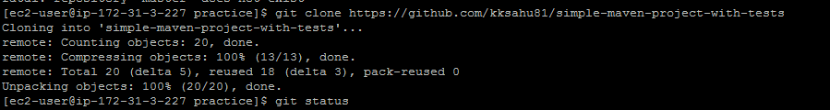

### 

### 

git branch --v Execute above command to show branches:



git branch -a

### 

Now switch to desired branch

Lets go into master branch

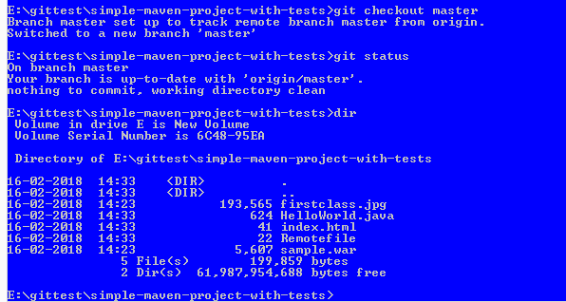

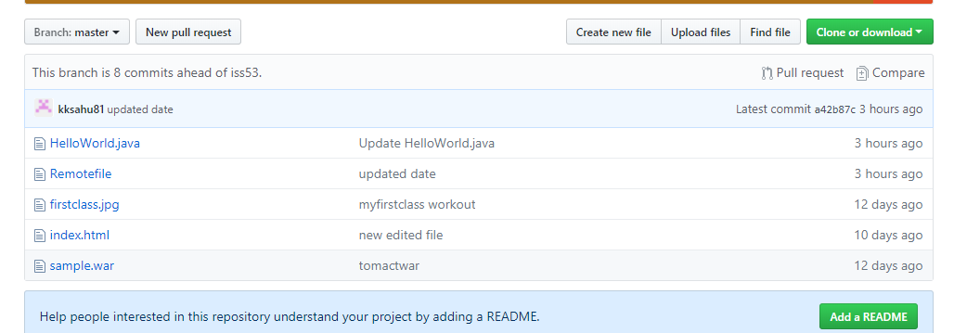

**clone a specific branch in git**

git clone -b <branch> <remote_repo>

git clone -b test https://github.com/kksahu81/simple-maven-project-with-tests

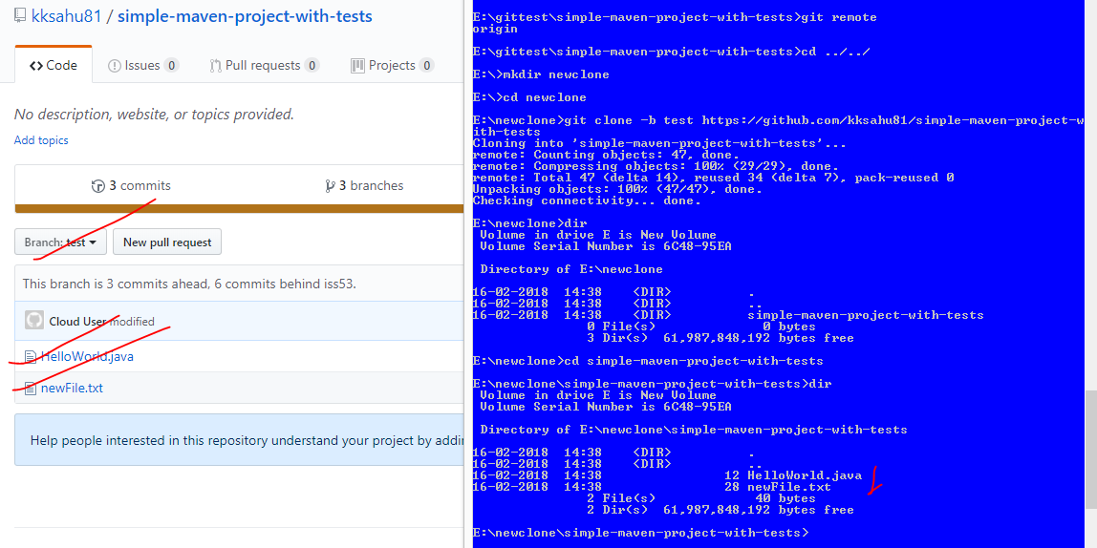

git clone -b test --single-branch https://github.com/kksahu81/simple-maven-project-with-tests gitnewbranch

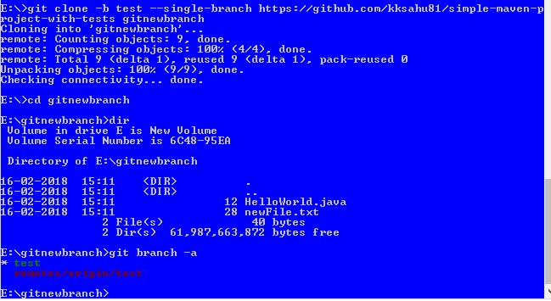

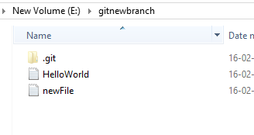

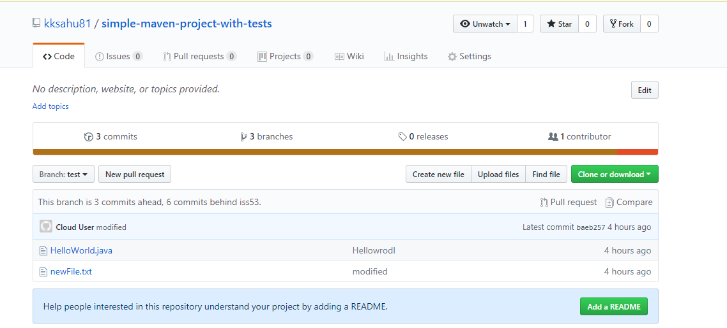



You could create a new repo with

git init

and then use

git fetch url-to-repo branchname:refs/remotes/origin/branchname

to fetch just that one branch into a local remote-tracking branch.

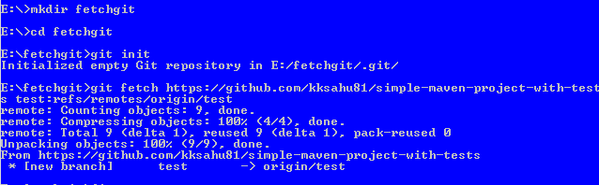

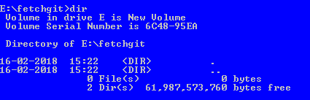

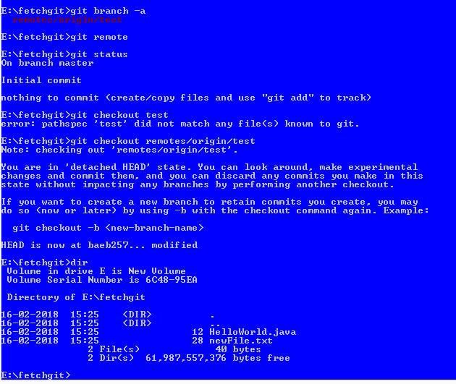

**Showing Your Remotes**

To see which remote servers you have configured, you can run the git remote command. It lists the shortnames of each remote handle you’ve specified. If you’ve cloned your repository, you should at least see origin — that is the default name Git gives to the server you cloned from:

[ec2-user@ip-172-31-3-227 simple-maven-project-with-tests]$ git remote

origin

[ec2-user@ip-172-31-3-227 simple-maven-project-with-tests]$

**Branches in GIT**

A branch in Git is simply a lightweight movable pointer to one of these commits. The default branch name in Git is master. As you start making commits, you’re given a master branch that points to the last commit you made. Every time you commit, it moves forward automatically.

The “master” branch in Git is not a special branch. It is exactly like any other branch. The only reason nearly every repository has one is that the git init command creates it by default and most people don’t bother to change it.

When you make a commit, Git stores a commit object that contains a pointer to the snapshot of the content you staged. This object also contains the author’s name and email, the message that you typed, and pointers to the commit or commits that directly came before this commit (its parent or parents): zero parents for the initial commit, one parent for a normal commit, and multiple parents for a commit that results from a merge of two or more branches.

$ git add README test.rb LICENSE

$ git commit -m 'The initial commit of my project'

When you create the commit by running git commit, Git checksums each subdirectory (in this case, just the root project directory) and stores those tree objects in the Git repository. Git then creates a commit object that has the metadata and a pointer to the root project tree so it can re-create that snapshot when needed.

Your Git repository now contains five objects: one blob for the contents of each of your three files, one tree that lists the contents of the directory and specifies which file names are stored as which blobs, and one commit with the pointer to that root tree and all the commit metadata.

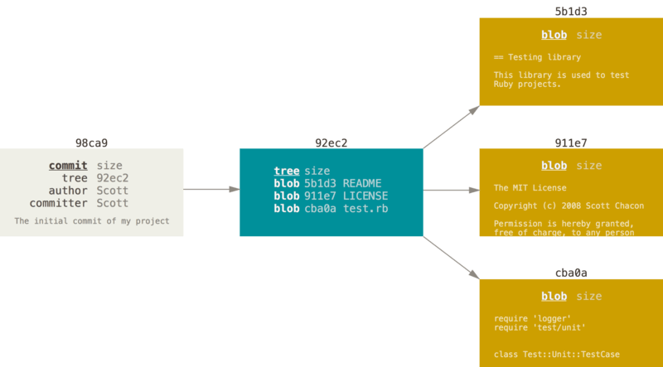

If you make some changes and commit again, the next commit stores a pointer to the commit that came immediately before it.

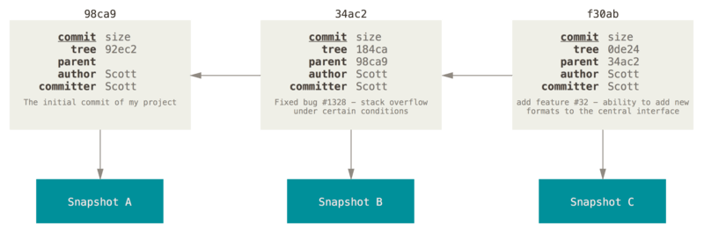

**Create File in Master Branch:**

Admin@VAIO MINGW64 ~/Desktop/Nandeesh-devops/first-repo (master)

$ vim textfile

Admin@VAIO MINGW64 ~/Desktop/Nandeesh-devops/first-repo (master)

$ git add textfile

warning: LF will be replaced by CRLF in textfile.

The file will have its original line endings in your working directory.

Admin@VAIO MINGW64 ~/Desktop/Nandeesh-devops/first-repo (master)

$ git commit -m "hello" textfile

warning: LF will be replaced by CRLF in textfile.

The file will have its original line endings in your working directory.

[master 4b1446d] hello

warning: LF will be replaced by CRLF in textfile.

The file will have its original line endings in your working directory.

1 file changed, 1 insertion(+)

create mode 100644 textfile

Admin@VAIO MINGW64 ~/Desktop/Nandeesh-devops/first-repo (master)

$

We want to push changes up to the project’s [GitHub repository](http://github.com/qrush/gitready) . The syntax of this command is usually git push <remote> <branch>. A remote is basically the address of a cloned repository.

**git push <remote> <branch>.**

$ git push https://github.com/kksahu81/simple-maven-project-with-tests master

Username for 'https://github.com': kksahu81

Counting objects: 3, done.

Delta compression using up to 4 threads.

Compressing objects: 100% (2/2), done.

Writing objects: 100% (3/3), 286 bytes | 0 bytes/s, done.

Total 3 (delta 1), reused 0 (delta 0)

remote: Resolving deltas: 100% (1/1), completed with 1 local object.

To https://github.com/kksahu81/simple-maven-project-with-tests

* [new branch] master -> master

Admin@VAIO MINGW64 ~/Desktop/Nandeesh-devops/first-repo (master)

$

Now remote repository is updated, and if you visit GitHub and you can see updated file in github.

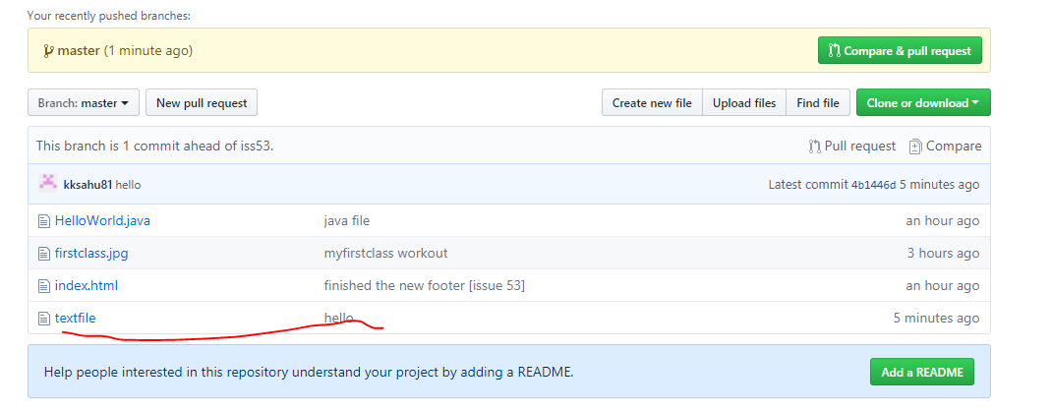

$ git pull https://github.com/kksahu81/simple-maven-project-with-tests master

remote: Counting objects: 3, done.

remote: Compressing objects: 100% (1/1), done.

remote: Total 3 (delta 1), reused 3 (delta 1), pack-reused 0

Unpacking objects: 100% (3/3), done.

From https://github.com/kksahu81/simple-maven-project-with-tests

* branch master -> FETCH_HEAD

Updating 6025cfb..4b1446d

Fast-forward

textfile | 1 +

1 file changed, 1 insertion(+)

create mode 100644 textfile

Admin@VAIO MINGW64 ~/Desktop/Nandeesh-devops/localrepo (localbrnch)

$ dir

firstclass.jpg HelloWorld.java index.html textfile

Admin@VAIO MINGW64 ~/Desktop/Nandeesh-devops/localrepo (localbrnch)

$

Admin@VAIO MINGW64 ~

$ cd Desktop/Nandeesh-devops/first-repo/

Admin@VAIO MINGW64 ~/Desktop/Nandeesh-devops/first-repo (master)

Admin@VAIO MINGW64 ~/Desktop/Nandeesh-devops/first-repo (master)

$ dir

firstclass.jpg

Admin@VAIO MINGW64 ~/Desktop/Nandeesh-devops/first-repo (master)

$ git status

On branch master

nothing to commit, working directory clean

Admin@VAIO MINGW64 ~/Desktop/Nandeesh-devops/first-repo (master)

$ git branch -vv

* master 2a23285 myfirstclass workout

myNewBranch 2a23285 myfirstclass workout

Admin@VAIO MINGW64 ~/Desktop/Nandeesh-devops/first-repo (master)

$ ls -F .git/refs/heads/

master myNewBranch

Admin@VAIO MINGW64 ~/Desktop/Nandeesh-devops/first-repo (master)

$ ls -al

total 196

drwxr-xr-x 1 Admin 197121 0 Feb 4 22:22 ./

drwxr-xr-x 1 Admin 197121 0 Feb 4 22:21 ../

drwxr-xr-x 1 Admin 197121 0 Feb 4 23:32 .git/

-rw-r--r-- 1 Admin 197121 193565 Feb 4 22:22 firstclass.jpg

Admin@VAIO MINGW64 ~/Desktop/Nandeesh-devops/first-repo (master)

$ git log

commit 2a232857677099929d4ab5e276dcd3daf609a234

Author: kaushal sahu <kksahu81@gmail.com>

Date: Sun Feb 4 22:24:00 2018 +0530

myfirstclass workout

Admin@VAIO MINGW64 ~/Desktop/Nandeesh-devops/first-repo (master)

$ git checkout master

Already on 'master'

Admin@VAIO MINGW64 ~/Desktop/Nandeesh-devops/first-repo (master)

$ git checkout -b iss53

Switched to a new branch 'iss53'

Admin@VAIO MINGW64 ~/Desktop/Nandeesh-devops/first-repo (iss53)

$ git branch iss53

fatal: A branch named 'iss53' already exists.

Admin@VAIO MINGW64 ~/Desktop/Nandeesh-devops/first-repo (iss53)

$ vim index.html

Admin@VAIO MINGW64 ~/Desktop/Nandeesh-devops/first-repo (iss53)

$ git add index.html

warning: LF will be replaced by CRLF in index.html.

The file will have its original line endings in your working directory.

Admin@VAIO MINGW64 ~/Desktop/Nandeesh-devops/first-repo (iss53)

$ git commit -a -m 'added a new footer [issue 53]'

[iss53 404f910] added a new footer [issue 53]

warning: LF will be replaced by CRLF in index.html.

The file will have its original line endings in your working directory.

1 file changed, 1 insertion(+)

create mode 100644 index.html

Admin@VAIO MINGW64 ~/Desktop/Nandeesh-devops/first-repo (iss53)

$ git status iss53

On branch iss53

nothing to commit, working directory clean

Admin@VAIO MINGW64 ~/Desktop/Nandeesh-devops/first-repo (iss53)

$ git checkout master

Switched to branch 'master'

Admin@VAIO MINGW64 ~/Desktop/Nandeesh-devops/first-repo (master)

$ git merge iss53

Updating 2a23285..404f910

Fast-forward

index.html | 1 +

1 file changed, 1 insertion(+)

create mode 100644 index.html

Admin@VAIO MINGW64 ~/Desktop/Nandeesh-devops/first-repo (master)

$ dir

firstclass.jpg index.html

Admin@VAIO MINGW64 ~/Desktop/Nandeesh-devops/first-repo (master)

$ git checkout iss53

Switched to branch 'iss53'

Admin@VAIO MINGW64 ~/Desktop/Nandeesh-devops/first-repo (iss53)

$ dir

firstclass.jpg index.html

Admin@VAIO MINGW64 ~/Desktop/Nandeesh-devops/first-repo (iss53)

$ vim index.html

Admin@VAIO MINGW64 ~/Desktop/Nandeesh-devops/first-repo (iss53)

$ git commit -a -m 'finished the new footer [issue 53]'

[iss53 66fed30] finished the new footer [issue 53]

1 file changed, 1 insertion(+)

Admin@VAIO MINGW64 ~/Desktop/Nandeesh-devops/first-repo (iss53)

$ git status

On branch iss53

nothing to commit, working directory clean

Admin@VAIO MINGW64 ~/Desktop/Nandeesh-devops/first-repo (iss53)

$ dir

firstclass.jpg index.html

Admin@VAIO MINGW64 ~/Desktop/Nandeesh-devops/first-repo (iss53)

$ vi index.html

Admin@VAIO MINGW64 ~/Desktop/Nandeesh-devops/first-repo (iss53)

$ git checkout master

Switched to branch 'master'

Admin@VAIO MINGW64 ~/Desktop/Nandeesh-devops/first-repo (master)

$ vi index.html

Admin@VAIO MINGW64 ~/Desktop/Nandeesh-devops/first-repo (master)

$ git merge iss53

Updating 404f910..66fed30

Fast-forward

index.html | 1 +

1 file changed, 1 insertion(+)

Admin@VAIO MINGW64 ~/Desktop/Nandeesh-devops/first-repo (master)

$ vi index.html

Admin@VAIO MINGW64 ~/Desktop/Nandeesh-devops/first-repo (master)

$ git branch

iss53

* master

myNewBranch

Admin@VAIO MINGW64 ~/Desktop/Nandeesh-devops/first-repo (master)

$ git checkout myNewBranch

Switched to branch 'myNewBranch'

Admin@VAIO MINGW64 ~/Desktop/Nandeesh-devops/first-repo (myNewBranch)

$ vim HelloWorld.java

Admin@VAIO MINGW64 ~/Desktop/Nandeesh-devops/first-repo (myNewBranch)

$ git add HelloWorld.java

warning: LF will be replaced by CRLF in HelloWorld.java.

The file will have its original line endings in your working directory.

Admin@VAIO MINGW64 ~/Desktop/Nandeesh-devops/first-repo (myNewBranch)

$ git commit -m "java file" HelloWorld.java

warning: LF will be replaced by CRLF in HelloWorld.java.

The file will have its original line endings in your working directory.

[myNewBranch cd7bac0] java file

warning: LF will be replaced by CRLF in HelloWorld.java.

The file will have its original line endings in your working directory.

1 file changed, 16 insertions(+)

create mode 100644 HelloWorld.java

Admin@VAIO MINGW64 ~/Desktop/Nandeesh-devops/first-repo (myNewBranch)

$ git checkout master

Switched to branch 'master'

Admin@VAIO MINGW64 ~/Desktop/Nandeesh-devops/first-repo (master)

$ dir

firstclass.jpg index.html

Admin@VAIO MINGW64 ~/Desktop/Nandeesh-devops/first-repo (master)

$ git merge myNewBranch

Admin@VAIO MINGW64 ~/Desktop/Nandeesh-devops/first-repo (master)

$ git merge myNewBranch

Merge made by the 'recursive' strategy.

HelloWorld.java | 16 ++++++++++++++++

1 file changed, 16 insertions(+)

create mode 100644 HelloWorld.java

Admin@VAIO MINGW64 ~/Desktop/Nandeesh-devops/first-repo (master)

$ dir

firstclass.jpg HelloWorld.java index.html

Admin@VAIO MINGW64 ~/Desktop/Nandeesh-devops/first-repo (master)

$ git checkout iss53

Switched to branch 'iss53'

Admin@VAIO MINGW64 ~/Desktop/Nandeesh-devops/first-repo (iss53)

$ git branch --v

* iss53 66fed30 finished the new footer [issue 53]

master 6025cfb Merge branch 'myNewBranch'

myNewBranch cd7bac0 java file

Admin@VAIO MINGW64 ~/Desktop/Nandeesh-devops/first-repo (iss53)

$ git checkout master

Switched to branch 'master'

Admin@VAIO MINGW64 ~/Desktop/Nandeesh-devops/first-repo (master)

$ git checkout iss53

Switched to branch 'iss53'

Admin@VAIO MINGW64 ~/Desktop/Nandeesh-devops/first-repo (iss53)

$ git push https://github.com/kksahu81/simple-maven-project-with-tests iss53

Username for 'https://github.com': kksahu81

Counting objects: 9, done.

Delta compression using up to 4 threads.

Compressing objects: 100% (6/6), done.

Writing objects: 100% (9/9), 34.70 KiB | 0 bytes/s, done.

Total 9 (delta 0), reused 0 (delta 0)

To https://github.com/kksahu81/simple-maven-project-with-tests

* [new branch] iss53 -> iss53

Admin@VAIO MINGW64 ~/Desktop/Nandeesh-devops/first-repo (iss53)

$ dir

firstclass.jpg index.html

Admin@VAIO MINGW64 ~/Desktop/Nandeesh-devops/first-repo (iss53)

$ git checkout master

Switched to branch 'master'

Admin@VAIO MINGW64 ~/Desktop/Nandeesh-devops/first-repo (master)

$ git branch --v

iss53 66fed30 finished the new footer [issue 53]

* master 6025cfb Merge branch 'myNewBranch'

myNewBranch cd7bac0 java file

Admin@VAIO MINGW64 ~/Desktop/Nandeesh-devops/first-repo (master)

$ git branch -d iss53

Deleted branch iss53 (was 66fed30).

Admin@VAIO MINGW64 ~/Desktop/Nandeesh-devops/first-repo (master)

$ git checkout -b iss53

Switched to a new branch 'iss53'

Admin@VAIO MINGW64 ~/Desktop/Nandeesh-devops/first-repo (iss53)

$ git push https://github.com/kksahu81/simple-maven-project-with-tests iss53

Username for 'https://github.com': kksahu81

Counting objects: 5, done.

Delta compression using up to 4 threads.

Compressing objects: 100% (5/5), done.

Writing objects: 100% (5/5), 922 bytes | 0 bytes/s, done.

Total 5 (delta 1), reused 0 (delta 0)

remote: Resolving deltas: 100% (1/1), done.

To https://github.com/kksahu81/simple-maven-project-with-tests

66fed30..6025cfb iss53 -> iss53

Admin@VAIO MINGW64 ~/Desktop/Nandeesh-devops/first-repo (iss53)

$ dir

firstclass.jpg HelloWorld.java index.html

Admin@VAIO MINGW64 ~/Desktop/Nandeesh-devops/first-repo (iss53)

$ git branch --v

* iss53 6025cfb Merge branch 'myNewBranch'

master 6025cfb Merge branch 'myNewBranch'

myNewBranch cd7bac0 java file

Admin@VAIO MINGW64 ~/Desktop/Nandeesh-devops/first-repo (iss53)

$ git checkout master

Switched to branch 'master'

Admin@VAIO MINGW64 ~/Desktop/Nandeesh-devops/first-repo (master)

$ vim textfile

Admin@VAIO MINGW64 ~/Desktop/Nandeesh-devops/first-repo (master)

$ git add textfile

warning: LF will be replaced by CRLF in textfile.

The file will have its original line endings in your working directory.

Admin@VAIO MINGW64 ~/Desktop/Nandeesh-devops/first-repo (master)

$ git commit -m "hello" textfile

warning: LF will be replaced by CRLF in textfile.

The file will have its original line endings in your working directory.

[master 4b1446d] hello

warning: LF will be replaced by CRLF in textfile.

The file will have its original line endings in your working directory.

1 file changed, 1 insertion(+)

create mode 100644 textfile

Admin@VAIO MINGW64 ~/Desktop/Nandeesh-devops/first-repo (master)

$

Admin@VAIO MINGW64 ~/Desktop/Nandeesh-devops/first-repo (master)

$ git push https://github.com/kksahu81/simple-maven-project-with-tests master

Username for 'https://github.com': kksahu81

Counting objects: 3, done.

Delta compression using up to 4 threads.

Compressing objects: 100% (2/2), done.

Writing objects: 100% (3/3), 286 bytes | 0 bytes/s, done.

Total 3 (delta 1), reused 0 (delta 0)

remote: Resolving deltas: 100% (1/1), completed with 1 local object.

To https://github.com/kksahu81/simple-maven-project-with-tests

* [new branch] master -> master

Admin@VAIO MINGW64 ~/Desktop/Nandeesh-devops/first-repo (master)

$

Admin@VAIO MINGW64 ~/Desktop/Nandeesh-devops/first-repo (master)

$ cd ..

Admin@VAIO MINGW64 ~/Desktop/Nandeesh-devops

$ mkdir localrepo

Admin@VAIO MINGW64 ~/Desktop/Nandeesh-devops

$ cd localrepo/

Admin@VAIO MINGW64 ~/Desktop/Nandeesh-devops/localrepo

$ git init

Initialized empty Git repository in C:/Users/Admin/Desktop/Nandeesh-devops/localrepo/.git/

Admin@VAIO MINGW64 ~/Desktop/Nandeesh-devops/localrepo (master)

$ git checkout -b localbrnch

Switched to a new branch 'localbrnch'

Admin@VAIO MINGW64 ~/Desktop/Nandeesh-devops/localrepo (localbrnch)

$ git pull https://github.com/kksahu81/simple-maven-project-with-tests

remote: Counting objects: 14, done.

remote: Compressing objects: 100% (10/10), done.

remote: Total 14 (delta 2), reused 13 (delta 1), pack-reused 0

Unpacking objects: 100% (14/14), done.

From https://github.com/kksahu81/simple-maven-project-with-tests

* branch HEAD -> FETCH_HEAD

Admin@VAIO MINGW64 ~/Desktop/Nandeesh-devops/localrepo (localbrnch)

$ dir

firstclass.jpg HelloWorld.java index.html

Admin@VAIO MINGW64 ~/Desktop/Nandeesh-devops/localrepo (localbrnch)

$ dir

firstclass.jpg HelloWorld.java index.html

Admin@VAIO MINGW64 ~/Desktop/Nandeesh-devops/localrepo (localbrnch)

$ git pull https://github.com/kksahu81/simple-maven-project-with-tests master

remote: Counting objects: 3, done.

remote: Compressing objects: 100% (1/1), done.

remote: Total 3 (delta 1), reused 3 (delta 1), pack-reused 0

Unpacking objects: 100% (3/3), done.

From https://github.com/kksahu81/simple-maven-project-with-tests

* branch master -> FETCH_HEAD

Updating 6025cfb..4b1446d

Fast-forward

textfile | 1 +

1 file changed, 1 insertion(+)

create mode 100644 textfile

Admin@VAIO MINGW64 ~/Desktop/Nandeesh-devops/localrepo (localbrnch)

$ dir

firstclass.jpg HelloWorld.java index.html textfile

Admin@VAIO MINGW64 ~/Desktop/Nandeesh-devops/localrepo (localbrnch)

$ git branch --v

* localbrnch 4b1446d hello

Admin@VAIO MINGW64 ~/Desktop/Nandeesh-devops/localrepo (localbrnch)

$ pwd

/c/Users/Admin/Desktop/Nandeesh-devops/localrepo

Admin@VAIO MINGW64 ~/Desktop/Nandeesh-devops/localrepo (localbrnch)

$ cd ..

Admin@VAIO MINGW64 ~/Desktop/Nandeesh-devops

$ dir

day1 first-repo localrepo

Admin@VAIO MINGW64 ~/Desktop/Nandeesh-devops

$ cd first-repo/

Admin@VAIO MINGW64 ~/Desktop/Nandeesh-devops/first-repo (master)

$ git checkout master

Already on 'master'

Admin@VAIO MINGW64 ~/Desktop/Nandeesh-devops/first-repo (master)

$ git merge ../localrepo

merge: ../localrepo - not something we can merge

Admin@VAIO MINGW64 ~/Desktop/Nandeesh-devops/first-repo (master)

$ dir

firstclass.jpg HelloWorld.java index.html textfile

Admin@VAIO MINGW64 ~/Desktop/Nandeesh-devops/first-repo (master)

$

***********************************

Admin@VAIO MINGW64 ~/Desktop/Nandeesh-devops/first-repo (master)

$ git checkout iss53

Switched to branch 'iss53'

Admin@VAIO MINGW64 ~/Desktop/Nandeesh-devops/first-repo (iss53)

$ dir

firstclass.jpg HelloWorld.java index.html

Admin@VAIO MINGW64 ~/Desktop/Nandeesh-devops/first-repo (iss53)

$ dir

firstclass.jpg HelloWorld.java index.html sample.war

Admin@VAIO MINGW64 ~/Desktop/Nandeesh-devops/first-repo (iss53)

$ git add sample.war

Admin@VAIO MINGW64 ~/Desktop/Nandeesh-devops/first-repo (iss53)

$ git commit -m "tomactwar" sample.war

[iss53 ed6ee23] tomactwar

1 file changed, 0 insertions(+), 0 deletions(-)

create mode 100644 sample.war

Admin@VAIO MINGW64 ~/Desktop/Nandeesh-devops/first-repo (iss53)

$ git status

On branch iss53

nothing to commit, working directory clean

Admin@VAIO MINGW64 ~/Desktop/Nandeesh-devops/first-repo (iss53)

$

*************************************************

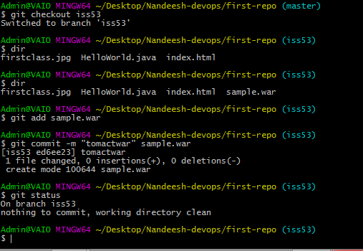

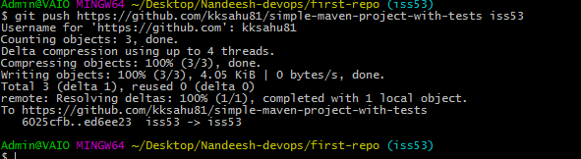

git pull https://github.com/kksahu81/simple-maven-project-with-tests iss53

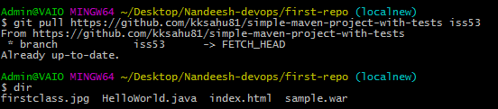

Admin@VAIO MINGW64 ~/Desktop/Nandeesh-devops/first-repo (master)

$ dir

firstclass.jpg HelloWorld.java index.html textfile

