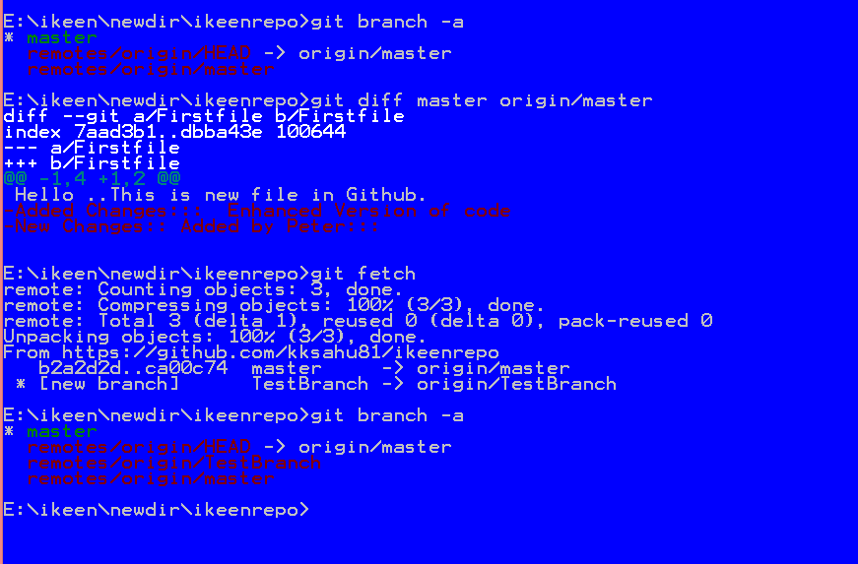

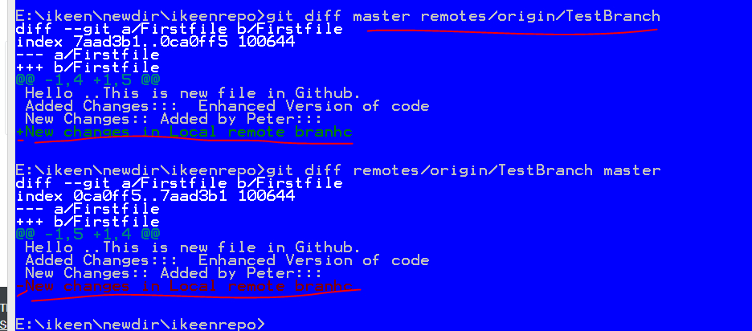

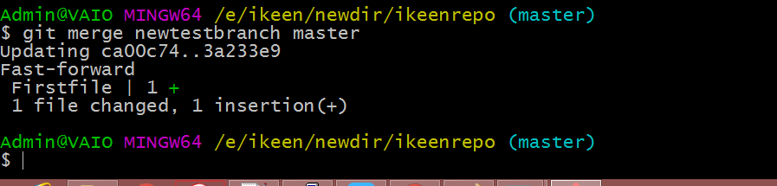

# Git: Show difference between local and remote branches

Sometimes we need to know which files will be pulled to our working tree from the remote repository. To do that just run:

git fetch origin ;

git diff --name-only master origin/master

The git fetch command will fetch all changes that happened in the origin. And the git diff will show us the difference files between our working tree and the remote.