Desktop &Networking Question & Answers

1. What is IP address?

IP address is an identifier for a Computer or Device.
Class A IP Address 1 – 126, Class B IP Address 128 – 191, Class C IP Address 192 –223. And 127.0.0.1 is Loop back IP address. It will check the System Connectivity. Each machine connected to the Internet has an address known as an Internet Protocol address (IP address). The IP address takes the form of four numbers separated by dots, for example: 192.168.0.1

You want to see System IP address goes to
Start- Run- Type cmd – type ipconfig /all

You want to confirm any system connected in the system network type ping 192.168.0.1 (192.168.0.1 this system IP address)

2. What is subnet mask?
Subnet mask is used for identify the Network.
Example:
For a class A address, a standard subnet mask is 255.0.0.0,
For a class B address, a standard subnet mask is 255.255.0.0,
For a class C address, a standard subnet mask is 255.255.255.0,

3. What is DNS?
Domain Naming Service. It‘ll Resolve IP Address to Hostname (FQDN) and Hostname to IP address. In DNS there are two Zones.
1. Forward Lookup Zone
2. Reverse Lookup Zone.
FQDN – Fully Qualified Domain Name

4. What is WINS?
Windows Internet Naming Service. It is used to resolve NetBIOS name to IP address & Vice versa. Short for Windows Internet Naming Service, a system that determines the IP address associated with a particular network computer. This is called name resolution. WINS supports network client and server computers running Windows and can provide name resolution for other computers with special arrangements. Determining the IP address for a computer is a complex process when DHCP servers assign IP addresses dynamically. For example, it is possible for DHCP to assign a different IP address to a client each time the machine logs on to the network.
WINS uses a distributed database that is automatically updated with the names of computers currently available and the IP address assigned to each one.
DNS is an alternative system for name resolution suitable for network computers with fixed IP addresses.
5. What is DHCP?
Dynamic Host Configuration Protocol. It is used to Assign IP address automatically to the Client Machine.
DHCP is a protocol used by networked computers (clients) to obtain IP addresses and other parameters such as the default gateway, subnet mask, and IP addresses of DNS servers from a DHCP server. It facilitates access to a network because these settings would otherwise have to be made manually for the client to participate in the network.
DHCP operations fall into four basic phases. These phases are IP lease request, IP lease offer, IP lease selection, and IP lease acknowledgement
DHCP discovery
DHCP offers
DHCP requests
DHCP acknowledgement
What protocol and port does DHCP use?
DHCP, like BOOTP runs over UDP, utilizing ports 67 and 68.

DNS Root Hints in Windows 2003
Root Hints are a vital cog in configuring your DNS Server. If your server receives a query for an unknown domain, then the root hints give a clue as to where to search for the answer. Maybe you were lucky and the root hints magically configured themselves correctly. Perhaps it was a triumph for planning that you examined the root hints as soon as you ran DCPROMO. However, in my opinion you cannot be a successful DNS troubleshooter without understanding root hints.

DHCP in Windows Server 2003
D ynamic - Means that clients IP address may change
H ost - Indicates that this is a system for clients, e.g. XP machines
C onfiguration - A clue that you are in charge of the options, e.g. DNS Server
P rotocol - The rules controlling the flow of packets between client and server

DHCP Address Leases
Lease is a good name for a DHCP IP property. Take for example the 8 day default lease; if the client is shutdown for 2 days, when it restarts it will continue to have the same IP address. Halfway through their lease clients attempt to renew their lease. IPCONFIG /all will show you the lease, while /renew will do what it says, top up the lease.
Only reduce the duration if you are short of IP addresses. For example, if you only have 250 IP addresses but 300 possible clients. It also makes sense to set short leases if you are likely to discontinue a scope in the near future.
Here is a table summarising how a DHCP service results in clients getting an IP address. If you are interested in seeing these packets, use Network monitor to capture DHCP in action. Here are the classic 4 packets that clients exchange during a lease negotiation.
Client | Server
DHCPDiscover --> | <--- DHCPOffer
DHCPRequest --> | <--- DHCPack
DHCPInform Server check that it is Authorized in Active Directory

Note 1: DHCPRequest may seem strange, but it comes into play if there are two DHCP servers and both make an offer to a potential client.
Note 2: DHCPack. Once in a blue moon you see DHCPNack this is a negative acknowledgement which mean, ' I do no know you'. The most likely cause of Nack is the client is trying to renew an IP address from the wrong DHCP server.

Scope Options.
Take the time to investigate Scope Options, this the most likely place that I will win my bet that you will find a new setting which will improve your network performance. These options can be set at the Scope Level, Server Level, Reservation Level or at the Class Level (Tricky). So find all four places and make up your mind which would be the best level for your network.
Examples of DHCP Scope Options:
- Router (Default Gateway), DNS Servers (006)
- Domain Name (015) WINS (044 and 046)
Classes (Advanced Tab)
- Vendor Class - Windows 98 Machines
- User Class - Routing and Remote Access
- Creating your own User Class

Address Reservation
Reserving IP addresses is useful in two situations, for file and print servers and for important machines where leases are in short supply. How does DHCP know which machine to lease a particular IP? The answer is by its MAC address (also called NIC or Physical address). In Windows 2003 when you enter the MAC address DHCP strips out the hyphens if you absentmindedly include them amongst the HEX numbers. To find the MAC address ping the machine then type arp -a.
Remember that you can set DHCP Options for the reservations; after all that may have been the very reason why you decided to make reservations in the first place.

Authorize - DHCP Server
In a Windows Server 2003 (or 2000) domain all DHCP servers need to be authorized in Active Directory. This is an example of Microsoft's new security initiative, and an attempt to eliminate rogue DHCP servers set up junior administrators in a large company. So, you need to logon (or RunAs) a member of the Enterprise Admins group. Then right click the DHCP server icon, and authorize.
Incidentally, The RIS service also needs to be authorized before it becomes active.

Activate - DHCP Scope
Even after you authorize a server, each scope must be activated individually. So, right click the scope to activate (or deactivate). Keep your eye on the red or green arrows to judge your success. Note you may have to refresh from the server icon, often pressing F5 is not enough.

6. What is Relay Agent?
If we want to assign IP address automatically to other subnets then we need to require relay agent. DHCP server always uses broadcast traffic to assign IP address for the clients. But Router does not forward broadcast Packets. Router only broadcast unicast packets. To overcome this problem across subnets we are using DHCP Relay agent.

7. What is Clustering?
Clustering means it is a group of two or more server running same application and fault tolerance it is called Clustering.
Windows 2000 Advanced server support and Data center server support 8 Nodes.
Windows 2003 enterprise edition and Datacenter server support 4 Nodes.
But, Windows 2000 server and 2003 Standard Edition Not support for Clustering.

8. What is Transferring and Seizing?
Transferring: If your Domain Computer wants to Shutdown for a while, you can transfer roles to another domain controller.
Seizing: If your Computer wants to Shutdown Permanently then you can seize your Roles from your Computer to another Computer by using Ntdsutil.

9. What is Device manager?
The Device Manager is a tool included with Microsoft Windows operating systems that allows the user to display and control the hardware attached to the computer. When a piece of hardware is not working, the offending hardware is highlighted where the user can deal with it.

10. Definition of CMOS? (Complementary Metal oxide Semiconductor)
A part of the motherboard that maintains system variables in static RAM. It also supplies a real-time clock that keeps track of the date, day and time. CMOS Setup is typically accessible by entering a specific sequence of keystrokes during the POST at system start-up.

11. FSMO (Flexible Single Master Operation) Roles?
- Schema Master: It will Contain all the object Attributes, Nothing but user Properties.
- Domain naming Master: If we are adding any server or Removing any server from the Domain. This will contain all the information.
- PDC Emulator: Any password changes by other Domain it will be updated to PDC Emulator, It will work in mixed mode, where NT B dc domain is there.
- RID Master: It will give SID ( Security Identify) to any objects created in that Domain.
- Infrastructure Master: It will have the group information for that Domain.

12. Volume types?
1) Simple volume,
2) Stripped volume
3) Spanned Volume
4) Mirrored Volume (Raid 1)
5) Raid 5 Volume.

Raid 1 (Mirrored Volume)
Mirrored volumes are created using two physical disks. A mirrored volume required same amount of unallocated space on each physical disk is used. When the data is written to a mirrored volume the data is written to a disk and then synchronized on the second disk an exact copy of the data is available on both physical disks.

Raid 5
Raid 5 volume provides fault tolerance and performance. But write operation is slower than stripped volume. Here we need 3 hard disk. Here it is a distributed data, data and parity. If data loss we can get information from parity

13. FAT file system want to convert in to NTFS file system which command?

Convert E: /FS: NTFS

14. What is NAT?

Network Address Translator. Network devices that are assigned private IP address cannot access Internet site directly therefore traffic must be routed through a net device called NAT.
Here we have to assign Private IP address and a Public IP address

15. What is ADS?

Ads is the Active directory service It will store all the information database in the centralized location and allow the users to access the resources from the network.
In windows Ntds.dit database
IN Win NT SAM database
Active Directory is an implementation of LDAP directory services by Microsoft for use in Windows environments. Active Directory allows administrators to assign enterprise-wide policies, deploy programs to many computers, and apply critical updates to an entire organization. An Active Directory stores information and settings relating to an organization in a central, organized, accessible database. Active Directory networks can vary from a small installation with a few hundred objects, to a large installation with millions of objects.
Active Directory is a directory service used to store information about the network resources across a domain.
An Active Directory (AD) structure is a hierarchical framework of objects. The objects fall into three broad categories — resources (e.g. printers), services (e.g. e-mail), and users (accounts, or users and groups). The AD provides information on the objects, organizes the objects, controls access, and sets security.
Each object represents a single entity — whether a user, a computer, a printer, an application, or a shared data source—and its attributes. Objects can also be containers of other objects. An object is uniquely identified by its name and has a set of attributes—the characteristics and information that the object can contain—defined by a schema, which also determines the kind of objects that can be stored in the AD.
Each attribute object can be used in several different schema class objects. These schema objects exist to allow the schema to be extended or modified when necessary. However, because each schema object is integral to the definition of AD objects, deactivating or changing these objects can have serious consequences because it will fundamentally change the structure of AD itself. A schema object, when altered, will automatically propagate through Active Directory and once it is created it can only be deactivated — not deleted. Changing the schema usually requires a fair amount of planning
Active directory Logical Unit => Schema, Domain Tree
Active Directory Physical Unit => OU, Site, Objects

Schema
- conceptual schema, a map of concepts and their relationships
- logical schema, a map of entities and their attributes and relations
- physical schema, a particular implementation of a logical schema
Flexible single master operation:

Forest-wide FSMO Roles:
- Schema Master that manages modifications to the AD schema and its replication to other Domain controllers.
- Domain Naming Master that manages adding, and some modification operations for domains.

Domain-wide FSMO Roles:
- Relative ID Master that allocates security RIDs to DCs to assign to new AD security principals (users, groups or computer objects). It also manages objects moving between domains.
- Infrastructure Master that maintains security identifiers, GUIDs, and DNs for objects referenced across domains. Most commonly it updates user and group links.
- PDC Emulator that emulates a Windows NT Primary Domain Controller (PDC). It is also the favored DC for other DCs in replicating and confirming password information, and is the authoritative source of time in the domain.

Lightweight Directory Access Protocol (LDAP)
In computer networking, the Lightweight Directory Access Protocol, or LDAP (It is a networking protocol for querying and modifying directory services running over TCP/IP.

A directory is a set of information with similar attributes organized in a logical and hierarchical manner. The most common example is the telephone directory, which consists of a series of names (either of a person or organization) organized alphabetically, with an address and phone number attached.

A client starts an LDAP session by connecting to an LDAP server, by default on TCP port 389. The client then sends operation requests to the server, and the server sends responses in turn. With some exceptions the client need not wait for a response before sending the next request, and the server may send the responses in any order.

The basic operations are:
- Start TLS - optionally protect the connection with Transport Layer Security (TLS), to have a more secure connection
- Bind - authenticate and specify LDAP protocol version
- Search - search for and/or retrieve directory entries
- Compare - test if a named entry contains a given attribute value
- Add a new entry
- Delete an entry
- Modify an entry
- Modify DN - move or rename an entry
- Abandon - abort a previous request
- Extended Operation - generic operation used to define other operations
- Unbind - close the connection (not the inverse of Bind)

FSMO PARTITION
Application partition
Schema Partition
Configuration Partition

16. What is global catalog?

When you installing a new domain in the forest it is called as global catalog. It will have all the information object of entire forest

17. What's the difference between Windows 2000 and Windows XP?
Windows 2000 and Windows XP are essentially the same operating system (known internally as Windows NT 5.0 and Windows NT 5.1, respectively.) Here are some considerations if you're trying to decide which version to use:
Windows 2000 benefits
- Windows 2000 has lower system requirements, and has a simpler interface (no "Styles" to mess with).
- Windows 2000 is slightly less expensive, and has no product activation.
- Windows 2000 has been out for a while, and most of the common problems and security holes have been uncovered and fixed.
- Third-party software and hardware products that aren't yet XP-compatible may be compatible with Windows 2000; check the manufacturers of your devices and applications for XP support before you upgrade.
Windows XP benefits
- Windows XP is somewhat faster than Windows 2000, assuming you have a fast processor and tons of memory (although it will run fine with a 300 Mhz Pentium II and 128MB of RAM).
- The new Windows XP interface is more cheerful and colorful than earlier versions, although the less-cartoon "Classic" interface can still be used if desired.
- Windows XP has more bells and whistles, such as the Windows Movie Maker, built-in CD writer support, the Internet Connection Firewall, and Remote Desktop Connection.
- Windows XP has better support for games and comes with more games than Windows 2000.
- Windows XP is the latest OS - if you don't upgrade now, you'll probably end up migrating to XP eventually anyway, and we mere mortals can only take so many OS upgrades.
- Manufacturers of existing hardware and software products are more likely to add Windows XP compatibility now than Windows 2000 compatibility.
18. Difference bet domain and workgroup.
Domains
Domains are collections of computers grouped for management purposes; they share a group name. Domains let users’ access resources using a single logon. Administrators don’t have to create multiple user accounts for a single user to give that user access to all domain resources.
From a security perspective, a domain is a set or collection of computers that share a common security database and a common security policy. NT domains advance the concepts seen in LAN Manager for UNIX and LAN Server domains. Each domain has a unique domain name.
Workgroups
The terms workgroup and domain are used extensively in Microsoft networking and refer to the management mechanisms available to network members. Workgroups imply decentralized management, whereas domains imply centralized control.
Workgroups are collections of computers grouped just for viewing purposes; each computer user is responsible for managing its security functions. A workgroup can consist of NT Workstations, NT Servers, UNIX computers running Server Message Block (SMB) services, and others. They communicate using a common set of networking protocols at all seven layers of the OSI model
19. Difference between NT4.0 & windows 2000

- File system difference (NTFS, FAT, FAT32)
- In winnt server concept pdc and bdc but there is no concept in 2000.
- In winnt server sam database r/w format in pdc and read only format in bdc ,but in 2000 domain and every domain controller sam database read/writer format .
2000 server can any time any moment become server or member of server simple add/remove dcpromo. But in winnt you have to reinstall operating system.
- Even though Windows 2000 is built on the Windows NT architecture, Microsoft has added many new features (Plug and Play, USB support, Recovery Console, IntelliMirror, Group Policy, Active Directory, integration of IIS and Terminal Services)

20. What is Boot.ini?
The "boot.ini" is a Microsoft initialization file found on the Microsoft Windows NT Microsoft Windows 2000, and Microsoft Windows XP operating systems. This file is always located on the root directory of the primary hard disk drive. In other words, it is located at "C:\" directory or the "C Drive". This file is used by Microsoft Windows as a method of displaying a menu of operating systems currently on the computer and allowing the user to easily select which operating system to load. In addition, this file is also used to point to the locations of each of the operating systems.
Basic example of the boot.ini file:
[boot loader]
timeout=5
default=multi(0)disk(0)rdisk(1)partition(1)\WINDOWS
[operating systems]
multi(0)disk(0)rdisk(1)partition(1)\WINDOWS="Microsoft Windows XP Home Edition" /fastdetect
In the above example, the boot.ini contains two sections, the "[boot loader]", and "[operating systems]". Within the boot loader section there are two lines. The "timeout" line is used for how long the boot menu time should be displayed, in seconds; we recommend that the timeout be set to at least five if you wish the computer to boot faster and commonly use the default operating systems. The "default" line is the default operating system that the boot.ini will load. If multiple operating systems are in the boot.ini, the default operating system will be automatically selected and used if the user does not specify a different operating system by the time the timeout value expires.
The next section, or the "operating system" section, is used to list and specify the location of each of the operating systems installed on the computer. Below is a listing of each of the options.

Option | Description
multi(x) | This option is used with IDE and ESDI drives and is also used with SCSI drives for computers using Windows NT. The number used in the above example is "0", this number is the adapter's number and should always be "0" for computers that rely on the BIOS to load system files.  - In a computer using only IDE this option will work with up to four hard disk drives.  - In a computer using only SCSI this option will work with the first two drives on the primary SCSI controller.  - Finally, if a computer is using IDE and SCSI this option will work with the IDE drives on the first controller.
scsi(x) | If the computer has a SCSI controller and is not using BIOS to load the system files, the boot.ini may have "scsi(x)" instead of "multi(x).
disk(x) | The disk on the controller. If "multi(x)" is used used, this value will always be "0". However, if "scsi(x)" is defined, this value will be SCSI address.
rdisk(x) | Which disk on the controller is being used. In the above example we are using an rdisk of "1", which indicates the second disk on the primary controller is being used. This value may be between "0" and "3" and is always set to "0" when "scsi(x)" is being used.
paritions(x) | Which partition the operating system is on. In the above example, the operating system is on the first partition of the drive.
\WINDOWS="..." | Finally, the last portion of this line defines the directory of where windows is located and what the boot menu should display as the operating system. In the above example, the boot menu would display "Microsoft Windows XP Home Edition" as a selection.
Example of the boot menu:
If multiple operating systems are setup in the boot.ini, as the computer is booting you will see a menu similar to the below example. This allows the user to select between multiple operating systems. If your computer does not have multiple operating systems, but this menu still appears each time your computer boots, it is likely that your boot.ini is improperly configured.

Please select the operating system to start:
Microsoft Windows XP Home Edition
Microsoft Windows 2000
Use the up and down arrow keys to move the highlight to your choice.
Press ENTER to choose.

For troubleshooting and advanced startup options for Windows, press F8.

How to modify the boot.ini:
The boot.ini file is a hidden system file located in the root directory of your primary hard disk drive. To edit this file we recommend you follow the below steps.
- From Windows, open an MS-DOS prompt by clicking "Start" and then "Run" and typing "cmd" in the text box. If you are not able to get into a MS-DOS prompt to edit the boot.ini file, boot into the recovery console to edit the file. Additional information about the recovery console can be found on document CH000627.
- At the MS-DOS prompt, type:
C:\ <press enter>
C:\ cd\ <press enter>
C:\ attrib -r -a -s -h boot.ini <press enter>
C:\ edit boot.ini <press enter>
- What is SMTP, pop3? Port number for the same
Short for Simple Mail Transfer Protocol, a protocol for sending e-mail messages between servers. Most e-mail systems that send mail over the Internet use SMTP to send messages from one server to another; the messages can then be retrieved with an e-mail client using either POP or IMAP. In addition, SMTP is generally used to send messages from a mail client to a mail server. This is why you need to specify both the POP or IMAP server and the SMTP server when you configure your e-mail application.
Port number: 25
POP3 (Post Office Protocol 3) is the most recent version of a standard protocol for receiving e-mail. POP3 is a client/server protocol in which e-mail is received and held for you by your Internet server. Periodically, you (or your client e-mail receiver) check your mail-box on the server and download any mail, probably using POP3.
Port number : 110
22. Difference between Outlook express & Microsoft Outlook.

Outlook Express

Outlook Express is the e-mail client that is included with Microsoft Internet Explorer 4.x, Microsoft Internet Explorer 5.x, the Microsoft Windows 98 operating system, the Microsoft Windows Millennium Edition (Me) operating system, the Microsoft Windows 2000 operating systems, and Microsoft Office 98 for the Macintosh. Outlook Express is designed for home users who gain access to their e-mail messages by dialing in to an Internet service provider (ISP).
Built on open Internet standards, Outlook Express is designed for use with any Internet standard system, for example, Simple Mail Transfer Protocol (SMTP), Post Office Protocol 3 (POP3), and Internet Mail Access Protocol (IMAP). It provides full support for today's most important e-mail, news, and directory standards such as Lightweight Directory Access Protocol (LDAP), Multipurpose Internet Mail Extension Hypertext Markup Language (MHTML), Hypertext Markup Language (HTML), Secure/Multipurpose Internet Mail Extensions (S/MIME), and Network News Transfer Protocol (NNTP). Full support ensures that you can take advantage of new technologies as well as seamlessly send and receive e-mail.
New migration tools that automatically import your existing mail settings, address book entries, and e-mail messages from Eudora, Netscape, Microsoft Exchange Server, the Windows Inbox, and Outlook make it easy for you to quickly take advantage of all that Outlook Express has to offer. The ability to receive mail from multiple e-mail accounts, as well as the ability to create Inbox rules, helps you manage and organize your e-mail.
In addition, full support for HTML mail enables you to personalize your messages with custom backgrounds and graphics. This makes it easy to create unique, visually powerful messages.
.

Outlook
Outlook is Microsoft's premier messaging and collaboration client. It is a stand-alone application that is integrated into Microsoft Office and Exchange Server. Outlook also provides performance and integration with Internet Explorer 5.5. Complete integration of e-mail, calendaring, and contact management, makes Outlook the perfect client for many business users.
Outlook helps you find and organize information so that you can work seamlessly with Office applications. This helps you communicate and share information more effectively.
Powerful Inbox rules enable you to filter and organize e-mail messages. With Outlook, you can integrate and manage e-mail from multiple e-mail accounts, personal and group calendars, contacts, and tasks.
When you use Outlook with Exchange Server, you can use workgroup information sharing and workflow communications, group scheduling, public folders, forms, and enhanced Internet connectivity.
Outlook is designed for use with the Internet (SMTP, POP3, and IMAP4), Exchange Server, or any other standards-based communication system that supports Messaging Application Programming Interface (MAPI), including voice mail. Outlook is based on Internet standards and supports today's most important e-mail, news, and directory standards, including LDAP, MHTML, NNTP, MIME, and S/MIME, vCalendar, vCard, iCalendar, and full support for HTML mail.

Outlook Configuration:

Step 1 - Open MS Outlook. If this is the first time you have opened Outlook Express, and you do not have any e-mail accounts set up, you will be prompted to set up a new account, go through the wizard until you see the screen that looks like Fig 1. If you are prompted to import an account from Outlook Express AND that account is the e-mail hosted on our server, go ahead and follow the wizard to import the settings, you should be complete once that wizard is done. If the wizard does not come up, click on 'Tools' and then on 'E-Mail Accounts'. You should see a similar screen as Fig 1, click on 'Add a new e-mail account', click 'Next'. | 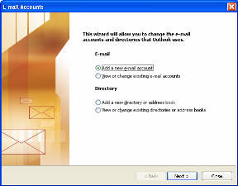
Step 2 - Select the type of e-mail account as shown and click 'Next' | 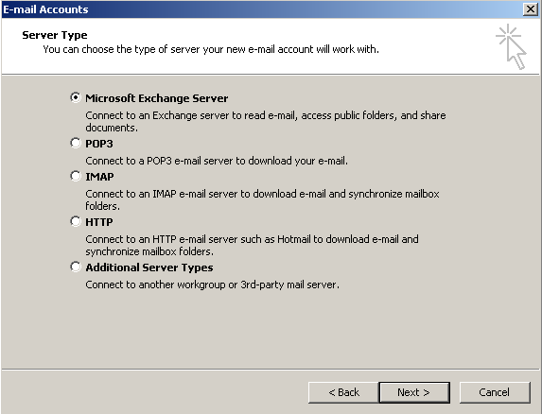
Step 3 –  Microsoft Exchange Server : fmg-nt  User Name : ajayka (for example)  Click Next | 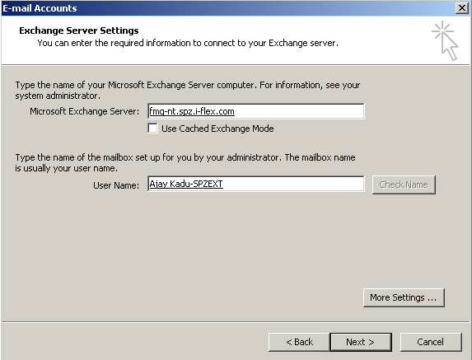
Step 4 –  Click Finish | 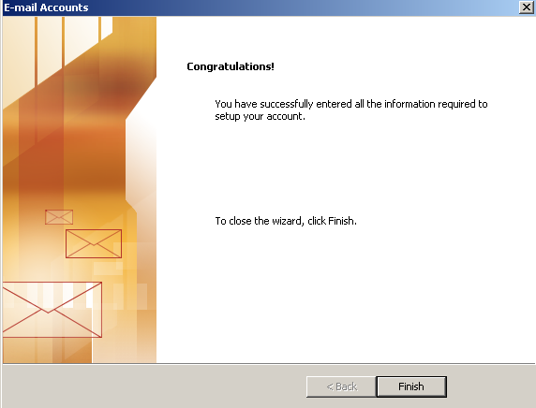
To Configure PST:
Step 5 –  Open Outlook  Go to Tools -> Options | 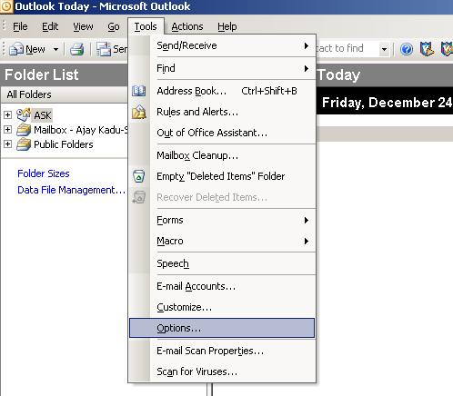
Step 6 –  In Options go to Mail Setup tab  Click on Data Files… | 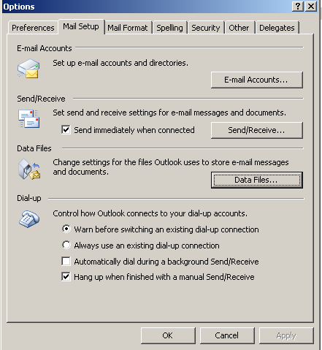
Step 7 –  Click Add  Select Option as shown  Click OK | 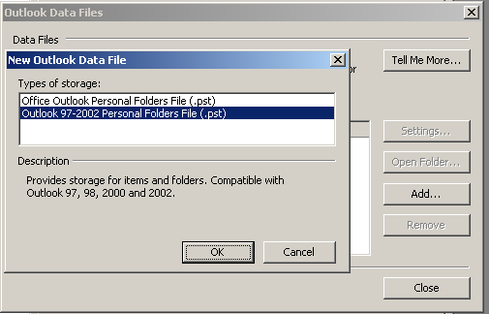
Step 8 –  Create New File  For example : ajayk (as shown)  OR  Browse to exsisting file location  Click OK | 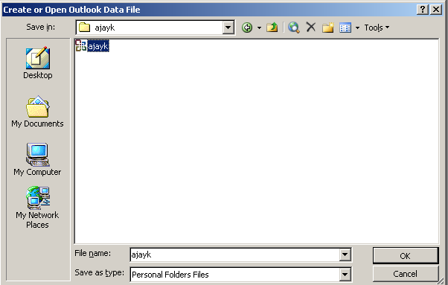
Step 9 –  Give display name.  Click OK | 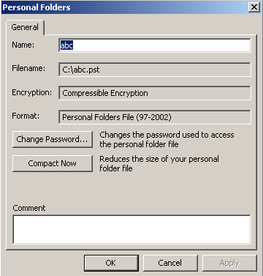

Repeat Step-5  Go to ->Mail Setup -> E-mail Accounts | 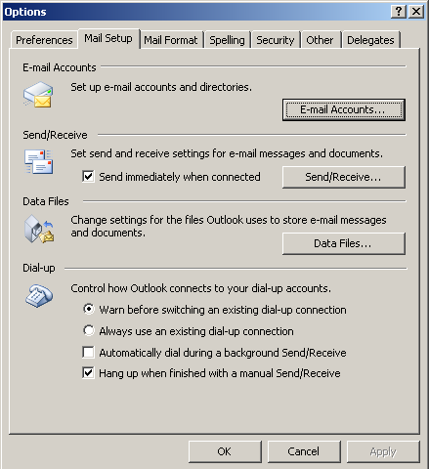
Check Option as shown
Click Next
In Deliver new e-mail to following location dropdown list select your PST instead of Mailbox.  Click Finish  Click OK on Mail Setup tab  Close Outlook  Reopen Outlook  Now Outlook is ready with your PST | 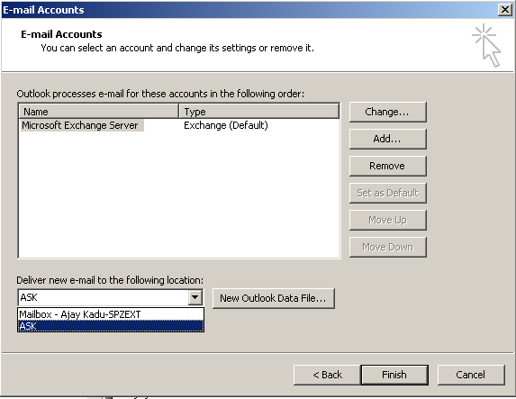

To configure multiple PST?

We can Configure multiple PST by repeating the same step from step 5 – step 9 .

To change delivery option to various PST?

In Deliver new e-mail to following location dropdown list select your PST instead of Mailbox. you can select the delivery mail location.

Click Finish

Click OK on Mail Setup tab

Close Outlook

Reopen Outlook

Now Outlook is ready with your PST

- About types of Printer?

Any of the current types of printers satisfies the work and cost requirements for someone. Each has strengths and weaknesses. Choose your type of printer based on which of the features previously discussed are important to your work, then choose the specific printer that best suits both your tasks and pocketbook.

Impact Printers
With this type of printer something strikes paper & ribbon together to form a character, like a typewriter.

Advantages: | Less expensive  Fast (some types)  Can make multiple copies with multipart paper
Disadvantages: | Noisy!  Print quality lower in some types.  Poor graphics or none at all.

Types of Impact Printers

Dot matrix

Daisy Wheel

Chain and Band printer

Dot Matrix | Forms characters using row(s) of pins, 9, 18, or 24 which impact the ribbon on top of the paper. Also called pin printers.  The more pins, the smoother-looking the characters.  Most dot matrix printers have the characteristics below:



Bi-directional - |  | prints left to right and also right to left
Tractor feed - |  | uses sprockets to pull continuous-feed paper
Friction feed - |  | uses pressure to pull single sheets
Advantages: |  | Inexpensive  Can do multi-copy forms
Disadvantages: |  | Can be slow  Loud  Graphics of low quality, if possible at all
Daisy Wheel | Characters are fully formed on the "petals", like typewriter keys. |  | 
Advantages: | Best print quality
Disadvantages: | Very slow - 20 to 80 cps  Only one font can be used at a time because you must change out the Daisy Wheel to change fonts.  Cannot print graphics.

Chain and Band Printers | Uses characters on a band or chain that is moved into place before striking the characters onto the paper.
  Advantages: | Very fast  up to 3000 lpm (lines per minute)
  Disadvantages: | Very expensive  Very loud

Non-Impact Printers
This type of printer does not involve actually striking the paper. Instead, it uses ink spray or toner powder.

Advantages: | Quiet!  Can handle graphics and often a wider variety of fonts than impact printers.
Disadvantages: | More expensive  Slower

Types of Non-Impact Printers
Ink Jet | Sprays ink onto paper to form characters | 
  Advantages: | Quiet  High quality text and graphics. Some can do color.
  Disadvantages: | Cannot use multiple-copy paper  Ink can smear
Thermal | Uses heat on chemically treated paper to form characters. Fax machines that use rolls of paper are also of this type.
  Advantages: | Quiet
  Disadvantages: | Relatively slow  Expensive, requiring special paper  Cannot use multiple-copy paper
Page Printer | Works like a copy machine, using toner and a heat bar. Laser printers are in this category.
  Advantages: | Quiet  Faster than other non-impact printers, from 4 to 16 ppm (pages per minute)  High quality print and graphics. Some can do color.
  Disadvantages: | More expensive than impact printers  Cannot use multiple-copy paper

Thus, Things to Consider When Choosing a Printer:
How much output? | What speed is needed?  Is heavy-duty equipment necessary?
Quality of output needed? | Letter quality?  Near letter quality?  Draft?
Location of printer? | How big a footprint can be handled?  Is loudness important?
Multiple copies needed?
Color print needed

24. Explain about Printer Spooler?

Spooler Introduction
The Printer Spooler enables the printer to be shared among multiple processes. This allows each process to see a virtual printer which it can print to and also allows a process to submit a file for printing. It can be used by both native tasks and by virtual tasks via the `vprinter' module.
Spooler Operation
When a file is submitted for printing, its name is added to a list. A separate process processes this list in order to print the files. The list is processed in a FIFO (First In First Out) fashion. Although scheduling algorithms are available including SJF (Shortest Job First) and LJF (Longest Job First), a FIFO system was used in order to maintain simplicity and functionality. A virtual printer can also be opened allowing a process to print to a file when it doesn't know how much is to be printed. When the file is closed, it is added to the list. This is used by the `vprinter' module for emulating printer ports.
When the thread handling the printing of files is initially created, it looks in the spool directory and if there are any files there it automatically adds them to the list. The spool directory is defined in the header file `<vmm/spooler.h>' and is by default set to spool.
Because of the dual access to the spool list by both the thread adding a spool file and the thread processing the spool list, access to the list is protected by a semaphore.
If the Print Spooler service fails when printing, when Windows starts or it can not be restarted, the usual reason is that one or more printer drivers is defective. If the Print Spooler service is not running, the Printers and Faxes folder will be empty and you can not use it to remove (or add) printers or printer drivers.

25. How to edit registry manually to clean up spooler and drivers?

Here's how to clean up the print spooler stuff if any third party kit is not available or you prefer to do things manually.

Warning! be very careful using regedit - if you delete the wrong things, you may render your computer inoperative!
- open regedit (e.g. click Start, key regedit and press Enter)
- navigate to
HKEY_LOCAL_MACHINE\SYSTEM\CurrentControlSet\Control\Print\Environments\Windows NT x86\Drivers under this key, there will be the keys Version-2 and Version-3 (one or the other of these may be absent - not a problem) the sub-keys under these contain the printer driver configuration information delete all the sub-keys inside Version-2 and Version-3, but not these keys themselves.
The Microsoft Knowledgebase article at http://support.microsoft.com/default.aspx?scid=kb;en-us;312052 lists some other registry entries to delete, but this is not usually necessary.
- Open a Command Prompt window
- Key the commands
net stop spooler
net start spooler
- Open Windows Explorer
- Navigate to %systemroot%\system32\spool\printers\ and delete any files there. By default, this is where the print spooler stores print files.
- Navigate to %systemroot%\system32\spool\drivers\w32x86 (%systemroot% is usually Windows, but it might be winnt or something else; this is set when the OS is installed).
- Inside w32x86, there will be folders with the names 2 and 3 (one or more of these may be absent - not a problem) delete all of the files and sub-folders in each of the 2 and 3 folders, but not the folders themselves inside w32x86, there may be other folders with names starting with "hewlett_packard", "hphp" or something else; delete these folders also.
- Restart the print spooler (see steps 8 and 9 above)
At this point, the system should be pretty well back to the way it was before any printers were installed. Some would suggest restarting Windows at this point, but with Windows 2000 and later, this does not seem to be required.

Change the Printer Spooler Priority (Windows NT/2000/XP)
Normally the printer spooler runs at the same priority as other services on a system. If your system is being mainly used for printing or handles a large number of print jobs you can use this tweak to change the priority class the print spooler.
Open your registry and find or create the key below.
Create a new DWORD value, or modify the existing value, called "SpoolerPriority" and set it according to the value data below.
Exit your registry, you may need to restart or log out of Windows for the change to take effect.

 |  | (Default) | REG_SZ | (value not set)
 |  | SpoolerPriority | REG_DWORD | 0x00000001 (1)

HKEY_LOCAL_MACHINE\SYSTEM\CurrentControlSet\Control\Print

Registry Settings
System Key: [HKEY_LOCAL_MACHINE\SYSTEM\CurrentControlSet\Control\Print]
Value Name: SpoolerPriority
Data Type: REG_DWORD (DWORD Value)
Value Data: 0 = Normal priority, 1 = High priority, 0xFFFFFFFF = Idle priority

Troubleshooting Printers

Solution Title: Print Spooler Service won't start - Windows XP

I can not print or add printers because the Print Spooler Service is not started. The startup type is set to Automatic but it is not running. When I try and start the service receive the following error:
Could not start the Print Spooler Service on Local Computer. Error 1068: The dependency service or group failed to start.
The only dependency that I know of is Remote Procedure Call is is started. I'm missing something but don't know what it is. Any help would be greatly appreciated.

Try this:
Click Start->Run->Services.msc
Locate the Printer Spooler service double-clicks it to get to the properties.
From the recovery tab, change all three options to "Restart the Service".
Leave the bottom two options set to "1” Ok out of this dialogue.
Now go back and try to restart the service...

26. About Ethernet?

Ethernet uses an access method called CSMA/CD. This is a system where each computer listens to the cable before sending anything through the network. If the network is clear, the computer will transmit. If some other node is already transmitting on the cable, the computer will wait and try again when the line is clear. Sometimes, two computers attempt to transmit at the same instant. When this happens a collision occurs. Each computer then backs off and waits a random amount of time before attempting to retransmit. With this access method, it is normal to have collisions. However, the delay caused by collisions and retransmitting is very small and does not normally affect the speed of transmission on the network. The Ethernet protocol allows for linear bus, star, or tree topologies. Data can be transmitted over twisted pair, coaxial, or fiber optic cable at a speed of 10 Mbps.

27. About Fast Ethernet?
To increase transmission speed, the Ethernet protocol has developed a new standard that supports 100 Mbps. This is commonly called Fast Ethernet. Fast Ethernet requires the use of different, more expensive network concentrators/hubs and network interface cards. In addition, category 5 twisted pair or fiber optic cable is necessary.

28. About Token Ring?
In Token Ring, the computers are connected so that the signal travels around the network from one computer to another in a logical ring. A single electronic token moves around the ring from one computer to the next. If a computer does not have information to transmit, it simply passes the token on to the next workstation. If a computer wishes to transmit and receives an empty token, it attaches data to the token. The token then proceeds around the ring until it comes to the destination computer. At this point, the data
is captured by the receiving computer. The Token Ring protocol requires a star-wired ring using twisted pair or fiber optic cable. It can operate at transmission speeds of 4 Mbps or 16 Mbps. Due to the increasing popularity of Ethernet, the use of Token Ring has decreased.

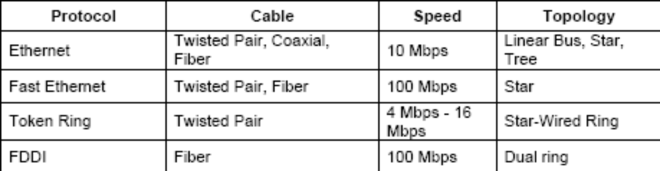
.
29. About Cabling?
In a twisted-pair network (10 Base T) each PC has a twisted-pair cable that runs to a centralized hub. Category 5 is the most reliable and widely compatible twisted-pair. It runs easily with 10Mbps or networks, and is required for Fast Ethernet. You can buy Category 5 cabling that is pre-made, or you can cut & crimp your own.
Category 5 cables can be purchased or crimped as either straight through or crossed. A Category 5 cable has 8 thin, color-coded wires inside that run from one end of the cable to the other. Only wires 1, 2, 3, and 6 are used by Ethernet networks for communication. Although only four wires are used, if the cable has 8 wires, all the wires have to be connected in both jacks.
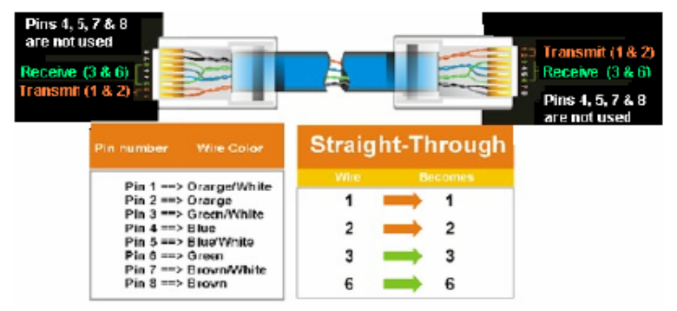
Straight-through cables are used for connecting computers to a hub.
Crossed cables are used for connecting devices of similar type like hub-to-hub, switch-to-switch, etc
In a straight-through cable, also known as a patch cable, wires 1, 2, 3, and 6 at one end of the cable are also wires 1, 2, 3, and 6 at the other end. In a crossed cable, the order of the wires changes from one end to the other: wire 1 becomes 3 and 2 become 6.
To figure out which wire is wire number 1, hold the cable so that the end of the plastic RJ-45 tip, (the part that goes into a wall jack first), is facing away from you. Flip the clip so that the copper side faces up, (the springy clip will now be parallel to the floor). When looking down on the coppers, wire 1 will be on the far left.
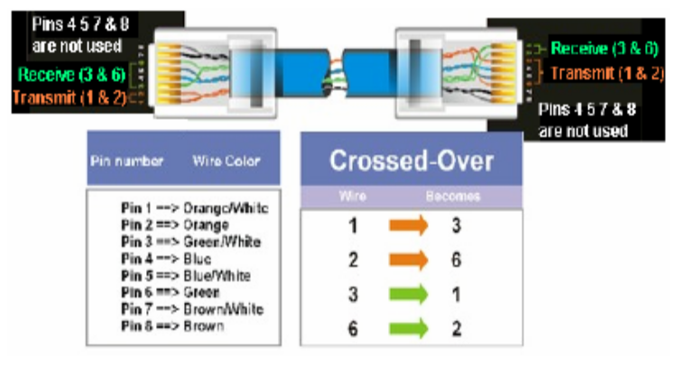

30. What is a layer 3 switch?
Layer 3 switches combine the speed and cost-effectiveness of switching, with the control and scalability of routing. Like a router, a Layer 3 switch runs routing protocols such RIP, RIP2, OSPF or any other routing protocol. The Layer 3 switch communicates with all other "routers" in the network. From a router's perspective, it appears as if the Layer 3 switch is just another router exchanging information about topology and moving packets.
Unlike traditional routers a Layer 3 switch applies switching technologies in the forwarding plane. The main CPU does not inspect packets unless they are exceptions

31. Difference between Router-Switch-Hub-Bridge?

Hubs work at the Physical layer. A hub is a totally dumb device. If it gets a data signal, it just forwards the signal to all devices. It cannot do any kind of filtering or addressing. Performance is not so good because a hub can't establish a direct connection from one computer to another.
If a switch gets a data packet, it will try and find the destination device, and then send it to that device only, i.e. it establishes a point-to-point connection between the sending and receiving devices. But the devices must be on the same subnet. A switch won’t send data packet to computers on different subnets. A switch breaks up collision domains but it does not break up broadcast domains unless we use VLANs.
Like Switches, Bridges operate at the Data Link layer and filter packets based on the MAC address. Generally bridges are used to extend the distance capabilities of the network while minimizing overall traffic, and switches are used mainly for their filtering capabilities to create multiple VLANs. Bridges have less number of ports than switches.
Routers work at the Network layer and operate on the IP Address. Router only gets a data packet if the destination computer isn’t on the same subnet or LAN. The router then finds the location of the destination device and then sends it in the right direction. A router breaks up broadcast domains.

32. How is a full-duplex switch different from a switch?
A full duplex switch has one set of lines for receiving and one set of lines for transmitting, thus it can do both operations at the same time.
Connecting to a 2500 Router
Basically the router is connected from the console port
Use a rollover cable, the one supplied by Cisco is blue and flat, RJ-45 connectors.
Connect 1 end to the console port and the other to an RJ-45 to serial converter;
Plug that to the computers' serial port
Then go to HyperTerminal
Select the COM port from connect using: probably COM2 or COM3
Change bits per second on the next screen to 9600 and click ok
You should be in the router if u did it correctly...

Picture of 2503 Router
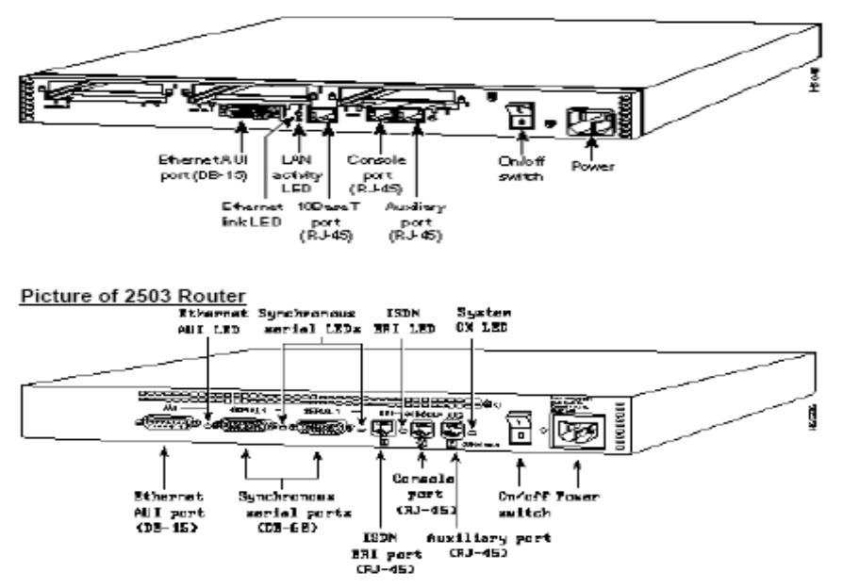

33. Difference between Firewall and Proxy?

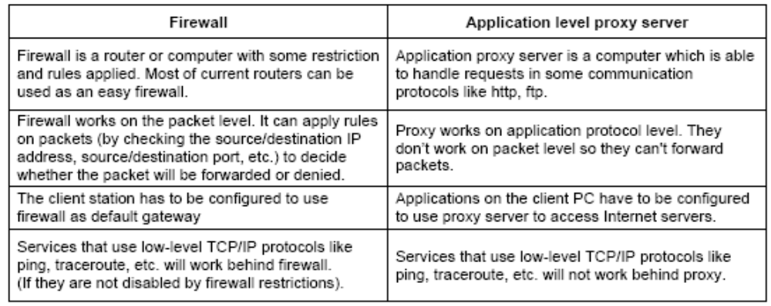

34. Layers in TCP/IP?

- Process/Application Layer
- Host-to-Host Layer
- Internet Layer
- Network Access Layer

35. Difference between TCP and UDP?

- TCP converts upper layer data in to segments and the segments are numbered and sequenced so that the destination TCP can place them in the same order, and can easily detect a missing segment. But in UPD data is broken in to segments and the segments are numbered but not sequenced.
- TCP is connection oriented because it creates a virtual circuit between the source and destination before sending data. But UDP does not create any virtual circuit before sending data.
- TCP uses acknowledgement to resent missing segments, but there is no acknowledgement in UDP.
- So we can say TCP provide reliable communication but UDP provides unreliable communication.
- Since TCP is creating virtual circuits, TCP is costly in terms of bandwidth. But UDP has low overhead

36. Classes of IP Address?

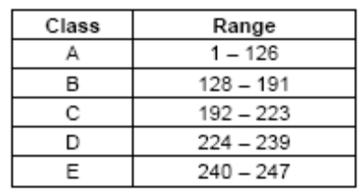

37. What is the Private IP Address range?
10.0.0.0 - 10.255.255.255
172.16.0.0 - 172.31.255.255
192.168.0.0 - 192.168.255.255

38. How many bytes in an IPX network address?
80 Bits or 10 Bytes

39. Different type of monitoring tools
Performance Monitor - Monitors network and computer statistics. Is able to log the data and export it for spreadsheet usage.
Network Monitor - Monitors network activity and is able to capture and look at packets of data sent over the network.
Netstat - Displays protocol statistics and current TCP/IP network connections. Netstat shows statistics since the server was booted.

40. Network troubleshooting commands?
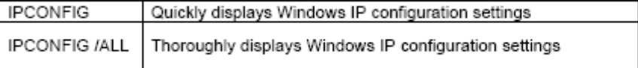
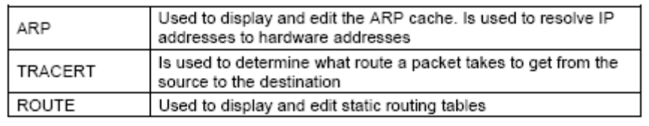

41. What are some of the problems associated with operating a switched LAN?
Even though switch breakup collision domains it cannot break up broadcast traffic. Broadcasts, multicasts and slow convergence of spanning tree can cause problems.

42. What is a Layer 4 Switch?
Layer 4 switches operate at the transport layer of the TCP/IP stack. Layer 4 switches operate at the UDP and TCP level, making switching decisions based on information held in the transport layer

43. What is binding?
A process that establishes the initial communication channel between the protocol driver and the network adapter card driver
In a client/server system, a client transmits a request to a server, the server performs a processing operation, and the server returns a result. List all the possible things that can go wrong with transmission in this scenario.
1. Request gets lost, client waits.
2. Request gets temporarily lost, client sends another, and then two requests arrive at server.
3. Results from server are lost.
4. Results from server temporarily lost, then client sends request again, getting two sets of results.
5. Client crashes before results come back.
6. Server crashes before request arrives or after results start their way back.

44. What is the difference between SSL and S-HTTP?
SSL: Secure Sockets Layer, a protocol developed by Netscape for transmitting private documents via the Internet. SSL works by using a private key to encrypt data that's transferred over the SSL connection. Both Netscape Navigator and Internet Explorer support SSL and many Web sites use the protocol to obtain confidential user information, such as credit card numbers. By convention, Web pages that require an SSL connection start with https: instead of http:S-HTTP: Secure-HTTP is the protocol used for transmitting data securely over the World Wide Web Whereas SSL creates a secure connection between a client and a server, over which any amount of data can be sent securely, S-HTTP is designed to transmit individual messages securely. SSL and S-HTTP, therefore, can be seen as complementary rather than competing technologies. Both protocols have been submitted to the Internet Engineering Task Force (IETF) for approval as a standard

45. What is Packet Switching?
Packet switching refers to protocols in which messages are divided into packets before they are sent.
Each packet is then transmitted individually and can even follow different routes to its destination. Once all the packets forming a message arrive at the destination, they are recompiled into the original message.
Most modern Wide Area Network (WAN) protocols, including TCP/IP, X.25, and Frame Relay, are based on packet-switching technologies.
The normal telephone service is based on a circuit-switching technology, in which a dedicated line is allocated for transmission between two parties. Circuit-switching is ideal when data must be transmitted quickly and must arrive in the same order in which it is sent. This is the case with most real-time data, such as live audio and video. Packet switching is more efficient and robust for data that can withstand some delays in transmission, such as e-mail messages and Web pages. A packet switched network is simply a digital data transmission network that uses packet switching technology.

46. Firewalls – An overview
As the Name implies, firewalls are an electronic barrier designed to exclude unauthorized access to private networks. They come in various forms and different degrees of sophistication, depending on the size of the organization and the nature of the information stored.
Firewalls, both hardware and or software-based, primarily protect a network or central system from hacker intrusion from the Internet or other public network. In addition, some firewalls also restrict LAN user access to inappropriate websites. All networks with access to the Internet need a firewall.

How a Firewall works
1. In the middle of the two networks sits a router.
2. An access control list is placed on the router which has a list of IP addresses that can be allowed on to the network.
3. When you try to access the network, the router automatically checks the list.
4. If your IP address is one of those on the list, you're allowed in. If not, you sit outside

Limitations of Firewalls
• Firewalls must be updated with a list of inappropriate banned websites, as new sites appear very quickly.
• Firewalls are not an effective protection against software viruses. We recommend that all users install anti--virus software.
• Often Firewalls are positioned between an Internet router and the internal LAN, this result in a network bottleneck. Careful consideration should be paid to where a firewall is placed. We recommend that the firewall is installed between a switch and an Internet router.
• Firewalls cannot protect against 'back doors', where a single network user has installed a separate Internet connection. To prevent this, companies should put an effective Internet access policy in place.
• Equipped with the correct password, hackers can gain access to your network in spite of a firewall. To solve this, all passwords should be changed regularly

47. In the TCP client-server model, how does the three-way handshake work in opening connection?
A: The client first sends a packet with sequence "x" to the server. When the server receives this packet, the server will send back another packet with sequence "y", acknowledging the request of the client. When the client receives the acknowledgement from the server, the client will then send an acknowledgement back to the server for acknowledging that sequence "y" has been received.

48. What is the purpose of exchanging beginning sequence numbers during the connection in the TCP client-server model?
To ensure that any data lost during data transfer can be retransmitted.

49. What is HTTP Tunneling?
HTTP Tunneling is a security method that encrypts packets traveling thought the internet. Only the intended recipient should be able to decrypt the packets. It can be used to Create Virtual Private Networks. (VPN)

50. Most Common Port Numbers
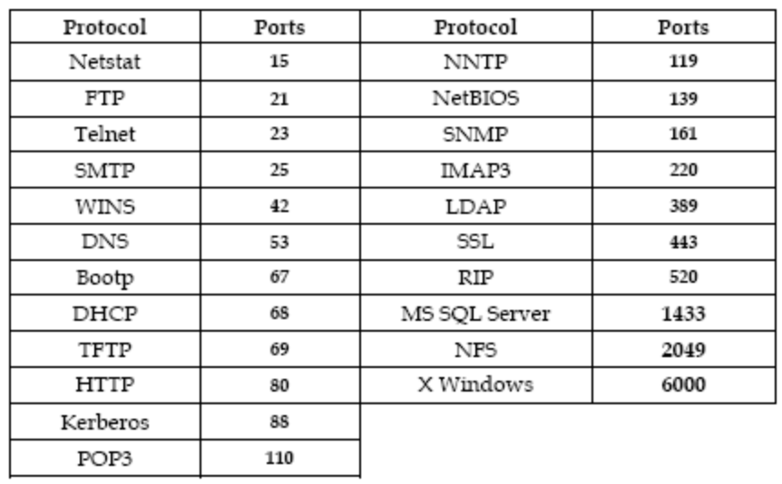

51. OSI Layers & Functions
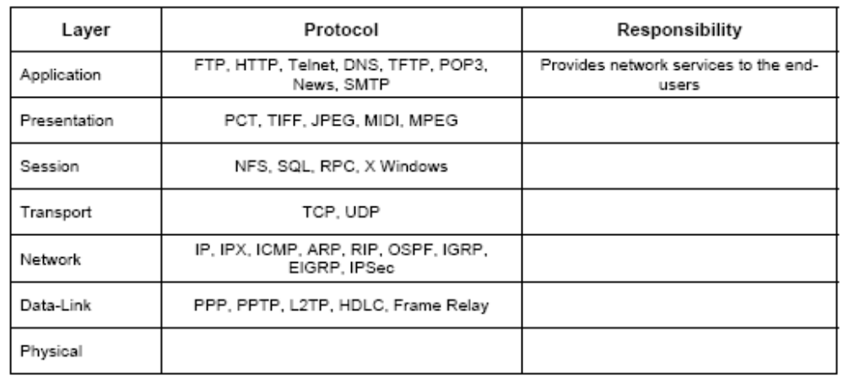

52. Simple Mail Transfer Protocol
SMTP allows ASCII text messages to be sent to mailboxes on TCP/IP hosts that have been configured with mail service.
1. A user wanting to send mail interacts with the local mail system through the User Agent (UA) component of the mail system.
2. The mail is deposited in a local outgoing mailbox.
3. The sender SMTP process periodically polls the outgoing box and if a message is found it establishes a TCP connection on port 25 with the destination host to which the message is to be sent.
4. The receiver-SMTP at the destination receives the connection and the mail message is sent on that connection.
5. The receiver-SMTP deposits the mail in the destination mail box in the dest. host.
6. If no matching mailbox is found, a mail is send to the sender indicating that the mail box does not exists.
(The sender-SMTP and receiver-SMTP processes which are responsible for the transfer of mail are called Message Transfer Agents)
To send nontext messages using SMTP, we can encode them as text using the UUENCODE utility. The receiver will decode it using another utility called UUDECODE. We can also use MIME protocol
(Multipurpose Internet Mail Extensions) to send nontext messages like rich text, image, audio, video and HTML.

53. Some SMTP commands
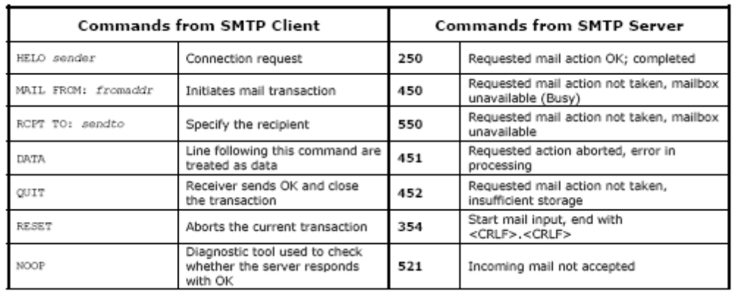
54. Using telnet to contact SMTP on port 25 (Troubleshooting)

Client: Telnet 130.130.20.1 25 (130.130.20.1: IP of SMTP Server. If connection is established, then server is reachable)
Try sending a mail to the server
Client: HELO machine (machine: Our machines DNS host name)
Server: HELO machine pleased to meet you
Client: MAIL FROM: sanjo900@yahoo.com
Server: 250 OK
Client: RCPT TO: krishna900@yahoo.com
Server: 250 OK
Client: DATA
Server: 354 start mail input; end with <CRLF>.<CRLF>
Client: This is the test message 1
Client: This is the test message 1
Client: .
Server: 250 OK

55. Post Office Protocol Version 3
SMTP wants the destination host (Mail Server) to be online. Otherwise a TCP connection can not be established with the destination host. Since desktop machines are not always online we can not use SMTP for receiving mail.
The SMTP mail server is always online and provides a mail drop service. Work stations retrieve mail from server using POP3. POP3 TCP and listens on port 110. POP3 is used only to download mail. With POP3, MD5 (Message Digest version 5) can be used for authentication.
A POP3 session has 4 phases
1. Connection state: TCP connection with POP3 server is established
2. Authorization state: User must provide Username and Password to be authenticated by the server
3. Transaction state: After authentication is the transaction state in which a number of commands like STAT, LIST, RETR, DELE and RSET can be issued.
4. Update state: After the message has been downloaded POP3 enters update state in which POP3 clients issue the QUIT command to close the connection
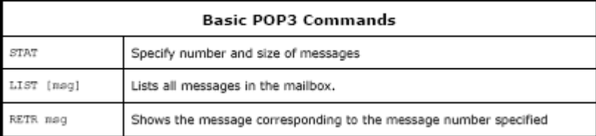

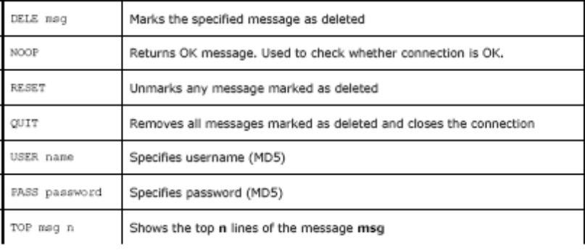

POP3 Troubleshooting
Telnet 130.130.20.1 110 (If telnet connection is established it means the server is reachable)
+OK POP3 server is ready
USER sanjo900@yahoo.com
+OK
PASS *********
+OK m n (M is the number of messages and N is the total bytes in all messages)
LIST
1 s1
2 s2 (S1, S2 are the size of message 1 and 2)
RETR 1 (Retrieves message 1)
Here goes the text of message 1
DELE 1 (Deletes message 1)
QUIT
+OK POP3 server signing off

56. Internet Message Application Protocol (IMAP)?
POP3 does not allow the direct manipulation of mail messages at the server. The mail must be downloaded to the workstation before it can be manipulated. IMAP4 is designed to access and manipulate mails on the server. With IMAP4 we can manipulate remote mailboxes like local mailboxes.
IMAP4 allows an offline client to resynchronize its mailbox with the server.
Features of IMAP include the ability to:
• Access and manipulate portions of email on a server without downloading them.
• Review messages and attachment without downloading them
• Download all messages for offline operation
• Resynchronize local mailboxes with those at the server

With IMAP we can:
• Create, delete, and rename mailboxes
• Check for new messages
• Permanently remove messages from mailboxes
• Set and clear flags indicating the status of messages
• Recognize RFC-822 headers and parse MIME-encoded messages
• Search and selectively fetch message attributes, text, and portions thereof
Messages in IMAP4 are accessed by the use of numbers – either message sequence numbers or unique identifiers. IMAP4 can be used only to receive mail.
IMAP4 can be in one of four states.
Non-Authenticated – This state is entered when a connection starts Authenticated - This state is entered when acceptable authentication credentials have been provided Selected - This state is entered after a valid mailbox has been selected Logout - The Connection is terminated and IMAP server closes the connection.

57. What is an operating system? List the basic functions of an operating system.
The Operating System is a software program that controls the processing and hardware associated with a computer. The operating system is the first piece of software loaded into memory when a computer starts. It is the operating system that launches or starts other software programs such as word processors, spreadsheets, databases, etc. The operating system manages all of the resources on the computer; it controls all the hardware in a machine. Manage all programs and resources; handle I/O, security, memory management, storage management, etc are the important functions of an OS.

58. Sharing a folder?
Who can create share a folder
In a DC - Members of Domain Admins, Administrator and Server Operators groups
Local Computer - Members of Administrator and Power Users groups
Share permissions
• Share permissions are – Full Control, Read, and Change.
• Least restrictive permission is the user’s effective permission.
• A denied permission always overrides an allowed permission
• When NTFS and Share permissions are applied to a folder the most restrictive will be applied when we access the folder over the network Administrative Shares One for the root of each HDD volume, C$, D$ and so on
ADMIN$ - The system root e.g. C:\WINNT
The $ sign hides the share from normal users other than Administrator.
Naming conventions
Share Name can be up 80 char. But win 98/95 can read up to 12 char.
UNC – Universal Naming Convention
Consists of Server name and share name e.g. \\Server\Share
FQDN – Used in networks which use DNS and TCP/IP
E.g. server_name.domain_name.root_domain_name
Use NET USE to map a shared folder.
Net use d: \\Server1\Share1

59. NTFS File & Folder Security
Standard NTFS permissions are: Full Control, Modify, Write, List Folder Contents, Read & Execute, Read , Default NTFS permission is Everyone Full Control
We can use Explorer or Cacls.exe to assign NTFS permissions
To apply NTFS permissions you must have Full Control OR you must be the Owner of the file.

How permissions are applied to New, Moved and Copied files?
Move to different folder on different volume – Receives destination permission regardless of original Permission
Move to different folder on same volume – Retains original permissions regardless of destination Permission
Copy to a different folder on a different volume – Receives destination permission regardless of original Permission
Copy to a different folder on the same volume – Receives destination permission regardless of original Permission
Who can take ownerships?
Administrator, user with Full Control, or user with “Take Ownership of Files and Folders” user right assigned

60. About Disk Quota?
Only Administrators can configure disk quota.
Disk quota cannot be set to Groups

61. Permissions for Printing?
Who can add a printer?
Local Computer: Administrators and Power Users
DC: Administrators, Print Operators and Server Operators
• We can add printers on a remote computer by browsing through the network neighborhood
• To access internet printer through the web browser type http:// Server01/ PrinterShareName

62. User Accounts
Who can create User Accounts?
Administrator or Power Users Group in a Non-DC
Administrator & Account Operators Group In DC
(The Power Users and Account Operators cannot do everything regarding user configuration)
UserName can be up to 20 char (Allows entering more than 20 but will recognize only 1st 20)
Logon scripts for all domain users are stored in the NETLOGON share in the
%systemroot%\SYSVOL\sysvol\domain_name\scripts

63. List of Built-in Groups?
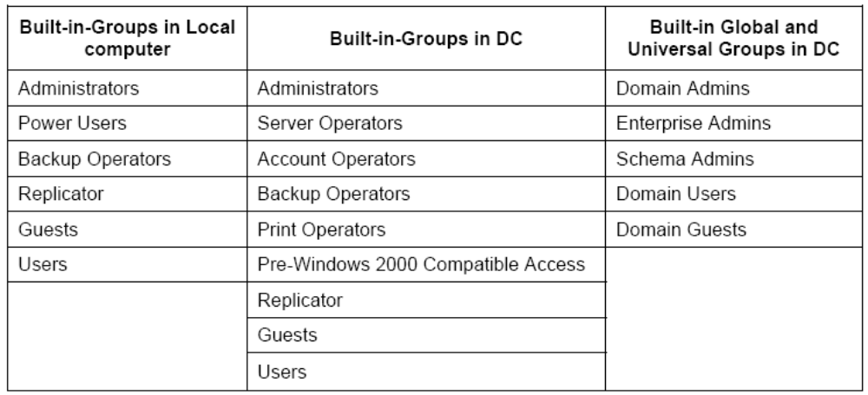

There are 12 built-in special groups: Everyone, Anonymous Logon, Authenticated users, Creator Owner, Creator, Batch, Dialup, Interactive, Network, Service, System, Terminal Server User, who can logon locally on a DC Administrators, Account Operators, Backup Operators, Print Operators, and Server Operators

64. Relationship between AD & DNS
AD uses DNS for name resolution. So when we setup AD, DNS must be present. AD is a directory service and DNS is name resolution service. AD uses DNS to resolve name to IP address. Specifically, AD uses DNS to find DNS resource (SRV) records for LDAP services. AD use LADP protocol to exchange directory information and uses DNS to discover the IP address of LDAP services.

65. Emergency Repair Disk
ERD contains 3 files AUTOEXEC.NT (Installs CD ROM support), CONFIG.NT (Loads DOS in to Upper Memory Block in conventional memory and loads HIMEM.SYS to read memory above 640KB) and SETUP.LOG.

66. Securing the PWs?
Don’t use your name, name of family members or part of the name as password
Never tell the password to any one
Do not write down the password on a paper of fix it to monitor
Use significantly long passwords
Use a mix of uppercase, lowercase, number and special characters in the password
Change password regularly and don’t use the same password again

67. Explain the boot process of Windows 2000

Step 1 Loading NTLDR
NTLDR is located in the boot partition of the servers’ hard disk. What it does is,
1. Shift the processor in to 386 mode
2. Start a simple file system that allows w2k to boot from the HDD
3. Reads the content of Boot.ini and displays a list of possible boot options
4. Accepts our choice of which OS to load
Now NTDLR pass the control to NTDETECT.COM to detect the hardware.

Step 2 Running NTDETECT.COM
NTDETECT.COM is responsible for figuring out what hardware is present on the server. And it involves
1. PC’s machine ID type
2. The BUS type
3. The video board type
4. The keyboard and mouse type
5. The serial and parallel ports present on the machine
6. The Floppy and CD drives present on the computer
If you cannot get pass the NTDETECT.COM stage, it means there is some hardware problem.
When NTDETECT.COM is successfully completed, it builds the hardware key of the registry, listed under
the HKEY_LOCAL_MACHINE. This part of registry is built every time you boot the computer so that t can
reflect the current hardware configuration.

Step 3 Loading NTOSKRNL
W2K kernel loads with the Hardware Abstraction Layer (HAL.DLL), some assembly language code that
acts as an interface between server’s hardware and the operating system and thus w2k to be hardware
independent. The kernel loads in 4 phases.
Kernel load phase
Kernel initialization phase
Service load phase
Windows subsystem load phase
Kernel load phase
Once the HAL.DLL and NTOSKRNL are loaded in to memory, w2k loads the system settings, and stores them in HKEY_LOCAL_MACHINE \System\Current Control Set\ Services. W2k reads the information to determine which drivers it must load and in which order.
Kernel initialization phase
After the kernel load phase, the kernel initializes and scans the Current Control Set for drivers with a current value of 1 and starts them. W2k builds a new Current Control Set but does not save it. AUTOCHK.EXE, a CHKDSK-like utility runs to make sure that the file system is intact. And this is also the stage where the page file is set up.
Service load phase
Now w2k loads the service manager (SMS.EXE) and the win32 subsystem. All services with a start value of 2 starts and write the Current Control Set to the System key.
Windows subsystem load phase
Finally, the windows subsystem (the most part of w2k, the one that users most often interacts with). The subsystem starts with winlogon.exe that handles the logon and logoff. Winlogon.exe captures the username and password and passes them to local security authority (LSASS.EXE) which compares the username and password with the information stored in SAM. If they match and user has logon rights, another process called USERINIT.EXE runs the shell referenced in the shell value of HKEY_LOCAL_MACHINE\ Software\ Microsoft \Windows NT\ Current Version\ Winl ogon. (Normallyexplorer.exe, which loads the desktop)

68. Difference Windows 2000 and Windows 98?
• W2K supports NTFS and provides more security than Win 98 i.e., File and Folder Security permissions, Encryption, Disk Quota.
• W2K has easier management of the hardware with Advanced Plug-n-play like ‘Hot Swapping’.
• Windows 98 is just for the desktop and home users, but w2k is for a networked corporate environment.
• W2k is more stable than win98

69. Difference between Windows 2000 and NT 4.0?
Even though Windows 2000 is built on the Windows NT architecture, there are many new features
• W2K supports FAT32, and the EFS. NT does not support FAT32 and EFS.
• Instead of SAM database in NT, W2k uses Active Directory and Group Policy for centralized and scalable domain administration.
• W2K has easier management of the hardware with Advanced Plug-n-play like ‘Hot Swapping’.
• NT uses NT/LAN Manager as the authentication protocol. But W2k uses Internet standard kerberose V5 for authentication.
• And some other new features of w2k are, USB support, Recovery Console, IntelliMirror, integration of IIS and Terminal Services
• And redesigned many of the management tools MMC, Disk Administration, ADSI, etc

70. What are the differences between Windows 2000 Professional, Server, Advanced Server, and Data Center?
Windows 2000 Professional is a desktop operating system. It can support 2 processors, 4 GB RAM, as well as multiple monitors.
Windows 2000 Server supports 4 processors, 4 GB RAM and is designed to hold the role of a DC, file and print server, application server, etc.
Windows 2000 Advanced Server is designed for high end mission critical platforms, supports 8 processors, 8 GB RAM and includes support for 2 way server clustering.
Windows 2000 Data Center Server goes even further than Advanced Server in that it can support up to 32 processors, 64 GB RAM, cascading failover among 4 nodes, and 32 node network load balancing.

71. What is the difference between XP Home Edition and Professional?
Windows XP Professional includes: Roaming user profiles, Remote desktop, Encrypting file system, Offline files and folders, Remote installation service, Windows server domain support, Group policy.

72. What are the disadvantages of Windows 2000 Server?
Windows 2000 Server requires more system resource. You need a powerful machine to run Windows 2000 Server. The Windows 2000 Server does not have a good reputation in term of server stability. The Windows 2000 Server needs reboot more frequent than UNIX and Linux. If you are using Windows 2000 Server hosting services, you need to invest a lot of money in the development tools. Most of them are Microsoft products. The costs of applications that can run on your web site are usually higher than that of UNIX. For example, you can find a lot of free scripts to run web board, chat room, web stats, email for your Unix-based web site, but you won't find many free applications in Windows 2000 Server world.

73. What's the difference between Windows 2000 and Windows XP?
• Windows XP has higher system requirements but somewhat faster than Windows 2000.
• XP has more colorful GUI than earlier versions and we can switch back to 2000 like classic interface.
• Windows XP has more features, such as the Windows Movie Maker, built-in CD writer support, the Internet Connection Firewall, and Remote Desktop Connection.
• Windows XP has better support for games and multimedia.
• Backward compatibility with 95/98/Me/w2k and NT4(SP5).
• Windows XP has product activation
• Switching between different users sessions with out logging of.
• We have the option of using simple file sharing or file permissions at an NTFS drive.
• More advanced search for finding users, groups, etc.

74. What is Active Directory?
AD is the directory service in Windows2000 network. AD is a hierarchical database. A directory service stores information about network resources and make the resources accessible to users and computers. It helps to centrally manage, organize and control access to resources. AD objects include users, groups, computers, printers, etc. Servers, domains and sites are also considered as AD objects.

75. Define Multitasking, Multiprocessing and Multithreading?
Multitasking is the ability to execute more than one task at the same time. In Multitasking, only one CPU is involved, but it switches from one program to another so quickly that it gives the appearance of executing all of the programs at the same time. Multiprocessing is the capability of an OS to use more than one processors in a single computer simultaneously. Symmetric Multiprocessing is the type of multiprocessing in which system processes and applications can be run on any available processor. Here no particular application or process is assigned to a particular processor. The smallest unit of processing that can be scheduled by w2k kernel is called a thread. All applications require at least one thread. When an application has more than one thread each of them can be executed independently. This is called multithreading.

76.What is multicasting?
It is the transmission of an IP datagram to a group of hosts that is identified by a single class D IP address i.e. from a single source to many destinations.

77. What are the benefits of NTFS?
Provides both file and folder security, supports encryption, compression, disk quota and provides faster access than FAT and FAT32, maintains a recycle bin for each user, allows disk mounting and it is a highly reliable and recoverable file system. Is has built in automatic file system repairing capabilities.

FAT 32 NTFS

It does not support file level security only It support both file level and directory
It support directory level security level security

It support only network level security It supports both local and network level
Security
It does not support file compression and It support both.
Encryption data

It does not support disk quota It support disk quota.

78. Difference between FAT, FAT32 and NTFS
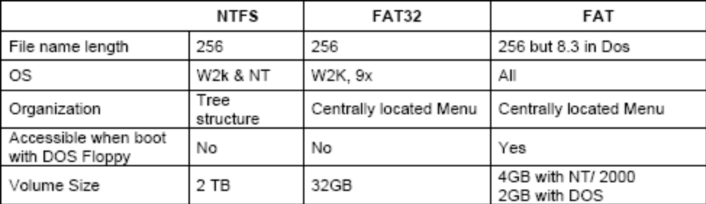

Windows 2000/NT/95/98 support CDFS and UDF and does not support HPFS. W2k does not support HPFS. Only NT 3.51 and some earlier versions support HPFS

79. You cannot log on to my network. What will you do?
• Make sure that the Hub/Switch is on
• Make sure that the machine is in the correct work group or domain.
• Make sure that the appropriate network client and protocols installed
• Check the adapter settings and verify TCP/IP configuration i.e. check the IP and Subnet Mask.
• Make sure that the network adapter is installed correctly.
• The adapter and slot functioning are properly.
• The cable securely connected to your network adapter
• Some times some failed services can prevent you from logging into the domain

80. User(s) are complaining of delays when using the network. What would you do?
• Check whether this is network-wide problem or system specific.
• Make sure you don't have many programs running in the background, particularly ones that use an Internet connection. File sharing programs can often cause extreme slowness.
• Delete any temporary Internet files and make sure the cache sizes are set correctly.
• Bad connections are sometimes caused by faulty cables. Try a different cable.
• Run a virus scan. Viruses often run in the background and use up tons of resources.

81. Basic Disk and Dynamic Disk?
Basic disks use standard formatting and partitioning and contain primary partitions, extended partitions and logical drives. A basic disk can have maximum of 4 partitions. There can be only one extended partition which can be divided in to logical drives. You must use basic disk if you want to support dual booting since dynamic disk is only recognized by w2k.
Dynamic disk does not contain primary partitions, extended partitions or logical drives. It contains dynamic volumes. Unlike the 4 partition limit in basic disk dynamic disk can support unlimited number of volumes. In w2k we must use dynamic disk to create any volume that extents over more than one physical disk. W2k will support NT basic disk if they are created in NT but with w2k you can create only dynamic disks.

82. What is a RAID? Define different RAID levels?
A RAID system is a collection of hard drives joined together for speed and fault tolerance.
RAID 0: At least 2 hard drives are required, preferably identical. None of the space is wasted as long as the hard drives used are identical. Data is stored evenly and sequentially across all disks. A striped volume is accessed with a single drive letter as if all the disks were combined in to a single drive. It can be created on FAT, FAT32 and NTFS. This level offers the highest level of performance but no redundancy. If any of the hard drives in the array fails, everything will be lost.
RAID 1: This level is known as mirroring. Two identical copies of data are stored on two drives. When one drive fails, the other drive still has the data to keep the system going. Rebuilding a lost drive is very simple since you still have the second copy. It can be created on FAT, FAT32 and NTFS.
Using an extra RAID controller can increase the fault tolerance even more. Even though the performance benefits are not great, it provides the highest degree of fault tolerance. It is supported only in Windows 2000 Server and Advanced Server
RAID 5: RAID-5 is identical sized areas of formatted disk space located in 3 or more dynamic disks. Data is stored evenly and sequentially among all disks and parity information is written across all disks in the volume.
RAID5 is accessed with a single drive letter as if all the disks were combined in to a single drive. It can be formatted with FAT, FAT32 and NTFS. If a single disk in the RAID5 fails data can be recovered using the parity information but if more than one disk fails you can not recover data. It is supported only in Windows 2000 Server and Advanced Server.

Non-RAID and RAID
RAID prevents data loss and ensures continuous data supply, even during and after limited disk failure. But non-RAID does not support fault tolerance. RAID is more expensive than non RAID.

Software RAID and Hardware RAID
Hardware RAID is typically easier to manage, maintain, and upgrade. Software RAID does not allow many advanced RAID features like Online Capacity Expansion nor does software RAID allow pre-notification of disk drive failure, auto rebuild, or hot-pluggable hard disk drives.

83. What is Hot Spares?
A hot spare is a stand by drive assigned to any disk array or a group of arrays. If a drive goes down in an array, it will be automatically replaced by the hot spare.

84. What is a computer virus?
A computer virus is a piece of malicious code that attaches to important areas within computers, such as executable files, and the boot areas of floppy disks and hard disks.
The basic virus types are defined by the area of the computer they infect:
Boot viruses: Insert instructions into the boot sectors of floppy disks, or the boot sector or master boot record (partition sector) of a hard disk.
Program viruses: Infect executable files such as .COM, .EXE, and .DLL files.
Macro viruses: Infect document files such as Microsoft Word .DOC files by changing the way macros behave.
Other types of destructive code include worms, Trojan horses, and logic bombs. These types of destructive code are different than viruses because they don't replicate.

85. 16bit and 32bit Operating Systems?
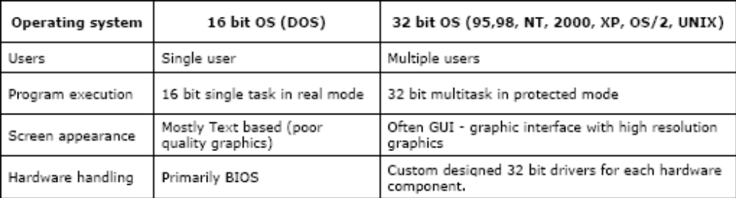

86. What is USB?
USB (Universal Serial Bus) is a new method of connecting peripherals to a PC that is simpler and more flexible than traditional methods.
For each USB port on a computer, users can connect up to 127 devices. Every time a device is added, the operating system (Win95 Version 2, Win98, Win2000, MAC OS 8.1 or higher) loads the devices automatically, allowing the device to be used without having to reboot the PC. The device may be unplugged, used elsewhere, then plugged back again - and it will work right away without having to reboot the PC.
USB operates at two speeds, 1.5Mbps for devices such as mice, keyboards and scanners, and 122 Mbps for devices using large amounts of data like hard drives and video cameras (compared with older serial ports which have a maximum speed of only 115.2 KBps).

87. Most Common hardware problems?
One of the most common problems is hardware conflict, when two devices are configured to use the same IRQ. Reconfigure one of the conflicting devices to use a nonconflicting setting.
Another type of hardware problem occurs when a device is physically configured in one way (i.e. through jumpers, switches) and the driver software is configured in another way. Either change the hardware settings or use device manager to use the software settings.
Common steps in hardware troubleshooting
• Look for conflicts
• Verify that the correct device driver is installed
• If it is an external device make sure that it is powered on and all cables are correctly connected to the system
• Verify that the device is enabled in the current hardware profile
• Try rebooting the computer
• Try uninstalling and reinstalling the device
• Replace the device with another similar device
• Check the device with HCL
Some hardware problems and causes Symptom Cause (Probably)
Computer does not boot at all, does not make any noise, does not do anything at all Dead Power Supply or Dead Power Cord. Only starts the fan and does not do anything Problem with mother board Counts up memory but does not display anything on the screen (Can hear it, can’t see it) Problem with video cars Boots and finds the CD and Floppy, but not the HDD Problem with HDD controller Boot and identify the HDD controller but does not find a bootable HDD HDD problem.

88. Difference between uninstalling and unplugging a device?
Uninstalling completely remove all drivers associated with a hardware device that you plan to physically remove from a device.
In unplugging you only stop all divers running for a device before physically removing the device from the computer. But all the drivers remain installed in the computer so that you can plug the device back at a later time.

89. Switched Mode Power Supply (SMPS)?
The main function of SMPS is to convert AC in to DC. It converts Ac to +/- 5 or +/- 12 DC.

90. What is BIOS?
BIOS: Basic input Output System
It is a small program stored in a ROM chip soldered to the motherboard. This is never changing and controls the core devices of the PC. It also manages data flow between the computer's operating system and attached devices such as the hard disk, video adapter, keyboard, mouse, and printer.

BIOS shadowing
Shadowing is the process of copying BIOS code from slow ROM chips into faster RAM chips during bootup so that any access to BIOS routines will be faster. DOS and other operating systems may access BIOS routines frequently. System performance is greatly improved if the BIOS is accessed from RAM rather than from a slower ROM chip.

91. What is CMOS?
A chip located in the mother board that contains the data used by the system BIOS for system configuration. This information is updatable and requires constant power to keep it from loosing information.
CMOS: Cylindrical Metal Oxide Semiconductor

92.IRQ - Interrupt Requests
An IRQ is a hardware interrupt; this means that there is a physical line run to each of the slots on the motherboard.
There are 8 IRQ (IRQ0-7) lines that run to the 8 bit ISA slot. There are 8 more (IRQ8-15) that run to the 16 bit ISA extension slot. For a total of 16 IRQs in a typical ISA bus PC. IRQ0 has the highest priority and IRQ7 the lowest priority. IRQ8-15 has "special" priority as will be explained.
An IRQ can be assigned to only one active device at a time. If 2 devices share the same IRQ, this is called a conflict. This means that when the IRQ line becomes active, the CPU does not know which device needs to "talk". For example if a modem used IRQ5 and a NIC used IRQ5.
IRQ Function
IRQ 0 System Timer
IRQ 1 Keyboard Controller
IRQ 2 Cascaded to IRQ8-15
IRQ 3 Com2/Com4
IRQ 4 Com1/Com3
IRQ 5 Sound card/LPT2
IRQ 6 Floppy drive controller
IRQ 7 Parallel port LPT1
IRQ 8 Real-time clock
IRQ 9 *-Available (IRQ2)
IRQ 10 NIC
IRQ 11 SCSI adapter
IRQ 12 Motherboard mouse/available
IRQ 13 Math coprocessor
IRQ 14 Primary IDE controller
IRQ 15 Secondary IDE controller

COM Port Conflicts
Note that COM1 and COM3 share IRQ4. This is allowed as long as only one device is active at a time.
This means that if you are running a mouse on COM1 then you cannot use COM3 for an internal modem. You will run into a conflict. Some communication packages will allow you to do this but most will choke or cause flaky operation. A common symptom is if you move the mouse, you see garbage on your terminal program.
COM2 and COM4 have a similar problem except that most people don't use COM2. It is usually safe to configure an internal modem to COM4. If COM2 is used, it is typically used for an external modem or a plotter. Usually, both are not active at the same time.
Standard COM Port Assignment

93. SCSI Card (Small Scale System Interface):
A SCSI card is a card that will control the interface between SCSI hard drives, CD-ROM drives, CDROM burners, removable drives, external devices such as scanners, and any other SCSI components.
Most are PCI and there is a wide range of types. The three main types of connectors on these cards are 25-pin for SCSI-1, 50-pin for Narrow SCSI, and 68-pin for Wide SCSI (and Ultra-Wide SCSI, Ultra2-SCSI, and Ultra160 SCSI).
SCSI controllers provide fast access to very fast SCSI hard drives. They can be much faster than the IDE controllers that are already integrated into the motherboards. SCSI controllers have their own advanced processing chips, which allow them to rely less on the CPU for handling instructions than IDE controllers do.
SCSI cards also have the ability to have up 15 devices or more per card, while an IDE controller is limited to only 4 devices. SCSI cards allow these drives to be in a chain along the cable. Each drive on the cable has to have a separate SCSI ID (this can be set by jumpers on the drive). The last drive on the end of the cable (or the cable itself) has to "terminate" the chain. You turn termination on by setting a termination jumper on the drive.

94. Group Policy
Group Policy and the Active Directory services infrastructure in Windows Server 2003 enable IT administrators to automate one-to-many management of users and computers—simplifying administrative tasks and reducing IT costs. With the debut of Group Policy Management Console (GPMC), policy-based management is even easier. Administrators can efficiently implement security settings, enforce IT policies, and distribute software consistently across a given site, domain, or range of organizational units

File server has the following meanings:
- A form of disk storage that hosts files within a network; file servers do not need to be high-end but must have enough disk space to incorporate a large amount of data. Many people mistake file servers for a high-end storage system, but in reality, file servers do not need to possess great power or super fast computer specifications.
- A computer program, that allows different programs, running on other computers, to access the files of that computer
- In common parlance, the term file server refers specifically to a computer on which a user can map or mount a drive or directory so that the directory appears to be on the machine at which the user is sitting. Additionally, on this type of file server, the user can read or write a file as though it were part of the file system of the user's computer.
Files and directories on the remote computer are usually accessed using a particular protocol, such as WebDAV, SMB, CIFS, NFS, Appletalk or their mutations.
- Although files can be sent to and received from most other computers unless their primary function is access by the above means, they are generally not considered file servers as such.

95. Proxy server
A proxy server is a computer that offers a computer network service to allow clients to make indirect network connections to other network services. A client connects to the proxy server, then requests a connection, file, or other resource available on a different server. The proxy provides the resource either by connecting to the specified server or by serving it from a cache. In some cases, the proxy may alter the client's request or the server's response for various purposes.

96. Remote Installation Service
Remote Installation Service (RIS) is a feature included in Microsoft's Windows 2000 server that allows network administrators to install the Windows 2000 Professional operating system and its upgrades to any number of client computers at one time from a centralized location. If the client computer is connected to the server through a local area network (LAN), the computer's hardware will find the RIS server and request a copy of the operating system. The network administrator can use the RISrep imaging option to copy several versions, or images, of a company's desktop configuration to the server so that if a request is made, the server can issue an "image" for a particular computer or user. Microsoft promotes the use of RIS as a way to configure new computers right out of the box and to restore the operating system on a computer that has failed

RIS Pre-requisites and Dependencies
Active Directory in general and DNS in particular.
DHCP - to enable the PXE network cards to find the RIS Server.
2GB (+) NTFS partition. Store the image away from the system files.
Virgin client machines with PXE network cards
Detailed Step-by-Step RIS Setup
Phase 1 - Add or Remove Programs:
Think of installing the actual RIS Service as a two stage process. Begin just as you install WINS or Certificate or any other service. Navigate to Add or Remove Programs, Windows Components, select Remote Installation Services.
Unlike any another service that I know, there is more work to do after the Add or Remove programs session completes. After you reboot the Windows 2003 Server, seek out the Administrative Tools menu, and Remote Installation Services Setup. The RIS wizard is one of Microsoft's best; it guides you through selecting the partition, and the name for the first XP Professional image.
Note: The above method works for Windows Server 2003, but on Windows 2000, return to the Add or Remove programs and see the newly added item, which leads you through to phase 2. Beware this is a truly bizarre experience and many give up at this point
Phase 2 - Wizard to Copy the XP Image:
It sounds silly now, but the first time the RIS wizard prompted me for the CD, I put in the Windows Server 2003 CD. Wrong. I should have put the XP Professional CD in the caddy, clearly the wizard wants to create the client image. (It did not need any server files.) It takes a fair time to copy the image into your NTFS partition. Here is a screen shot taken at the copying stage.
Phase 3 - Active Directory Users and Computers:
Another surprise, most of the rest of your RIS configuration is at the Computer object in Active Directory Users and Computers (ADUC). However, if you think about what's going to happen, it makes sense to configure RIS in Active Directory.
In the ADUC interface, navigate to the Computers container or the Domain Controllers if you installed RIS on a DC. The initial surprise is that the Computer Object of the machine where you just installed RIS has extra Tab called, Remote Install. See diagram below.
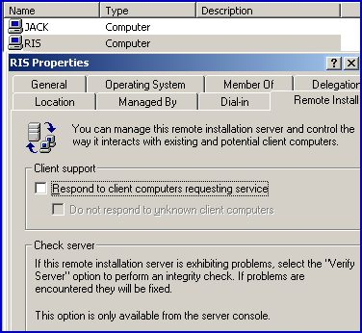
Note that the Respond to client computers requesting service is not checked by default. As an aside, my view is that finding this check box is your passing out test. Officially, the reason its unchecked is that Microsoft don't want rogue laptops picking up images before you are ready.
What Next?
So, you have successfully installed the Service, What next?
- Authorize RIS / DHCP
- More Configuration at the Remote Install Tab. Including checking Respond to client computers requesting service.
- Collect more RIS Images
- Get ready at the client to install the actual XP Professional Client using RIS
97. Backup

Full backup
This is the elementary type of backing up. Each time the newly created backup file replaces the old one.

Stack backup
This archive consists of the last created backup and N previous versions. (N - is a stack size parameter). This N previous versions are organized in stack manner. Their filenames are differs with suffix "_K" added to filename (K is in range 1-N).
Than older the backup, that greater the K. All backup files are located in the same directory.

Advanced stack backup
The structure of this archive is like stack archive with one addition: it allows not to store the unchanged files in the old versions of backup copies.

Incremental backup
This is a backup in which only the files that have been modified since the last backup are copied. It consists of "full backup" and N folowing sequental incremental backups. (where N - is a stack size parameter). The first backup should include all files - a "full backup". The next backup copy could also be a "full backup" but it is usually much quicker to do, because only files which have been changed since the last backing up will be included in the incremental backup. When N incremental copies will be created, at the next step all old backup files will be deleted and the cycle will be repeated from the beginning.
Exists possibility to save the full backup at the beginning of the new cycle. If an additional parameter save full backups it checked, then the full backup is renamed and saved in the same directory.

Differential backup
This backup is consists of two files - full and differential backup.
At first the program creates full backup. Next executions generate a differential backup - the backup copy of changed or newly added files since the last full backing up. If the volume of differential copy exceeds N percents of the full copy (Make a full backup only if ... parameter) or at least N days has passed since the full backup creation (Make a full backup only after ... parameter) then the program begins a new cycle with a full backup.

The main difference between incremental and differential backups
- The incremental backup saves several intermediate versions of files which have been modified or created since the last backing up.
- The differential backup saves files which are not included in the full backup (newly created or added files) or which are differ from the same files in the full backup. (The files are considered identical, if they have equal size and date-time stamp)
Backup
Administrator or Backup Operator can take backups. OR Users with backup files and directories user right can take backup. You cannot backup system state data over the network.

98. Difference between windows server 2003 and windows server 2000
1. In 2k3 We can Rename the Domain and Domain Controller name.
2. Stub zone is available.
3. Remote Desktop connection is there.
4. Automated System Recovery(ASR) is there, but 2k only Emergency Repair Disk(ERD) is there.

In 2003 we have concept of Volume shadow copy service which is used to create hard disk snap shot which is used in Disaster recovery and 2000 doesn’t have this service
A) In 2000 we cannot rename domain whereas in 2003 we can rename Domain
B) In 2000 it supports of 8 processors and 64 GB RAM (In 2000 Advance Server) whereas in 2003 supports up to 64 processors and max of 512GB RAM
C)2000 Supports IIS 5.0 and 2003 Supports IIS6.0
D) 2000 doesn’t support Dot net whereas 2003 Supports Microsoft .NET 2.0
E) 2000 has Server and Advance Server editions whereas 2003 has Standard, Enterprise, Datacenter and Web server Editions.
F) 2000 doesn’t have any 64 bit server operating system whereas 2003 has 64 bit server operating systems (Windows Server 2003 X64 Std and Enterprise Edition)
G) 2000 has basic concept of DFS (Distributed File systems) with defined roots whereas 2003 has Enhanced DFS support with multiple roots.
H) In 2000 there is complexity in administering Complex networks whereas 2003 is easy administration in all & Complex networks
I) In 2000 we can create 1 million users and in 2003 we can create 1 billion users.
J) In 2003 we have concept of Volume shadow copy service which is used to create hard disk snap shot which is used in Disaster recovery and 2000 doesn’t have this service.
K) In 2000 we don’t have end user policy management, whereas in 2003 we have a End user policy management which is done in GPMC (Group policy management console).
L) In 2000 we have cross domain trust relation ship and 2003 we have Cross forest trust relationship.
M) 2000 Supports 4-node clustering and 2003 supports 8-node clustering.
N) 2003 has High HCL Support (Hardware Compatibility List) issued by Microsoft
O) Code name of 2000 is Win NT 5.0 and Code name of 2003 is Win NT 5.1
P) 2003 has service called ADFS (Active Directory Federation Services) which is used to communicate between branches with safe authentication.
Q) In 2003 their is improved storage management using service File Server Resource Manager (FSRM)
R) 2003 has service called Windows Share point Services (It is an integrated portfolio of collaboration and communication services designed to connect people, information, processes, and systems both within and beyond the organizational firewall.)
S) 2003 has Improved Print management compared to 2000 server
T) 2003 has telnet sessions available.
U) 2000 supports IPV4 whereas 2003 supports IPV4 and IPV6

99. NTLDR is missing:
Issue:
NTLDR is missing.
Related errors:
Below are the full error messages that may be seen when the computer is booting.
NTLDR is Missing
Press any key to restart
Boot: Couldn't find NTLDR
please insert another disk
NTLDR is missing
Press Ctrl Alt Del to Restart
Cause:
- Computer is booting from a non-bootable source.
- Computer hard disk drive is not properly setup in BIOS.
- Corrupt NTLDR and/or NTDETECT.COM file.
- Miss configuration with the boot.ini file.
- Attempting to upgrade from a Windows 95, 98, or ME computer that is using FAT32.
- New hard disk drive being added.
- Corrupt boot sector / master boot record.
- Seriously corrupted version of Windows 2000 or Windows XP.
- Loose or Faulty IDE/EIDE hard disk drive cable.
Solutions:
Computer is booting from a non-bootable source

Many times this error is caused when the computer is attempting to boot from a non-bootable floppy disk or CD-ROM. First verify that no floppy diskette is in the computer, unless you are attempting to boot from a diskette.
If you are attempting to boot from a floppy diskette and are receiving this error message it is likely that the diskette does not have all the necessary files and/or is corrupt.
If you are attempting to install Windows XP or Windows 2000 and are receiving this error message as the computer is booting verify that your computer BIOS has the proper boot settings. For example, if you are attempting to run the install from the CD-ROM make sure the CD-ROM is the first boot device, and not the hard disk drive.
Second, when the computer is booting you should receive the below prompt.
Press any key to boot from the CD…
Important: When you see this message press any key such as the Enter key immediately, otherwise it will try booting from the hard drive and likely get the NTLDR error again.
Note: If you are not receiving the above message and your BIOS boot options are set properly it's also possible that your CD-ROM drive may not be booting from the CD-ROM properly. Verify the jumpers are set properly on the CD-ROM drive. Additional information about checking the CD-ROM drive connections can be found on document CH000213.
Additional information: This error has also been known to occur when a memory stick is in a card reader and the computer is attempting to boot from it. If you have any type of card reader or flash reader make sure that no memory stick is inside the computer.

Computer hard disk drive is not properly setup in BIOS
Verify that your computer hard disk drive is properly setup in the BIOS / CMOS setup. Improper settings can cause this error. Additional information on how to enter the BIOS / CMOS setup can be found in document CH000192.

Corrupt NTLDR and/or NTDETECT.COM file
Windows 2000 users
Windows XP users
Windows 2000 users
If your computer is using Microsoft Windows 2000 and you are encountering the NTLDR error. Create the below boot.ini file on the floppy diskette drive.
[boot loader]
timeout=30
default=multi(0)disk(0)rdisk(0)partition(1)\WINNT
[operating systems]
multi(0)disk(0)rdisk(0)partition(1)\WINNT="Microsoft Windows 2000 Professional" /fastdetect
Copy the NTLDR and NTDETECT.COM files from another computer using the same Operating System. Both of these files are located in the root directory of the primary hard disk drive. For example, C:\NTLDR and C:\NTDETECT.COM should be the locations of these files on many computers.
Please keep in mind that these files are hidden system files, if you need additional help with viewing hidden files in Windows please see document CH000516.
Once these files have been copied to a floppy diskette reboot the computer and copy the NTLDR and NTDETECT.COM files to the root directory of the primary hard disk drive. Below is an example of what commonly should be performed from the A:\> drive.
copy ntldr c:
copy ntdetect.com c:
After the above two files have been copied, remove the floppy diskette and reboot the computer.
Windows XP users
- Insert the Windows XP bootable CD into the computer.
- When prompted to press any key to boot from the CD, press any key.
- Once in the Windows XP setup menu press the "R" key to repair Windows.
- Log into your Windows installation by pressing the "1" key and pressing enter.
- You will then be prompted for your administrator password, enter that password.
- Copy the below two files to the root directory of the primary hard disk. In the below example we are copying these files from the CD-ROM drive letter "E". This letter may be different on your computer.
copy e:\i386\ntldr c:\
copy e:\i386\ntdetect.com c:\
- Once both of these files have been successfully copied, remove the CD from the computer and reboot.

Miss configuration with the boot.ini file
Edit the boot.ini on the root directory of the hard disk drive and verify that it is pointing to the correct location of your Windows Operating System and that the partitions are properly defined. Additional information about the boot.ini can be found on document CH000492.

Attempting to upgrade from a Windows 95, 98, or ME computer that is using FAT32
If you are getting this error message while you are attempting to upgrade to Windows 2000 or Windows XP from Windows 95, Windows 98, or Windows ME running FAT32 please try the below recommendations.
- Boot the computer with a Windows 95, Windows 98 or Windows ME bootable diskette.
- At the A:\> prompt type:
sys c: <press enter>
- After pressing enter you should receive the "System Transferred" message. Once this has been completed remove the floppy diskette and reboot the computer.

New hard disk drive being added
If you are attempting to add a new hard disk drive to the computer make sure that drive is a blank drive. Adding a new hard disk drive to a computer that already has Windows installed on it may cause the NTLDR error to occur.
If you are unsure if the new drive is blank or not try booting from a bootable diskette and format the new hard disk drive.

Corrupt boot sector / master boot record
It's possible your computer's hard disk drive may have a corrupt boot sector and/or master boot record. These can be repaired through the Microsoft Windows Recovery console by running the fixboot and fixmbr commands.
Additional information and help in getting into the Microsoft Windows Recovery console can be found on document CH000627.

Seriously corrupted version of Windows 2000 or Windows XP
If you have tried each of the above recommendations that apply to your situation and you continue to experience this issue it is possible you may have a seriously corrupted version of Microsoft Windows. Therefore we would recommend you reinstall Microsoft Windows 2000 and Windows XP.
If you are encountering this issue during your setup you may wish to completely erase your computer hard disk drive and all of its existing data and then install Microsoft Windows 2000 / Windows XP. Additional information about erasing the computer and starting over can be found on document CH000186.

Loose or Faulty IDE/EIDE hard disk drive cable
This issue has been known to be caused by a loose or fault IDE/EIDE cable. If the above recommendation does not resolve your issue and your computer hard disk drive is using an IDE or EIDE interface. Verify the computer hard disk drive cable is firmly connected by disconnected and reconnecting the cable.
If the issue continues it is also a possibility that the computer has a faulty cable, try replacing the hard disk drive cable with another cable and/or a new cable.
100. Differences between a Quick format and a regular format during a "clean" installation?

During a "clean" installation of Microsoft Windows XP, you are prompted to choose from the following format options:
• | Format the partition by using the NTFS file system (Quick)
• | Format the partition by using the FAT file system (Quick)
• | Format the partition by using the NTFS file system
• | Format the partition by using the FAT file system
• | Leave the current file system intact (no changes)

This article describes the differences between a Quick format and a regular format.

When you choose to run a regular format on a volume, files are removed from the volume that you are formatting and the hard disk is scanned for bad sectors. The scan for bad sectors is responsible for the majority of the time that it takes to format a volume.
If you choose the Quick format option, format removes files from the partition, but does not scan the disk for bad sectors. Only use this option if your hard disk has been previously formatted and you are sure that your hard disk is not damaged.
If you installed Windows XP on a partition that was formatted by using the Quick format option, you can also check your disk by using the chkdsk /r command after the installation of Windows XP is completed.

101. User profiles
There are 3 types
- Local profiles
- Roaming profiles
- Mandatory profiles

Local profiles: It is stored in document and setting when a user logs o to a machine for the first time the subdirectory machine to the name will be created under document and settings

Roaming profiles: The user want to access more than one machine or move around the network a roaming profile is created. Roaming profile can e created to ensure that the user wills receiver his or her user settings and preference no matter where they can log on. It is stored in ntuser.dat and shared over the network.
Roaming profile can be modified has local profile or mandatory
To convert a Roaming profile to local profile
Right click my computer-> properties->user profile and select the user and click on change type
Whenever you creating a user the user account are created with the security ID [SID] under ntuser.dat file by default it is hidden and read only file.

Roaming profiles basically allow a user’s settings to follow them when they move workstations. This may be useful for staffs that regularly use multiple workstations, but it comes into its own when a workstation has to be rebuilt or replaced. If the user has a roaming profile, their settings will be returned to their new machine as soon as they log on.
Roaming profiles mean that at logoff time, all the users settings are copied up to a network share. When they log on, the settings are copied back down to the local machine, and stored under c:\documents and settings\{userid}. Note that the settings are not read directly from the network share while users work, they are always accessed from the local disk and only copied to and from the network share at logon/logoff time. This is very different from ‘Redirected folders’, which are used FROM the network rather than copied locally each time.
Note also, that if you do not use Redirected folders then the users ‘my documents’ and ‘desktop’ folders are considered part of the profile. Copying these to and from the server when ever a user logs in or out will take a long time, so Redirected Folders should be implemented before roaming profiles.
Although ISS do provide central file store, we are not yet in a position to implement roaming profiles for all members of staff. Therefore, this document deals with Schools who wish to use file store provided by one or more servers installed and supported by the School itself.

Roaming Profiles Permissions Group
Permissions are required on the network share used to hold the roaming profiles, and as with all permissions within Active Directory and Windows servers, you should avoid giving permissions directly to user objects. Instead, always grant permissions to group objects. Following the ‘Account -> Group -> Domain Local Group -> Permissions’ model, you should grant the permissions to a Domain Local group, place the users into a Global group and nest the two together. Further details on the A->G->DL->P model can be found in the related links.

Creating the Share
To allow users to have a roaming profile, you must first provide a shared folder to store them. This is just a standard share, from a Windows2000/2003 server (or almost any SMB compatible system, such as SAMBA). It is recommended that the profile share is held on a separate NTFS partition/volume, for reasons of quota limits explained below.
Create a folder on a new NTFS volume, and share it as normal. If you don’t want the share to be visible to users who use network neighbourhood to browse, use a $ character on the end of the name:
e.g. \\server_name\share_name$
Set the ‘Share Level’ permissions as shown in Figure 1 below (don’t worry; share level permissions are overridden by the NTFS permissions below). Share level permissions are configured from the ‘Sharing’ tab of the folder properties as shown in Figure 2

User Account | Minimum Permissions Required
Everyone | No permissions
Security group of users needing to use roaming profiles | Full Control
Figure 2 - Share Level Permissions for Profiles directory
Once the share is established, and the Share Permissions set, you need to set the NTFS permissions. The problem here is that when a user logs in for the very first time, their Profile folder will be created, using their own credentials rather than ‘administrator level’ permissions. This means that you need to give the user permissions to create folders in the profile directory, and then to ‘own’ the folders they have created.
Set the permissions as follows:
User Account | Minimum Permissions Required | Special Permissions | Apply To
Security group of users needing to use roaming profiles | Special Permissions | Traverse Folder/Execute File  List Folder/Read Data  Read Attributes  Read Extended Attributes  Create Folders/Append Data  Read Permissions | This Folder Only
CREATOR OWNER | Special Permissions | Full Control | SubFolders and Files Only
Administrator | Full Control
SYSTEM | Full Control
Everyone | No Permissions
Figure 4 - NTFS Level Permissions for Profiles directory
Note that the Group permissions and the CREATOR owner permissions are ‘special’ and cannot be set from the usual NTFS permissions interface. To set these, click the Advanced button on the NTFS security tab. Note also, that these two sets of permissions apply to different objects (This Folder Only, and Sub Folders and Files only). This must also be set from the ‘Advanced’ Permissions dialog
Configuring Users to have a roaming profile
Roaming profiles are enabled on a per user basis, there is no way to do this through Group Policy. To enable a roaming profile for a user, use the Active Directory Users and Computers tool and set the ‘profile path’ value on the properties of the user. Note, you can use %username% in the path value, which will automatically be replaced by the user name

Roaming Profile size limits
It is possible to set quota limits of profiles, to limit the size they can grow to and therefore minimize both the storage requirements and the time taken to log on and logoff. This IS set via the Group Policy key ‘Limit Profile Size’, which is located in the Users Configuration | Administrative Templates | System | User Profiles section. The maximum you can set the profile size to is 30MB. ISS recommend that you do this before starting to use roaming profiles, as unlimited profiles can cause problems.
If a profile constantly gets bigger than this limit, it may be because an application is incorrectly storing data there, rather than in ‘my documents’ etc. If this is the case, you can use the ‘Exclude directories in roaming profiles’ group policy setting to ensure that the folder causing problems does not ‘roam’. This value has a hard limit of 260 characters, and will stop working entirely if you exceed this. Remember that excluding folders using this policy will mean the settings or data stored in the folder is not available on other workstations when the user logs on.
Once you have limited the size of the profile, it is sensible to set a quota limit for the NTFS volume that holds the profiles on the network. The recommended quota limit is three times the maximum size of a quota plus a little bit extra, so 100MB is recommended in this case. This is due to the way in which a profile is copied back up to the server when a user logs off, merged with the existing one and then a new copy created. In general, users will only use 30MB of space on the servers, but may temporarily use up to 100MB at the time they log off.
Mandatory profiles: Mandatory profiles can be used when user should be prevented from savings changes to the user settings.
Mandatory profiles are the permanent profile which can not be modify further.
Once after converting mandatory profile log in has a user go to
My computer->user profile, now you can not change he mandatory profile
The benefit of Roaming Profile and Mandatory Profile is all the user data is stored I the server in centralized location the administration is easy
Ex: Taking back up
Converting Roaming Profile to Mandatory Profile
D :\> cd shared folder name
D: \ shared folder name>cd user name
D: \ shared folder name>cd user name>dir
--------- (some hidden file is containing here)
-------
D: \ shared folder name>cd user name> attrib –r –h (r-> read file h-> hidden file)
D: \ shared folder name>cd user name> dir
D: \ shared folder name>cd user name>ren ntuser.dat ntuser.man

NTUSER.DAT: this file contains all of the registry settings that are specific to a user account when a user logs on; the settings in file are copied to the HKEY_CURRENT_USER registry settings on the local computer.
NTUSER.DAT.LOG: This file is used by windows 2000 to recover the user’s original NTUSER.DAT file if an error occurs which updating the NTUSER.DAT files.

NTUSER.ini: this file contains settings that determine the components of a users roaming users profile that are not copied to the server each time the user logs off.
102. Features of Windows Vista:
1 User interface
1.1 Windows Aero
1.2 Shell
1.3 Windows Flip and Flip 3D
1.4 Search
1.5 Sidebar
2 New and upgraded applications
2.1 Windows Internet Explorer 7
2.2 Windows Media Player 11
2.3 Windows Media Center
2.4 Internet Information Services 7
3 Security and safety
4 Graphics
4.1 Desktop Window Manager
4.2 DirectX
4.3 Icons
4.4 Windows Imaging Component
4.5 Color management
5 Audio
5.1 Audio devices support
5.2 Speech recognition
5.3 Speech synthesis
6 Print
6.1 XML Paper Specification
6.2 XPS Print Path
6.3 Print Schemas
7 Networking
7.1 IPv6
7.2 Wireless networks
7.3 Network profiles
7.4 Network performance
7.5 Security and network reliability
7.6 Windows Filtering Platform
7.7 Peer-to-peer communication
7.8 Server Message Block 2.0
8 Mobile computing
8.1 Power management
9 Kernel and core OS changes
9.1 Memory management
9.2 File systems
9.3 Drivers
9.4 System performance
10 Management and administration
10.1 Installation and recovery
10.2 Deployment
10.3 Diagnostics, monitoring and reporting
10.4 Remote management
10.5 System tools
10.6 Management Console
10.7 Group policy
10.8 Task Scheduler
10.9 Command-line tools
10.10 Scripting
11 Programmability
11.1 .NET Framework 3.0
11.1.1 WPF
11.1.2 WCF
11.1.3 WF
11.1.4 Windows Card Space
11.1.5 Other .NET Framework APIs
11.2 Media Foundation
11.3 Winsock Kernel
11.4 Crypto NexGen

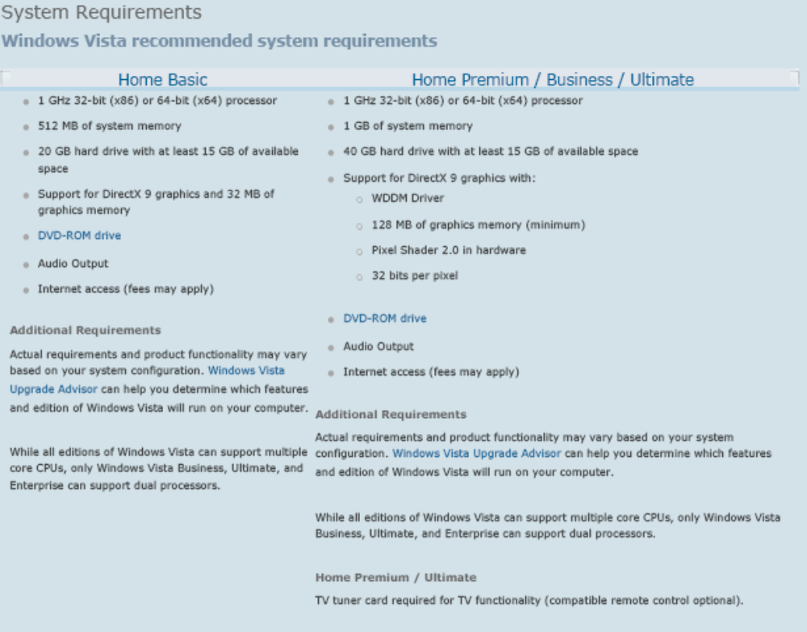

103. Hardware Components

Socket 478 => Pentium IV
Slot 1 => Pentium II, III and all SECC and SECC2

System board components

Expansion slots:
ISA [Industry Standard Architecture] => made before 1997 these are 16 bit and 8 bit
PCI [Peripheral Component Interconnect] => it is short 3 inches long (white color) these are 64bit
AGP [Accelerated Graphics Port] => Used as high speed accelerated 3d graphics video card, it is shorter than PCI. These are 128 bit

Memory slots: RAM

CPU and Processor slots or sockets: CPU is brain of computer.

Power connectors: ATX Power connector having 20 pin.
SMPS: It converts AC input to lower level DC output
230v => +5- >red, -5->white, +12->yellow, -12->blue, 0v and Gnd-> black, pg-> orange

On-board disk drive connectors:

Keyboard connectors:
Mouse ps/2 => Standard Green color having 6 pin
Keyboard ps/2 => Standard Purple color

Peripheral port and connectors:
Serial port => 9 pin male serial ports and 25 pin male serial ports
Parallel ports => Used for Printer. Having 25 pin female connector
USB ports => Universal serial bus, its supports 0 to 127 devices. Speed is 1.5mbps
SVGA Ports => 15 pin general
Ethernet port => RJ-45
BIOS chip [Basic input/output System]: Processor how to interact with the rest of the hardware.
CMOS battery [Complementary Metal Oxide Semiconductor]: A chip located on the mother board that contains data used by the system BIOS or System configuration.
It will store the settings
Jumpers and DIP Switches
Firm ware

Memory
DRAM [Dynamic Random Access Memory] => It is used expand the memory in the computer; it is cheaper and less complex. Having 400MHz system bus speed
SRAM [Static Random Access Memory] => it is Faster; this is more complex and more expensive. Having 168 pin

SIMM => Single Inline Memory Modules, Having 30 pin
DIMM => Dual Inline Memory Modules, Having 70 pin
RIMM, SODIMM, Micro DIMM.
CD –ROM drive:
CDR and CD-RW drive: 32x-16x-4x , means read 32x, write 16x, and rewrite 4x.
DVD-ROM:

Adapter cards:
Video Cards
Network Interface Card [NIC]
Mode m -> Speed of mode m is 56kbps,its called Powdered
Sound Card

DB Series Port: 15-pin video port, 25-pin 4 male printer port and 9-pin male serial port
RJ-Series: RJ-11 and RJ-45
RJ-11 => connectors used most often telephone hookups
RJ-45 => commonly found in Ethernet
USB: It is used for connecting multiple (up to 127) peripherals to one computer through a single port
RCA jack: It is used in phonographs both audio and video information.
Ps/2: It is also known as mini-pin 6 connectors.
Centronics: It has a unique shape used in parallel printer connectors.

Mother board Architecture: It is the largest component of a computer, components are
- Chipset
- Memory slot type
- Communication ports
- Processor Sockets
- Cache Memory
- BUS Architecture
- BIOS
Configuring Jumpers: They should be located in between the data connector and power connector.
Types of HDD

- st(Seagate) 506/412
- ESDI -> Enhanced system Driver Interface
- IDE-> Integrated Driver Electronic -> Its having 40 pin and data transfer speed of IDE 10mbps,20,30,40mbps, we can configure up to 4 IDE
- EIDE
- SCST -> Its having 70 pins and 70mbps

104. Distributed file system (DFS)
DFS provides fault tolerance and load balance
Fault tolerance: the application install in one server will be a replicated to the other computer, if computer one fails computer two provides services to the users without network failure.

Load balance: when you have more no of users the network load [traffic] can be shared by both the computer which ate having the same application copy.
This concepts reduces the network traffic
Ex: DFS and Child domain
DFS is the default service available under administrative tools.
Goto start->programs->administrative tolls->DFS<-new dfsroot->create a domain dfs root->keep the default domain name->keep your existing ,server name and it is called Full Qualify Domain Name [FQDN]-> select on existing share <- dfs link select automatic replication at the end of that under replication plicy click on set master.
Select replica and click on enable
Now link will become master & Replica will become slave
In domain you must have only one dfsroot, you can create multiple link and replica
DFS also provide centralized data administration we can configure the data available from different place to a centralized place.

105. Networking Terms
Broadband: A network transmission method in which a single transmission medium is divided so that multiple signals can travel across the same medium simultaneously.

Browser: A computer program that uses the HTTP and is used on a workstation to access hosts on the web.
Client/Server network: A server-centric network in which all resources are stored on a file server. Processing power is distributed among workstations and the file server.

Default gateway: The router that all packets are sent to when the workstation doesn’t know where the destination station is or when it can’t find the destination station on the local segment.

DNS: The network service used in TCP/IP networks that translates host names to IP addresses

DNS Server: Any server that performs DNS host name to IP address resolution.

DNS resolver: Client software used to make requests of the DNS server in order to resolve DNS host names into IP addresses.

DHCP: A protocol used on a TCP/IP based network to send client configuration data, including TCP/IP address, default gateway, subnet mask, and DNS configuration to clients.

Gateway: The hardware and software needed to connect tow disparate network environments so that communication.

HTML: A set of codes used to format text and graphics that will be displayed in a browser. The codes define how data will be displayed.

HTTP: The protocol used for communication between a web server and a web browser.

Internet: A global network made up of a large number for individual networks interconnected through the use of public telephone lines and TCP/IP Protocols.

IP address: A address used by the internet protocol that identifies the devices location on the network.

Ipconfig: A Windows NT utility used to display that machine’s current configuration.

IPX: Internet work packet exchange.

IPX network address: A number that represents an entire network. All servers on the network must use the same external network number.

Tracert: This utility is similar to the UNIX traceroute. It reports the IP address and name of each interface between the client and the target. If Ping fails, Tracert can tell you where the responses have stopped
Ex: C:\Documents and Settings\Admin> tracert www.google.com
Here are the Tracert switches:
- Tracert –d. turns off host name lookups. This significantly speeds up traces. Highly recommended.
- Tracert –h. Increases the maximum hop count. The default is 30.
- Tracert –j host-list. This option is used to force Tracert to use a specific router via source routing.
- Tracert –w. Increases the maximum timeout

106. Definition of Boot Partition and System Partition?
System partition: This is the partition that contains the files required to boot Windows. For an Intel platform, these files are Ntldr, Boot.ini, Ntdetect.com, Bootsect.dos, and Ntbootdd.sys (if a SCSI device has no onboard BIOS). The system partition must be flagged as Active (or bootable) in the Master Boot Record. The files must be at the root of the boot drive. Setup assumes that the first IDE drive on the primary IDE controller is the boot drive. If a partition on this drive is not marked Active, Setup will mark it as Active.
Boot partition: This is the partition that contains the files requires to run the operating system. By default in Windows Server 2003, Setup puts these files in a directory called \Windows. (In Windows 2000 and NT, the boot files are put in the \WINNT folder.) The boot partition can be on any drive. If you put the boot partition somewhere other than the boot drive, Setup prompts you to create a small system partition on the boot drive. This partition can be less than 1MB, just big enough to hold Ntldr, Ntdetect.com, Boot.ini, and Ntbootdd.sys.

