**RITUALS:**

**Nandhi:**

The Nandhi is a Pooja that is held before any major occasion in the family, around 10 days before the date of the actual function. The Pooja is held to invoke blessings of all the gods and ancestors, and to ensure that the rituals and functions are concluded without any hindrance.

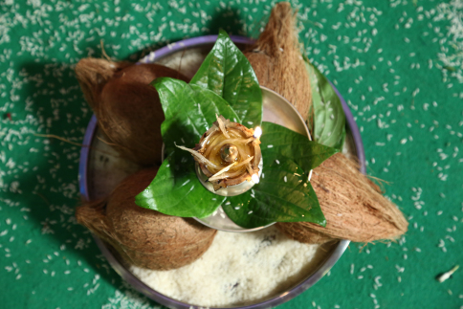

**11/12/2019:**

**DAY 1**

**PRARTHANA**

Rituals on Day 1 begin around 3pm, the bride’s brother goes to the groom’s house and invites them to the wedding venue, with a box of sweets and flowers for the women in the family.

**YEDURU KANSANI (Welcoming the Groom):**

Once the groom and party have reached the venue, they are greeted by the bride’s family.

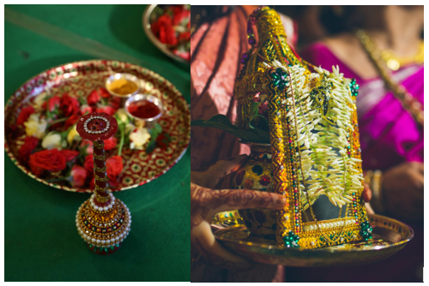

**PHOOL MUDDI:**

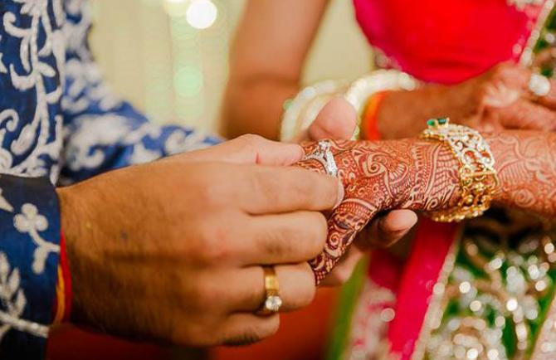

Phool Muddi translates to flowers and ring in konkani, and was supposedly the equivalent of an engagement/ ring ceremony of present times.

**SANGEET:**

The Sangeet is traditionally a fixture in most north Indian weddings. Recently, the culture has started to feature in South Indian weddings as well.

This celebration includes dances performed by relatives and friends of the Bride and Groom

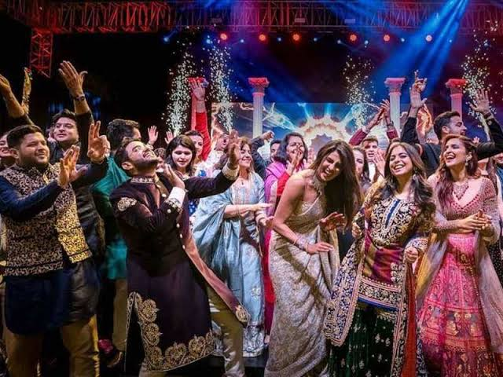

**DINNER:**

*Kushaal please write something here *

12/12/2019:

**UDIDA MAHURAT**

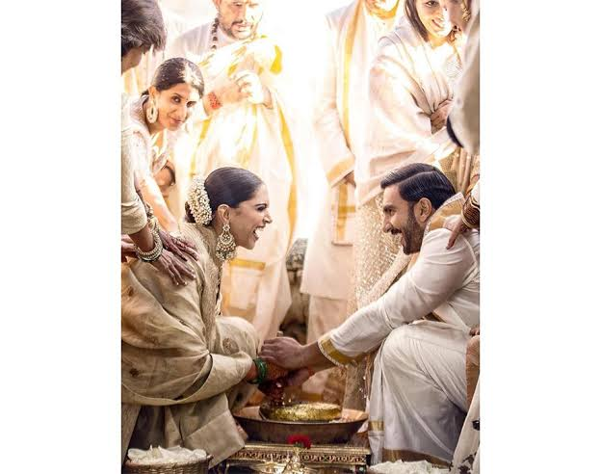

Udidu- black gram- is a staple for Konkanis in all of their dosas, idlis and vadas. This is supposed to be a ceremony for the bride to learn how to grind the all-important gram for use in the kitchen every day. Even the mother in-law drops by for the brides udida-mahurat, to ensure the bahu is learning the nuances right!

What is weird is that the groom also does the grinding ritual. Apparently, it’s for the groom to be aware of the process in case his wife is unwell.

**KASHI YATRA**

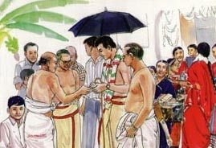

Tired of all the day long rituals, the groom decides to give up all worldly possessions and starts for Kashi to lead a life of solitude.

The bride’s father then stops him, and requests him to come back and marry his daughter.

**MANTAP POOJA:**

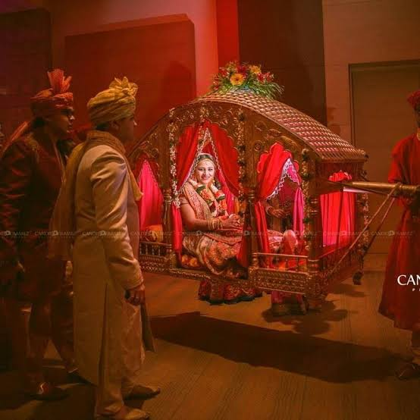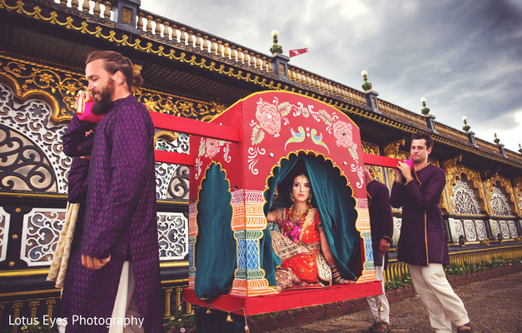

The Bride is escorted by her maternal uncles to the stage in a procession of sorts in a Dholi.

**VARMALA:**

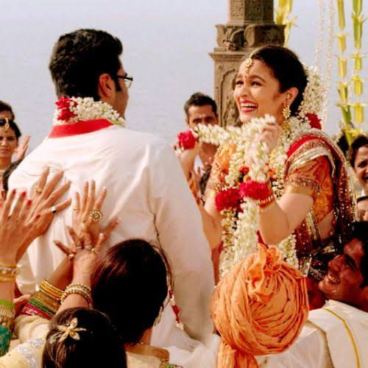

The antarpatt (Holy cloth) separates the bride and the groom as the priests from both sides and chant the shlokas.

When the antarpatt is finally brought down, the bride and groom garland each other.

**KANYADAAN**

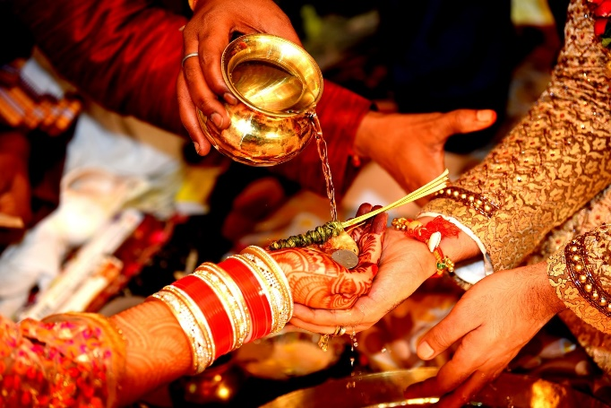

After this the kanyadaan ritual begins, with the bride’s father placing her hands in the  
groom’s hand and the mother of the bride pouring milk and water.

**LAYI HOMA:**

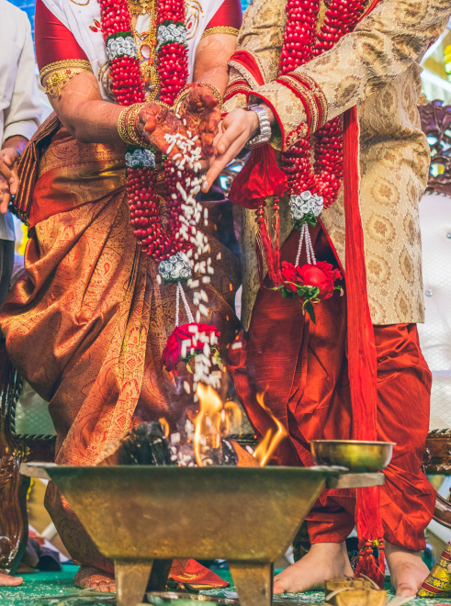

A handful of layi (puffed rice) is passed from the youngest member onwards and the bride and groom together put this layi in the homa kund. This process is repeated 5 times.

After this the eldest uncle puts silver toe rings on the bride’s toes.

**SAPTAPADI (7 Phere):**

The bride and groom stand with 7 mounds of rice between them and hold right hands.

 It is said that the couple has tied themselves together for seven lifetimes to come once this part of the ceremony is finished.

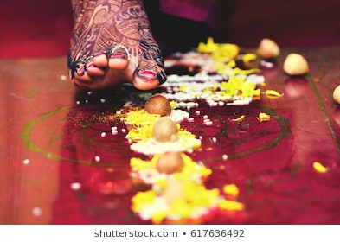

**LUNCH:**

**\*Kushaal to write something about south indian lunch\***

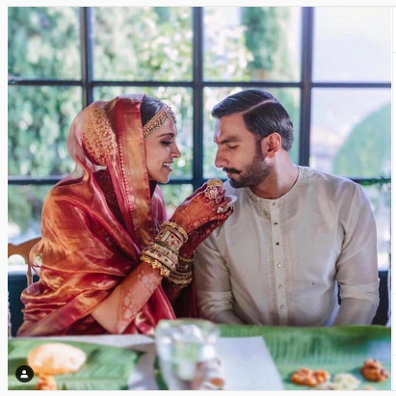s

**GHAR BHORCHE (Welcoming the bride):**

The bride and groom are both asked to kick a coconut each on the threshold at Groom’s house. The bride then kicks in a kalash full of rice and enters the house. This indicates the prosperity that the bride has brought along with her.

After this, the baagil dhorche(blocking the door/entrance) ritual is held. Where the groom’s sisters block the bride and groom from entering the house/room and rag the bride.

This is followed by a few fun games that are supposed to be rituals.

Game 1: Vokkul: This is the game common to a lot if Indian weddings, where the bride and groom find a ring form a pot full of milk/water and flowers etc. Usually the ring is a female one, and whoever wins, the bride gets to keep the ring.

Game 2: Chandu: Chandu meaning ball, is usually a paper ball decorated with flower garlands. The bride and groom are supposed to play a game of catch with this ball. The one who drops first loses!

The winner of these games is supposed to be the dominating spouse.

