PROJECT RESULTS AND OUTPUT
An Integrated Smart Helmet System Using IoT for Enhanced Rider Safety

1. Result Summary
The developed system, Integrated Smart Helmet System using IoT, was successfully implemented and tested to enhance rider safety through real-time monitoring and automation. The system effectively detects whether the rider is wearing the helmet using the limit switch and checks alcohol consumption using the MQ-3 sensor before allowing vehicle ignition through the relay module. In addition, the MPU6050 sensor accurately identifies sudden impacts or abnormal motion, indicating accidents and triggering alert mechanisms. The ESP32 ensures fast processing and enables reliable communication between components, while the buzzer provides immediate warning alerts. The power management system using a battery, buck converter, and TP4056 module ensures stable and efficient operation. Overall, the project demonstrates a compact, cost-effective, and reliable IoT-based solution that significantly improves rider safety and reduces accident risks.
The implemented system successfully demonstrates real-time location tracking using the GPS module integrated with the microcontroller. The system continuously transmits live location data in the form of Google Maps links containing latitude and longitude coordinates. The repeated “Live Location” messages indicate that the GPS module is actively receiving satellite signals and updating the position at regular intervals. Additionally, the system successfully detects emergency conditions: when an accident is identified (based on sensor threshold values from the accelerometer/gyroscope), the system sends an “Accident Detected!” alert, confirming that the integration between the GPS module and the accident detection mechanism functions correctly.

Key Result Highlights
• Accurately acquires GPS coordinates
• Successfully sends real-time location updates
• Detects emergency situations (accidents)
• Provides immediate location sharing for safety and rescue purposes

1a. Prototype Photos
The photographs below show the physical hardware setup and live outputs captured during testing of the smart helmet system.
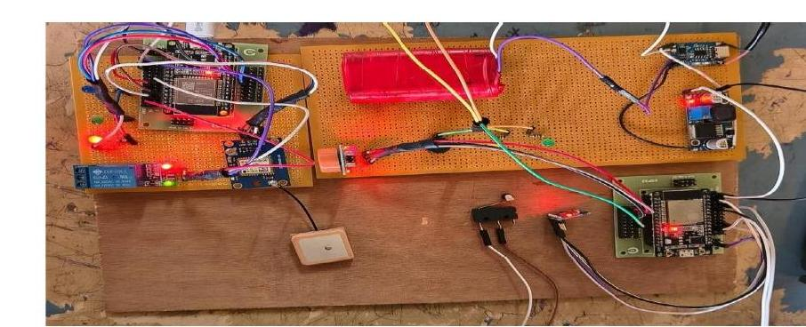
FIG. 6.1 Prototype of the Integrated Smart Helmet System — Initial Hardware Stage
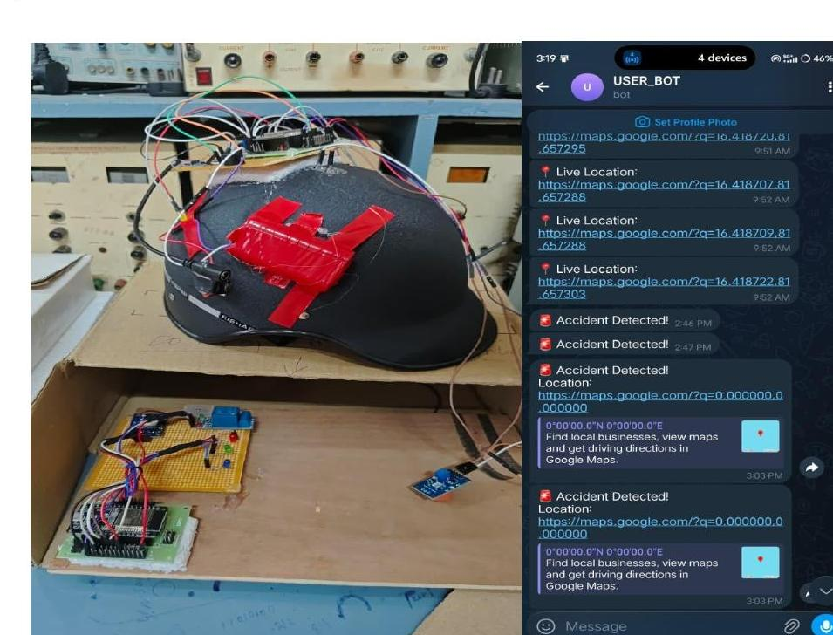
FIG. 6.2 Prototype Implementation of IoT-Based Smart Helmet System with GPS Module Working (Telegram Live Location & Accident Alerts)

2. Serial Monitor Output — Smart Helmet System Status, Alert Transmission and GPS Signal Transmission
The following is the real-time output of the smart helmet system displayed on the Arduino IDE serial monitor. It shows continuous updates of key parameters such as helmet status, alcohol detection, accident detection, and GPS coordinates. When an accident is detected (Accident: 1), the system automatically triggers an emergency alert, indicated by the message “Telegram Sent!”, and the HTTP response “200 OK” confirms successful delivery of the alert.
15:18:31.780 -> Accident: 0
15:18:31.780 -> ==========================
15:18:32.297 -> Lat: 0.000000
15:18:32.297 -> Lng: 0.000000
15:18:32.297 -> ===== BIKE STATUS =====
15:18:32.297 -> Helmet: 1
15:18:32.297 -> Alcohol: 1
15:18:32.297 -> Accident: 0
15:18:32.297 -> ==========================
15:18:32.772 -> Lat: 0.000000
15:18:32.772 -> Lng: 0.000000
15:18:32.772 -> ===== BIKE STATUS =====
15:18:32.772 -> Helmet: 1
15:18:32.772 -> Alcohol: 1
15:18:32.772 -> Accident: 1
15:18:33.811 -> Telegram Sent!
15:18:34.331 -> HTTP/1.1 200 OK
15:18:34.331 -> Server: nginx/1.18.0
15:18:34.331 -> Date: Mon, 06 Apr 2026 09:48:34 GMT
15:18:34.331 -> Content-Type: application/json
15:18:34.331 -> Content-Length: 470
15:18:34.331 -> Connection: close
15:18:34.331 -> Strict-Transport-Security: max-age=31536000; includeSubDomains; preload
15:18:34.331 -> Access-Control-Allow-Origin: *
15:18:34.331 -> Access-Control-Allow-Methods: GET, POST, OPTIONS
15:18:34.331 -> Access-Control-Expose-Headers: Content-Length,Content-Type,Date,Server,Connection
15:18:34.331 ->
15:18:35.372 -> {"ok":true,"result":{"message_id":171,"from":{"id":8779350127,"is_bot":true,"first_name":"USER_BOT","username":"BOT0308...
15:18:35.428 -> ==========================
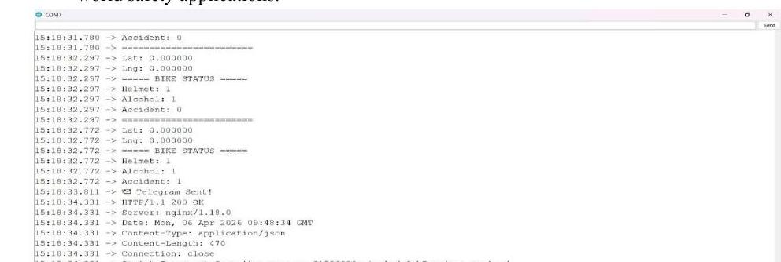
FIG. 6.3 Serial Monitor Output Showing Smart Helmet System Status, Alert Transmission and GPS Signal Transmission

3. Experimental Test Cases
The system was tested under four distinct scenarios to validate the correct operation of all safety mechanisms. Each case tests a specific combination of helmet wearing status, alcohol detection, and accident detection.
Case | Helmet | Alcohol Detected | Accident Detected | System Output
Case 1 | Not Worn | — | — | Bike OFF (Ignition Blocked)
Case 2 | Worn | Not Detected | Not Detected | Bike ON (Normal Ride)
Case 3 | Worn | Detected | Not Detected | Bike OFF (Alcohol Blocked)
Case 4 | Worn | Not Detected | Detected | Alert Triggered + GPS Sent

In Case 1, the rider does not wear the helmet, and the system immediately blocks the ignition regardless of other conditions.
In Case 2, all safety conditions are satisfied — helmet worn, no alcohol detected, no accident — and the bike is allowed to start normally.
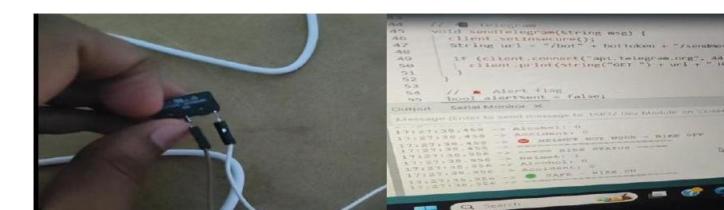
FIG. 6.4 Representation of Case 1 and Case 2
In Case 3, the MQ-3 alcohol sensor detects intoxication and the relay module blocks ignition even though the helmet is worn.
In Case 4, the MPU6050 detects a sudden impact indicating an accident, triggering the buzzer alert and transmitting the GPS location via Telegram to emergency contacts.
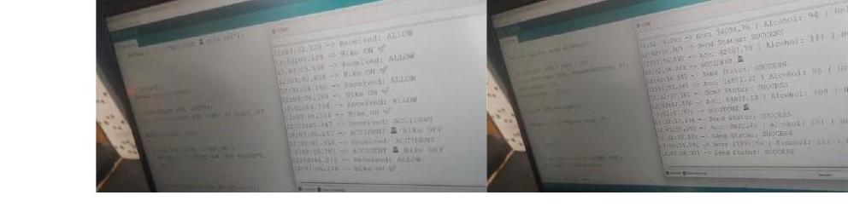
FIG. 6.5 Representation of Case 3 and Case 4
All four cases confirm that the system behaves correctly and reliably under real-world test conditions.

4. Serial Monitor Output — All Conditions Satisfied (Normal Operation)
Representative output captured when the helmet is worn, alcohol level is within the safe range, and motion values remain within normal limits, with status messages successfully transmitted:
13:02:22.633 -> Acc: 16341.24 | Alcohol: 113 | Helmet: 1
13:02:22.633 -> Send Status: SUCCESS
13:02:23.149 -> Acc: 16348.92 | Alcohol: 112 | Helmet: 1
13:02:23.149 -> Send Status: SUCCESS
13:02:23.660 -> Acc: 16392.09 | Alcohol: 112 | Helmet: 1
13:02:23.707 -> Send Status: SUCCESS
13:02:24.222 -> Acc: 16341.51 | Alcohol: 99 | Helmet: 1
13:02:24.222 -> Send Status: SUCCESS
13:02:24.737 -> Acc: 16381.80 | Alcohol: 105 | Helmet: 1
13:02:24.737 -> Send Status: SUCCESS
13:02:25.251 -> Acc: 16365.63 | Alcohol: 106 | Helmet: 1
13:02:25.251 -> Send Status: SUCCESS
13:02:25.761 -> Acc: 16298.07 | Alcohol: 114 | Helmet: 1
13:02:25.761 -> Send Status: SUCCESS

FIG. 6.6 Representation if All Conditions Satisfy

5. Project Specification / Performance Table
Parameter | Observation | Performance
Helmet Detection | Accurate detection | High
Alcohol Detection | Threshold-based detection | Reliable
Accident Detection | Sudden motion detected | Fast response
Alert System | Immediate buzzer + message | Effective
Communication | IoT-based transmission | Real-time
Power Efficiency | Stable operation | Efficient
Overall System | Integrated functioning | Excellent

6. Conclusion of Results
The results confirm that the Integrated Smart Helmet System reliably enforces helmet-wearing and sobriety checks before allowing ignition, accurately detects accident conditions using the MPU6050 sensor, and transmits real-time GPS-based emergency alerts via Telegram over Wi-Fi. The system operated consistently across all four experimental test cases, validating it as an effective, low-cost, and real-time IoT-based rider safety solution.

