Name | Kinnari Shah
UID no. | 2021700058
Experiment No. | 10

AIM: | String Matching algorithm
Program 1
PROBLEM STATEMENT : | To implement Rabin Karp’s Algorithm
ALGORITHM: | The Rabin-Karp string matching algorithm calculates a hash value for the pattern, as well as for each M-character subsequences of text to be compared. If the hash values are unequal, the algorithm will determine the hash value for next M-character sequence. If the hash values are equal, the algorithm will analyze the pattern and the M-character sequence. In this way, there is only one comparison per text subsequence, and character matching is only required when the hash values match.  - Initially calculate the hash value of the pattern.  - Start iterating from the starting of the string:  - Calculate the hash value of the current substring having length m.  - If the hash value of the current substring and the pattern are same check if the substring is same as the pattern.  - If they are same, store the starting index as a valid answer. Otherwise, continue for the next substrings.  - Return the starting indices as the required answer.
PROGRAM: | #include<stdio.h>  #include<string.h>  int main (){  char txt[80], pat[80];  int q;  printf ("Enter the container string ");  scanf ("%s", &txt);  printf ("Enter the pattern to be searched ");  scanf ("%s", &pat);  int d = 256;  printf ("Enter a prime number ");  scanf ("%d", &q);  int M = strlen (pat);  int N = strlen (txt);  int i, j;  int p = 0;  int t = 0;  int h = 1;  for (i = 0; i < M - 1; i++)  h = (h * d) % q;  for (i = 0; i < M; i++){  p = (d * p + pat[i]) % q;  t = (d * t + txt[i]) % q;  }  for (i = 0; i <= N - M; i++){  if (p == t){  for (j = 0; j < M; j++){  if (txt[i + j] != pat[j])  break;  }  if (j == M)  printf ("Pattern found at index %d ", i);  }  if (i < N - M){  t = (d * (t - txt[i] * h) + txt[i + M]) % q;  if (t < 0)  t = (t + q);  }  }  return 0;  }
RESULT:
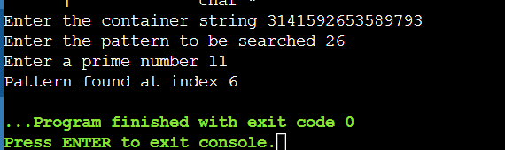
OBSERVATION: | Time complexity:  The running time in the worst case scenario O ((n-m+1) *m).  Average and best case running time is O (m+n) where m is length of pattern and n is length of text.  Space complexity: O(1)  We have used constant space. So, the space complexity is O(1).
CONCLUSION: | In this experiment, we implemented Rabin Karp’s Algorithm to find the matching string.

