Project: Diamond Prices

Complete each section. When you are ready, save your file as a PDF document and submit it here: [https://classroom.udacity.com/nanodegrees/nd008/parts/235a5408-0604-4871-8433-a6d670e37bbf/project#](https://classroom.udacity.com/nanodegrees/nd008/parts/235a5408-0604-4871-8433-a6d670e37bbf/project)

# Step 1: Understanding the Model

*Answer the following questions:*

1. According to the model, if a diamond is 1 carat heavier than another with the same cut, how much more should I expect to pay? Why?

$8413 more. The coefficient of the carat variable is 8413. Ceteris Paribus, an increase of 1 carat times the coefficient of 8413 equals a price increase of 8413.

1. If you were interested in a 1.5 carat diamond with a **Very Good** cut (represented by a 3 in the model) and a **VS2** clarity rating (represented by a 5 in the model), how much would the model predict you should pay for it?

Price = -5,269 + 8,413 x 1.5 Carat + 158.1 x 3 Cut + 454 x 5 Clarity

I predict to pay $10 094.80 for this diamond.

# Step 2: Visualize the Data

Make sure to plot and include the visualizations in this report. For example, you can create graphs in Excel and copy and paste the graphs into this Word document.

1. Plot 1 - Plot the data for the diamonds in the database, with carat on the x-axis and price on the y-axis. 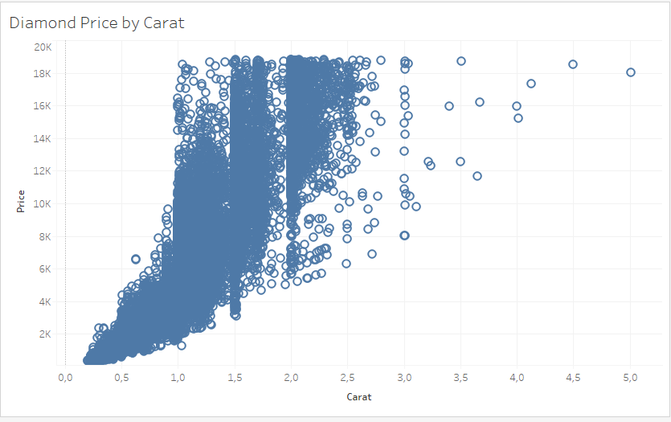
2. Plot 2 - Plot the data for the diamonds for which you are predicting prices with carat on the x-axis and predicted price on the y-axis.
   * **Note**: You can also plot both sets of data on the same chart in different colors. 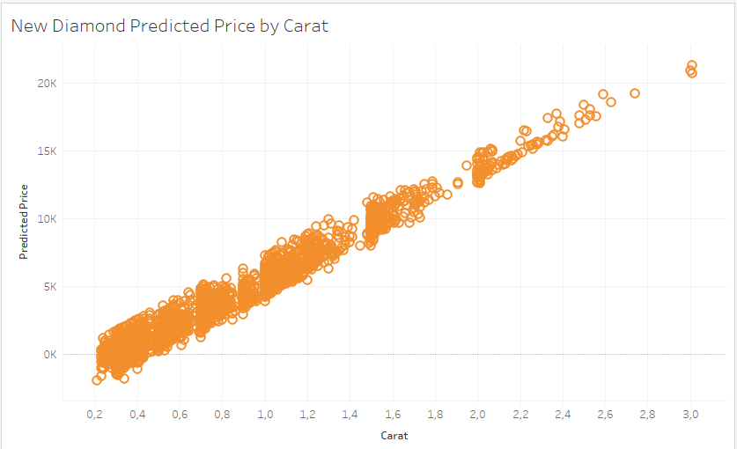
3. What strikes you about this comparison? After seeing this plot, do you feel confident in the model’s ability to predict prices?

The comparison shows where and how the model begins to fail. I am confident in the model only at the lower carat ranges. As the carat size increases, the model becomes less accurate because it increasingly understates the price of the diamond.

# Step 3: Make a Recommendation

*Answer the following questions:*

1. What price do you recommend the jewelry company to bid? Please explain how you arrived at that number.

$8 213 465.93

I used Alteryx to read the csv. I used the formula tool to calculate predicted price for each diamond. I summarise the prices and multiply by .7 to get the recommended bid of $8 213 465.93.

I arrived at this bid using the model. Given that the model underbids on larger carat diamonds, I would prefer to use a more accurate model.

