Project: Creditworthiness

Complete each section. When you are ready, save your file as a PDF document and submit it here: <https://classroom.udacity.com/nanodegrees/nd008/parts/11a7bf4c-2b69-47f3-9aec-108ce847f855/project>

## Step 1: Business and Data Understanding

*Provide an explanation of the key decisions that need to be made. (250 word limit)*

### Key Decisions:

*Answer these questions*

1. What decisions needs to be made?

The decision is whether new customers qualify for loan approvals. Once this decision is made, the bank can then extend loans to these qualified customers. The bank is looking to come up with an better and automatic way to manage the huge increase in credit applications. The short term decision is dealing with the 500 applications. The long term decision is which model to use to automate the process and deal with increased business on a consistent basis.

1. What data is needed to inform those decisions?

The data needed for this decision comprises non-financial information about the applicant such as age, occupation, and dependents, and financial information about the applicant such as assets and stocks. Additional relevant information on all past applications will also be used to build the model.

1. What kind of model (Continuous, Binary, Non-Binary, Time-Series) do we need to use to help make these decisions?

A customer can either be approved or not approved. This is a classification problem in which a customer can fall into one of two classes. Therefore, we need to use a binary classification model to make this decision.

## Step 2: Building the Training Set

*Build your training set given the data provided to you. The data has been cleaned up for you already so you shouldn’t* ***need to convert any data fields to the appropriate data types.***

*Here are some guidelines to help guide your data cleanup:*

* *For numerical data fields, are there any fields that highly-correlate with each other? The correlation should be at least .70 to be considered “high”.*
* *Are there any missing data for each of the data fields? Fields with a lot of missing data should be removed*
* *Are there only a few values in a subset of your data field? Does the data field look very uniform (there is only one value for the entire field?). This is called “low variability” and you should remove fields that have low variability. Refer to the "Tips" section to find examples of data fields with low-variability.*
* *Your clean data set should have 13 columns where the Average of Age Years should be 36 (rounded up)*

***Note:****For the sake of consistency in the data cleanup process, impute data using the average of the entire data field instead of removing a few data points. (100 word limit)*

***Note****: For students using software other than Alteryx, please format each variable as:*

|  |  |
| --- | --- |
| **Variable** | **Data Type** |
| Credit-Application-Result | String |
| Account-Balance | String |
| Duration-of-Credit-Month | Double |
| Payment-Status-of-Previous-Credit | String |
| Purpose | String |
| Credit-Amount | Double |
| Value-Savings-Stocks | String |
| Length-of-current-employment | String |
| Instalment-per-cent | Double |
| Guarantors | String |
| Duration-in-Current-address | Double |
| Most-valuable-available-asset | Double |
| Age-years | Double |
| Concurrent-Credits | String |
| Type-of-apartment | Double |
| No-of-Credits-at-this-Bank | String |
| Occupation | Double |
| No-of-dependents | Double |
| Telephone | Double |
| Foreign-Worker | Double |

*To achieve consistent results reviewers expect.*

*Answer this question:*

1. In your cleanup process, which fields did you remove or impute? Please justify why you removed or imputed these fields. Visualizations are encouraged.

*After I reviewed the variability of each field using the field summary tool, I decided to remove the Concurrent Credits, Foreign worker, No of depedents, Guarantors, and Occupation fields due to their low variability, as depicted below. Although the telephone field also displays low variability, it is probably not going to be a predictive factor in my model and this is why I will remove it.*

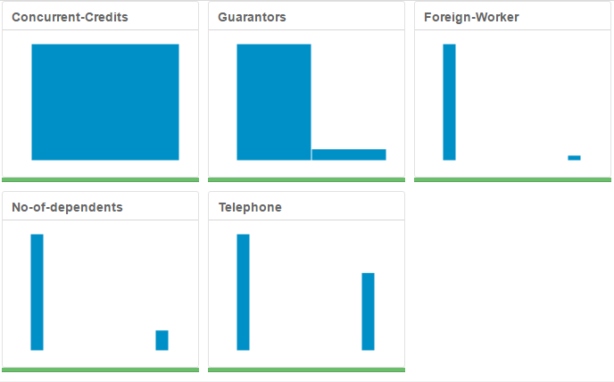

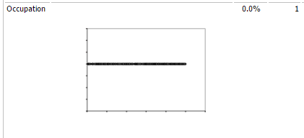

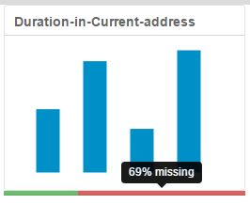

*I decided to remove Duration in Current address because this field is missing 68.8% of its values.*

*Finally, I decided to impute Age years because it is only missing 2.4% of its values. I imputed using the median age of 33.*

## Step 3: Train your Classification Models

*First, create your Estimation and Validation samples where 70% of your dataset should go to Estimation and 30% of your entire dataset should be reserved for Validation. Set the Random Seed to 1.*

*Create all of the following models: Logistic Regression, Decision Tree, Forest Model, Boosted Model*

*Answer these questions for* ***each model*** *you created:*

LOG

1. Which predictor variables are significant or the most important? Please show the p-values or variable importance charts for all of your predictor variables.

Account balance is the most statistically significant variable of the LOG model.

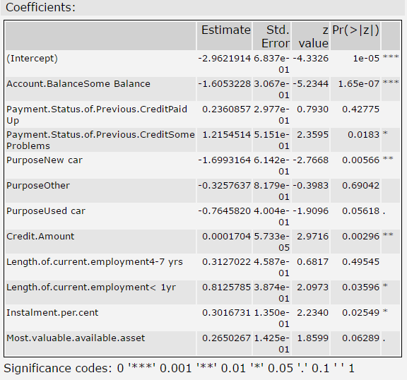

1. Validate your model against the Validation set. What was the overall percent accuracy? Show the confusion matrix. Are there any bias seen in the model’s predictions?

The LOG model is 76% accurate. There is a bias towards Creditworthiness.

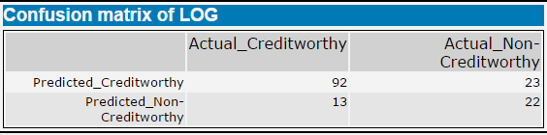

TREE

1. Which predictor variables are significant or the most important? Please show the p-values or variable importance charts for all of your predictor variables.

Credit amount and Account balance are the most important variables of this model.

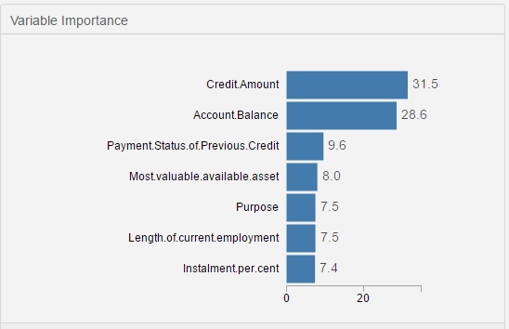

1. Validate your model against the Validation set. What was the overall percent accuracy? Show the confusion matrix. Are there any bias seen in the model’s predictions?

The TREE model is 74% accurate. There is a bias towards Creditworthiness.

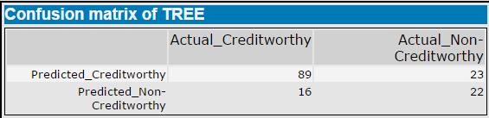

FOREST

1. Which predictor variables are significant or the most important? Please show the p-values or variable importance charts for all of your predictor variables.

Credit amount is by far the most important variable of this model.

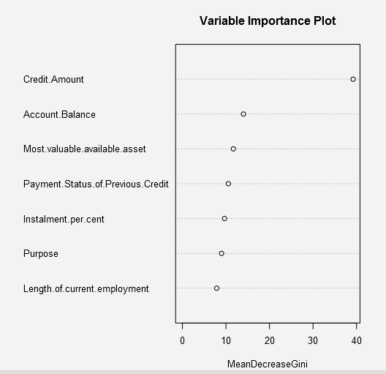

1. Validate your model against the Validation set. What was the overall percent accuracy? Show the confusion matrix. Are there any bias seen in the model’s predictions?

The FOREST model is 76% accurate. There is a bias towards Creditworthiness.

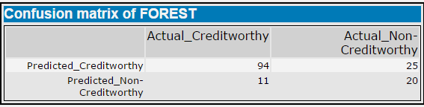

BOOST

1. Which predictor variables are significant or the most important? Please show the p-values or variable importance charts for all of your predictor variables.

The Account balance and Credit amount variables seem to be the most important.

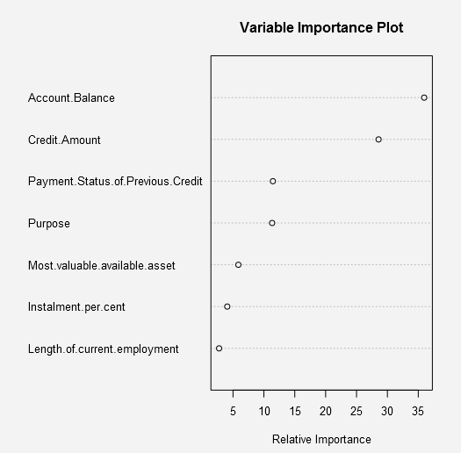

1. Validate your model against the Validation set. What was the overall percent accuracy? Show the confusion matrix. Are there any bias seen in the model’s predictions?

The BOOST model is 76.67% accurate. There does not seem to be significant bias in either direction.

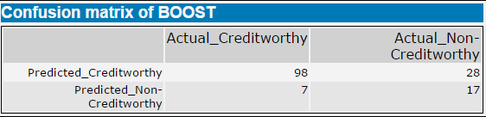

*You should have four sets of questions answered. (500 word limit)*

## Step 4: Writeup

*Decide on the best model and score your new customers. For reviewing consistency, if Score_Creditworthy is greater than Score_NonCreditworthy, the person should be labeled as “Creditworthy”*

*Write a brief report on how you came up with your classification model and write down how many of the new customers would qualify for a loan. (250 word limit)*

*Answer these questions:*

1. Which model did you choose to use? Please justify your decision using only the following techniques:
   1. Overall Accuracy against your Validation set
   2. Accuracies within “Creditworthy” and “Non-Creditworthy” segments
   3. ROC graph
   4. Bias in the Confusion Matrices

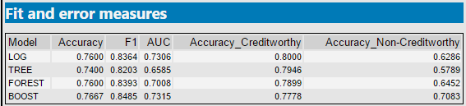

The chart above demonstrates that the BOOST model has a slightly higher accuracy rate than the other models. The BOOST model has a 76.67% accuracy rate. This means that the predictive power of the model is strong.

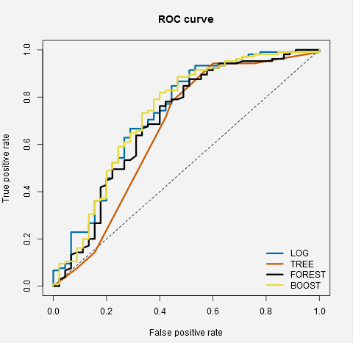

According to the ROC graph above, the BOOST model performs well in general. It does not perform especially better in comparison to the other models.

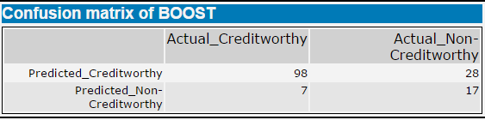

Per the confusion matrix of the BOOST model above, there is no bias in either direction.

**Note**: Remember that your boss only cares about prediction accuracy for Credityworthy and Non-Creditworthy segments.

1. How many individuals are creditworthy?

437 individuals are creditworthy out of the 500 new applicants.

Before you Submit

Please check your answers against the requirements of the project dictated by the [rubric](https://review.udacity.com/#!/rubrics/265/view) here. Reviewers will use this rubric to grade your project.