Project: Forecasting Sales

Complete each section. When you are ready, save your file as a PDF document and submit it here: <https://classroom.udacity.com/nanodegrees/nd008/parts/edd0e8e8-158f-4044-9468-3e08fd08cbf8/project>

## Step 1: Plan Your Analysis

*Look at your data set and determine whether the data is appropriate to use time series models. Determine which records should be held for validation later on (250 word limit).*

*Answer the following questions to help you plan out your analysis:*

1. Does the dataset meet the criteria of a time series dataset? Make sure to explore all four key characteristics of a time series data.

Yes, the dataset conforms to each of the four key characteristics of a time series. The dataset is over a continuous time interval from 2008-01 through 2013-09, inclusive. Each measurement takes place in sequence and there is equal spacing of one month between each measurement. Finally, each unit, the month, has at most one data point.

1. Which records should be used as the holdout sample?

The business has asked for a forecast for the next four months. Therefore, the last four records, which are the most recent periods, should be the holdout sample. These four records take place in a period between 2013-06 and 2013-09, inclusive.

## Step 2: Determine Trend, Seasonal, and Error components

Graph the data set and decompose the time series into its three main components: trend, seasonality, and error.  *(250 word limit)*

*Answer this question:*

1. What are the trend, seasonality, and error of the time series? Show how you were able to determine the components using time series plots. Include the graphs.

According to the decomposition plot below, the seasonality difference grows in magnitude and is multiplicative. The trend is relatively constant and changes in a linear fashion over time and is additive. The remainder, or error, displays changing variance as the time series moves along and is multiplicative.

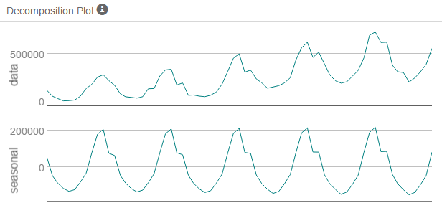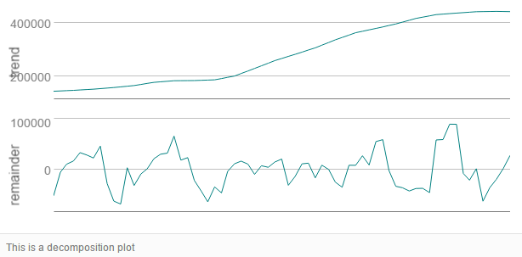

Step 3: Build your Models

*Analyze your graphs and determine the appropriate measurements to apply to your ARIMA and ETS models and describe the errors for both models. (500 word limit)*

*Answer these questions:*

1. What are the model terms for ETS? Explain why you chose those terms.

The model terms for ETS are MAM. The Error term is multiplicative, the Trend term is additive, and the Seasonality term is multiplicative.

* 1. Describe the in-sample errors. Use at least RMSE and MASE when examining results

The in-sample errors are depicted below. The RMSE represents the sample standard deviation of the differences between predicted and observed values. The RMSE of this ETS model is 33153.5267713. The MASE has a value of 0.3675478. MASE errors significantly lower than 1 are ideal. These sample errors will be compared against those of ARIMA to determine the better model.

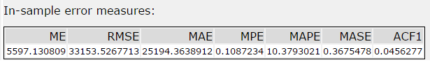

1. What are the model terms for ARIMA? Explain why you chose those terms. Graph the Auto-Correlation Function (ACF) and Partial Autocorrelation Function Plots (PACF) for the time series and seasonal component and use these graphs to justify choosing your model terms.

Depicted below are the ACF and the PACF of the time series. The ACF plot shows seasonality that must be differenced. The ARIMA model will need to be of the form ARIMA(p,d,q)(P,D,Q)[period] because of this seasonality. The period is 12 because the time series is monthly.

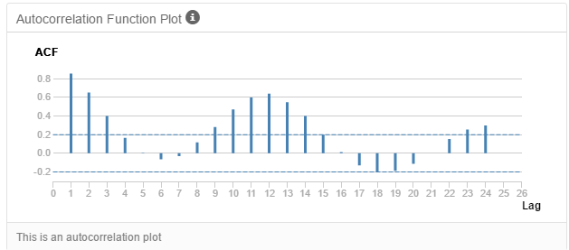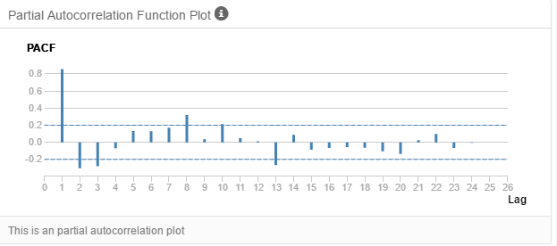

Depicted below are the Seasonal Difference ACF and the PACF plots. The time series still exhibits correlation and is not yet stationary. The seasonal difference term is D(1). The ARIMA terms are now ARIMA(p,d,q)(0,1,0)[12].

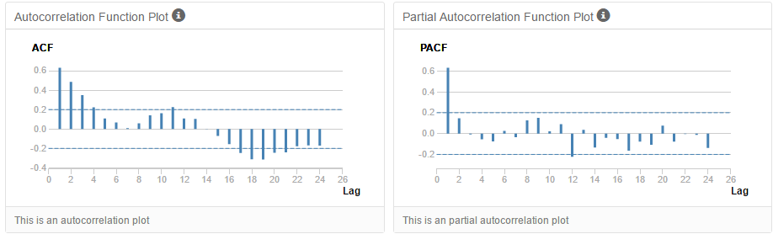

Depicted below are the Seasonal First Difference ACF and the PACF plots. The plots show that the time series is now stationary. The first difference indicates a d(1) term and there is no need for further differencing. Lag 1 on the ACF plot is negative, which indicates an MA model and a q(1) term. Since it is rare to have both a q(1) term and a p(1), then p(0). This is confirmed by the lack of significant correlation at the seasonal lags (12, 24, etc.). The ARIMA model is now ARIMA(0,1,1)(0,1,0)[12].

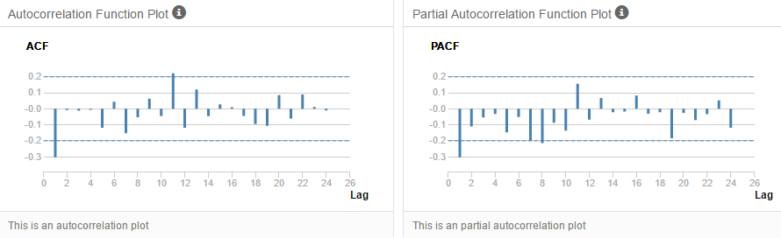

Depicted below are the ACF and the PACF of the time series after the final model terms have been chosen. The holdout sample has not been included.

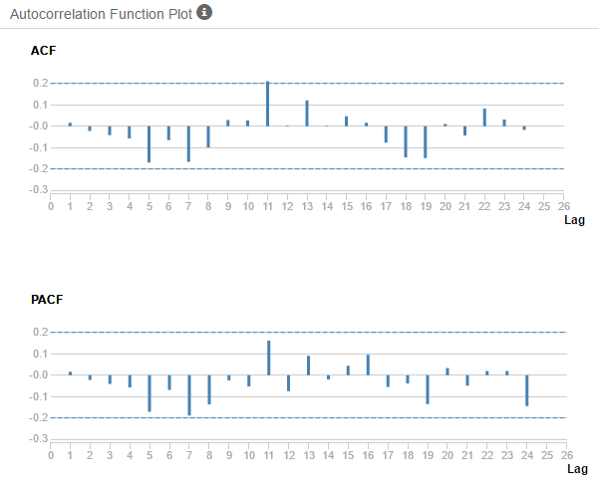

* 1. Describe the in-sample errors. Use at least RMSE and MASE when examining results

The in-sample errors are depicted below. The RMSE represents the sample standard deviation of the differences between predicted and observed values. The RMSE of this ARIMA model is 36761.5281724. The MASE has a value of 0.3646109. MASE errors significantly lower than 1 are ideal. These sample errors will be compared against those of ETS to determine the better model.

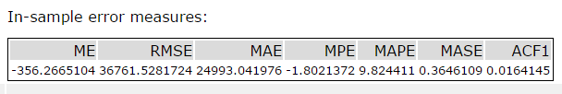

* 1. Regraph ACF and PACF for both the Time Series and Seasonal Difference and include these graphs in your answer.

Below are the ACF and PACF plots for the ARIMA model for the time series and include all data points including the holdout sample.

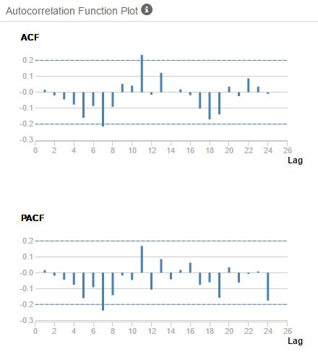

## Step 4: Forecast

*Compare the in-sample error measurements to both models and compare error measurements for the holdout sample in your forecast. Choose the best fitting model and forecast the next four periods. (250 words limit)*

*Answer these questions.*

1. Which model did you choose? Justify your answer by showing: in-sample error measurements and forecast error measurements against the holdout sample.

I chose the ARIMA(0,1,1)(0,1,0)[12] model.



Depicted below are the Actual values of the holdout sample compared against the Forecast values of both models.

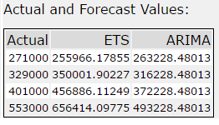

Below is a chart depicting the in-sample error measurements. The ARIMA model has smaller absolute values in most of the metrics. The ARIMA model appears to produce smaller predictive errors in more metrics than the ETS model.

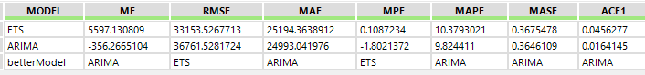

I created an additional chart, shown below, which shows the absolute and relative differences between the Actual values and the ETS and ARIMA forecasted values. The final field shows the better model as determined by the smaller absolute value of the relative difference of each model. The ARIMA model forecasts more accurately.

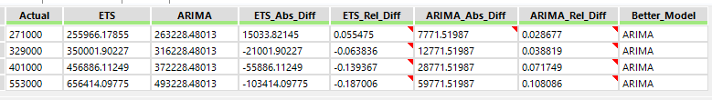

Below are the accuracy measures of both models. The ARIMA model beats the ETS model in each measure by having smaller absolute values. This shows the ARIMA model has better predictive powers in just about every metric.

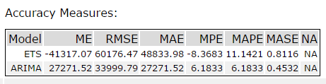

I included the AIC measures for each model as well. The better model is usually the one with the lower AIC score. In this case, the ARIMA model has the better score and this fits with the rest of the information which points to the ARIMA model.

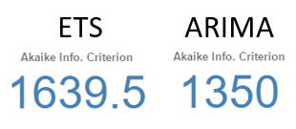

1. What is the forecast for the next four periods? Graph the results using 95% and 80% confidence intervals.

The forecast for the next four periods is shown below, in addition to the 80% and 95% confidence intervals.

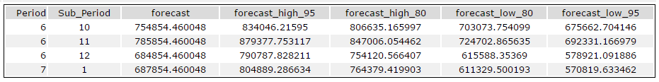

The 80% and 95% confidence intervals are graphed below with the forecast.

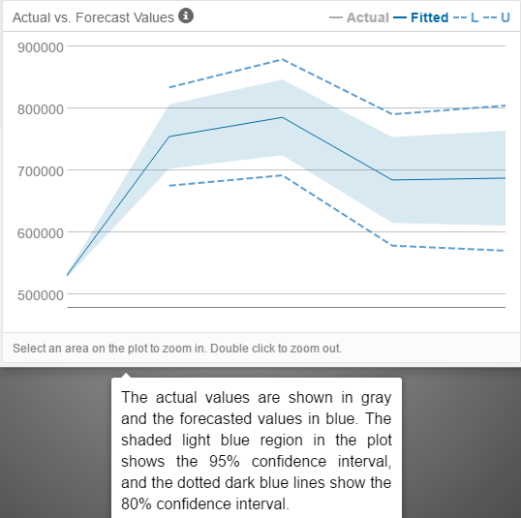

Before you Submit

Please check your answers against the requirements of the project dictated by the [rubric](https://review.udacity.com/#!/rubrics/302/view) here. Reviewers will use this rubric to grade your project.