Supplementary Material (Online Resource 1)
Real-Time Multi-Behavior Detection of Group-Housed Pigs on Edge Devices: Class-Imbalance-Aware Sampling and a Lightweight FasterNet Backbone — Supplementary Material
Tropical Animal Health and Production · Zhan Zhang · Linlin Gou · Corresponding author: Zhan Zhang, 851709772@qq.com
Table S1. Per-class AP50 on the validation set. On the held-out test set, the key rare-class result is active 0.526 → 0.639 (baseline → M4, +11.3 points); sitting 0.534 → 0.571; fight 0.840 → 0.871.
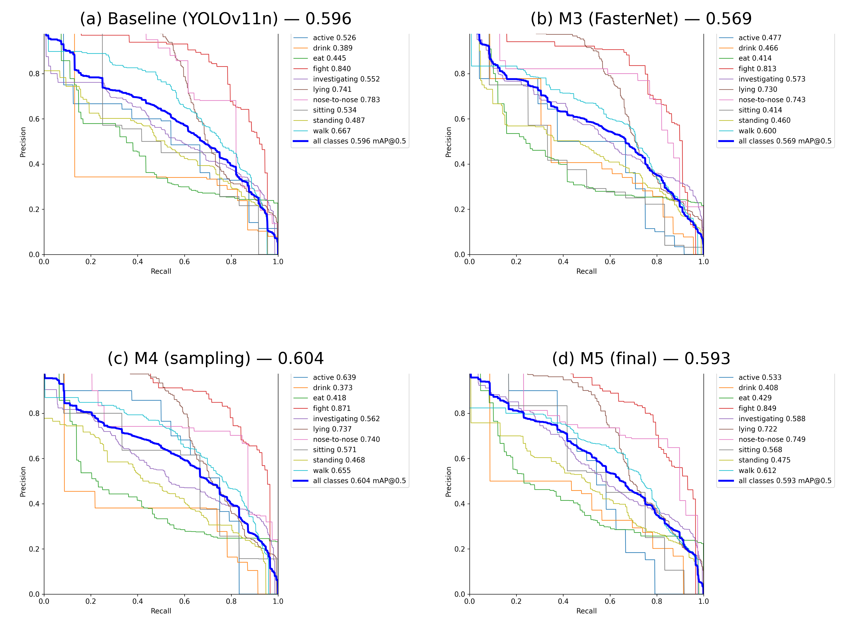
Fig. S1 Precision–recall curves on the held-out test set for the four ablation models: (a) baseline YOLOv11n (mAP50 0.596), (b) M3 FasterNet-only (0.569), (c) M4 sampling-only (0.604), (d) final M5 (0.593). Behaviour-class curves are shown thin; the thick blue curve is the all-class average
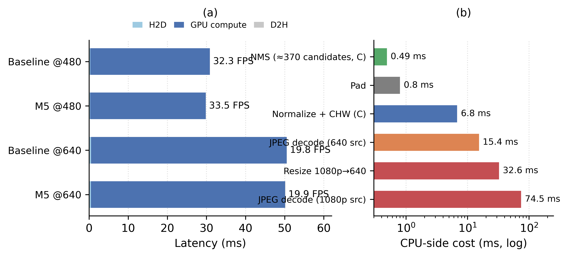
Fig. S2 Latency budget on the Jetson Nano. (a) Engine-side decomposition (TensorRT measurement): GPU compute dominates at both input sizes; H2D/D2H transfers are negligible. (b) CPU-side pre/post-processing costs in a pure-Python pipeline (log scale): naive decode and resize can exceed GPU compute, so production pipelines should implement pre/post-processing in C or CUDA
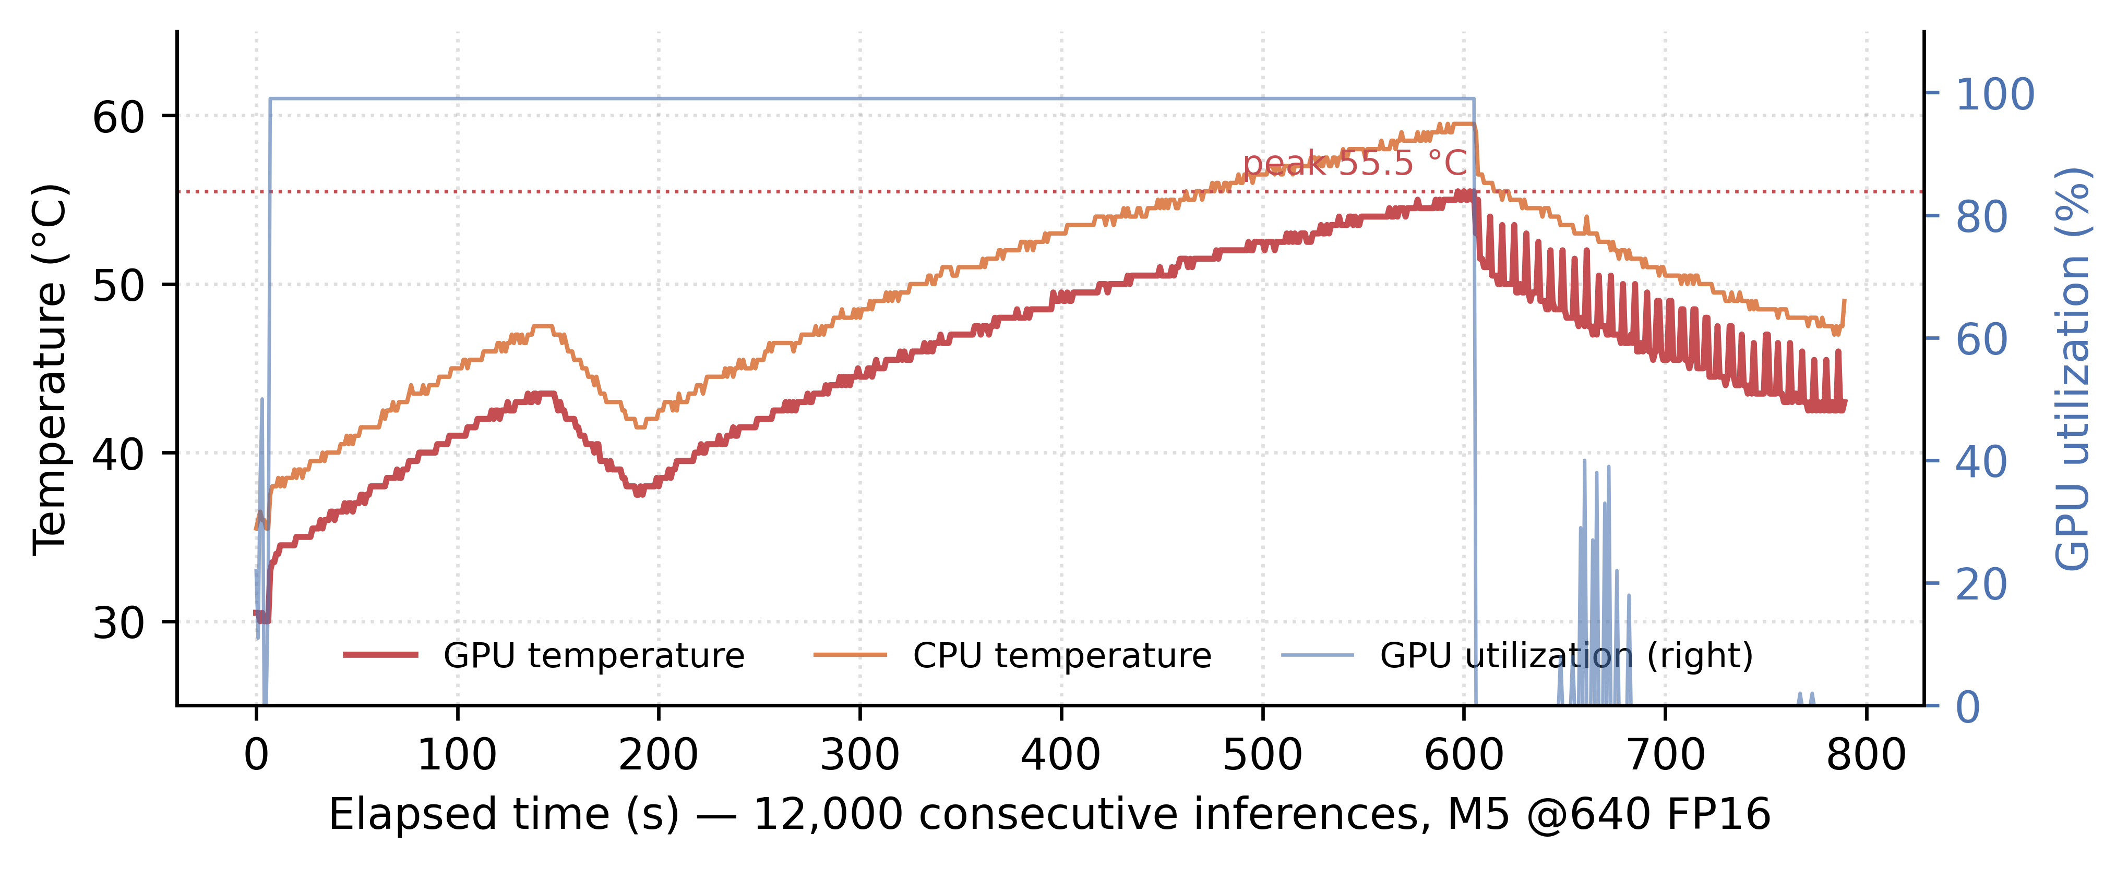
Fig. S3 Sustained-operation timeline on the Jetson Nano over 12,000 consecutive inferences (10.7 min, M5 at 640×640 FP16). Throughput holds at 20.0 FPS (99th-percentile latency 51.3 ms); GPU temperature peaks at 55.5 °C with zero thermal-throttling events and no clock drop
Class | Baseline | M3 (FasterNet) | M4 (sampling) | M5 (combined) | M4 − baseline
active | 0.459 | 0.372 | 0.552 | 0.452 | +9.3
drink | 0.408 | 0.440 | 0.459 | 0.430 | +5.1
eat | 0.436 | 0.437 | 0.447 | 0.449 | +1.1
fight | 0.858 | 0.828 | 0.842 | 0.786 | −1.6
investigating | 0.581 | 0.571 | 0.570 | 0.577 | −1.1
lying | 0.783 | 0.764 | 0.766 | 0.743 | −1.7
nose-to-nose | 0.686 | 0.655 | 0.622 | 0.710 | −6.4
sitting | 0.403 | 0.233 | 0.423 | 0.349 | +2.0
standing | 0.438 | 0.429 | 0.449 | 0.445 | +1.1
walk | 0.687 | 0.646 | 0.686 | 0.667 | −0.1
mAP50 (all) | 0.573 | 0.537 | 0.582 | 0.561 | +0.9
Table S2. Per-class AP50 on the held-out test set for the baseline and the two adopted variants. The rare-class pattern mirrors the validation set (Table S1): the gains of M4 concentrate on active, sitting and fight; M5 keeps part of the rare-class gain while carrying 4.4% fewer parameters. All entries are single-run values (seed 0); the three-seed means for the overall metric are reported in Section 4.5 of the main text. M5 values were re-measured under the official validation protocol (overall mAP50 0.5933, matching the cloud-reported 0.5932).
Class | Baseline | M4 (sampling) | M5 (combined)
active | 0.526 | 0.639 | 0.533
drink | 0.389 | 0.373 | 0.408
eat | 0.445 | 0.418 | 0.429
fight | 0.840 | 0.871 | 0.849
investigating | 0.552 | 0.562 | 0.588
lying | 0.741 | 0.737 | 0.722
nose-to-nose | 0.783 | 0.740 | 0.749
sitting | 0.534 | 0.571 | 0.568
standing | 0.487 | 0.468 | 0.475
walk | 0.667 | 0.655 | 0.612
mAP50 (all) | 0.596 | 0.604 | 0.593

