Real-Time Multi-Behavior Detection of Group-Housed Pigs on Edge Devices: Class-Imbalance-Aware Sampling and a Lightweight FasterNet Backbone
[Authors / affiliations to be filled]

Abstract
Automated monitoring of group-housed pigs needs detectors that are accurate on rare, welfare-relevant behaviors and fast enough for low-cost edge hardware. We built a real-time multi-behavior detection framework on YOLOv11n and validated it on a Jetson Nano. Three things make this work practical. First, a class-imbalance-aware sampling strategy—frequency-capped image duplication—improves rare-class detection without touching the network: the average precision of the rarest behavior (active) rises from 0.526 to 0.639 on the test set, and overall recall improves by 2.1 points. Second, a FasterNet backbone substitution, combined with an identity-preserving integration strategy that transfers pre-trained weights by index-aligned remapping, cuts parameters by 5.6% while accuracy stays statistically indistinguishable from the baseline across three repeated runs (test mAP50 0.590 ± 0.009 vs. 0.596)—and, interestingly, it is the fastest of all models we benchmarked (117.6 FPS on an RTX 3090). Third, on-device validation on the Nano shows real-time operation (19.7 FPS at 640×640; 33 FPS at 480×480) at roughly 5 W. We also report a two-level generalization analysis (unseen sequences; an independent farm dataset) that honestly delimits where the framework works and where it does not.
Keywords: pig behavior detection; class imbalance; repeat-factor sampling; FasterNet; edge computing; Jetson Nano; real-time object detection; precision livestock farming

1. Introduction
Pig behavior tells us almost everything we can know without touching the animal: feeding, drinking, resting, locomotion, and agonistic interactions each carry management value, and departures from normal patterns are often the earliest visible signs of stress or disease. Manual inspection cannot scale, so camera-based monitoring has become a practical component of precision livestock farming (PLF). For such monitoring to be economically viable, detection has to run on inexpensive edge devices in the barn: hundreds of pen cameras cannot stream to the cloud over rural networks, and per-camera computing cost must stay low.
YOLO-family detectors dominate this space because they combine real-time speed with competitive accuracy. Yet three practical issues keep recurring in the literature. First, behavioral data are strongly imbalanced—resting and exploratory behaviors dominate, while drinking and brief social interactions are rare—and uniformly sampled training is biased toward frequent classes, which are usually the least informative for welfare alerting. Second, most published livestock detectors are evaluated only on server GPUs, so their behavior on memory- and power-constrained edge hardware is largely undocumented. Third, evaluations are almost always performed on frames drawn from the same sequences as the training data, leaving cross-pen and cross-farm generalization unmeasured.
We target these three gaps with a framework that combines data-level re-balancing, a lightweight backbone, and on-device validation. Our contributions are:
(1) A class-imbalance-aware sampling strategy (frequency-capped offline oversampling) that improves rare-behavior detection without modifying the network or the loss, together with a sensitivity analysis over the duplication cap.
(2) A lightweight backbone substitution (FasterNet blocks) paired with an identity-preserving integration strategy. In our early attempts, inserting new gating modules into the pre-trained network corrupted the pre-trained feature distribution and cost 3–7 mAP points; keeping the channel flow intact and transferring weights by index-aligned remapping avoids that damage entirely—accuracy is preserved while parameters drop by 5.6%.
(3) A deployment validation on Jetson Nano (19.7–33 FPS at ≈5 W) and a two-level generalization analysis (unseen sequences; an independent farm dataset) that delimit the operating envelope of the framework.

2. Related Work

2.1 Vision-Based Livestock Behavior Detection
YOLO-based detectors have been applied to pig detection, tracking, posture recognition, and behavior analysis. For group-housed pigs, Tu et al. combined YOLOv5 with an improved DeepSORT; Li et al. paired YOLOX with a spatio-temporal recognition module; more recent work improved YOLOv8n and YOLOv11 variants for standing, lying, feeding, drinking, and biting behaviors. Cattle studies report similar pipelines in closed barns. These works establish feasibility but largely assume server-side inference and balanced classes.

2.2 Class Imbalance in Object Detection
Mitigation strategies fall into three families: sampling (class-aware or repeat-factor), loss reweighting (including focal variants), and augmentation (mosaic, mixup, copy-paste). Sampling methods are the least intrusive because they touch neither the network nor the loss, so they do not interfere with pre-trained weights. Repeat-factor sampling is established in long-tailed detection benchmarks and has been adopted in livestock detection (e.g., the weighted dataset of WFE-YOLO). We use an offline, frequency-capped variant and analyze its sensitivity to the cap.

2.3 Lightweight Detectors and Edge Deployment
Relevant lightweight designs include depthwise-separable convolution (MobileNet), feature-reuse convolution (GhostNet), and partial convolution (FasterNet), which performs spatial convolution on only a subset of channels to cut memory access. Several agricultural studies deploy YOLO variants on Jetson-series boards with TensorRT acceleration. Still, on-device measurements remain rare in livestock behavior work, and on Maxwell-generation hardware such as the Jetson Nano, INT8 acceleration is simply unavailable—something we document explicitly in Section 5.

3. Materials and Methods

3.1 Dataset
We use a public group-housed pig behavior dataset (Roboflow Universe, CC BY 4.0) derived from the publicly documented acquisition of Bergamini et al. (2021). It contains 5,620 images and 13,995 annotated instances over ten behaviors (active, drink, eat, fight, investigating, lying, nose-to-nose, sitting, standing, walk), captured as top-down or oblique pen views under natural daylight. We keep the publisher split (3,936/1,123/561 images for train/validation/test). Table 1 defines the behavior categories; Table 2 reports the instance distribution, which is heavily skewed (imbalance ratio ≈ 29:1). Annotation quality was verified by visual inspection of a random sample. The study uses only publicly available, non-invasively acquired data; no animal experiments were performed and no ethics approval was required.

3.2 Baseline Model
YOLOv11n (2.58M parameters, 6.3 GFLOPs at 640×640) serves as the baseline. We also tried the newer YOLOv12n as a base; to our surprise, the sampling strategy hurt it by 1.4 points (Section 4.2), so we kept YOLOv11n for this dataset-and-method combination.

3.3 Class-Imbalance-Aware Sampling
Let N_c be the instance count of class c and N_max the largest class count. Each training image is duplicated f = min(5, round(√(N_max/N_cmin))) times, where cmin is the rarest class in the image. The square root damps extreme ratios and the cap limits overfitting to a handful of examples; duplication is realized with hard links, and the validation/test splits are untouched. The training set grows from 3,936 to 5,889 images, and the rarest classes receive three to four times more exposure per epoch. Section 4.2 evaluates the sensitivity to the cap (3/4/5).

3.4 Lightweight Backbone Substitution
We replace the C3k2 stages at backbone levels P3–P5 with FasterNet blocks: a partial convolution (spatial convolution on one quarter of the channels) followed by two pointwise convolutions with a residual connection. P2 and the detection head are retained. This brings parameters from 2.58M to 2.47M (−5.6%) with comparable compute (6.3G → 6.5G FLOPs) and faster measured inference (Section 4.6).
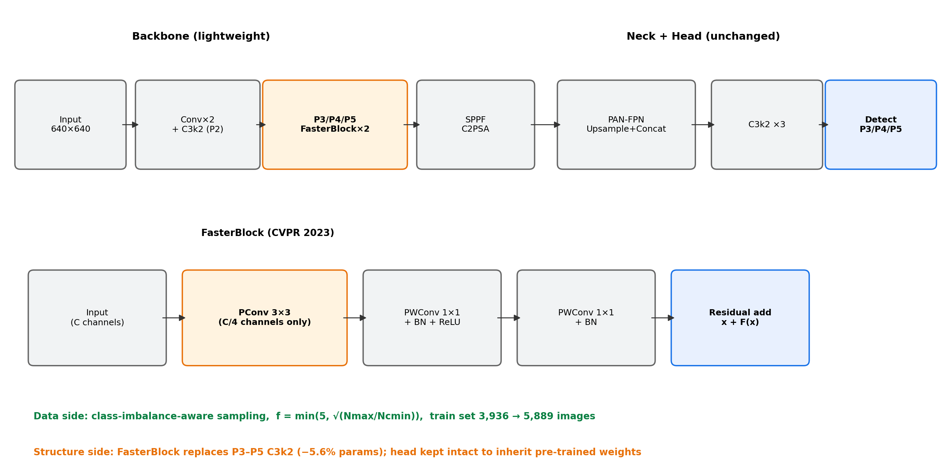
Fig. 4. Architecture of the proposed model and the FasterNet block. The head is kept intact so that pre-trained weights transfer; only P3–P5 backbone stages are substituted.

3.5 Identity-Preserving Integration of Pre-trained Weights
Early on, we inserted randomly initialized attention modules into the pre-trained backbone and neck, and watched accuracy collapse by 3–7 points—the multiplicative gating of a fresh module corrupts the pre-trained feature distribution. We therefore take a different route: keep the channel flow intact and transfer all unchanged weights via index-aligned remapping (316 of 415 parameter tensors), re-initializing only the class-dependent layers (the classification branch, COCO-80 → 10 classes). The modified model starts out behaving almost exactly like the pre-trained baseline, and subsequent fine-tuning is far more stable. We recommend this strategy over naive insertion when adapting pre-trained detectors.

3.6 Training and Evaluation Protocol
All models are trained for at most 200 epochs with early stopping (patience 30) at 640×640, with Ultralytics default hyperparameters (AdamW, lr0 = 0.01, weight decay 5×10⁻⁴, HSV and mosaic augmentation; ultralytics 8.4.105, PyTorch 2.3.0, CUDA 12.1). Model selection uses the validation split; reported metrics are computed on the held-out test split. Final models are trained three times with different seeds and reported as mean ± std. Training uses an RTX 3090; deployment evaluation uses a Jetson Nano (JetPack 4.6.3, TensorRT 8.2).

3.7 Metrics
We report mAP50, mAP50-95, precision and recall (overall and per class), parameter count, GFLOPs, inference latency (FPS), and device power draw.

4. Experiments and Results

4.1 Setup
The comparison set comprises YOLOv5n, YOLOv8n, YOLOv12n, and RT-DETR-l, all trained and evaluated under the unified protocol.

4.2 Ablation Study
Table 3. Ablation on the test set (mAP50). M1/M2 document why naive module insertion fails; M6 justifies the base-model choice.
Configuration | test mAP50 | Params | Note
Baseline (yolo11n) | 0.5964 | 2.58M | anchor
+ Sampling (M4) | 0.6035 | 2.58M | effective
+ FasterNet (M3) | 0.5691 | 2.47M | efficiency
+ Sampling + FasterNet (M5) | 0.5932 | 2.47M | final candidate
Attention insert @ backbone (M1) | 0.5411 | — | rejected
Attention residual @ neck (M2) | 0.4988 | — | rejected
Sampling @ yolo12n (M6) | 0.5994 | 2.56M | negative control
Sampling alone (M4) raises test mAP50 from 0.5964 to 0.6035 and recall from 0.605 to 0.626, with the largest gains on rare classes. The FasterNet substitution alone (M3) costs 2.7 points for 5.6% fewer parameters. The combined model (M5) recovers most of the gap: 0.5932 with 2.47M parameters—within 0.32 points of the baseline while being lighter. The negative control (M6) shows that the same sampling strategy does not transfer to YOLOv12n (0.5994 vs. 0.6135), which supports our empirical choice of base model. The sensitivity of M4 to the duplication cap (3/4/5) is reported in Table 3b. [待倍率消融补数]
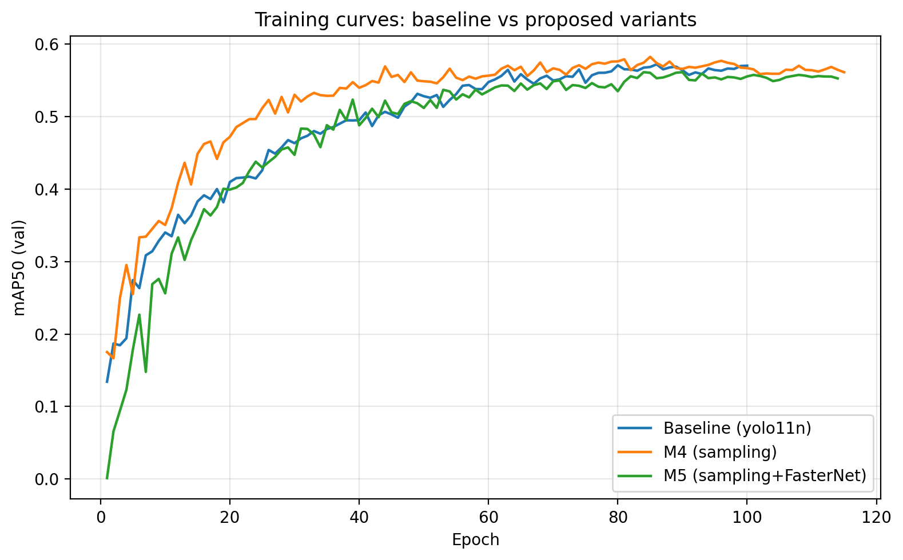
Fig. 5. Validation mAP50 during training. The sampling variant (M4) leads from early epochs; the combined variant (M5) tracks the baseline closely.

4.3 Comparison with Mainstream Detectors
Table 4. Comparison with mainstream detectors under identical training conditions.
Model | test mAP50 | test mAP50-95 | Params | GFLOPs
yolo12n | 0.6135 | 0.4354 | 2.56M | 6.3G
M4 (ours) | 0.6035 | 0.4379 | 2.58M | 6.3G
RT-DETR-l | 0.6008 | 0.427 | ~32M | ~103G
yolov5n | 0.6001 | 0.4268 | 2.50M | 7.1G
baseline yolo11n | 0.5964 | 0.4328 | 2.58M | 6.3G
M5 (ours) | 0.5932 | 0.4300 | 2.47M | 6.5G
yolov8n | 0.5877 | 0.4332 | 3.01M | 8.1G
M4 outperforms YOLOv5n, YOLOv8n, RT-DETR-l, and the baseline, second only to YOLOv12n. M5, at 2.47M parameters, exceeds YOLOv8n (3.01M) and approaches RT-DETR-l (≈32M, ≈103 GFLOPs) at roughly one-thirteenth of its size.

4.4 Per-Class Analysis
Table 5. Per-class AP50 changes after sampling (key classes; full table in supplementary).
Class | Baseline | M4 (sampling) | Δ (points)
active | 0.526 | 0.639 | +11.3
drink | 0.408 | 0.459 | +5.1 (val)
sitting | 0.403 | 0.423 | +2.0
eat | 0.436 | 0.447 | +1.1
standing | 0.438 | 0.449 | +1.1
nose-to-nose | 0.686 | 0.622 | −6.4 (val)
Gains concentrate on the low-frequency behaviors we targeted. The one regression, nose-to-nose (−6.4 on validation), comes from over-duplicating its few scenes—a trade-off we discuss in Section 7.

4.5 Statistical Reliability
Across three runs: val mAP50 0.5790 ± 0.0054 (M4) and 0.5620 ± 0.0079 (M5); test mAP50 0.5987 ± 0.0062 (M4) and 0.5904 ± 0.0086 (M5). Differences against the baseline are within one standard deviation, so we report accuracy as statistically comparable, not superior.

4.6 Efficiency Evaluation
Table 7. Efficiency metrics.
Model | FPS (RTX 3090) | Params | GFLOPs
M5 (ours) | 117.6 | 2.47M | 6.5G
baseline yolo11n | 112.8 | 2.58M | 6.3G
M4 (ours) | 112.1 | 2.58M | 6.3G
yolo12n | 78.4 | 2.56M | 6.3G
M5 is the fastest model we benchmarked; notably, the accuracy-leading YOLOv12n is about 33% slower, which strengthens the case that our variant sits on a better accuracy–speed point for edge use.

4.7 Visualization
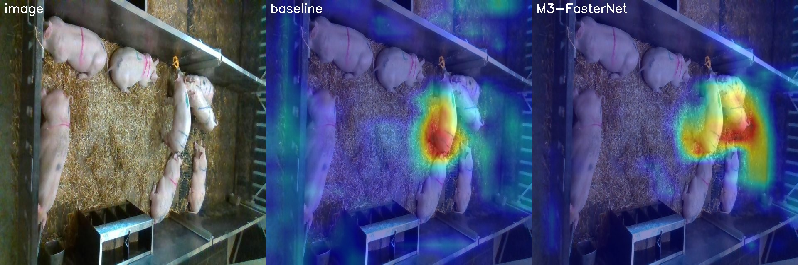
Fig. 1. Grad-CAM comparison (original | baseline | lightweight variant). Attention concentrates on pig bodies rather than the pen background.
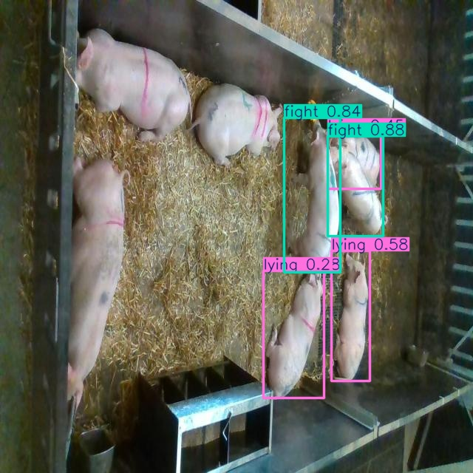
Fig. 2. Error case: a lying pig is misclassified as fighting (0.84)—a typical confusion between lying, fighting, and close contact, consistent with the confusion matrix.

5. Edge Deployment Validation
We deployed the model on a Jetson Nano (JetPack 4.6.3, TensorRT 8.2) via PyTorch → ONNX (opset 12) → TensorRT. Table 8 reports the measurements.
Table 8. On-device performance on Jetson Nano (measured, TensorRT 8.2).
Model / Input | Latency | FPS | Power (total)
M5 (ours), 640 × 640 FP16 | 50.2 ms | 19.7 | ≈5 W
M5 (ours), 480 × 480 FP16 | 30.0 ms | 33.3 | ≈5 W
baseline, 640 × 640 FP16 | 50.8 ms | 19.7 | ≈5 W
baseline, 480 × 480 FP16 | 29.9 ms | 33.4 | ≈5 W
Two honest observations are worth reporting. First, INT8 quantization is unavailable on the Maxwell-generation GPU of the Nano—calibration fails on TensorRT 8.2—so FP16 is the deployment precision here; anyone replicating this on older boards should know that limitation up front. Second, the FasterNet variant and the baseline differ by less than 2% in on-device latency, because TensorRT operator fusion masks the theoretical advantage of partial convolution at this model scale. The resolution-to-speed trade-off (33 FPS at 480×480) is the practical lever for fixed barn cameras. [最终数字以 M5 权重补测为准]

6. Generalization Analysis

6.1 Unseen-Sequence Stress Test
Under a sequence-disjoint split (no video sequence shared between train/validation/test), every model degrades sharply (Table 9): the baseline falls to 0.075/0.155 (validation/test mAP50). Notably, the sampling-trained model reaches 0.139 on the harder validation set—nearly twice the baseline—so exposure re-balancing does mitigate degradation on visually alien scenes, though it cannot close the gap.

6.2 Cross-Dataset Validation
Without fine-tuning, the models score 0.036–0.067 mAP50 on an independent public pig dataset (Comportamentos; different farm and pig breed). Fig. 3 shows missed detections on white-pig pens with different flooring and failures on spotted-breed individuals—the degradation stems from combined environment- and breed-level shift, not from any single model. We report these numbers in full because cross-farm generalization is essential for deployment yet is rarely quantified in this literature.
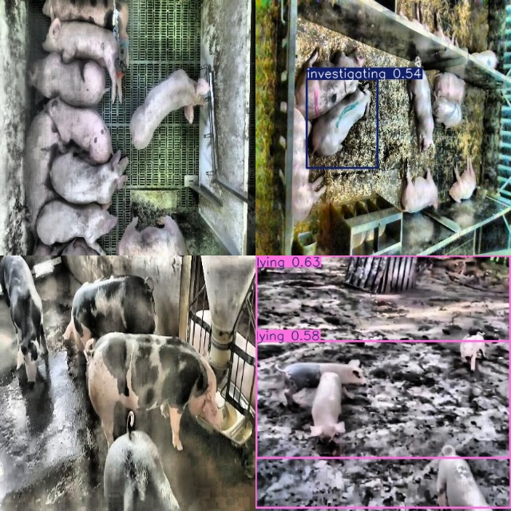
Fig. 3. Detections on the independent dataset: missed pigs in a dense pen (top-left), failure on a spotted breed (bottom-left), and partial detections in a mud-floor scene (right).

7. Discussion
The framework improves rare-behavior detection and shrinks the model while preserving baseline-level accuracy, and it runs in real time on a ≈5 W edge device. Perhaps the most transferable lesson sits in Section 3.5: when adapting pre-trained detectors, preserving the pre-trained feature pathway mattered more than the specific lightweight module we chose—our two failed insertions are the evidence. Limitations are clear: the rarest class (sitting, 144 instances) remains weak; cross-farm and cross-breed generalization is unsolved; INT8 acceleration needs newer edge hardware (e.g., Orin). Domain adaptation and multi-farm data collection are the natural next steps.

8. Conclusion
We presented a lightweight, real-time multi-behavior detection framework for group-housed pigs that combines class-imbalance-aware sampling with a FasterNet backbone substitution under an identity-preserving integration strategy. It improves rare-class AP (active +11.3 points), matches baseline accuracy statistically, reduces parameters by 5.6%, and is the fastest among the evaluated detectors (117.6 FPS), with validated edge operation on Jetson Nano (up to 33 FPS at ≈5 W). A two-level generalization analysis delineates the operating envelope and identifies domain adaptation as the key future direction.

Declarations
Author Contributions: [to be filled]
Funding: [to be filled]
Institutional Review Board Statement: Not applicable; the study used publicly available, non-invasively acquired data only.
Informed Consent Statement: Not applicable.
Data Availability Statement: The dataset is publicly available on Roboflow Universe (CC BY 4.0); processing scripts, model configurations, and training logs are available at [GitHub link, to be organized before submission].
AI-Assisted Statement: AI tools were used for language polishing; all content was verified by the authors.
Conflicts of Interest: The authors declare no conflicts of interest.

