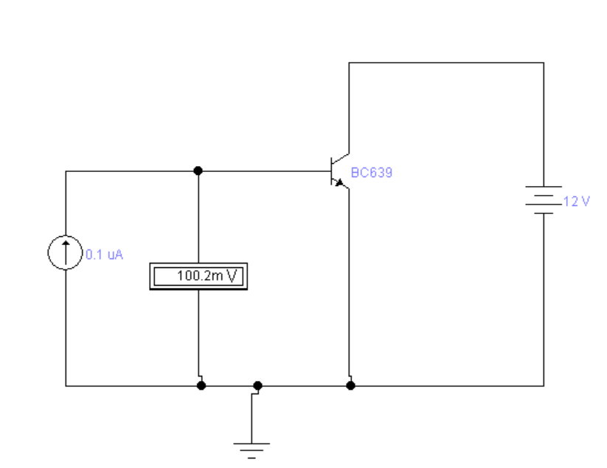

|  |  |
| --- | --- |
| I mkA | mV |
| 0.1 | 100.2 |
| 0.25 | 235.7 |
| 1 | 334 |
| 100 | 464 |
| 500 | 505.7 |
| 1000 | 523.7 |
| 2000 | 541.6 |
| 3000 | 552.1 |
| 4000 | 559.5 |
| 5000 | 565.3 |