# 编译安装包

<http://azkaban.github.io/azkaban/docs/latest/#webserver-setup>

<https://azkaban.github.io/downloads.html>

## 下载

从GitHub上下载当前的releases

<https://github.com/azkaban/azkaban/releases>

解压，然后进入解压目录，README.md文件里有打包说明

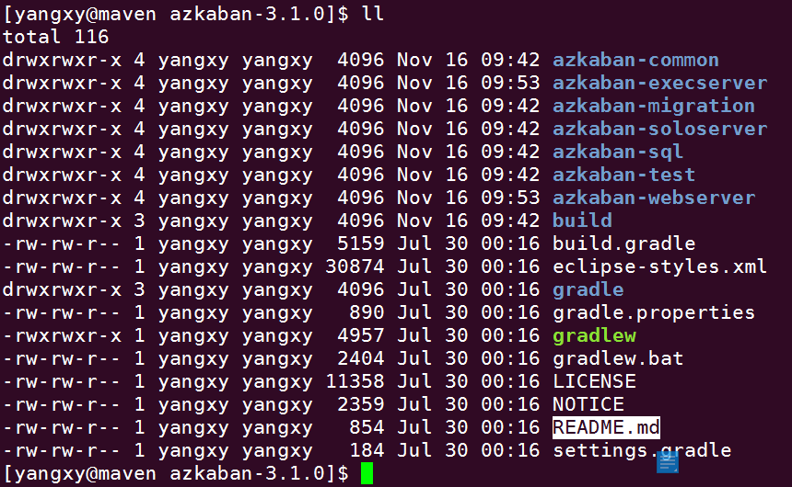

## 打包

http://azkaban.github.io/azkaban/docs/latest/#building-from-source

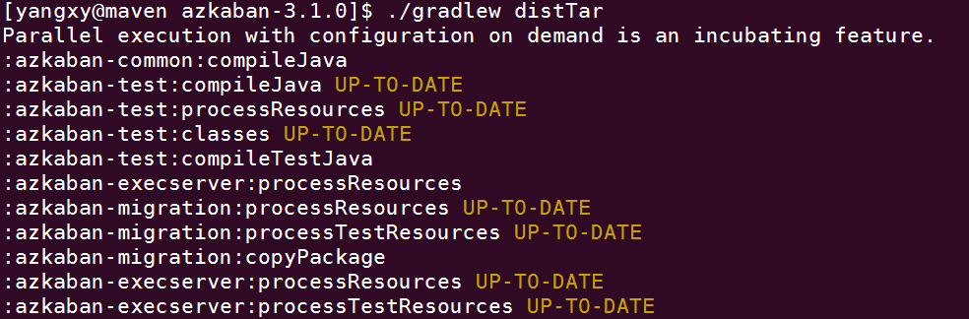

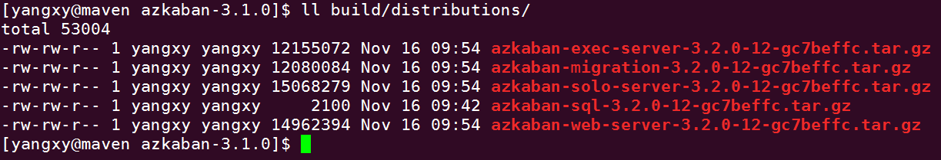

## 遇到的问题

Execution failed for task ':azkaban-common:linkMainExecutable'.

> Could not find Linker 'g++' in system path.

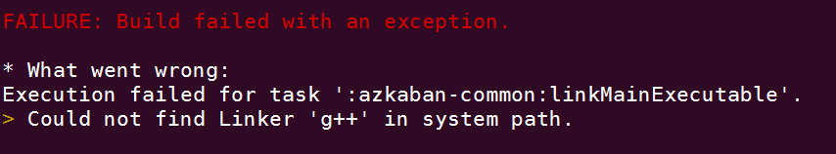

安装gcc相关依赖

yum install gcc*

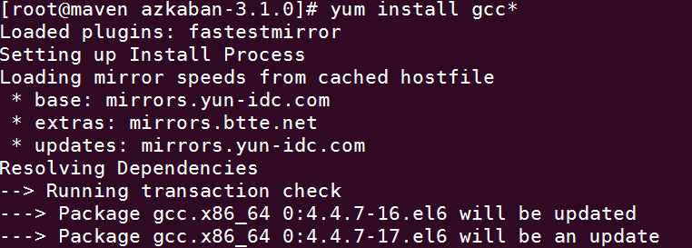

# 安装

## 初始数据库

<http://azkaban.github.io/azkaban/docs/latest/#database-setup>

mysql> CREATE DATABASE azkaban;

mysql> CREATE USER 'azkaban'@'%' IDENTIFIED BY 'azkaban';

mysql> GRANT ALL PRIVILEGES ON azkaban.* to 'azkaban'@'%' WITH GRANT OPTION;

mysql> GRANT ALL PRIVILEGES ON azkaban.* to 'azkaban'@'localhost' IDENTIFIED BY 'azkaban' WITH GRANT OPTION;

mysql [azkaban]> source /home/spark/azkaban-sql-3.2.0-12-gc7beffc/create-all-sql-3.2.0-12-gc7beffc.sql;

[mysqld]

...

max_allowed_packet=1024M

To restart MySQL, you can run...

$ sudo /sbin/service mysqld restart

## Azkaban Web Server

### 配置

<http://azkaban.github.io/azkaban/docs/latest/#webserver-setup>

<http://azkaban.github.io/azkaban/docs/latest/#azkaban-webserver>

#conf/azkaban.properties

# Azkaban Personalization Settings

azkaban.name=CSDN Work Flow Manager

azkaban.label=CSDN Azkaban

azkaban.color=#FF3601

azkaban.default.servlet.path=/index

web.resource.dir=web/

default.timezone=Asia/Shanghai

# Azkaban UserManager class

user.manager.class=azkaban.user.XmlUserManager

user.manager.xml.file=conf/azkaban-users.xml

# Loader for projects

executor.global.properties=conf/global.properties

azkaban.project.dir=projects

#MySQL Connection Parameter

database.type=mysql

mysql.port=3306

mysql.host=localhost

mysql.database=azkaban

mysql.user=azkaban

mysql.password=azkaban

mysql.numconnections=100

# Azkaban Jetty server properties.

jetty.use.ssl=false

jetty.maxThreads=25

jetty.port=8081

# mail settings

mail.sender=

mail.host=

job.failure.email=

job.success.email=

# Multiple Executor Mode Parameters

azkaban.use.multiple.executors=true

## Azkaban Executor Server

### 配置

多Executor模式需要手动初始executors表

insert into executors(host,port,active) values("EXECUTOR_PORT",EXECUTOR_PORT,1);

<http://azkaban.github.io/azkaban/docs/latest/#executor-setup>

<http://azkaban.github.io/azkaban/docs/latest/#azkaban-execserver>

<http://azkaban.github.io/azkaban/docs/latest/#azkaban-plugin-configuration>

1. Execute.as.user is set to true by default. In case needed, it can also be configured to false in azkaban-plugin’s commonprivate.properties
2. Configure azkaban.native.lib= to the place where you are going to put the compiled execute-as-user.c file (see below)
3. Generate an executable on the Azkaban box for azkaban-common/src/main/c/execute-as-user.c. **it should be named execute-as-user**Below is a sample approach
   * scp ./azkaban-common/src/main/c/execute-as-user.c onto the Azkaban box
   * run: gcc execute-as-user.c -o execute-as-user
   * run: chown root execute-as-user (you might need root privilege)
   * run: chmod 6050 execute-as-user (you might need root privilege)

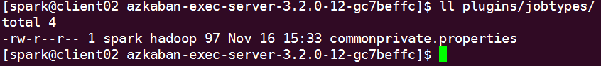

[spark@client02 azkaban-exec-server-3.2.0-12-gc7beffc]$ cat conf/azkaban.properties

database.type=mysql

mysql.port=3306

mysql.host=mysql.csdn.net

mysql.database=azkaban

mysql.user=azkaban

mysql.password=azkaban

mysql.numconnections=100

# Azkaban Executor settings

executor.maxThreads=50

executor.port=12321

executor.flow.threads=30

executor.host=clinet02.csdn.net

azkaban.jobtype.plugin.dir=plugins/jobtypes

[spark@client02 azkaban-exec-server-3.2.0-12-gc7beffc]$ cat plugins/jobtypes/commonprivate.properties

# Execute-As-User

azkaban.native.lib=/home/spark/azkaban-exec-server-3.2.0-12-gc7beffc/nativ-lib

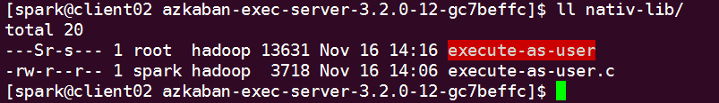

# Spark Job

type=command

user.to.proxy=spark

command=spark-submit --master yarn --class org.apache.spark.examples.SparkPi examples/spark-examples_2.11-2.0.1.jar 100