# Getting Started

## Exploring Your Cluster

### Cluster Health

GET /_cat/health?v

GET /_cat/nodes?v

### List All Indices

GET /_cat/indices?v

### Create an Index

PUT /customer?pretty

GET /_cat/indices?v

### Index and Query a Document

PUT /customer/external/1?pretty

{

"name": "John Doe"

}

GET /customer/external/1?pretty

### Delete an Index

DELETE /customer?pretty

GET /_cat/indices?v

### Updating Documents

POST /customer/external/1/_update?pretty

{

"doc": { "name": "Jane Doe" }

}

POST /customer/external/1/_update?pretty

{

"doc": { "name": "Jane Doe", "age": 20 }

}

POST /customer/external/1/_update?pretty

{

"script" : "ctx._source.age += 5"

}

GET /customer/external/1?pretty

### Deleting Documents

DELETE /customer/external/2?pretty

### Batch Processing

POST /customer/external/_bulk?pretty

{"index":{"_id":"1"}}

{"name": "John Doe" }

{"index":{"_id":"2"}}

{"name": "Jane Doe" }

## Exploring Your Data

## Loading the Sample Dataset

[**https://github.com/elastic/elasticsearch/blob/master/docs/src/test/resources/accounts.json?raw=true**](https://github.com/elastic/elasticsearch/blob/master/docs/src/test/resources/accounts.json?raw=true)

curl -XPOST 'localhost:9200/bank/account/_bulk?pretty&refresh' --data-binary "@accounts.json"

curl 'localhost:9200/_cat/indices?v'

curl -XGET 'localhost:9200/bank/_search?q=*&sort=account_number:asc&pretty&pretty'

curl -XGET 'localhost:9200/bank/_search?pretty' -H 'Content-Type: application/json' -d'

{

"query": { "match_all": {} },

"sort": [

{ "account_number": "asc" }

]

}

'

# 索引

## 添加纪录

<https://www.elastic.co/guide/en/elasticsearch/reference/current/docs-index_.html>

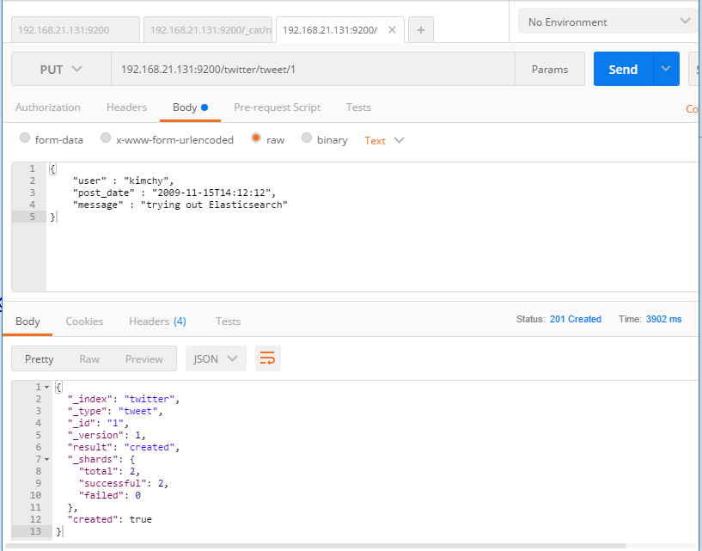

## 查看设置

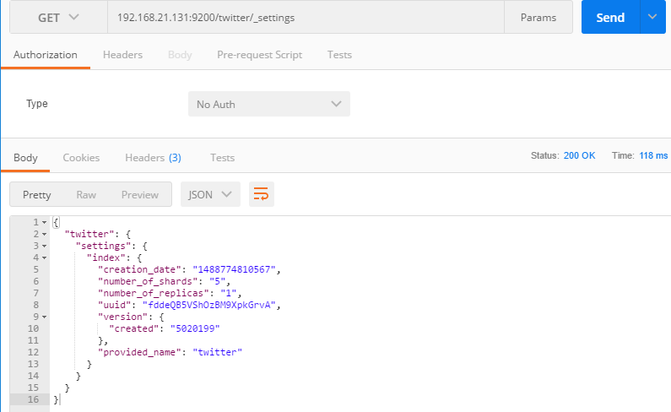

## 修改设置

