# 主机

123.56.8.167是 172.16.249.65的外网IP

172.16.249.65：iZ25m448zmaZ

172.16.249.66 iZ25o8heu1zZ

# 用户

Hadoop 密码：csdn.net

# Hadoop

## Core-site.xml

<property>

<name>fs.defaultFS</name>

<value>hdfs://172.16.249.65:9000</value>

</property>

<property>

<name>hadoop.tmp.dir</name>

<value>/data/hadoop-2.6.0-cdh5.7.1/tmp</value>

</property>

## Hdfs-site.xml

<property>

<name>dfs.name.dir</name>

<value>/data/hadoop/namenode</value>

</property>

<property>

<name>dfs.data.dir</name>

<value>/data/hadoop/datanode</value>

</property>

<property>

<name>dfs.replication</name>

<value>2</value>

</property>

<property>

<name>dfs.namenode.secondary.http-address</name>

<value>172.16.249.66:50090</value>

<description>

The secondary namenode http server address and port.

</description>

</property>

## Yarn-site.xml

<property>

<name>yarn.resourcemanager.hostname</name>

<value>172.16.249.65</value>

</property>

<property>

<name>yarn.nodemanager.aux-services</name>

<value> mapreduce_shuffle</value>

</property>

## mapred-site.xml

<property>

<name>mapreduce.framework.name</name>

<value>yarn</value>

</property>

Hive-site.xml

<?xml version="1.0"?>

<?xml-stylesheet type="text/xsl" href="configuration.xsl"?>

<configuration>

<property>

<name>javax.jdo.option.ConnectionURL</name>

<value>jdbc:mysql://172.16.249.66:3306/hive?createDatabaseIfNotExist=true</value>

<description>JDBC connect string for a JDBC metastore</description>

</property>

<property>

<name>javax.jdo.option.ConnectionDriverName</name>

<value>com.mysql.jdbc.Driver</value>

<description>Driver class name for a JDBC metastore</description>

</property>

<property>

<name>javax.jdo.option.ConnectionUserName</name>

<value>root</value>

<description>username to use against metastore database</description>

</property>

<property>

<name>javax.jdo.option.ConnectionPassword</name>

<value>csdn.net</value>

<description>password to use against metastore database</description>

</property>

<property>

<name>hive.metastore.uris</name>

<value>thrift://172.16.249.66:9083</value>

</property>

<property>

<name>hive.server2.logging.operation.enabled</name>

<value>true</value>

<description>When true, HS2 will save operation logs and make them available for clients</description>

</property>

</configuration>

<http://123.56.8.167:60010/master-status>

<http://123.56.8.167:50070/dfshealth.htm>

http://123.56.8.167:8088/cluster/apps

# 防火墙端口

<http://www.cloudera.com/documentation/enterprise/latest/topics/cdh_ig_ports_cdh5.html>

# mariadb

<http://jingyan.baidu.com/article/fea4511a1b8041f7bb91258a.html>

安装

yum install mariadb*

启动

[root@iZ25o8heu1zZ ~]# systemctl start mariadb.service

#第一次连接密码为空

[root@iZ25o8heu1zZ ~]# mysql -u root -p

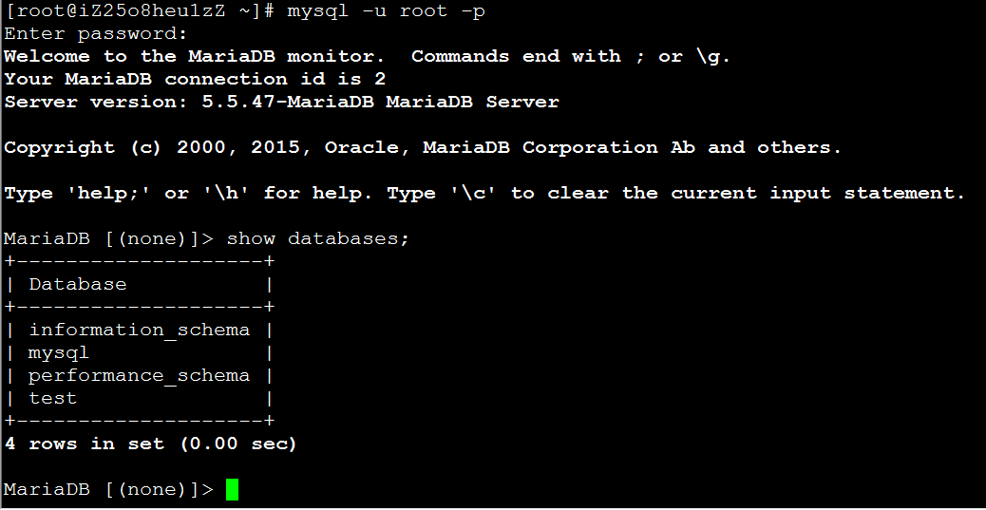

use mysql;

update user set password=password(‘密码’) where user='root';

flush privileges;

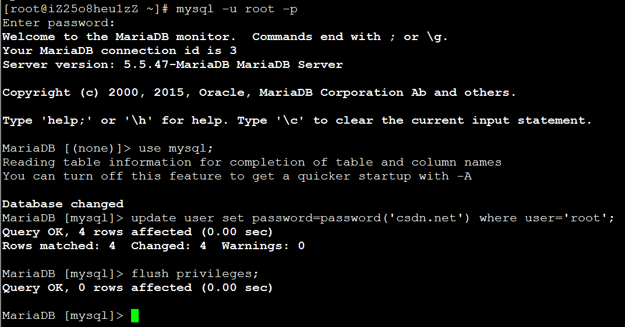

授权远程访问

grant all privileges on *.* to 'root'@'172.16.249.65' identified by '****' with grant option;



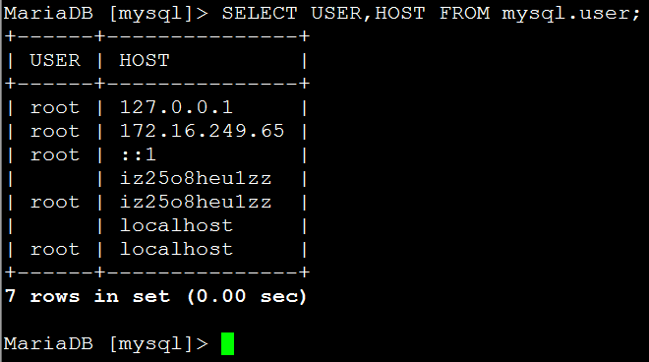

systemctl start mariadb.service #启动MariaDB  
systemctl stop mariadb.service #停止MariaDB  
systemctl restart mariadb.service #重启MariaDB  
systemctl enable mariadb.service #设置开机启动

systemctl is-enabled mariadb.service

systemctl is-enabled iptables.service  
systemctl is-enabled servicename.service #查询服务是否开机启动  
systemctl enable *.service #开机运行服务  
systemctl disable *.service #取消开机运行  
systemctl start *.service #启动服务  
systemctl stop *.service #停止服务  
systemctl restart *.service #重启服务  
systemctl reload *.service #重新加载服务配置文件  
systemctl status *.service #查询服务运行状态  
systemctl --failed #显示启动失败的服务