# 帐号

Knox Master Secret: csdn.net

## FreeIPA

帐号：admin

密码：csdn.net

## MySQL

Ipa02为主库，ip01为备库

复制帐号: repl 密码：csdn.net

Root帐号：root 密码：csdn.net

ambari帐号：ambari 密码:ambaricsdnnet

# Ambari

## Prepare the Environment

### Set Up Password-less SSH

<http://docs.hortonworks.com/HDPDocuments/Ambari-2.4.0.1/bk_ambari-installation/content/set_up_password-less_ssh.html>

# 常见问题

## ntp启动失败

解决步骤：

1. 先向ntp server同步一下时间
2. 重启ntp进程

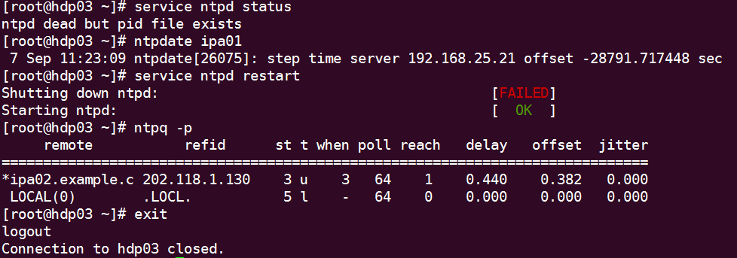

## Ambari Agents May Fail to Register with Ambari Server

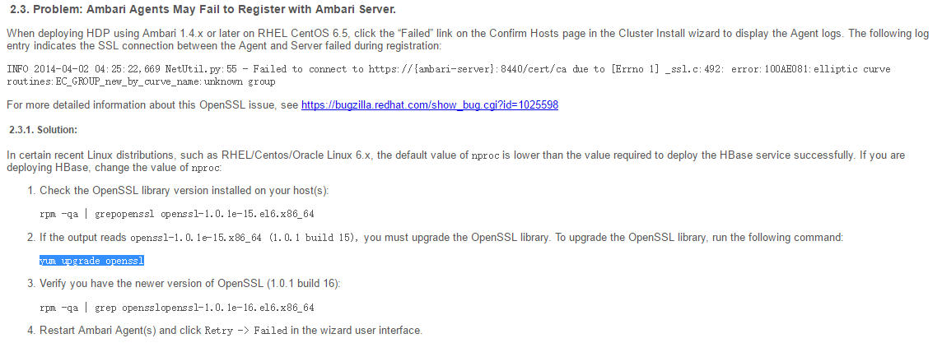

## Mysql Driver

**ambari-server setup --jdbc-db=mysql --jdbc-driver=/usr/share/java/mysql-connector-java.jar**

## MySQL函数不能创建的解决方法

ERROR 1418 (HY000): This function has none of DETERMINISTIC, NO SQL, or READS SQL DATA in its declaration and binary logging is enabled (you *might* want to use the less safe log_bin_trust_function_creators variable)  
ERROR 1418 (HY000): This function has none of DETERMINISTIC, NO SQL, or READS SQL DATA in its declaration and binary logging is enabled (you *might* want to use the less safe log_bin_trust_function_creators variable)

**show variables like '%func%';**

set global log_bin_trust_function_creators=1;

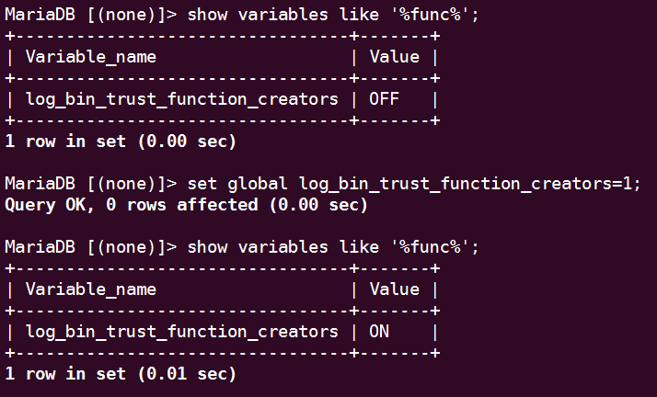

## Setup-kerberos-IPA

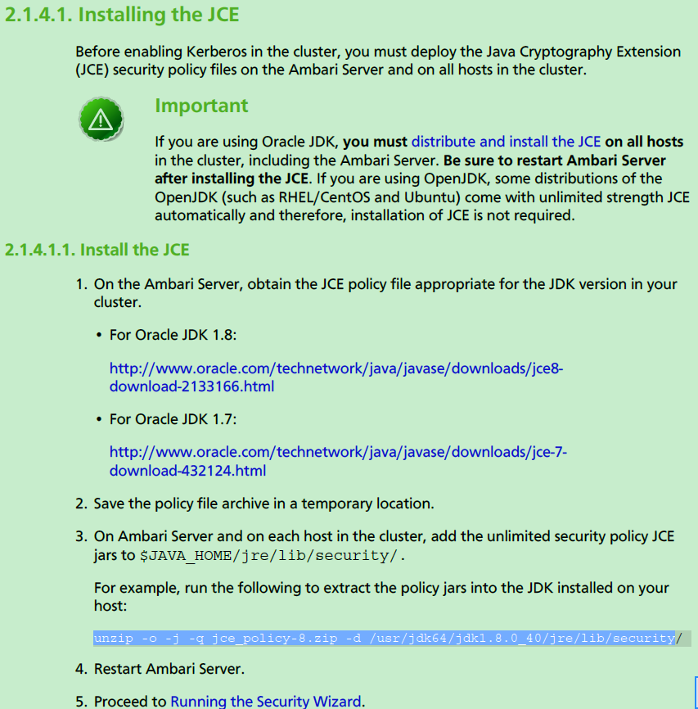

1、

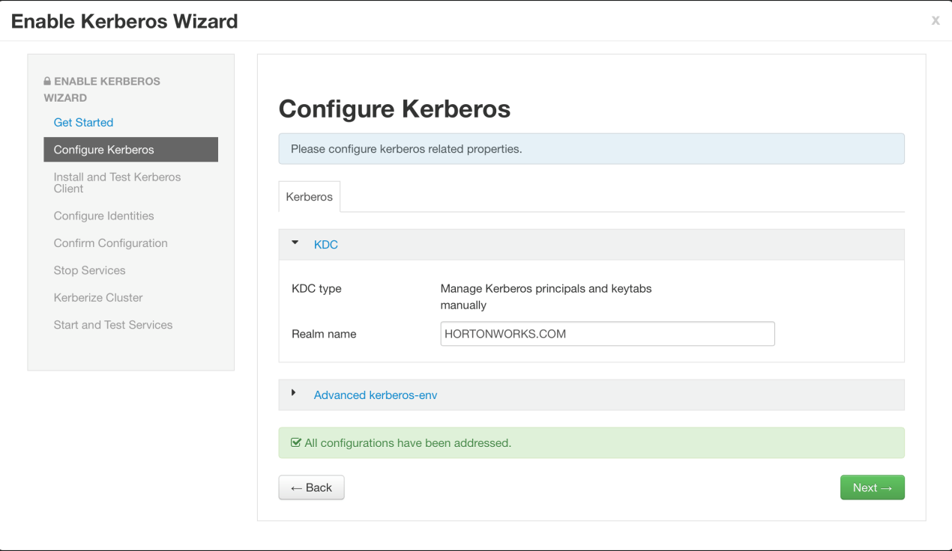

2、Remove clustername from smoke/hdfs principals to remove the -${cluster_name} references to look like below

* smoke user principal: ${cluster-env/smokeuser}@${realm}
* HDFS user principal: ${hadoop-env/hdfs_user}@${realm}
* HBase user principal: ${hbase-env/hbase_user}@${realm}

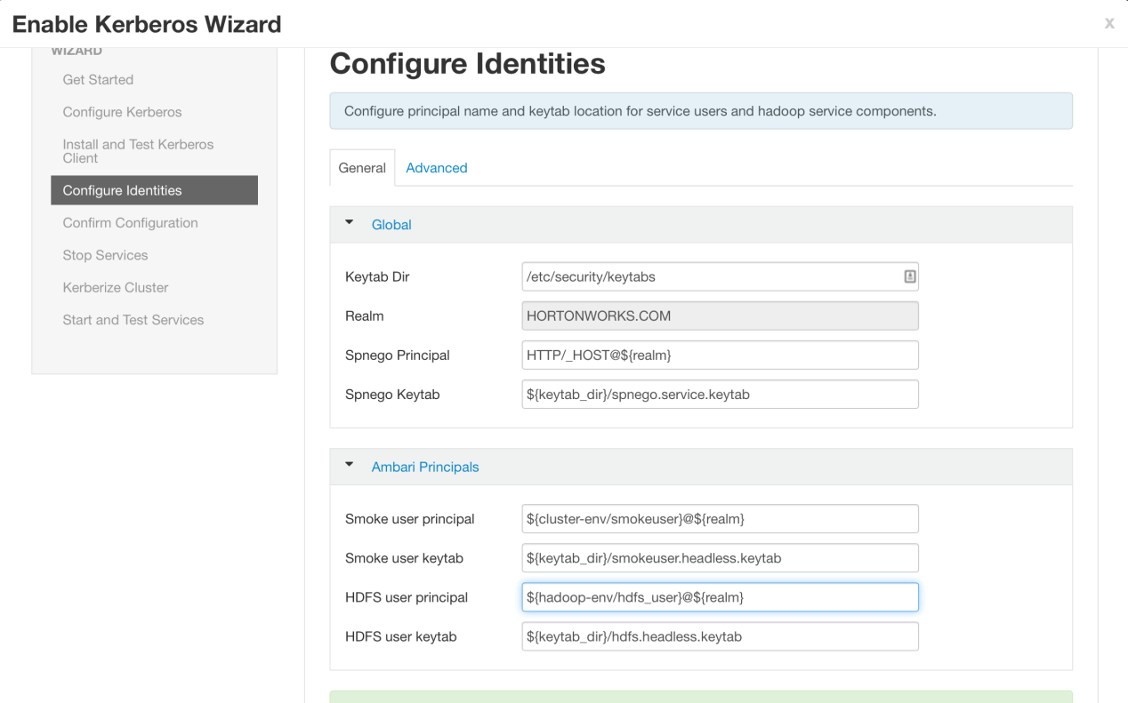

1. On next page download csv file but **DO NOT** click Next yet

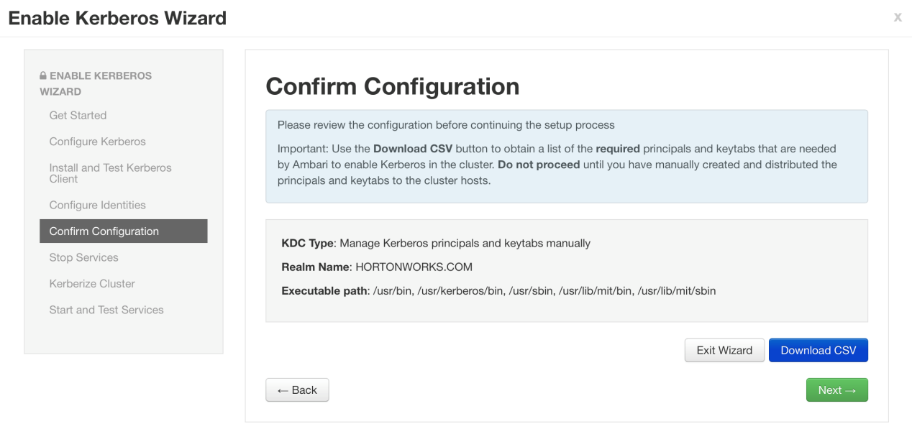

4、

* Paste contents to a file *on both IPA host and on the HDP node*, making sure to remove empty lines at the end.

vi kerberos.csv

* If you are deploying storm, the storm user maybe missing from the storm USER row. If you see something like the below:

storm@HORTONWORKS.COM,USER,,/etc

replace the ,, with ,storm,

storm@HORTONWORKS.COM,USER,storm,/etc

* **On the IPA node** Create principals using csv file

## authenticate

kinit admin

awk -F"," '/SERVICE/ {print "ipa service-add --force "$3}' kerberos.csv | sort -u > ipa-add-spn.sh

awk -F"," '/USER/ {print "ipa user-add "$5" --first="$5" --last=Hadoop --shell=/sbin/nologin"}' kerberos.csv > ipa-add-upn.sh

sh ipa-add-spn.sh

sh ipa-add-upn.sh

* **On the HDP node** authenticate and create the keytabs

## authenticate

sudo kinit admin

ipa_server=$(cat /etc/ipa/default.conf | awk '/^server =/ {print $3}')

sudo mkdir /etc/security/keytabs/

sudo chown root:hadoop /etc/security/keytabs/

awk -F"," '/'$(hostname -f)'/ {print "ipa-getkeytab -s '${ipa_server}' -p "$3" -k "$6";chown "$7":"$9,$6";chmod "$11,$6}' kerberos.csv | sort -u > gen_keytabs.sh

sudo bash ./gen_keytabs.sh

* Verify kinit works before proceeding (should not give errors)

sudo sudo -u hdfs kinit -kt /etc/security/keytabs/nn.service.keytab nn/$(hostname -f)@HORTONWORKS.COM

sudo sudo -u ambari-qa kinit -kt /etc/security/keytabs/smokeuser.headless.keytab ambari-qa@HORTONWORKS.COM

sudo sudo -u hdfs kinit -kt /etc/security/keytabs/hdfs.headless.keytab [hdfs@HORTONWORKS.COM](mailto:hdfs@HORTONWORKS.COM)



genServicektab.sh 需要在HDP各个节点上执行，生成服务的keytab文件

genUserkeytab.sh 只能在一个节点上执行，让后把生成的keytab文件分发到各个HDP节点

说明： this password is automatically changed when creating a keytab file

所以在使用

<https://cwiki.apache.org/confluence/display/AMBARI/Automated+Kerberization+Troubleshooting>

5、Press next on security wizard and proceed to stop services

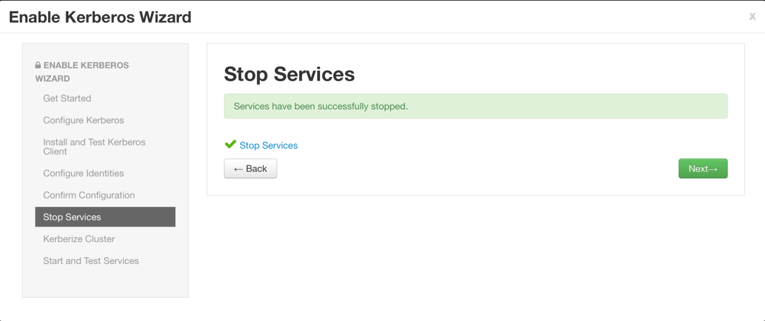

## IPA

# authconfig --enablemkhomedir --update

# nisdomainname *example.com*

#service sssd start

添加用户组

ipa group-add --desc='hadoop service account' hadoop

添加用户

ipa user-add fangbin --first=fang --last=binbin --shell=/bin/bash --gidnumber=1040900500

ipa user-add yangxy --first=yang --last=xueyou --shell=/bin/bash --gidnumber=1040900500

修改密码

ipa passwd ambari

添加DNS

ipa dnsrecord-add example.com client01 --a-rec=192.168.25.23 --a-create-reverse

ipa dnsrecord-add example.com client02 --a-rec=192.168.25.24 --a-create-reverse

ipa dnsrecord-add example.com hdp01 --a-rec=192.168.25.25 --a-create-reverse

ipa dnsrecord-add example.com hdp02 --a-rec=192.168.25.26 --a-create-reverse

ipa dnsrecord-add example.com hdp03 --a-rec=192.168.25.27 --a-create-reverse

ipa dnsrecord-add example.com hdp04 --a-rec=192.168.25.28 --a-create-reverse

ipa dnsrecord-add example.com hdp06 --a-rec=192.168.25.30 --a-create-reverse

ipa dnsrecord-add example.com hdp07 --a-rec=192.168.25.31 --a-create-reverse

添加命令

ipa sudocmd-add /bin/less --desc="For reading log files"

ipa sudocmd-add /bin/tail

ipa sudocmd-add /bin/cat

ipa sudocmd-add /bin/mkdir

ipa sudocmd-add /bin/chmod

ipa sudocmd-add /bin/chown

## 添加节点 IPA

添加服务

ipa service-add --force [livy/client01.example.com@EXAMPLE.COM](mailto:livy/client01.example.com@EXAMPLE.COM)

生成keytab

ipa-getkeytab -s ipa01.example.com -p livy/client01.example.com@EXAMPLE.COM -k /etc/security/keytabs/livy.service.keytab

修改权限

chown livy:hadoop /etc/security/keytabs/livy.service.keytab

chmod 400 /etc/security/keytabs/livy.service.keytab