Problem Domains:
- Grail works with semantic triplets (head, relation, tail) in the domain of knowledge graphs
- Placn works with edges and vertices in a weighted graph.

Subgraph Extraction:
- Grail: The number of hops is constant during the experiments. “Let Nk(u) and Nk(v) be set of nodes in the k-hop (undirected) neighborhood of the two target nodes in the KG. We compute the enclosing subgraph by taking the intersection, Nk(u) ∩ Nk(v), of these k-hop neighborhood sets and then prune nodes that are isolated or at a distance greater than k from either of the target nodes.”
- Placn: The maximum number of nodes is constant during the experiments. Placn increases the number of hops on each iteration to build up the subgraphs.

Subgraph labelling
- Grail labels each node i, in a subgraph of u,v, with a tuple (d(i,u),d(i,v)) where d(i,x) is the distance from i to the target node x.
- Placn labels each node with its ordinal number. It calculates the order from the node's average number of hops to target nodes, then average weight to target nodes. Closer nodes will have lower order.
Heuristics
- Grail does not use a heuristic function or features. Relies on the combine, aggregate, scoring functions of the Graph Neural Network.
- Placn uses 5 different heuristics, plus the weighted adjacency matrix

Neural Network Training
- Grail trains Graph Neural Network to find probability of a target relation given the labeled subgraph of two nodes.
- Placn trains Convolutional Neural Network to classify a labeled subgraph as having a future link between two nodes, or not having a future link.

PLACN Subgraph Extraction Used in GRAIL

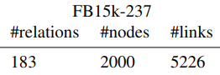
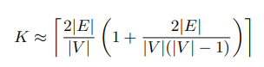
K = (2*5225 / 2000) * (1 + (2*5225 / (2000 * 1999))
= 5.225 + 1.026
= 6.026
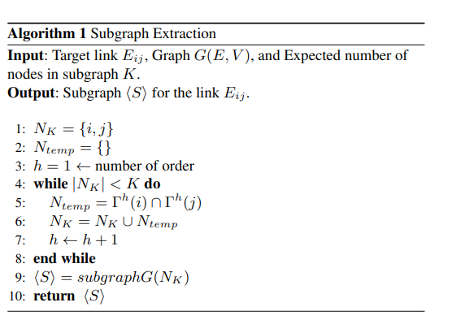
When writing this code, removed N_temp from implementation. Proof of validity below.

Proof the Ntemp set is not needed in algorithm. Can just assign to N_k

PLACN Node Labelling

def placn_node_label(subgraph, max_distance=1, k=6):
# implementation of the node labeling scheme described in PLACN
roots = [0, 1]
node_map = [.5, .5]
dist_to_roots = np.clip(ssp.csgraph.dijkstra(subgraph, indices=[0, 1], directed=False, unweighted=True, min_only=False, limit=1e6), 0, 1e7)

for r in range(subgraph.shape[0])[2:]:
h_i = dist_to_roots[0][r]
h_j = dist_to_roots[1][r]
#weights not available, just use distance
d = (h_i+h_j)/2
node_map += [d]
enclosing_subgraph_nodes = np.where(np.array(node_map) <= 90000000)[0]
return np.argsort(np.argsort(node_map)), enclosing_subgraph_nodes

TODO:
- Implement feature matrices as node embeddings
- Generate graph weights
KG, links qualitative, placn: numeric

Dataset | Nodes | Edges | Relations | Subgraph size, Calculated K Value | AUC_PR | AUC_PR Grail
WNRR18_v1_ind | 992 | 1991 | 9 | 5 | 96.38 | 94.32
WNRR18_v2_ind | 2923 | 4863 | 10 | 4 | 95.77 | 94.18
WNRR18_v3_ind | 5084 | 7470 | 11 | 3 | 89.28 | 85.8
WNRR18_v4_ind | 7208 | 15157 | 9 | 5 | 95.66 | 92.72
Bible | 2564 | 6683 | 15 | 6 | 86.98 | 85.05
nell_v2_ind | 4937 | 5521 | 79 | 3 | 93.7 | 92.62
nell_v3_ind | 4921 | 9668 | 122 | 4 | 94.18 | 93.34
fb237_v1_ind | 1500 | 2404 | 146 | 4 | 73.5 | 84.69
fb237_v1_ind | 1500 | 2404 | 146 | 6 | 80.78 | 84.69
fb237_v2_ind | 2000 | 5092 | 176 | 6 | 84.56 | 90.57
fb237_v2_ind | 2000 | 5092 | 176 | 9 |  | 90.57
fb237_v3_ind | 3000 | 9137 | 187 | 7 | 76.4 | 91.68
fb237_v3_ind | 3000 | 9137 | 187 | 14 | 76.4 | 91.68

Introduction

Related Work

Proposed Solution

Our approach to knowledge graph link prediction combines the subgraph and feature extraction methods of Placn with the inductive graph machine learning of methods of Grail. node labelling and feature extraction to supply a trained Graph Neural Network with node and edge features which are extracted from the graph topology. The GNN acts as a subgraph classifier function. Given a proposed knowledge graph triple and its related subgraph, the GNN will determine the likelyhood of the triple existing in the knowledge graph. The features are found by analyzing the neighborhoods of the nodes in a knowledge triplet.

The general steps of the process are

- Create negative samples from training data. These are corrupted triples which are generated from the real triples.
- Extract the subgraphs for all positive and negative triples. This is done by crawling the adjacency graph for all relationship types in the neural network.
- Label nodes in all subgraphs. The nodes are given a unique label according to their weight.
- Calculate node features using the entire training graph. The features reflect qualities of the topology of the neighborhoods of nodes.
- Train GNN on positive and negative labeled subgraphs, their node features, and the relationship type of the test triple.
- Use GNN for link prediction by classifying subgraphs of proposed test triples.

Predict Missing Tail

To find the missing tail of a triple (h,r, t), where t is the missing missing tail, the GNN must evaluate every possible triple (h,r,y), where y belongs to the set of all nodes. If a triple (h,r,y) has the highest score, then y is the most likely missing tail t.

Predict Missing Relation

To find the missing relation of a triple (h, r, t), where r is the missing missing relation, the GNN must evaluate every possible triple (h,q,t), where q belongs to the set of all relations. If a triple (h,q, t) has the highest score, then q is the most likely missing relation r.

