**Information for filling the metadata dataset template**

The metadata template excel file (matadata_template_ver1.xlsx) is a detailed list of metadata that allows to comprehensively describe any associated preclinical image dataset. This list will be deposited into the **PIDAR** (Preclinical Imaging DAtaset Repository) repository (<https://pidar.hpc4ai.unito.it/> ) for ensuring the findability of the associated images.

The overall aim is to create a repository of preclinical image datasets adhering to the FAIR principles (findable, accessible, interoperable and reusable) by collecting detailed information for each dataset by filling this metadata template.

This list of information (metadata) needed to describe a given preclinical imaging dataset is divided in 8 main sections (and additional sub-sections), covering several domains, underlined in different colors on the template:

1. **Study design**
2. **Study component**
3. **IVEP (in vivo experimental parameters)**
4. **Experimental procedures**
5. **Image acquisition**
6. **Image data**
7. **Image correlation**
8. **Analysed data**

These 8 sections are related to:

1. general information of the study and of the associated publication **(Study design**),
2. information about imaging modality, imaging facility and licenses for reusing the dataset (**Study component**)
3. information about animal species, sample size, disease model (**IVEP**),
4. information about any pharmacological/surgical/anesthesia/contrast agent administration/histologyical procedures and (**Experimental procedures**),
5. instrument vendor and specifications (**Image acquisition**),
6. image format, dimension, pixel size (**Image data**),
7. information for multimodality studies (**Image correlation**),
8. type of analysis performed (**Analysed data**).

In the Excel file:

* Column A corresponds to the Section or Sub-section
* Column B corresponds to the name of the metadata
* Column C provide an explanation for the information related to the metadata or expected to be filled
* **Column D is the only one to be filled with the information requested**

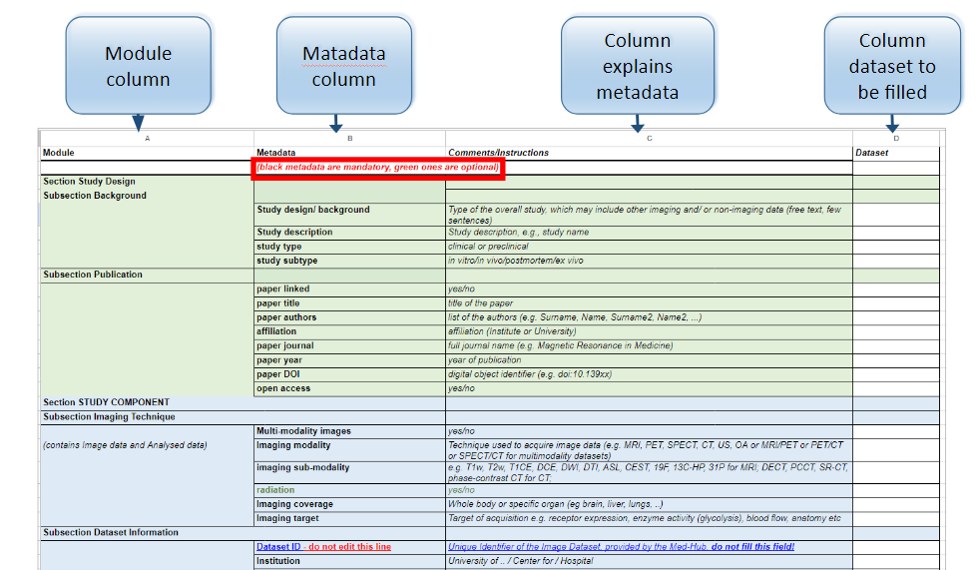

Recommendations for filling the template:

* It is highly recommended to fill as much as possible metadata fields (cells) to better describe the dataset (and making it findable!).
* If some of the metadata are not applicable to the dataset please leave the corresponding cells empty.
* Metadata in "black" are mandatory, those in "green" are optional.
* If you think that some metadata are missing to properly describe the dataset and the study, please add this information as a comment, in red, in the revised version of the metadata template we will take into account your suggestions.
* Please include the email of the contact person to whom request additional information/details for the provided metadata (***Row #45***), if needed from our side for the curation of the datasets.
* if there is a peer-reviewed publication associated to the image dataset or it’s in progress, please add this information about the peer-review paper (***Rows #10 - #17***).
* Please provide the information whether the image dataset is public or limited (***Row #39***)
* If the image dataset is public, please select the proper license type (***Row #40***). Please refer to **Table #1** below for the proper license type attributed to the image dataset.
* Additional metadata (**Data Usage Ontology** or **DUO)** are used to provide information about
  + restriction/permission on their usage (***Row #42***)
  + limitation on their re-usage based on specific research type (***Row #43***)
  + which type of investigation the dataset is associated with (***Row #44***).

Please refer to **Tables #2 - #4** below for a more detailed description of each code number to be reported in the metadata template.

**Tables**

**Table 1 (Row #40)**

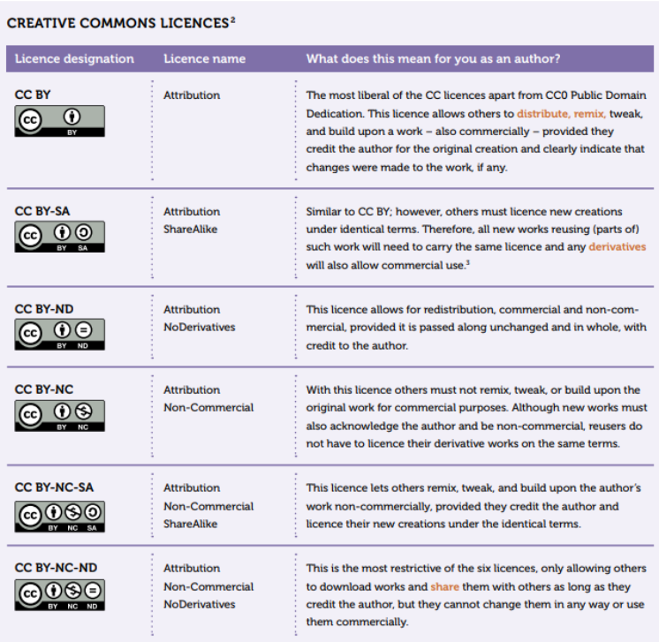

for more details click here: <https://it.wikipedia.org/wiki/Licenze_Creative_Commons>

**Table 2 (Row #42)**

|  |  |  |
| --- | --- | --- |
| **Term** | **Label** | **Description** |
| *DUO:0000001* | *data use permission* | *A data item that is used to indicate consent permissions for datasets and/or materials, and relates to the purposes for which datasets and/or material might be removed, stored or used.* |
| DUO:0000042 | General Research Use | This data use limitation indicates that use is allowed for health/medical/biomedical purposes and other biological research, including the study of population origins or ancestry. |
| DUO:0000004 | no restriction | This consent code primary category indicates there is no restriction on use. |
| DUO:0000006 | health/medical/biomedical research and clinical care | This primary category consent code indicates that use is allowed for health/medical/biomedical purposes; does not include the study of population origins or ancestry. |
| DUO:0000007 | disease-specific research and clinical care | This primary category consent code indicates that use is allowed provided it is related to the specified disease. |
| DUO:0000011 | population origins or ancestry research | This primary category consent code indicates that use of the data is limited to the study of population origins or ancestry. |
| **Table 3 (Row #43)** |  |  |
| *DUO:0000012* | *research-specific restrictions* | *This secondary category consent code indicates that use is limited to studies of a certain research type.* |
| DUO:0000015 | no general methods research | This secondary category consent code indicates that use includes methods development research(e.g., development of software or algorithms) only within the bounds of other use limitations. |
| DUO:0000016 | genetic studies only | This secondary category consent code indicates that use is limited to genetic studies only (i.e., no phenotype-only research). |
| DUO:0000017 | data use modifier | Data use modifiers indicate additional conditions for use. |
| DUO:0000018 | not-for-profit use only | This requirement indicates that use is limited to not-for-profit organizations. |
| DUO:0000019 | publication required | This requirement indicates that requestor agrees to make results of studies using the data available to the larger scientific community. |
| DUO:0000020 | collaboration required | This requirement indicates that the requestor must agree to collaboration with the primary study investigator(s). |
| DUO:0000021 | ethics approval required | This requirement indicates that the requestor must provide documentation of local IRB/ERB approval. |
| DUO:0000022 | geographical restriction | This requirement indicates that use is limited to within a specific geographic region.. |
| DUO:0000024 | publication moratorium | This requirement indicates that requestor agrees not to publish results of studies until a specific date. |
| DUO:0000025 | time limit on use | This requirement indicates that use is approved for a specific number of months. |
| DUO:0000026 | user-specific restriction | This requirement indicates that use is limited to use by approved users. |
| DUO:0000027 | project-specific restriction | This requirement indicates that use is limited to use within an approved project. |
| DUO:0000028 | institution-specific restriction | This requirement indicates that use is limited to use within an approved institution. |
| DUO:0000029 | return to database/resource | This requirement indicates that the requestor must return derived/enriched data to the database/resource. |
| DUO:0000043 | clinical care use | This data use modifier indicates that use is allowed for clinical use and care. |
| DUO:0000044 | population origins or ancestry research prohibited | This data use modifier indicates use for purposes of population, origin, or ancestry research is prohibited. |
| DUO:0000045 | not for profit organisation use only | This data use modifier indicates that use of the data is limited to not-for-profit organizations. |
| DUO:0000046 | non-commercial use only | This data use modifier indicates that use of the data is limited to not-for-profit use. |
| **Table 4 (Row #44)** |  |  |
| *OBI:0000066* | *Investigation* | *a planned process that consists of parts: planning, study design execution, documentation and which produce conclusion(s).* |
| DUO:0000034 | Age category research | Should be paired with the an ontology term representing this population (e.g., xxx). |
| DUO:0000033 | Ancestry research | An investigation concerning ancestry or population origins. |
| DUO:0000037 | Biomedical research | An investigation concerning health, medical, or biomedical research. |
| DUO:0000040 | Disease category research | Biomedical research research concerning specific disease/s |
| DUO:0000039 | Drug development research | Biomedical research concerning drug development. |
| DUO:0000038 | Genetic research | Biomedical research concerning genetics (i.e., the study of genes, genetic variations and heredity). |
| DUO:0000035 | Gender category research | An investigation concerning specific gender categories. |
| DUO:0000031 | Method development | An investigation concerning development of methods, algorithms, software or analytical tools. |
| DUO:0000032 | Population research | An investigation concerning a specific population group. |
| DUO:0000036 | Research control | An investigation concerning use of data as reference or control material. |

for more details click here: <https://www.ncbi.nlm.nih.gov/pmc/articles/PMC8591903/>