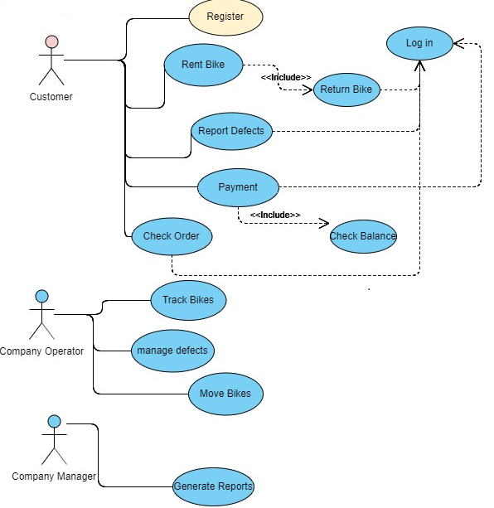

Actors: Customer, Bike company operators, bike company managers

|  |  |  |
| --- | --- | --- |
| **Actor** | **Use Case** | **Description** |
| Customer | Register | Create user account by email address, phone number and password |
|  | Login | Login in order to do other operations (ref. Use case diagram), by entering right email and password |
|  | Rent Bike | Show nearby bikes (in map format), select/enter bike with unique id and confirm order, start showing elapsed usage time |
|  | Return Bike | Confirm bike return, reduce account balance by usage e.g. duration of usage time * rate charge, tell the user amount consumed and account outstanding |
|  | Payment | Pre-paid by entering bank account & top up amount |
|  | Check Balance | Check balance, remaining amount in account |
|  | Check Order | Show order history including duration, start time, end time, status of payment (paid/unpaid), fee of the order |
|  | Report defects | Enter bike id, select defect category to report, with remark field to supplement defect information |
| Company Operator | Track Bikes | Show all bikes location on map |
|  | Manage Defects | Show defects reported by users, including bike unique number and defection information; Mark follow up status (e.g. fixed, need to follow) |
|  | Move Bikes | Show location of bikes not in proper location, that need to be relocated |
| Company Manager | Generate Reports | Activities-  List of bike usage, available bikes, defect bikes across defined time period  Provide heat map, showing which areas with high bikes demand  Revenue-  List of top-up amount across defined time period |
|  |  |  |

*Even no money in the account, user can rent the bike

Each bike should have a unique number print on it.

Customer can rent one bike only.