**Project:**

* Step 1: Download and install MySQL workbench use the below link to download

https://dev.mysql.com/downloads/workbench/

* Step 2: Download and setup a convenient server for web hosting here, I used XAMPP server. To download XAMPP server use the below link.

https://www.apachefriends.org/index.html

* Step 3: I have used PHP script to connect to MySQL.

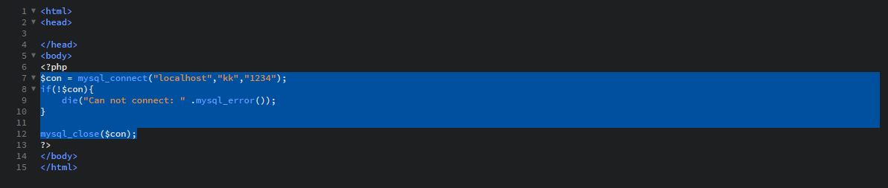

* Step 4: Create a Database

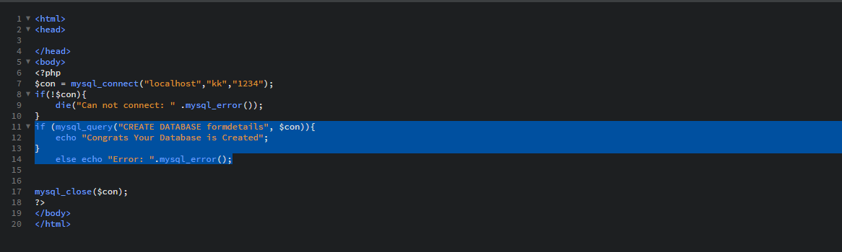

* Step 5: Create a Table with required number of columns.

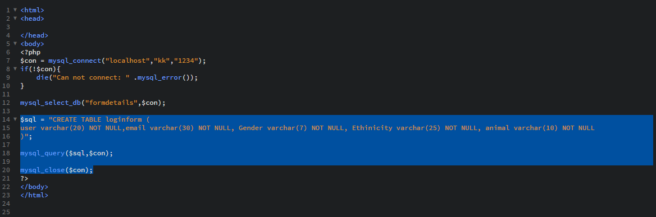

* Step 6: Write a PHP code to insert the data into MySQL

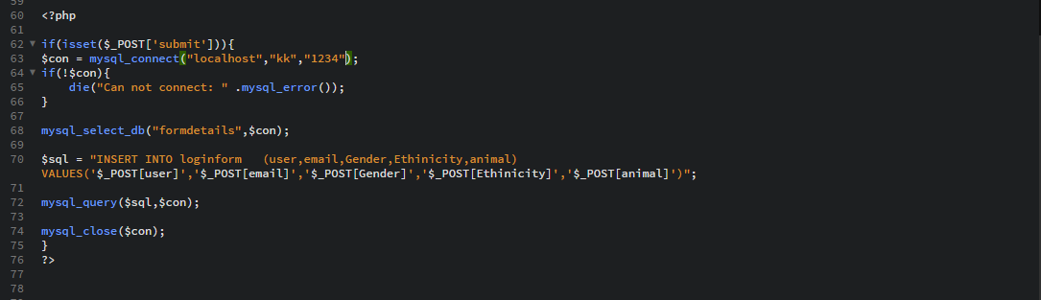

Below image show the form code in PHP

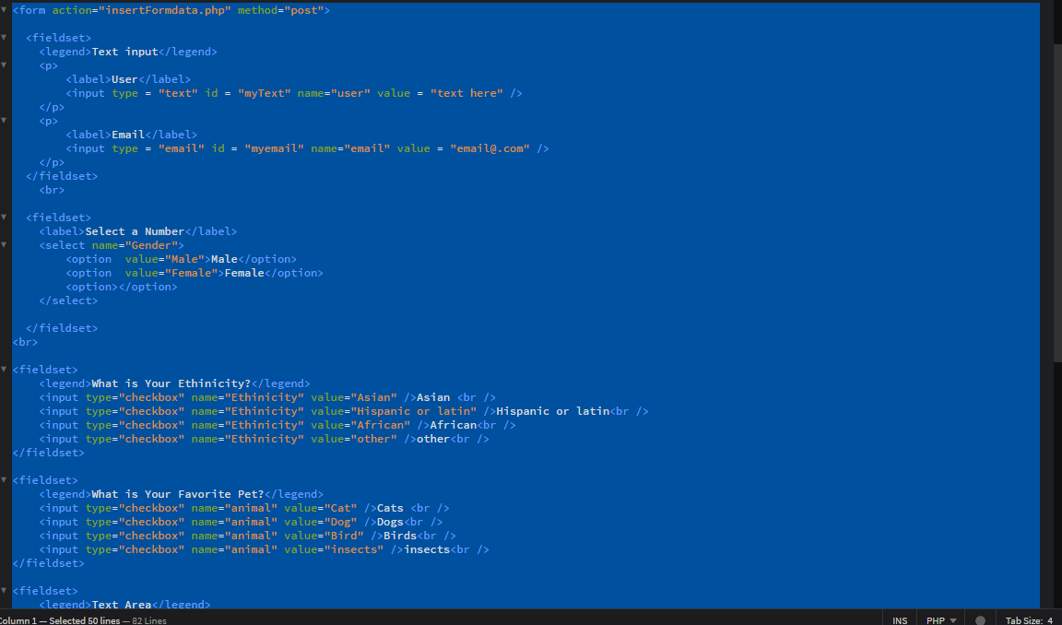

* Step 7: Below image show the inserted data into the table in MyPHPAdmin

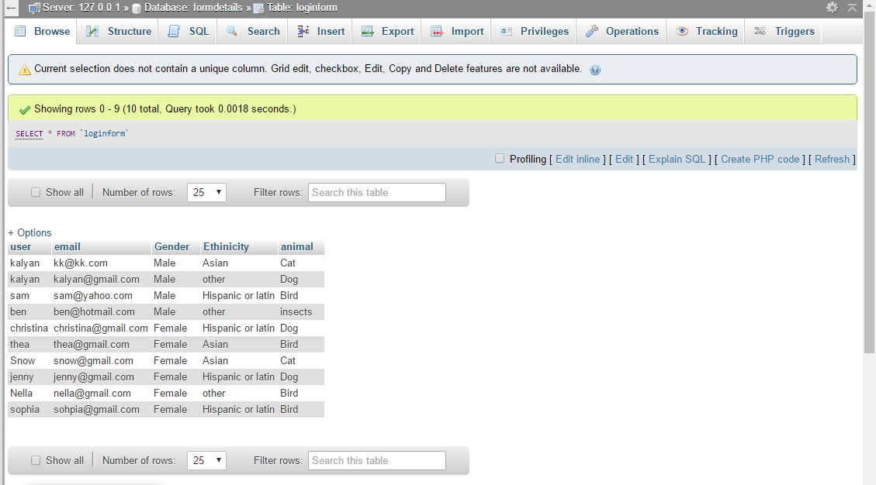

* Step 8: Below image show the table created in MySQL.

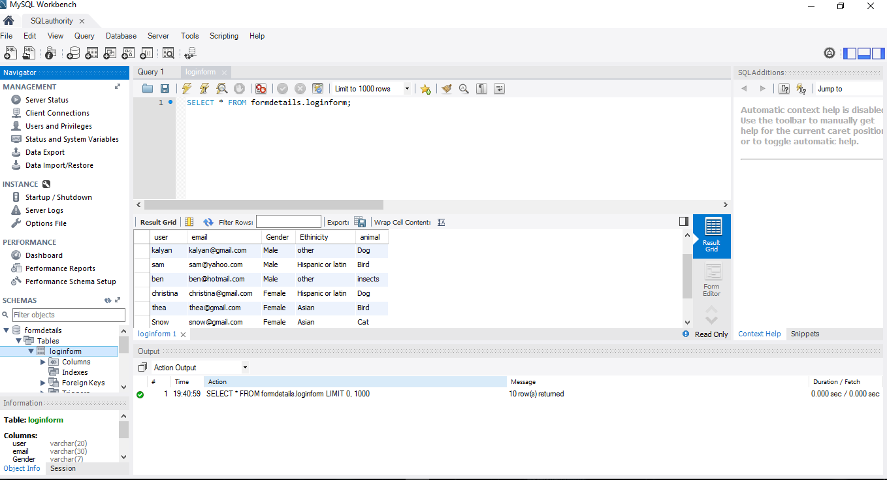

* Step 9: To get the MySQL data on the PHP page below code is used.



* Step 10: Below image show the data displayed on the PHP page.

