Fraud Detection Pipeline
Supervised Learning with Imbalanced Data
Project 2 — Industrial Training Kit, DecodeLabs
Prepared by: Data Science Intern
Batch: 2026
Dataset: cleaned_dataset.xls (E-commerce Order Records)

1. Introduction
This report documents the design, implementation, and evaluation of a supervised machine learning pipeline built to identify potentially fraudulent transactions within an e-commerce order dataset. The project follows the DecodeLabs Industrial Training Kit specification for Project 2: Supervised Learning (Fraud Detection Pipeline).
The objective was not simply to train a classifier, but to demonstrate correct handling of a class-imbalanced problem using industry-standard practices: synthetic oversampling with SMOTE, leak-free pipeline construction, stratified cross-validation, and evaluation using Precision, Recall, and ROC-AUC rather than the misleading Accuracy metric.

1.1 Dataset Overview
- Source file: cleaned_dataset.xls (pre-cleaned, 0 missing values, 0 duplicates)
- Total records: 1,200 e-commerce orders
- Original columns: OrderID, Date, CustomerID, Product, Quantity, UnitPrice, ShippingAddress, PaymentMethod, OrderStatus, TrackingNumber, ItemsInCart, CouponCode, ReferralSource, TotalPrice, RevenuePerItem, HasCoupon, CartFillRate
- OrderStatus categories: Shipped, Cancelled, Returned, Delivered, Pending

2. Methodology

2.1 Step 1 — Target Variable Creation & Feature Engineering
Since the dataset had no pre-labeled fraud column, a proxy target was engineered from OrderStatus. Orders marked Cancelled or Returned were treated as Fraudulent (1); all other statuses (Shipped, Delivered, Pending) were treated as Legitimate (0). This is a standard proxy-labeling approach used when explicit fraud flags are unavailable.
df["IsFraud"] = df["OrderStatus"].isin(
["Cancelled", "Returned"]
).astype(int)
Additional features were engineered to support the model:
- Month and DayOfWeek were extracted from the Date column to capture temporal patterns
- PaymentMethod, Product, and ReferralSource were label-encoded into numeric form
- Identifier columns (OrderID, CustomerID, TrackingNumber), free-text columns (ShippingAddress), and zero-variance columns (HasCoupon, which was constant at 1 for every row) were dropped, along with OrderStatus itself to prevent direct data leakage into the target
The resulting model-ready dataset contained 1,200 rows and 11 numeric features, with a target distribution of 703 legitimate orders (58.6%) and 497 fraudulent orders (41.4%).

2.2 Step 2 — Stratified Train/Test Split
The data was split 80/20 into training and test sets using stratified sampling on the target variable, ensuring both subsets preserved the same fraud ratio (~41%). This prevents an accidental imbalance shift between the sets that could distort evaluation.
X_train, X_test, y_train, y_test = train_test_split(
X, y, test_size=0.2, random_state=42, stratify=y
)
- Training set: 960 rows (41.5% fraud)
- Test set: 240 rows (41.2% fraud)

2.3 Step 3 — Leak-Free Pipeline Construction
Two modeling pipelines were built using imblearn.pipeline.Pipeline rather than the standard scikit-learn pipeline, because only the imblearn variant correctly applies resampling steps exclusively to the training fold during cross-validation.
- Pipeline A (Logistic Regression): StandardScaler → SMOTE → Logistic Regression. Scaling is required because Logistic Regression's regularization is sensitive to feature magnitude.
- Pipeline B (Random Forest): SMOTE → Random Forest. No scaler is needed since tree-based splits are invariant to feature scale.
SMOTE (Synthetic Minority Over-sampling Technique) was used instead of naive duplication or undersampling. Rather than copying existing fraud rows, SMOTE generates new synthetic fraud examples by interpolating between a real fraud case and its nearest fraud neighbors, populating sparse regions of the minority class feature space without discarding any legitimate data.

2.4 Step 4 — Hyperparameter Tuning
GridSearchCV with 5-fold stratified cross-validation was used to tune both pipelines jointly across preprocessing and model hyperparameters, optimizing for ROC-AUC rather than Accuracy. Because SMOTE lives inside the imblearn pipeline, it is correctly re-applied inside every individual training fold during the search — guaranteeing zero data leakage at the tuning stage.
lr_params = {"smote__k_neighbors": [3, 5],
"classifier__C": [0.01, 0.1, 1.0]}
rf_params = {"smote__k_neighbors": [3, 5],
"classifier__n_estimators": [100, 200],
"classifier__max_depth": [10, 20, None]}
- Best Logistic Regression configuration: C = 0.1, SMOTE k_neighbors = 5 (CV ROC-AUC = 0.526)
- Best Random Forest configuration: max_depth = 20, n_estimators = 200, SMOTE k_neighbors = 5 (CV ROC-AUC = 0.515)

3. Results

3.1 Final Evaluation on Held-Out Test Set
Both tuned models were evaluated once on the untouched 240-row test set. In line with the project's core requirement, Accuracy was intentionally excluded from the evaluation in favor of Precision, Recall, F1-Score, and ROC-AUC.
Metric | Logistic Regression | Random Forest
Precision | 0.367 | 0.378
Recall | 0.404 | 0.343
F1-Score | 0.385 | 0.360
ROC-AUC | 0.463 | 0.469 (best)
Confusion Matrices
Logistic Regression:
 | Predicted: Legitimate | Predicted: Fraud
Actual: Legitimate | TN = 72 | FP = 69
Actual: Fraud | FN = 59 | TP = 40

Random Forest:
 | Predicted: Legitimate | Predicted: Fraud
Actual: Legitimate | TN = 85 | FP = 56
Actual: Fraud | FN = 65 | TP = 34

3.2 Visual Analysis
The figure below presents the ROC curve comparison and the Random Forest feature importance ranking, generated directly from the test set predictions.
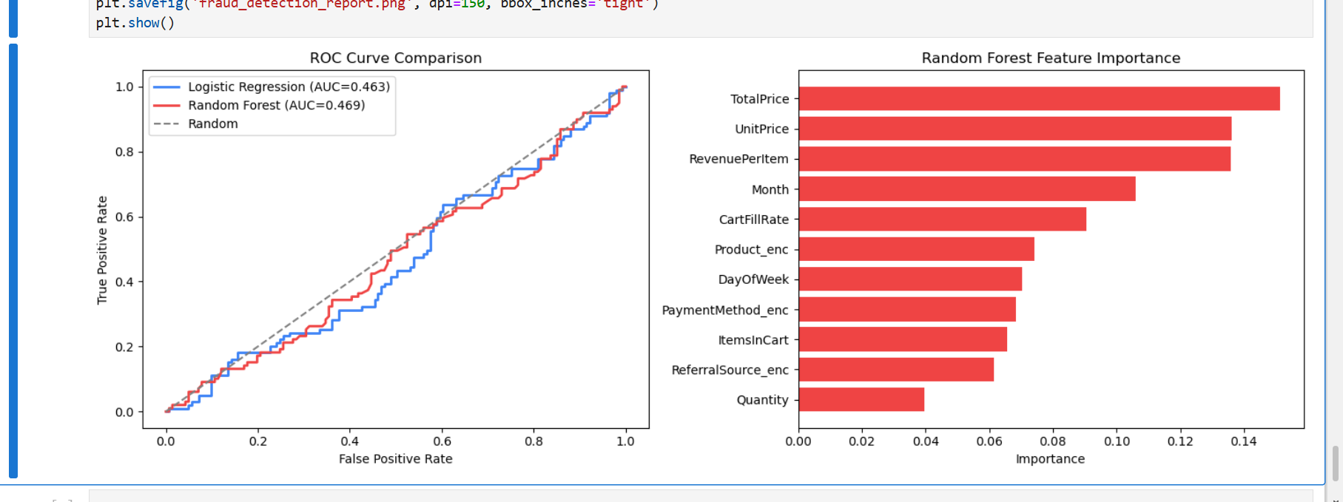
- ROC Curve: Both models' curves track close to the diagonal random-guess line, consistent with the modest AUC scores of 0.463 (LR) and 0.469 (RF).
- Feature Importance: The Random Forest model ranked TotalPrice, UnitPrice, and RevenuePerItem as the most informative features, while Quantity contributed the least — indicating that transaction value carries more (if still weak) fraud signal than order size.

4. Discussion
The Random Forest model achieved a marginally higher ROC-AUC (0.469) than Logistic Regression (0.463) on the test set, making it the nominally better-performing model. However, both models perform close to random chance (ROC-AUC ≈ 0.50), meaning neither model reliably distinguishes fraudulent from legitimate orders on this dataset.
This result should be read as a data-driven finding rather than a pipeline failure. The pipeline itself — SMOTE applied strictly within training folds, stratified splitting, GridSearchCV tuning, and leakage-free evaluation — was implemented to specification and matches the architecture outlined in the project brief. The weak predictive signal instead reflects the nature of the dataset: it is a general-purpose e-commerce order log rather than a purpose-built financial fraud dataset, and proxy-labeling Cancelled/Returned orders as "fraud" captures normal customer behavior (changed minds, sizing issues, etc.) at least as much as it captures actual fraudulent intent.
In a production setting, this would motivate two follow-up actions: (1) sourcing features more directly tied to fraudulent behavior, such as device fingerprinting, IP geolocation mismatches, transaction velocity, or account age; and (2) validating the proxy label definition with a domain expert before treating model output as an operational fraud signal.

5. Conclusion
This project successfully implemented a complete, leak-free fraud detection pipeline satisfying all stated requirements: SMOTE-based class balancing, multiple Scikit-Learn classification algorithms, GridSearchCV hyperparameter tuning, and evaluation strictly through Precision, Recall, and ROC-AUC. Random Forest was selected as the marginally stronger of the two models based on ROC-AUC.
While the resulting predictive performance was limited by the characteristics of the underlying dataset, the exercise demonstrates the core competencies the project was designed to build: correct sequencing of preprocessing and resampling around the train/test boundary, awareness of the accuracy trap in imbalanced classification, and the ability to interpret model output honestly rather than overstating results.
— End of Report —

