Electrical Overview

Year: 2022 Semester: Fall Team: 05 Project: Metaporter

Creation Date: September 12,2022 Last Modified: September 17, 2022

Author: Sen Wang Email: wang3989@purdue.edu

Assignment Evaluation:

|  |  |  |  |  |
| --- | --- | --- | --- | --- |
| **Item** | **Score (0-5)** | **Weight** | **Points** | **Notes** |
| **Assignment-Specific Items** | | | | |
| **Electrical Overview** |  | x3 |  |  |
| **Electrical Considerations** |  | x3 |  |  |
| **Interface Considerations** |  | x3 |  |  |
| **System Block Diagram** |  | x3 |  |  |
| **Writing-Specific Items** | | | | |
| **Spelling and Grammar** |  | x2 |  |  |
| **Formatting and Citations** |  | x1 |  |  |
| **Figures and Graphs** |  | x2 |  |  |
| **Technical Writing Style** |  | x3 |  |  |
| **Total Score** |  | | |  |

5: Excellent 4: Good 3: Acceptable 2: Poor 1: Very Poor 0: Not attempted

General Comments:

*Relevant overall comments about the paper will be included here*

**1.0 Electrical Overview**

Due to the ongoing chip shortage, this project will utilize an off-the-shelf Nvidia Jetson Nano to compensate for the lack of camera support on available MCUs as well as the computational constraints during sensor fusion using Extended Kalman Filter (EKF) [1].

With CPU-bound tasks being managed by the Jetson Nano, our microcontroller would focus more heavily on the I/O-bound tasks. Therefore, a 32-bit, 64-pin microcontroller with 12 channels of DMA will be utilized to handle data collection of a LiDAR sensor, accept user input via a 4x4 keypad, and display status via an LCD interface. In addition, our microcontroller will also be responsible for transferring LiDAR data and user feedback via UART to the Jetson Nano.

Lastly, no external flash memory or SD cards are required as the 128KB internal flash memory is sufficient for storing our program.

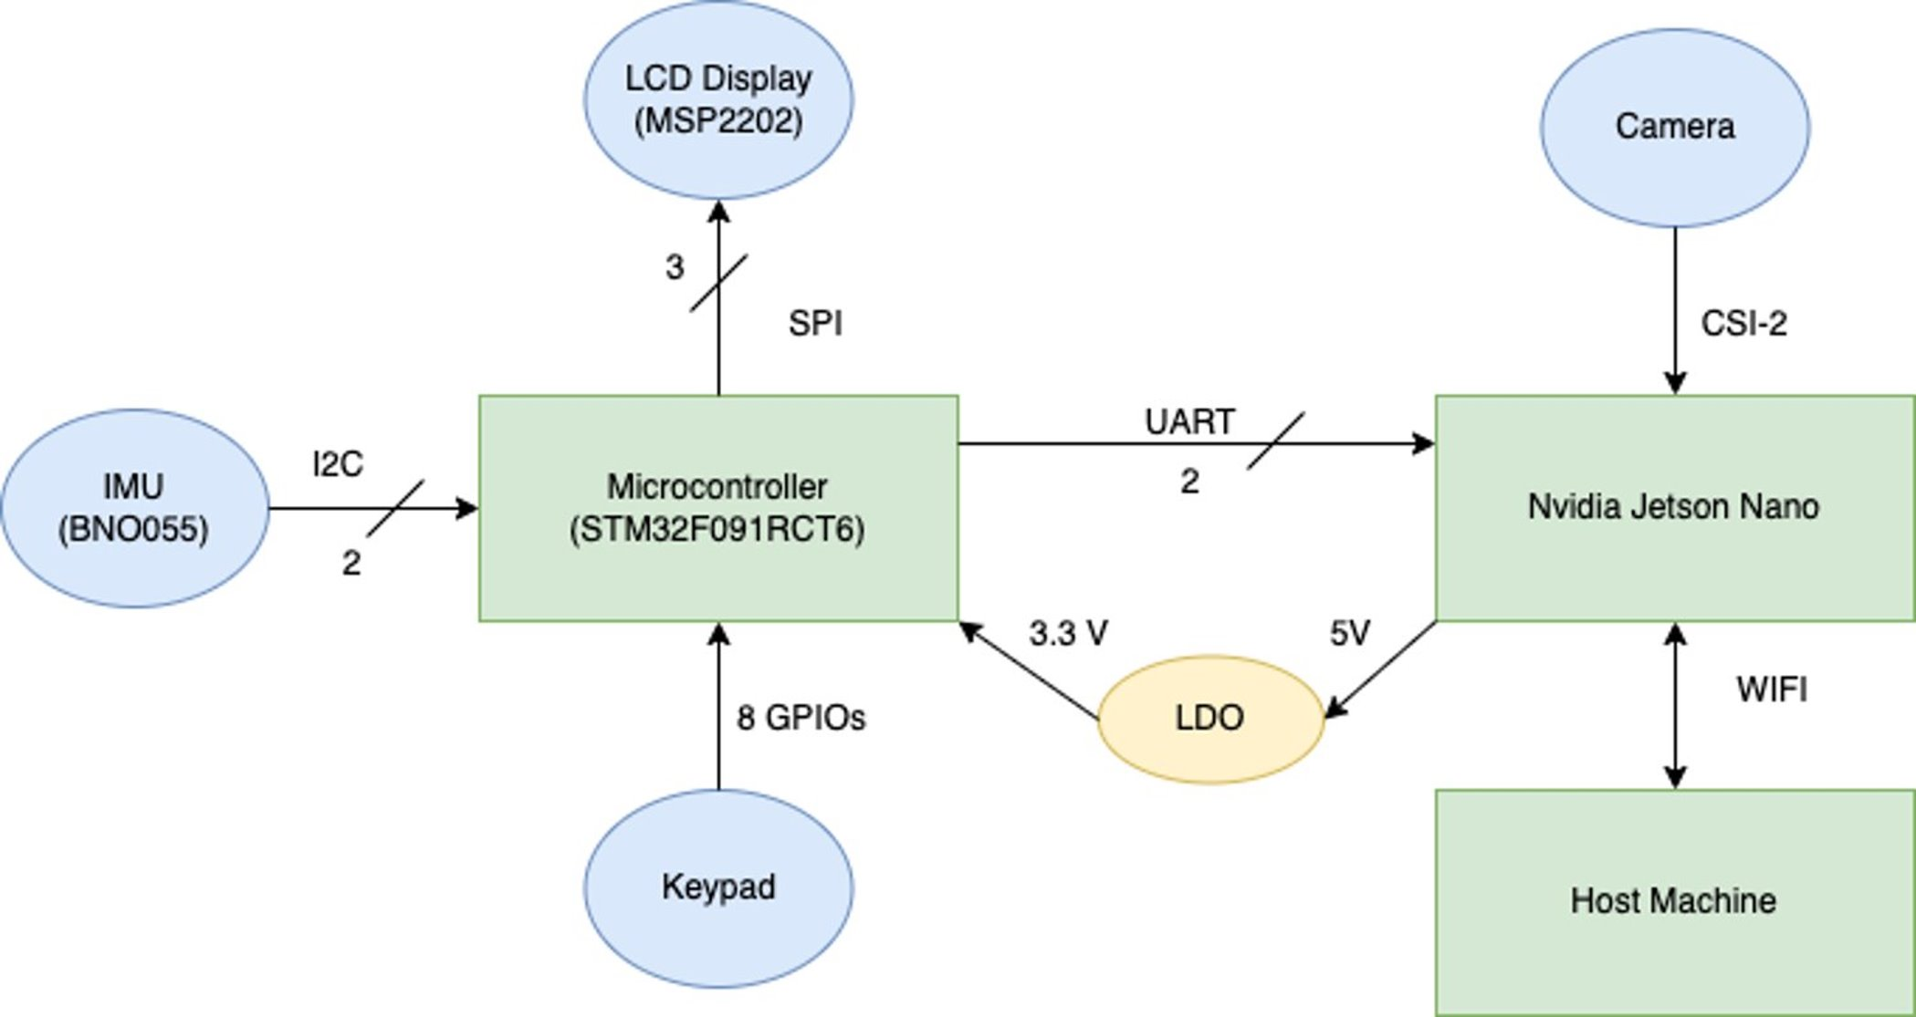

Figure 1: component overview diagram

**2.0 Electrical Considerations**

2.1 Operating Voltage

The operating voltage of the microcontroller of our choice (STM32F091RCT6) will be 3.3V with a maximum tolerance of 3.6V and a minimum voltage of 2.0V [2]. Both the LCD display and the 4x4 keypad will operate at the same voltage (3.3V) as the microcontroller.

Two of the components, the LiDAR and Nvidia Jetson Nano, require a higher operating voltage at 5V. As such, the power design of the board will feature two main power rails, 3.3V and 5V. No boost converter is necessary for our design, but capacitors to filter out DC noises from the power supply may be necessary.

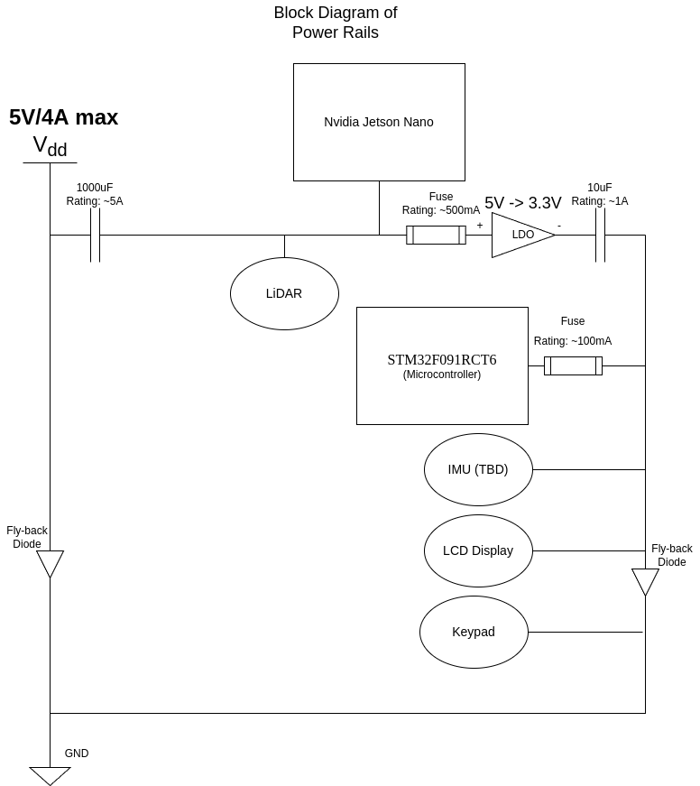

Figure 2: Functional Block Diagram of Power Rails

2.2 Operating Frequency

One of the critical design considerations during our design process is to make sure the communication channel that we allocated has enough bandwidth to transmit what's necessary in real time; therefore, the operating frequency for each communication channel must be carefully designed to ensure a cohesive user experience.

The system clock and the operating frequency of our selected microcontroller is 48MHz. This will be the basis for the majority of our component operating frequency.

The SPI bus connecting to the LCD display has a baud rate scaling factor of 2, which means that its operating frequency would be 48/2 = 24MHz. This ensures a prompt response from our display in the event of a status update.

The I2C bus connecting to the LiDAR runs at an SCL rate of 100kHz with 7-bit address mode to archive an estimated baud rate of 490Kb/sec. It provides sufficient data bandwidth even under extreme circumstances as the LiDAR samples at a maximum rate of 1000Hz with 16bit data format and a required baud rate of 16Kb/sec.

The UART bus connecting to the Jetson Nano is the most I/O demanding channel as it takes care of all communications between the two devices. Subsequently, it will have a clock prescaler of 417 to archive a baud rate of 921.6Kb/sec (115200 bytes/s). This allows there to be fast data transfers and plenty of data bandwidth.

2.3 Power Supply

In this project, we will be using an AC wall outlet to power the microcontroller and the Jetson Nano. For the sake of unifying power inputs for both components, a power system with a barrel plug port will be used to take in the 5V power adapter and connect to the Jetson Nano and LiDAR on the same 5V rail.

Then from the 5V input, an LDO regulator will be used to step down the voltage to 3.3V for our microcontroller, keypad, and display. Thus, it creates the two power rails that our team needs for each component.

The 5V power adapter can supply a maximum of 4A. Since an LDO regulator doesn't change the amperage rating when down-converting, it is required that both power rails must not exceed a cumulative current of 4A. The breakdown of our current usage is as follows:

* Microcontroller = 19.1mA (Assume all system clock enabled at 60Mhz [2])
* Display = 80mA
* LiDAR = 130mA (continuous capture)
* Keypad = 30mA (maximum power draw with external 1K pull-down resistor)
* Jetson Nano + Camera = 2.5A (using 10W power mode as its heatsink passive cooling has a TDP of 10W [3])

In total, the whole system would consume about 2.76A current, or 13.7W total package power under full capacity, which is within the limits of 4A/20W from the power adapter. The power efficiency of the power system will be quite high, as most power draws are through the 5V rail, the maximum potential power lost from the LDO regulator will be 129mA * (5V - 3.3V) = 0.219W. And therefore, the usage of an LDO regulator is justified as its power loss and heat dissipation won't be a significant concern of the design consideration.

**3.0 Interface Considerations**

3.1 Microcontroller Interface

For our microcontroller, one I2C bus will be used to communicate with LiDAR. The I2C channel is configured at its default standard mode of 100kHz clock speed using 7 bit addressing mode to archive an estimated baud rate of 490Kb/sec (assuming continuous I2C transfer).

Our display will be interfaced via SPI, with a clock frequency of 24Mhz and a baud rate of 24Mb/sec to ensure a prompt response of our display in the event of a status update.

Furthermore, our current keypad of choice requires 8 GPIO ports with 4 ports pulling high using pull-up resistors and 4 ports as an input. Finally, one duplex UART channel will be used to communicate with the Jetson nano using a baud rate of 921.6Kb/sec.

All in all, our microcontroller of choice offers plenty of port selection for what we need. Nonetheless, our microcontroller doesn't come without flaws. The internal resistors are pretty weak; therefore, external pull-up resistors are required for the I2C line to accomplish an open-drain configuration. Pull-up and pull-down resistors are also required for the keypad in order to reduce noise and prevent electrostatic discharge from damaging the circuit.

3.2 Jetson Nano Interface

As to the Nvidia Jetson Nano, the camera module will be directly plugged into the CSI-2 port embedded into the Nano carrier board. This will archive a maximum video quality of 1080p 30fps, and suffice to say, it offers an adequate frame rate and resolution for our product.

**4.0 Sources Cited:**

[1] “Extended Kalman Filters,” *Extended Kalman Filters - MATLAB & Simulink*. [Online]. Available: <https://www.mathworks.com/help/driving/ug/extended-kalman-filters.html>. [Accessed: 17-Sep-2022].

[2] ARM®-based 32-bit MCU, up to 256 KB Flash, CAN, 12 timers, ADC, DAC, and comm. interfaces, 2.0 - 3.6V*.* Accessed: Sep. 17, 2022. [Online]. Available: https://www.mouser.com/datasheet/2/389/stm32f091cc-1588803.pdf

[3] *Jetson Nano Developer Kit User Guide.* Accessed: Sep. 17, 2022. [Online]. Available: https://developer.nvidia.com/embedded/learn/jetson-nano-2gb-devkit-user-guide

**Appendix 1: System Block Diagram**

