Mechanical Overview

Year: __2022____ Semester: ___Fall_____ Team: __5___

Project: Metpaorter

Creation Date: ___9/24___________________ Last Modified: September 19, 2021

Author: Manav Bhasin Email: [mbhasin@purdue.edu](mailto:mbhasin@purdue.edu)

Assignment Evaluation:

|  |  |  |  |  |
| --- | --- | --- | --- | --- |
| **Item** | **Score (0-5)** | **Weight** | **Points** | **Notes** |
| **Assignment-Specific Items** | | | | |
| **Commercial Packaging Analysis 1** |  | x2 |  |  |
| **Commercial Packaging Analysis 2** |  | x2 |  |  |
| **CAD Model Illustrations** |  | x4 |  |  |
| **Project Packaging Specifications** |  | x2 |  |  |
| **PCB Footprint Layout** |  | x2 |  |  |
| **Writing-Specific Items** | | | | |
| **Spelling and Grammar** |  | x2 |  |  |
| **Formatting and Citations** |  | x1 |  |  |
| **Figures and Graphs** |  | x2 |  |  |
| **Technical Writing Style** |  | x3 |  |  |
| **Total Score** |  | | |  |

5: Excellent 4: Good 3: Acceptable 2: Poor 1: Very Poor 0: Not attempted

Comments:

*Comments from the grader will be inserted here.*

1. Commercial Product Packaging
   1. Product #1

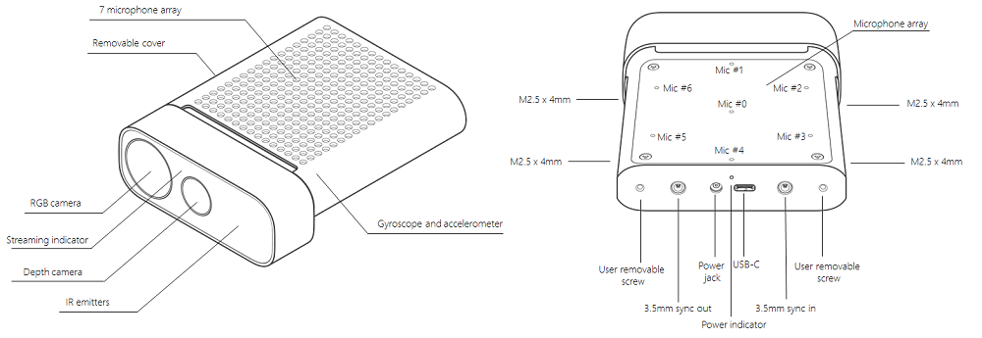

The first similar commercial product that we decided to analyze was the Azure Kinect DK. The Kinect has many sensors and features that will also be included in Metaporter. Some of these include the RGB camera, IMU, and several indicators to let the user know the progress of their recordings. The Azure Kinect is mainly used as a developer tool to provide users with the hardware to perform complex AI tools such as Body tracking and speech translation. [1]

The packaging for the Azure Kinect has many positives. The main positive is the compactness of the design, which allows the product to be used in many different situations. We also liked how all the sensors that were not needed on the outside of the Kinect were neatly tucked within the packaging. Another positive of this packaging is the user removable cover. This would allow a developer to examine or potentially alter the sensors within the packaging if they saw fit.

The biggest drawback of this package is the difficulty of adding external modifications to it. From the schematics it seems that it could be difficult to mount it to something or attach additional hardware to it.

Our packaging will slightly differ from the Kinect’s. We plan to use a LCD screen as a user interface, so our packaging will have an opening to accommodate for that. We also plan to attach handles to our device so that it can easily be moved around a target for reconstruction. Finally, we also plan to have some ventilation so that the internal compute unit can utilize its built-in active cooling.

* 1. Product #2

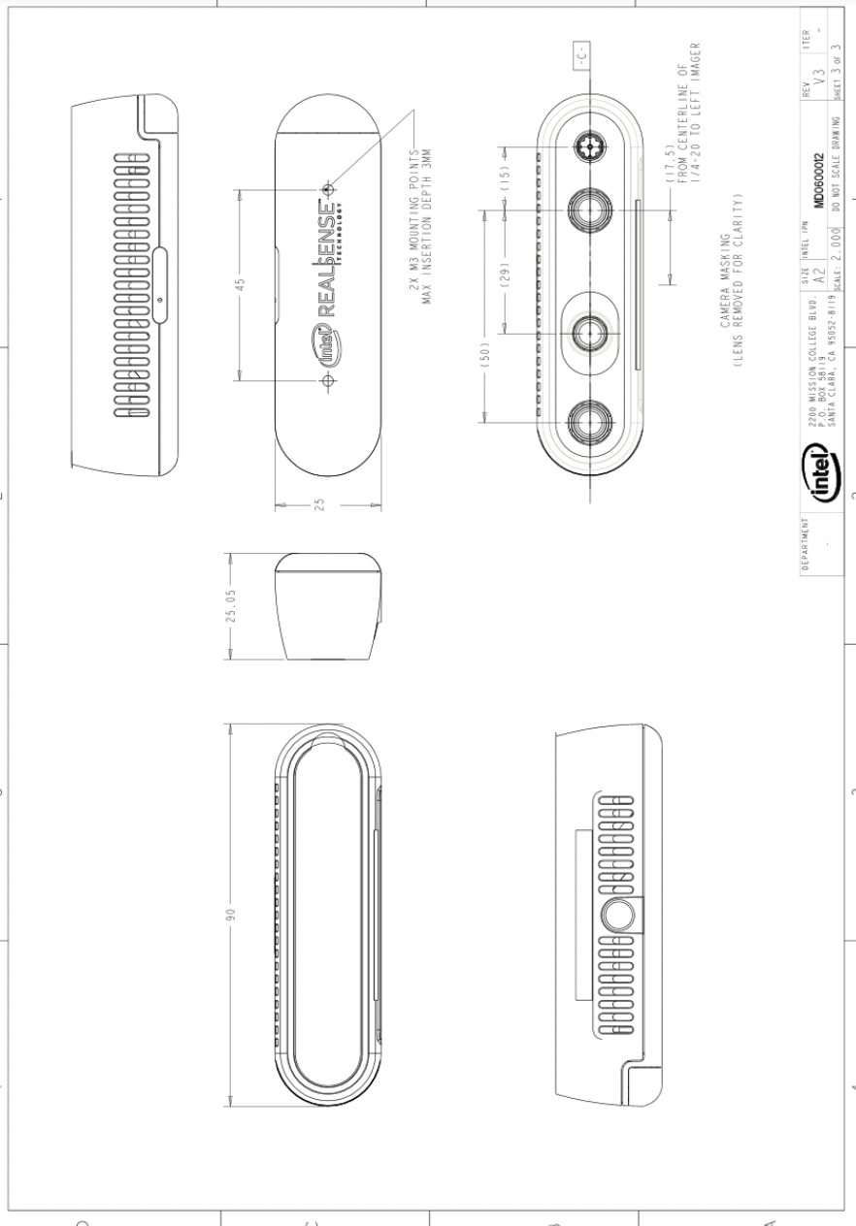

The second similar product that we decided to analyze was the intel real sense camera. The intel real sense camera is like the Azure Kinect in that it is a developer kit for AI applications. It contains a rgb camera, LiDAR as well as an internal IMU.

Like the Azure Kinect the intel real sense has many positives with regards to the compactness to the packaging. This allows it to be very portable and applicable in many different scenarios. Another thing that we like about this packaging is the ventilation. This would make sure that the internal components do not get overheated while processing is ongoing.

Like the Azure Kinect the biggest drawback of this packaging is the inability to make external modifications to the package.

Our package will be slightly different from the intel real sense camera but will incorporate some features. Unlike the real sense camera, we will have a keypad and LCD user interface, so our packaging will have to be much larger in order to incorporate those features. However, we plan to incorporate ventilation similar to the real sense camera.

2.0 Project Packaging Description

Our packaging will take on a multiplate design. The front plate will mount the cameras, IMU and the camera hat. On the middle plate we will have the PCB and Jetson Nano. On the back plate we will have the LCD and Keypad Matrix. The dimensions of these plates are 4.72 inches by 6.28 inches. We will also have top and bottom plates whose dimensions are 4.72 inches by 6 inches.

3.0 Sources Cited

[1] Tesych, “About azure kinect DK,” *Microsoft Learn*. [Online]. Available: <https://learn.microsoft.com/en-us/azure/kinect-dk/about-azure-kinect-dk>. [Accessed: 24-Sep-2022].

[2] “Intel RealSense™ D400 series/sr300 viewer.” [Online]. Available: <https://www.intel.com/content/dam/support/us/en/documents/emerging-technologies/intel-realsense-technology/Intel-RealSense-Viewer-User-Guide.pdf>. [Accessed: 24-Sep-2022].

Appendix 1: CAD Model Illustrations

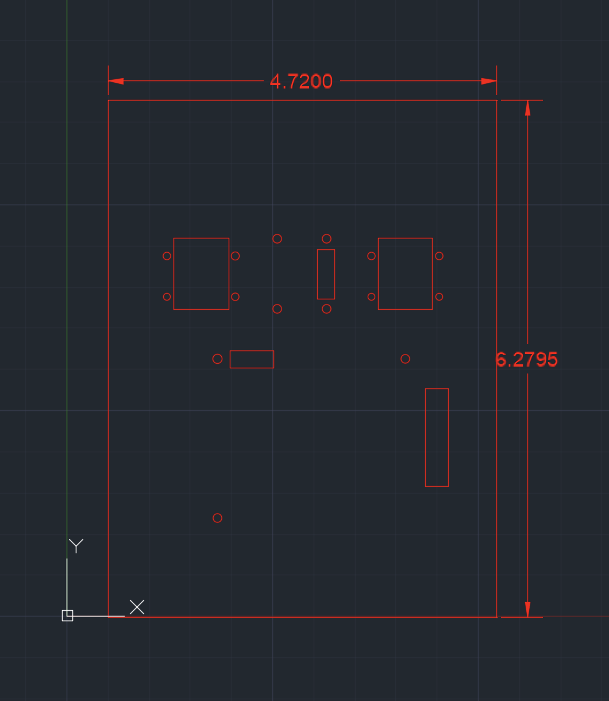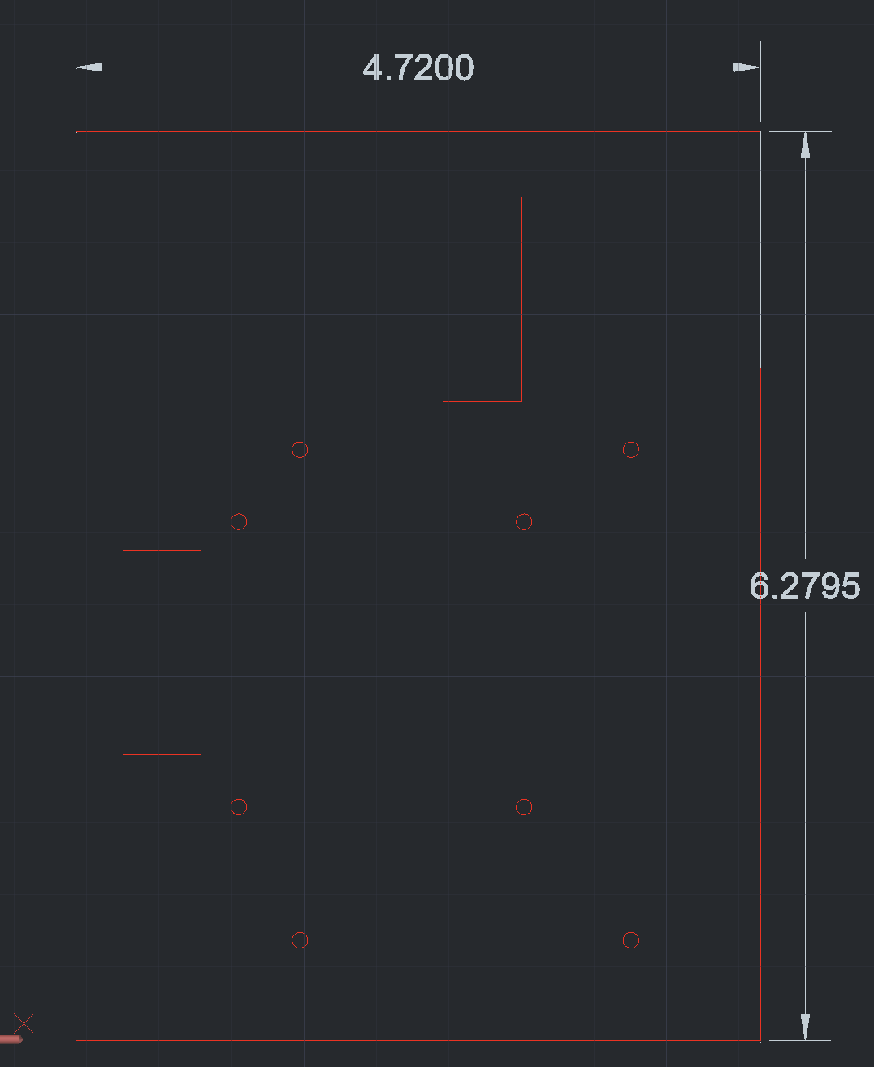

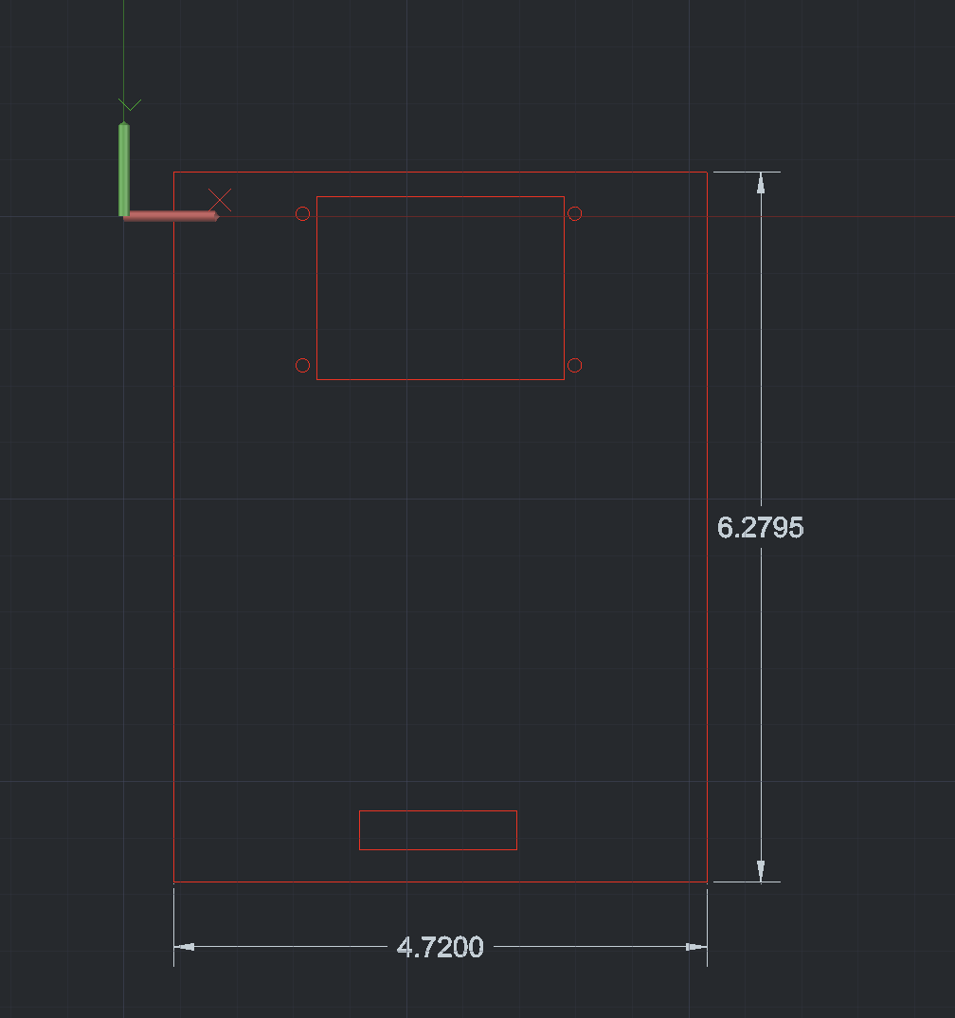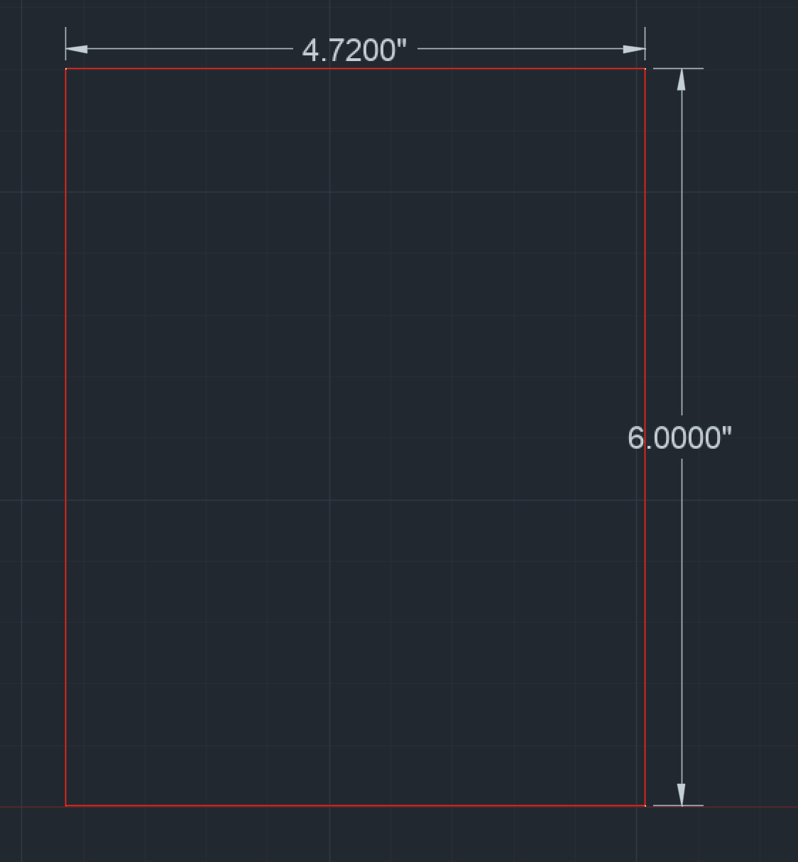

Appendix 2: Project Packaging Specifications

|  |  |  |  |
| --- | --- | --- | --- |
| Item | *Quantity* | Weight | Price |
| Acrylic Sheets 1/8 | *2* | *0.5kg* | *$24* |
| *Acrlyic Sheets 1/4* | *1* | *0.25* | *#8* |

We plan to use the Laser Cutter at the BIDC so the fabrication cost will be free.

Appendix 3: PCB Footprint Layout

