Employee Management Portal
Business Requirements and System Analysis

Introduction

The Employee Management Portal is a web application for maintaining employee records personal details, department, and job role in one place, rather than relying on spreadsheets or paper-based processes.

Original Statement
“Build a web application to track employee personal details, department, and job roles.”

Business ​Requirements

The following requirements describe what the organization needs from the system, independent of how it will be implemented:

Sl.No | Requirement
1 | HR/Admin must be able to create a new employee record using the agreed personal details, Department, Job Role and application Role.
2 | HR/Admin must be able to update any employee record when employee information changes.
3 | A Manager may update permitted personal and contact information only for employees in the Manager’s own Department.
4 | Only HR/Admin may change an employee’s Department, Job Role or application Role.
5 | HR/Admin must be able to retire an employee without deleting the historical record. Retired employee records remain visible only to HR/Admin and cannot be reactivated.
6 | Employees must be able to register their own login account against an existing employee record.
7 | After login, an Employee can view only their own employee profile in read-only mode.
8 | The system must identify the signed-in user’s Role and Department before displaying employee data or allowing an action.
9 | HR/Admin must be able to add, view, update and delete Departments.
10 | HR/Admin must be able to add, view, update and delete Job Roles, with each Job Role belonging to one Department.
11 | HR/Admin and Managers must be able to search the employee list. Manager results remain limited to the Manager’s own Department.
12 | The system must validate required values and business rules before employee or reference data is saved.

​Objectives

The portal is intended to replace manual or spreadsheet based record keeping with a single system that HR, managers, and employees can each use appropriately. Specifically, the project aims to give HR a centralized and accurate record of every employee's personal details, department, and job role to keep access to that information limited to what each person's role actually requires, rather than left open to everyone to keep department and job role information reusable and consistent, instead of retyped for every employee; and to make routine administration adding, updating, and retiring employee records something HR can do directly, without needing technical help.

​Scope
4.1 In Scope
- Employee record creation, update, view and retirement.
- Employee self-registration and login.
- Read-only employee self-profile.
- Department and Job Role maintenance by HR/Admin.
- Role-based access for HR/Admin, Manager and Employee users.
- Search for employee records.

4.2 Out of Scope
- Payroll and salary processing
- Attendance tracking
- Leave management
- Employee self-editing of profile information
- Managers viewing or updating employees outside their own department
- Reactivation of retired employees
- Recruitment and candidate management

​Stakeholders, Roles and Permissions

- HR/Admin - main administrator of the portal; maintains employee records, Departments and Job Roles, and can view retired employee history.
- Manager - views and updates permitted information for employees within the Manager’s own Department.
- Employee - registers an account and views only the employee profile linked to that account in read-only mode.

Role | View Employees | Edit Employee Details | Manage Dept / Job Role | Retired History
HR/Admin | All employees | All permitted fields | Yes | Yes
Manager | Own Department | Personal/contact details only | No | No
Employee | Own profile only | No - read only | No | No

Business Rules and Validation
- Each Employee belongs to one Department, one Job Role and one application Role.
- Each Job Role belongs to exactly one Department.
- A Manager cannot change Department, Job Role or application Role.
- An Employee cannot edit employee data, including the Employee’s own record.
- A retired employee is retained for HR/Admin reference and cannot be reactivated.
- Required fields must be completed before a record is saved.
- Email must be valid and unique for employee records.
- Phone values must contain a valid usable value
- Date of Birth cannot be a future date.
- The selected Job Role must belong to the selected Department.

Application Workflow

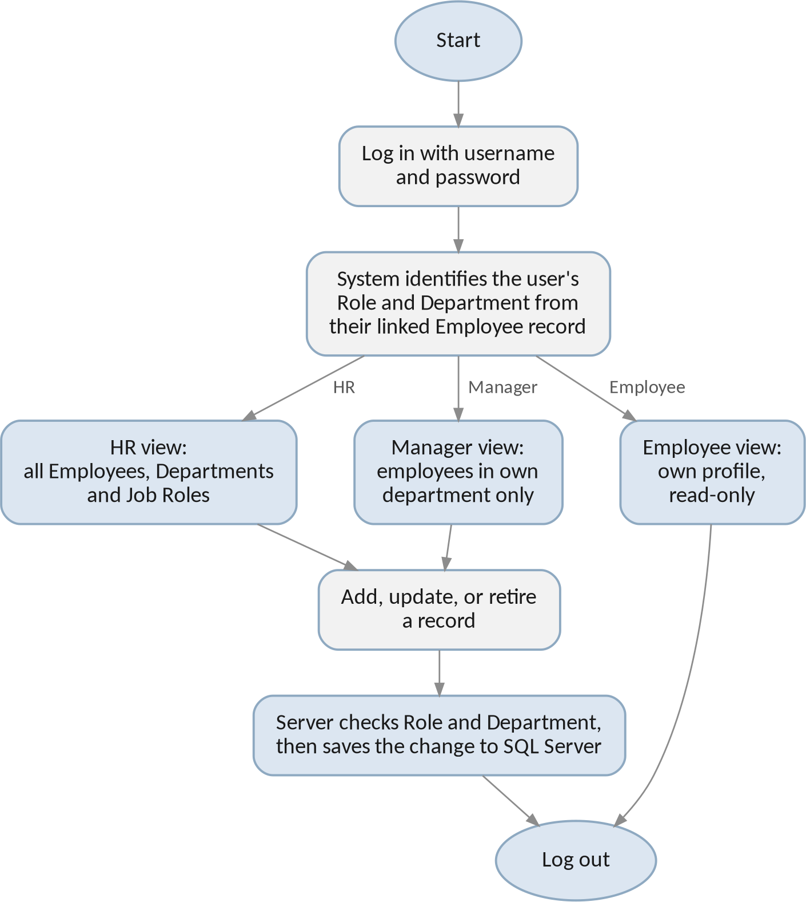

Figure 1: Application workflow from login to saving a change.

Use Cases

Use Case | Actor | Step | User Action | System Response | Exception
UC-01 Employee Registration | Employee | 1 | Enter registration details using the email already stored on the employee record. | Validate the details and locate the matching Employee record. | If the employee record cannot be matched uniquely, registration is not completed.
 |  | 2 | Submit registration. | Create the Identity account and link it to the Employee record.
 |  | 3 | Sign in. | Open the linked employee profile in read-only mode.
UC-02 Login and Role-Based Access | HR/Admin, Manager, Employee | 1 | Enter login credentials. | Authenticate the account. | Invalid credentials are rejected and employee data is not displayed.
 |  | 2 | Open the portal. | Read the Role and Department from the linked Employee record.
 |  | 3 | Continue to the application. | Show only the employee data and actions allowed for that user.
UC-03 Add Employee | HR/Admin | 1 | Select Add Employee. | Display the Employee form. | If validation fails, the record is not saved.
 |  | 2 | Enter employee details and assignments. | Validate required values and the Department/Job Role relationship.
 |  | 3 | Submit the form. | Create the Employee record and initial timestamps.
UC-04 Update Employee | HR/Admin, Manager | 1 | Open an employee record. | Check the user Role and Department before enabling edit actions. | A Manager attempt to change Department, Job Role, or Role is rejected.
 |  | 2 | Change permitted fields. | Validate the new values and block restricted field changes.
 |  | 3 | Submit the update. | Save the changes and update Modified Date.
UC-05 Retire Employee | HR/Admin | 1 | Open an active employee and select Retire. | Request confirmation. | Reactivation is not available for a retired employee.
 |  | 2 | Confirm retirement. | Mark the employee inactive without deleting the record.
 |  | 3 | Open retired history. | Show the retired employee to HR/Admin only.
UC-06 View Own Profile | Employee | 1 | Sign in and open My Profile. | Retrieve the Employee record linked to the account. | An attempt to access another employee record is blocked.
 |  | 2 | Review profile information. | Display the record without edit controls.
UC-07 Search and Sort Employees | HR/Admin, Manager | 1 | Enter a search value | Apply the request to the employee records the user is allowed to view. | If there are no matching records, the system shows an empty result state.
 |  | 2 | Browse the results. | Return paged results. Manager results remain within the Manager's Department.
UC-08 Manage Departments and Job Roles | HR/Admin | 1 | Open Department or Job Role maintenance. | Display the available reference data. | Deletion is blocked when employees or job roles still depend on the selected record.
 |  | 2 | Add or update a record. | Validate and save the change.
 |  | 3 | Request deletion. | Delete only when the record is not referenced by existing data.

Technologies Used

- .NET 8: Application framework and runtime.
- Blazor Server: Server-side web user interface using Razor components.
- Entity Framework Core - Code First: Entity mapping, database access, migrations and relationship configuration.
- Microsoft SQL Server: Relational database for employee, reference and authentication-related data.
- ASP.NET Core Identity: Employee self-registration, login, password hashing and account session management.
- Visual Studio 2022: Development environment.
- SQL Server Management Studio (SSMS): Database inspection, verification and ad-hoc queries.

Application Architecture

Presentation Layer (Components and Pages)
Razor components handle listing, creating, and editing Employees, Departments, and Job Roles. Which actions are visible to a given user depends on their role, checked through Blazor's Authorize View.

Service Layer
Business rules such as limiting a Manager's edits to their own department sit in a services layer between the interface and the database, so the same rule applies no matter how the update is triggered.

Data Access Layer (Entity Framework Core)
ApplicationDbContext, entity configuration, and migrations live here. This is the only layer that communicates with SQL Server directly.

Identity Layer
ASP.NET Core Identity's own tables and services handle user accounts and login.

​Database Design (Code First)

The tables below follow the original data model Employees, Departments, Job Roles, and Roles, the foreign keys needed to link roles and login accounts to individual employees. The actual SQL Server tables are generated from these C# entity classes through EF Core Migrations, rather than created by hand in SSMS.

Employees

Field | Type | Notes
EmployeeId | int | Primary key, identity
FirstName | string | Required, max length 100
LastName | string | Required, max length 100
Email | string | Required, unique index
Phone | string | Required; stored as text to preserve formatting
DOB | DateOnly | Required
Address | string | Required, max length 250
DepartmentId | int (FK) | References Departments; required
JobRoleId | int (FK) | References JobRoles; required
RoleId | int (FK) | References Roles; determines HR / Manager / Employee
UserId | string (FK) | References AspNetUsers; links this record to a login account once created
IsActive | bool | Default true; set to false when an employee is retired
CreatedDate / ModifiedDate | DateTime | Added for auditing

Departments

Field | Type | Notes
DepartmentId | int | Primary key, identity
Name | string | Required, unique, max length 100
Description | string | Optional, max length 250

Job Roles

Field | Type | Notes
JobRoleId | int | Primary key, identity
Title | string | Required, max length 100
DepartmentId | int (FK) | References Departments each job role belongs to exactly one department

Roles

Field | Type | Notes
RoleId | int | Primary key, identity
RoleName | string | Required, unique values: HR, Manager, Employee

Linking Login Accounts to Employees

Each Employee record carries a RoleId, referencing the Roles table above this is what determines whether a given person is HR, a manager, or a standard Employee, and it is visible directly on the Employees table itself. Opening the Employees table in SSMS and joining Roles shows, immediately, who holds which role there is no separate or hidden place this information lives.

Login credentials are handled separately, through ASP.NET Core Identity's own AspNetUsers table, which stores the username and hashed password used to sign in. Each Employee record also carries a UserId column linking it to the matching AspNetUsers account once that person's login is created. In effect, Identity is responsible only for authentication confirming who someone is when they log in while what they are allowed to do once logged in is read from RoleId and, for Managers, from the DepartmentId already present on their own Employee record.

Entity Relationships
Each employee belongs to exactly one department, holds exactly one job role, and is assigned exactly one role. A job role is itself defined within a single department. A department, job role, or role that is still referenced by an employee cannot be deleted, which is enforced through a restrict rule at the database level, so existing records can never be left pointing at something that no longer exists.

Department (1) ──< JobRole (many) Department (1) ──< Employee (many) JobRole (1) ──< Employee (many) Role (1) ──< Employee (many)
AspNetUsers (1) ── (0..1) Employee [via UserId]

Development Environment

Development uses Visual Studio 2022 (17.8 or later) with the ASP.NET and web development workload installed, targeting .NET 8.0. SQL Server Management Studio 19 is used to inspect and verify the schema that Entity Framework Core generates and to run ad-hoc queries, rather than to create tables by hand the schema itself is managed through EF Core Migrations.

Conclusion

Employee Management Portal: a system built around four core entities Employee, Department, Job Role, and Role with role based access for HR, Manager, and Employee users. The technology stack (.NET 8, Blazor Server, Entity Framework Core, SQL Server) and the database design, including exactly how roles and login accounts map to employee records, are intended to give development a clear, agreed starting point.

