Employee Management Portal

1. Introduction

The Employee Management Portal is a web application for maintaining employee records personal details, department, and job role in one place, rather than relying on spreadsheets or paper-based processes.

1.1 Original Statement

“Build a web application to track employee personal details, department, and job roles.”

1.2 Interpretation

Although the statement is a single sentence, it implies a specific set of capabilities. The word “track” means the system has to do more than display information it needs to support adding, updating, and retiring records, since they will change over time as employees join, move between teams, or leave.

“Employee personal details” points to a core Employee record holding identity and contact information. “Department” and “job roles” are called out separately from the employee's own details, which suggests they are meant to be managed as their own reference data so a department or job title can be added, renamed, or reused across many employees rather than typed freely into each employee's record.

four core entities are required for the system:
Entity | Purpose
Employee | Stores each staff member's personal and employment details.
Department | Represents an organisational unit that employees belong to.
JobRole | Represents a job title, specific to one department.
Role | Represents the level of access a user has HR, Manager, or Employee.

1.3 Scope

This project covers maintaining Employee, Department, and Job Role records, together with role-based access for HR, Manager, and Employee users, as set out in the Requirements below.

2. Requirements

The following requirements describe what the organisation needs from the system, independent of how it will be implemented:
Sl.No | Requirement
1 | HR needs a way to add a new employee to the company's records, capturing their personal details, department, and job role.
2 | HR needs to keep an employee's details up to date as circumstances change.
3 | HR needs to retire an employee's record when they leave the company, while keeping their history for reference rather than deleting it outright.
4 | Employees should not edit their own details directly, their manager needs to be able to update that information on their behalf.
5 | Employees need to be able to check that their own details are correct, without being able to change them themselves.
6 | HR needs to keep the department structure up to date as the organisation changes.
7 | HR needs to define and maintain job roles within each department.
8 | Only authorised staff can access employee data.
9 | Different staff need to see and do different things depending on their position in the company.
10 | HR and Managers need to find a specific employee quickly as headcount grows.
11 | The employee list needs to stay usable and quick to browse
12 | The information entered into the system is valid and usable.

3. Objectives

The portal is intended to replace manual or spreadsheet based record keeping with a single system that HR, managers, and employees can each use appropriately. Specifically, the project aims to give HR a centralised and accurate record of every employee's personal details, department, and job role to keep access to that information limited to what each person's role actually requires, rather than left open to everyone to keep department and job role information reusable and consistent, instead of retyped for every employee; and to make routine administration adding, updating, and retiring employee records something HR can do directly, without needing technical help.

4. NonFunctional Requirements

4.1 Usability

The interface is simple and form based, suited to HR and administrative staff who are not necessarily technical, and should not require formal training to use.

4.2 Security

User passwords are stored using hashing rather than plain text, and every access rule is checked on the server before data is returned or changed not only hidden in the interface.

4.3 Performance

The employee list remains responsive as the number of records grows, through paging rather than loading the entire list at once.

4.4 Maintainability

The application is organised into distinct layers for the interface, rules, and data access, so that one part can be changed or tested without affecting the others.

4.5 Data Integrity

Relationships between Employees, Departments, Job Roles, and Roles are enforced at the database level, so a record can never reference a department, job role, or role that does not exist.

4.6 Audibility

Key tables record when a record was created and when it was last changed, so data history can be reviewed if needed.

5. User Roles and Access Control

5.1 Role Overview

Three roles control what a user can see and do: HR, Manager, and Employee. HR has full access to all records. A Manager can view and update employees within their own department, including updating personal details on an employee's behalf, since employees themselves have readonly access to their own profile

5.2 Permissions

The specific permissions are:
Role | View Employees | Edit Employees | Manage Depts / Job Roles
HR | All employees | All employees | Yes
Manager | Own department only | Own department only | No
Employee | Own profile only | No (readonly) | No

6. Application Workflow

The diagram below shows how a typical session moves through the system, from logging in to a change being saved in the database.

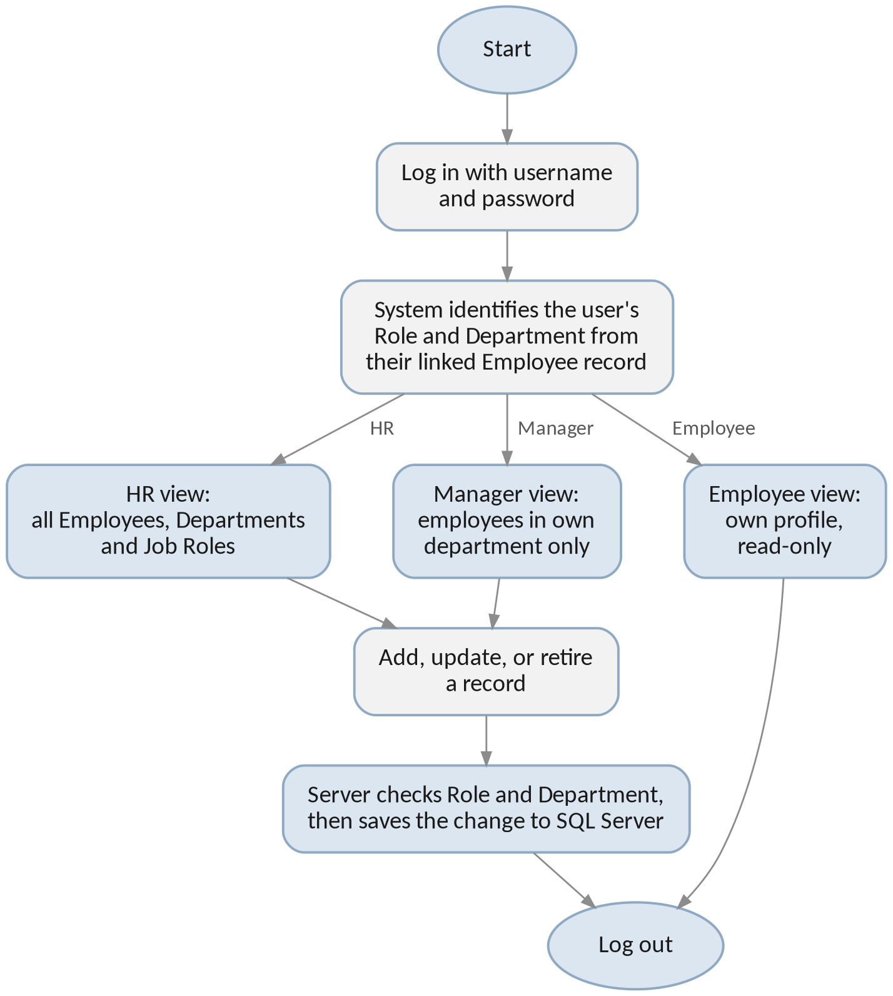

Figure 1: Application workflow from login to saving a change.

If the credentials entered at login are not valid, the user is simply returned to the login page to try again. Once logged in, the system reads the user's Role and Department from their own Employee record and shows the corresponding view: HR sees every record, a Manager sees only their own department, and an Employee sees only their own profile, with no edit option. When HR or a Manager submits a change, the server checks that the action is actually allowed for that user's Role and Department before saving anything if it is not allowed, the action is blocked and nothing is written to the database.

7. Proposed Technology Stack

7.1 .NET 8

.NET 8 is Microsoft's current LongTerm Support release, Using it requires Visual Studio 2022,.

7.2 Blazor Server

Blazor Server was chosen over MVC or Blazor WebAssembly because it keeps the interface and backend logic together in a single project, with no separate API layer to build and consume. This keeps the amount of new material manageable for a first .NET project while still relying on standard ASP.NET Core patterns.

7.3 Entity Framework Core (Code First)

Entities are defined as C# classes, and the database schema is generated and evolved through Migrations. This keeps the code and the database in agreement without maintaining SQL scripts by hand.

7.4 Microsoft SQL Server

SQL Server, managed through SSMS, is the specified database platform. It enforces the relationships between Employees, Departments, Job Roles, and Roles at the database level, rather than relying on the application alone to keep the data consistent.

7.5 ASP.NET Core Identity

ASP.NET Core Identity provides the login mechanism account storage, password hashing, and session handling rather than building authentication from scratch. Its role in this system is limited to authentication which records a user can access is determined separately.

8. Application Architecture

8.1 Presentation Layer (Components and Pages)

Razor components handle listing, creating, and editing Employees, Departments, and Job Roles. Which actions are visible to a given user depends on their role, checked through Blazor's Authorise View.

8.2 Service Layer

Business rules such as limiting a Manager's edits to their own department sit in a services layer between the interface and the database, so the same rule applies no matter how the update is triggered.

8.3 Data Access Layer (Entity Framework Core)

ApplicationDbContext, entity configuration, and migrations live here. This is the only layer that communicates with SQL Server directly.

8.4 Identity Layer

ASP.NET Core Identity's own tables and services handle user accounts and login.

9. Database Design (Code First)

The tables below follow the original data model Employees, Departments, Job Roles, and Roles, the foreign keys needed to link roles and login accounts to individual employees. The actual SQL Server tables are generated from these C# entity classes through EF Core Migrations, rather than created by hand in SSMS.

9.1 Employees
Field | Type | Notes
EmployeeId | int | Primary key, identity
FirstName | string | Required, max length 100
LastName | string | Required, max length 100
Email | string | Required, unique index
Phone | string | Required; stored as text to preserve formatting
DOB | DateOnly | Required
Address | string | Required, max length 250
DepartmentId | int (FK) | References Departments; required
JobRoleId | int (FK) | References JobRoles; required
RoleId | int (FK) | References Roles; determines HR / Manager / Employee
UserId | string (FK) | References AspNetUsers; links this record to a login account once created
IsActive | bool | Default true; set to false when an employee is retired
CreatedDate / ModifiedDate | DateTime | Added for auditing

9.2 Departments
Field | Type | Notes
DepartmentId | int | Primary key, identity
Name | string | Required, unique, max length 100
Description | string | Optional, max length 250

9.3 Job Roles
Field | Type | Notes
JobRoleId | int | Primary key, identity
Title | string | Required, max length 100
DepartmentId | int (FK) | References Departments each job role belongs to exactly one department

9.4 Roles
Field | Type | Notes
RoleId | int | Primary key, identity
RoleName | string | Required, unique values: HR, Manager, Employee

9.5 Linking Login Accounts to Employees

Each Employee record carries a RoleId, referencing the Roles table above this is what determines whether a given person is HR, a Manager, or a standard Employee, and it is visible directly on the Employees table itself. Opening the Employees table in SSMS and joining to Roles shows, immediately, who holds which role there is no separate or hidden place this information lives.

Login credentials are handled separately, through ASP.NET Core Identity's own AspNetUsers table, which stores the username and hashed password used to sign in. Each Employee record also carries a UserId column linking it to the matching AspNetUsers account once that person's login is created. In effect, Identity is responsible only for authentication confirming who someone is when they log in while what they are allowed to do once logged in is read from RoleId and, for Managers, from the DepartmentId already present on their own Employee record.

9.6 Entity Relationships

Each employee belongs to exactly one department, holds exactly one job role, and is assigned exactly one role. A job role is itself defined within a single department. A department, job role, or role that is still referenced by an employee cannot be deleted, which is enforced through a restrict rule at the database level, so existing records can never be left pointing at something that no longer exists.

Department (1) ──< JobRole (many)

Department (1) ──< Employee (many)

JobRole (1) ──< Employee (many)

Role (1) ──< Employee (many)

AspNetUsers (1) ── (0..1) Employee [via UserId]

10. Development Environment

Development uses Visual Studio 2022 (17.8 or later) with the ASP.NET and web development workload installed, targeting .NET 8.0. SQL Server Management Studio 19 is used to inspect and verify the schema that Entity Framework Core generates and to run ad-hoc queries, rather than to create tables by hand the schema itself is managed through EF Core Migrations.

11. Conclusion

This document sets out the requirements, objectives, and technical design for the Employee Management Portal: a system built around four core entities Employee, Department, Job Role, and Role with role based access for HR, Manager, and Employee users. The technology stack (.NET 8, Blazor Server, Entity Framework Core, SQL Server) and the database design, including exactly how roles and login accounts map to employee records, are intended to give development a clear, agreed starting point.

