Employee Management Portal
Version: 1.2
Table of Contents
1. Introduction 3
1.1 Original Statement 3
2. Business Requirements 3
3. Objectives 4
4. Scope 4
4.1 In Scope 4
4.2 Out of Scope 5
5. Stakeholders, Roles and Permissions 5
5.1 Permission Summary 5
6. Business Rules and Validation 6
7. Application Workflow 7
7.1 New Joiner Onboarding and Password Reset 7
7.2 Employee Profile Change Approval 8
8. Use Cases 9
9. Acceptance Criteria 13
9.1 HR/Admin Acceptance Criteria 13
9.2 Employee Acceptance Criteria 13
9.3 Manager Acceptance Criteria 14
9.4 End-to-End System Behavior 14
10. Technologies Used 14
11. Application Architecture 15
11.1 Presentation Layer (Components and Pages) 15
11.2 Service Layer 15
11.3 Data Access Layer (Entity Framework Core) 15
11.4 Identity Layer 15
12. Database Design (Code First) 16
12.1 Employees 16
12.2 Employee Profile Change Requests 17
12.3 Departments 17
12.4 Job Roles 18
12.5 Roles 18
12.6 Linking Login Accounts to Employees 18
12.7 Entity Relationships 19
13. Development Environment 19
14. Conclusion 19

1. Introduction
The Employee Management Portal is a web application for maintaining employee records, personal details, department assignments, job roles, and role-based access in one place. It replaces spreadsheet- or paper-based processes with a controlled portal used by HR/Admin, Managers, and Employees.

1.1 Original Statement
“Build a web application to track employee personal details, department, and job roles.”

2. Business Requirements
The following requirements describe what the organization needs from the system, independent of implementation details.
Sl. No. | Requirement
1 | HR/Admin must be able to create a new employee record using the agreed personal details, Department, Job Role, and application Role.
2 | For a new joiner, HR/Admin must create the employee’s login account and provide a username/email and temporary password.
3 | Before first regular login, the new employee must use Forgot Password on the portal to set a new personal password for the account.
4 | HR/Admin must be able to update any employee record when employee information changes.
5 | A Manager may update permitted personal and contact information only for employees in the Manager’s own Department.
6 | An Employee must be able to view and edit permitted fields on their own profile only.
7 | When an Employee submits profile changes, the system must create a pending change request instead of immediately changing the approved profile.
8 | The pending profile change request must be available to an authorized Manager for the Employee’s Department for review.
9 | After the Manager approves the request, the approved values must be applied to the Employee record and become visible on the portal. If rejected, the current approved profile remains visible.
10 | Only HR/Admin may change an employee’s Department, Job Role, or application Role.
11 | HR/Admin must be able to retire an employee without deleting the historical record. Retired employee records remain visible only to HR/Admin and cannot be reactivated.
12 | The system must identify the signed-in user’s Role and Department before displaying employee data or allowing an action.
13 | HR/Admin must be able to add, view, update, and delete Departments.
14 | HR/Admin must be able to add, view, update, and delete Job Roles, with each Job Role belonging to one Department.
15 | HR/Admin and Managers must be able to search the employee list. Manager results remain limited to the Manager’s own Department.
16 | The system must validate required values and business rules before employee, profile-change, or reference data is saved.

3. Objectives
The portal is intended to provide a single, controlled source of employee information and make common employee-management activities easier to perform without technical assistance.
- Maintain a centralized and accurate employee record for HR/Admin.
- Apply role- and department-based access so users see only the information and actions they are permitted to use.
- Allow Employees to maintain permitted parts of their own profile while keeping Manager approval as the control point before changes become official.
- Give HR/Admin a controlled onboarding process in which employee accounts are created before the new joiner accesses the portal.
- Keep Department and Job Role information reusable and consistent.
- Support routine administration such as adding, updating, searching, and retiring employee records.

4. Scope

4.1 In Scope
- Employee record creation, update, view, search, and retirement.
- HR/Admin-provisioned login accounts for new joiners.
- First-time password reset using Forgot Password.
- Employee self-service profile viewing and editing for permitted fields.
- Manager approval or rejection of employee-submitted profile changes.
- Department and Job Role maintenance by HR/Admin.
- Role-based and Department-based access for HR/Admin, Manager, and Employee users.
- Retained history for retired employees.

4.2 Out of Scope
- Payroll and salary processing.
- Attendance tracking.
- Leave management.
- Managers viewing or updating employees outside their own Department.
- Employee changes to Department, Job Role, or application Role.
- Reactivation of retired employees.
- Recruitment and candidate management.

5. Stakeholders, Roles and Permissions
- HR/Admin - main administrator of the portal; creates employee records and login accounts, maintains employee data, Departments and Job Roles, and can view retired employee history.
- Manager - views employees in the Manager’s own Department, updates permitted information, and reviews employee-submitted profile change requests for that Department.
- Employee - signs in using the HR/Admin-provisioned account, views their own profile, edits permitted fields, and submits changes for Manager approval.

5.1 Permission Summary
Role | View Access | Employee Profile Actions | Administrative Access
HR/Admin | All employees | Edit all permitted employee fields; may administer requests as authorized | Manage Departments/Job Roles; view retired history
Manager | Employees in own Department | Edit permitted fields; approve or reject Employee-submitted profile changes | No Department/Job Role maintenance; no retired history
Employee | Own profile only | Edit own permitted fields and submit changes for Manager approval | No administrative access

6. Business Rules and Validation
- Each Employee belongs to one Department, one Job Role, and one application Role.
- Each Job Role belongs to exactly one Department.
- A Manager cannot change the Department, Job Role, or application Role.
- An Employee can edit only permitted fields on the Employee’s own profile.
- Employee-submitted profile changes must remain Pending until an authorized Manager approves or rejects them.
- Pending values must not replace the currently approved Employee record before approval.
- On approval, the approved values are written to the Employee record and become visible on the portal.
- On rejection, the current approved profile remains unchanged.
- HR/Admin creates an Identity account for a new joiner; employee self-registration is not allowed.
- A new joiner uses Forgot Password to set a personal password before normal portal use.
- Required fields must be completed before a record is saved.
- Email must be valid and unique for employee records and login accounts.
- Phone values must contain a valid usable value.
- Date of Birth cannot be a future date.
- The selected Job Role must belong to the selected Department.

7. Application Workflow

7.1 New Joiner Onboarding and Password Reset
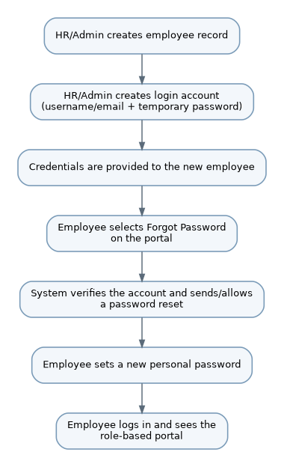

7.2 Employee Profile Change Approval
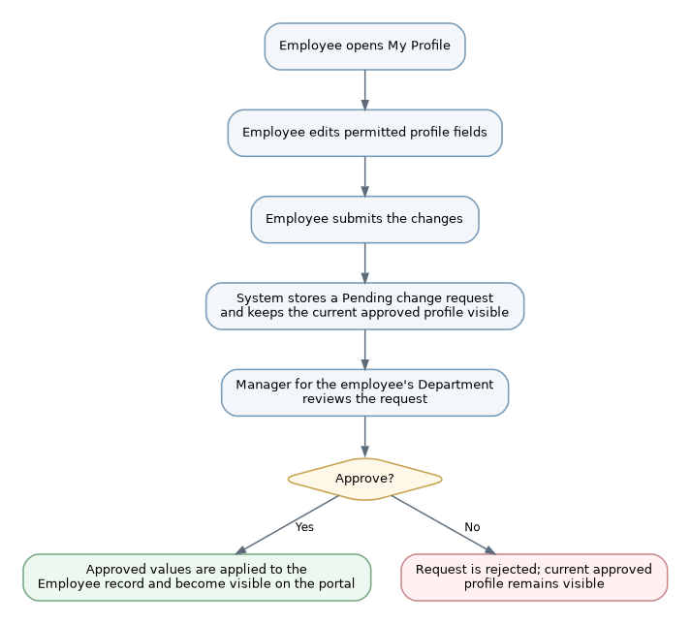

8. Use Cases

UC-01 - Provision New Employee
Actor | HR/Admin
Purpose | Create the employee record and login account for a new joiner.
Main flow | 1. Select Add Employee and enter employee details, Department, Job Role, and application Role.  2. Submit the form.  3. System validates the data, creates the Employee record, and creates the linked Identity account using the employee username/email and a temporary password.  4. HR/Admin provides the username/email and temporary password to the new employee.
Exception / rule | If required data is invalid or the email/username already exists, the employee/account is not created.

UC-02 - First-Time Password Reset
Actor | Employee
Purpose | Set a personal password before normal portal use.
Main flow | 1. Open the portal and select Forgot Password.  2. Enter the registered username/email.  3. Complete the password-reset verification provided by the portal.  4. Set a new password and sign in.
Exception / rule | Password reset is available only for an existing active account. Invalid or unrecognized email/username is not accepted.

UC-03 - Login and Role-Based Access
Actor | HR/Admin, Manager, Employee
Purpose | Authenticate the user and show only permitted data/actions.
Main flow | 1. Enter login credentials.  2. System authenticates the Identity account.  3. System reads Role and Department from the linked Employee record.  4. Portal displays only the data and actions allowed for that user.
Exception / rule | Invalid credentials are rejected and employee data is not displayed.

UC-04 - View and Submit Own Profile Changes
Actor | Employee
Purpose | Allow an Employee to maintain permitted profile fields under Manager approval.
Main flow | 1. Sign in and open My Profile.  2. Review the currently approved profile.  3. Edit permitted fields and submit the changes.  4. System validates the data and stores a Pending profile change request.  5. The currently approved profile remains visible until the request is approved.
Exception / rule | An Employee cannot edit another employee’s record or change restricted fields such as Department, Job Role, or application Role.

UC-05 - Review Employee Profile Change
Actor | Manager
Purpose | Approve or reject an Employee profile change request within the Manager’s Department.
Main flow | 1. Open the Pending Profile Changes list.  2. Select a request for an employee in the Manager’s Department.  3. Review current values and requested values.  4. Approve or reject the request.  5. If approved, the system applies the approved values to the Employee record; if rejected, the Employee record remains unchanged.
Exception / rule | A Manager cannot review requests for employees outside the Manager’s Department.

UC-06 - Update Employee
Actor | HR/Admin, Manager
Purpose | Update employee data within the actor’s permitted scope.
Main flow | 1. Open an employee record.  2. System checks Role and Department before enabling edit actions.  3. Change permitted fields and submit.  4. System validates and saves the changes.
Exception / rule | A Manager attempts to change Department, Job Role, application Role, or an employee outside the Manager’s Department is rejected.

UC-07 - Retire Employee
Actor | HR/Admin
Purpose | Retain history while removing the employee from active use.
Main flow | 1. Open an active employee and select Retire.  2. Confirm retirement.  3. System marks the employee inactive without deleting the record.  4. Retired history remains available to HR/Admin only.
Exception / rule | Reactivation is not available for a retired employee.

UC-08 - Search and Sort Employees
Actor | HR/Admin, Manager
Purpose | Find employee records within the actor’s permitted scope.
Main flow | 1. Enter a search value or sorting option.  2. System applies the request to employee records the user is allowed to view.  3. System returns paged results.
Exception / rule | Manager results remain within the Manager’s Department. If there are no matching records, the system shows an empty result state.

UC-09 - Manage Departments and Job Roles
Actor | HR/Admin
Purpose | Maintain reference data used by employee records.
Main flow | 1. Open Department or Job Role maintenance.  2. Add or update a record.  3. Validate and save the change.  4. Request deletion when needed.
Exception / rule | Deletion is blocked when existing Employees or Job Roles still reference the selected record.

9. Acceptance Criteria
The application is considered acceptable when the complete employee lifecycle works correctly for all three stakeholders - HR/Admin, Manager, and Employee - and the system consistently applies role-based access, Department-based restrictions, validation, and Manager approval rules from onboarding through ongoing profile maintenance and employee retirement.

9.1 HR/Admin Acceptance Criteria
AC-HR-01 - HR/Admin can create a new Employee record with the required personal details, Department, Job Role, and application Role. The system validates the entered data before the record is saved.
AC-HR-02 - For a new joiner, HR/Admin can create and link the login account using the employee username/email and a temporary password, then provide those credentials to the employee. Invalid or duplicate account details are not accepted.
AC-HR-03 - After login, HR/Admin can view all employee records, update permitted employee information, search employees, and manage Departments and Job Roles.
AC-HR-04 - HR/Admin can retire an employee without deleting the historical record. Retired employee information remains available only to HR/Admin and the employee cannot be reactivated.

9.2 Employee Acceptance Criteria
AC-EMP-01 - A new employee can use Forgot Password with the HR/Admin-provisioned account to set a personal password before normal portal use, and can then sign in successfully with the new password.
AC-EMP-02 - After login, an Employee can access only the Employee's own profile and cannot view or edit another employee's record.
AC-EMP-03 - An Employee can edit only permitted profile fields. Department, Job Role, and application Role remain restricted and cannot be changed by the Employee.
AC-EMP-04 - When the Employee submits profile changes, the system creates a Pending profile-change request. The currently approved profile remains visible until a Manager reviews the request.
AC-EMP-05 - If the Manager approves the request, the approved values are applied to the Employee record and become visible on the portal. If the request is rejected, the existing approved profile remains unchanged.

9.3 Manager Acceptance Criteria
AC-MGR-01 - After login, a Manager can view and search employee records only within the Manager's own Department.
AC-MGR-02 - A Manager can update only permitted employee information within the Manager's own Department and cannot change Department, Job Role, or application Role.
AC-MGR-03 - A Manager can view Pending profile-change requests only for employees in the Manager's own Department and can compare the current approved values with the requested values.
AC-MGR-04 - The Manager can approve or reject an authorized request. Approval applies the requested values to the Employee record; rejection leaves the current approved Employee record unchanged.
AC-MGR-05 - The system blocks a Manager from viewing, updating, or reviewing profile-change requests for employees outside the Manager's Department.

9.4 End-to-End System Behavior
AC-SYS-01 - Before displaying employee data or enabling an action, the system identifies the signed-in user's Role and Department and shows only the data and actions permitted for that user.
AC-SYS-02 - The system validates required values and business rules before saving employee, profile-change, Department, or Job Role data, including unique valid email, usable phone value, non-future Date of Birth, and a Job Role that belongs to the selected Department.
AC-SYS-03 - Employee-submitted profile changes remain separate from the approved Employee record while the request is Pending, so unapproved values do not become visible as official profile data.
AC-SYS-04 - Access remains consistent across the portal: HR/Admin can access all employee records, Managers remain limited to their own Department, and Employees remain limited to their own profile.
AC-SYS-05 - The portal preserves the correct final state after each action: approved profile changes become visible, rejected changes leave the approved profile unchanged, and retired employee history is retained for HR/Admin only.

10. Technologies Used
Technology | Purpose
.NET 8 | Application framework and runtime.
Blazor Server | Server-side web user interface using Razor components.
Entity Framework Core - Code First | Entity mapping, database access, migrations, and relationship configuration.
Microsoft SQL Server | Relational database for employee, reference, authentication, and pending profile-change data.
ASP.NET Core Identity | HR/Admin-provisioned user accounts, login, password hashing, Forgot Password/password reset, and account session management.
Visual Studio 2022 | Development environment.
SQL Server Management Studio (SSMS) | Database inspection, verification, and ad-hoc queries.

11. Application Architecture

11.1 Presentation Layer (Components and Pages)
Razor components handle employee listing, onboarding, profile editing, Manager approval, Department maintenance, and Job Role maintenance. Visible actions depend on the signed-in user’s Role and Department and are controlled through Blazor authorization components.

11.2 Service Layer
Business rules are enforced in services between the interface and database. This includes Department-scoped Manager access, validating Employee profile edits, creating pending change requests, approving or rejecting requests, and applying approved values to the Employee record.

11.3 Data Access Layer (Entity Framework Core)
ApplicationDbContext, entity configuration, and migrations live in this layer. It is the only application layer that communicates directly with SQL Server.

11.4 Identity Layer
ASP.NET Core Identity handles account creation, password hashing, sign-in, Forgot Password/password reset, and session management. Employee accounts are provisioned by HR/Admin and linked to Employee records; employees do not self-register.

12. Database Design (Code First)
The data model keeps Employees, Departments, Job Roles, and Roles as the core entities and adds a profile-change request entity so Employee edits can remain pending until Manager approval. SQL Server tables are generated from C# entity classes through EF Core Migrations rather than created manually in SSMS.

12.1 Employees
Field | Type | Notes
EmployeeId | int | Primary key, identity
FirstName | string | Required, max length 100
LastName | string | Required, max length 100
Email | string | Required, unique index; also used for account provisioning/password reset
Phone | string | Required; stored as text to preserve formatting
DOB | DateOnly | Required
Address | string | Required, max length 250
DepartmentId | int (FK) | References Departments; required
JobRoleId | int (FK) | References JobRoles; required
RoleId | int (FK) | References Roles; determines HR/Admin, Manager, or Employee
UserId | string (FK) | References AspNetUsers; created/linked by HR/Admin during onboarding
IsActive | bool | Default true; set to false when an employee is retired
CreatedDate / ModifiedDate | DateTime | Used for auditing

12.2 Employee Profile Change Requests
This table stores proposed Employee profile edits separately from the approved Employee record until a Manager completes the review.

Field | Type | Notes
ProfileChangeRequestId | int | Primary key, identity
EmployeeId | int (FK) | Employee whose profile is being changed
RequestedData | nvarchar(max) | Proposed permitted profile values; can be stored as a serialized request payload
Status | string | Pending, Approved, or Rejected
SubmittedDate | DateTime | When the Employee submitted the request
ReviewedByUserId | string (FK), nullable | Manager account that reviewed the request
ReviewedDate | DateTime, nullable | When the request was approved or rejected
ManagerComments | string, nullable | Optional Manager note or rejection reason

12.3 Departments
Field | Type | Notes
DepartmentId | int | Primary key, identity
Name | string | Required, unique, max length 100
Description | string | Optional, max length 250

12.4 Job Roles
Field | Type | Notes
JobRoleId | int | Primary key, identity
Title | string | Required, max length 100
DepartmentId | int (FK) | References Departments; each Job Role belongs to exactly one Department

12.5 Roles
Field | Type | Notes
RoleId | int | Primary key, identity
RoleName | string | Required, unique values: HR/Admin, Manager, Employee

12.6 Linking Login Accounts to Employees
RoleId identifies whether an Employee is HR/Admin, a Manager, or an Employee. For Managers, DepartmentId limits employee records and pending approval requests to their own Department.
ASP.NET Core Identity stores login credentials. HR/Admin creates the account during onboarding and links it to the Employee through UserId. The new employee then uses Forgot Password to set a personal password before normal portal use.

12.7 Entity Relationships
Each Employee belongs to one Department, one Job Role, and one application Role; each Job Role belongs to one Department. Employees may submit multiple profile-change requests. Referenced Departments, Job Roles, and Roles cannot be deleted.

Relationship | Cardinality / Purpose
Department -> JobRole | One Department to many Job Roles
Department -> Employee | One Department to many Employees
JobRole -> Employee | One Job Role to many Employees
Role -> Employee | One Role to many Employees
AspNetUsers -> Employee | One login account to zero or one Employee record through UserId
Employee -> ProfileChangeRequest | One Employee to many profile-change requests
AspNetUsers (Manager) -> ProfileChangeRequest | One Manager account may review many requests

13. Development Environment
Development uses Visual Studio 2022 (17.8 or later) with the ASP.NET and web development workload, targeting .NET 8.0. SQL Server Management Studio 19 is used to inspect the EF Core-generated schema and run ad-hoc queries; schema changes are managed through EF Core Migrations.

14. Conclusion
The Employee Management Portal supports controlled employee administration, role-based access, HR/Admin-provisioned user accounts, and Employee self-service profile updates with Manager approval. The .NET 8, Blazor Server, Entity Framework Core, SQL Server, and ASP.NET Core Identity stack, together with the updated data model, provides a clear implementation baseline.

