**. Set Up Azure Blob Storage**

1. **Create Storage Accounts:**
   * **Storage Account Name:** xyzretailstorage
   * **Resource Group:** RetailDataGroup
   * **Region:** Choose an appropriate region (e.g., East US)

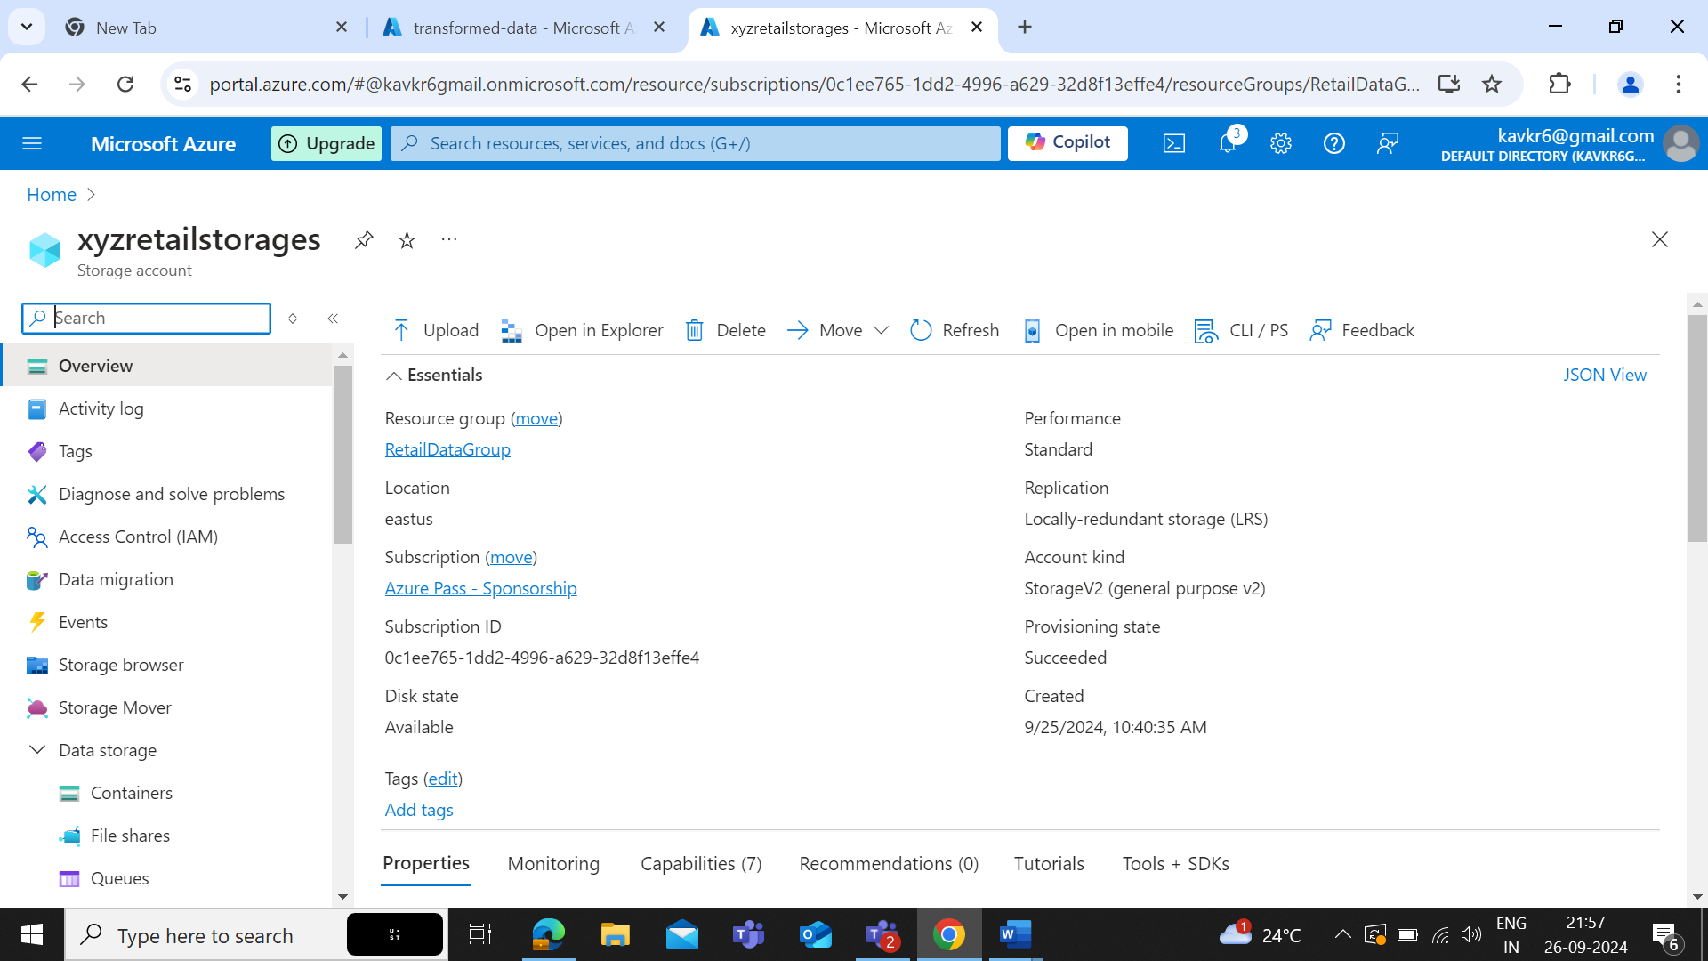

1. **Create Containers:**
   * **Source Container:** source-data
   * **Destination Container:** processed-data

1. **Upload Sample Data:**
   * Upload sample CSV files with sales data to the source-data container for initial testing.

**2. Configure Azure Data Factory**

1. **Create Data Factory:**
   * **Data Factory Name:** RetailDataFactory
   * **Resource Group:** RetailDataGroup
   * **Region:** Same as storage account (e.g., East US)

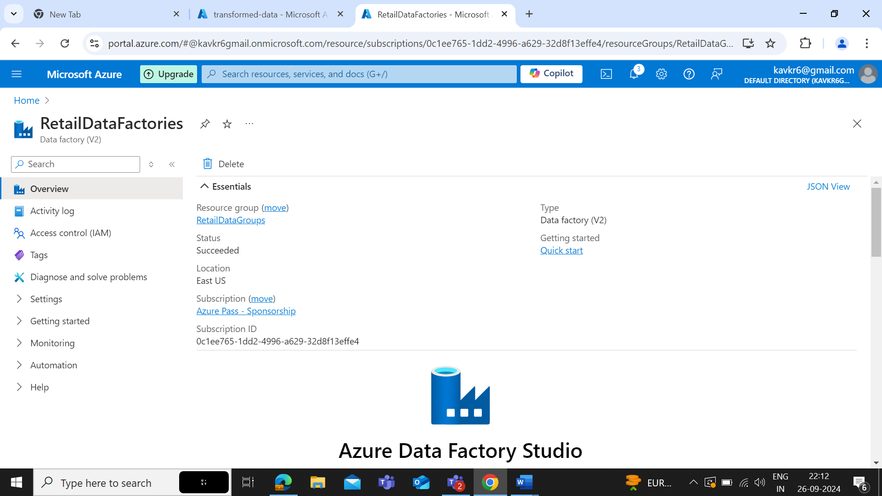

1. **Create Linked Services:**
   * **Azure Blob Storage Linked Service:**
     + Configure connection to xyzretailstorage.
     + Use the storage account connection string.

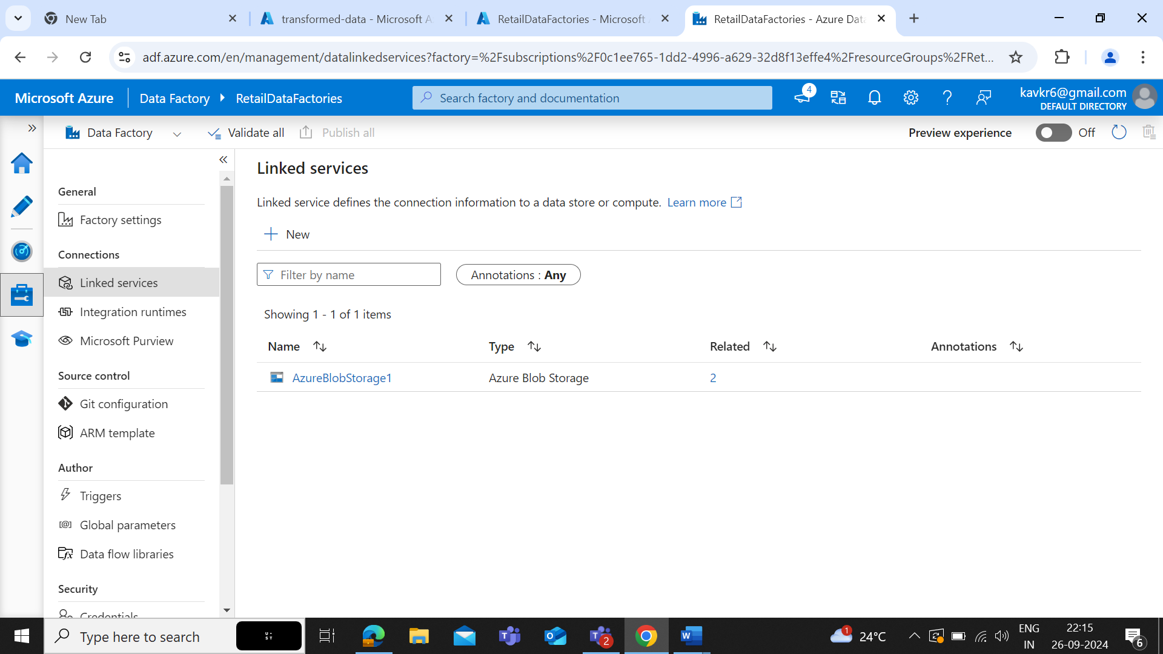

1. **Create Datasets:**
   * **Source Dataset:**
     + Data source: source-data container
     + Format: CSV
     + Schema: Configure based on the CSV file

* + **Destination Dataset:**
    - Data source: processed-data container
    - Format: CSV
    - Schema: Define or infer schema based on transformation.

**3. Build and Configure Pipeline**

1. **Create Pipeline:**
   * **Pipeline Name:** SalesDataPipeline
   * **Activities:**
     + **Copy Data Activity:**
       - **Source:** Link to source-data dataset.
       - **Sink:** Link to processed-data dataset.
       - **Transformation:** Optionally, configure transformations like column mapping and data filtering.
2. **Optional Data Flow:**
   * Create a Data Flow if more complex transformations are needed.
   * Add steps for data cleaning (e.g., removing null values) and aggregation (e.g., summing sales by date).

